|  | **MINISTRY OF EDUCATION AND TRAINING** |
| --- | --- |

| **FPT UNIVERSITY** |
| --- |
| Capstone Project Document |
| **SRPM - Science Research Project Management** |

| **GSU25SE20** | |
| --- | --- |
| **Group Members** | Phan Trần Bảo Thiên - SE172958  Đoàn Huỳnh Tường Vy - SE173622  Phạm Huy Hoàng - SE172789  Phùng Trần Mai Hà - SE172939 |
| **Supervisor** | Nguyễn Thị Cẩm Hương |
| **Ext Supervisor** |  |
| **Capstone Project code** | SU25SE098 |

– Ho Chi Minh city, April 2025 –

**Table of Contents**

**Acknowledgement** **22**

**Definition and Acronyms** **22**

**I. Project Introduction** **24**

1. Overview 24

1.1 Project Information 24

1.2 Project Team 24

Table 1.2 : List of member in project team 24

2. Product Background 24

3. Existing Systems 25

4. Business Opportunity 25

5. Software Product Vision 26

6. Project Scope & Limitations 27

6.1 Major Features 27

6.2 Limitations & Exclusions 32

**II. Project Management Plan** **33**

1. Overview 33

1.1 Scope & Estimation 33

Table 2.1.1 : Project Management Plan 33

1.2 Project Objectives 36

Table 2.1.2 : Project Objectives 36

1.3 Project Risks 36

Table 2.1.3: Project Risks 36

2. Management Approach 38

2.1 Project Process 38

Figure 2.2.1 : Project Process 38

2.2 Quality Management 39

2.3 Training Plan 40

Table 2.2.3 : Training Plan 40

3. Project Deliverables 40

Table 2.3: Project Deliverables 40

4. Responsibility Assignments 41

Table 2.4 : Responsibility Assignments 41

5. Project Communications 42

Table 2.5.1 : Communication plan 42

6. Configuration Management 42

6.1 Document Management 42

6.2 Source Code Management 43

6.3 Tools & Infrastructures 43

Table 6.3 : Tools & Infrastructure 43

**III. Software Requirement Specification** **43**

1. Product Overview 43

2. User Requirements 44

2.1 Actors 44

Table 3.2.1 : List of actors 44

2.2 Use Case 48

2.2.1 Diagram(s) 48

2.2.2 Descriptions 48

Table 2.2.2.2: Uses case description 48

3. Functional Requirements 50

3.1 System Functional Overview 50

3.1.1 Screen Flows 50

3.1.1.a Researcher Screen Flows 50

3.1.1.b Principle Investigator Screen Flows 50

3.1.1.c Host Institution Screen Flows 51

3.1.1.d Appraisal Council Screen Flows 51

3.1.1.e Administrator Screen Flows 52

3.1.1.f Staff Screen Flows 53

3.1.2 Screen Descriptions 53

Table 3.1.2.a : Researcher Screen Descriptions 53

Table 3.1.2.b : Principle Investigator Screen Descriptions 55

Table 3.1.2.c : Host Institution Screen Descriptions 56

Table 3.1.2.d : Appraisal Council Screen Descriptions 57

Table 3.1.2.e: Administrator Screen Descriptions 58

Table 3.1.2.f: Staff Screen Descriptions 59

3.1.3 Non-Screen Functions 61

Table 3.1.3: Non-Screen Functions 61

3.1.4 Screen Authorization 61

Table 3.1.4.1: Screen Authorization 61

3.1.5 Entity Relationship Diagram 63

Figure 3.1.5.1: Conceptual ERD 64

Figure 3.1.5.2: Logical ERD 65

Table 3.1.5: Entity Description 69

3.2 Applications for All Users (Common Features) 69

3.2.1 Login Page 69

Figure 3.2.1: Login Page 70

Figure 3.2.1: Staff login Page 71

Figure 3.2.1.2: Forget Password Page 71

Figure 3.2.2: Home Page 73

Figure 3.2.3.1 User Profile Page 74

Figure 3.2.5 Create Scientific CV Page 75

Figure 3.2.5 Edit Scientific CV Page 76

Figure 3.2.5 View Scientific CV Page 77

3.2.6 Notifications Center 77

Figure 3.2.6 Notifications Center Read Page 78

3.3 Applications for Researchers 78

3.3.1 Projects List Page 78

Figure 3.3.1 Projects List Page 80

3.3.2 My Projects Page (Researcher View) 80

Figure 3.3.2 My Projects Page 81

Figure 3.3.2 My Projects Detail Page 81

Figure 3.3.2 My Projects Detail Documents Page 82

3.3.3 Task Management for Researchers 82

Figure 3.3.3 Task Dashboard 83

Figure 3.3.3 Task Table View 84

Figure 3.3.3 Task Kanban Board 85

Figure 3.3.3 Advanced Task Management 86

3.4 Applications for Principal Investigators 86

3.4.1 My Projects (PI View) 86

Figure 3.4.1 My Projects Dashboard 87

3.4.2 Project Detail 87

Figure 3.4.2 Project Detail 89

Figure 3.4.2 Project Detail 90

Figure 3.4.2 Project Detail 90

Figure 3.4.2 Project Detail 91

Figure 3.4.2 Project Detail 91

Figure 3.4.2 Project Detail 92

Figure 3.4.2 Project Detail 92

Figure 3.4.2 Project Detail 92

3.4.3 Projects List Page 92

Figure 3.4.3 Projects List Page 94

3.4.4 Project Enrollment Page 94

Figure 3.4.4 Project Registration Form 95

Figure 3.4.4 Project Registration Form 95

Figure 3.4.4 Project Invite Members 97

3.4.5 Document Management 97

Figure 3.4.3.1 Project Document 98

Figure 3.4.3.1 Project Document 98

3.4.6 Meeting Coordination 98

Figure 3.4.6 Meeting Coordination 99

3.5 Applications for Host Institutions 99

3.5.1 Project Registration 99

Figure 3.5.1. Project Registration System Step 1 100

Figure 3.5.1 Project Registration System Step 2 101

3.5.2 My Project (Host view) 101

Figure 3.5.2 My Project 102

3.5.3 Projects List Page 102

Figure 3.5.3 Projects List Page for HI 103

3.6 Applications for Appraisal Council Members 103

3.6.1 My Council 103

Figure 3.6.1 My Council Dashboard 105

Figure 3.6.1 My Council Project Detail 106

Figure 3.6.1 My Council Evaluation Detail 106

Figure 3.6.1 My Council Evaluation Stage 107

3.6.2 Project Approval System 107

Figure 3.6.2 Project Approval System 108

Figure 3.6.2 Review Project Topics 109

Figure 3.6.2 Proposal Detail 110

Figure 3.6.2 Review Proposal 110

Figure 3.6.2 Choose and Select Proposal 111

3.6.3 Advanced Evaluation 111

Figure 3.6.3 Create Individual Evaluation 113

Figure 3.6.3 View Individual Evaluation 113

Figure 3.6.3 View AI Individual Evaluation 114

3.6.4 Meeting Management 114

Figure 3.6.4 Council Meeting 115

3.7 Applications for Staff Members 115

3.7.1 Staff Dashboard 115

Figure 3.7.1 Staff Dashboard 116

3.7.2 Project Management 116

Figure 3.7.2 Project Oversight 117

Figure 3.7.2 Register New Project 118

Figure 3.7.2 Assign Council 119

Figure 3.7.2 Assign Council 119

3.7.3 Document Form Management 119

Figure 3.7.3 Document Form Management 119

3.7.4 Fields and Majors Administration 120

Figure 3.7.3 Fields Management 121

Figure 3.7.3 Major Management 121

3.7.5 Appraisal Council Management 122

Figure 3.7.5 Appraisal Council Management 122

Figure 3.7.5 Appraisal Council Management 123

3.7.6 Meeting Management System 123

Figure 3.7.6 Meeting Management System 124

Figure 3.7.6 Meeting Management System 125

3.7.7 User Management 125

Figure 3.7.7 User Management 125

Figure 3.7.7 User Management 126

3.7.8 Contract Management 126

Figure 3.7.8 Contract Management 127

Figure 3.7.8 Contract Management 129

Figure 3.7.8 Contract Management 129

Figure 3.7.8 Contract Management 129

3.8 Applications for System Administrators 129

3.8.1 System Config Management 129

Figure 3.8.1 System Config Management 130

3.8.2 Transaction Management 130

Figure 3.8.2 Transaction Administration 131

4. Non-Functional Requirements 131

4.1 External Interfaces 131

4.2 Quality Attributes 132

4.2.1 Usability 133

4.2.2 Reliability 133

4.2.3 Performance 134

5. Requirement Appendix 135

5.1 Business Rules 135

Table 5.1 : Business Rules 135

**IV. Software Design Description** **139**

1. System Design 140

1.1 System Architecture 140

1.2 Package Diagram 141

1.2.1 Backend Package Diagram 141

1.2.2 Web Application Package Diagram 142

2. Database Design 142

3. Detailed Design 148

3.1 Sign In 148

3.1.1 Class Diagram 148

3.1.2 Sequence Diagram 149

3.1.3 Class Specification 149

3.1.3.a Authentication Controller 149

Table 3.1.3.a: Authentication Controller Description Table 149

3.1.3.b Authentication Service 149

Table 3.1.3.b: Authentication Service Description Table 149

3.2 Account Management 149

3.2.1 Create 149

3.2.1.1 Class Diagram 150

3.2.1.2 Sequence Diagram 151

3.2.1.3 Class Specification 151

3.2.1.3.a Account Controller 151

3.2.1.3.b Account Service 151

3.2.2 Update 151

3.2.2.1 Class Diagram 151

3.2.2.2 Sequence Diagram 153

3.2.2.3 Class Specification 153

3.2.2.3.a AccountController 153

3.2.2.3.b Account Service 153

3.2.3 Get By Id 153

3.2.3.1 Class Diagram 153

3.2.3.2 Sequence Diagram 154

3.2.3.3 Class Specification 155

3.2.2.3.a Account Controller 155

3.2.2.3.b Account Service 155

3.2.4 Delete 155

3.2.4.1 Class Diagram 155

3.2.4.2 Sequence Diagram 156

3.2.4.3 Class Specification 156

3.2.4.3.a Account Controller 156

3.2.4.3.b Account Service 156

3.2.5 Get List 157

3.2.5.1 Class Diagram 157

3.2.5.2 Sequence Diagram 158

3.2.5.3 Class Specification 158

3.2.5.3.a Authentication Controller 158

3.2.5.3.b Authentication Service 158

3.3 Manage Appraisal Council 158

3.3.1.Create 159

3.3.1.1 Class Diagram 159

3.3.1.2 Sequence Diagram 160

3.3.1.3 Class Specification 160

3.3.1.3.a AppraisalCouncilController 160

3.3.1.3.b Appraisal Council Service 160

3.3.2.Update 160

3.3.2.1 Class Diagram 160

3.3.2.2 Sequence Diagram 162

3.3.2.3 Class Specification 162

3.3.2.3.a AppraisalCouncilController 162

3.3.2.3.b Account Service 162

3.3.3.Get By Id 162

3.3.3.1 Class Diagram 162

3.3.3.2 Sequence Diagram 163

3.3.3.3 Class Specification 164

3.3.3.3.a AppraisalCouncilController 164

3.3.3.3.b AppraisalCouncilService 164

3.3.4.Delete 164

3.3.4.1 Class Diagram 164

3.3.4.2 Sequence Diagram 165

3.3.4.3 Class Specification 165

3.3.4.3.a AppraisalCouncilController 165

3.3.4.3.b AppraisalCouncilService 165

3.3.5.Get List 165

3.3.5.1 Class Diagram 165

3.3.5.2 Sequence Diagram 167

3.3.5.3 Class Specification 167

3.3.5.3.a AppraisalCouncilController 167

3.3.5.3.b AppraisalCouncilService 167

3.4 Manage Document 167

3.4.1.Create 167

3.4.1.1 Class Diagram 168

3.4.1.2 Sequence Diagram 169

3.4.1.3 Class Specification 169

3.4.1.3.a DocumentController 169

3.4.1.3.b DocumentService 169

3.4.2.Update 169

3.4.2.1 Class Diagram 169

3.4.2.2 Sequence Diagram 171

3.4.2.3 Class Specification 171

3.4.2.3.a DocumentController 171

3.4.2.3.b DocumentService 171

3.4.3.Get By Id 172

3.4.3.1 Class Diagram 172

3.4.3.2 Sequence Diagram 173

3.4.3.3 Class Specification 173

3.4.3.3.a DocumentController 173

3.4.3.3.b DocumentService 173

3.4.4.Delete 173

3.4.4.1 Class Diagram 173

3.4.4.2 Sequence Diagram 174

3.4.4.3 Class Specification 175

3.4.4.3.a DocumentController 175

3.4.4.3.b DocumentService 175

3.4.5.Get List 175

3.4.5.1 Class Diagram 175

3.4.5.2 Sequence Diagram 176

3.4.5.3 Class Specification 176

3.4.5.3.a DocumentController 176

3.4.5.3.b DocumentService 176

3.5 Manage Evaluation 176

3.5.1.Create 176

3.5.1.1 Class Diagram 177

3.5.1.2 Sequence Diagram 177

3.5.1.3 Class Specification 178

3.5.1.3.a EvaluationController 178

3.5.1.3.b EvaluationService 178

3.5.2.Update 178

3.5.2.1 Class Diagram 178

3.5.2.2 Sequence Diagram 179

3.5.2.3 Class Specification 179

3.5.2.3.a EvaluationController 179

3.5.2.3.b EvaluationService 179

3.5.3.Get By Id 179

3.5.3.1 Class Diagram 179

3.5.3.2 Sequence Diagram 180

3.5.3.3 Class Specification 180

3.5.3.3.a EvaluationController 180

3.5.3.3.b EvaluationService 181

3.5.4.Delete 181

3.5.4.1 Class Diagram 181

3.5.4.2 Sequence Diagram 182

3.5.4.3 Class Specification 182

3.5.4.3.a EvaluationController 182

3.5.4.3.b EvaluationService 182

3.5.5.Get List 183

3.5.5.1 Class Diagram 183

3.5.5.2 Sequence Diagram 184

3.5.5.3 Class Specification 184

3.5.5.3.a EvaluationController 184

3.5.5.3.b EvaluationService 184

3.5.6.AI Review 184

3.5.5.1 Class Diagram 184

3.5.5.2 Sequence Diagram 185

3.5.5.3 Class Specification 186

3.5.5.3.a EvaluationController 186

3.5.5.3.b EvaluationService 186

3.5.5.3.c ITaskQueueHandler 186

3.5.5.3.d IOpenAIService 186

3.6 Manage Evaluation Stage 187

3.6.1.Create 188

3.6.1.1 Class Diagram 188

3.6.1.2 Sequence Diagram 189

3.6.1.3 Class Specification 189

3.6.1.3.a EvaluationStageController 189

3.6.1.3.b EvaluationStageService 189

3.6.2.Update 189

3.6.2.1 Class Diagram 189

3.6.2.2 Sequence Diagram 191

3.6.2.3 Class Specification 191

3.6.2.3.a EvaluationStageController 191

3.6.2.3.b EvaluationStageService 191

3.6.3.Get By Id 192

3.6.3.1 Class Diagram 192

3.6.3.2 Sequence Diagram 193

3.6.3.3 Class Specification 193

3.6.3.3.a EvaluationStageController 193

3.6.3.3.b EvaluationStageService 193

3.6.4.Delete 193

3.6.4.1 Class Diagram 193

3.6.4.2 Sequence Diagram 195

3.6.4.3 Class Specification 195

3.6.4.3.a EvaluationStageController 195

3.6.4.3.b EvaluationStageService 195

3.6.5.Get List 195

3.6.5.1 Class Diagram 195

3.6.5.2 Sequence Diagram 197

3.6.5.3 Class Specification 197

3.6.5.3.a EvaluationStageController 197

3.6.5.3.b EvaluationStageService 197

3.7 Manage Individual Evaluation 197

3.7.1.Create 198

3.7.1.1 Class Diagram 198

3.7.1.2 Sequence Diagram 199

3.7.1.3 Class Specification 199

3.7.1.3.a IndividualEvalutionController 199

3.7.1.3.b IndividualEvalutiontService 199

3.7.2.Update 200

3.7.2.1 Class Diagram 200

3.7.2.2 Sequence Diagram 201

3.7.2.3 Class Specification 201

3.7.2.3.a IndividualEvalutionController 201

3.7.2.3.b IndividualEvalutionService 201

3.7.3.Get By Id 202

3.7.3.1 Class Diagram 202

3.7.3.2 Sequence Diagram 202

3.7.3.3 Class Specification 203

3.7.3.3.a IndividualEvalutionController 203

3.7.3.3.b IndividualEvalutionService 203

3.7.4.Delete 203

3.7.4.1 Class Diagram 203

3.7.4.2 Sequence Diagram 205

3.7.4.3 Class Specification 205

3.7.4.3.a IndividualEvalutionController 205

3.7.4.3.b IndividualEvalutionService 205

3.7.5.Get List 206

3.7.5.1 Class Diagram 206

3.7.5.2 Sequence Diagram 207

3.7.5.3 Class Specification 207

3.7.5.3.a IndividualEvalutionController 207

3.7.5.3.b IndividualEvalutionService 207

3.8 Manage Fields 207

3.8.1.Create 207

3.8.1.1 Class Diagram 208

3.8.1.2 Sequence Diagram 208

3.8.1.3 Class Specification 208

3.8.1.3.a FieldController 208

3.8.1.3.b FieldService 209

3.8.2.Update 209

3.8.2.1 Class Diagram 209

3.8.2.2 Sequence Diagram 210

3.8.2.3 Class Specification 210

3.8.2.3.a FieldController 210

3.8.3.Get By Id 210

3.8.3.1 Class Diagram 210

3.8.3.2 Sequence Diagram 211

3.8.3.3 Class Specification 212

3.8.3.3.a FieldController 212

3.8.3.3.b FieldService 212

3.8.4.Delete 212

3.8.4.1 Class Diagram 212

3.8.4.2 Sequence Diagram 214

3.8.4.3 Class Specification 214

3.8.4.3.a FieldController 214

3.8.4.3.b FieldService 214

3.8.5.Get List 214

3.8.5.1 Class Diagram 214

3.8.5.2 Sequence Diagram 215

3.8.5.3 Class Specification 215

3.8.5.3.a FieldController 215

3.8.5.3.b FieldService 216

3.9 Manage Major 216

3.9.1.Create 216

3.9.1.1 Class Diagram 216

3.9.1.2 Sequence Diagram 217

3.9.1.3 Class Specification 217

3.9.1.3.a MajorController 217

3.9.1.3.b MajorService 217

3.9.2.Update 217

3.9.2.1 Class Diagram 217

3.9.2.2 Sequence Diagram 218

3.9.2.3 Class Specification 219

3.9.2.3.a MajorController 219

3.9.2.3.b MajorService 219

3.9.3.Get By Id 219

3.9.3.1 Class Diagram 219

3.9.3.2 Sequence Diagram 220

3.9.3.3 Class Specification 220

3.9.3.3.a MajorController 220

3.9.3.3.b MajorService 220

3.9.4.Delete 220

3.9.4.1 Class Diagram 220

3.9.4.2 Sequence Diagram 221

3.9.4.3 Class Specification 222

3.9.4.3.a MajorController 222

3.9.4.3.b 6MajorService 222

3.9.5.Get List 222

3.9.5.1 Class Diagram 222

3.9.5.2 Sequence Diagram 223

3.9.5.3 Class Specification 223

3.9.5.3.a MajorController 223

3.9.5.3.b MajorService 223

3.10 Manage Role 223

3.10.1.Create 223

3.10.1.1 Class Diagram 224

3.10.1.2 Sequence Diagram 224

3.10.1.3 Class Specification 224

3.10.1.3.a RoleController 224

3.10.1.3.b RoleService 225

3.10.2.Update 225

3.10.2.1 Class Diagram 225

3.10.2.2 Sequence Diagram 226

3.10.2.3 Class Specification 226

3.10.2.3.a RoleController 226

3.10.2.3.b RoleService 226

3.10.3.Get By Id 227

3.10.3.1 Class Diagram 227

3.10.3.2 Sequence Diagram 228

3.10.3.3 Class Specification 228

3.10.3.3.a RoleController 228

3.10.3.3.b RoleService 228

3.10.4.Delete 228

3.10.4.1 Class Diagram 228

3.10.4.2 Sequence Diagram 230

3.10.4.3 Class Specification 230

3.10.4.3.a RoleController 230

3.10.4.3.b RoleService 230

3.10.5.Get All 230

3.10.5.1 Class Diagram 230

3.10.5.2 Sequence Diagram 231

3.10.5.3 Class Specification 231

3.10.5.3.a RoleController 231

3.10.5.3.b RoleService 232

3.11 Manage Transaction 232

3.11.1.Create 232

3.11.1.1 Class Diagram 232

3.11.1.2 Sequence Diagram 233

3.11.1.3 Class Specification 235

3.11.1.3.a TransactionController 235

3.11.2.Update 235

3.11.2.1 Class Diagram 235

3.11.2.2 Sequence Diagram 236

3.11.2.3 Class Specification 237

3.11.2.3.a TransactionController 237

3.11.2.3.b TransactionService 237

3.11.3.Get By Id 237

3.11.3.1 Class Diagram 237

3.11.3.2 Sequence Diagram 238

3.11.3.3 Class Specification 238

3.11.3.3.a TransactionController 238

3.11.3.3.b TransactionService 238

3.11.4.Delete 238

3.11.4.1 Class Diagram 238

3.11.4.2 Sequence Diagram 240

3.11.4.3 Class Specification 240

3.11.4.3.a TransactionController 240

3.11.4.3.b TransactionService 240

3.11.5.Get List 240

3.11.5.1 Class Diagram 240

3.11.5.2 Sequence Diagram 241

3.11.5.3 Class Specification 242

3.11.5.3.a TransactionController 242

3.11.5.3.b TransactionService 242

3.12 Manage ProjectTag 242

3.12.1.Create 242

3.12.1.1 Class Diagram 242

3.12.1.2 Sequence Diagram 243

3.12.1.3 Class Specification 243

3.12.1.3.a ProjectTagController 243

3.12.1.3.b ProjectTagService 243

3.12.2.Update 243

3.12.2.1 Class Diagram 243

3.12.2.2 Sequence Diagram 245

3.12.2.3 Class Specification 245

3.12.2.3.a ProjectTagController 245

3.12.2.3.b ProjectTagService 245

3.12.3.Get By Id 245

3.12.3.1 Class Diagram 245

3.12.3.2 Sequence Diagram 246

3.12.3.3 Class Specification 247

3.12.3.3.a ProjectTagController 247

3.12.3.3.b ProjectTagService 247

3.12.4.Delete 247

3.12.4.1 Class Diagram 247

3.12.4.2 Sequence Diagram 249

3.12.4.3 Class Specification 249

3.12.4.3.a ProjectTagController 249

3.12.4.3.b ProjectTagService 249

3.12.5.Get List 249

3.12.5.1 Class Diagram 249

3.12.5.2 Sequence Diagram 250

3.12.5.3 Class Specification 250

3.12.5.3.a ProjectTagController 250

3.12.5.3.b ProjectTagService 251

3.13 Manage Project Result 251

3.13.1.Create 251

3.13.1.1 Class Diagram 251

3.13.1.2 Sequence Diagram 252

3.13.1.3 Class Specification 252

3.13.1.3.a ProjectResultController 252

3.13.1.3.b ProjectResultService 252

3.13.2.Update 252

3.13.2.1 Class Diagram 252

3.13.2.2 Sequence Diagram 254

3.13.2.3 Class Specification 255

3.13.2.3.a ProjectResultController 255

3.13.2.3.b ProjectResultService 255

3.13.3.Get By Id 255

3.13.3.1 Class Diagram 255

3.13.3.2 Sequence Diagram 256

3.13.3.3 Class Specification 256

3.13.3.3.a ProjectResultController 256

3.13.3.3.b ProjectResultService 256

3.13.4.Delete 256

3.13.4.1 Class Diagram 256

3.13.4.2 Sequence Diagram 257

3.13.4.3.a ProjectResultController 258

3.13.4.3.b ProjectResultService 258

3.13.5.Get List 258

3.13.5.1 Class Diagram 258

3.13.5.2 Sequence Diagram 259

3.13.5.3 Class Specification 259

3.13.5.3.a ProjectResultController 259

3.13.5.3.b ProjectResultService 259

3.14 Manage MemberTask 259

3.14.1.Create 259

3.14.1.1 Class Diagram 260

3.14.1.2 Sequence Diagram 261

3.14.1.3 Class Specification 261

3.14.1.3.a MemberTaskController 261

3.14.1.3.b MemberTaskService 262

3.14.2.Update 262

3.14.2.1 Class Diagram 262

3.14.2.2 Sequence Diagram 263

3.14.2.3 Class Specification 263

3.14.2.3.a MemberTaskController 263

3.14.2.3.b MemberTaskService 263

3.14.3.Get By Id 263

3.14.3.1 Class Diagram 263

3.14.3.2 Sequence Diagram 264

3.14.3.3 Class Specification 265

3.14.3.3.a MemberTaskController 265

3.14.3.3.b MemberTaskService 265

3.14.4.Delete 265

3.14.4.1 Class Diagram 265

3.14.4.2 Sequence Diagram 266

3.14.4.3 Class Specification 267

3.14.4.3.a MemberTaskController 267

3.14.4.3.b MemberTaskService 267

3.14.5.Get List 267

3.14.5.1 Class Diagram 267

3.14.5.2 Sequence Diagram 268

3.14.5.3 Class Specification 268

3.14.5.3.a MemberTaskController 268

3.14.5.3.b MemberTaskService 268

3.15 Manage Milestone 268

3.15.1.Create 268

3.15.1.1 Class Diagram 269

3.15.1.2 Sequence Diagram 269

3.15.1.3 Class Specification 270

3.15.1.3.a MilestoneController 270

3.15.1.3.b MilestoneService 270

3.15.2.Update 270

3.15.2.1 Class Diagram 270

3.15.2.2 Sequence Diagram 271

3.15.2.3 Class Specification 271

3.15.2.3.a MilestoneController 271

3.3.2.3.b MilestoneService 271

3.15.3.Get By Id 272

3.15.3.1 Class Diagram 272

3.15.3.2 Sequence Diagram 273

3.15.3.3 Class Specification 273

3.15.3.3.a MilestoneController 273

3.15.3.3.b MilestoneService 273

3.15.4.Delete 273

3.15.4.1 Class Diagram 273

3.15.4.2 Sequence Diagram 275

3.15.4.3 Class Specification 275

3.15.4.3.a MilestoneController 275

3.15.4.3.b MilestoneService 275

3.15.5.Get List 275

3.15.5.1 Class Diagram 275

3.15.5.2 Sequence Diagram 276

3.15.5.3 Class Specification 277

3.15.5.3.a MilestoneController 277

3.15.5.3.b MilestoneService 277

3.16 Manage Notification 277

3.16.1.Create 277

3.16.1.1 Class Diagram 278

3.16.1.2 Sequence Diagram 279

3.16.1.3 Class Specification 281

3.16.1.3.a NotificationController 281

3.16.1.3.b NotificationService 281

3.16.2.Update 281

3.16.2.1 Class Diagram 281

3.16.2.2 Sequence Diagram 283

3.16.2.3 Class Specification 283

3.16.2.3.a NotificationController 283

3.16.2.3.b DocumentService 283

3.16.3.Get User’s Notifications 284

3.16.3.1 Class Diagram 284

3.16.3.2 Sequence Diagram 285

3.16.3.3 Class Specification 285

3.16.3.3.a NotificationController 285

3.16.3.3.b NotificationService 285

3.16.4.Delete 285

3.16.4.1 Class Diagram 285

3.16.4.2 Sequence Diagram 287

3.16.4.3 Class Specification 287

3.16.4.3.a NotificationController 287

3.16.4.3.b NotificationService 288

3.16.5.Get List 288

3.16.5.1 Class Diagram 288

3.16.5.2 Sequence Diagram 289

3.16.5.3 Class Specification 289

3.16.5.3.a NotificationController 289

3.16.5.3.b NotificationService 289

3.17 Manage Project 289

3.17.1.Create 289

3.17.1.1 Class Diagram 290

3.17.1.2 Sequence Diagram 291

3.17.1.3 Class Specification 291

3.17.1.3.a ProjectController 291

3.17.1.3.b ProjectService 291

3.17.2.Update 291

3.17.2.1 Class Diagram 291

3.17.2.2 Sequence Diagram 293

3.17.2.3 Class Specification 293

3.17.2.3.a ProjectController 293

3.17.2.3.b ProjectService 293

3.17.3.Get By Id 293

3.17.3.1 Class Diagram 293

3.17.3.2 Sequence Diagram 295

3.17.3.3 Class Specification 295

3.17.3.3.a ProjectController 295

3.17.3.3.b ProjectService 295

3.17.4.Delete 295

3.17.4.1 Class Diagram 295

3.17.4.2 Sequence Diagram 298

3.17.4.3 Class Specification 298

3.17.4.3.a ProjectController 298

3.17.4.3.b ProjectService 298

3.17.5.Get List 298

3.17.5.1 Class Diagram 298

3.17.5.2 Sequence Diagram 300

3.17.5.3 Class Specification 300

3.17.5.3.a ProjectController 300

3.17.5.3.b ProjectService 300

3.18 Manage ProjectMajor 300

3.18.1.Create 300

3.18.1.1 Class Diagram 301

3.18.1.2 Sequence Diagram 301

3.18.1.3 Class Specification 302

3.18.1.3.a ProjectMajorController 302

3.18.1.3.b ProjectMajorService 302

3.18.2.Update 302

3.18.2.1 Class Diagram 302

3.18.2.2 Sequence Diagram 303

3.18.2.3 Class Specification 303

3.18.2.3.a ProjectMajorController 303

3.18.2.3.b ProjectMajorService 303

3.18.3.Delete 303

3.18.3.1 Class Diagram 303

3.18.3.2 Sequence Diagram 304

3.18.3.3 Class Specification 305

3.18.3.3.a ProjectMajorController 305

3.18.3.3.b ProjectMajorService 305

3.18.4.Get List 305

3.18.4.1 Class Diagram 305

3.18.4.2 Sequence Diagram 306

3.18.4.3 Class Specification 306

3.18.4.3.a ProjectMajorController 306

3.18.4.3.b ProjectMajorService 306

3.19 Manage Signature 306

3.19.1.Create 306

3.19.1.1 Class Diagram 307

3.19.1.2 Sequence Diagram 307

3.19.1.3 Class Specification 308

3.19.1.3.a SignatureController 308

3.19.1.3.b SignatureService 308

3.19.2.Get Document’s Signature 308

3.19.2.1 Class Diagram 308

3.19.2.2 Sequence Diagram 309

3.19.2.3 Class Specification 309

3.19.2.3.a SignatureController 309

3.19.2.3.b SignatureService 309

3.19.3.Delete 309

3.19.3.1 Class Diagram 309

3.19.3.2 Sequence Diagram 310

3.19.3.3 Class Specification 311

3.19.3.3.a SignatureController 311

3.19.3.3.b SignatureService 311

3.20 Manage System Configuration 311

3.20.1.Create 312

3.20.1.1 Class Diagram 312

3.20.1.2 Sequence Diagram 313

3.20.1.3 Class Specification 313

3.20.1.3.a SystemConfigurationController 313

3.20.1.3.b SystemConfigurationService 313

3.20.2.Update 313

3.20.2.1 Class Diagram 313

3.20.2.2 Sequence Diagram 315

3.20.2.3 Class Specification 315

3.20.2.3.a SystemConfigurationController 315

3.20.2.3.b SystemConfigurationService 315

3.20.3.Get By Id 315

3.20.3.1 Class Diagram 315

3.20.3.2 Sequence Diagram 316

3.20.3.3 Class Specification 317

3.20.3.3.a SystemConfigurationController 317

3.20.3.3.b SystemConfigurationService 317

3.20.4.Delete 317

3.20.4.1 Class Diagram 317

3.20.4.2 Sequence Diagram 318

3.20.4.3 Class Specification 318

3.20.4.3.a SystemConfigurationController 318

3.20.4.3.b SystemConfigurationService 318

3.20.5.Get List 318

3.20.5.1 Class Diagram 318

3.20.5.2 Sequence Diagram 319

3.20.5.3 Class Specification 320

3.20.5.3.a SystemConfigurationController 320

3.20.5.3.b SystemConfigurationService 320

3.21 Manage Task 320

3.21.1.Create 320

3.21.1.1 Class Diagram 321

3.21.1.2 Sequence Diagram 322

3.21.1.3 Class Specification 322

3.21.1.3.a TaskController 322

3.21.1.3.b TaskService 322

3.21.2.Update 322

3.21.2.1 Class Diagram 322

3.21.2.2 Sequence Diagram 323

3.21.2.3 Class Specification 324

3.21.2.3.a TaskController 324

3.21.2.3.b TaskService 324

3.21.3.Get By Id 324

3.21.3.1 Class Diagram 324

3.21.3.2 Sequence Diagram 325

3.21.3.3 Class Specification 326

3.21.3.3.aTaskController 326

3.21.3.3.b TaskService 326

3.21.4.Delete 326

3.21.4.1 Class Diagram 326

3.21.4.2 Sequence Diagram 329

3.21.4.3 Class Specification 329

3.21.4.3.a TaskController 329

3.21.4.3.b TaskService 329

3.21.5.Get List 330

3.21.5.1 Class Diagram 330

3.21.5.2 Sequence Diagram 331

3.21.5.3 Class Specification 331

3.21.5.3.a TaskController 331

3.21.5.3.b TaskService 331

3.22 Manage UserRole 331

3.22.1.Create 331

3.22.1.1 Class Diagram 332

3.22.1.2 Sequence Diagram 333

3.22.1.3 Class Specification 335

3.22.1.3.a UserRoleController 335

3.22.1.3.b UserRoleService 335

3.22.2.Update 335

3.22.2.1 Class Diagram 335

3.22.2.2 Sequence Diagram 336

3.22.2.3 Class Specification 336

3.22.2.3.a UserRoleController 336

3.22.2.3.b UserRoleService 336

3.22.3.Get By Id 337

3.22.3.1 Class Diagram 337

3.22.3.2 Sequence Diagram 338

3.22.3.3 Class Specification 338

3.22.3.3.a UserRoleController 338

3.22.3.3.b UserRoleService 338

3.22.4.Delete 338

3.22.4.1 Class Diagram 338

3.22.4.2 Sequence Diagram 340

3.22.4.3 Class Specification 340

3.22.4.3.a UserRoleController 340

3.22.4.3.b UserRoleService 340

3.22.5.Get List 340

3.22.5.1 Class Diagram 340

3.22.5.2 Sequence Diagram 341

3.22.5.3 Class Specification 341

3.22.5.3.a UserRoleController 341

3.22.5.3.b UserRoleService 342

**V. Software Testing Documentation** **342**

1. Scope of Testing 342

Table 5.1 : Scope of Testing 342

2. Test Strategy 348

2.1 Testing Types 348

Table 5.2.1 : Testing Types 348

2.2 Test Levels 349

Table 5.2.2 : Test Levels 349

2.3 Supporting Tools 349

Table 5.2.3: Supporting Tools 349

3. Test Plan 350

3.1 Human Resources 350

Table 5.3.1 Human Resources 350

3.2 Test Environment 350

Table 5.3.2 : Test Environment 350

3.3 Test Milestones 350

Table 5.3.3 : Test Milestones 350

4. Test Cases 351

Figure 5.4.1 : Unit test case 352

Figure 5.4.2 : Test Statistic 352

**VI. Release Package & User Guides** **352**

1. Deliverable Package 352

2. Installation Guides 353

2.1 System Requirements 353

2.1.1 Hardware requirements 353

Table 6.2.1.1 : Hardware requirements 353

2.1.2 Software requirements 354

Table 6.2.1.2 : Software requirements 354

2.2 Installation Instruction 354

2.2.1 Front-end 354

Figure 6.2.2.1.1: Front-end 354

Figure 6.2.2.1.2: Front-end 356

Figure 6.2.2.1.3: Front-end 356

Figure 6.2.2.1.4: Front-end 356

Figure 6.2.2.1.5: Front-end 356

Figure 6.2.2.1.6: Front-end 357

Figure 6.2.2.1.7: Front-end 357

Figure 6.2.2.1.8: Front-end 358

2.2.2 Back-end 358

Figure 6.2.2.2.1: Back-end 359

Figure 6.2.2.2.2: Back-end 359

Figure 6.2.2.2.3: Back-end 360

Figure 6.2.2.2.4: Back-end 360

Figure 6.2.2.2.5: Back-end 360

Figure 6.2.2.2.6: Back-end 361

Figure 6.2.2.2.7: Back-end 362

Figure 6.2.2.2.8: Back-end 362

3. User Manual 363

3.1 Overview 363

3.2 WorkFlow 1 364

3.3 WorkFlow 2 368

3.4 WorkFlow 3 372

3.5 WorkFlow 4 375

3.6 WorkFlow 5 377

# Acknowledgement

Our journey through the intricate world of Science Research Project Management would not have been possible without the extraordinary support and expertise of our supervisor, Ms. Nguyen Thi Cam Huong. From the initial stages of defining our research framework to the final touches on our project, her visionary guidance, insightful critique, and unwavering commitment have continually inspired us to excel. Her mentorship transformed challenges into learning opportunities and propelled us to pursue excellence at every turn.

We are equally grateful to our reviewers, Mr. Tri, Mr. Vu, Mr Tai, Mr Tai, whose thoughtful and incisive feedback brought new dimensions to our work. Their rigorous analysis and actionable suggestions not only sharpened our research but also enriched our perspectives, ensuring that our project met the highest standards of clarity and academic integrity.

In addition, we extend heartfelt gratitude to our families and friends for providing the much-needed support, encouragement, and understanding throughout this intensive process. Their belief in our potential was a constant source of motivation and strength.

This project stands as a testament to the power of collective effort and the transformative impact of exemplary mentorship. May the insights derived from our work contribute to the ongoing dialogue in science research project management and inspire future endeavors in this dynamic field.

# Definition and Acronyms

| **Acronym** | **Definition** |
| --- | --- |
| BR | Business Rule |
| ERD | Entity Relationship Diagram |
| GUI | Graphical User Interface |
| PM | Project Manager |
| SDD | Software Design Description |
| SPMP | Software Project Management Plan |
| SRS | Software Requirement Specification |
| UAT | User Acceptance Test |
| UC | Use Case |
| API | Application Program Interface |
| FE | Feature |
| SRPM | Science Research Project Management |
| HI/Host | Host Institution |
| PI | Principle Investigator |
| Admin/Ad | Administrator |
| AI | Artificial Intelligence. |

# I. Project Introduction

## 1. Overview

### 1.1 Project Information

* Project name: SRPM - Science Research Project Management
* Project code: SU25SE098
* Group name: GSU25SE20
* Software type: Web application

### 1.2 Project Team

##### Table 1.2 : List of member in project team

| **Full Name** | **Role** | **Email** | **Mobile** |
| --- | --- | --- | --- |
| Nguyễn Thị Cẩm Hương | Lecturer | Huongntc2@fe.edu.vn |  |
| Phan Trần Bảo Thiên | Leader | thienptbse172958@fpt.edu.vn | 0902579872 |
| Phùng Trần Mai Hà | Member | haptmse172939@fpt.edu.vn | 0902694262 |
| Đoàn Huỳnh Tường Vy | Member | vydhtse173622@fpt.edu.vn | 0981927941 |
| Phạm Huy Hoàng | Member | hoangphse172789@fpt.edu.vn | 0763160426 |

## 2. Product Background

Science research project management has traditionally been handled using emails and Google Forms—a method that has served the community well in many respects. However, as collaborative research becomes increasingly complex, there is a growing need for a more comprehensive and efficient system that not only maintains the effectiveness of existing processes but also elevates project oversight and collaboration to a new standard.

The Science Research Project Management (SRPM) system is designed to meet these needs by integrating advanced digital tools into the research workflow. SRPM offers a centralized platform where every aspect of project development—from proposal submission to final reporting—can be managed seamlessly. This system brings together interactive dashboards, real-time progress tracking, and automated notification.

One of the standout features of SRPM is its built-in AI-driven proposal evaluation functionality. This intelligent component assists in analyzing research proposals, providing valuable insights and recommendations that help to streamline the approval process and ensure that each project aligns with strategic objectives. By automating part of the evaluative process, SRPM not only saves time but also promotes a more objective review of proposals.

SRPM’s modular architecture supports all stages of a research project, enabling teams to set clear milestones, allocate resources effectively, and monitor progress with precision. Its comprehensive approach transforms traditional project management practices into a collaborative, data-driven, and transparent process, facilitating smoother project execution and more efficient decision-making.

## 3. Existing Systems

Based on research and stakeholder interviews, there are currently no dedicated digital platforms designed specifically for Science Research Project Management. Academic institutions and research teams typically rely on manual tools such as Microsoft Excel, Google Drive, and email threads to track progress, share documents, and coordinate tasks. While these methods offer basic functionality, they lack the centralized control, real-time collaboration, and scalability needed for complex scientific workflows. This fragmented approach often leads to version control issues, communication delays, and difficulty maintaining transparency across teams.

To address these limitations, our project introduces an advanced, unified platform built to support the entire research lifecycle—from proposal to publication. By integrating powerful management features, tailored data tracking, and streamlined collaboration tools, the system aims to enhance efficiency, reduce administrative overhead, and promote innovation in the scientific community.

## 4. Business Opportunity

The rapid evolution of research methodologies and digital collaboration has created a significant market opportunity in the science research management domain. Traditional methods, such as emails and basic form applications, have served researchers for years but are increasingly falling short in addressing the demands of modern, complex research environments. In contrast, the Science Research Project Management (SRPM) system offers a comprehensive, digital solution tailored to the nuances of scientific project administration—from proposal evaluation through to project completion.

The SRPM system is designed to address several unmet needs in the current market:

* **Integrated Project Oversight:** While tools like Asana and ClickUp have introduced structure and organization, they often lack specialized features for detailed research management, such as AI-driven proposal evaluation and custom analytics. SRPM uniquely fills this gap by combining these advanced capabilities with unified project tracking and resource management.
* **Enhanced Decision-Making:** Decision-making in research often involves multiple stakeholders and complex criteria. By incorporating AI to objectively evaluate proposals and provide actionable insights, SRPM reduces the subjectivity and manual effort associated with traditional evaluation methods, thereby increasing efficiency and promoting data-driven decision-making.
* **Streamlined Communication:** Modern research projects involve collaboration across disciplines and geographies where communication delays can impact project outcomes. SRPM's centralized platform mitigates these issues by integrating real-time updates, automated notifications, and coordinated task management, ensuring seamless information flow between team members.
* **Scalability and Customization:** Universities, research institutions, and private sector research labs operate under diverse constraints and requirements. SRPM's modular design and flexible configuration allow it to be scalable and customizable, aligning with varying market needs and growing alongside an organization’s research portfolio.
* **Support for Strategic Growth:** As research institutions increasingly prioritize innovation and efficiency, there is a growing demand for systems that not only facilitate effective project execution but also align with broader institutional strategies and resource optimization. SRPM fits within these trends by offering strategic oversight, robust analytics, and support for collaboration that together create a competitive edge in the dynamic research ecosystem.

By filling these current gaps in the market and enhancing traditional processes with cutting-edge technology, SRPM positions itself as an attractive tool for modern research organizations. It promises to transform the landscape of scientific inquiry by enabling more agile, transparent, and data-informed research management. In doing so, it not only meets the demands of today’s research environment but also lays a foundation for future advances in project management within the science sector.

## 5. Software Product Vision

Our vision for the Science Research Project Management (SRPM) system is to transform the way scientific research is coordinated and executed. We aspire to create a central, intelligent hub that seamlessly integrates project planning, collaboration, and evaluation—empowering research teams to focus on discovery rather than administrative overhead. By harnessing advanced AI capabilities for proposal evaluation and incorporating real-time progress tracking, our platform will enable researchers, project coordinators, and institutions to achieve unprecedented clarity, efficiency, and innovation in project management.

In a world that embraces SRPM, research endeavors evolve into a more transparent, engaging, and productive experience. Researchers and institutions will enjoy a balanced ecosystem where diverse needs are met—from streamlined communication and resource allocation to data-driven decision-making and personalized project insights. Our vision is a future where the boundaries of scientific inquiry expand effortlessly, driving transformative advancements that benefit society as a whole, all while remaining grounded in practical, scalable solutions for today's dynamic research landscape.

## 6. Project Scope & Limitations

### 6.1 Major Features

**FE-01: Authentication**

* Sign in with Email/Password
* Sign in with Google
* Sign out
* Sign up
* Verify Email
* Forgot Password
* Change Password

**FE-02: Role/Permission Management**

* Retrieve Available Roles
* View User Permissions
* Create New Role
* Edit Existing Role
* Delete Role
* Assign Role to User
* Modify Role Access Level
* Assign Role to Project or Council
* Get UserRoles Soft Delete
* Restore
* Delete UserRole

**FE-03: Task Management**

* Create Task
* Delete Task
* Update Task
* Get Task by User in Project
* Assign Task to member in project

**FE-04: Project Management**

* Create Project
* Update Project
* Delete Project
* Get Project(s) with filter
* Track Budget, Members, Type, Progress
* Soft Delete / Restore

**FE-05: Major Management**

* Get Majors
* Create Major
* Update Major
* Delete Majors Link to Field

**FE-06: Analytics & Dashboard**

* Visual Progress Tracking
* Proposal Evaluation Metrics
* Research Performance Statistics
* Exportable Reports for Administrators

**FE-05: Major Management**

* Get Majors
* Create Major
* Update Major
* Delete Major
* Assign Major to Field

**FE-06: ProjectMajor Management**

* Assign Major to Project
* Update ProjectMajor
* Delete ProjectMajor
* Get Majors by Project

**FE-07: Evaluation Management**

* Get Evaluations
* Get Evaluation by ID
* Create Evaluation
* Update Evaluation
* Delete Evaluation

**FE-08: Evaluation Stage Management**

* Get Evaluation Stages
* Get Stages by Evaluation ID
* Create Stage
* Update Stage
* Assign Appraisal Council

**FE-09: Individual Evaluation Management**

* Get Individual Evaluations
* Get Evaluations by Stage
* Create Individual Evaluation
* Update Individual Evaluation

**FE-10: Notification Management**

* Get Notifications by User ID
* Send Notification (Public/Private)
* Mark Notification as Read
* Mark All as Read

**FE-11: Account Management**

* Create Account
* Update Account Credentials
* Link Account to UserRole
* Get Account by Email or ID
* Change Account Status (Soft Delete/Restore)

**FE-12: Appraisal Council Management**

* Create Appraisal Council
* Update Appraisal Council
* Get Council by ID
* Soft Delete / Restore
* Assign Council to Evaluation Stage

**FE-13: Document Management**

* Upload Document
* Get Documents by Entity ID
* Delete Document
* Soft Delete / Restore
* Attach Document to Evaluation or Project

**FE-14: Milestone Management**

* Get Milestones
* Get Milestones by Project
* Create Milestone
* Update Milestone
* Delete Milestone

**FE-15: Transaction Management**

* Get Transactions
* Get Transactions by Project or Evaluation
* Create Transaction
* Delete Transaction

**FE-16: Research Paper Management**

* Get Research Paper by Project
* Create Research Paper
* Update Research Paper
* Delete Research Paper

**FE-17: Project Tag Management**

* Get Project Tags
* Create Tag
* Assign Tag to Project
* Delete Tag

**FE-18: Language & Category Configuration**

* Set Available Languages
* Set Project Categories
* Set Project Types
* Filter Projects by Attributes

**FE-19: Field Management**

* Get Fields
* Create Field
* Update Field
* Delete Field

### 6.2 Limitations & Exclusions

**Limitations**

* **LI-01:** AI only supports initial evaluation; the final decision must be approved by expert panels.
* **LI-02:** External council members must be manually provisioned with accounts.
* **LI-03:** Requires continuous internet connection; offline mode is not supported.
* **LI-04**: Session timeout is fixed at 10 minutes and cannot be customized.
* **LI-05:** File upload is restricted by size and format limitations.
* **LI-06:** Google OAuth authentication is limited to FPTU domain accounts only.
* **LI-07:** Role switching is restricted to roles predefined by the administrator.
* **LI-08:** Evaluation system is not integrated with external research or academic databases.
* **LI-09:** Budget tracking features are basic and not connected with institutional accounting systems.
* **LI-10:** Notification system supports push-only alerts with no customization or scheduling options.
* **LI-11:** System performance may degrade under high traffic or with large datasets.
* **LI-12:** User interface customization is minimal and limited to default themes.
* **LI-13**: Data backup is periodic (manual or scheduled), not continuous or real-time.
* **LI-14:** Limited scalability for large-scale multi-institution deployments.
* **LI-15:** No automated error recovery; manual intervention is required in case of system failures.

**Exclusions**

* **EX-01:** No support for social media logins (e.g., Facebook, Instagram, GitHub, LinkedIn).
* **EX-02:** No accessibility features (e.g., screen readers, voice commands, WCAG compliance).
* **EX-03:** No support for advanced authentication methods such as 2FA, SSO, or biometric login.
* **EX-04:** No dedicated mobile app; only a responsive web version is available.
* **EX-05:** No advanced encryption standards or digital signature functionality.
* **EX-06:** No real-time collaboration or co-editing features.
* **EX-07:** No advanced reporting, analytics dashboards, or visual data insights.
* **EX-08:** No integration with external research management systems.
* **EX-09:** No automated workflow or process orchestration tools.
* **EX-10:** No support for multi-language expansion beyond English and Vietnamese.
* **EX-11:** No advanced search or filtering capabilities (e.g., semantic search, AI search).
* **EX-12:** Limited data export/import functionalities (basic CSV/PDF only).
* **EX-13:** No advanced user management (e.g., delegation, bulk role assignment, groups).
* **EX-14:** No version control, history tracking, or detailed audit trails.
* **EX-15:** No optimization for extremely large or distributed datasets.
* **EX-16:** No AI-driven plagiarism detection or originality checks for uploaded research.
* **EX-17:** No offline document editing or synchronization.
* **EX-18:** No integration with e-signature platforms (e.g., DocuSign, Adobe Sign).
* **EX-19:** No built-in training, tutorials, or interactive onboarding for new users.
* **EX-20:** No automatic system scaling or load balancing for cloud infrastructure.

# II. Project Management Plan

## 1. Overview

### 1.1 Scope & Estimation

##### Table 2.1.1 : Project Management Plan

| **#** | **Plan’s Item** | **Complexity** | **Est. Effort**  **(man-days)** |
| --- | --- | --- | --- |
| **1** | **Initiating** |  |  |
| 1.1 | Collect Requirements | Medium | 30 |
| 1.2 | Deliver Report 1 – Project Introduction | Simple | 7 |
| 1.3 | Deliver Report 2 – Project Management Plan | Simple | 8 |
| 1.4 | Deliver Report 3 – System Requirement Specification | Medium | 15 |
| **2** | **Design** |  |  |
| 2.1 | Design user interface prototypes | Complex | 10 |
| 2.2 | Deliver Report 4 – Software Design Description | Medium | 20 |
| **3** | **Training** |  |  |
| 3.1 | Learn backend and frontend frameworks | Medium | 5 |
| 3.2 | Study document editor tool (e.g.,TinyMCE) | Complex | 7 |
| 3.3 | Research AI-powered features (e.g.,OpenAI) | Complex | 7 |
| 3.4 | Research cloud service integration (e.g., Azure Storage ) | Medium | 5 |
| **4** | **Implementation (Core Features)** |  |  |
| 4.1 | Web Application (Researcher) |  |  |
| 4.1.1 | Project’s progress tracking (draft, submitted, in-progress, done) | Medium | 3 |
| 4.1.2 | Managing task (in-process, overdue, complete) | Medium | 5 |
| 4.1.3 | Context-based AI training for evaluate project | Complex | 7 |
| 4.1.4 | Research product management (application product, source code, research paper) | Medium | 2 |
| 4.1.5 | Audit log monitoring | Simple | 2 |
| 4.1.6 | Researcher’s profile management | Medium | 5 |
| 4.1.7 | Report and statistics generation | Medium | 5 |
| 4.2 | Web Application (Host Institution) |  |  |
| 4.2.1 | View projects | Simple | 2 |
| 4.2.2 | Utilize advanced search (e.g., OPAC, Elasticsearch, auto-complete) | Medium | 3 |
| 4.2.3 | Register on a project | Simple | 2 |
| 4.2.4 | Receive notifications | Simple | 2 |
| 4.2.5 | Access to research final product | Simple | 2 |
| 4.3 | Web Application (Admin) |  |  |
| 4.3.1 | Manage user roles and permissions | Medium | 5 |
| 4.3.2 | Configure system settings | Medium | 5 |
| 4.3.3 | Manage payment transactions | Simple | 3 |
| 4.3.4 | Oversee audit logs and system activities | Simple | 3 |
| **5** | **Integration** |  |  |
| 5.1 | Integrate cloud services | Medium | 3 |
| 5.2 | Integrate payment gateway solutions | Medium | 3 |
| 5.3 | Integrate an AI-powered evaluate system | Complex | 7 |
| 5.4 | Implement a CI/CD pipeline using GitHub Actions | Complex | 7 |
| **6** | **Testing** |  |  |
| 6.1 | Unit tests for backend services | Complex | 12 |
| 6.2 | Unit tests for frontend services | Medium | 8 |
| 6.3 | Integration tests | Complex | 12 |
| 6.4 | Delivery Report 5 - Software Test Documentation | Complex | 18 |
| **7** | **Deployment** |  |  |
| 7.1 | Configure CD for the backend using Azure App Service and Github Action | Medium | 7 |
| 7.2 | Deploy the frontend application on Azure App Service | Medium | 4 |
| 7.3 | Final deployment and launch | Medium | 7 |
| 7.4 | Set up CI/CD with GitHub action and expo | Medium | 7 |
| **8** | **Closing** |  |  |
| 8.1 | Deliver Report 6 – Software User Guide | Medium | 7 |
| 8.2 | Deliver Report 7 – Final Project Report | Simple | 14 |

**Total Estimated Effort: 286 (man-days)**

### 1.2 Project Objectives

##### Table 2.1.2 : Project Objectives

| **#** | **Testing Stage** | **No. of Defects** | **% of Defect** | **Notes** |
| --- | --- | --- | --- | --- |
| 1 | Reviewing | 10 | 10 |  |
| 2 | Unit Test | 15 | 20 |  |
| 3 | Integration Test | 45 | 55 |  |
| 4 | System Test | 20 | 15 |  |
|  | Total | 100 | 100 |  |

### 1.3 Project Risks

##### Table 2.1.3: Project Risks

| **No.** | **Risk Description** | **Impact** | **Possibility** | **Response Plans** |
| --- | --- | --- | --- | --- |
| 1 | Out of scope change in requirements | High | High | - Create a deliverable plan with clear objectives and requirements.  - Make frequent communication with teammates and Mentor. |
| 2 | Delay in timeline task | High | High | Ensure that each team member contributes the same amount of effort to the task. |
| 3 | Insufficient Testing | High | High | Create a thorough schedule that incorporates testing at every stage of the development process. |
| 4 | Unreliable User Interface | Medium | Medium | Iterative UI improvements are made through frequent usability testing and feedback loops with both customers and employees. |
| 5 | Lost or damaged data | High | Medium | Perform regular backups, use data recovery mechanisms. |
| 6 | Personal information leakage | High | Low | Use data encryption, access control, API protection. |
| 7 | Third-party issues cause system interruption | High | Low | System monitoring, have a plan to quickly fix the problem. |
| 8 | Security attacks (SQL Injection, XSS, Brute Force,...) | High | High | Update security regularly, use a firewall, check data input, monitoring for strange activity in the system. |
| 9 | Account security unsafe | High | High | Two-factor authentication (2FA), check for unusual login activity. |
| 10 | System overload when many users access at the same time | High | Medium | Optimize performance, expand infrastructure according to demand. |
| 11 | Abuse of admin's authority | High | High | Restrict rights by role, log data changes. |
| 12 | Bugs or unfriendly features | Medium | High | Test carefully before deployment, collect feedback from users. |
| 13 | Response from AI features like AI Evaluation maybe wrong | Medium | Medium | Improve AI accuracy by training models on diverse datasets, enabling user feedback, and incorporating manual validation mechanisms. |

## 2. Management Approach

### 2.1 Project Process

##### *Figure 2.2.1 : Project Process*

**Reference:** [**https://agilemanifesto.org/iso/en/principles.html**](https://agilemanifesto.org/iso/en/principles.html)

This project embraces the **Agile methodology** to promote adaptability, continuous feedback, and customer collaboration. Development is divided into **biweekly sprints**, and each sprint includes the following iterative and collaborative stages:

* **Sprint Planning**
* Define sprint objectives based on stakeholder input
* Prioritize user stories from the product backlog
* Break down tasks and estimate efforts collaboratively
* **Requirement Refinement**
* Engage with users and stakeholders to clarify requirements
* Refine and update user stories to reflect evolving needs
* Maintain a dynamic backlog that supports change
* **Collaborative Design**
* Create lightweight prototypes or mockups
* Emphasize simplicity and user-centric design
* Incorporate team feedback to adapt design quickly
* **Iterative Development**
* Develop working software in small increments
* Embrace pair programming, TDD, and regular code reviews
* Ensure frequent integration and continuous delivery
* **Continuous Testing**
* Conduct automated and manual testing throughout the sprint
* Include unit, integration, and acceptance tests
* Fix bugs rapidly and improve based on test results
* **Incremental Deployment**
* Deliver usable features at the end of each sprint
* Release to staging or production based on readiness
* Collect user feedback for future improvements
* **Sprint Review & Retrospective**
* Demonstrate completed features to stakeholders
* Reflect on the sprint’s successes and challenges
* Identify improvements for the next sprint

### 2.2 Quality Management

To achieve and maintain the desired quality standards for the SRPM, the following strategies will be implemented throughout the development lifecycle:

* **Peer Code Review**: All code contributions will undergo a thorough review by another team member before being merged into the main repository, ensuring correctness, consistency, and maintainability.
* **API Design Standards**: APIs will follow a well-defined structure, featuring intuitive route naming conventions and uniform response formats to support clarity and ease of integration.
* **Component-Level Validation**: Unit tests will be written and executed to confirm that individual modules perform as intended, promoting early bug detection and reliable behavior.
* **System Integration Testing**: End-to-end integration tests will validate seamless communication between the frontend and backend components, ensuring they work cohesively.
* **Comprehensive System Verification**: Full-system testing will be conducted to verify overall functionality, performance, and reliability before deployment.

### 2.3 Training Plan

##### Table 2.2.3 : Training Plan

| **Training Area** | **Participants** | **When, Duration** | **Waiver Criteria** |
| --- | --- | --- | --- |
| Figma design | Doan Huynh Tuong Vy, Phung Tran Mai Ha | Week 1 - 6 days | Mandatory |
| Integrate real time with SignalR | Phan Tran Bao Thien, Pham Huy Hoang | Week 1 - 6 days | Mandatory |
| Integrate AI Evaluation, Online Text Editor | Phung Tran Mai Ha, Pham Huy Hoang | Week 2 - 14 day | Mandatory |

## 3. Project Deliverables

##### Table 2.3: Project Deliverables

| **No** | **Deliverable** | **Due Date** | **Deliverable Scope** |
| --- | --- | --- | --- |
| 1 | Project Plan Document, SRS Document | Week 4 | This deliverable provides a comprehensive project roadmap, clearly defining the goals, scheduling milestones, and resource allocation necessary for successful execution. Additionally, the System Requirements Specification (SRS) will articulate the system’s functional and non-functional expectations, supplemented by user personas and essential business logic. |
| 2 | Design Document & UI Prototypes | Week 6 | This section outlines the overall structure of the system, detailing how various components interact and how data is organized through the database schema. It also presents user interface mockups that prioritize clarity, usability, and accessibility to enhance the user experience. |
| 3 | Core Features Implementation (Phase 1) | Week 8 | Implements fundamental modules such as authentication, account management, and basic project lifecycle management (create, evaluate, enroll). Introduces initial AI components |
| 4 | Extended Features Implementation (Phase 2) | Week 10 | Adds advanced functionalities: AI-based project evaluation, online meeting in platform, and admin tools (roles, transactions history). Ensures deeper integration of learned frameworks. |
| 5 | Integration & Testing | Week 12 | Integrates cloud services, payment gateways.. Conducts unit, integration, and system tests. |
| 6 | Deployment | Week 14 | Configures continuous deployment using Azure App Service for the system, and finalizes system launch. Also includes setting up CI/CD pipelines. |
| 7 | Final Documentation & Closure | Week 15 | Delivers the Software User Guide, Final Project Report, and completes project closure activities. This includes handing over all documentation. |

## 4. Responsibility Assignments

*D~Do; R~Review; S~Support; I~Informed.*

##### Table 2.4 : Responsibility Assignments

| **Responsibility** | **ThienPTB**  **SE172958** | **VyDHT**  **SE173622** | **HaPTM**  **SE172939** | **HoangPH**  **SE172789** | **Nguyễn Thị Cẩm Hương** |
| --- | --- | --- | --- | --- | --- |
| Project Planning & Tracking | D | R | R | D | I |
| Prepare Project Introduction Document | D | R | R | D | I |
| Prepare SRS Document (Overview Part) | D | R | R | D | I |
| Prepare SRS Document (User Requirements) | D | R | R | D | I |
| Create and Prioritize Backlog | D | I | I | S | I |
| Sprint Planning | D | S | S | R | I |
| Daily Stand-ups | I | I | I | D | I |
| Development of Features | D | S | D | D | I |
| Testing & Quality Assurance | R | D | D | S | I |
| Sprint Review | I | D | S | I | I |
| Release Planning | D | S | I | I | I |

## 5. Project Communications

##### Table 2.5.1 : Communication plan

| **Communication Item** | **Who/ Target** | **Purpose** | **When, Frequency** | **Type, Tool, Method(s)** |
| --- | --- | --- | --- | --- |
| Working with advisor | Supervisor and team members | * Review documentation * Demonstrate features * Evaluate progress and result | 1 time per week | Google Meet |
| Working in team | Team members | * Raise opinions, problems * Ask for help from other members | many times per day | Zalo,Google Meet |
| Working in team | Team members | * Report the working status to the leader offline | 2,3 time per week | Offline Meeting |

## 6. Configuration Management

### 6.1 Document Management

* Use Google Docs, Google Sheets, Google Drive to save documents, system messages, issue logs and for real-time editing.
* Google drive for documents: [Documents Link](https://drive.google.com/drive/u/0/folders/1--3Y4hZ5lWp9MZxfi1qg_MtAw5PEV5wd)

### 6.2 Source Code Management

Our team relies on GitHub to streamline source code management. The platform’s version control features empower us to monitor commit history, collaborate smoothly, and execute code merges efficiently.

We adhere to key Git best practices:

* Make regular commits with clear, descriptive messages
* Carefully review all changes and ensure proper formatting, linting, and build success before committing
* Create separate branches for developing new features
* Use a consistent and agreed-upon workflow across the team
* Identify and resolve merge conflicts before integration

### 6.3 Tools & Infrastructures

##### Table 6.3 : Tools & Infrastructure

| **Category** | **Tools / Infrastructure** |
| --- | --- |
| **Technology** | ReactTS (front end), .NET Core (back end) |
| **Database** | SQL Server |
| **IDEs/Editors** | Visual Studio Code, Visual Studio 2022 |
| **Diagramming** | Visual Paradigm, Lucidchart |
| **Documentation** | Microsoft Office, Google Docs/Sheets/Slides |
| **Version Control** | GitHub (source code), Google Docs (documents) |
| **Deployment server** | ngRok (test deploy), Azure App Service(production), |
| **Project management** | Google Sheets |
| **Design Tool** | Figma, V0 |

# III. Software Requirement Specification

## 1. Product Overview

The Science Research Project Management system (SRPM) is a full-cycle research administration platform tailored for academic institutions, principal investigators, and managing staff. Designed to oversee every stage of a scientific project’s lifespan, SRPM simplifies planning, proposal submission, member allocation, milestone tracking, document management, and evaluation — all within a secure, role-sensitive digital environment.

SRPM operates through a streamlined backend powered by .NET and Entity Framework, integrating role-based logic that supports complex organizational structures. By leveraging user roles such as Principal Investigator, Staff, Leader, and Host Institution, SRPM enforces collaboration boundaries and permissions with precision. Projects evolve across controlled genres (normal, proposal, propose) and status phases (draft, submitted, approved, etc.), giving institutions complete oversight of research maturity and progress.

SRPM addresses the limitations of traditional systems by automating administrative tasks, preventing role duplication, and surfacing granular insights. It replaces fragmented tools with one cohesive research ecosystem — modernizing how science is proposed, reviewed, and executed.

## 2. User Requirements

### 2.1 Actors

##### Table 3.2.1 : List of actors

| **#** | **Actor** | **Description** |
| --- | --- | --- |
| 1 | Researcher | As a user, I want:   1. To view a list of all the projects I’m assigned to, so I can easily track my contributions and milestones. 2. To upload supporting documents to a project, so I can share literature, data, or notes with my team. 3. To receive notifications when a project I’m part of is updated or progresses to a new status, so I stay informed without constantly checking. 4. To see the evaluation timeline and requirements for my assigned projects, so I can prepare deliverables accordingly. 5. To view my assigned role within each project (e.g., Researcher, Secretary), so I understand expectations and responsibilities. 6. To view project milestones progres, so team collaboration happens asynchronously when needed. |
| 2 | Principle Investigator | As a Principle Investigator, I need:   1. To enroll in an existing research project, so I can modify its scope while retaining relevant metadata and structure. 2. To define and assign specific roles (Leader, Secretary, Researcher) to team members during proposal submission, so responsibilities are clearly distributed from the start. 3. To attach documentation, notes, and references during the proposal phase, so reviewers have adequate context for evaluation. 4. To track the progress of milestones and research activities, so I can ensure timelines are met and deliverables are completed. 5. To receive automated notifications when project status changes (e.g., approved, rejected, evaluated), so I remain informed without constant manual checking. 6. To submit a finalized proposal for appraisal, so the project can be reviewed by authorized councils and stakeholders and I can do the project. 7. To oversee budget allocation and resource management within the proposal, so financial planning aligns with research objectives. 8. To view evaluations and feedback from reviewers, so I can improve future proposals and ensure quality research. 9. To manage document revisions and uploads over time, so collaborators can access updated materials in one place. 10. To monitor member activity and official roles across my projects, so team accountability and reporting remain transparent. |
| 3 | Host Institution | As a Host Institution, I want:   1. To create baseline research projects with predefined metadata, structure, and requirements, so staff and investigators can propose research aligned with institutional focus. 2. To define general expectations such as field of study and desired outcomes, so proposal submissions remain guided without needing further involvement. 3. To view completed research outcomes derived from my baseline projects — including final documents, results, and evaluations — so I can assess the broader impact without intervening during execution. 4. To access completion metrics and deliverable summaries from derived proposals, institutional oversight remains high-level and hands-off. |
| 4 | Administrator | As an administrator, I want:   1. To set and manage overall system policies (mail, otp code time, budget limit, etc), so that the system aligns with the business rules and operational standards. 2. To create and assign roles with different access levels, so that system usage remains secure and well-structured. 3. To enforce data protection measures (e.g. multi-factor authentication), so that user information and projects remain safe. 4. Detailed audit logs of researcher actions for transparency and troubleshooting. |
| 5 | Appraisal Council | As an appraisal council, I want:   1. To receive proposals submitted by Principal Investigators, so I can evaluate them based on institutional and scientific standards. 2. To access supporting documents and metadata of each proposal, so I have sufficient context for fair assessment. 3. To score and provide qualitative feedback on proposals, so Principal Investigators can understand strengths and areas of improvement. 4. To view assigned proposals in one place, so workload management and deadlines remain clear. 5. To submit final evaluation decisions (approved, rejected, or revisions required), so the project can proceed according to governance rules. 6. To track the evaluation history of proposals, institutional memory and transparency are maintained. 7. To collaborate with other council members asynchronously, so evaluation can be done without requiring physical meetings. |
| 6 | Staff | As staff, I want:   1. To support researchers and Principal Investigators by uploading documents, forms, and references on their behalf, so processes remain efficient. 2. To manage schedules, reminders, and communication on behalf of project leads, so deadlines are not missed. 3. To view project statuses and milestones, so I can provide timely administrative assistance. 4. To generate summary reports of project activities and evaluations, so leadership and councils stay informed. 5. To maintain records of communications, approvals, and official correspondence, so project documentation remains complete. 6. To assist in coordinating meetings, reviews, and institutional requirements, so projects remain compliant with regulations. |

### 2.2 Use Case

#### 2.2.1 Diagram(s)

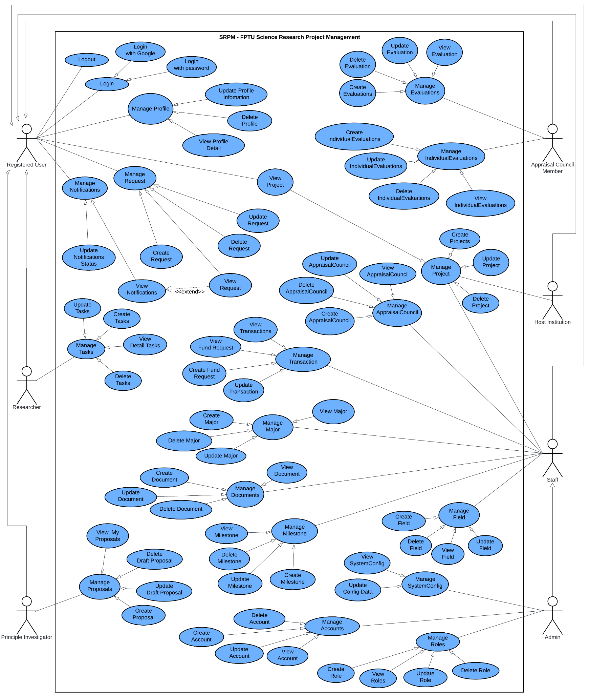

#### 2.2.2 Descriptions

| **ID** | **Use Case** | **Actors** | **Use Case Description** |
| --- | --- | --- | --- |
| 1 | Logout | Registered User | Registered users end their current session and return to the login screen. |
| 2 | Login with Google | Registered User | Registered users authenticate using their Google account credentials through OAuth integration. |
| 3 | Login with Password | Registered User | Registered users authenticate by entering their username/email and password. |
| 4 | Login | Registered User | Registered users access the system using available authentication methods. |
| 5 | Manage Profile | Registered User | Registered users view and modify their personal profile information including contact details and preferences. |
| 6 | Update Profile Information | Registered User | Registered users edit and save changes to their profile data such as name, contact information, and bio. |
| 7 | Delete Profile | Registered User | Registered users permanently remove their profile and associated data from the system. |
| 8 | View Profile Detail | Registered User | Registered users view their complete profile information in a detailed format. |
| 9 | Manage Notifications | Registered User | Registered users configure notification preferences and view notification history. |
| 10 | Manage Request | Registered User | Registered users handle incoming requests related to projects, collaborations, or system access. |
| 11 | Update Request Status | Registered User | Registered users modify the status of requests (approve, reject, pending) they are responsible for processing. |
| 12 | Create Request | Registered User | Registered users submit new requests for project access, resources, or administrative actions. |
| 13 | View Notifications | Registered User | Registered users view their current and historical notifications from the system. |
| 14 | Update Request | Registered User | Registered users modify details of existing requests they have submitted. |
| 15 | Delete Request | Registered User | Registered users remove requests they have previously submitted. |
| 16 | View Project | Registered User | Registered users access and view project details, progress, and associated information. |
| 17 | Update Tasks | Registered User | Registered users modify task details, status, and assignments within projects. |
| 18 | Create Tasks | Registered User | Registered users add new tasks to projects with descriptions, deadlines, and assignments. |
| 19 | View Fund Request | Registered User | Registered users review funding request details and status information. |
| 20 | Delete Tasks | Registered User | Registered users remove tasks from projects when they are no longer needed. |
| 21 | Manage Tasks | Registered User | Registered users oversee task organization, assignment, and progress tracking. |
| 22 | Detail Tasks | Registered User | Registered users view comprehensive information about specific tasks including requirements and progress. |
| 23 | Create Fund Request | Registered User | Registered users submit requests for project funding with budget details and justifications. |
| 24 | Update Transaction | Registered User | Registered users modify financial transaction records and details. |
| 25 | Manage Transaction | Registered User | Registered users oversee financial transactions related to project funding and expenses. |
| 26 | Create Major | Researcher | Researchers define new major research areas or specializations within the system. |
| 27 | Manage Major | Researcher | Researchers organize and maintain major research categories and their associated metadata. |
| 28 | Delete Major | Researcher | Researchers remove major research categories that are no longer relevant. |
| 29 | View Major | Researcher | Researchers browse available major research areas and their descriptions. |
| 30 | Update Major | Researcher | Researchers modify details of existing major research categories. |
| 31 | Create Document | Researcher | Researchers upload and create new research documents within the system. |
| 32 | View Document | Researcher | Researchers access and read research documents stored in the system. |
| 33 | Manage Documents | Researcher | Researchers organize, categorize, and maintain their research document collections. |
| 34 | Update Document | Researcher | Researchers edit and modify existing research documents. |
| 35 | Delete Document | Researcher | Researchers remove documents that are no longer needed from the system. |
| 36 | View My Proposals | Researcher | Researchers access a list of all proposals they have submitted or are working on. |
| 37 | Delete Draft Proposal | Researcher | Researchers remove draft proposals that they no longer wish to develop. |
| 38 | Manage Proposals | Researcher | Researchers organize and oversee their collection of research proposals. |
| 39 | Update Draft Proposal | Researcher | Researchers modify and improve draft proposals before final submission. |
| 40 | Create Proposal | Researcher | Researchers develop and submit new research proposals with objectives, methodology, and budget. |
| 41 | View Milestone | Researcher | Researchers review project milestones, deadlines, and completion status. |
| 42 | Manage Milestone | Researcher | Researchers organize and track project milestones and their associated deliverables. |
| 43 | Delete Milestone | Researcher | Researchers remove milestones that are no longer applicable to project timelines. |
| 44 | Update Milestone | Researcher | Researchers modify milestone details, dates, and requirements. |
| 45 | Create Milestone | Researcher | Researchers establish new project milestones with specific goals and deadlines. |
| 46 | Create Account | Principal Investigator | Principal investigators set up new user accounts for team members and collaborators. |
| 47 | Delete Account | Principal Investigator | Principal investigators remove user accounts for individuals no longer associated with projects. |
| 48 | Update Account | Principal Investigator | Principal investigators modify user account details and permissions. |
| 49 | View Account | Principal Investigator | Principal investigators review user account information and access levels. |
| 50 | Manage Accounts | Principal Investigator | Principal investigators oversee user account management for their research teams. |
| 51 | Create Role | Admin | Administrators define new user roles with specific permissions and access levels. |
| 52 | Update Role | Admin | Administrators modify existing user roles and their associated permissions. |
| 53 | Manage Roles | Admin | Administrators oversee the role-based access control system for the entire platform. |
| 54 | Delete Role | Admin | Administrators remove user roles that are no longer needed in the system. |
| 55 | View Field | Admin | Administrators view research field categories and their organizational structure. |
| 56 | Create Field | Admin | Administrators establish new research field classifications for better project organization. |
| 57 | Manage Field | Admin | Administrators maintain and organize research field taxonomies. |
| 58 | Update Field | Admin | Administrators modify research field definitions and hierarchical relationships. |
| 59 | Delete Field | Admin | Administrators remove research field categories that are obsolete. |
| 60 | View SystemConfig | Admin | Administrators access system configuration settings and parameters. |
| 61 | Manage SystemConfig | Admin | Administrators maintain overall system configuration and operational parameters. |
| 62 | Update Config Data | Admin | Administrators modify system configuration settings to optimize performance. |
| 63 | Create IndividualEvaluations | Appraisal Council Member | Council members initiate individual evaluation processes for researchers or projects. |
| 64 | Update IndividualEvaluations | Appraisal Council Member | Council members modify evaluation criteria, scores, and feedback. |
| 65 | Delete IndividualEvaluations | Appraisal Council Member | Council members remove evaluation records when necessary. |
| 66 | View IndividualEvaluations | Appraisal Council Member | Council members review completed and ongoing individual evaluations. |
| 67 | Manage IndividualEvaluations | Appraisal Council Member | Council members oversee the individual evaluation process and workflow. |
| 68 | Create Evaluations | Appraisal Council Member | Council members establish new evaluation frameworks and assessment criteria. |
| 69 | Delete Evaluations | Appraisal Council Member | Council members remove evaluation frameworks that are no longer applicable. |
| 70 | Manage Evaluations | Appraisal Council Member | Council members coordinate and supervise evaluation processes. |
| 71 | Update Evaluations | Appraisal Council Member | Council members modify evaluation criteria and assessment methodologies. |
| 72 | View Evaluations | Appraisal Council Member | Council members access evaluation results and assessment reports. |
| 73 | Create Projects | Host Institution | Host institutions initiate new research projects within their organizational framework. |
| 74 | Manage Projects | Host Institution | Host institutions oversee project administration, resources, and compliance. |
| 75 | Delete Projects | Host Institution | Host institutions terminate projects that are no longer viable or necessary. |
| 76 | View AppraisalCouncil | Host Institution | Host institutions access information about appraisal council composition and activities. |
| 77 | Update AppraisalCouncil | Host Institution | Host institutions modify appraisal council membership and operational procedures. |
| 78 | Delete AppraisalCouncil | Host Institution | Host institutions dissolve appraisal councils when reorganization is needed. |
| 79 | Create AppraisalCouncil | Host Institution | Host institutions establish new appraisal councils for project evaluation. |
| 80 | Manage AppraisalCouncil | Host Institution | Host institutions coordinate appraisal council operations and decision-making processes. |
| 81 | View Transactions | Host Institution | Host institutions monitor financial transactions related to hosted projects. |

##### Table 2.2.2.2: Uses case description

### 3.1 System Functional Overview

#### 3.1.1 Screen Flows

##### 3.1.1.a Researcher Screen Flows

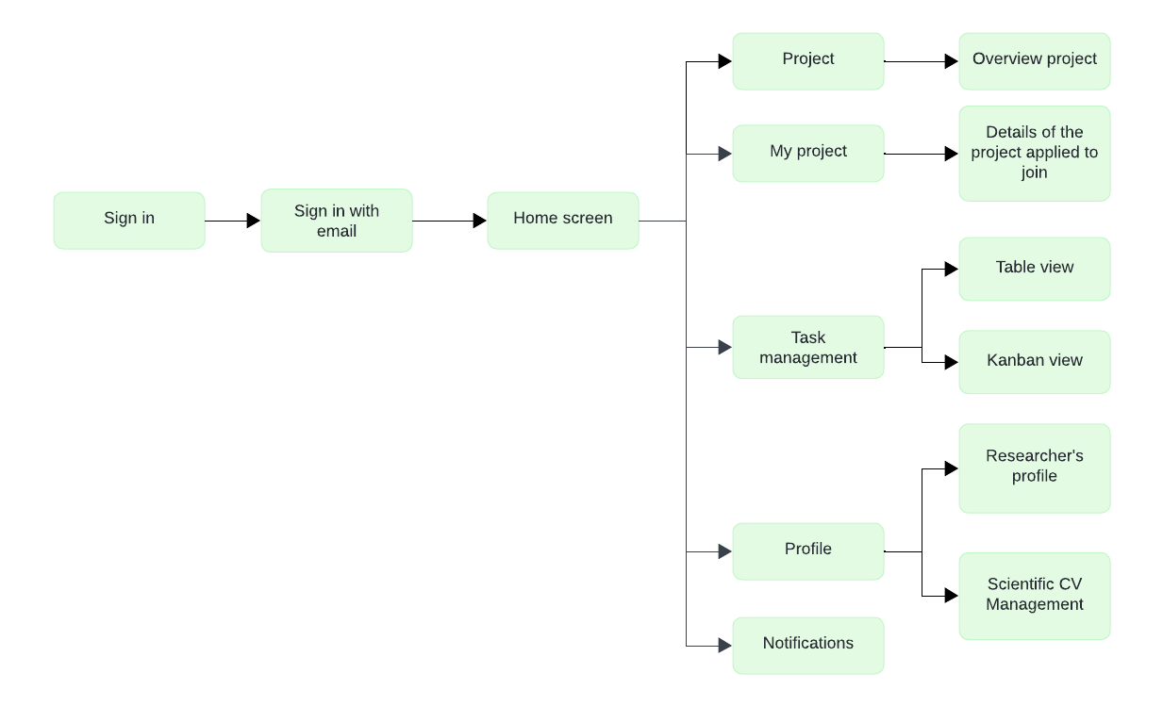

##### 3.1.1.b Principle Investigator Screen Flows

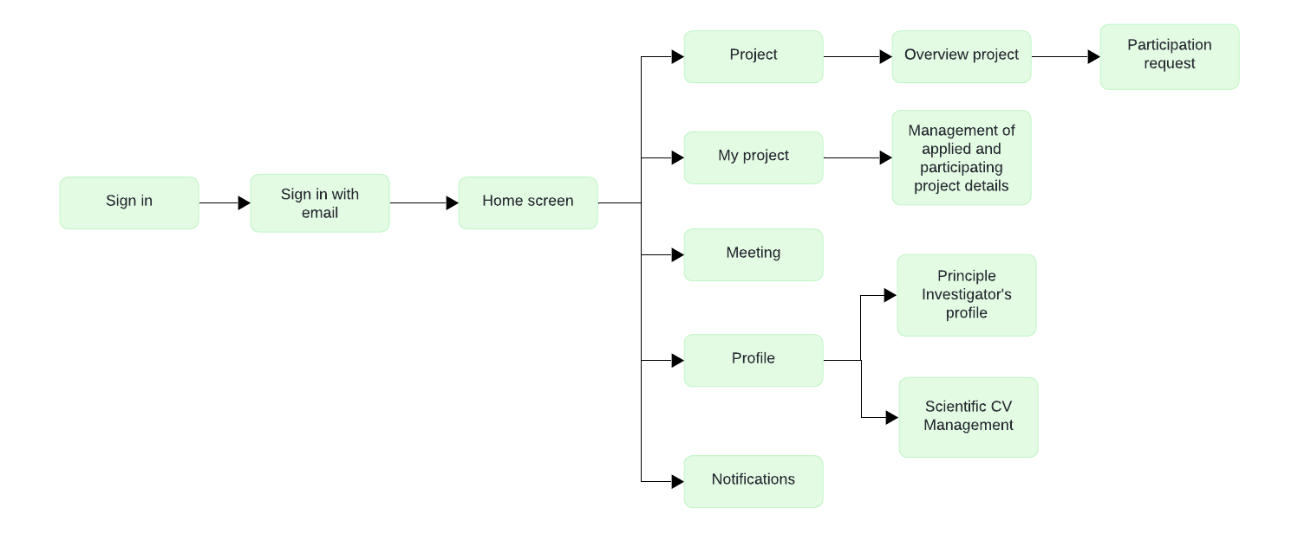

##### 3.1.1.c Host Institution Screen Flows

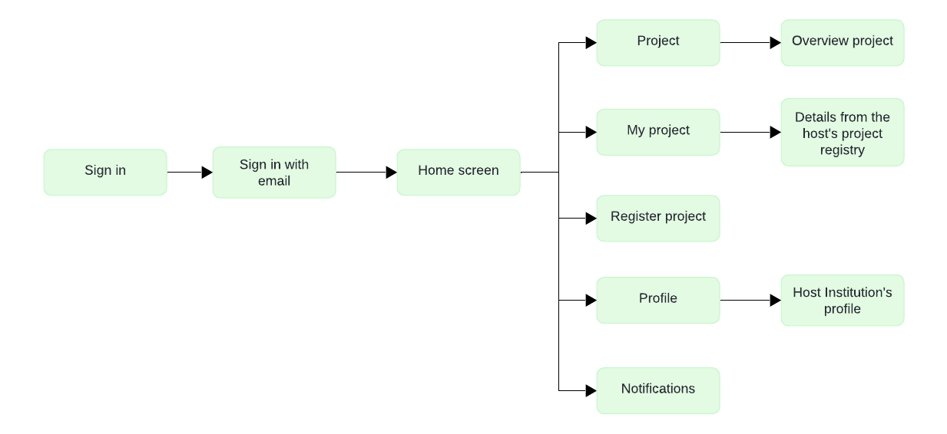

##### 3.1.1.d Appraisal Council Screen Flows

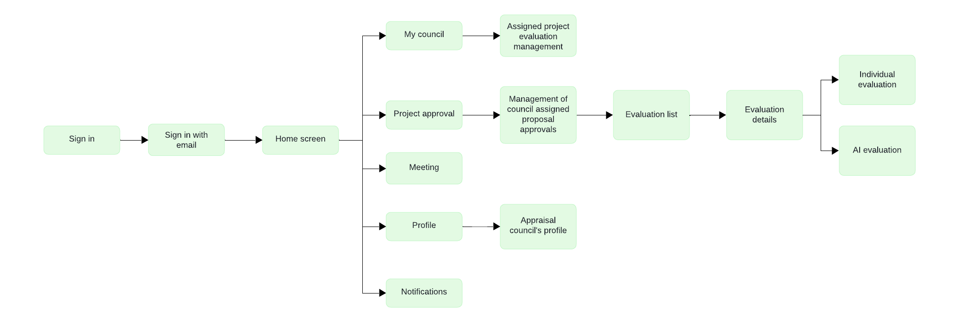

##### 3.1.1.e Administrator Screen Flows

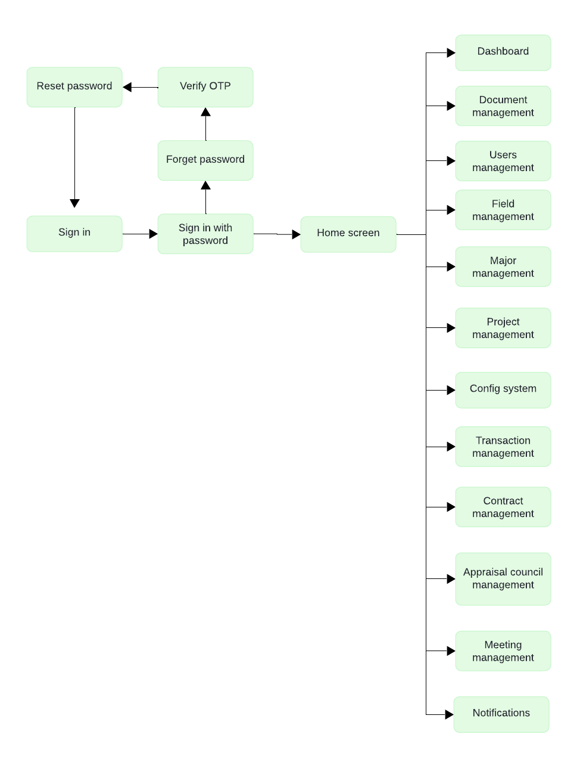

##### 3.1.1.f Staff Screen Flows

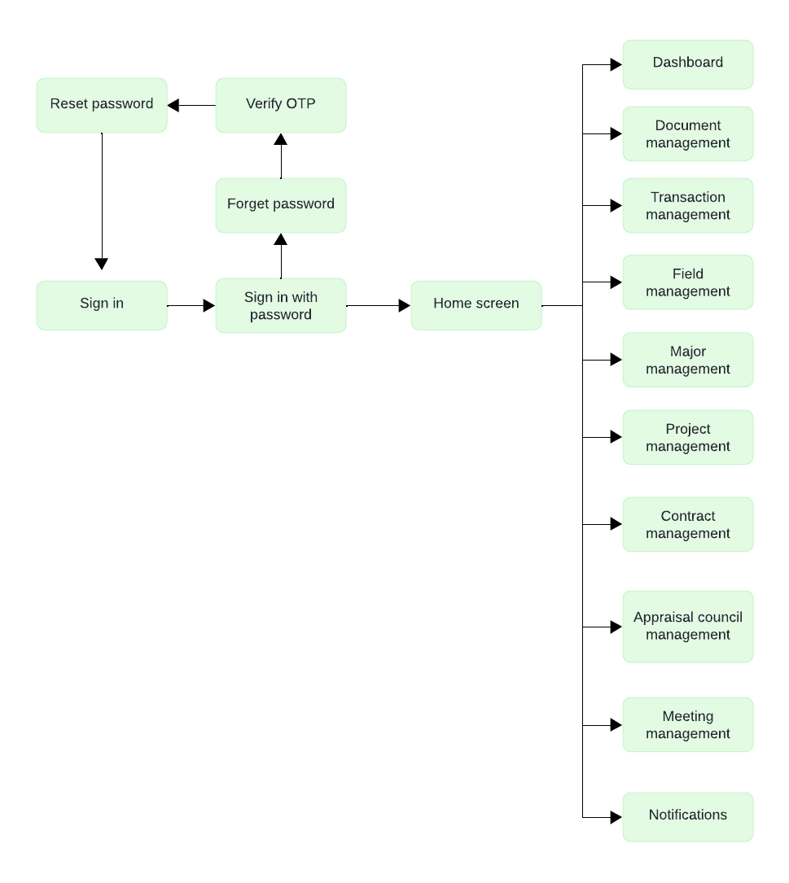

#### 3.1.2 Screen Descriptions

##### Table 3.1.2.a : Researcher Screen Descriptions

| **#** | **Feature** | **Screen** | **Description** |
| --- | --- | --- | --- |
| 1 | Home | Home screen | Allow users to access main navigation options including Projects list, My Projects, Task Management, Profile, and Notifications. |
| 2 | Authentication | Sign in | Allow users to sign in using Google One Tap authentication for FPTU accounts |
| 3 | Project Management | Projects List | Allow users to explore all available projects with search, filter, and sort capabilities, and view status. |
| 4 | Project Management | My Projects | Allow users to view and manage both their applied projects and participating projects with detailed tracking. |
| 5 | Project Management | Project Details | Allow participating users to view detailed project information with tabs for Overview, Team, Documents, Tasks, Milestones, Progress, and Evaluations based on permissions. |
| 6 | Task Management | Task Table View | Allow users to view tasks in a tabular format with columns for title, status, due date, priority, assigned members, and actions. |
| 7 | Task Management | Task Kanban Board | Allow users to organize tasks visually with drag-and-drop across workflow columns (To Do, In Progress, Completed). |
| 8 | Notifications | Notifications | Allow users to manage notifications with read/unread status and bulk read actions. |
| 9 | Profile | Researcher’s Profile | Allow researchers to view and edit their personal information including name, email, phone, role details, and avatar. |
| 10 | Profile | Scientific CV Management | Allow users to create, edit, view, and manage their Scientific CVs using TinyMCE editor with template support and image upload. |

##### Table 3.1.2.b : Principle Investigator Screen Descriptions

| **#** | **Feature** | **Screen** | **Description** |
| --- | --- | --- | --- |
| 1 | Home | Home screen | Allow users to access main navigation options including Projects, My Projects, Meetings, Profile, and Notifications. |
| 2 | Authentication | Sign in | Allow users to sign in using Google One Tap authentication for FPTU accounts |
| 3 | Project Management | Projects List | Allow users to explore all available projects with search, filter, and sort capabilities, and view status. |
| 4 | Project Management | Project Participation Request | Allow users to enroll projects by submitting a research proposal form, then invite members to participate. |
| 5 | Project Management | My Projects | Allow users to view and manage both their applied projects and participating projects with detailed tracking. |
| 6 | Project Management | Project Details | Allow participating users to view detailed project information with tabs for Overview, Team, Documents, Tasks, Milestones, Progress, Evaluations, Transactions and Result depending on permissions. |
| 7 | Meeting Management | Meetings List | Allow users to view all meetings with filtering by status, project, and date range, and to join upcoming meetings or review past ones. |
| 8 | Notifications | Notifications | Allow users to manage notifications with read/unread status and bulk read actions. |
| 9 | Profile | Principle Investigator’s Profile | Allow users to view and edit their personal information including name, email, phone, role details, and avatar. |
| 10 | Profile | Scientific CV Management | Allow users to view the Principle Investigator’s profile, including qualifications, research background, and contact details. |

##### Table 3.1.2.c : Host Institution Screen Descriptions

| **#** | **Feature** | **Screen** | **Description** |
| --- | --- | --- | --- |
| 1 | Home | Home screen | Allow users to access main navigation options including Projects List, My Projects, Project Registration, Profile, and Notifications. |
| 2 | Authentication | Sign in | Allow users to sign in using Google One Tap authentication for FPTU accounts |
| 3 | Project Management | Projects List | Allow users to explore all available projects with search, filter, and sort capabilities, and view status. |
| 4 | Project Management | My Projects | Allow users to view, track projects registered by their institution, with access to detailed project information. |
| 5 | Project Management | Project Details | Allow users to view comprehensive project information with tabs for Overview, Result |
| 6 | Project Management | Project Registration | Allow Host Institution users to register new research projects through a multi-step form including project information, requirements and submission. |
| 7 | Notifications | Notifications | Allow users to manage notifications with read/unread status and bulk read actions. |
| 8 | Profile | User Profile | Allow users to view and edit the institution’s profile including organization name, research fields, contact details, and representative information. |

##### Table 3.1.2.d : Appraisal Council Screen Descriptions

| **#** | **Feature** | **Screen** | **Description** |
| --- | --- | --- | --- |
| 1 | Home | Home screen | Allow users to access main navigation options and features. |
| 2 | Authentication | Sign in | Allow users to sign in using Google One Tap authentication for FPTU accounts |
| 3 | Council Management | My Council | Allow council members to select their appraisal councils, view assigned projects, and track evaluation progress. |
| 4 | Council Management | Project Approval | Allow council members to review and approve project proposals with detailed proposal comparison and selection proposal. |
| 5 | Evaluation System | Evaluation List | Allow users to view evaluations assigned to them or created by them, with status tracking, and access to evaluation details. |
| 6 | Evaluation System | Evaluation Details | Allow council members to view detailed evaluations with criteria, scores, comments and approval workflow. |
| 7 | Evaluation System | Individual Evaluation | Allow users to create and manage individual evaluations within evaluation stages, including scoring and comments. |
| 8 | Evaluation System | AI Evaluation | Allow users to view AI-powered evaluation results with automated scoring, content analysis, and comparison with manual evaluations. |
| 9 | Meeting Management | Meetings List | Allow users to view all meetings with filtering by status, project, and date range, and to join upcoming meetings or review past ones. |
| 10 | Notifications | Notifications | Allow users to manage notifications with read/unread status and bulk read actions. |
| 11 | Profile | User Profile | Allow users to view and edit their personal information including name, email, phone, role details, and avatar. |

##### Table 3.1.2.e: Administrator Screen Descriptions

| **#** | **Feature** | **Screen** | **Description** |
| --- | --- | --- | --- |
| 1 | Authentication | Sign in | Allow administrator login with email and password credentials with role-based authentication |
| 2 | Authentication | Forgot Password | Allow users enter their email address to receive password reset instructions via email for account recovery. |
| 3 | Staff Administration | Document Management | Allow users manage document templates and forms used throughout the system for various document types and workflows. |
| 4 | Staff Administration | Meeting Management | Allow users to create individual or bulk meetings with project assignment, attendee management, and scheduling. |
| 5 | Staff Administration | Majors Management | Allow users to administer academic majors with field relationships, statistics, and assignment tracking for project categorization. |
| 6 | Staff Administration | Fields Management | Allow users to create, edit, and manage research fields with statistics, project assignments, and hierarchical organization. |
| 9 | Staff Administration | Project Management | Allow users comprehensive project oversight with filtering, status management, council assignment, and detailed project administration. |
| 10 | Staff Administration | Transaction Management | Allow users to oversee financial transactions with creation, editing, approval workflows, and comprehensive reporting capabilities. |
| 11 | Staff Administration | Contract Management | Allow users to create and sign contracts with Principal Investigators. |
| 13 | Staff Administration | Appraisal Coucil Management | Allow users to manage appraisal councils with member assignment, role management (Chairman/Secretary/Member), and project allocation. |
| 14 | Admin System | Users Management | Allow administrators to manage users, roles, permissions, and account status with creation and modification capabilities. |
| 15 | Admin System | Config System | Allow administrators to configure application parameters, user permissions, integration settings, and system maintenance. |
| 16 | Notifications | Notifications | Allow users to manage notifications with read/unread status and bulk read actions. |

##### Table 3.1.2.f: Staff Screen Descriptions

| **#** | **Feature** | **Screen** | **Description** |
| --- | --- | --- | --- |
| 1 | Authentication | Sign in | Allow administrator login with email and password credentials with role-based authentication |
| 2 | Authentication | Forgot Password | Allow users enter their email address to receive password reset instructions via email for account recovery. |
| 3 | Staff Administration | Document Management | Allow users manage document templates and forms used throughout the system for various document types and workflows. |
| 4 | Staff Administration | Meeting Management | Allow users to create individual or bulk meetings with project assignment, attendee management, and scheduling. |
| 5 | Staff Administration | Majors Management | Allow users to administer academic majors with field relationships, statistics, and assignment tracking for project categorization. |
| 6 | Staff Administration | Fields Management | Allow users to create, edit, and manage research fields with statistics, project assignments, and hierarchical organization. |
| 9 | Staff Administration | Project Management | Allow users comprehensive project oversight with filtering, status management, council assignment, and detailed project administration. |
| 10 | Staff Administration | Transaction Management | Allow users to oversee financial transactions with creation, editing, approval workflows, and comprehensive reporting capabilities. |
| 11 | Staff Administration | Contract Management | Allow users to create and sign contracts with Principal Investigators. |
| 13 | Staff Administration | Appraisal Coucil Management | Allow users to manage appraisal councils with member assignment, role management (Chairman/Secretary/Member), and project allocation. |
| 14 | Notifications | Notifications | Allow users to manage notifications with read/unread status and bulk read actions. |

#### 3.1.3 Non-Screen Functions

##### Table 3.1.3: Non-Screen Functions

| **#** | **Feature** | **System Function** | **Description** |
| --- | --- | --- | --- |
| 1 | Authentication and Authorization | JWT Token Generation | Generates JSON Web Tokens (JWT) for secure authentication and authorization, allowing users to access protected resources. |
| 2 | Error Handling | Unauthorized Access | Error screen displayed when users attempt to access resources without proper permissions with role information and navigation options. |
| 3 | Error Handling | Not Found | 404 error page with navigation options and helpful links when users access non-existent routes or resources. |
| 4 | Error Handling | Error Boundary | System error handling interface that catches and displays application errors with recovery options and error reporting. |
| 5 | Notification Service | Email Notifications | Sends email notifications for important events or updates. |
| 6 | Coming Soon | Feature Placeholders | Placeholder screens for features under development with informative messages and navigation back to available features. |

#### 3.1.4 Screen Authorization

##### Table 3.1.4.1: Screen Authorization

| **Feature / Screen** | **Researcher** | **Principal Investigator** | **Host Institution** | **Appraisal Council** | **Administrator** | **Staff** |
| --- | --- | --- | --- | --- | --- | --- |
| Home screen | X | X | X | X |  |  |
| Sign in | X (Google) | X (Google) | X(Google) | X (Google) | X (Password) | X (Password) |
| Forgot Password |  |  |  |  | X | X |
| Projects List | X | X | X |  | X | X |
| My Projects | X | X | X |  | X | X |
| Project Details | X (Overview, Team, Docs, Tasks, Milestones, Progress, Evaluations) | X (Overview, Team, Docs, Tasks, Milestones, Progress, Evaluations, Transactions, Result) | X (Overview, Result) | X  (Assigned projects) | X  (All projects) | X  (All projects) |
| Project Participation Request |  | X |  |  |  |  |
| Project Registration |  |  | X |  | X | X |
| Project Approval |  |  |  | X |  |  |
| Task Table View | X |  |  |  |  |  |
| Task Kanban Board | X |  |  |  |  |  |
| Meetings List Management |  | X (view/join) |  | X (view/join) | X (create/manage) | X (create/manage) |
| Document Management |  |  |  |  | X | X |
| Majors Management |  |  |  |  | X | X |
| Fields Management |  |  |  |  | X | X |
| Evaluation List |  |  |  | X |  |  |
| Evaluation Details |  |  |  | X |  |  |
| Individual Evaluation |  |  |  | X |  |  |
| AI Evaluation |  |  |  | X |  |  |
| Transaction Management |  |  |  |  | X | X |
| Contract Management |  |  |  |  | X | X |
| Appraisal Council Management |  |  |  |  | X | X |
| Users Management |  |  |  |  | X |  |
| Config System |  |  |  |  | X |  |
| Notifications | X | X | X | X | X | X |
| User Profile | X | X | X | X |  |  |
| Scientific CV | X | X |  |  |  |  |

#### 3.1.5 Entity Relationship Diagram

**Conceptual ERD**

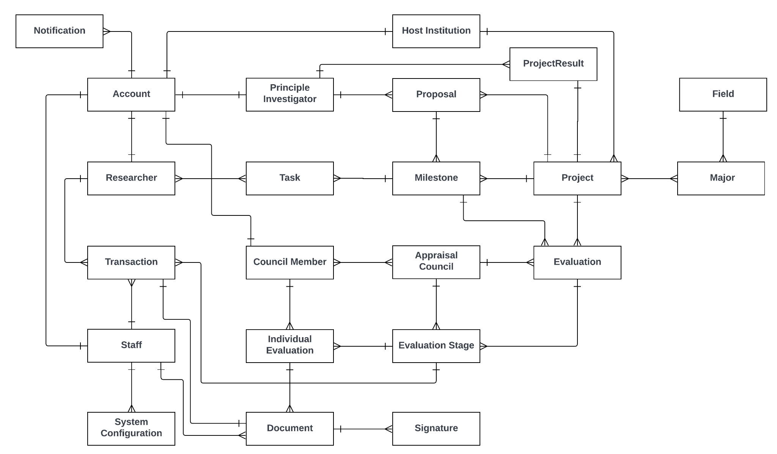

##### Figure 3.1.5.1: Conceptual ERD

**Logical ERD**

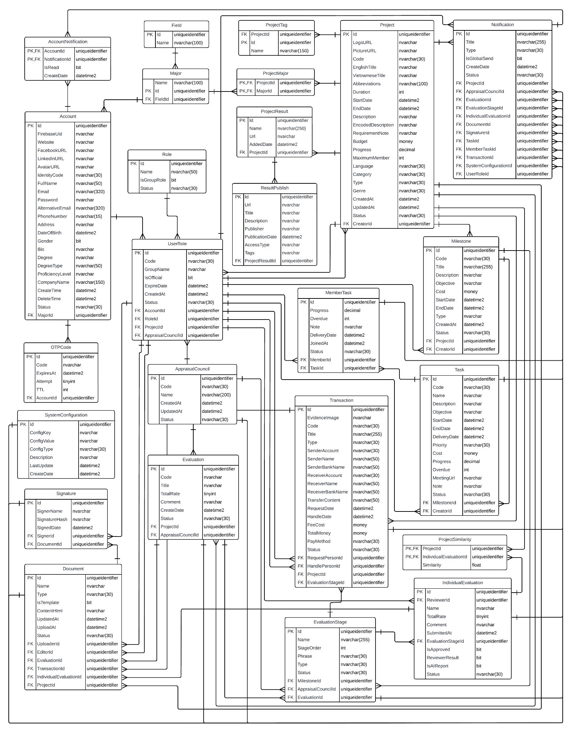

##### Figure 3.1.5.2: Logical ERD

**Entities Description**

| **#** | **Entity** | **Description** |
| --- | --- | --- |
| 1 | Account | Store a user’s login credentials and personal information.  - Primary keys: AccountId  - Foreign keys: MajorId |
| 2 | UserRole | Defines the role assigned to an account and associates it with a specific project or appraisal council.  - Primary keys: UserRoleId  - Foreign keys: AccountId, RoleId, ProjectId, AppraisalCouncilId |
| 3 | Role | Stores system roles and group-specific roles used to define user responsibilities and permissions at a point in time.  - Primary keys: RoleId  - Foreign keys: |
| 4 | OTPCode | Stores one-time passcodes used to verify user identity during password reset operations.  - Primary keys: OTPCodeId  - Foreign keys: AccountId |
| 5 | Major | Store academic or professional majors categorized under specific fields.  - Primary keys: MajorId  - Foreign keys: FieldId |
| 6 | Field | Store broad academic or professional domains that group related majors under a common category.  - Primary keys: FieldId  - Foreign keys: |
| 7 | ProjectResult | Stores information about scientific publications or final research outputs produced during the execution of a research project.  - Primary keys: ProjectResultId  - Foreign keys: ProjectId |
| 8 | ProjectMajor | Stores the academic or disciplinary majors associated with a specific research project.  - Primary keys: ProjectId, MajorId  - Foreign keys: ProjectId, MajorId |
| 9 | ProjectTag | Stores tags associated with a specific research project.  - Primary keys: ProjectTagId  - Foreign keys: ProjectId |
| 10 | Project | Stores comprehensive information about a research or development project.  - Primary keys: ProjectId  - Foreign keys: CreatorId |
| 11 | Milestone | Defines key stages or checkpoints within a project.  - Primary keys: MilestoneId  - Foreign keys: ProjectId |
| 12 | Task | Stores individual work items or actions that are part of a specific milestone within a project.  - Primary keys: TaskId  - Foreign keys: MilestoneId, CreatorId |
| 13 | MemberTask | Manages the assignment of tasks to individual members within a project, team, or organizational context.  - Primary keys: MemberTaskId  - Foreign keys: MemberId, TaskId |
| 14 | AppraisalCouncil | Stores information about appraisal or evaluation councils composed of users assigned specific roles.  - Primary keys: AppraisalCouncilId  - Foreign keys: |
| 15 | Evaluation | Stores overall assessment records of a project or a specific milestone, conducted by an appraisal council.  - Primary keys: EvaluationId  - Foreign keys: AppraisalCouncilId, ProjectId, MilestoneId |
| 16 | EvaluationStage | Stores segmented stages of an overall evaluation process, as defined in the Evaluation table.  - Primary keys: EvaluationStageId  - Foreign keys: EvaluationId, AppraisalCouncilId |
| 17 | IndividualEvaluation | Stores personal assessment records submitted by individual council members for a specific evaluation stage.  - Primary keys: IndividualEvaluationId  - Foreign keys: EvaluationStageId, ReviewerId |
| 18 | ProjectSimilarity | Stores the results of content similarity AI checks between a specific project—typically within an individual evaluation—and other existing projects.  - Primary keys: ProjectId, IndividualEvaluationId  - Foreign keys: ProjectId, IndividualEvaluationId |
| 19 | Transaction | Stores the financial transaction history related to a project or a specific evaluation stage.  - Primary keys: TransactionId  - Foreign keys: RequestPersonId, HandlePersonId, ProjectId, EvaluationStageId |
| 20 | Document | Stores written materials associated with various entities in the system, including projects, evaluations, individual evaluations, and transactions.  - Primary keys: DocumentId  - Foreign keys: UploaderId, EditorId, TransactionId, EvaluationId, IndividualEvaluationId, ProjectId |
| 21 | Signature | Records the act of signing a document by an individual within the system.  - Primary keys: SignatureId  - Foreign keys: DocumentId, SignerId |
| 22 | Notification | Stores system-generated messages intended to inform users about relevant events, actions, or updates.  - Primary keys: NotificationId  - Foreign keys: UserRoleId, ProjectId, AppraisalCouncilId, EvaluationId, EvaluationStageId, IndividualEvaluationId, DocumentId, SignatureId, TaskId, MemberTaskId, TransactionId, SystemConfigurationId |
| 23 | AccountNotification | Records the delivery of notifications to individual user accounts.  - Primary keys: AccountId, NotificationId  - Foreign keys: AccountId, NotificationId |
| 24 | SystemConfiguration | Serves as a centralized repository for storing configurable parameters and reusable settings that govern system behavior.  - Primary keys: SystemConfigurationId  - Foreign keys: |
| 25 | ResultPublish | Stores information about scientific publications during the execution of a research project.  - Primary keys: ResultPublishId  - Foreign keys: ProjectPublishId |

##### Table 3.1.5: Entity Description

### 3.2 Applications for All Users (Common Features)

#### 3.2.1 Login Page

**Function Description:** The login page allows users to log in using Google authentication or staff credentials (for administrative users). This page provides different authentication methods based on user type and allows navigation to other parts of the application.

**Function Trigger:**

When the user is not logged in, the Login page will display authentication options:

Log in to the web application via Google:

* Button/Navigation: There is a Google login button with the content "Continue with Google" and Google logo icon.
* Trigger: When clicked, it initiates Google One Tap authentication flow.
* Function: Users can log in using their FPTU Google account credentials and are automatically redirected based on their role.

Staff Login:

* Button/Navigation: There are email and password input fields with a "Login" button for administrative users.
* Trigger: When staff users enter their credentials and click "Login."
* Function: The system authenticates staff/admin users and redirects them to the staff dashboard upon successful login.

Forgot Password:

* Button/Navigation: There is a "Forgot your password?" link below the password field.
* Trigger: When clicked, it navigates to the password recovery page.
* Function: Users can reset their password by entering their email address.

**Business Rules: (BR-23, BR-25, BR-30, BR-42, BR-44)**

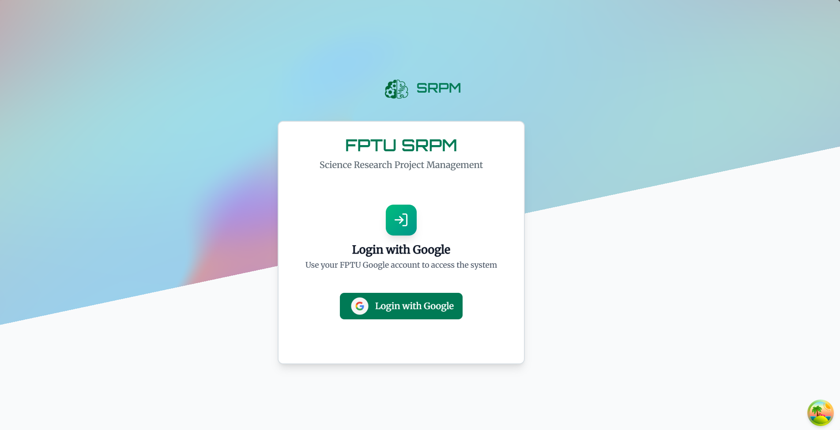

##### Figure 3.2.1: Login Page

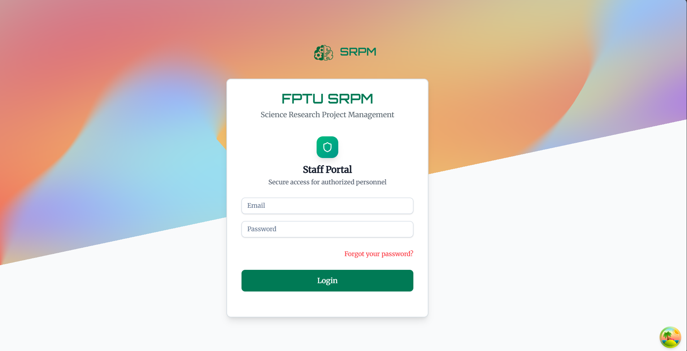

##### Figure 3.2.1: Staff login Page

3.2.2 Forgot Password Page

**Function Description:** This page allows users to recover their account access by requesting a password reset via email.

**Function Trigger**:

When users need to recover their password:

Request Password Reset:

* Button/Navigation: Email input field and "Send Reset Link" button.
* Trigger: When users enter their email and click the send button.
* Function: The system sends a password reset email to the provided address.

Return to Login:

* Button/Navigation: "Back to Login" link at the bottom of the form.
* Trigger: When users click the back link.
* Function: Users are redirected back to the main login page.

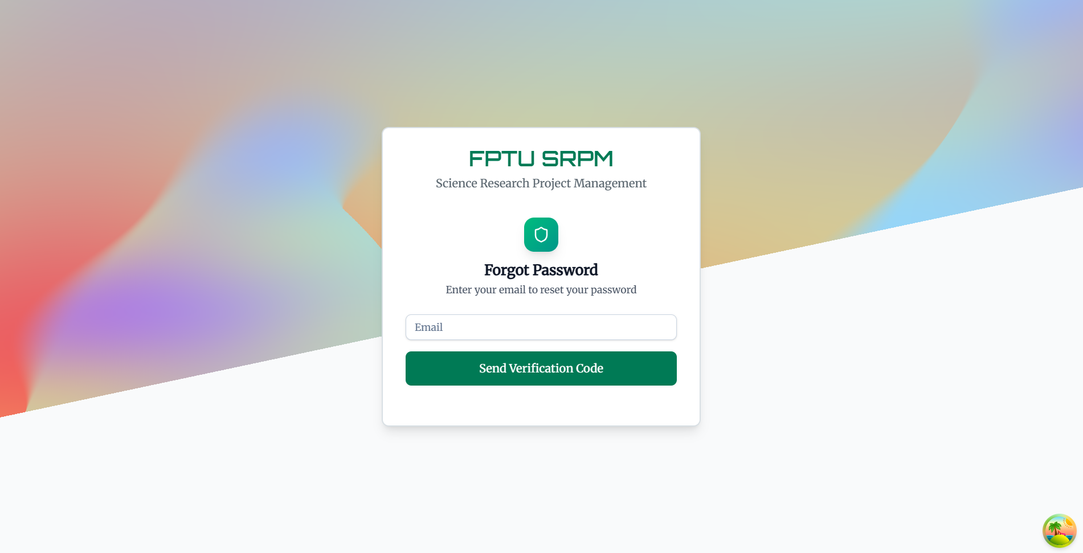

##### Figure 3.2.1.2: Forget Password Page

3.2.3 Home Page

**Function Description:** The home page serves as the main landing screen displaying welcome content, featured projects, system information, and navigation options for authenticated users

**Function Trigger**:

When users successfully log in or navigate to the home page:

View Featured Projects:

* Button/Navigation: Featured project cards are displayed with "View Details" buttons.
* Trigger: When users click on a project card or "View Details" button.
* Function: Users are redirected to the detailed project information page.

Navigate to Role-specific Dashboard:

* Button/Navigation: Navigation menu items based on user role (Projects, Tasks, My Projects, etc.).
* Trigger: When users click on any menu item in the header navigation.
* Function: Users are redirected to role-specific pages based on their permissions.

Access Profile:

* Button/Navigation: User avatar/profile dropdown in the header.
* Trigger: When users click on their profile avatar.
* Function: Dropdown menu appears with profile options and logout functionality.

**Business Rules: (BR-26, BR-29, BR-32)**



##### Figure 3.2.2: Home Page

3.2.4 User Profile Page

**Function Description:** The profile page allows users to view and edit their personal information, manage their Scientific CV, and update account settings.

**Function Trigger**:

When users navigate to their profile page:

Edit Personal Information:

* Button/Navigation: "Edit" button next to personal information fields.
* Trigger: When clicked, input fields become editable.
* Function: Users can modify their name, email, phone, address, and other personal details.

Save Profile Changes:

* Button/Navigation: "Save" button appears when in edit mode.
* Trigger: When users click "Save" after making changes.
* Function: The system validates and saves the updated profile information.

Upload Avatar:

* Button/Navigation: Camera icon overlay on the avatar image.
* Trigger: When users click on the avatar area.
* Function: File upload dialog opens for users to select and upload a new profile picture.

Manage Scientific CV:

* Button/Navigation: "View CV," "Edit CV," or "Create CV" buttons in the Scientific CV section.
* Trigger: When users click on any CV management button.
* Function: Users are redirected to the appropriate CV management page.

##### Figure 3.2.3.1 User Profile Page

3.2.5 Scientific CV Management

**Create Scientific CV Page**

Function Description: This page allows users to create their Scientific CV using a rich text editor with template support and image upload capabilities.

**Function Trigger**:

When users access the Create Scientific CV page:

Create from Template:

* Button/Navigation: "Create from Template" button.
* Trigger: When clicked, it loads the BM2 template.
* Function: The editor is populated with the predefined Scientific CV template structure.

Rich Text Editing:

* Button/Navigation: TinyMCE editor toolbar with formatting options.
* Trigger: When users interact with the editor or formatting tools.
* Function: Users can format text, add tables, insert images, and structure their CV content.

Upload Image:

* Button/Navigation: Image frame with upload functionality.
* Trigger: When users click on the image placeholder or drag files.
* Function: Users can upload and position their profile photo in the CV.

Save CV:

* Button/Navigation: "Save" button at the bottom of the page.
* Trigger: When users click "Save" after completing their CV.
* Function: The system saves the CV content and redirects to the profile page.

**Business Rules: (BR-22, BR-43)**

##### Figure 3.2.5 Create Scientific CV Page

**Edit Scientific CV Page**

Function Description: This page allows users to modify their existing Scientific CV with full editing capabilities and additional management options.

**Function Trigger:**

When users access the Edit Scientific CV page:

Edit Content:

* Button/Navigation: TinyMCE editor pre-loaded with existing CV content.
* Trigger: When users modify content in the editor.
* Function: Users can update any part of their existing CV content.

Reset to Template:

* Button/Navigation: "Reset" button with confirmation dialog.
* Trigger: When users click "Reset" and confirm the action.
* Function: The CV content is reset to the original template structure.

Delete CV:

* Button/Navigation: "Delete" button with confirmation dialog.
* Trigger: When users click "Delete" and confirm the action.
* Function: The entire CV is permanently deleted from the system.

Save Changes:

* Button/Navigation: "Save" button to persist modifications.
* Trigger: When users click "Save" after making changes.
* Function: The system updates the CV with the new content.

**Business Rules: (BR-22, BR-43)**

##### Figure 3.2.5 Edit Scientific CV Page

**View Scientific CV Page**

Function Description: This page displays the Scientific CV in read-only format with options for printing and editing.

**Function Trigger:**

When users view their Scientific CV

Save CV:

* Button/Navigation: "Edit" button in the header.
* Trigger: When users click the Edit button then click on Print Button.
* Function: The browser print dialog opens for CV printing then can save CV.

Edit CV:

* Button/Navigation: "Edit" button in the header.
* Trigger: When users click the edit button.
* Function: Users are redirected to the CV editing page.

**Business Rules: (BR-22, BR-43)**

##### Figure 3.2.5 View Scientific CV Page

#### 3.2.6 Notifications Center

**Function Description:** This page provides centralized notification management with filtering, bulk actions, and detailed notification viewing capabilities.

**Function Trigger:**

When users access the Notifications Center:

Mark as Read/Unread:

* Button/Navigation: Read/unread toggle buttons on individual notifications.
* Trigger: When users click read status buttons.
* Function: Notification read status is updated and visual indicators change.

**Business Rules: (BR-15)**

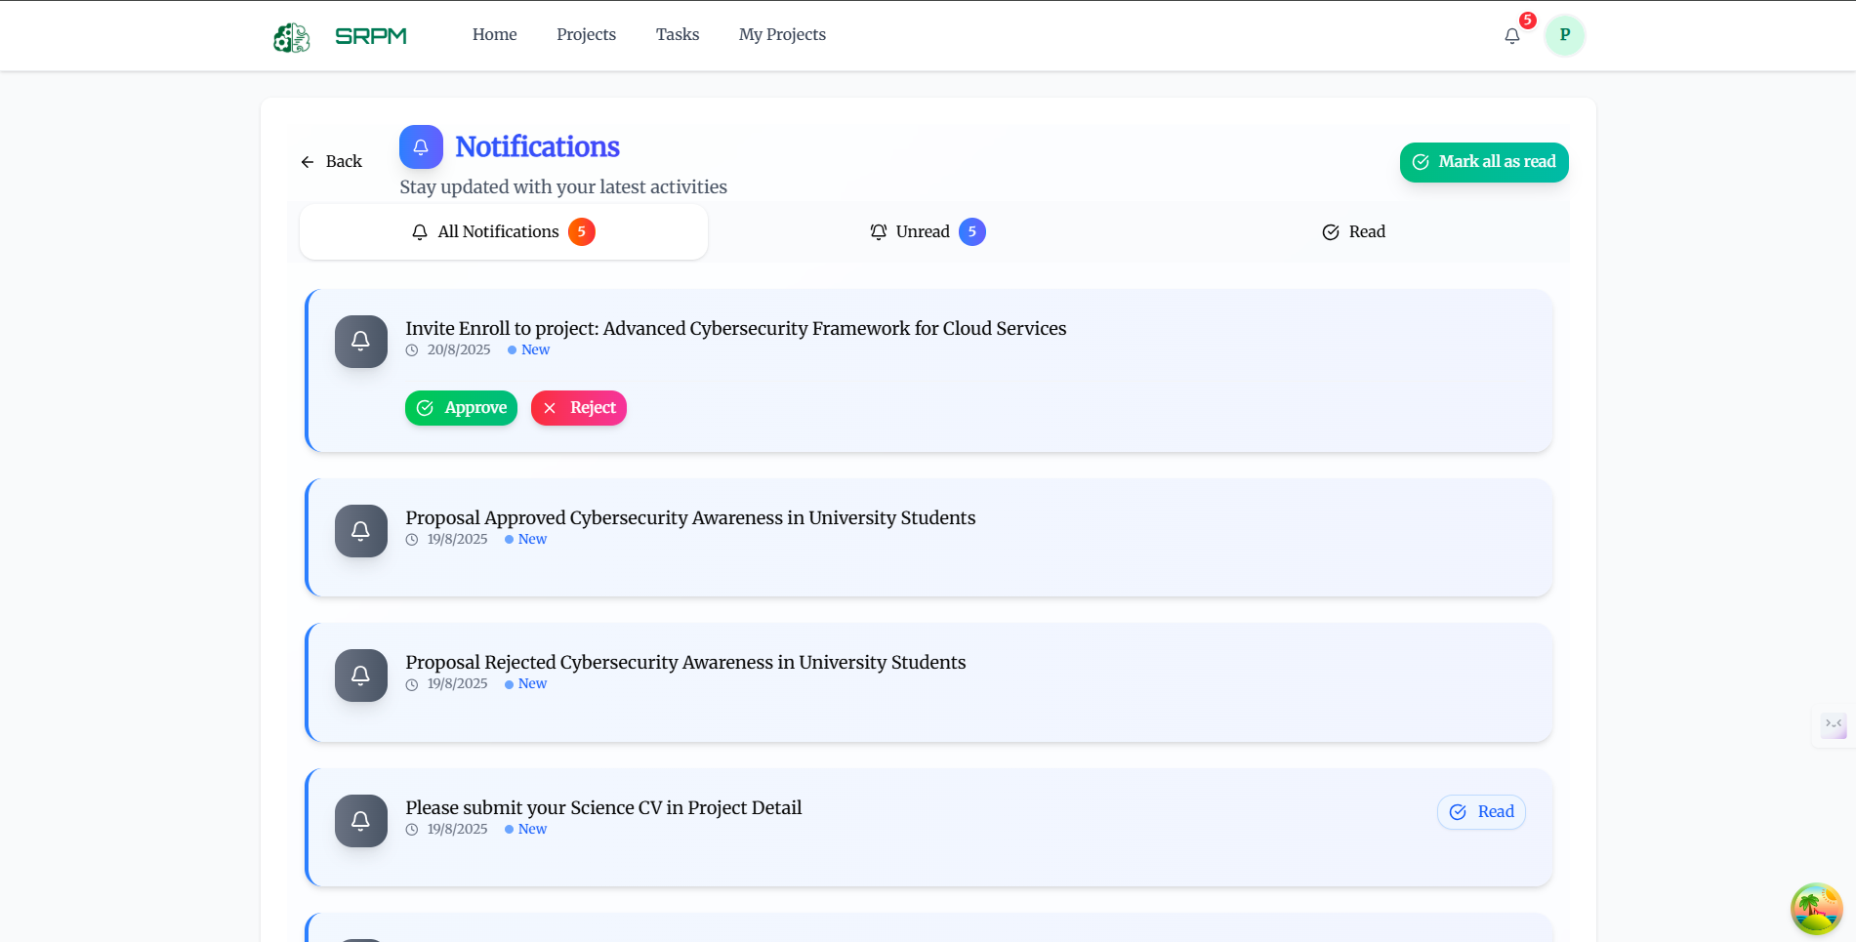Figure 3.2.4 Notifications Center Page

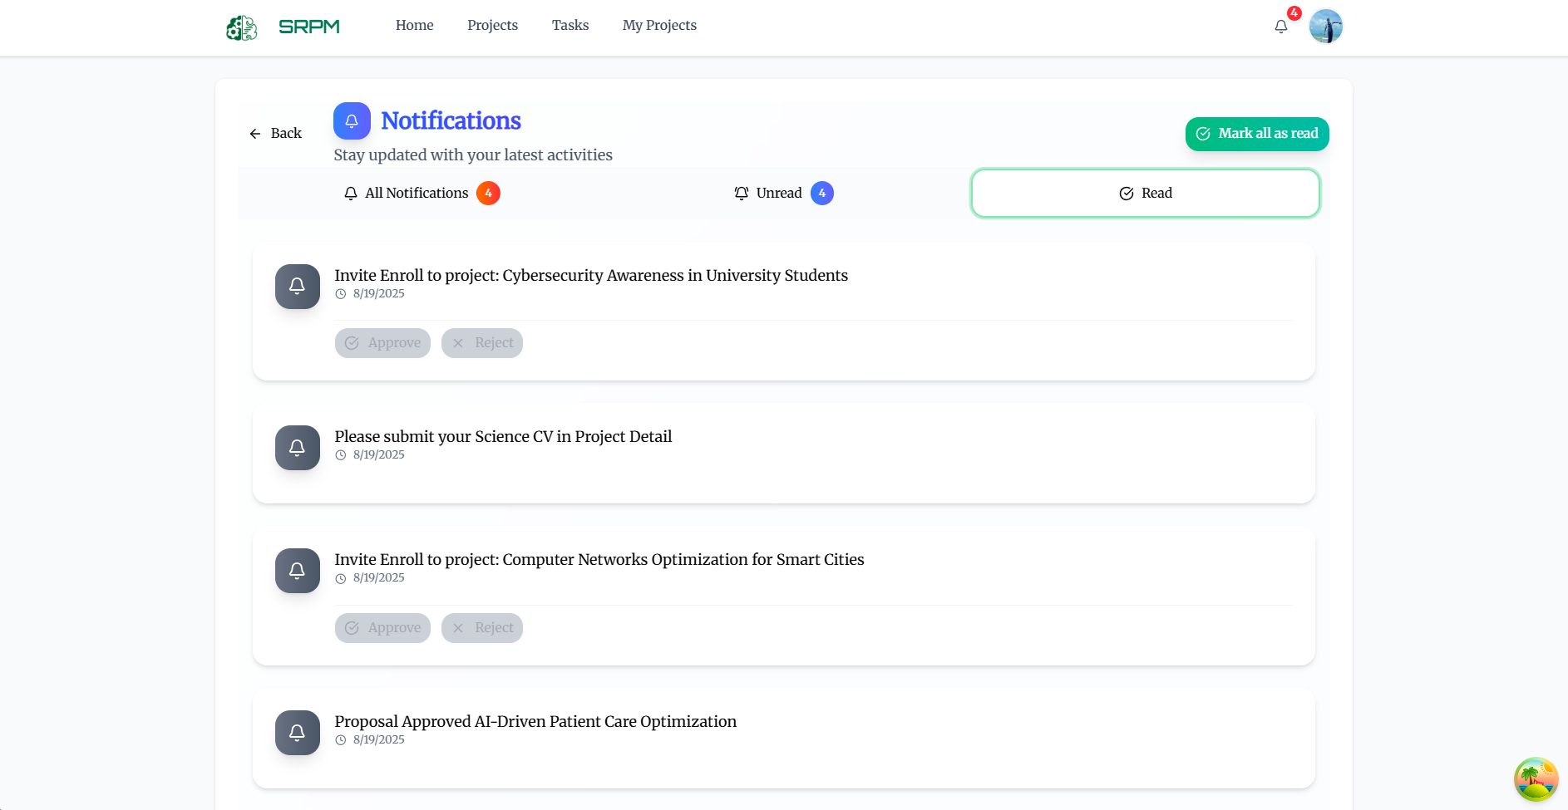

##### Figure 3.2.6 Notifications Center Read Page

### 3.3 Applications for Researchers

#### 3.3.1 Projects List Page

**Function Description:** This page displays all available projects in the system with search, filter, and sorting capabilities, allowing researchers to browse and join projects.

**Function Trigger:**

When researchers navigate to the Projects List page:

Search Projects:

* Button/Navigation: Search input field with search icon.
* Trigger: When researchers type in the search field or press Enter.
* Function: The system filters projects based on title, description, or keywords.

Filter Projects:

* Button/Navigation: Filter dropdown menus for status, category, field, and major.
* Trigger: When researchers select options from filter dropdowns.
* Function: The project list is filtered based on selected criteria.

View Project Details:

* Button/Navigation: "View Details" button on each project card.
* Trigger: When researchers click on a project card or "View Details" button.
* Function: Basic project information is displayed with requirements and description.

Sort Projects:

* Button/Navigation: Sort dropdown with options like "Newest," "Oldest," "Title A-Z."
* Trigger: When researchers select a sorting option.
* Function: The project list is reordered based on the selected criteria.

##### Figure 3.3.1 Projects List Page

#### 3.3.2 My Projects Page (Researcher View)

**Function Description:** This page shows projects that researchers are participating in with limited viewing capabilities and task access.

**Function Trigger:**

When researchers access their projects:

View Project Information:

* Button/Navigation: Project cards with basic information display.
* Trigger: When researchers click on project cards.
* Function: Limited project details are shown based on researcher permissions.

Access Assigned Tasks:

* Button/Navigation: "View Tasks" button on project cards.
* Trigger: When researchers click on task access buttons.
* Function: Researchers are redirected to their assigned tasks for that project.

View Project Documents:

* Button/Navigation: "Documents" button on project cards (if permitted).
* Trigger: When researchers click on document access buttons.
* Function: Researchers can view documents they have permission to access.

Check Project Status:

* Button/Navigation: Status indicators and progress bars on project cards.
* Trigger: Visual display updates automatically based on project data.
* Function: Researchers can see the current status and progress of their projects.

**Business Rules: (BR-05, BR-46)**

##### Figure 3.3.2 My Projects Page

##### Figure 3.3.2 My Projects Detail Page

##### Figure 3.3.2 My Projects Detail Documents Page

#### 3.3.3 Task Management for Researchers

**Task Dashboard**

**Function Description:** This page provides researchers with a comprehensive view of their assigned tasks across all projects with multiple viewing options.

**Function Trigger:**

When researchers access their task dashboard:

Switch View Modes:

* Button/Navigation: View toggle buttons for Table, Kanban, and Statistics views.
* Trigger: When researchers click on different view mode buttons.
* Function: The interface changes to display tasks in the selected format.

Filter Tasks:

* Button/Navigation: Filter dropdowns for project, status, priority, and due date.
* Trigger: When researchers select filter options.
* Function: The task list is filtered based on selected criteria.

View Task Statistics:

* Button/Navigation: Statistics cards showing task metrics.
* Trigger: Automatic updates based on task completion data.
* Function: Researchers can see their task completion statistics and performance.

**Business Rules: (BR-27, BR-28)**

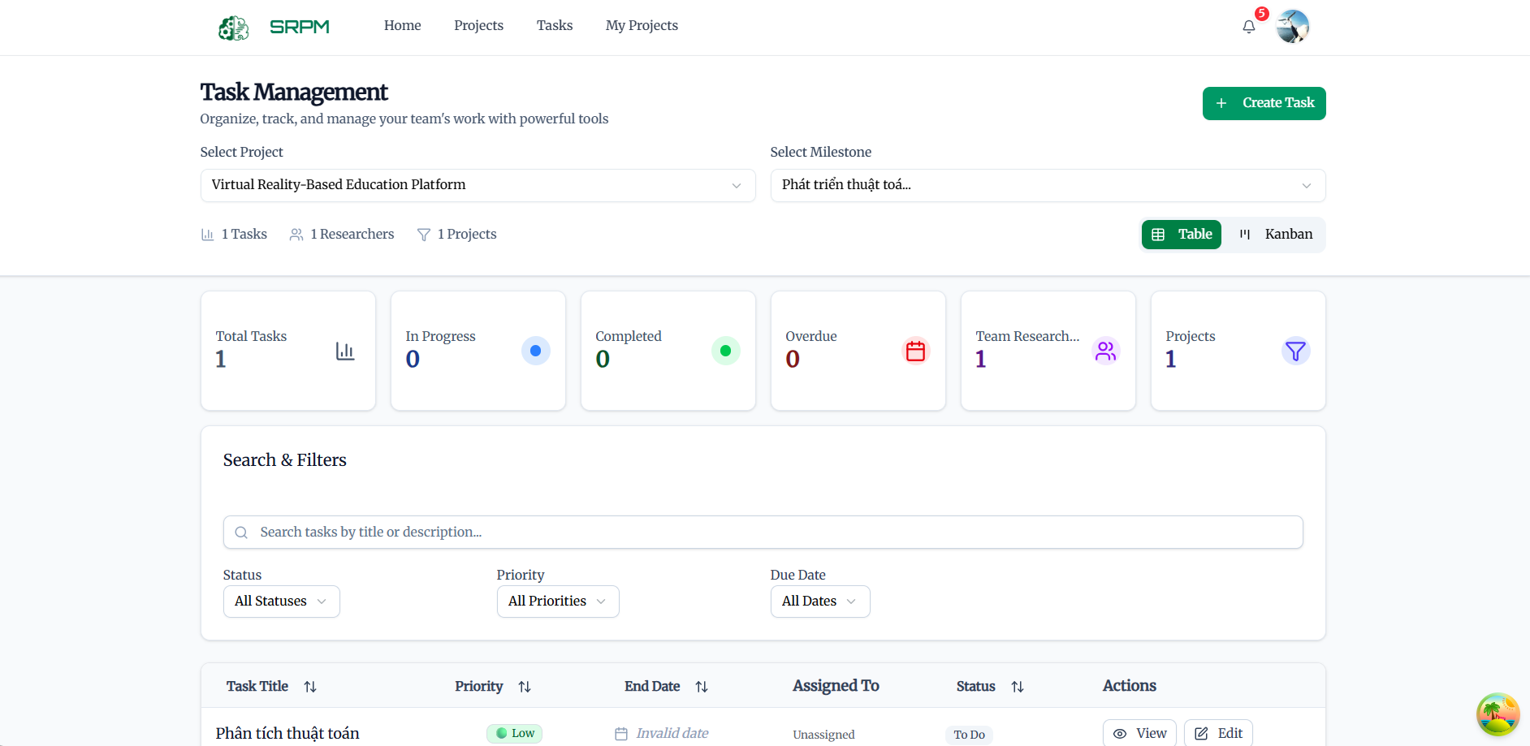

##### Figure 3.3.3 Task Dashboard

**Task Table View**

**Function Description:** This view displays tasks in a tabular format with detailed information and action capabilities

**Function Trigger:**

When researchers use the table view:

Update Task Status:

* Button/Navigation: Status dropdown menus in task rows.
* Trigger: When researchers change task status selections.
* Function: Task status is updated and reflected to project managers.

View Task Details:

* Button/Navigation: Task title links or "View Details" buttons.
* Trigger: When researchers click on task titles or detail buttons.
* Function: Detailed task information opens with requirements and deadlines.

Upload Task Attachments:

* Button/Navigation: "Attach File" buttons in task rows.
* Trigger: When researchers click attachment buttons.
* Function: File upload dialog opens for task-related document submission.



##### Figure 3.3.3 Task Table View

**Task Kanban Board**

**Function Description:** This view provides a visual workflow management interface with drag-and-drop functionality.

**Function Trigger**:

When researchers use the Kanban view:

Move Tasks Between Columns:

* Button/Navigation: Drag-and-drop functionality between status columns.
* Trigger: When researchers drag tasks from one column to another.
* Function: Task status is automatically updated based on the destination column.

View Task Cards:

* Button/Navigation: Task cards with summary information.
* Trigger: When researchers click on task cards.
* Function: Task detail modal opens with full task information.

Filter Kanban Board:

* Button/Navigation: Filter controls above the Kanban board.
* Trigger: When researchers apply filters to the board.
* Function: Only tasks matching the filter criteria are displayed.

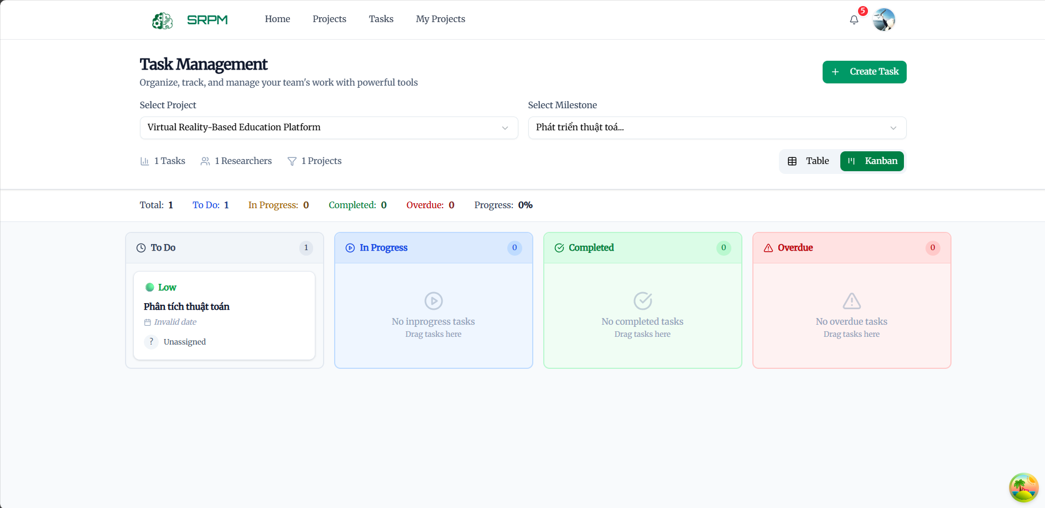

##### Figure 3.3.3 Task Kanban Board

**Advanced Task Management**

**Function Description:** This system provides PIs with comprehensive task creation, assignment, and monitoring capabilities.

**Function Trigger:**

When PIs manage project tasks:

Create Complex Tasks:

* Button/Navigation: "Create Task" button with advanced task creation form.
* Trigger: When click create task and fill out detailed task information.
* Function: Tasks are created with dependencies and detailed requirements.

Assign Tasks to Multiple Members:

* Button/Navigation: Multi-select member assignment interface.
* Trigger: When selecting multiple team members for task assignment.
* Function: Tasks are assigned to selected members with individual notifications.

Monitor Task Progress:

* Button/Navigation: Task progress dashboard with real-time updates.
* Trigger: Automatic updates based on member task status changes.
* Function: Can track task completion and identify potential delays.

Reassign Tasks:

* Button/Navigation: "Reassign" buttons on task entries.
* Trigger: When Reseacher needs to change task assignments.
* Function: Task reassignment interface opens with member selection options.

Link Tasks to Milestones:

* Button/Navigation: Task-milestone association interface.
* Trigger: When Researchers connect tasks to specific milestones.
* Function: Task completion contributes to milestone progress tracking.

##### Figure 3.3.3 Advanced Task Management

### 3.4 Applications for Principal Investigators

#### 3.4.1 My Projects (PI View)

**Function Description:** This comprehensive dashboard allows PIs to manage their research projects with full oversight and management capabilities.

**Function Trigger:**

When PIs access their project dashboard:

View Project Overview:

* Button/Navigation: Project cards with comprehensive information and management options.
* Trigger: When PIs click on project cards.
* Function: Detailed project management interface opens with all available tabs.

**Business Rules: (BR-03, BR-39, BR-59)**

##### Figure 3.4.1 My Projects Dashboard

#### 3.4.2 Project Detail

**Function Description:** This comprehensive interface provides PIs with detailed project management capabilities across multiple functional areas.

**Function Trigger:**

When PIs access detailed project management:

Navigate Between Management Tabs:

* Button/Navigation: Tab buttons for Overview, Team, Documents, Tasks, Milestones, Progress, and Evaluations.
* Trigger: When PIs click on different tab buttons.
* Function: The content area updates to show the selected management area.

Track Project Progress:

* Button/Navigation: Progress indicators and milestone tracking on project cards.
* Trigger: Automatic updates based on task completion and milestone data.
* Function: PIs can monitor overall project progress and identify bottlenecks.

Manage Project Deliverables (Results)

* Button/Navigation: Results tab → “Edit Result” or “Upload Deliverable.”
* Trigger: When PIs upload or update project deliverables (datasets, publications).
* Function: Upload, edit, or download deliverables to ensure research results are stored and accessible for evaluation and reporting.

Manage Budget Transactions

* Button/Navigation: Budget tab → “Request Transaction.”
* Trigger: When PIs submit a new transaction request (e.g., disbursement, reimbursement, milestone-based payment).
* Function: Opens transaction request form where users enter request name, type, and amount. The system validates inputs and submits the request for approval and financial processing.

Create and Manage Project Documents

* Button/Navigation: Documents tab → “Create Document.”
* Trigger: When PIs need to create or manage documents within the project.
* Function: Opens the document creation editor where PIs select document type (proposal, report, contract, etc.), enter document name, and write content. Supports template-based creation, editing, and structured archiving.

##### Figure 3.4.2 Project Detail

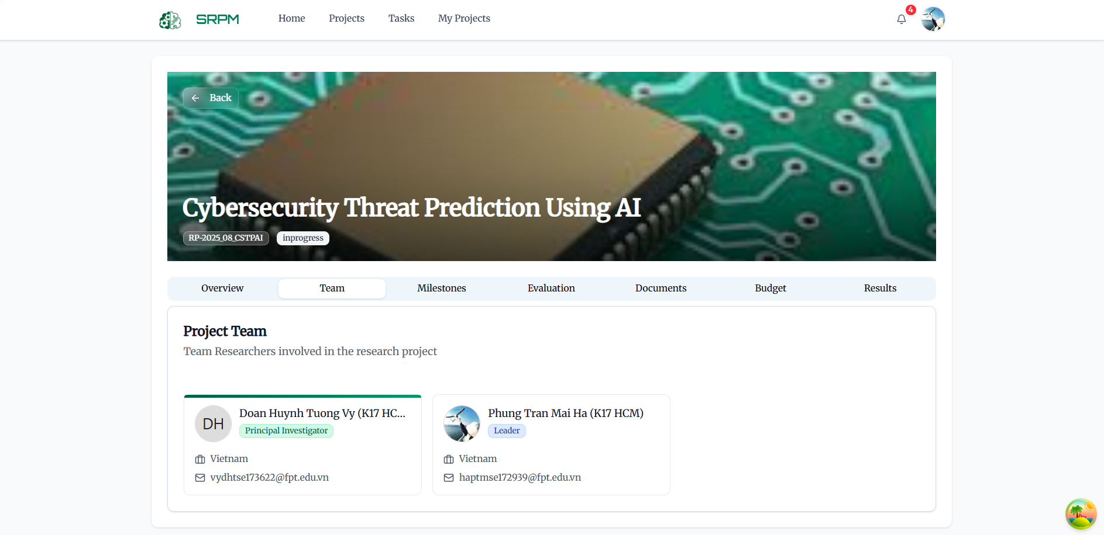

##### Figure 3.4.2 Project Detail

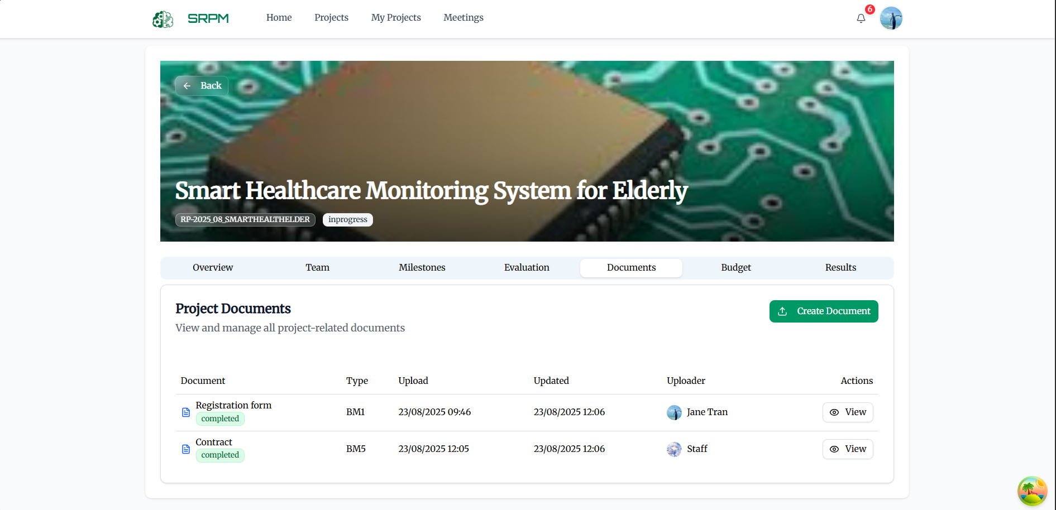

##### Figure 3.4.2 Project Detail

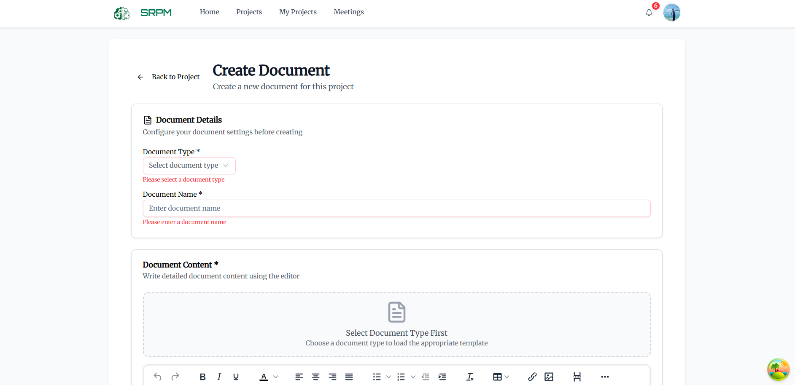

##### Figure 3.4.2 Project Detail

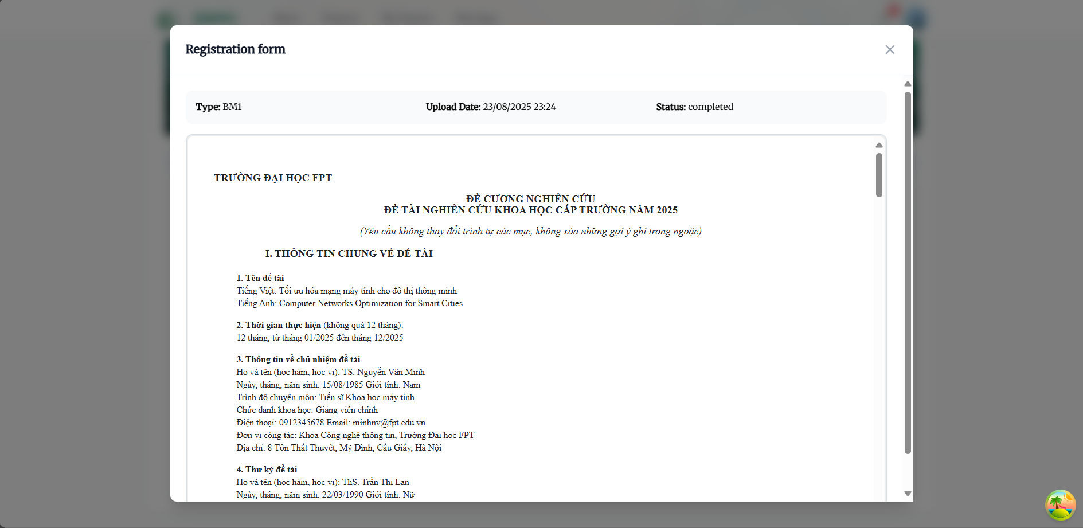

##### Figure 3.4.2 Project Detail

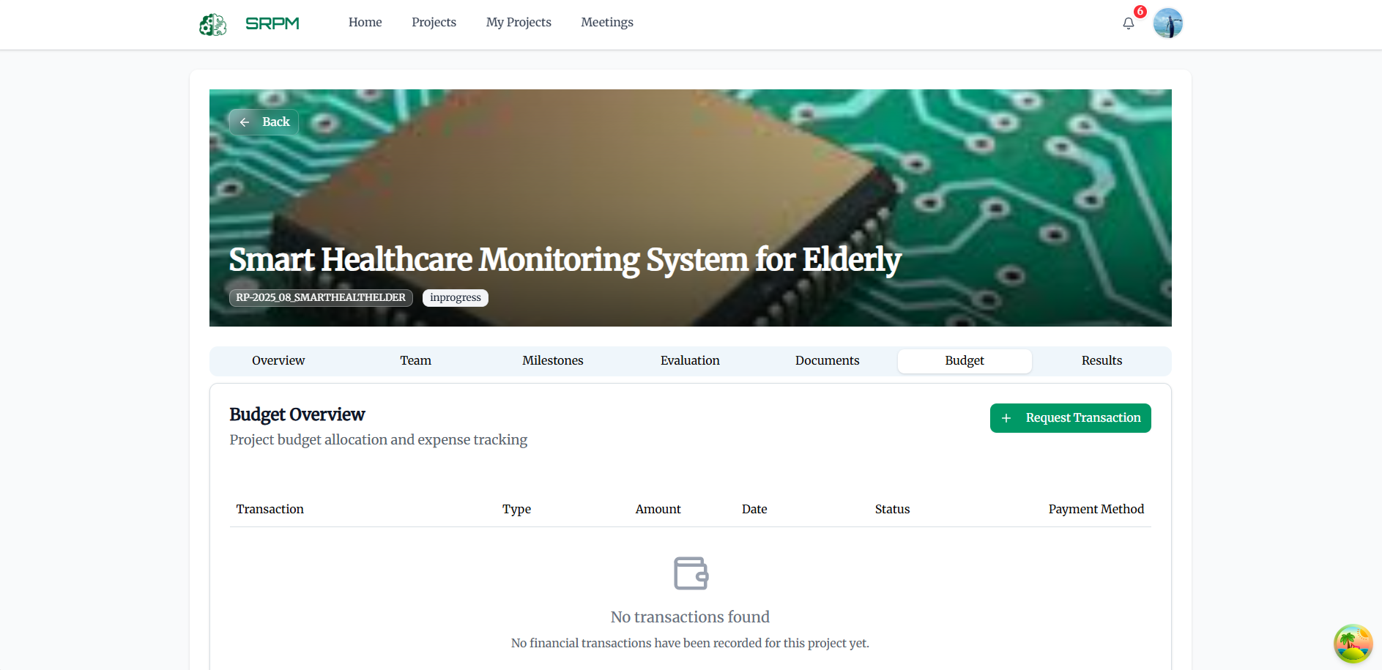

##### Figure 3.4.2 Project Detail

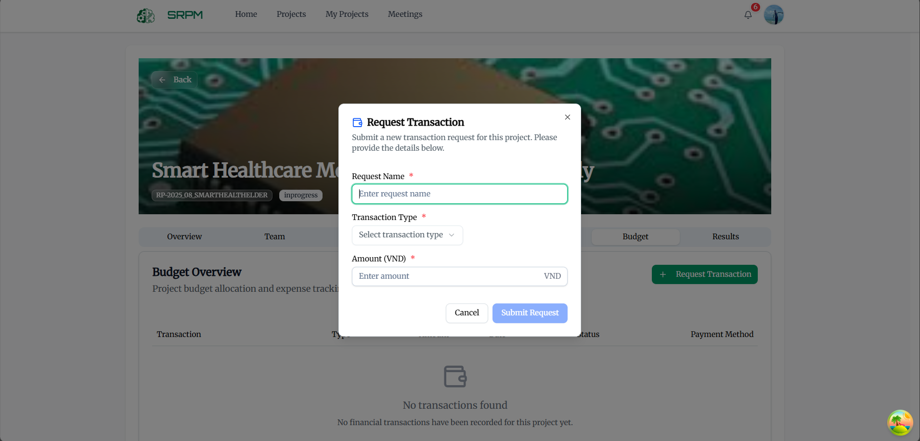

##### Figure 3.4.2 Project Detail

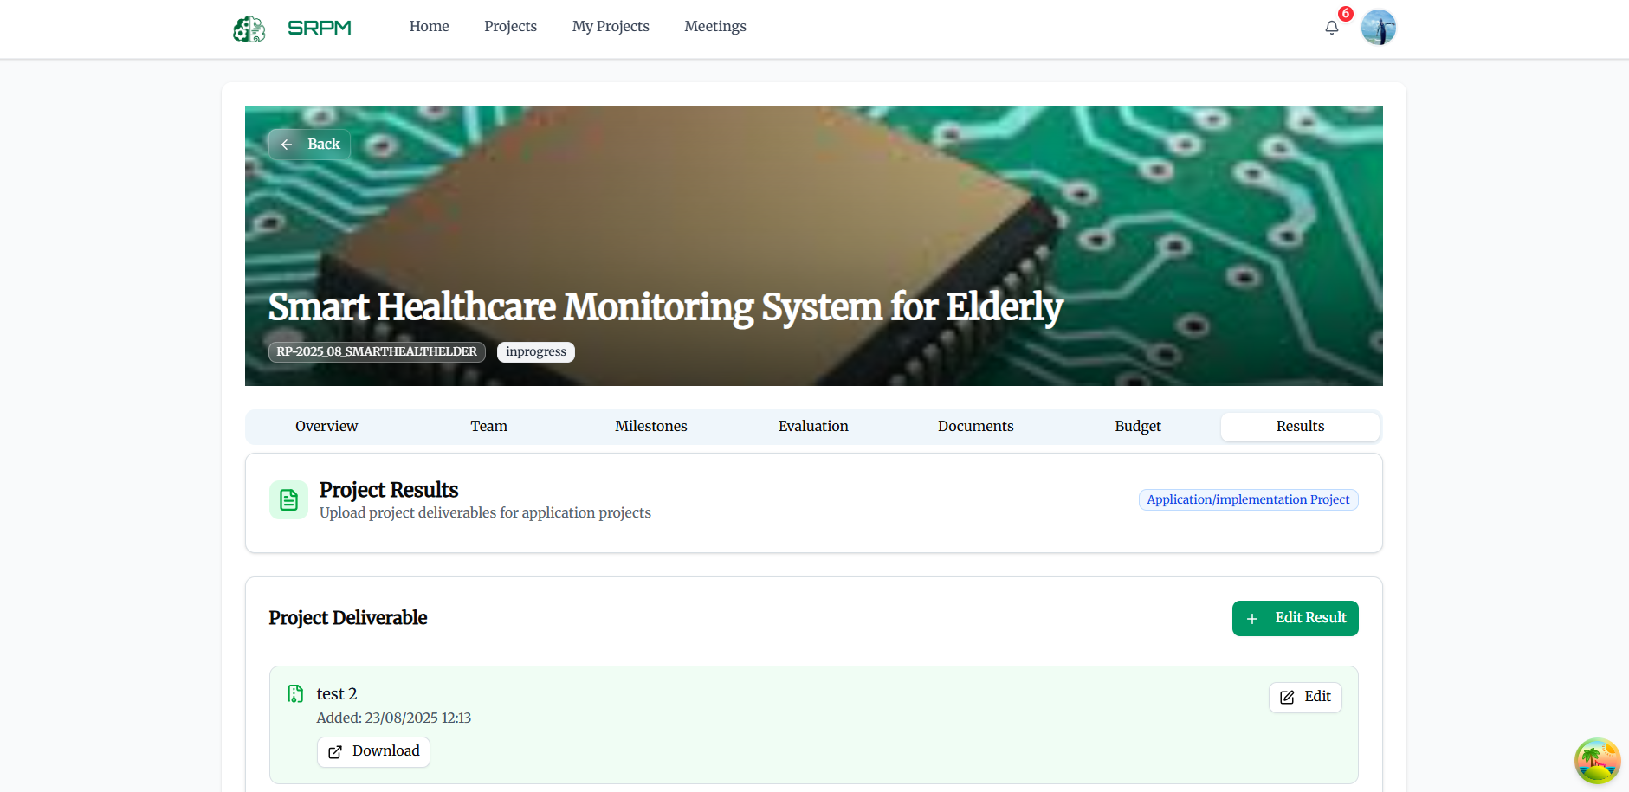

##### Figure 3.4.2 Project Detail

#### 3.4.3 Projects List Page

**Function Description:** This page displays all available projects in the system with search, filter, and sorting capabilities, allowing researchers to browse and join projects.

**Function Trigger:**

When PIs navigate to the Projects List page:

Search Projects:

* Button/Navigation: Search input field with search icon.
* Trigger: When researchers type in the search field or press Enter.
* Function: The system filters projects based on title, description, or keywords.

Filter Projects:

* Button/Navigation: Filter dropdown menus for status, category, field, and major.
* Trigger: When researchers select options from filter dropdowns.
* Function: The project list is filtered based on selected criteria.

View Project Details:

* Button/Navigation: "View Details" button on each project card.
* Trigger: When researchers click on a project card or "View Details" button.
* Function: Basic project information is displayed with requirements and description.

Request to Join Project:

* Button/Navigation: "Join Project" button on project cards.
* Trigger: When researchers click "Join Project" on an available project.
* Function: Researchers are redirected to the project enrollment form.

Sort Projects:

* Button/Navigation: Sort dropdown with options like "Newest," "Oldest," "Title A-Z."
* Trigger: When researchers select a sorting option.
* Function: The project list is reordered based on the selected criteria.

##### Figure 3.4.3 Projects List Page

#### 3.4.4 Project Enrollment Page

**Project Registration Form**

**Function Description:** This page allows PIs to apply for project participation by submitting detailed application forms.

**Function Trigger:**

When PIs want to join a project:

Fill Application Form:

* Button/Navigation: Multi-section form with personal information, qualifications, and motivation.
* Trigger: When researchers complete form sections and navigate between steps.
* Function: Application data is validated and prepared for submission.

Upload Supporting Documents:

* Button/Navigation: File upload areas for CV, certificates, and other documents.
* Trigger: When researchers drag files or click upload buttons.
* Function: Supporting documents are attached to the application.

Submit Application:

* Button/Navigation: "Submit Application" button at the end of the form.
* Trigger: When researchers complete all required fields and click submit.
* Function: The application is sent to project managers for review and approval.

Save as Draft:

* Button/Navigation: "Save Draft" button to preserve incomplete applications.
* Trigger: When researchers want to save progress without submitting.
* Function: Application data is saved and can be completed later.

**Business Rules: (BR-02, BR-37, BR-38, BR-18)**

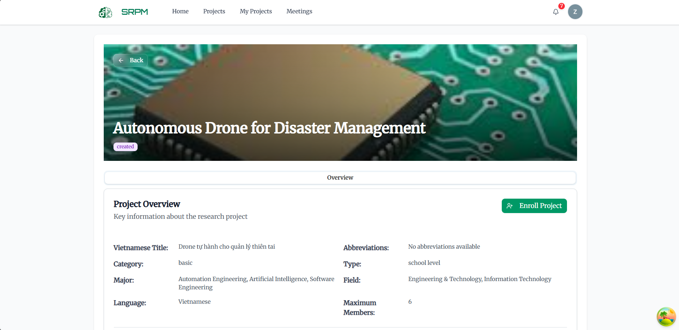

##### Figure 3.4.4 Project Registration Form

##### Figure 3.4.4 Project Registration Form

**Project Invite Members**

**Function Description:** This interface allows PIs to comprehensively manage their research team members, roles, and responsibilities.

**Function Trigger**:

When PIs manage their research team:

Add Team Members:

* Button/Navigation: "Add Member" button and member search interface.
* Trigger: When PIs search for and select new team members.
* Function: Member selection dialog opens with search and invitation capabilities.

Assign Member Roles:

* Button/Navigation: Role assignment dropdowns for each team member.
* Trigger: When PIs select or change member roles.
* Function: Member permissions and access levels are updated accordingly.

Remove Team Members:

* Button/Navigation: "Remove" buttons next to team member entries.
* Trigger: When PIs click remove buttons and confirm the action.
* Function: Members are removed from the project with notification

##### Figure 3.4.4 Project Invite Members

#### 3.4.5 Document Management

**Function Description:** This comprehensive system allows PIs to create, organize, and manage all project-related documents and research materials.

**Function Trigger:**

When PIs manage project documentation:

Create Research Documents:

* Button/Navigation: "Create Document" button with document type selection.
* Trigger: When PIs select document type and click create.
* Function: Document creation interface opens with appropriate templates and editors.

**Business Rules: (BR-11, BR-19)**

##### Figure 3.4.3.1 Project Document

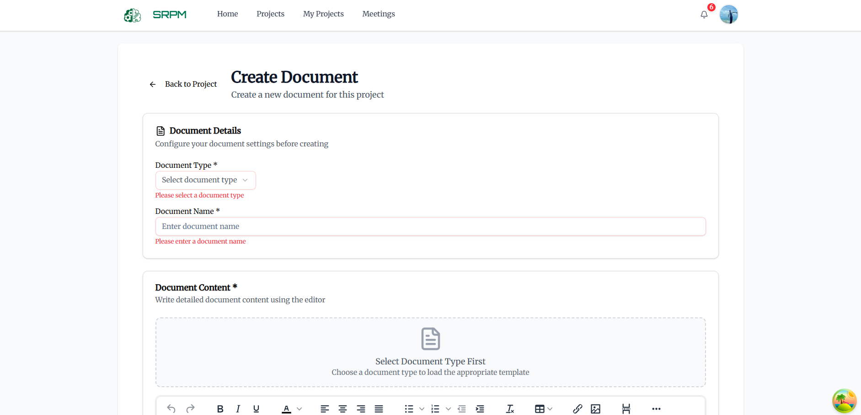

##### Figure 3.4.3.1 Project Document

#### 3.4.6 Meeting Coordination

**Function Description:** This interface allows PIs to schedule, manage, and track research meetings and team communications.

**Function Trigger:**

When PIs coordinate evaluation meetings:

Schedule Evaluation Meetings:

* Button/Navigation: Meeting scheduling interface with calendar integration and member availability checking.
* Trigger: When PIs need to schedule evaluation meetings.
* Function: Meeting scheduling system opens with availability coordination and invitation management.

##### Figure 3.4.6 Meeting Coordination

### 3.5 Applications for Host Institutions

#### 3.5.1 Project Registration

**Function Description:** This comprehensive system allows Host Institutions to register new research projects with detailed information, requirements, and team specifications.

**Function Trigger:**

When Host Institutions initiate new research projects:

Start Project Registration:

* Button/Navigation: "Register New Project" button on the main dashboard.
* Trigger: When Host Institution users click the registration button.
* Function: Multi-step project registration form opens with progress indicators.

Complete Project Information (Step 1):

* Button/Navigation: Project information form with required fields for titles, description, duration, and requirements.
* Trigger: When Host Institutions fill out project details and click "Next Step."
* Function: Project information is validated and stored, proceeding to the next registration step.

Set Project Requirements:

* Button/Navigation: Requirements specification interface with participant qualifications and project criteria.
* Trigger: When Host Institutions define project participation requirements and selection criteria.
* Function: Project requirements are established for potential participant evaluation.

Configure Project Settings:

* Button/Navigation: Project configuration options including maximum members, language, category, and field selections.
* Trigger: When Host Institutions set project parameters and constraints.
* Function: Project settings are configured to guide participant selection and project management.

Review and Submit (Step 2):

* Button/Navigation: Review interface with all project information and "Submit Project" button.
* Trigger: When Host Institutions review all information and click submit.
* Function: Project is registered in the system and becomes available for participant applications.

**Business Rules: (BR-01, BR-06, BR-47, BR-31)**

##### Figure 3.5.1. Project Registration System Step 1

##### Figure 3.5.1 Project Registration System Step 2

#### 3.5.2 My Project (Host view)

**Function Description:** This interface provides Host Institutions with comprehensive oversight of all their registered projects and their current status.

**Function Trigger:**

When Host Institutions manage their my project:

View Project History:

* Button/Navigation: "My Projects" navigation menu item.
* Trigger: When Host Institution users access their project portfolio.
* Function: Comprehensive list of all registered projects with status indicators and management options.

Filter and Search Projects:

* Button/Navigation: Search bar and filter dropdowns for status, category, type, and date range.
* Trigger: When Host Institutions apply search terms or filter criteria.
* Function: Project list is filtered to show only matching projects based on selected criteria.

Monitor Project Status:

* Button/Navigation: Status indicators and progress tracking on project cards.
* Trigger: Automatic updates based on project lifecycle and participant activity.
* Function: Host Institutions can track project progression through various stages.

##### Figure 3.5.2 My Project

#### 3.5.3 Projects List Page

**Function Description:** This page displays all available projects in the system with search, filter, and sorting capabilities, allowing researchers to browse and join projects.

**Function Trigger:**

When HIs navigate to the Projects List page:

Search Projects:

* Button/Navigation: Search input field with search icon.
* Trigger: When HIs type in the search field or press Enter.
* Function: The system filters projects based on title, description, or keywords.

Filter Projects:

* Button/Navigation: Filter dropdown menus for status, category, field, and major.
* Trigger: When HIs select options from filter dropdowns.
* Function: The project list is filtered based on selected criteria.

View Project Details:

* Button/Navigation: "View Details" button on each project card.
* Trigger: When HIs click on a project card or "View Details" button.
* Function: Basic project information is displayed with requirements and description.

Sort Projects:

* Button/Navigation: Sort dropdown with options like "Newest," "Oldest," "Title A-Z."
* Trigger: When HIs select a sorting option.
* Function: The project list is reordered based on the selected criteria.

##### Figure 3.5.3 Projects List Page for HI

### 3.6 Applications for Appraisal Council Members

#### 3.6.1 My Council

**Function Description:** This interface allows council members to manage their appraisal councils, view assigned projects, and coordinate evaluation activities.

**Function Trigger**:

When council members access their council management:

Select Active Council:

* Button/Navigation: Council selection dropdown with available council assignments.
* Trigger: When council members select a different council from their assignments.
* Function: Dashboard updates to show projects and activities for the selected council.

Access Assigned Projects:

* Button/Navigation: Project cards showing council evaluation assignments.
* Trigger: When council members click on assigned project cards.
* Function: Project evaluation interface opens with assessment tools and criteria.

Monitor Evaluation Progress:

* Button/Navigation: Progress tracking dashboard with evaluation status indicators.
* Trigger: Automatic updates based on evaluation completion and submission status.
* Function: Council members can track evaluation progress across all assigned projects.

Provide Evaluation Feedback:

* Button/Navigation: Feedback interface with detailed comment and recommendation capabilities.
* Trigger: When council members provide constructive feedback to project proposers.
* Function: Structured feedback system opens with categorized feedback areas and improvement suggestions.

Evaluate Project Proposals:

* Button/Navigation: Proposal evaluation interface with scoring mechanisms and assessment criteria.
* Trigger: When council members conduct detailed proposal evaluations.
* Function: Structured evaluation process opens with scoring rubrics and detailed assessment forms.

**Business Rules: (BR-04, BR-45, BR-48, BR-49)**

##### Figure 3.6.1 My Council Dashboard

##### Figure 3.6.1 My Council Project Detail

##### Figure 3.6.1 My Council Evaluation Detail

##### Figure 3.6.1 My Council Evaluation Stage

#### 3.6.2 Project Approval System

**Function Description:** This comprehensive system allows council members to review, evaluate, and approve research project proposals with detailed assessment capabilities.

**Function Trigger:**

When council members evaluate project proposals:

Review Project Topics:

* Button/Navigation: Topic review interface with comprehensive project information display.
* Trigger: When council members access projects assigned for evaluation.
* Function: Detailed project information is displayed with evaluation criteria and assessment tools.

Evaluate Project Proposals:

* Button/Navigation: Proposal evaluation interface with scoring mechanisms and assessment criteria.
* Trigger: When council members conduct detailed proposal evaluations.
* Function: Structured evaluation process opens with scoring rubrics and detailed assessment forms.

Compare Multiple Proposals:

* Button/Navigation: Proposal comparison interface with side-by-side analysis capabilities.
* Trigger: When council members need to compare competing proposals for the same project.
* Function: Comparative analysis tools open with proposal comparison matrices and scoring comparisons.

Make Approval Decisions:

* Button/Navigation: Decision interface with approval, rejection, and conditional approval options.
* Trigger: When council members finalize their evaluation decisions.
* Function: Decision recording system opens with justification requirements and stakeholder notification.

Provide Evaluation Feedback:

* Button/Navigation: Feedback interface with detailed comment and recommendation capabilities.
* Trigger: When council members provide constructive feedback to project proposers.
* Function: Structured feedback system opens with categorized feedback areas and improvement suggestions.

**Business Rules: (BR-07, BR-08, BR-09, BR-36)**

##### Figure 3.6.2 Project Approval System

##### Figure 3.6.2 Review Project Topics

##### Figure 3.6.2 Proposal Detail

##### Figure 3.6.2 Review Proposal

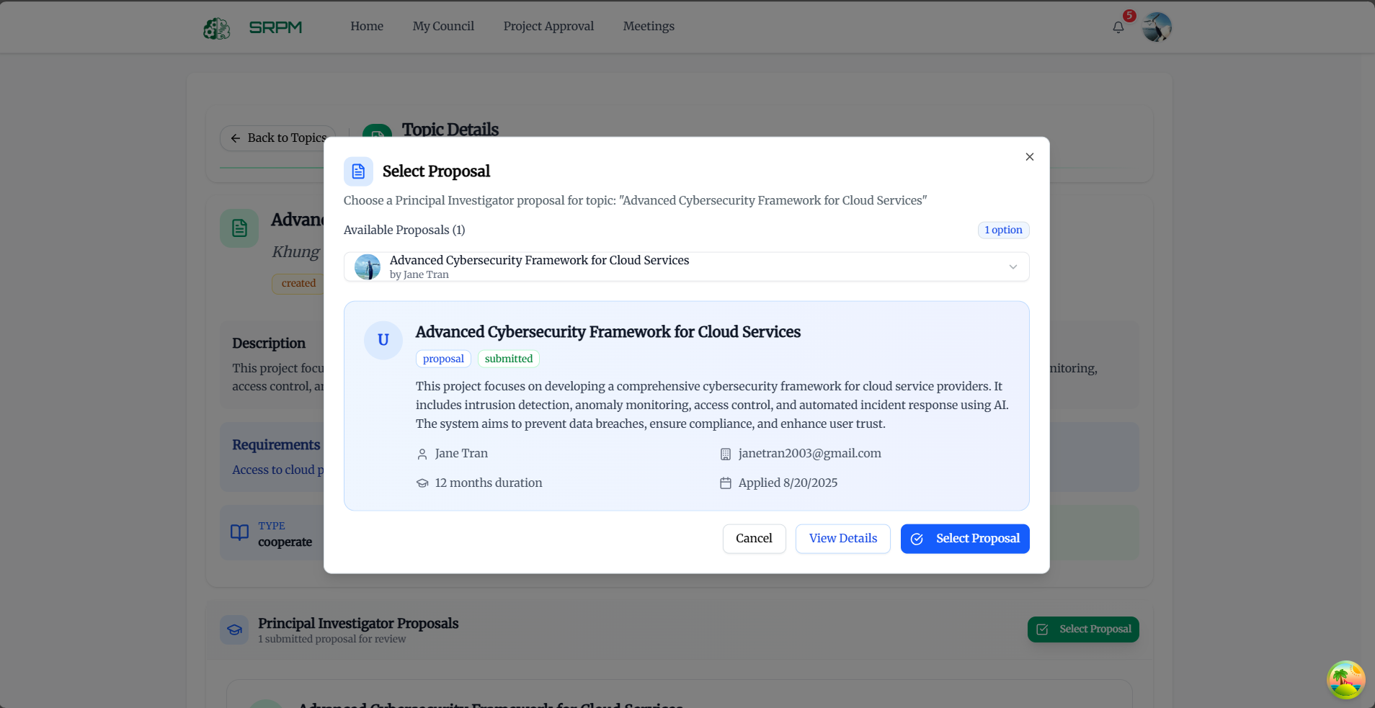

##### Figure 3.6.2 Choose and Select Proposal

#### 3.6.3 Advanced Evaluation

**Individual Evaluation Management**

**Function Description:** This system allows council members to create and manage individual evaluations with detailed assessment criteria and scoring mechanisms

**Function Trigger**:

When council members conduct individual evaluations:

Create Individual Evaluations:

* Button/Navigation: "Create Individual Evaluation" button with evaluation template selection.
* Trigger: When council members initiate new individual evaluation processes.
* Function: Individual evaluation creation interface opens with customizable criteria and scoring systems.

Set Evaluation Criteria:

* Button/Navigation: Criteria definition interface with customizable assessment parameters.
* Trigger: When council members define specific evaluation criteria for projects.
* Function: Evaluation criteria are established with weighting systems and scoring rubrics.

Assign Evaluation Scores:

* Button/Navigation: Scoring interface with numerical and qualitative assessment capabilities.
* Trigger: When council members assign scores based on evaluation criteria.
* Function: Scoring system records assessments with justification requirements and consistency checking.

Submit Individual Assessments:

* Button/Navigation: Assessment submission interface with review and finalization capabilities.
* Trigger: When council members complete and submit their individual evaluations.
* Function: Individual assessments are submitted with integration into overall evaluation processes.

**Business Rules: (BR-52, BR-53, BR-61)**

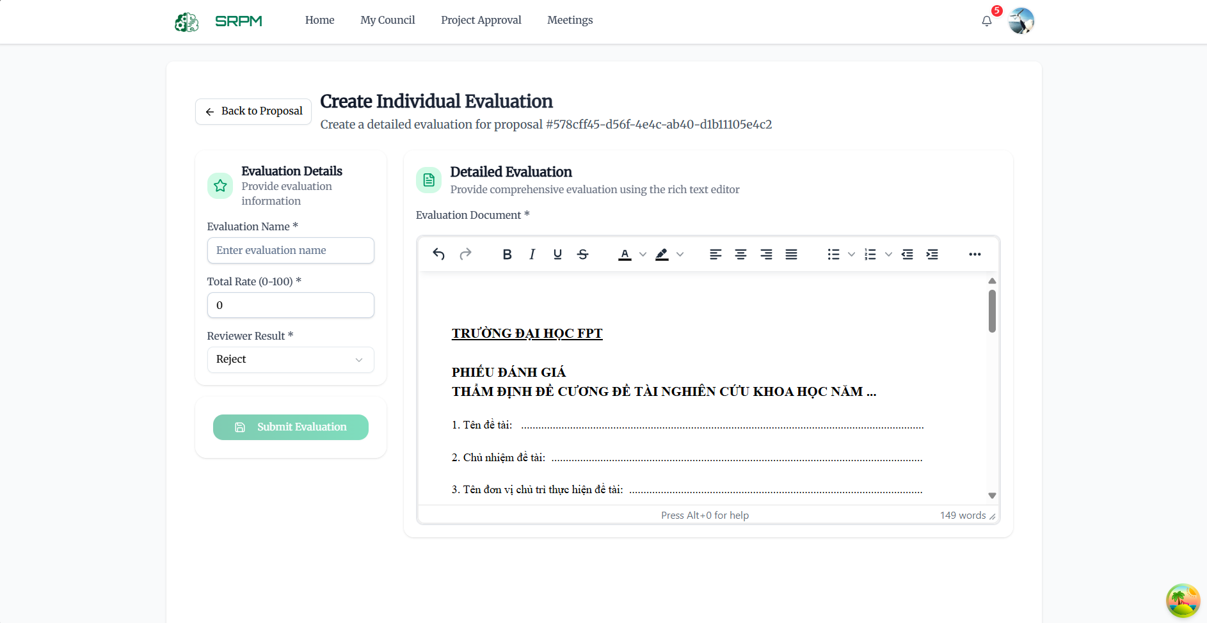

##### Figure 3.6.3 Create Individual Evaluation

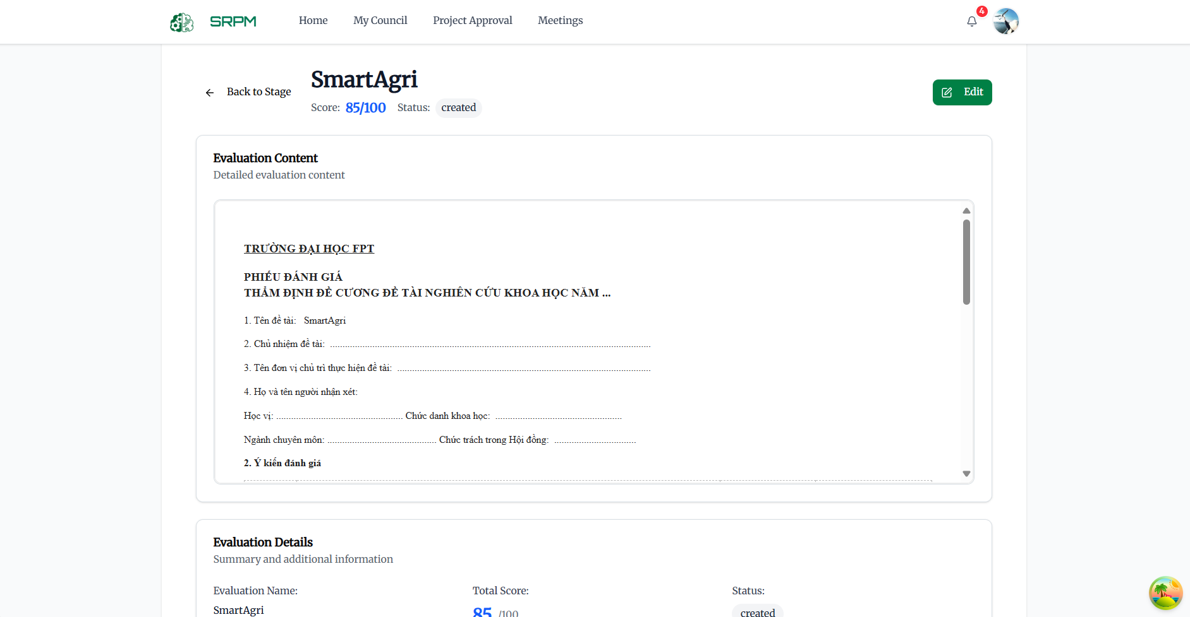

##### Figure 3.6.3 View Individual Evaluation

**AI-Assisted Evaluation Integration**

Function Description: This advanced system integrates AI-powered evaluation tools with human assessment for comprehensive project evaluation.Function Trigger:When council members utilize AI evaluation assistance:Access AI Evaluation Results:

* Button/Navigation: AI evaluation dashboard with automated assessment results and insights.
* Trigger: When council members review AI-generated evaluation data.
* Function: AI evaluation results are displayed with explanation of assessment methodology and confidence levels.

Compare AI and Human Assessments:

* Button/Navigation: Comparison interface showing AI versus human evaluation results.
* Trigger: When council members analyze differences between AI and human assessments.
* Function: Comparative analysis tools highlight assessment differences with reconciliation suggestions.

Validate AI Recommendations:

* Button/Navigation: AI recommendation validation interface with acceptance or override capabilities.
* Trigger: When council members review and validate AI-generated recommendations.
* Function: AI recommendations are reviewed with human oversight and final decision authority.

Integrate AI Insights:

* Button/Navigation: Integration interface for incorporating AI insights into final evaluations.
* Trigger: When council members incorporate AI analysis into their evaluation decisions.
* Function: AI insights are integrated with human judgment for comprehensive evaluation outcomes.

##### Figure 3.6.3 View AI Individual Evaluation

#### 3.6.4 Meeting Management

**Function Description:** This system facilitates council meeting scheduling, management, and decision recording for evaluation processes.

**Function Trigger:**

When council members coordinate evaluation meetings:

Schedule Evaluation Meetings:

* Button/Navigation: Meeting scheduling interface with calendar integration and member availability checking.
* Trigger: When council members need to schedule evaluation meetings.
* Function: Meeting scheduling system opens with availability coordination and invitation management.

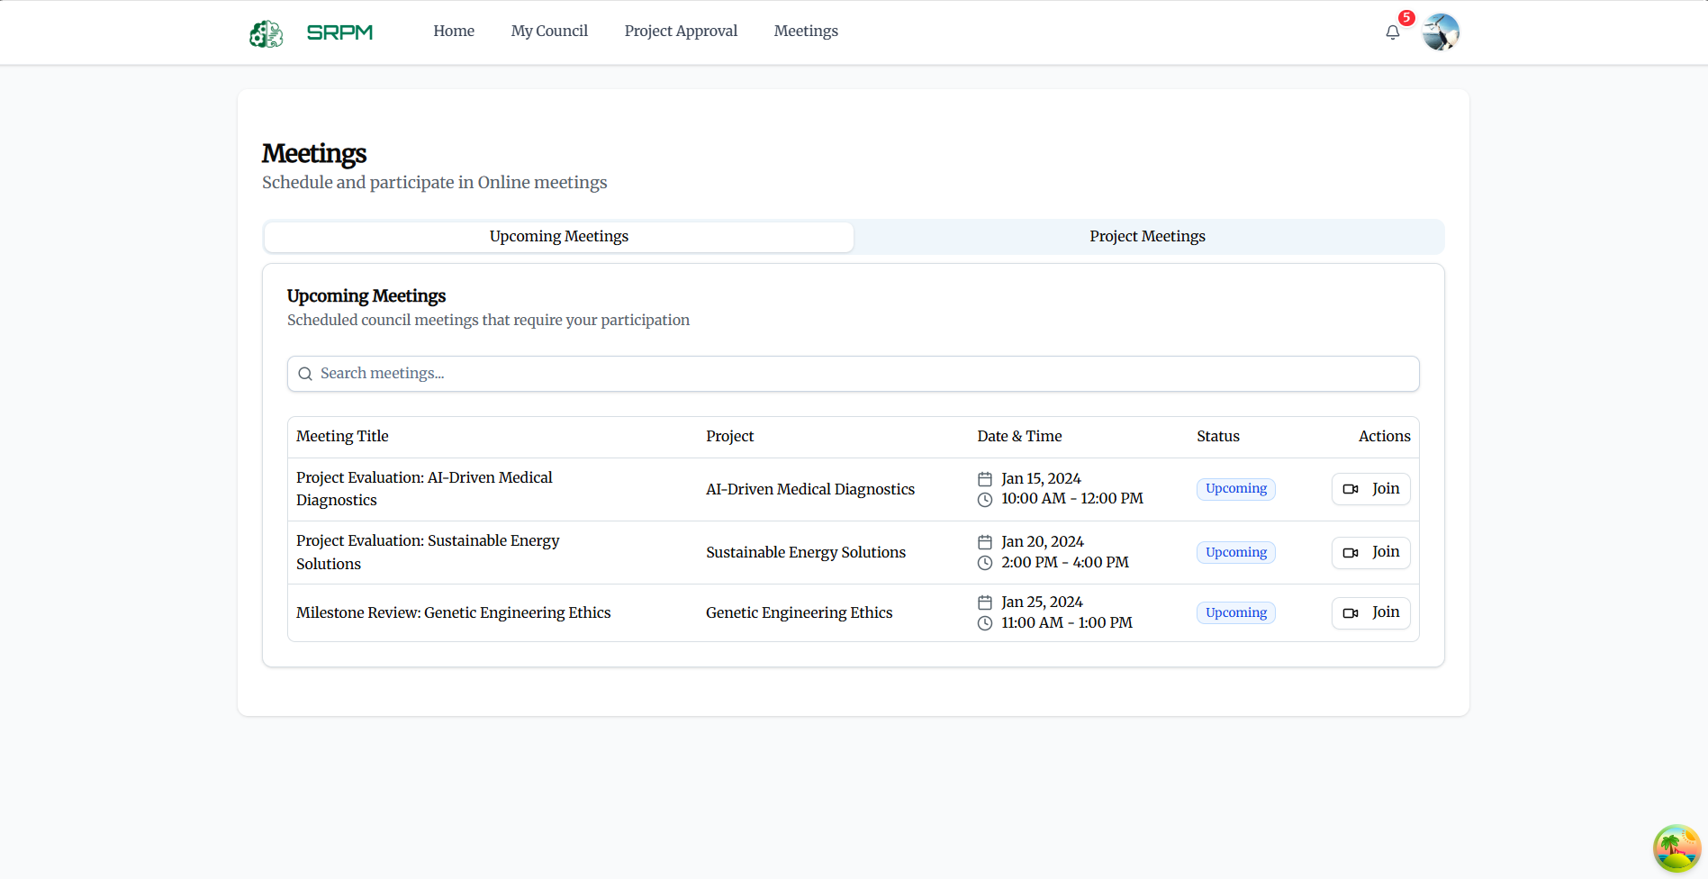

##### Figure 3.6.4 Council Meeting

### 3.7 Applications for Staff Members

#### 3.7.1 Staff Dashboard

**Function Description:** This comprehensive dashboard provides staff members with system overview.

**Function Trigger:**

When staff members access their administrative dashboard:

View System Statistics:

* Button/Navigation: Statistical overview cards showing system metrics, user activity, and project statistics.
* Trigger: Automatic updates based on real-time system data and activity monitoring.
* Function: Staff can monitor overall user engagement, and project activity levels.

Monitor Recent Activities:

* Button/Navigation: Activity feed showing recent system activities, user actions, and project updates.
* Trigger: Automatic updates based on system activity and user interactions.
* Function: Staff can track recent system activities and identify areas requiring attention or intervention.

**Business Rules: (BR-07, BR-08, BR-09, BR-36)**

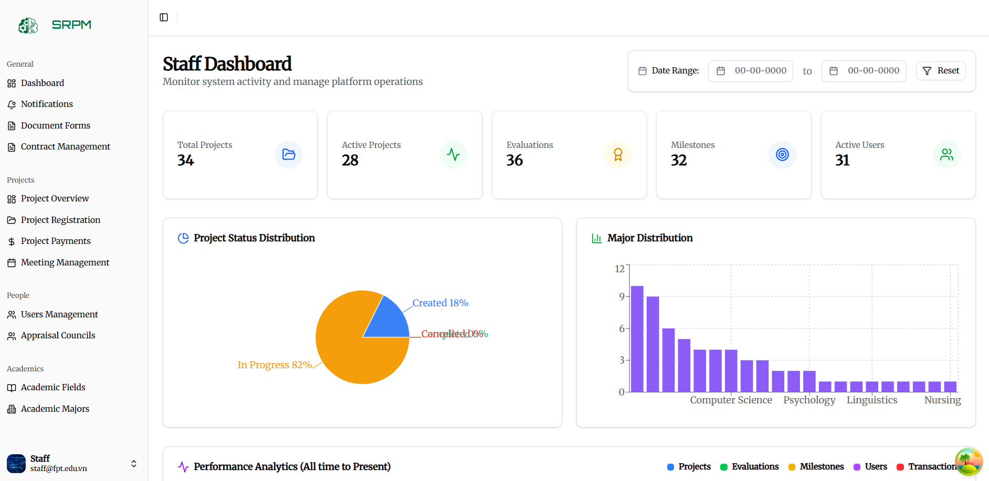

##### Figure 3.7.1 Staff Dashboard

#### 3.7.2 Project Management

**Function Description:** This system provides staff with full project management capabilities including project lifecycle management, status control.

**Function Trigger:**

When staff manage system projects:

View All Projects:

* Button/Navigation: Project management interface with comprehensive project listing and advanced filtering capabilities.
* Trigger: When staff access project management functions.
* Function: Complete project overview opens with management tools and status controls.

Manage Project Status:

* Button/Navigation: Project status management interface with lifecycle control and approval workflows.
* Trigger: When staff need to modify project status or manage project progression.
* Function: Project status management system provides controlled project lifecycle management with stakeholder notification.

Assign Council Evaluations:

* Button/Navigation: Council assignment interface with evaluation scheduling and council member coordination.
* Trigger: When staff assign projects to appraisal councils for evaluation.
* Function: Council assignment system coordinates evaluation assignments with scheduling and notification management.

Register New Project

* Button/Navigation: The “Project Registration” option in the sidebar menu opens the interface for creating a new research project. The interface includes two steps: Project Information → Review & Submit.
* Trigger: When a Staff selects Project Registration to create and register a new research project.
* Function: The system provides a structured form to enter project details (English/Vietnamese Title, Abbreviations, Duration, Description, Requirement Notes, Maximum Members, Category, Language, Type, Field, Major). Ensures standardized project information for management, evaluation, and monitoring. Stores the project data for the next step (Review & Submit) and subsequent workflows (council evaluation, contract signing, progress reporting, and final acceptance).

**Business Rules: (BR-10, BR-13, BR-35, BR-40, BR-41)**

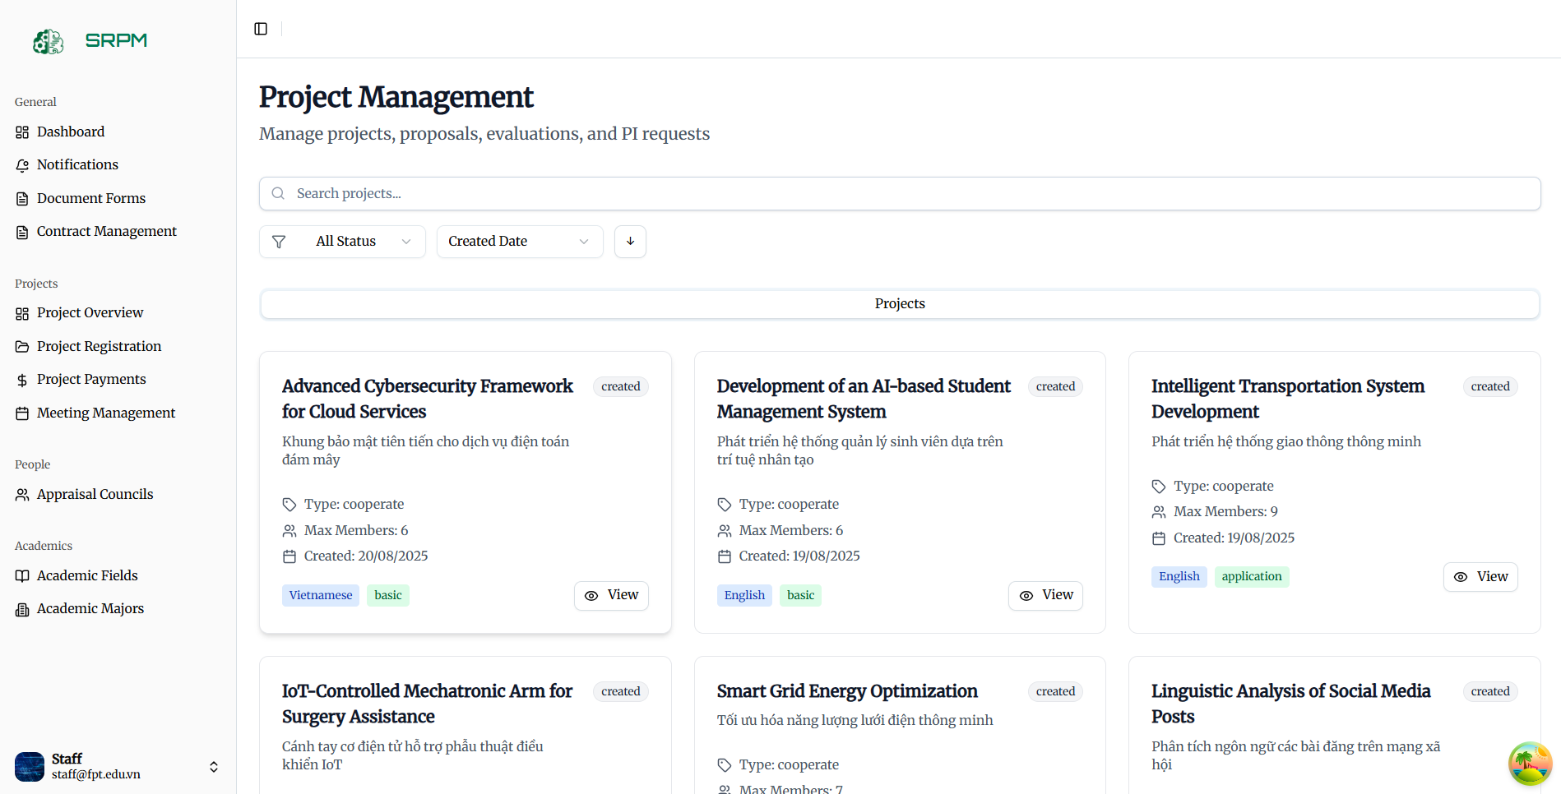

##### Figure 3.7.2 Project Oversight

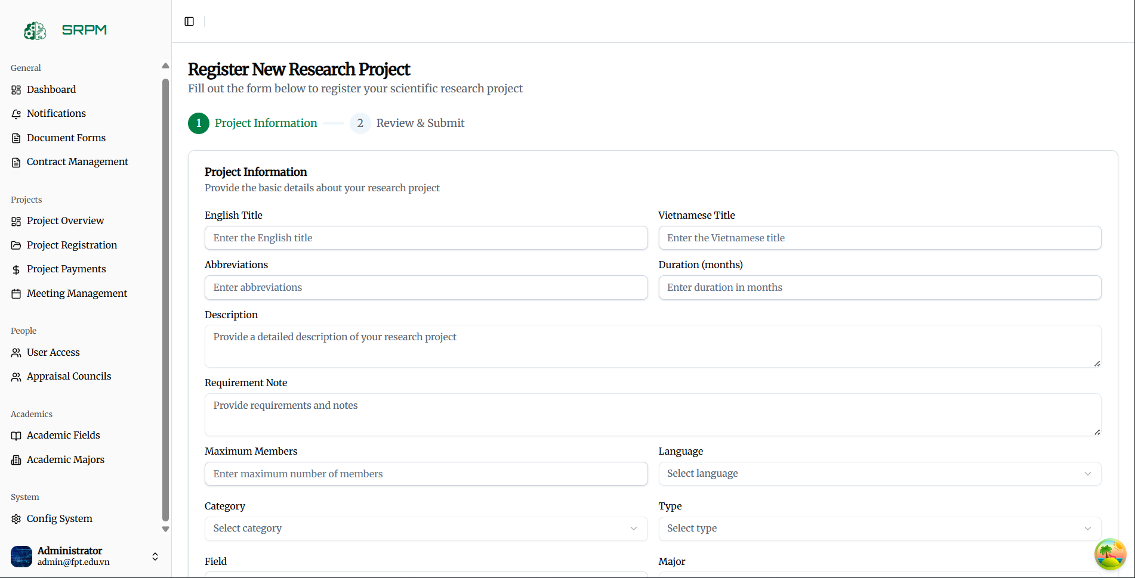

##### Figure 3.7.2 Register New Project

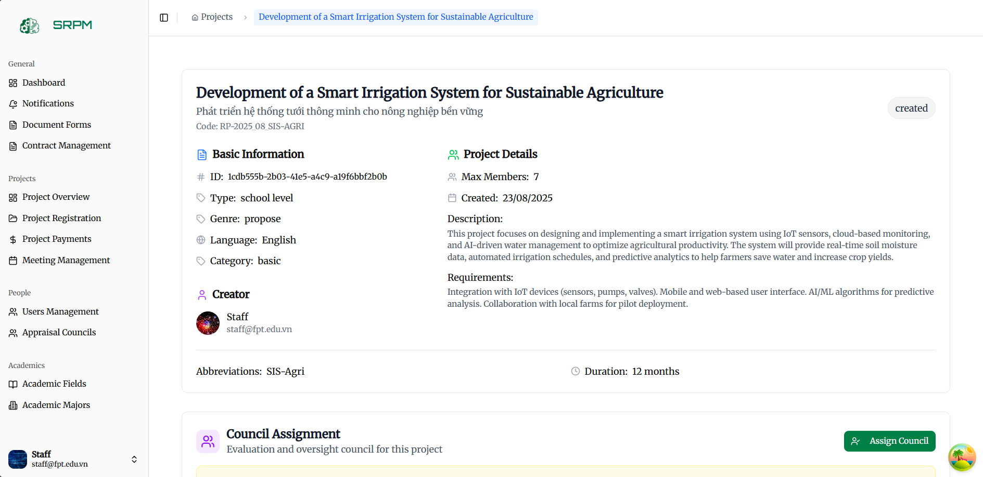

##### Figure 3.7.2 Assign Council

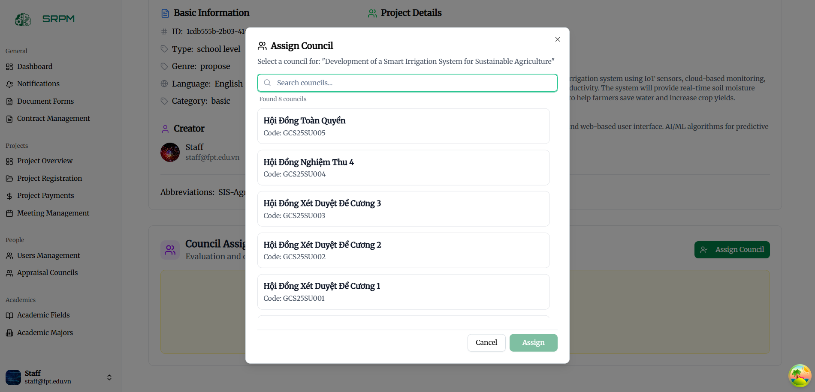

##### Figure 3.7.2 Assign Council

#### 3.7.3 Document Form Management

**Document Administration**

**Function Description:** This system allows staff to manage document templates, forms, and document workflows throughout the system.

**Function Trigger:**

When staff manage system documentation:

Manage Document Templates:

* Button/Navigation: Template management interface with template creation, modification, and version control.
* Trigger: When staff need to create or modify document templates.
* Function: Template management system provides document template lifecycle management with version control and approval workflows.

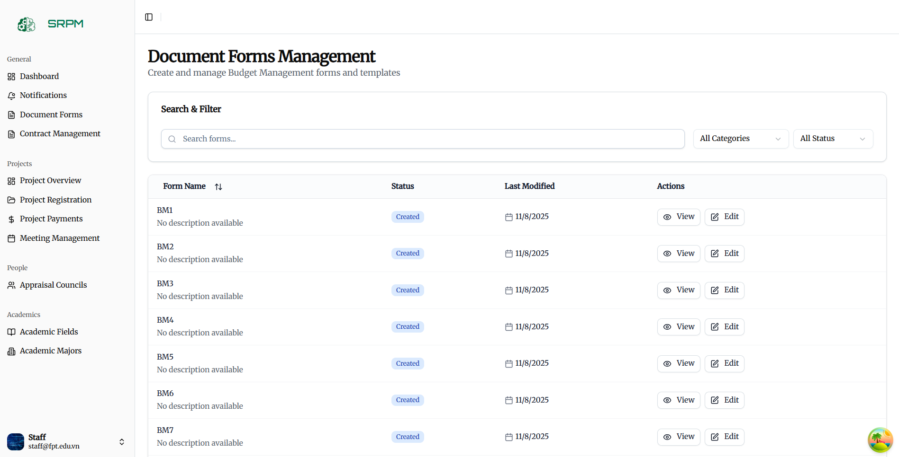

##### Figure 3.7.3 Document Form Management

#### 3.7.4 **Fields and Majors Administration**

**Function Description:** This system allows staff to manage the academic structure including research fields, academic majors, and their relationships.

**Function Trigger:**

When staff manage academic structure:

Manage Research Fields:

* Button/Navigation: Fields management interface with field creation, modification, and hierarchy management.
* Trigger: When staff need to add, modify, or organize research fields.
* Function: Fields management system provides comprehensive field administration with hierarchical organization and project association.

Administer Academic Majors:

* Button/Navigation: Majors management interface with major creation, field association, and statistics tracking.
* Trigger: When staff manage academic majors and their relationships to research fields.
* Function: Majors administration system provides major lifecycle management with field relationships and usage analytics.

Configure Field-Major Relationships:

* Button/Navigation: Relationship management interface with association mapping and validation rules.
* Trigger: When staff define relationships between research fields and academic majors.
* Function: Relationship management system establishes and maintains field-major associations with consistency validation.

**Business Rules: (BR-63)**

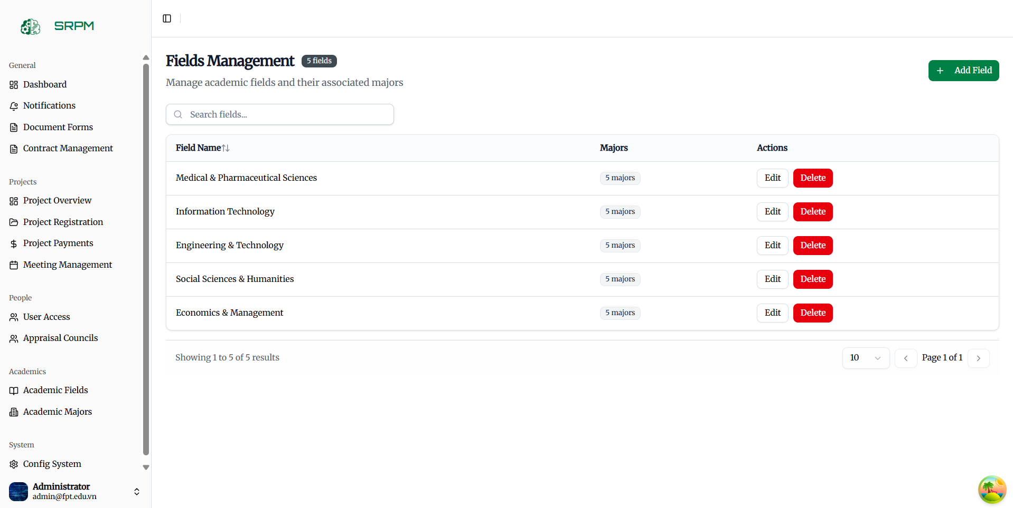

##### Figure 3.7.3 Fields Management

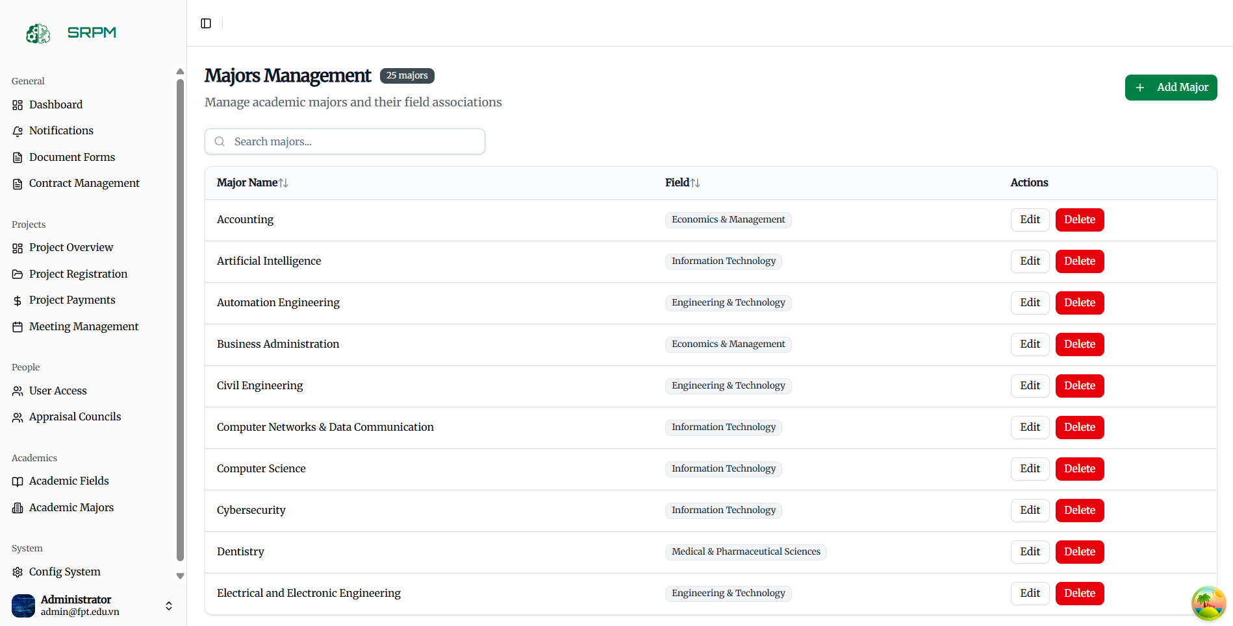

##### Figure 3.7.3 Major Management

#### 3.7.5 Appraisal Council Management

**Function Description:** This comprehensive system allows staff to create, manage, and coordinate appraisal councils with member assignment and project allocation.

**Function Trigger:**

When staff manage appraisal councils:

Create Appraisal Councils:

* Button/Navigation: Council creation interface with council setup, member assignment, and role definition.
* Trigger: When staff need to establish new appraisal councils.
* Function: Council creation system provides comprehensive council setup with member recruitment and role assignment.

Manage Council Membership:

* Button/Navigation: Membership management interface with member addition, removal, and role modification.
* Trigger: When staff modify council composition and member roles.
* Function: Council membership system provides controlled member lifecycle management with role-based permissions and responsibilities.

Assign Projects to Councils:

* Button/Navigation: Project assignment interface with council workload balancing and expertise matching.
* Trigger: When staff assign projects to appropriate councils for evaluation.
* Function: Project assignment system optimizes council workload and expertise matching with automated assignment suggestions.

##### Figure 3.7.5 Appraisal Council Management

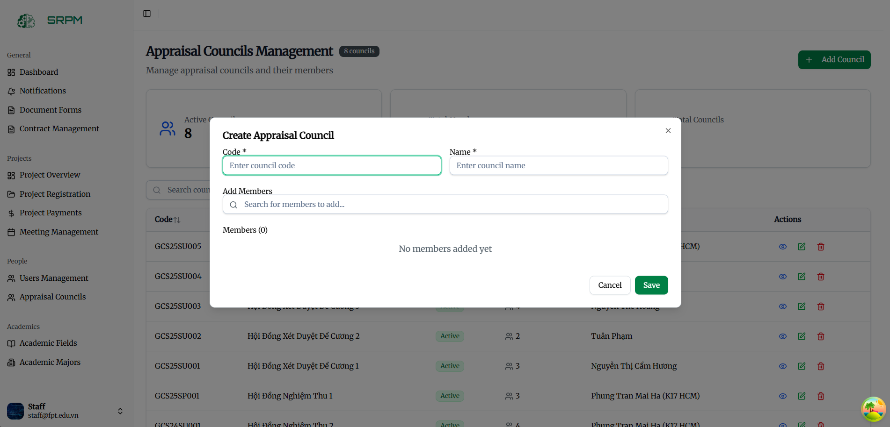

##### Figure 3.7.5 Appraisal Council Management

#### 3.7.6 **Meeting Management System**

**Function Description:** This system provides staff with comprehensive meeting management capabilities including scheduling, coordination, and outcome tracking.

**Function Trigger:**

When staff coordinate system meetings:

Schedule Individual Meetings:

* Button/Navigation: Meeting scheduling interface with calendar integration and participant coordination.
* Trigger: When staff need to schedule meetings for councils, projects, or administrative purposes.
* Function: Meeting scheduling system provides comprehensive meeting coordination with availability checking and invitation management.

Manage Meeting Resources:

* Button/Navigation: Resource management interface with room booking, equipment allocation, and material preparation.
* Trigger: When staff coordinate meeting logistics and resource requirements.
* Function: Meeting resource system provides comprehensive logistics coordination with resource tracking and conflict resolution.

Track Meeting Outcomes:

* Button/Navigation: Outcome tracking dashboard with decision monitoring and follow-up management.
* Trigger: When staff monitor meeting effectiveness and outcome implementation.
* Function: Meeting outcome system tracks decision implementation with accountability and progress monitoring.

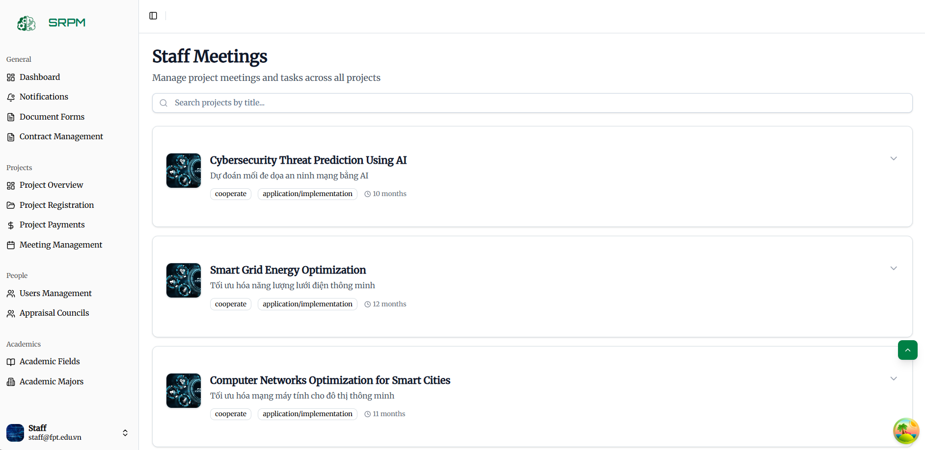

##### Figure 3.7.6 Meeting Management System

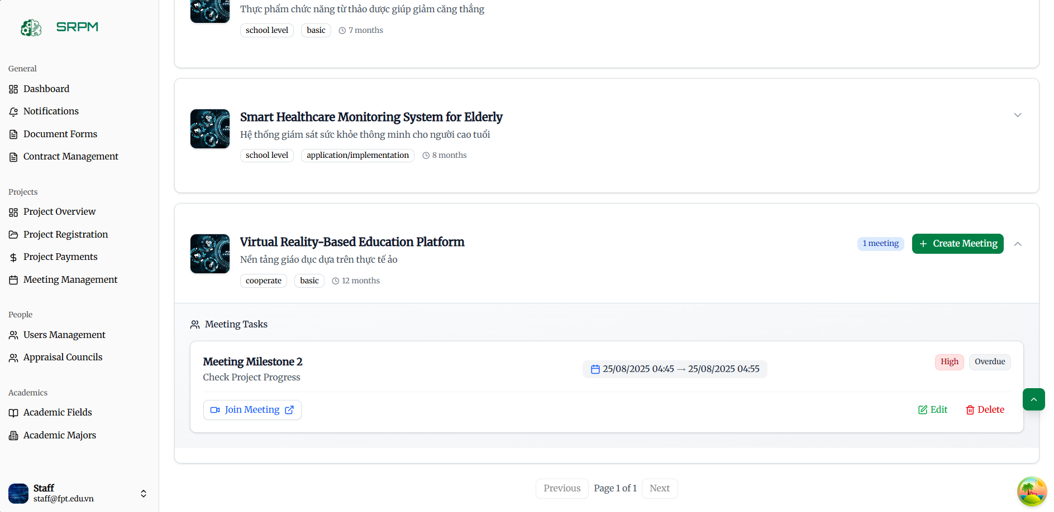

##### Figure 3.7.6 Meeting Management System

#### 3.7.7 User Management

**Function Description:** This system provides administrators with complete user lifecycle management including advanced user controls, bulk operations, and comprehensive user analytics.

**Function Trigger:**

When administrators manage system users with advanced capabilities:

Manage Advanced User Permissions:

* Button/Navigation: Advanced permission management interface with custom role creation and granular permission assignment.
* Trigger: When administrators create custom roles or assign specific permissions beyond standard roles.
* Function: Advanced permission system provides flexible role creation with granular permission control and inheritance management.

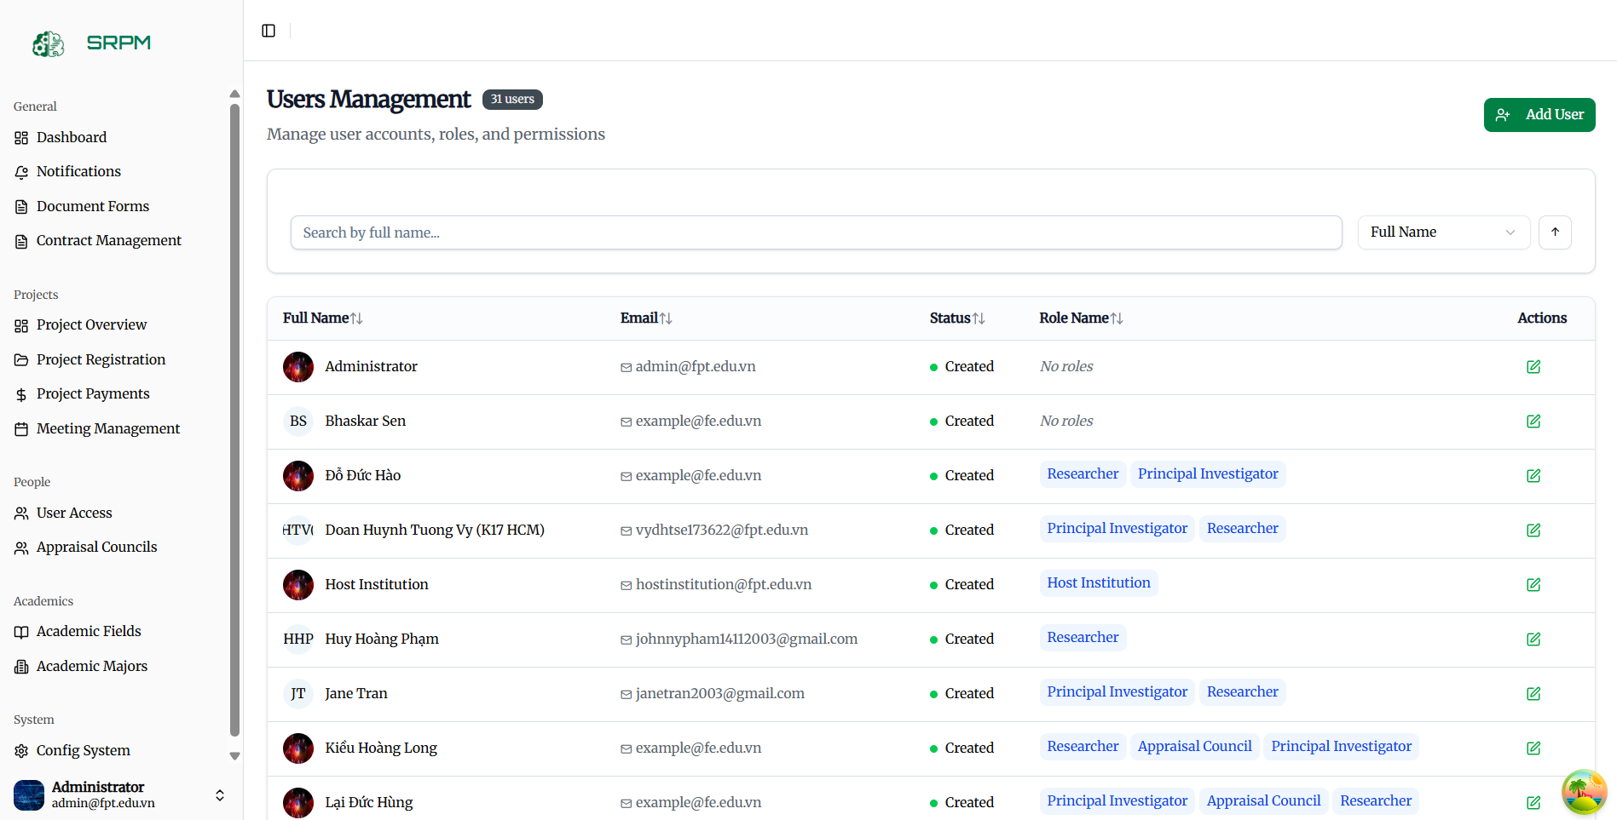

##### Figure 3.7.7 User Management

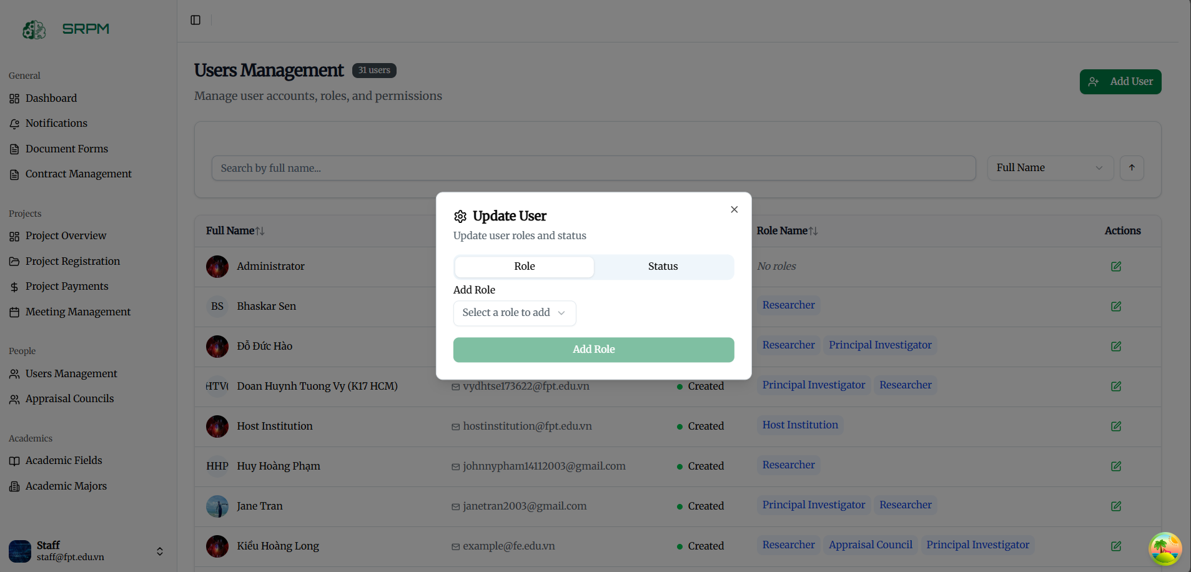

##### Figure 3.7.7 User Management

#### 3.7.8 Contract Management

**Function Description:**This module allows administrators and project leaders to create, manage, and track research contracts. It ensures contract consistency, approval workflows, and compliance with institutional policies.

**Function Trigger:** When administrators or project leaders manage contracts in the system:

Create Contract

* **Button/Navigation:** “Create Contract” button in the Contract Management module.
* **Trigger:** When a valid project is selected and users initiate the creation of a new BM5 contract.
* **Function:** The system opens a contract editor, where administrators input standardized contract details, attach required documents, and submit for approval.

Read Registration Form

* **Button/Navigation:** “View Registration Form” under the project details page.
* **Trigger:** When administrators, council members, or staff access submitted BM1 forms.
* **Function:** The system retrieves and displays the BM1 registration form in read-only mode, ensuring accessibility for evaluation and decision-making.

Create Milestone

* **Button/Navigation:** “Add Milestone” button in the contract/project management interface.
* **Trigger:** When administrators or project leaders plan and define project milestones after contract approval.
* **Function:** The system generates a milestone record with key details (title, description, start date, end date), links it to the project, and prepares it for task allocation.

Create Tasks in Milestone

* **Button/Navigation:** “Add Task” option within a milestone detail view.
* **Trigger:** When project leaders or administrators need to break down a milestone into specific tasks.
* **Function:** The system creates a new task, associates it with the selected milestone, and assigns it to designated team members with deadlines and descriptions.

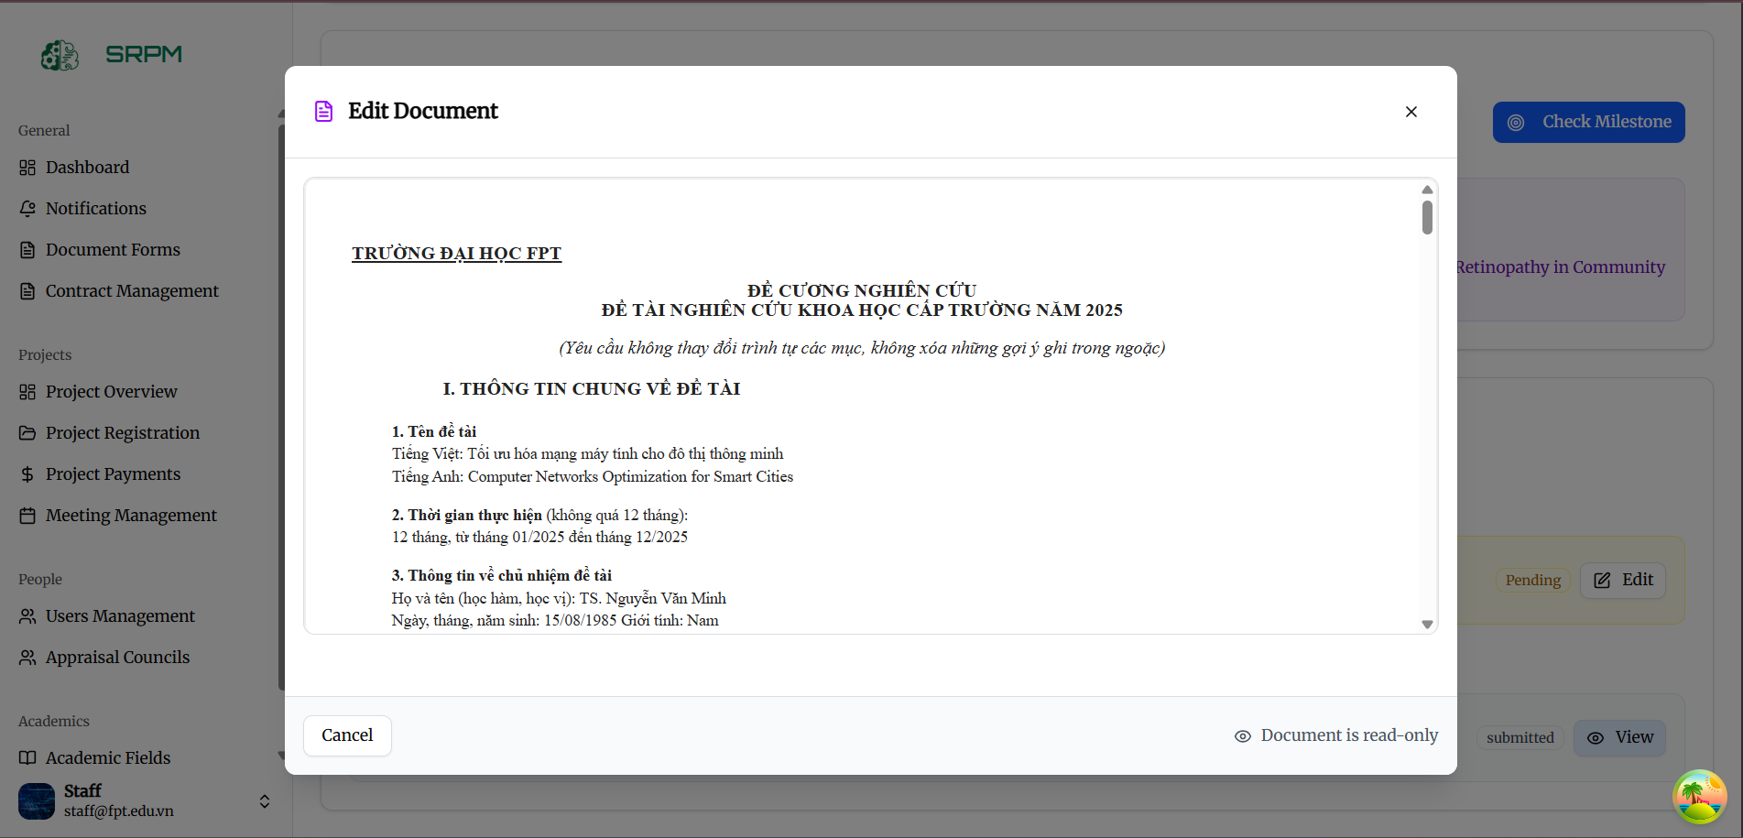

##### Figure 3.7.8 Contract Management

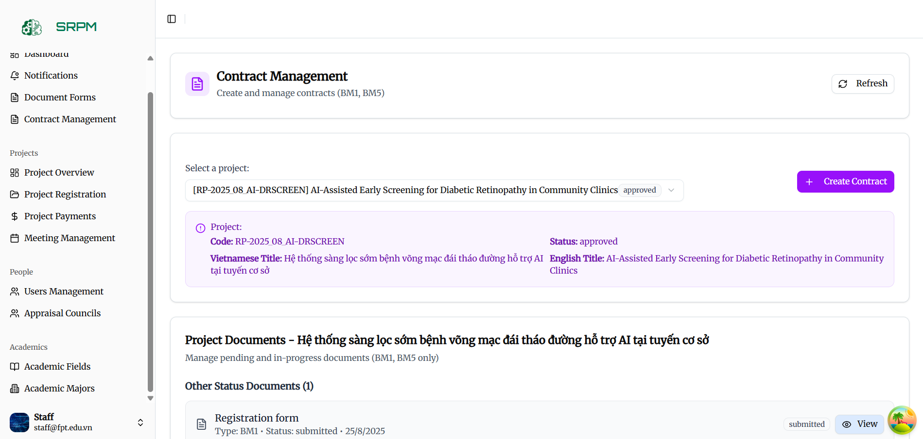

##### Figure 3.7.8 Contract Management

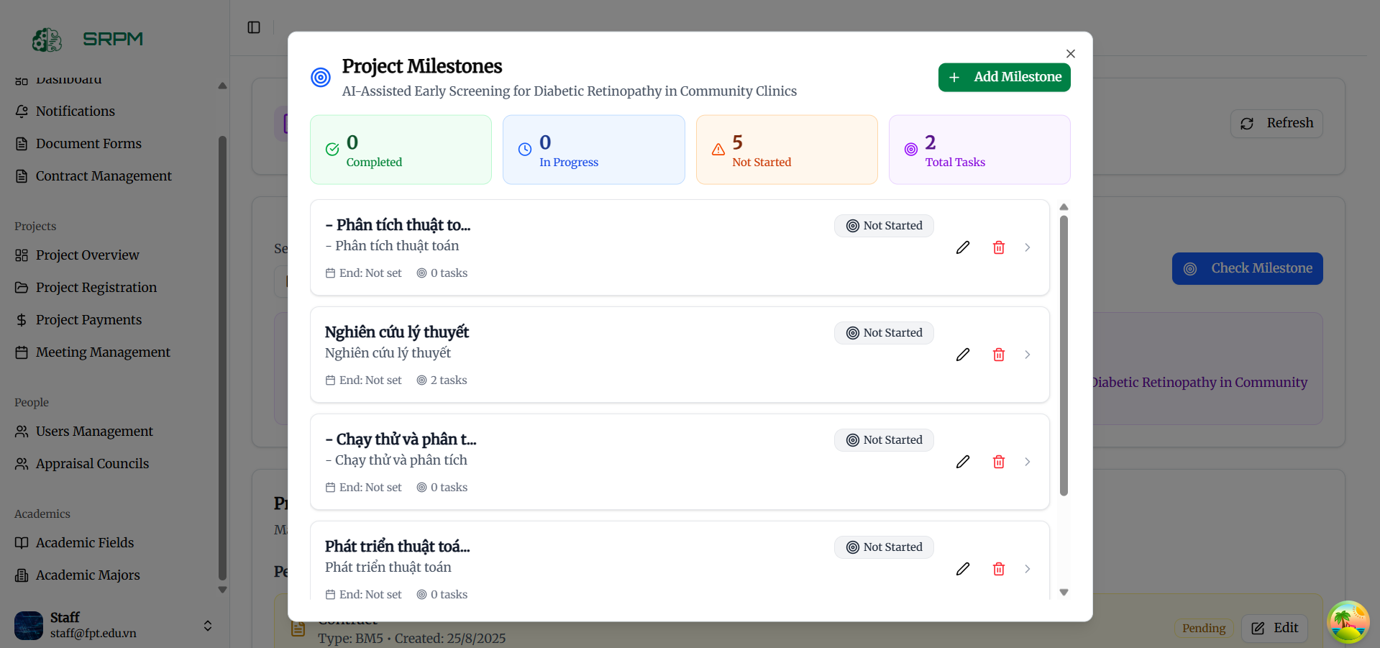

##### Figure 3.7.8 Contract Management

##### Figure 3.7.8 Contract Management

### 3.8 Applications for System Administrators

#### 3.8.1 System Config Management

**Function Description:** This comprehensive dashboard provides system administrators with advanced system monitoring, management tools, and complete administrative control over the FPTU SRPM system.

**Function Trigger:**

When system administrators access their administrative control center:

Manage System Configuration:

* Button/Navigation: System configuration interface with advanced settings, parameter tuning, and feature toggles.
* Trigger: When administrators need to modify system-wide settings and configurations.
* Function: System configuration management provides controlled system parameter modification with rollback capabilities and change tracking.

**Business Rules: (BR-17, BR-21, BR-33)**

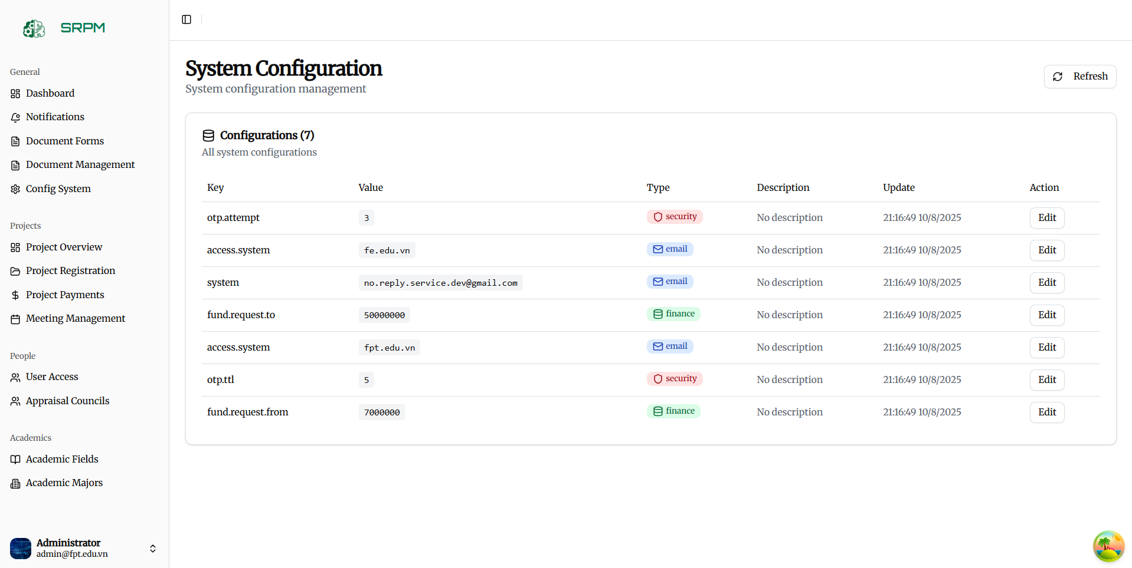

##### Figure 3.8.1 System Config Management

#### 3.8.2 Transaction Management

**Function Description:** This system provides staff with comprehensive financial transaction management including transaction processing, approval workflows, and financial reporting.

**Function Trigger:**

When staff manage financial transactions:

Process Financial Transactions:

* Button/Navigation: Transaction processing interface with transaction creation, modification, and status management.
* Trigger: When staff handle financial transactions related to projects and system operations.
* Function: Transaction processing system provides controlled financial transaction management with approval workflows and audit trails.

Manage Transaction Approvals:

* Button/Navigation: Approval workflow interface with transaction review, approval, and rejection capabilities.
* Trigger: When staff review and approve financial transactions.
* Function: Transaction approval system provides structured approval workflows with authorization levels and audit requirements.

**Business Rules: (BR-14, BR-54, BR-55, BR-56, BR-57, BR-58)**

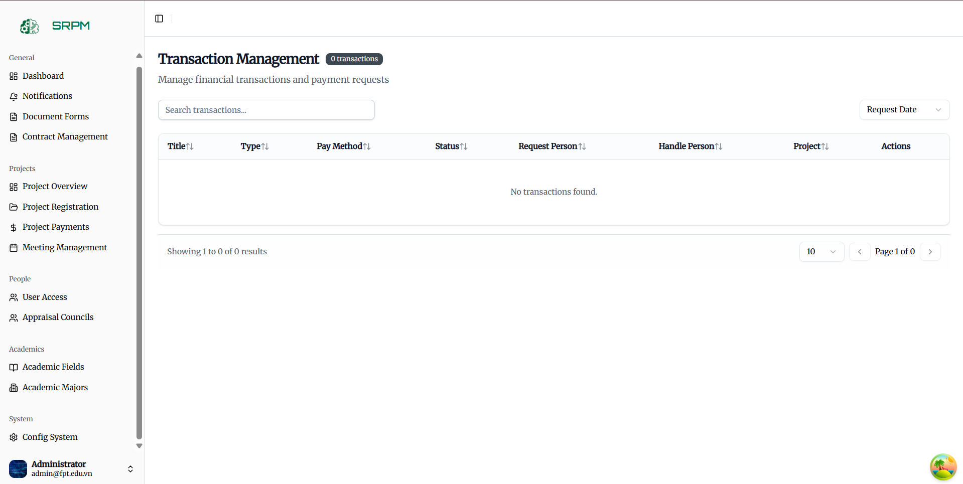

##### Figure 3.8.2 Transaction Administration

## 4. Non-Functional Requirements

### 4.1 External Interfaces

This section describes how SRPM interacts with users, institutional systems, and third-party services.

**Web Browsers**

SRPM is a responsive web application accessible across major browsers (Chrome, Edge, Firefox, Safari) and operating systems (Windows, macOS, Linux).

* Core project-lifecycle workflows (proposal submission, milestone tracking, evaluations) render consistently
* Real-time document editor and dashboards adapt fluidly to different viewport sizes

**Responsive Design for Mobile Access**

Although SRPM is web-only, all pages must be touch-friendly and performant on smartphones and tablets.

* Navigation menus collapse into mobile-optimized patterns
* Forms and buttons sized for finger taps
* Push notifications delivered via service workers

**Institutional Systems Integration**

SRPM will connect to host-institution infrastructure to leverage existing data and authentication:

* Single Sign-On (SSO) via OAuth 2.0/OpenID Connect against the university identity provider
* Read/write access to institutional research databases for participant profiles and historical project records
* Email server (SMTP/IMAP) for transactional emails (submission confirmations, defense invitations)

**External Systems**

SRPM integrates with several external APIs to extend functionality and streamline operations:

* OpenAI API
  + Initial automated evaluation of submitted proposals
  + Secure communication over HTTPS/TLS with API key management
* Google Meet
  + Embed video conferencing links in defense meeting schedules
  + Calendar invites generated automatically for teams and appraisal council members
* Notification Service
* Push notifications and email alerts via a third-party messaging platform
* Webhooks for event-driven updates (e.g., proposal status changes)

### 4.2 Quality Attributes

This section defines targets for usability, reliability, and performance to ensure SRPM is intuitive, robust, and scalable.

#### 4.2.1 Usability

**Training Time**

* Principal Investigators & Researchers  
   New users can complete project enrollment, proposal drafting, and AI-assisted evaluation within 30 minutes.
* Staff & Appraisal Council Members  
   Proficiency in review workflows, milestone scheduling, and dashboard analytics achieved within 1–2 days, supported by an illustrated user guide and screencast tutorials.

**Familiarity and Standards**

* Adhere to W3C accessibility guidelines (WCAG 2.1 AA)
* Follow Material Design or Microsoft Fluent UI patterns for consistency
* Intuitive workflows that mirror typical research-project lifecycles

**Task Efficiency**

* Proposal Submission  
   Users complete form entry and upload supporting documents in under 5 minutes on average.
* AI-Driven Initial Evaluation  
   Receive a preliminary assessment within 60 seconds of submission.
* Defense Meeting Scheduling  
   Generate and distribute Google Meet invitations in less than 2 minutes.

#### 4.2.2 Reliability

**Availability**

SRPM must achieve 98 % uptime across all services, ensuring continuous access to proposal management and defense scheduling.

**Mean Time Between Failures (MTBF)**

Design for a minimum of 12 months of uninterrupted operation before a major service-impacting event occurs.

**Mean Time To Repair (MTTR)**

* Critical issues (submission engine, AI evaluation, meeting scheduling): restore within 1 hour
* Non-critical issues (UI glitches, report exports): resolve within 24 hours

**Accuracy**

* AI-assisted proposal evaluations should align with expert assessments at least 85 % of the time
* Document editor sync accuracy must exceed 99 % to prevent data loss

**Bug and Defect Rate**

Limit critical-function defects to fewer than 5 per 1,000 lines of code (KLOC).

#### 4.2.3 Performance

**Response Time**

* Dashboard load and navigation: under 3 seconds
* Proposal form submission: acknowledgment within 5 seconds
* AI evaluation callback: within 60 seconds
* Real-time document collaboration latency: under 1 second

**Throughput**

* Support up to 10,000 concurrent sessions without perceptible slowdown
* Handle bursts of 200 proposal submissions per hour during enrollment windows
* Process up to 50 notifications per second for status alerts

**Capacity**

| **Metric** | **Target** |
| --- | --- |
| Registered Users | 10,000 |
| Active Projects | 2,000 |
| Daily Transactions | 5,000 (submissions, reviews, notifications) |
| Concurrent Users | 10,000 |

**Resource Utilization**

* Memory usage capped at 80 % of available server memory under normal load
* Implement log rotation and archival to prevent disk overconsumption
* Network bandwidth usage not to exceed 75 % of capacity during peak operations

## 5. Requirement Appendix

### 5.1 Business Rules

##### Table 5.1 : Business Rules

| **ID** | **Rule Definition** |
| --- | --- |
| BR-01 | Only Host Institution staff may propose a new project topic; Principal Investigators can suggest project topics but cannot create new project entries. |
| BR-02 | A Principal Investigator must assemble a team of at least two Researchers before submitting a project proposal. |
| BR-03 | Each project may have only one Principal Investigator assigned. |
| BR-04 | Appraisal Council members may not serve on any project team they evaluate. |
| BR-05 | Project proposal submissions are only accepted during the officially configured enrollment time; submissions outside the timeline are rejected. |
| BR-06 | Every proposal must use the standard SRPM proposal template and include mandatory sections: objectives, methodology, budget estimate, and timeline. |
| BR-07 | Upon submission, each proposal receives an AI-driven preliminary evaluation before scheduling a defense meeting. |
| BR-08 | Defense meetings must be scheduled at least 48 hours in advance via the integrated Google Meet channel and must include all team members and Appraisal Council attendees. |
| BR-09 | A defense outcome of “Approved” requires the successful team to sign the project contract within config date, or the approval will lapse. |
| BR-10 | For each approved project, Milestones must be defined in the contract and each Milestone Defense must be held on the scheduled completion date. |
| BR-11 | Tasks under each Milestone must be completed by the assigned team members before the end date; overdue tasks trigger automated notifications to Principal Investigator. |
| BR-12 | Only users with an Admin role may archive a project; archived projects become read-only and their dashboards transition to “Completed” status. |
| BR-13 | Any budget revision after contract signing must be submitted as an amendment request and approved by Staff within 5 business days. |
| BR-14 | Funding disbursements are only released upon config time. |
| BR-15 | The system automatically sends email and in-app notifications for these events: proposal submission, defense scheduling, defense outcome, budget amendment approval, milestone completion, and overdue tasks. |
| BR-16 | Only file types PDF, DOCX, XLSX, PPTX, and common image formats (JPEG, PNG) are permitted for upload; any other formats are rejected with an error message. |
| BR-17 | Every user action—logins, data edits, file uploads, approvals—must be logged with timestamp and user ID; audit logs are immutable and accessible only to Admin |
| BR-18 | When a Researcher account is deactivated, all their assigned tasks are automatically reassigned to the Principal Investigator or a delegate appointed by the PI. |
| BR-19 | The system automatically calculates and displays a project’s progress percentage based on completed milestones versus total milestones. |
| BR-20 | Role-based access control must be configured; only Admins can modify user roles and permissions within the system. |
| BR-21 | Final project reports and deliverables must be retained in the system for a minimum of 5 years after project completion, with access restricted to authorized roles. |
| BR-22 | Researchers must link their Science profile to their SRPM account; any discrepancy in identity requires manual verification by an Admin. |
| BR-23 | The platform must integrate with OAuth 2.0 for single sign-on via institutional identity providers; fallback to local authentication if the external provider is unavailable. |
| BR-24 | All personal data must be encrypted at rest and in transit using TLS 1.2+ and AES-256 encryption standards. |
| BR-25 | User sessions with 30 minutes of inactivity trigger automatic logout; a warning pop-up appears at 25 minutes of inactivity. |
| BR-26 | The UI supports English and Vietnamese locales; missing translations fall back to English and users can configure their preferred language. |
| BR-27 | Projects and tasks support user-defined keyword tags; tags drive search filtering, grouping. |
| BR-28 | Search results are ranked by relevance and support sorting and faceting by date, status, fields, majors. |
| BR-29 | Date, time, and number formats throughout the UI respect each user’s locale preference, with fallback to Vietnamese. |
| BR-30 | The system enforces password complexity requirements: minimum 8 characters, at least one uppercase letter, one lowercase letter, one digit, and one special character. |
| BR-31 | Each project is allocated a default file storage quota of 100MB |
| BR-32 | The platform must comply with WCAG 2.1 AA accessibility standards, including screen reader compatibility, keyboard navigation, and minimum contrast ratios. |
| BR-33 | All in-development features are hidden behind feature flags |
| BR-34 | When a project is cancelled, the system automatically closes all open tasks, halts any pending funding disbursements, updates the project status to “Cancelled,” and archives associated deliverables. |
| BR-35 | Principal Investigators may submit milestone deadline extension requests at least 72 hours before the original due date; Staff approval is required for any extension to take effect and no longer than the maximum time. |
| BR-36 | Defense meetings can only be scheduled when a proposal’s AI preliminary evaluation score meets or exceeds the institution’s configured threshold. |
| BR-37 | Only Principal Investigator roles can add or remove Researcher accounts from a project team; automated notifications are sent to affected users upon any change. |
| BR-38 | Team member can not change when the project is “In Progress” |
| BR-39 | Principal Investigator can track the Task progress. |
| BR-40 | Contract amendments require the Principal Investigator’s digital signature and Staff approval; the amendment becomes effective only after both signatures are recorded. |
| BR-41 | The Contract can be exported for offline sign. |
| BR-42 | Staff must login by email password. |
| BR-43 | Researchers can upload their Science CV anytime. |
| BR-44 | Researchers and Principal Investigator must login by Google account provided by the University |
| BR-45 | The Appraisal Council’s Member account will be provided by Staff in the system. |
| BR-46 | Researchers can request to be Principal Investigator |
| BR-47 | When creating a project or proposal, the abbreviation cannot exceed 22 characters. |
| BR-48 | When creating a new council group, staff must enter the code manually and it must not overlap with other council group codes. |
| BR-49 | Council group name cannot exceed 200 characters |
| BR-50 | Only staff can add, delete and edit template documents. |
| BR-51 | If the document has been signed by staff, it cannot be modified anymore. |
| BR-52 | Only the board chairman has the authority to manage the evaluation stage and the overall evaluation. |
| BR-53 | Each evaluation board member can only create 1 individual evaluation in 1 evaluation stage. |
| BR-54 | Only staff can approve payment requests. |
| BR-55 | Funding may be provided in stages and if the final results of the research team fail, it will be handled according to the responsibilities in the contract. |
| BR-56 | The principle is responsible for the funding procedures in a project. |
| BR-57 | Funds can be transferred to group members. |
| BR-58 | The amount of funding requested cannot exceed the range set by the system by staff. |
| BR-59 | The principle investigator must be invited by the staff to serve as a review board for another topic. |
| BR-60 | Each research project will have only 1 article or research result. |
| BR-61 | AI can generate individual assessments but the final decision still rests with the board chair |
| BR-62 | Researchers and project managers can propose research ideas but must still go through initial review. |
| BR-63 | Fields cannot be deleted if referenced by active projects |

# 

# IV. Software Design Description

## 1. System Design

### 1.1 System Architecture

##### 

##### 

#### 

### 1.2 Package Diagram

#### 1.2.1 Backend Package Diagram

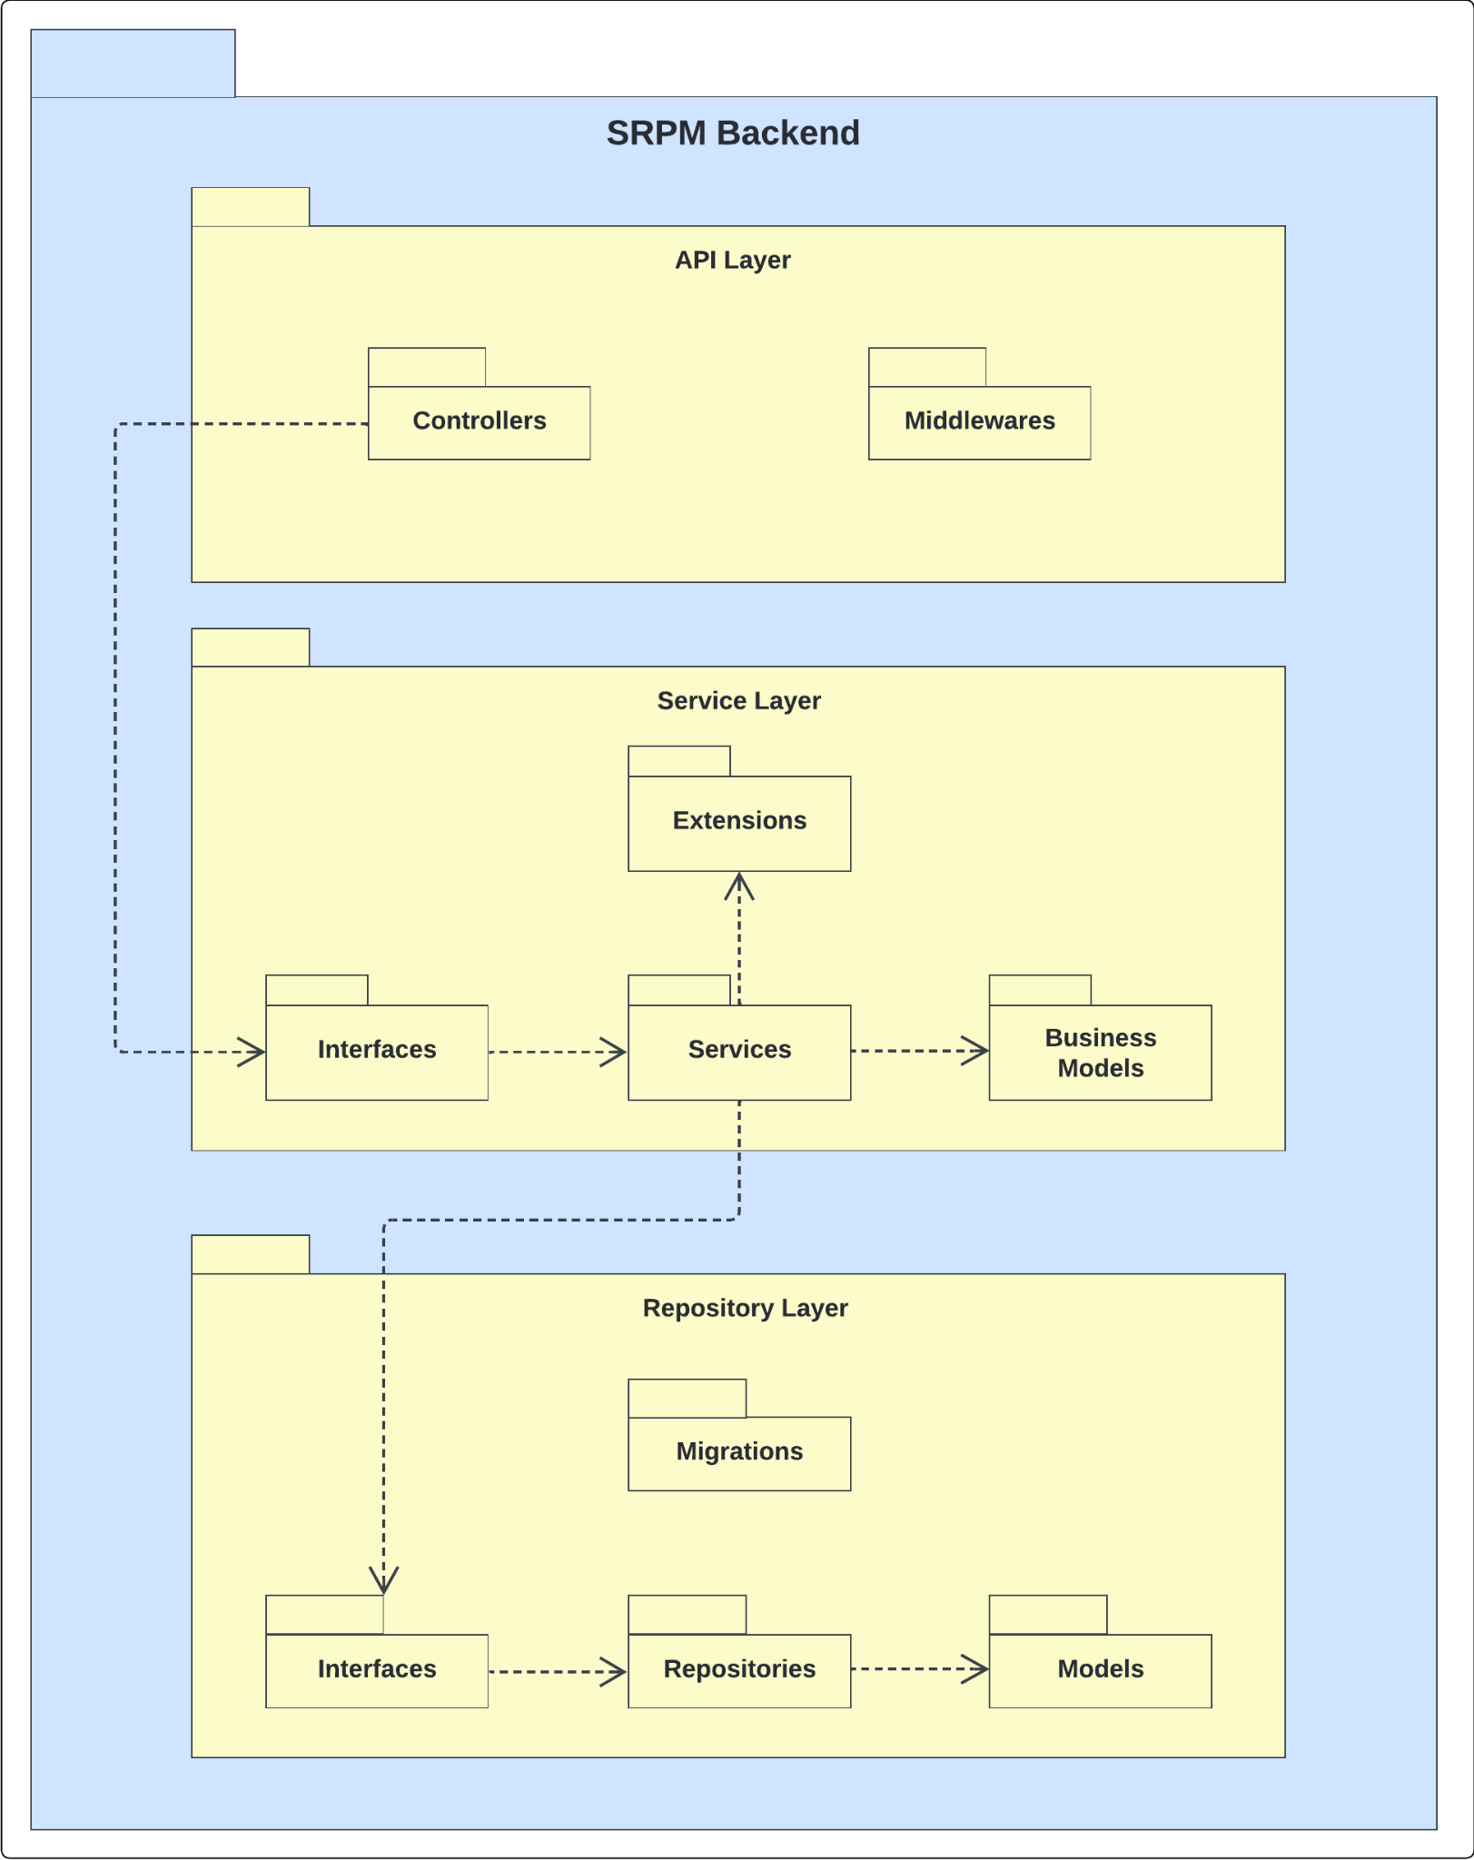

##### 

#### 1.2.2 Web Application Package Diagram

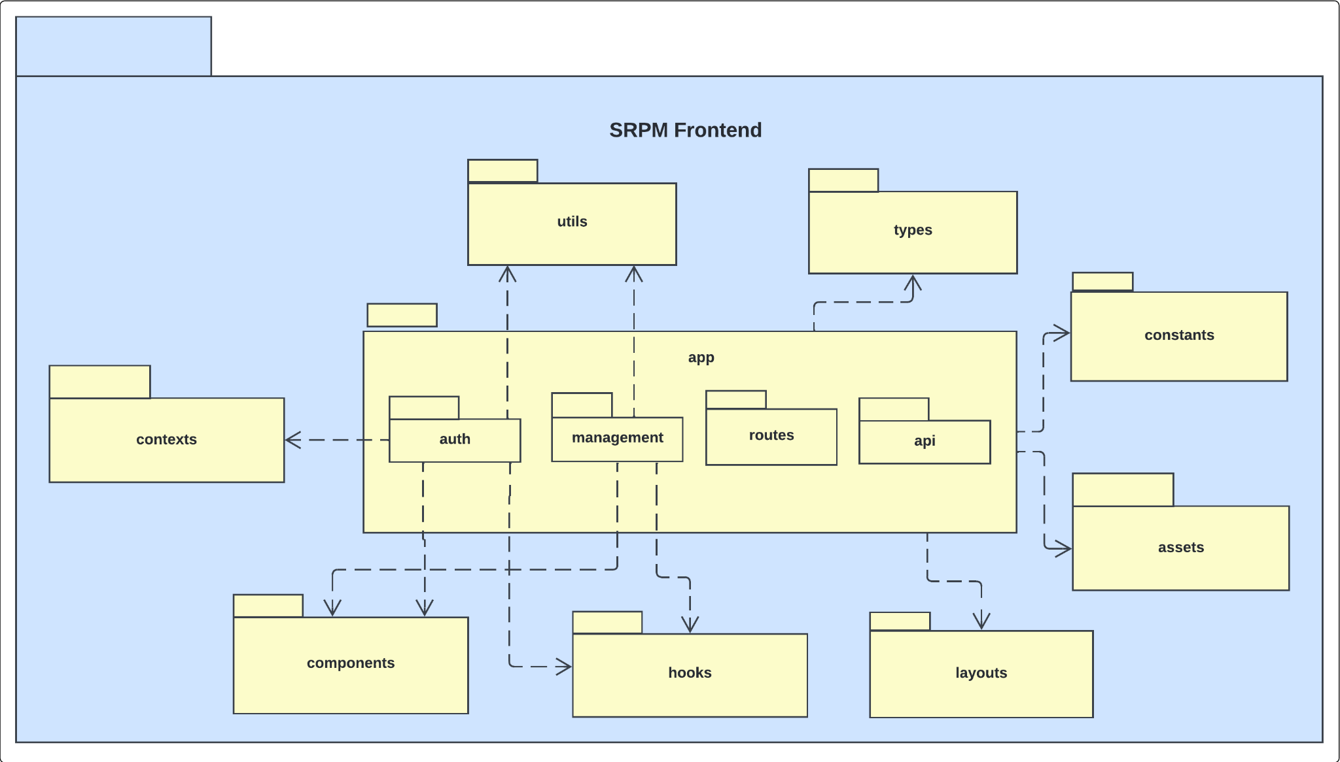

## 2. Database Design

**Conceptual ERD**



##### 

**Logical ERD**



##### 

**Entities Description**

##### 

| **#** | **Entity** | **Description** |
| --- | --- | --- |
| 1 | Account | Store a user’s login credentials and personal information.  - Primary keys: AccountId  - Foreign keys: MajorId |
| 2 | UserRole | Defines the role assigned to an account and associates it with a specific project or appraisal council.  - Primary keys: UserRoleId  - Foreign keys: AccountId, RoleId, ProjectId, AppraisalCouncilId |
| 3 | Role | Stores system roles and group-specific roles used to define user responsibilities and permissions at a point in time.  - Primary keys: RoleId  - Foreign keys: |
| 4 | OTPCode | Stores one-time passcodes used to verify user identity during password reset operations.  - Primary keys: OTPCodeId  - Foreign keys: AccountId |
| 5 | Major | Store academic or professional majors categorized under specific fields.  - Primary keys: MajorId  - Foreign keys: FieldId |
| 6 | Field | Store broad academic or professional domains that group related majors under a common category.  - Primary keys: FieldId  - Foreign keys: |
| 7 | ProjectResult | Stores information about scientific publications or final research outputs produced during the execution of a research project.  - Primary keys: ProjectResultId  - Foreign keys: ProjectId |
| 8 | ProjectMajor | Stores the academic or disciplinary majors associated with a specific research project.  - Primary keys: ProjectId, MajorId  - Foreign keys: ProjectId, MajorId |
| 9 | ProjectTag | Stores tags associated with a specific research project.  - Primary keys: ProjectTagId  - Foreign keys: ProjectId |
| 10 | Project | Stores comprehensive information about a research or development project.  - Primary keys: ProjectId  - Foreign keys: CreatorId |
| 11 | Milestone | Defines key stages or checkpoints within a project.  - Primary keys: MilestoneId  - Foreign keys: ProjectId |
| 12 | Task | Stores individual work items or actions that are part of a specific milestone within a project.  - Primary keys: TaskId  - Foreign keys: MilestoneId, CreatorId |
| 13 | MemberTask | Manages the assignment of tasks to individual members within a project, team, or organizational context.  - Primary keys: MemberTaskId  - Foreign keys: MemberId, TaskId |
| 14 | AppraisalCouncil | Stores information about appraisal or evaluation councils composed of users assigned specific roles.  - Primary keys: AppraisalCouncilId  - Foreign keys: |
| 15 | Evaluation | Stores overall assessment records of a project or a specific milestone, conducted by an appraisal council.  - Primary keys: EvaluationId  - Foreign keys: AppraisalCouncilId, ProjectId, MilestoneId |
| 16 | EvaluationStage | Stores segmented stages of an overall evaluation process, as defined in the Evaluation table.  - Primary keys: EvaluationStageId  - Foreign keys: EvaluationId, AppraisalCouncilId |
| 17 | IndividualEvaluation | Stores personal assessment records submitted by individual council members for a specific evaluation stage.  - Primary keys: IndividualEvaluationId  - Foreign keys: EvaluationStageId, ReviewerId |
| 18 | ProjectSimilarity | Stores the results of content similarity AI checks between a specific project—typically within an individual evaluation—and other existing projects.  - Primary keys: ProjectId, IndividualEvaluationId  - Foreign keys: ProjectId, IndividualEvaluationId |
| 19 | Transaction | Stores the financial transaction history related to a project or a specific evaluation stage.  - Primary keys: TransactionId  - Foreign keys: RequestPersonId, HandlePersonId, ProjectId, EvaluationStageId |
| 20 | Document | Stores written materials associated with various entities in the system, including projects, evaluations, individual evaluations, and transactions.  - Primary keys: DocumentId  - Foreign keys: UploaderId, EditorId, TransactionId, EvaluationId, IndividualEvaluationId, ProjectId |
| 21 | Signature | Records the act of signing a document by an individual within the system.  - Primary keys: SignatureId  - Foreign keys: DocumentId, SignerId |
| 22 | Notification | Stores system-generated messages intended to inform users about relevant events, actions, or updates.  - Primary keys: NotificationId  - Foreign keys: UserRoleId, ProjectId, AppraisalCouncilId, EvaluationId, EvaluationStageId, IndividualEvaluationId, DocumentId, SignatureId, TaskId, MemberTaskId, TransactionId, SystemConfigurationId |
| 23 | AccountNotification | Records the delivery of notifications to individual user accounts.  - Primary keys: AccountId, NotificationId  - Foreign keys: AccountId, NotificationId |
| 24 | SystemConfiguration | Serves as a centralized repository for storing configurable parameters and reusable settings that govern system behavior.  - Primary keys: SystemConfigurationId  - Foreign keys: |
| 25 | ResultPublish | Stores information about scientific publications during the execution of a research project.  - Primary keys: ResultPublishId  - Foreign keys: ProjectPublishId |

## 

## 3. Detailed Design

### 3.1 Sign In

#### 3.1.1 Class Diagram

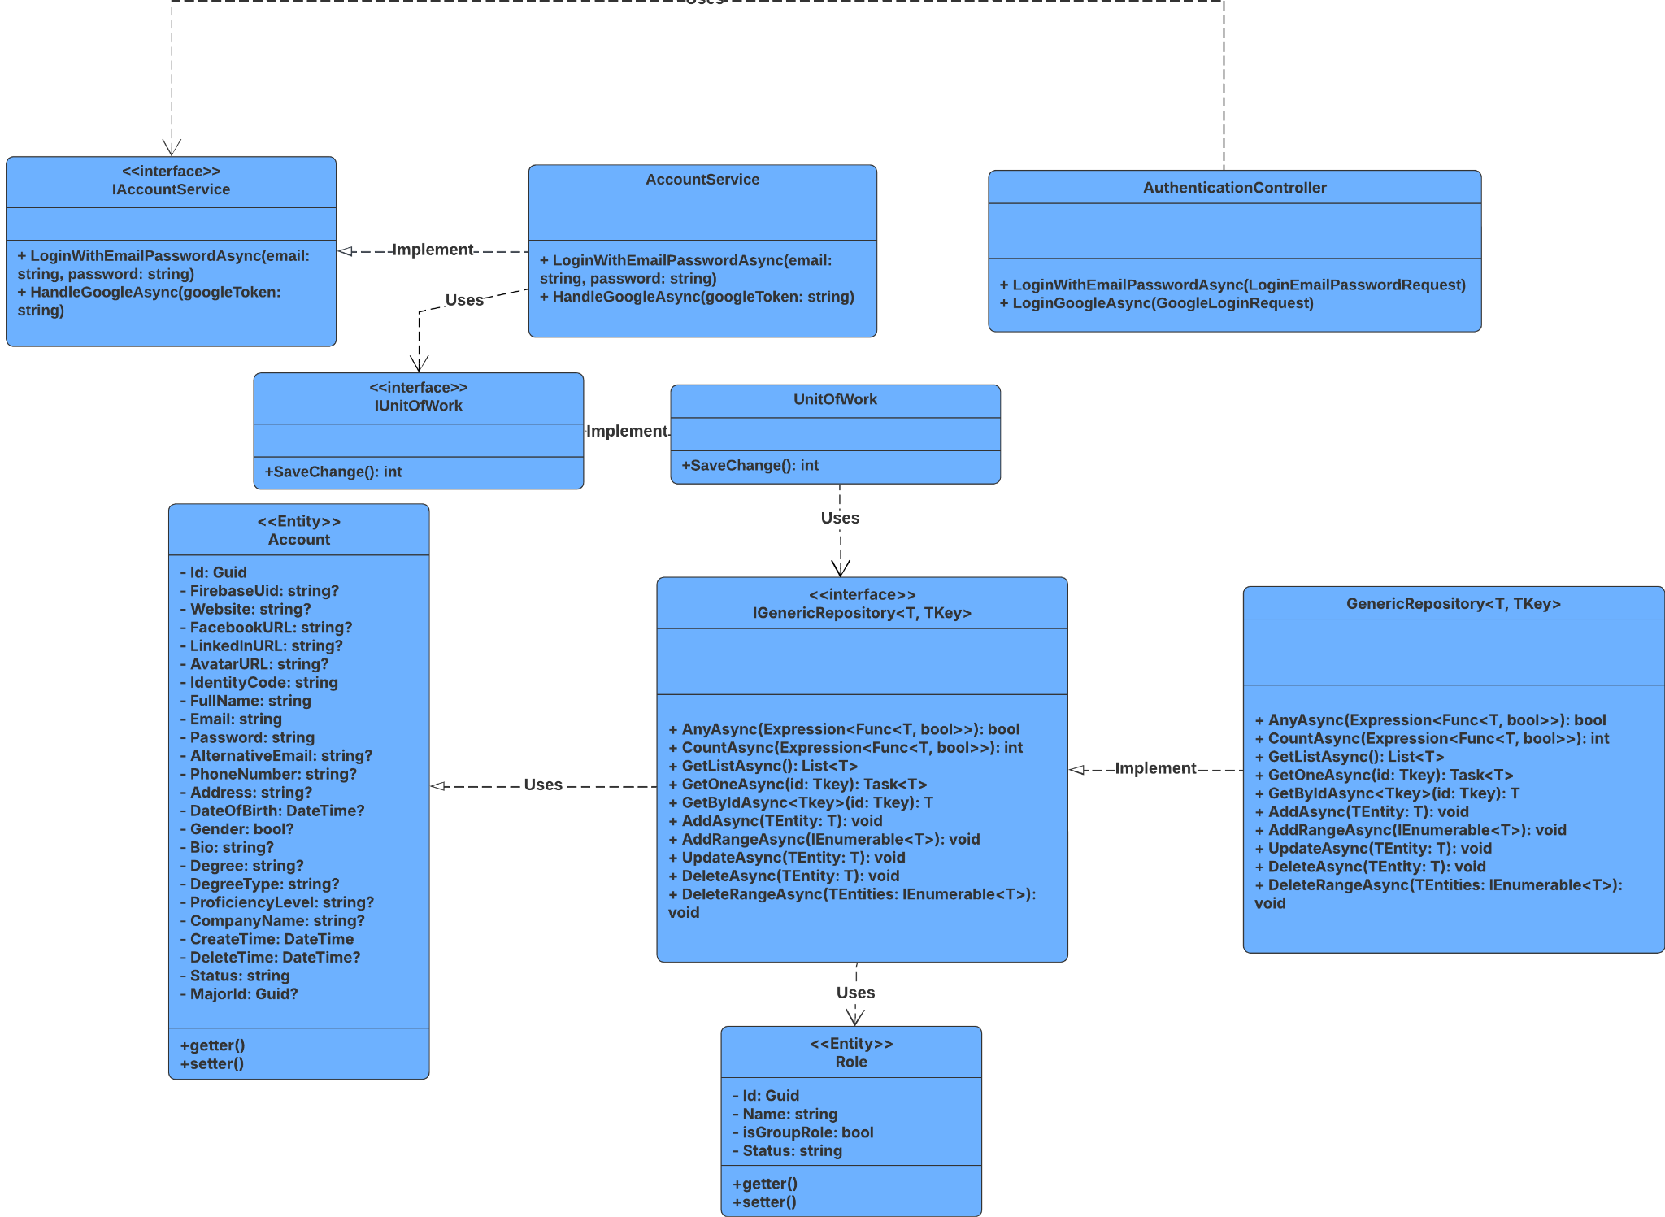

#### 3.1.2 Sequence Diagram

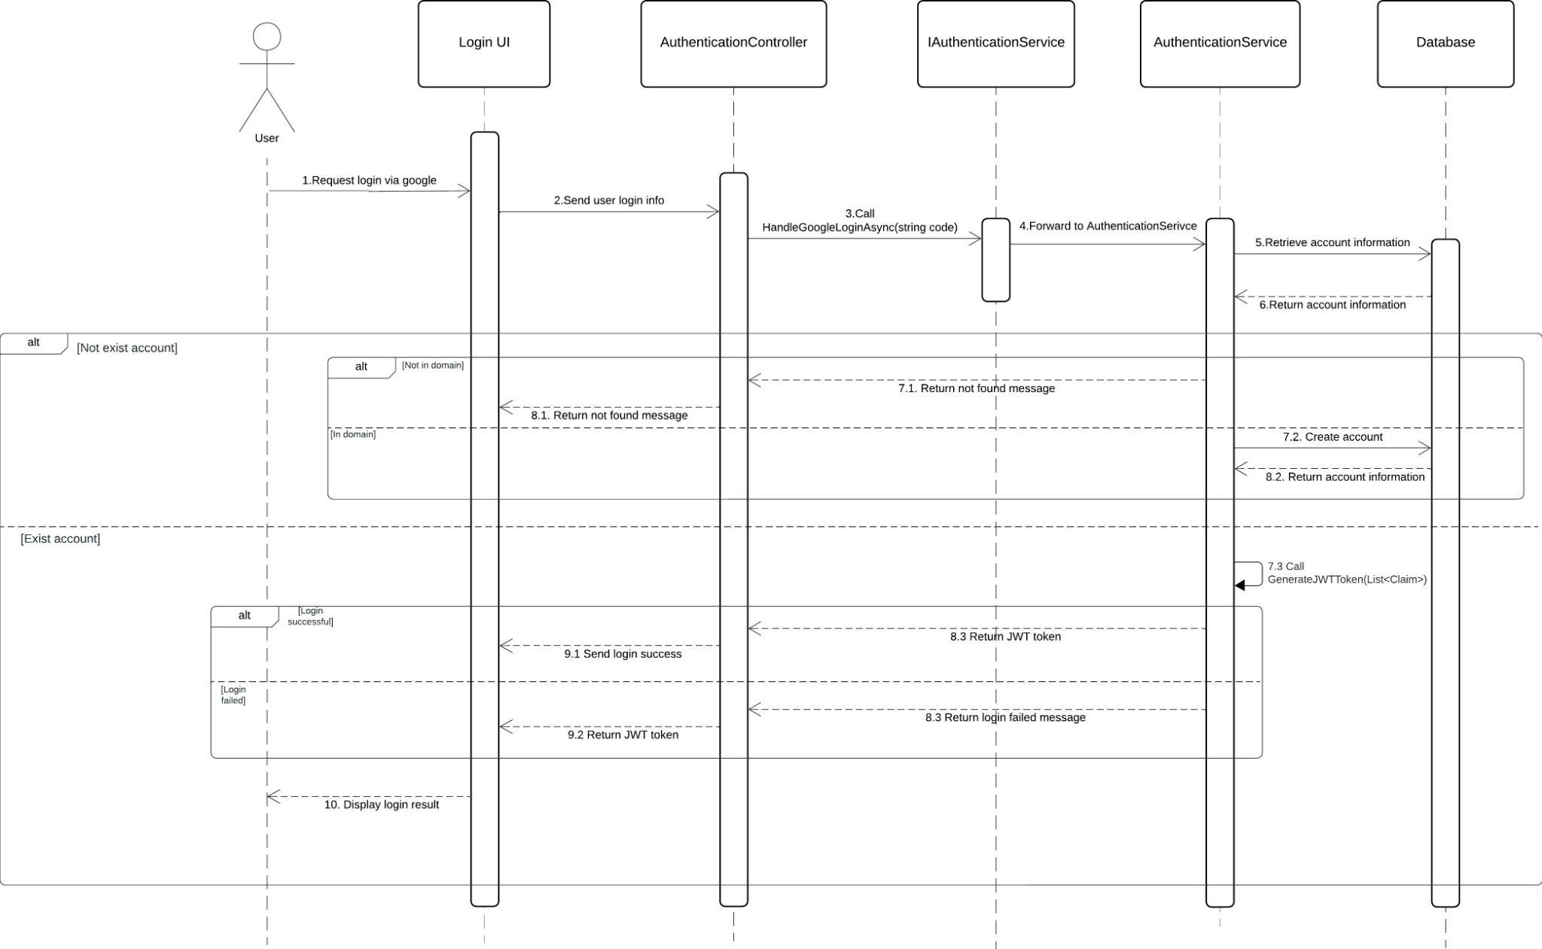

#### 3.1.3 Class Specification

##### 3.1.3.a Authentication Controller

###### Table 3.1.3.a: Authentication Controller Description Table

| **No** | **Method** | **Description** |
| --- | --- | --- |
| 1 | HandleGoogleLoginAsync(code) | Receives google access token via an HTTP request and initiates the login process. |

##### 3.1.3.b Authentication Service

###### Table 3.1.3.b: Authentication Service Description Table

| **No** | **Method** | **Description** |
| --- | --- | --- |
| 1 | HandleGoogleLoginAsync(code) | Decrypt the access token send from google and validate the email to authorize and grant access to the user |
| 2 | GenerateJWTToken(List<Claim>) | Creates a JWT token to authorize access to protected endpoints. |

### 3.2 Account Management

#### 3.2.1 Create

##### 3.2.1.1 Class Diagram

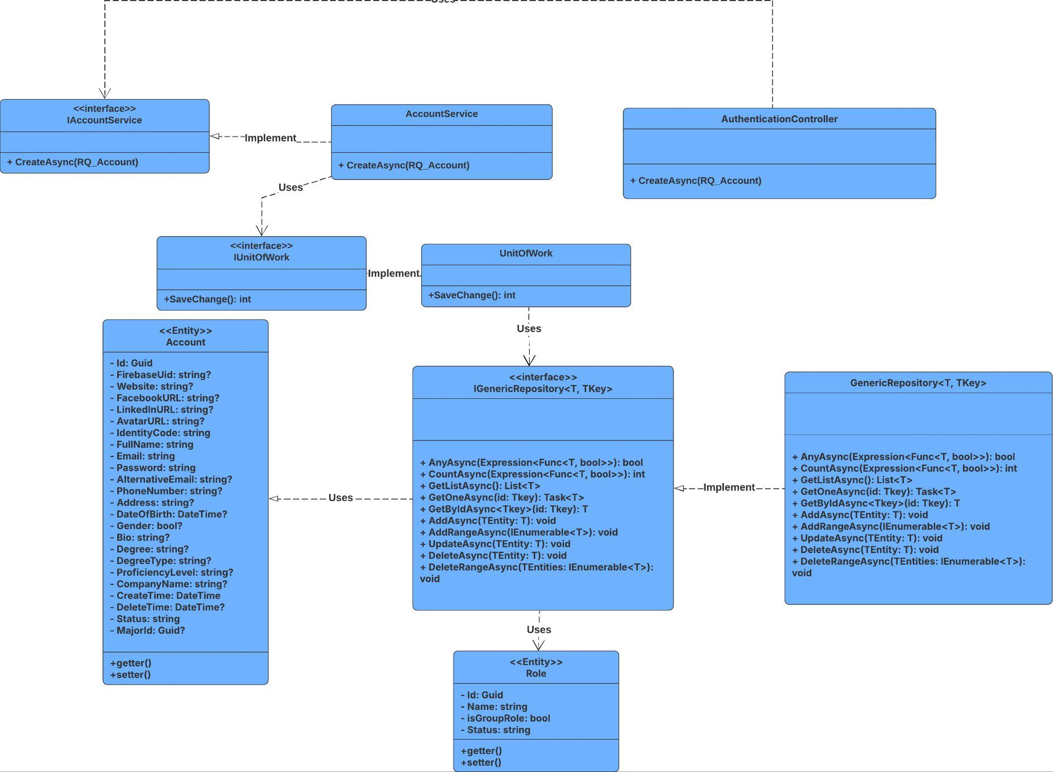

##### 3.2.1.2 Sequence Diagram

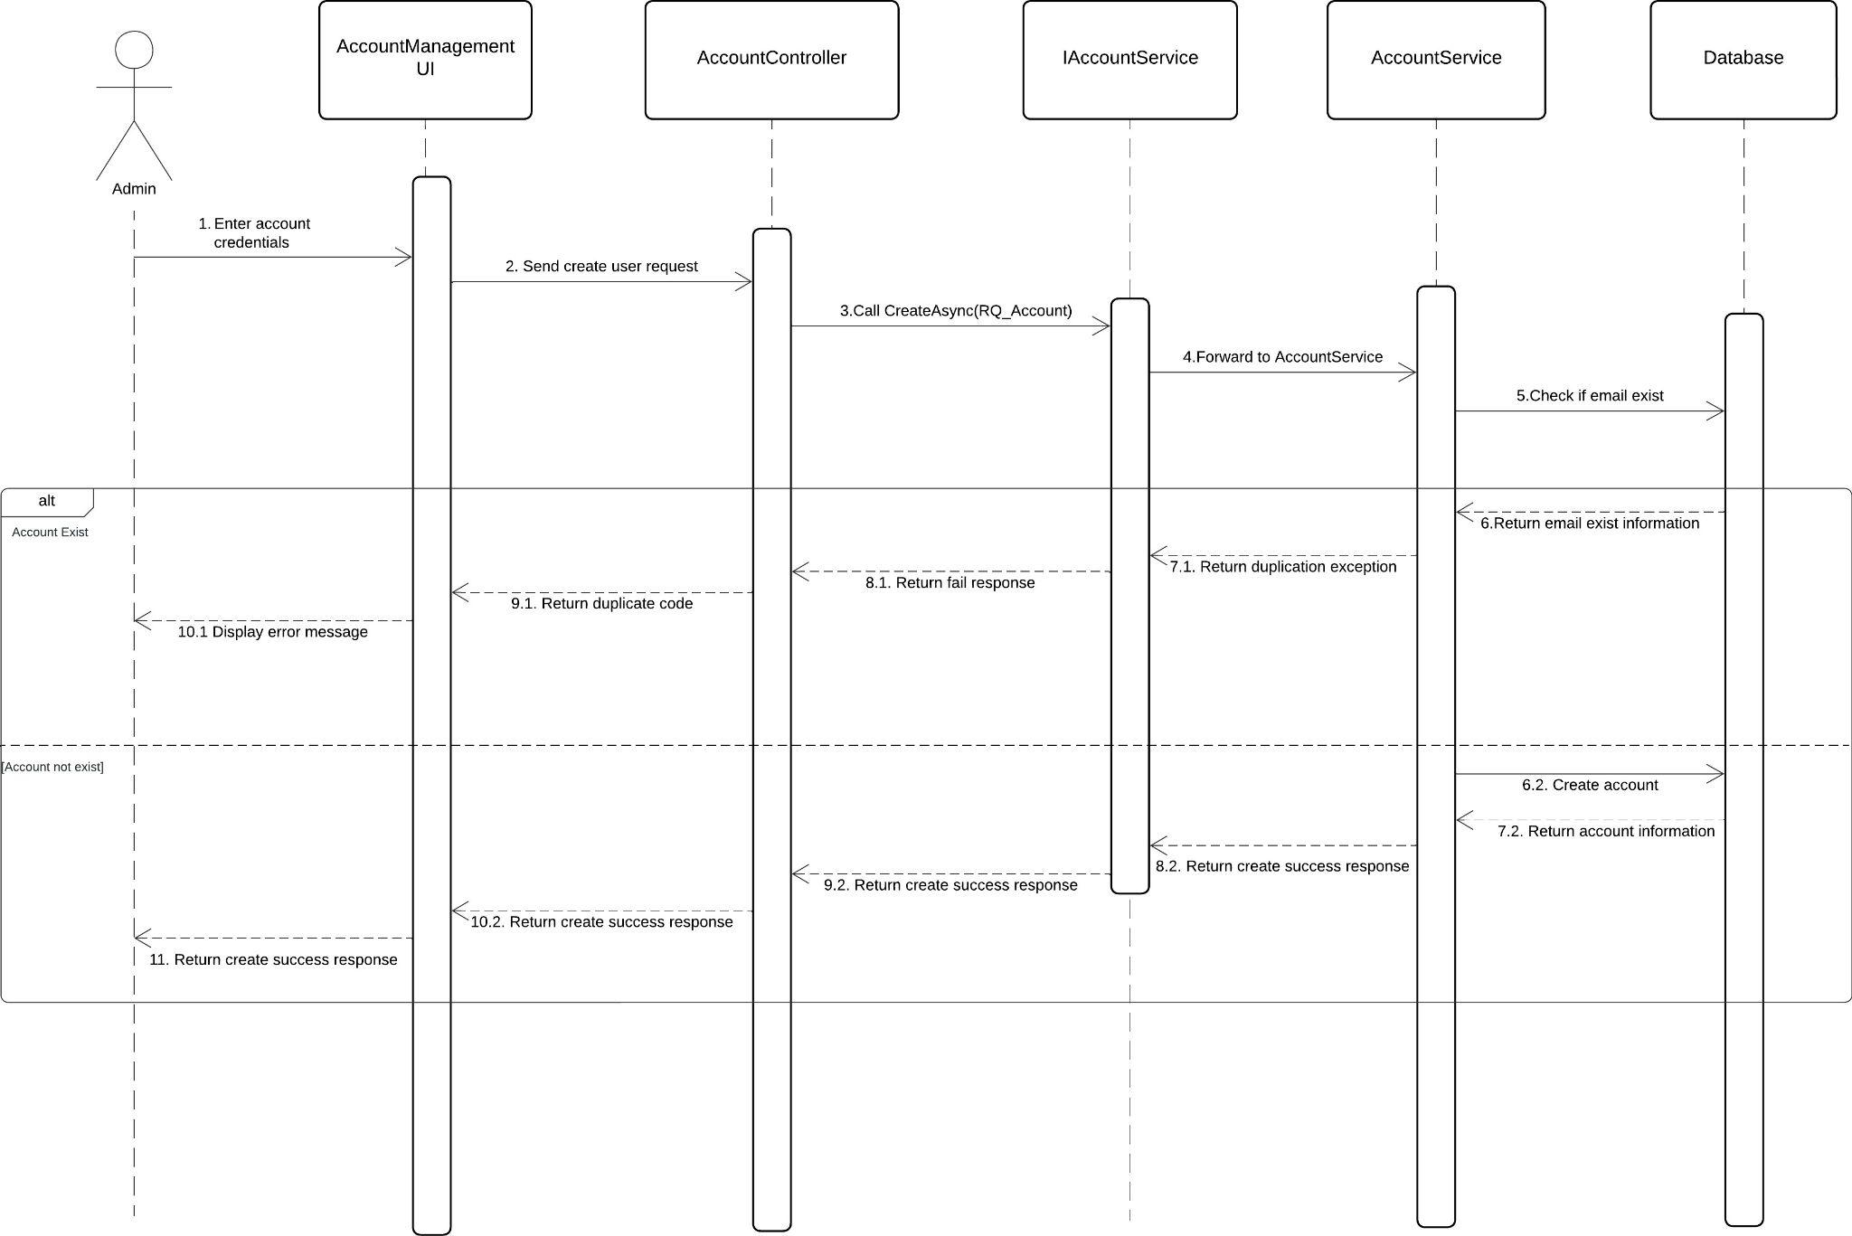

##### 3.2.1.3 Class Specification

###### 3.2.1.3.a Account Controller

| **No** | **Method** | **Description** |
| --- | --- | --- |
| 1 | CreateAsync(RQ_Account) | Receives account credentials and call CreateAsync to create it |

###### 3.2.1.3.b Account Service

| **No** | **Method** | **Description** |
| --- | --- | --- |
| 1 | CreateAsync(RQ_Account) | Map it to the entity and create it in database |

#### 3.2.2 Update

##### 3.2.2.1 Class Diagram

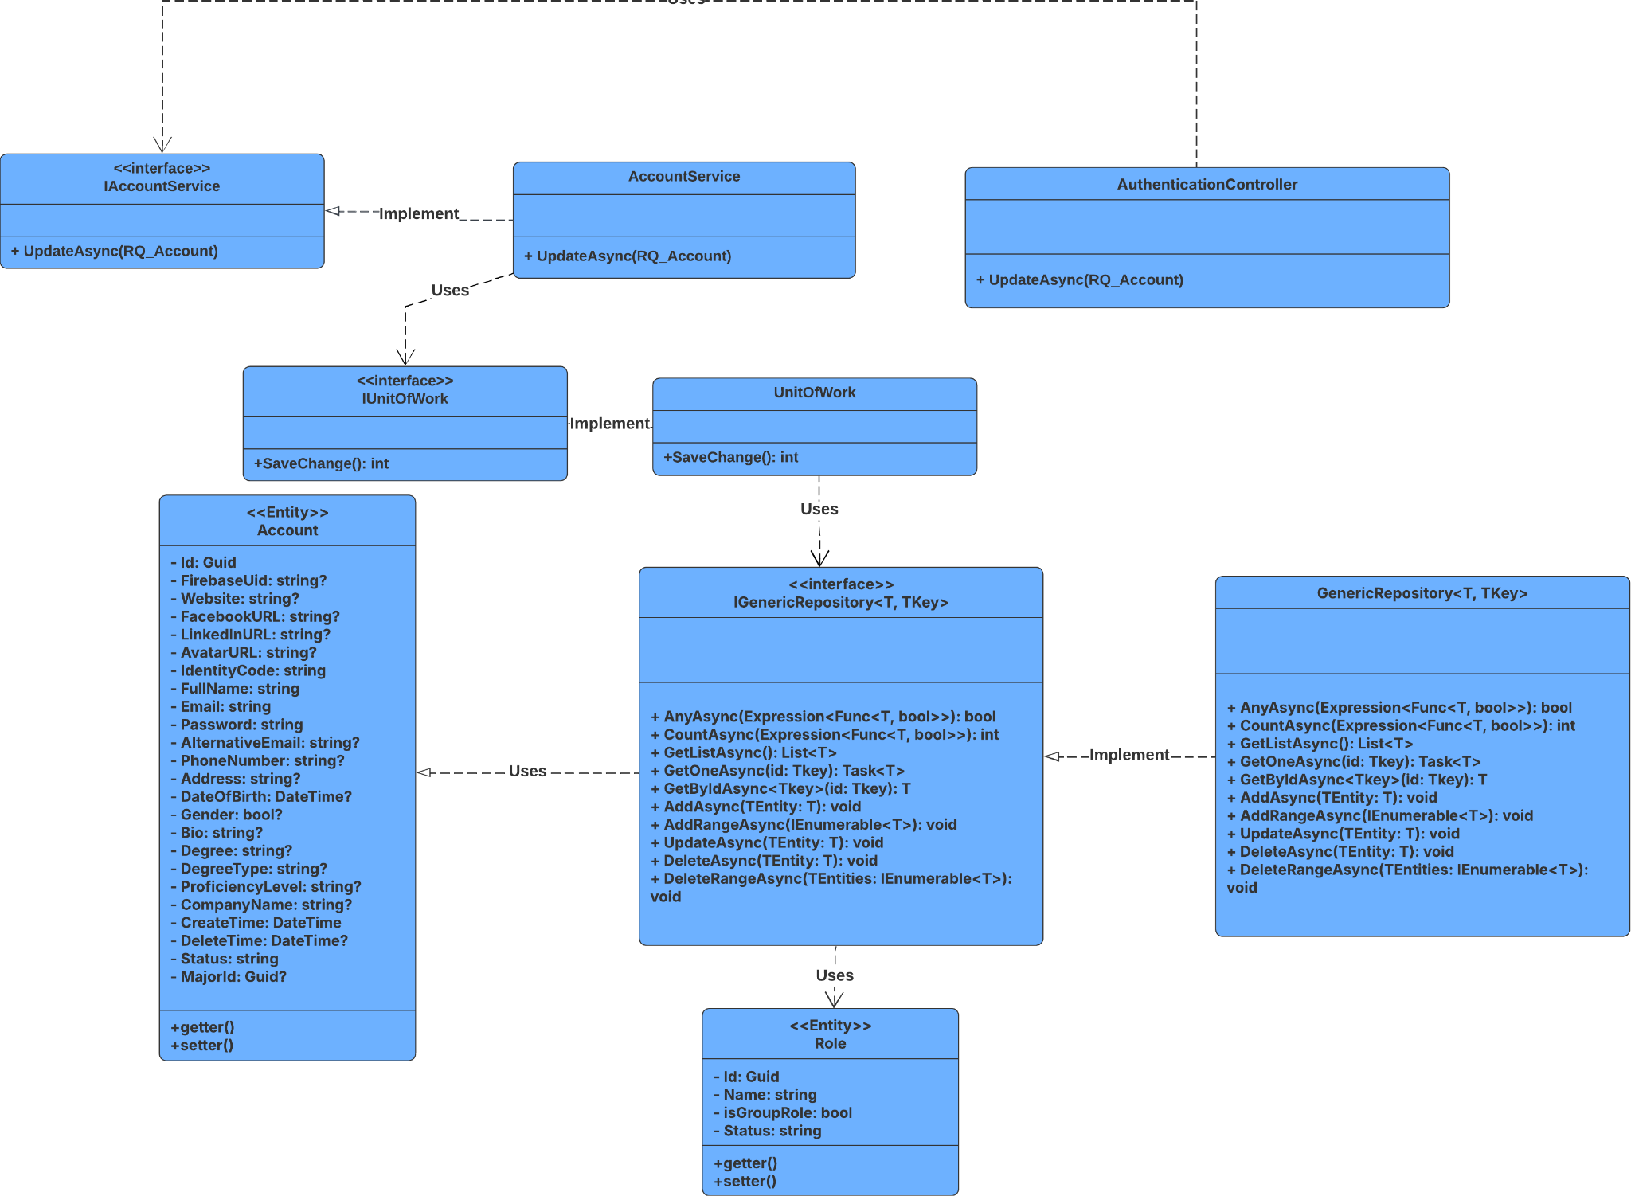

##### 3.2.2.2 Sequence Diagram

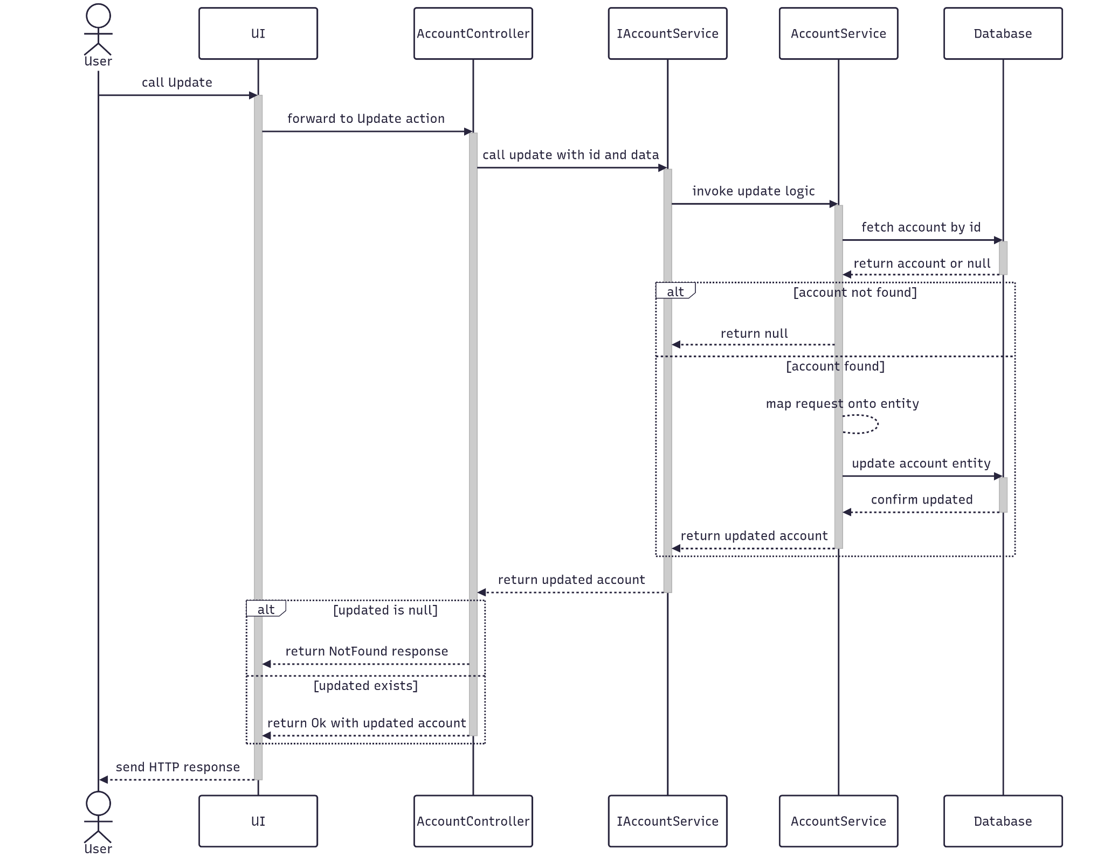

##### 3.2.2.3 Class Specification

###### 3.2.2.3.a AccountController

| **No** | **Method** | **Description** |
| --- | --- | --- |
| 1 | Update(RQ_Account) | Receives account credentials and call UpdateAsync to Update it |

###### 3.2.2.3.b Account Service

| **No** | **Method** | **Description** |
| --- | --- | --- |
| 1 | UpdateAsync(RQ_Account) | Query the entity, map it to the entity and Update it in database |

#### 3.2.3 Get By Id

##### 3.2.3.1 Class Diagram

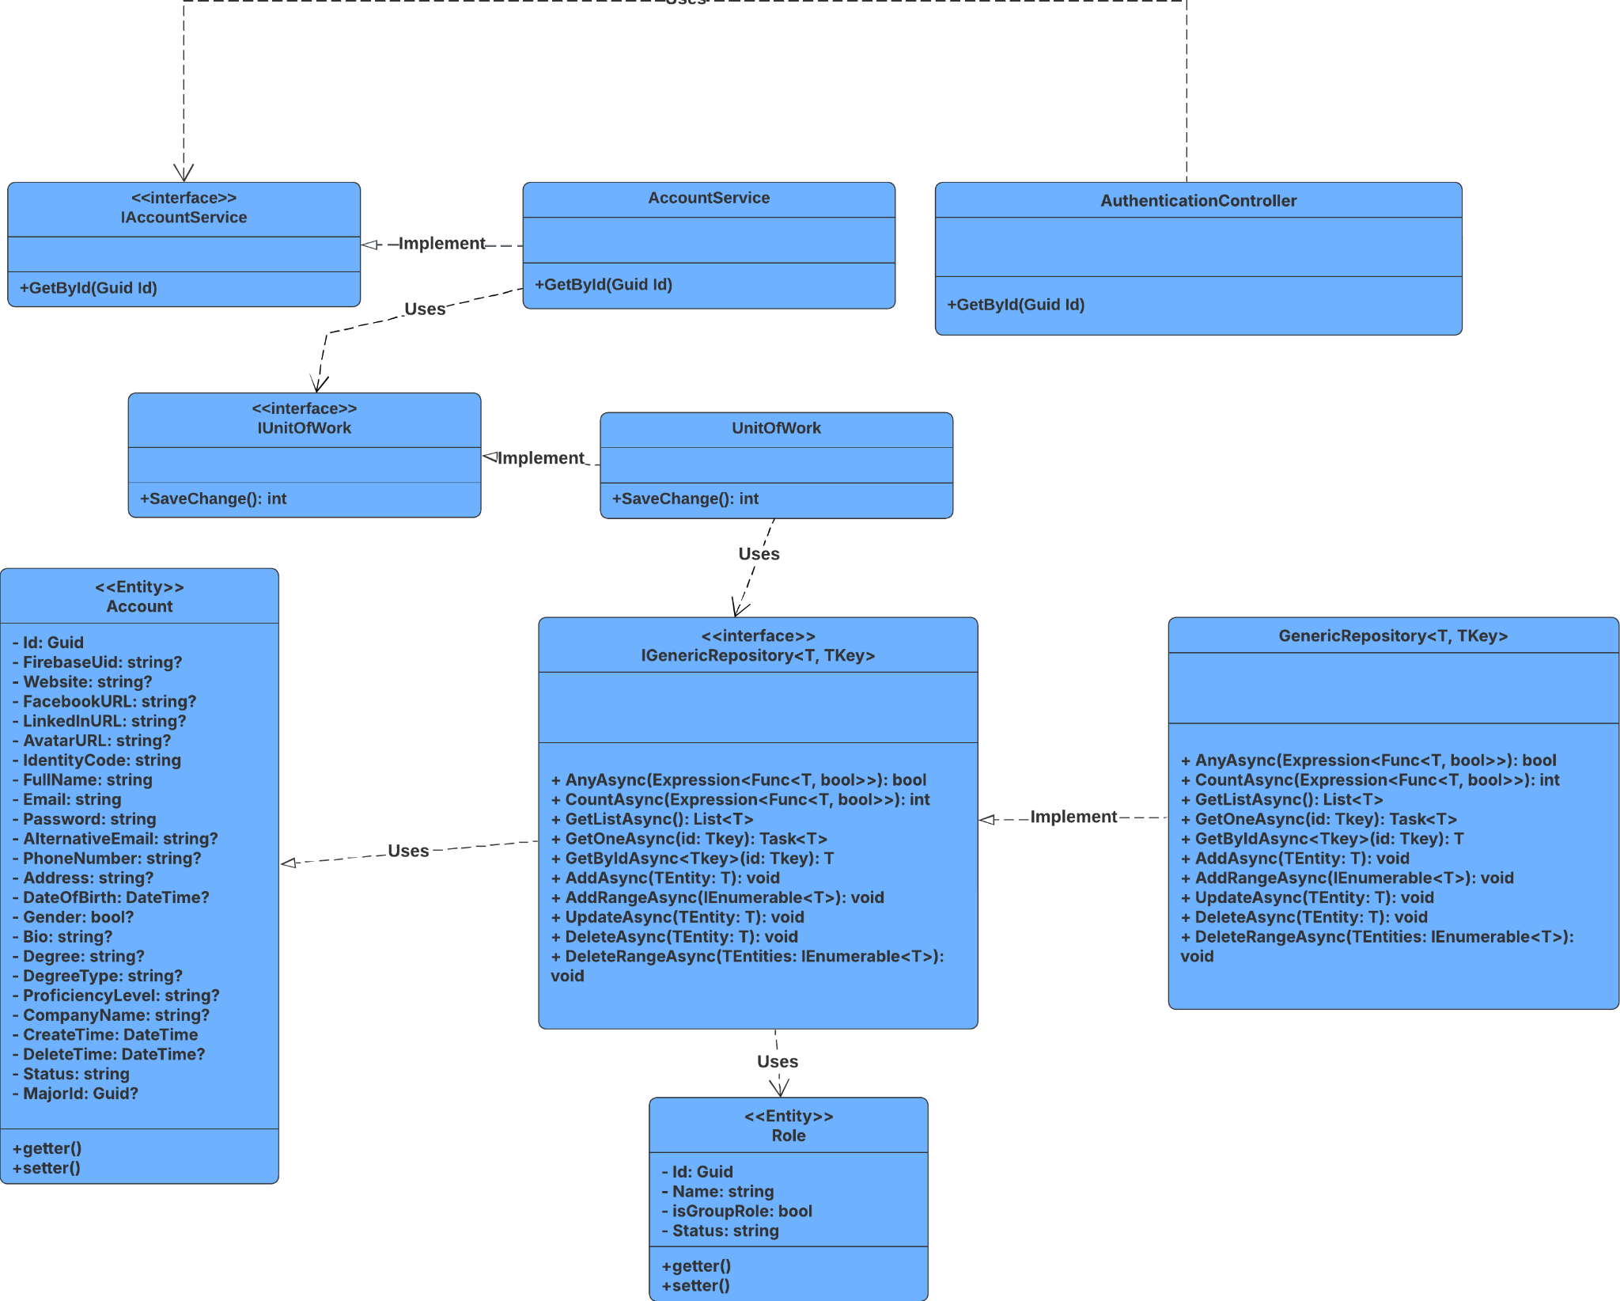

##### 3.2.3.2 Sequence Diagram

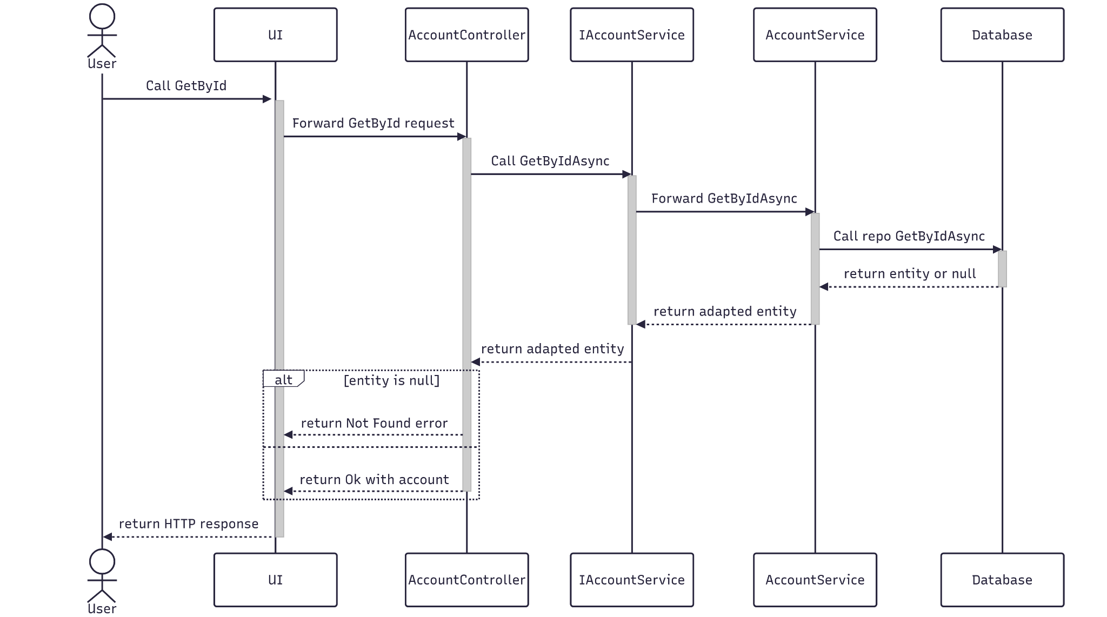

##### 3.2.3.3 Class Specification

###### 3.2.2.3.a Account Controller

| **No** | **Method** | **Description** |
| --- | --- | --- |
| 1 | GetById(Guid Id) | Receives the Id and call GetByIdAsync to find it |

###### 3.2.2.3.b Account Service

| **No** | **Method** | **Description** |
| --- | --- | --- |
| 1 | GetByIdAsync(Guid Id) | Query the entity, map it to the entity Response and Update it in database |

#### 3.2.4 Delete

##### 3.2.4.1 Class Diagram

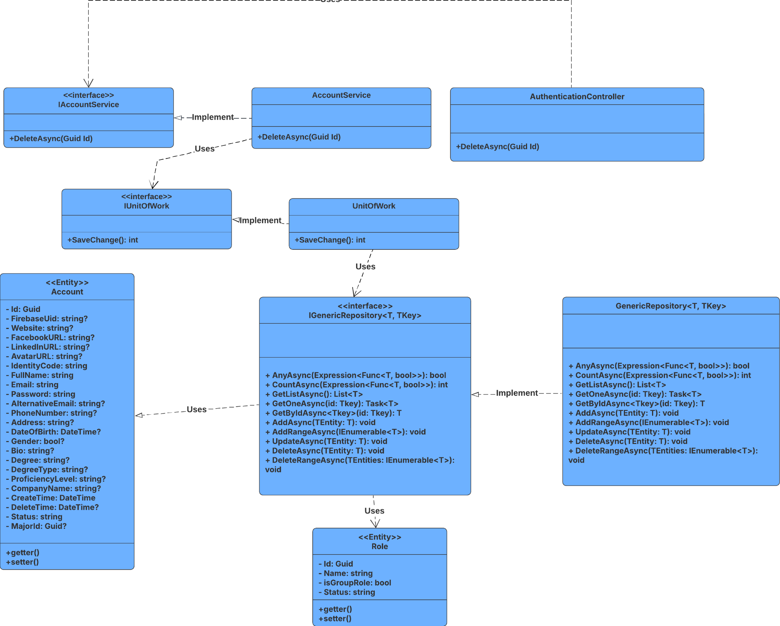

##### 3.2.4.2 Sequence Diagram

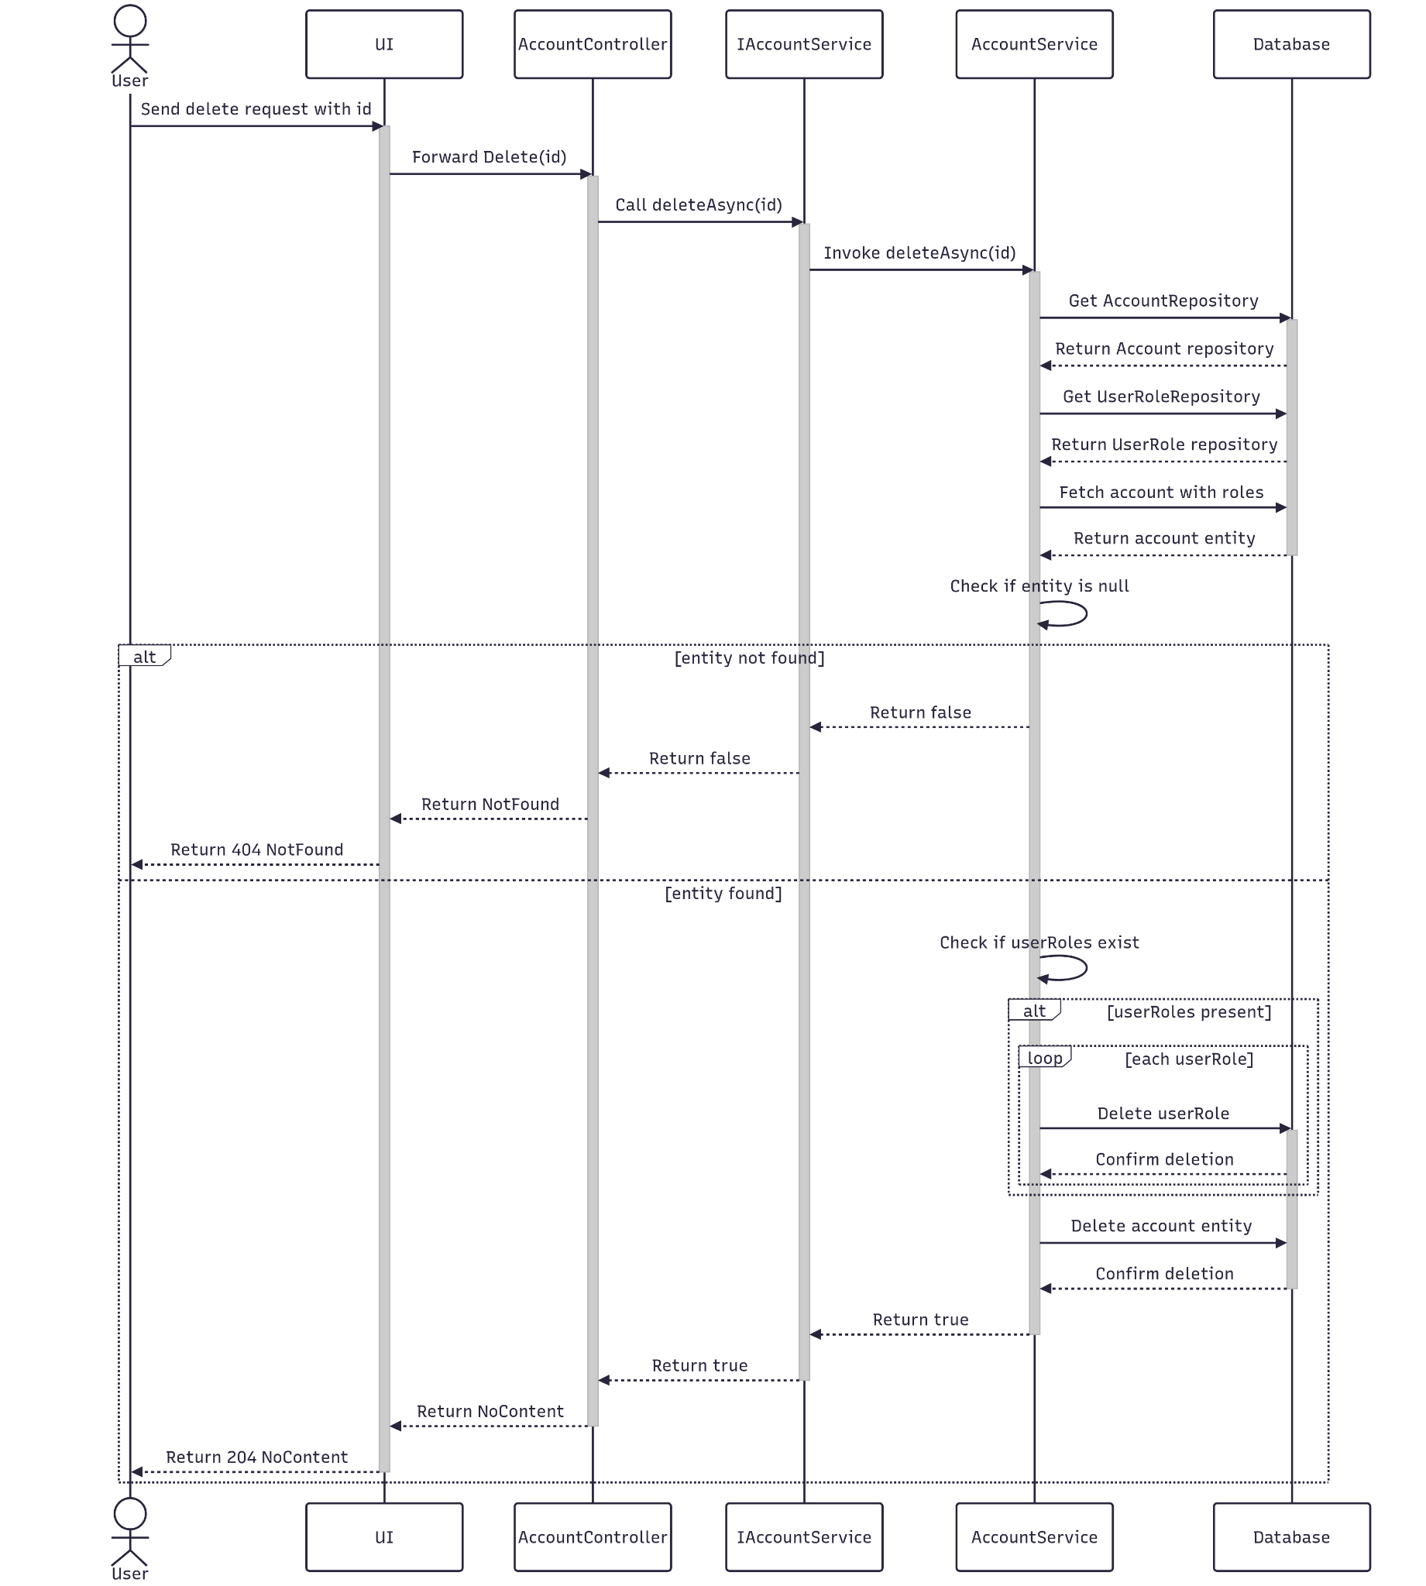

##### 3.2.4.3 Class Specification

###### 3.2.4.3.a Account Controller

| **No** | **Method** | **Description** |
| --- | --- | --- |
| 1 | Delete(Guid Id) | Receives the Id and call DeleteAsync to delete it |

###### 3.2.4.3.b Account Service

| **No** | **Method** | **Description** |
| --- | --- | --- |
| 1 | DeleteAsync(Guid Id) | Query the entity, map it to the entity Response and Update it in database |

#### 3.2.5 Get List

##### 3.2.5.1 Class Diagram

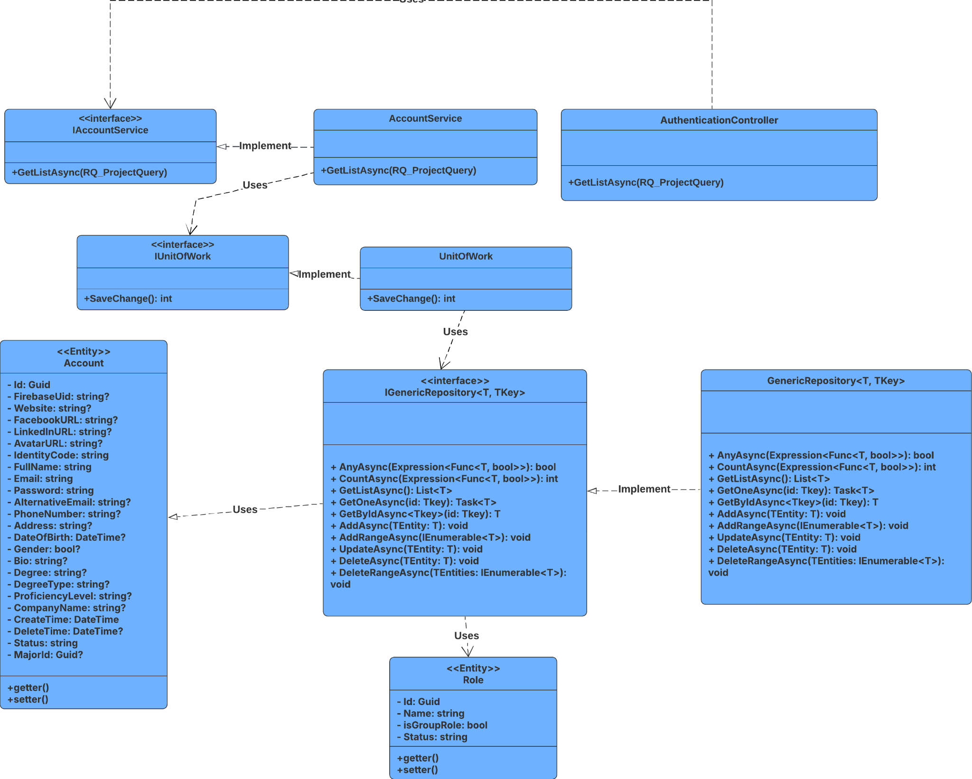

##### 3.2.5.2 Sequence Diagram

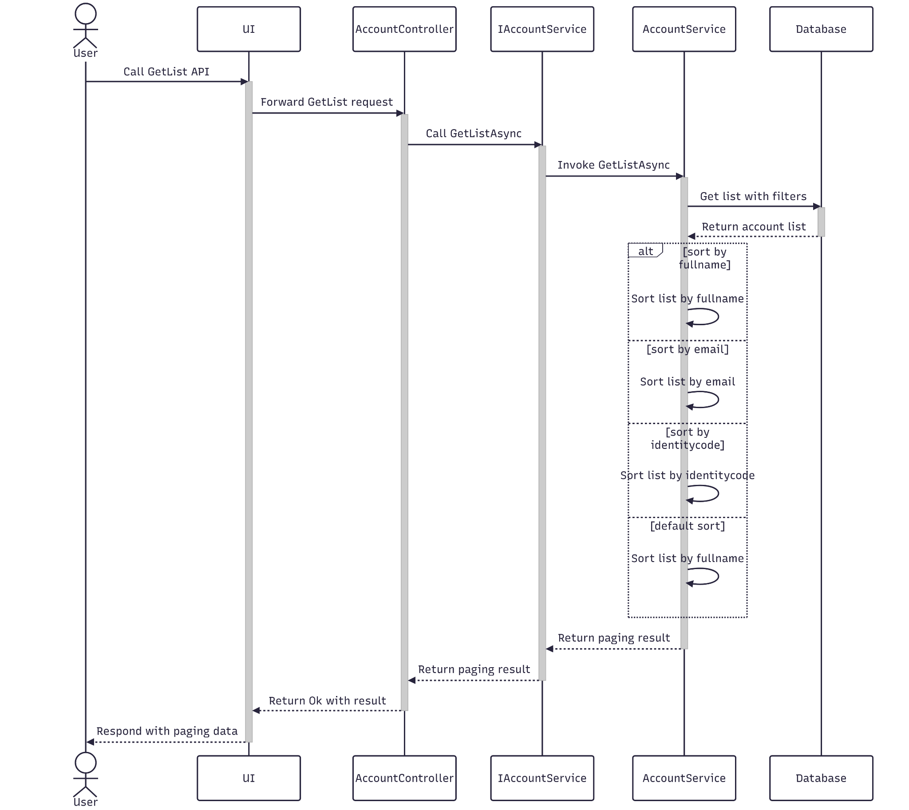

##### 3.2.5.3 Class Specification

###### 3.2.5.3.a Authentication Controller

| **No** | **Method** | **Description** |
| --- | --- | --- |
| 1 | GetListAsync(Q_Account) | Retrieves a list of accounts based on the provided Q_Account query parameter |

###### 3.2.5.3.b Authentication Service

| **No** | **Method** | **Description** |
| --- | --- | --- |
| 1 | GetListAsync(Q_UserRole) | This service method retrieves a collection of account entities that match the criteria specified in the Q_Account query object. |

### 3.3 Manage Appraisal Council

#### 3.3.1.Create

##### 3.3.1.1 Class Diagram

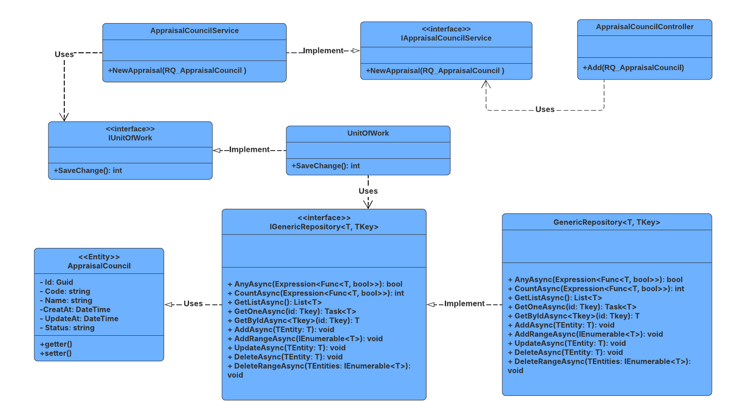

##### 3.3.1.2 Sequence Diagram

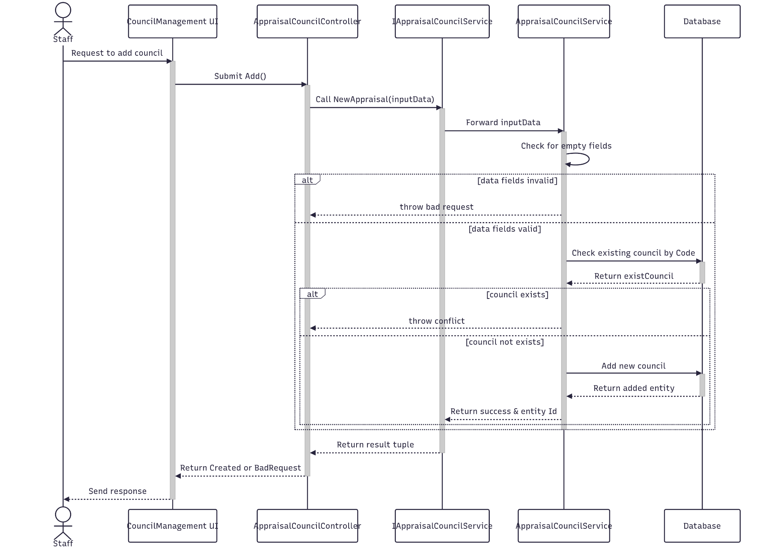

##### 3.3.1.3 Class Specification

###### 3.3.1.3.a AppraisalCouncilController

| **No** | **Method** | **Description** |
| --- | --- | --- |
| 1 | Add(RQ_Appraisal Council) | Receives Appraisal Council information and call CreateAsync to create it |

###### 3.3.1.3.b Appraisal Council Service

| **No** | **Method** | **Description** |
| --- | --- | --- |
| 1 | NewAppraisal(RQ_Appraisal Council) | Map it to the database entity and save it in database |

#### 3.3.2.Update

##### 3.3.2.1 Class Diagram

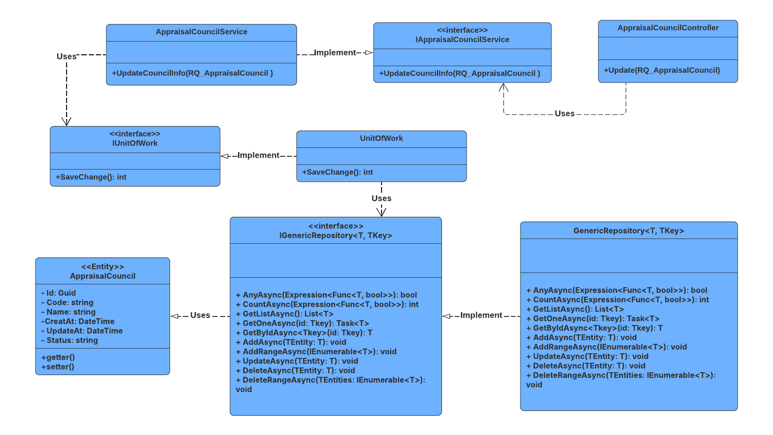

##### 3.3.2.2 Sequence Diagram

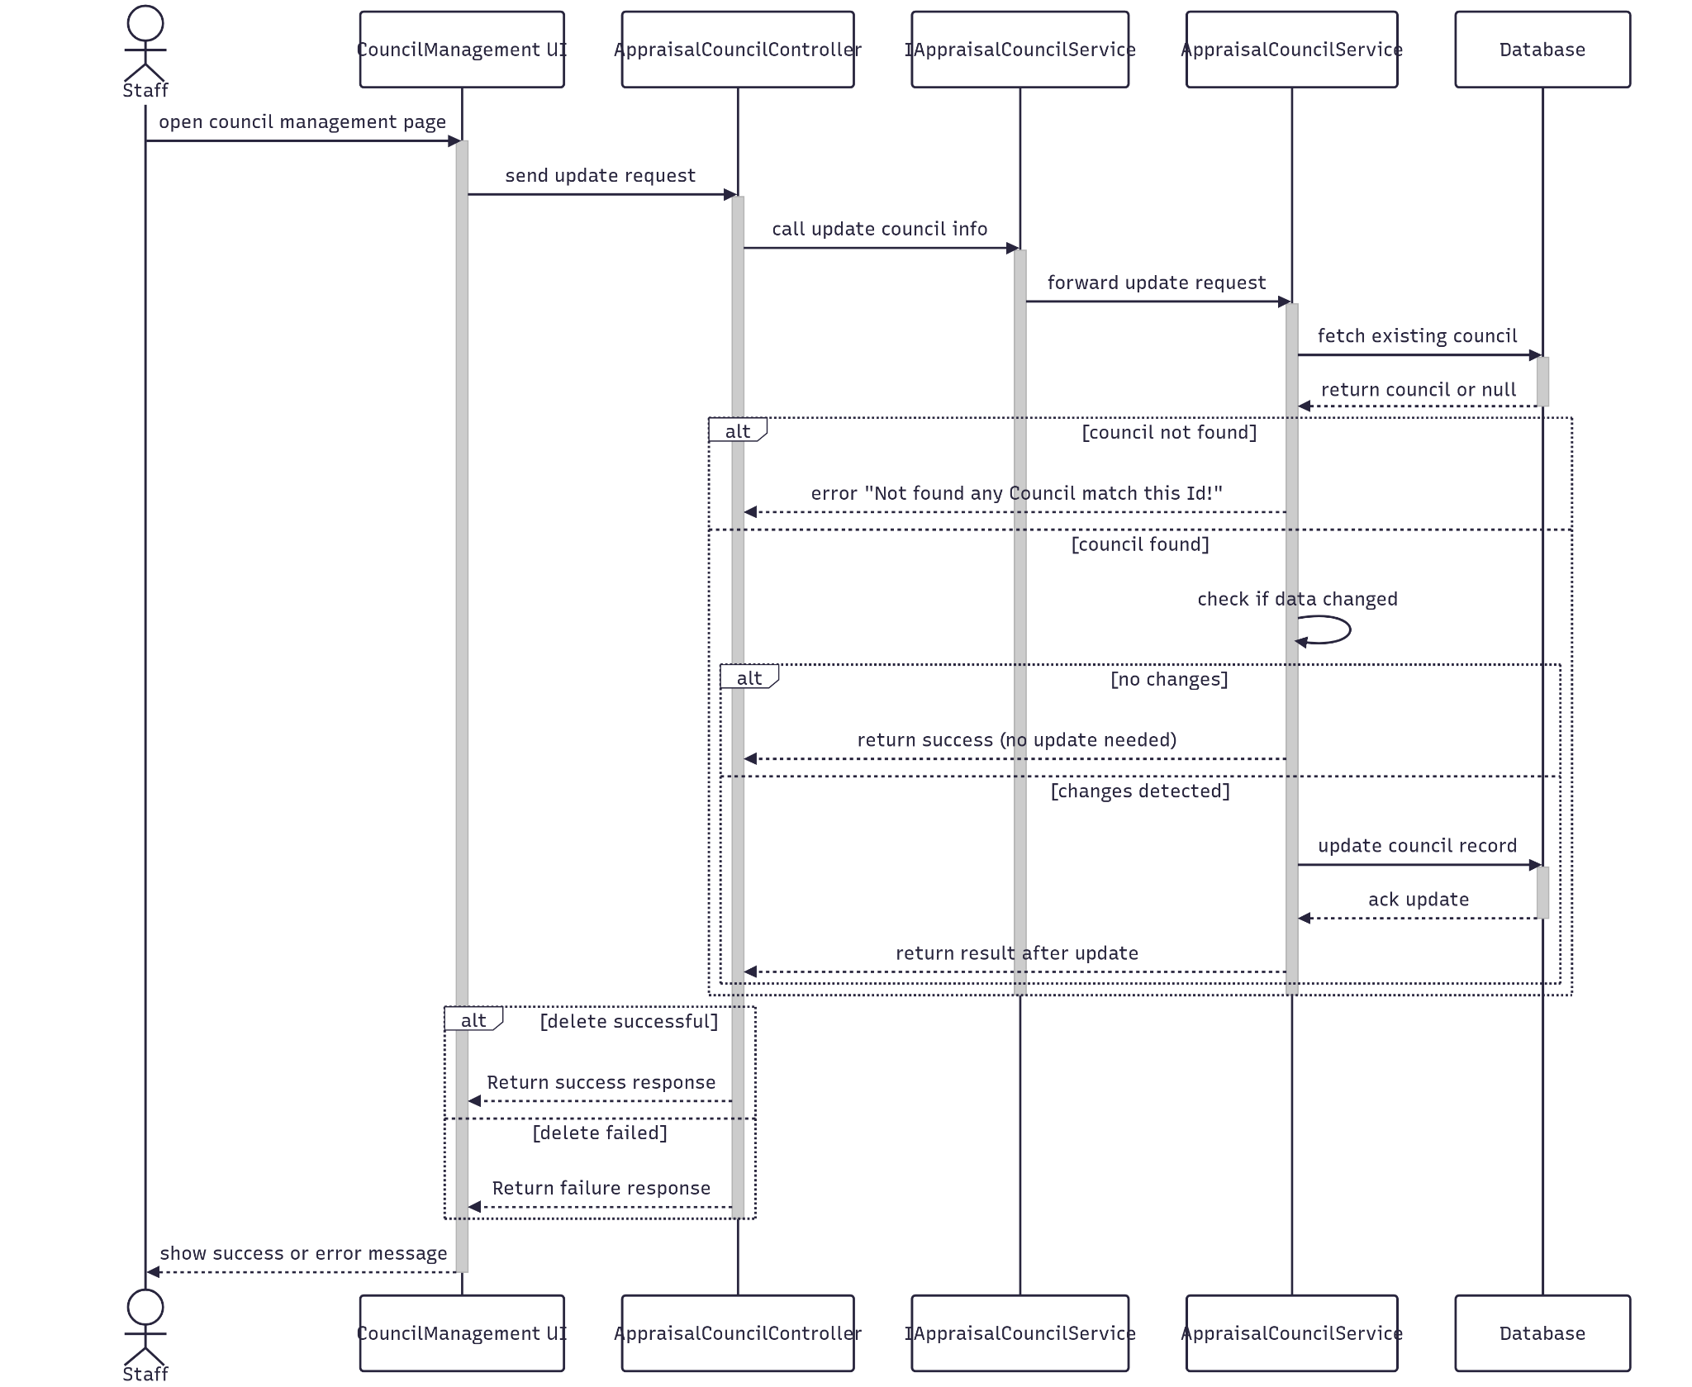

##### 3.3.2.3 Class Specification

###### 3.3.2.3.a AppraisalCouncilController

| **No** | **Method** | **Description** |
| --- | --- | --- |
| 1 | Update(RQ_AppraisalCouncil) | Receives new appraisal council information and call UpdateCoucilInfo to update it |

###### 3.3.2.3.b Account Service

| **No** | **Method** | **Description** |
| --- | --- | --- |
| 1 | UpdateCoucilInfo(RQ_AppraisalCouncil) | Query the entity, map it to the entity and update it in database |

#### 3.3.3.Get By Id

##### 3.3.3.1 Class Diagram

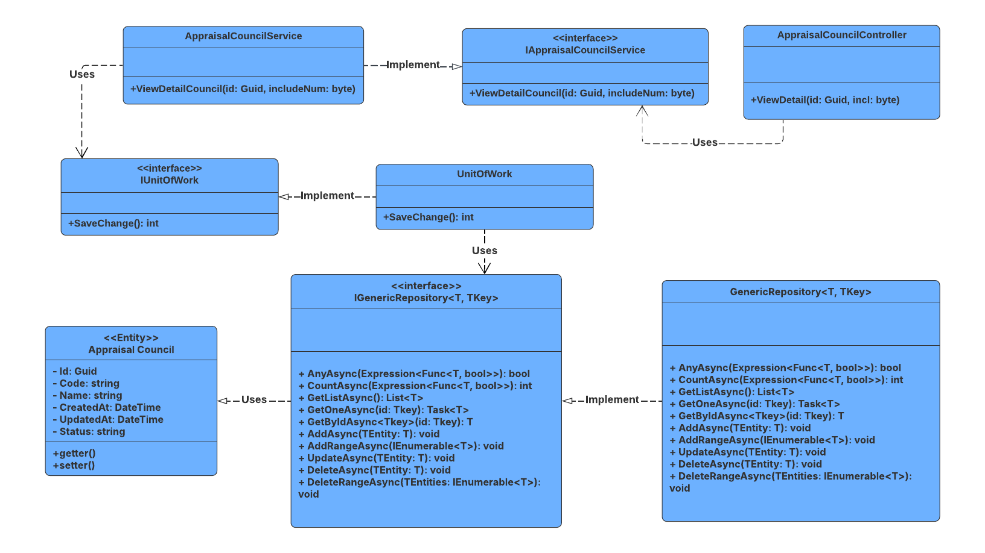

##### 3.3.3.2 Sequence Diagram

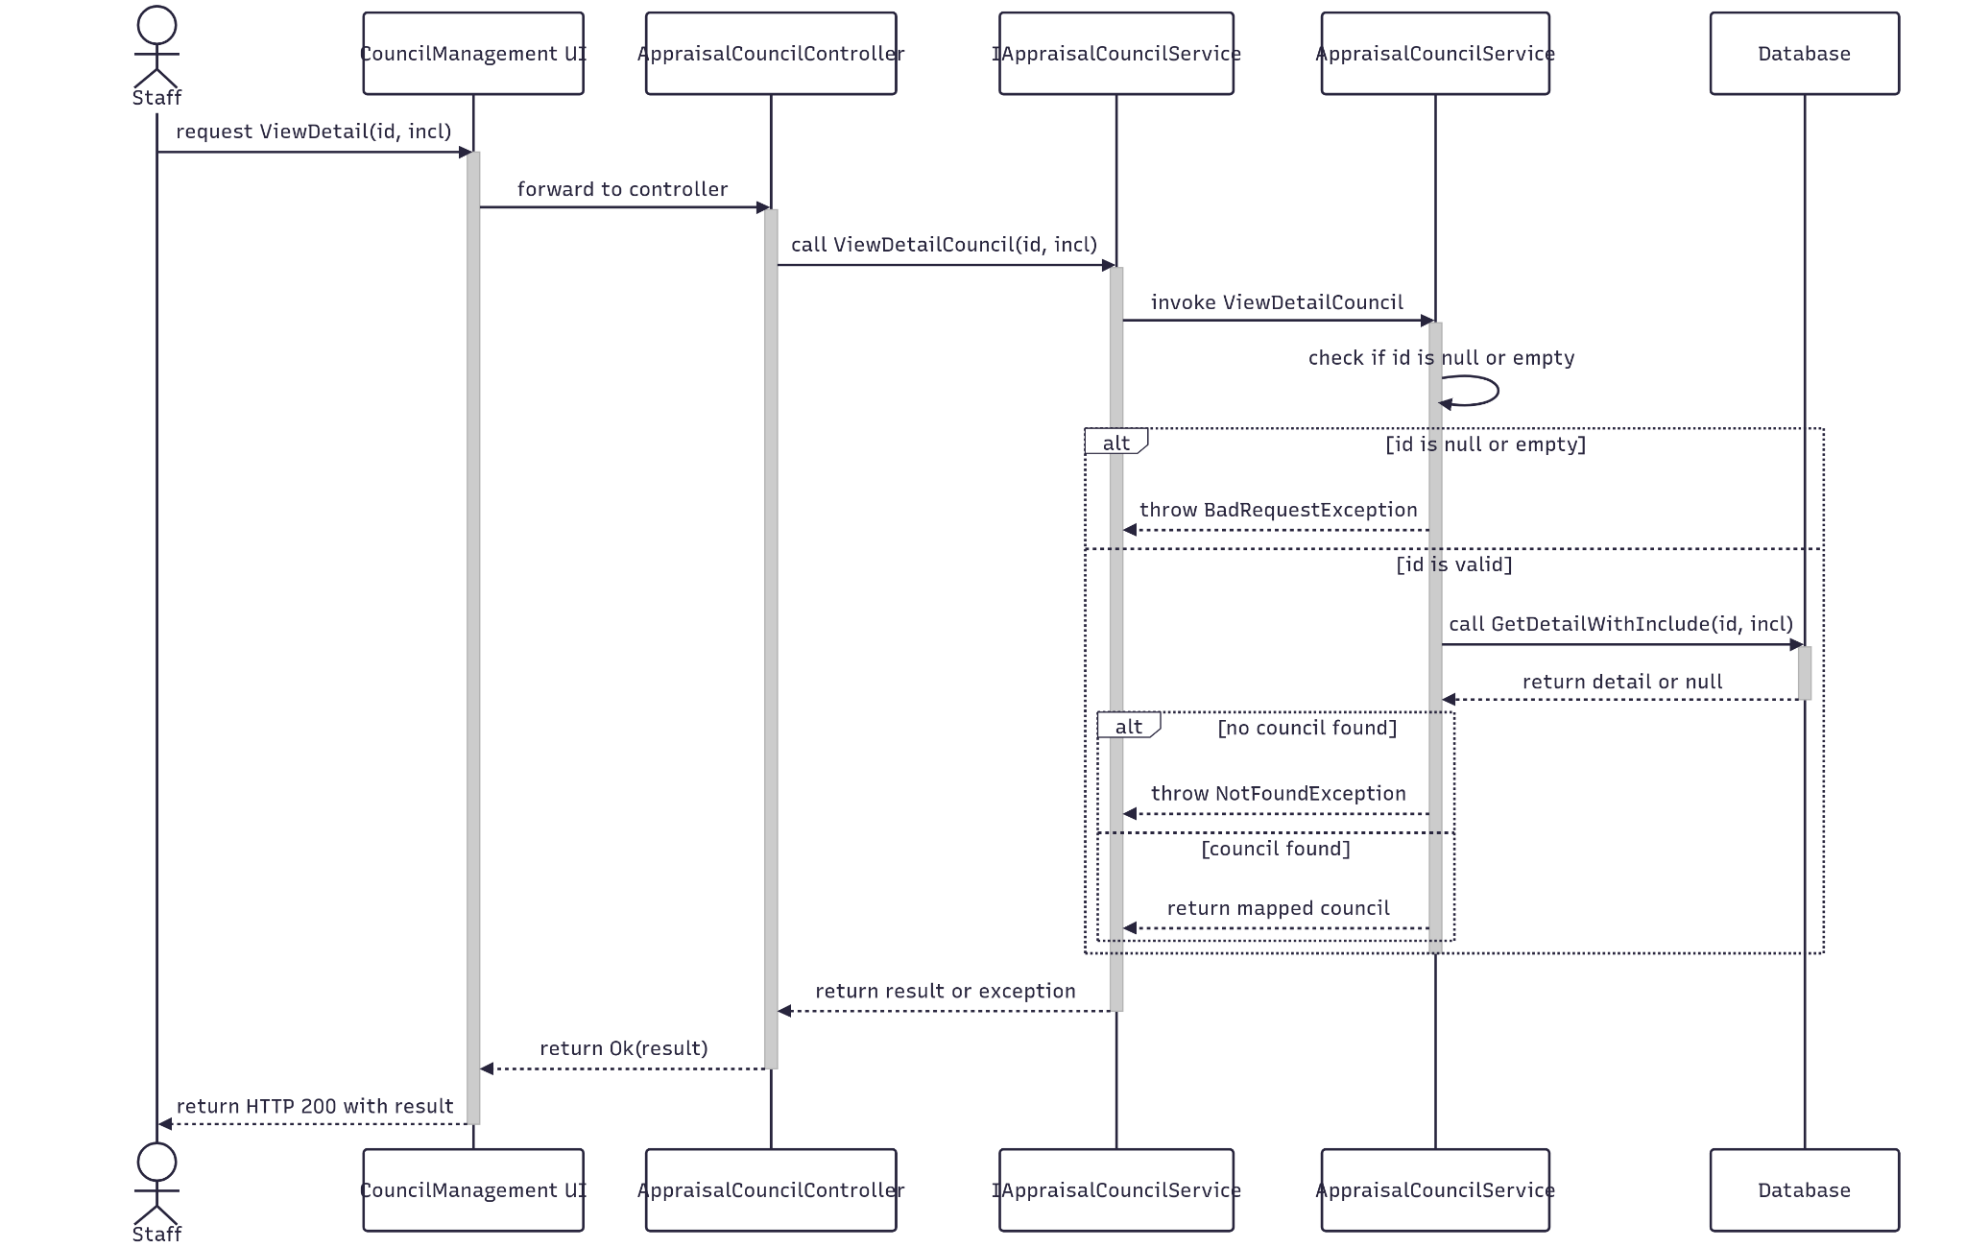

##### 3.3.3.3 Class Specification

###### 3.3.3.3.a AppraisalCouncilController

| **No** | **Method** | **Description** |
| --- | --- | --- |
| 1 | ViewDetail(Guid id, byte incl) | Receives the Id and call ViewDetailCouncil to find it. The incl is use for query include relate data. |

###### 3.3.3.3.b AppraisalCouncilService

| **No** | **Method** | **Description** |
| --- | --- | --- |
| 1 | ViewDetailCouncil(Guid id, byte incl) | Query the detail of counciland its relat data in database by its id, and specific incl number options. |

#### 3.3.4.Delete

##### 3.3.4.1 Class Diagram

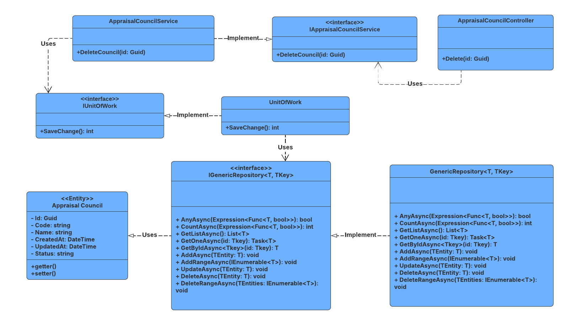

##### 3.3.4.2 Sequence Diagram

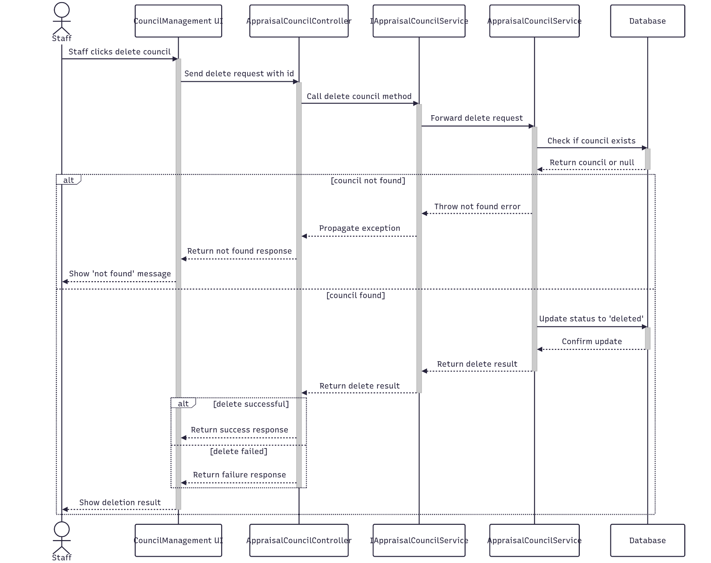

##### 3.3.4.3 Class Specification

###### 3.3.4.3.a AppraisalCouncilController

| **No** | **Method** | **Description** |
| --- | --- | --- |
| 1 | Delete(Guid Id) | Receives the Id and call DeleteCouncil to delete it |

###### 3.3.4.3.b AppraisalCouncilService

| No | Method | Description |
| --- | --- | --- |
| 1 | DeleteCouncil(Guid Id) | Query the entity, map it to the entity Response and Update it in database |

#### 3.3.5.Get List

##### 3.3.5.1 Class Diagram

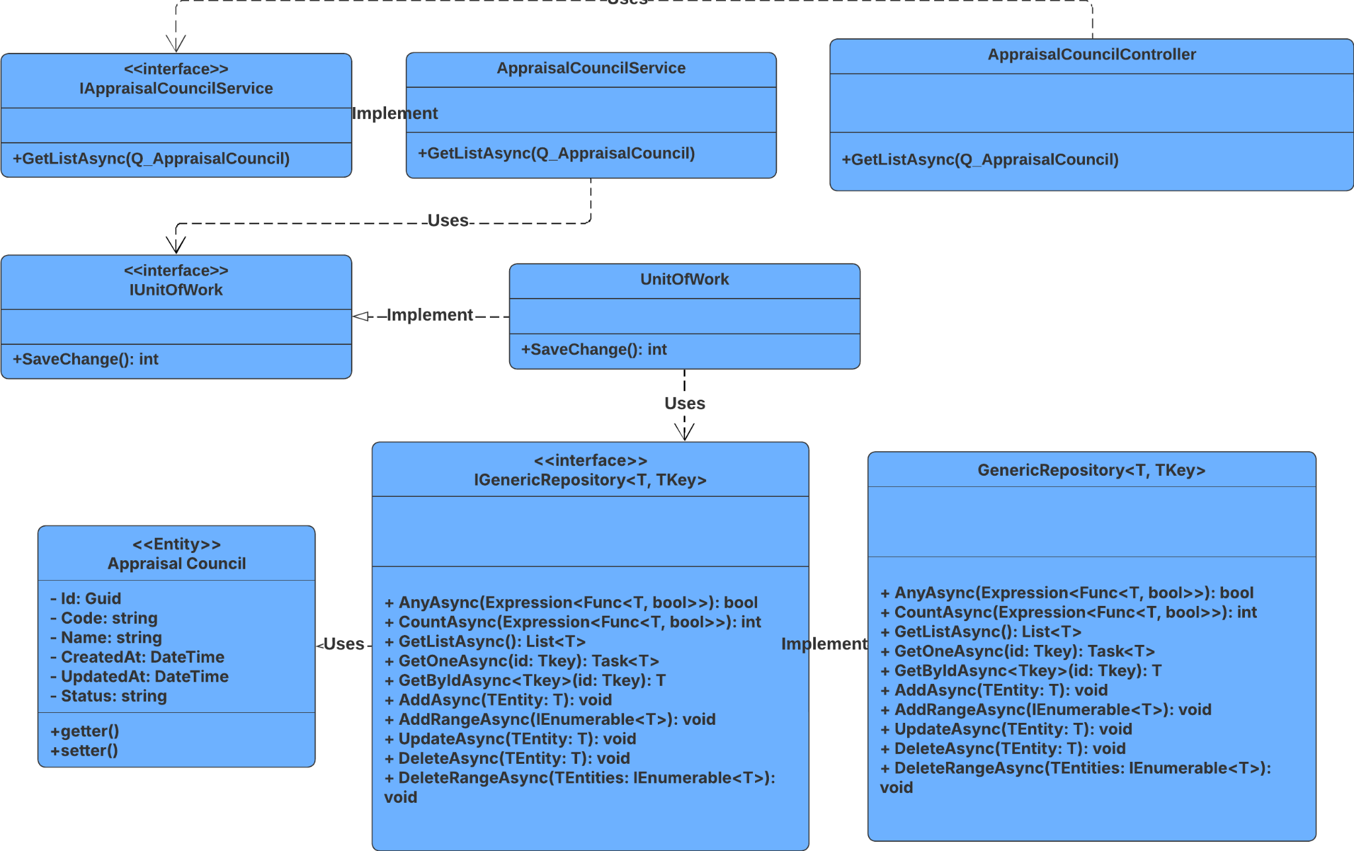

##### 3.3.5.2 Sequence Diagram

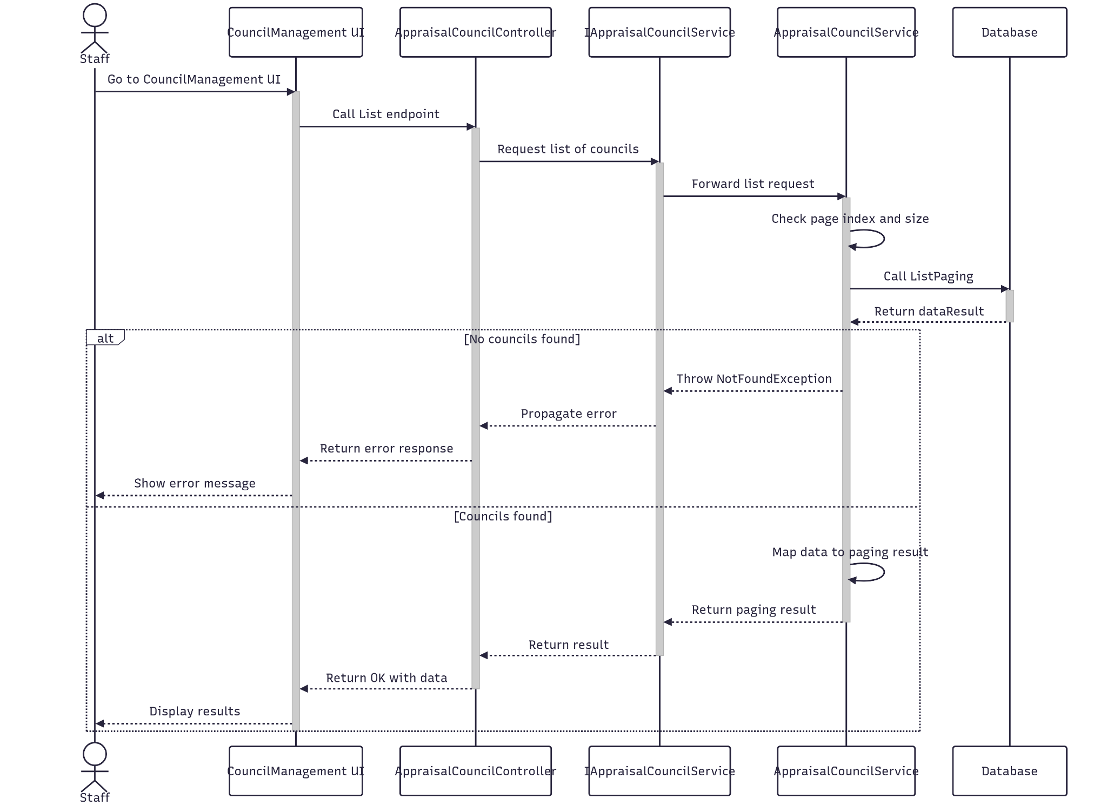

##### 3.3.5.3 Class Specification

###### 3.3.5.3.a AppraisalCouncilController

| No | Method | Description |
| --- | --- | --- |
| 1 | List(Q_Document) | Receives the custom input data and call ListDocument to apply custom query. |

###### 3.3.5.3.b AppraisalCouncilService

| No | Method | Description |
| --- | --- | --- |
| 1 | ListDocument(Q_Document) | Query the entity by custom input data, if it is null then return get all. All query are paging automaticaly. |

### 3.4 Manage Document

#### 3.4.1.Create

##### 3.4.1.1 Class Diagram

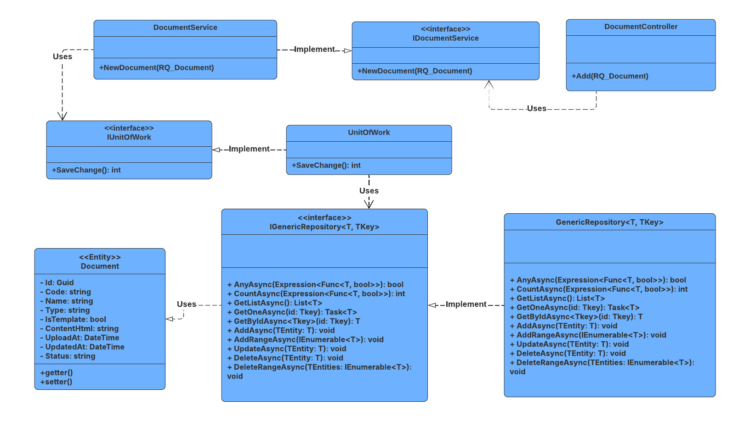

##### 3.4.1.2 Sequence Diagram

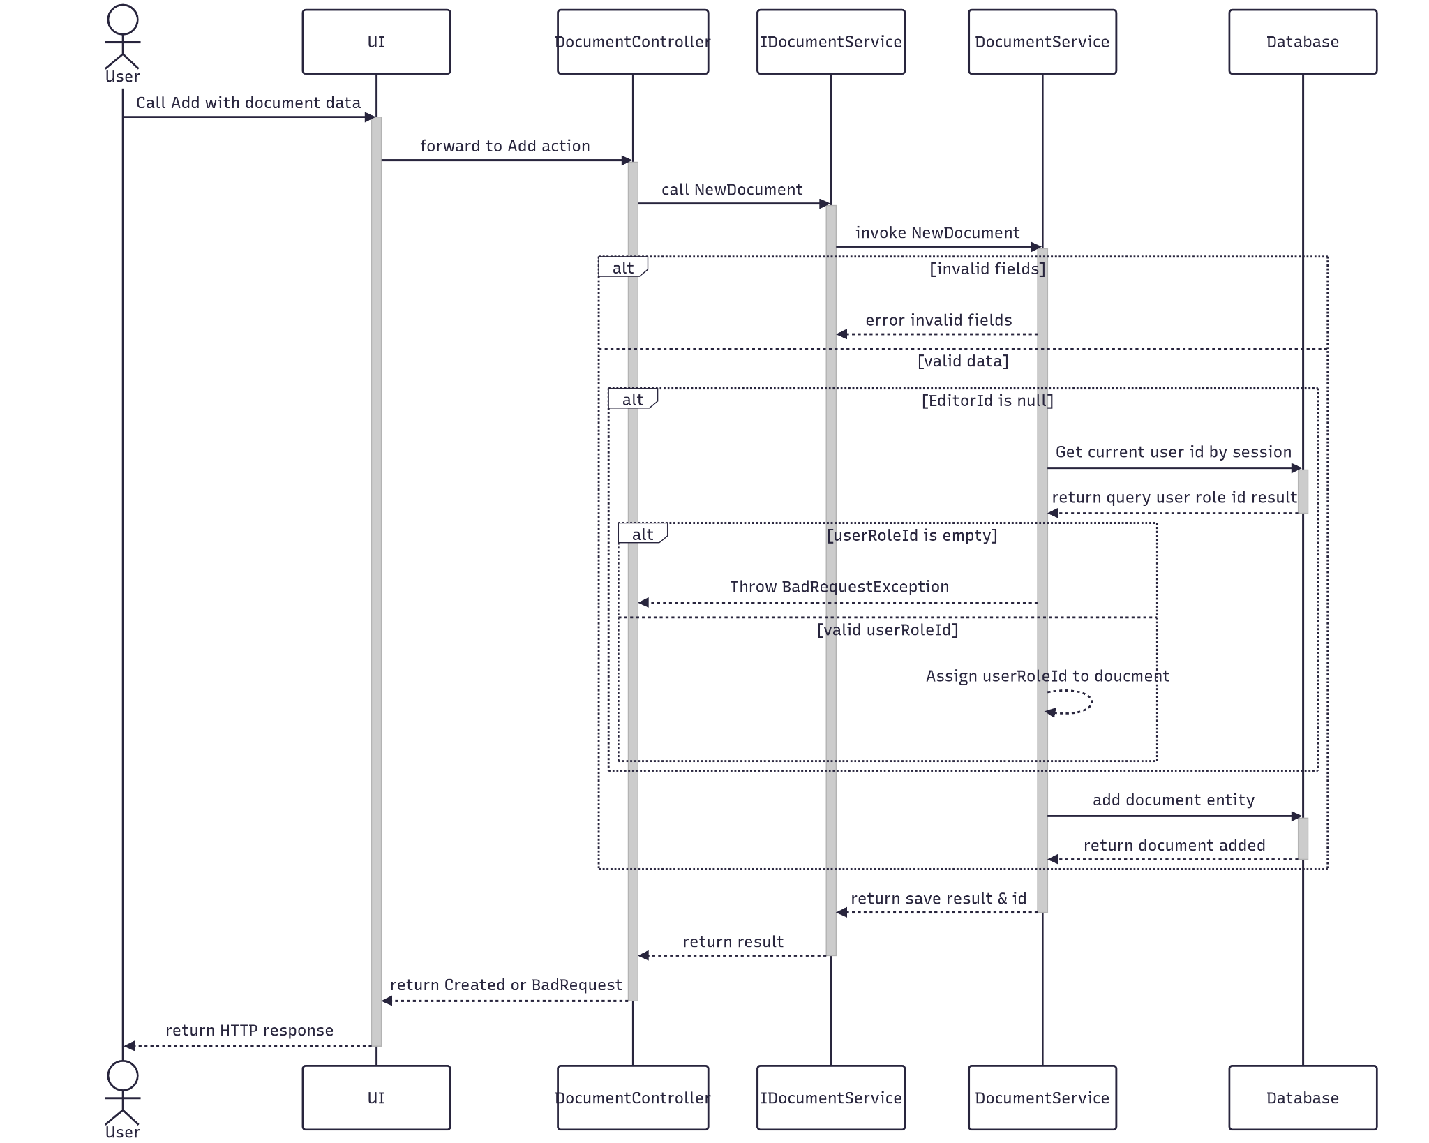

##### 3.4.1.3 Class Specification

###### 3.4.1.3.a DocumentController

| No | Method | Description |
| --- | --- | --- |
| 1 | Add(RQ_Document) | Receives Appraisal Council information and call CreateAsync to create it. |

###### 3.4.1.3.b DocumentService

| No | Method | Description |
| --- | --- | --- |
| 1 | NewDocument(RQ_Document) | Map it to the database entity and save it in database. |

#### 3.4.2.Update

##### 3.4.2.1 Class Diagram

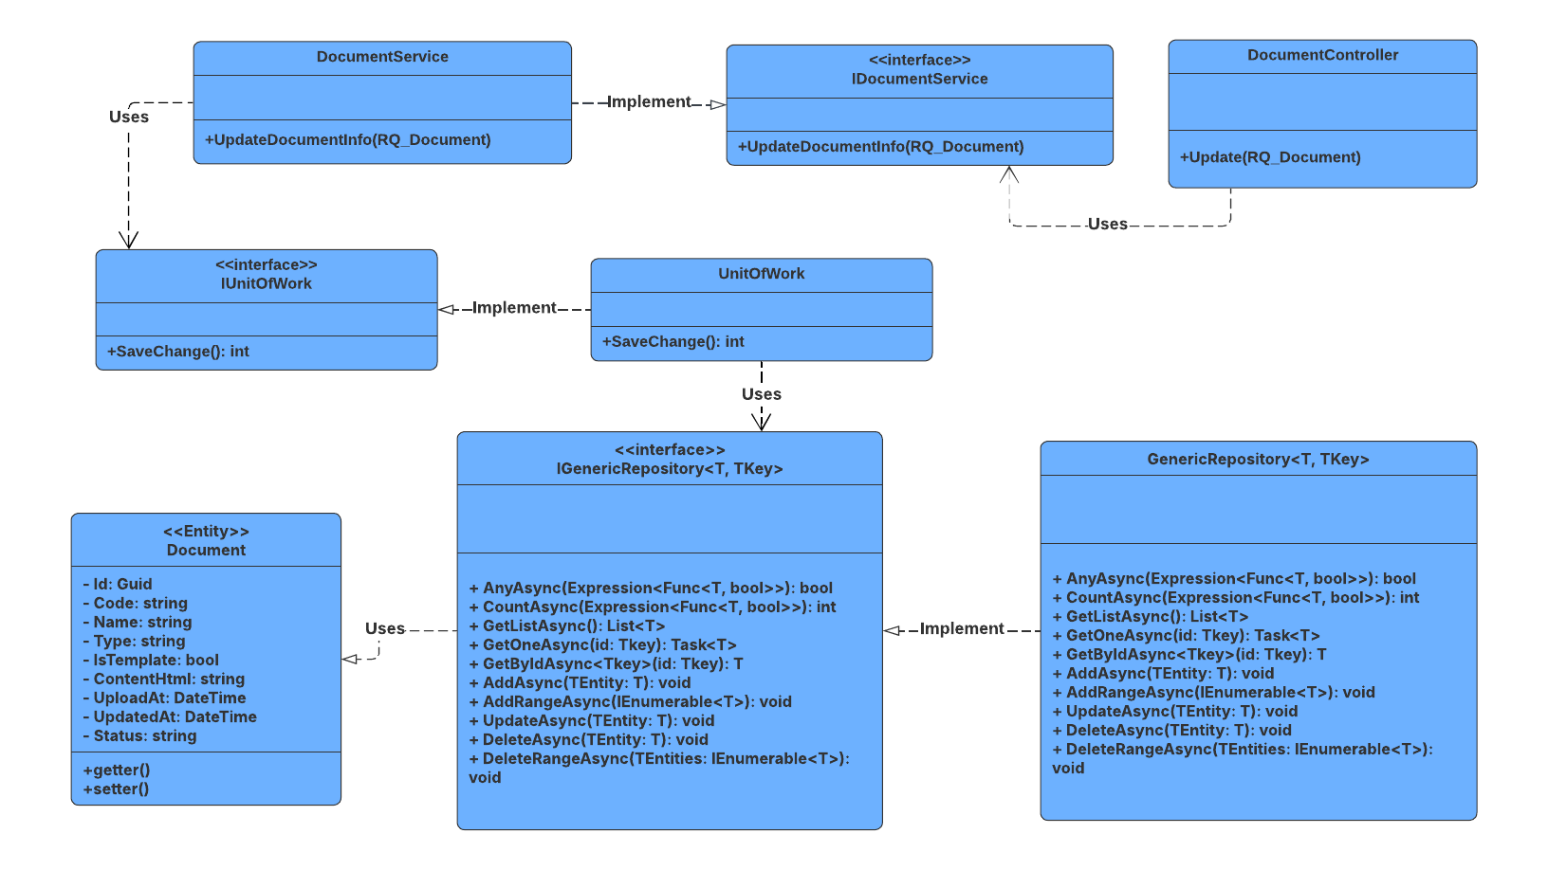

##### 3.4.2.2 Sequence Diagram

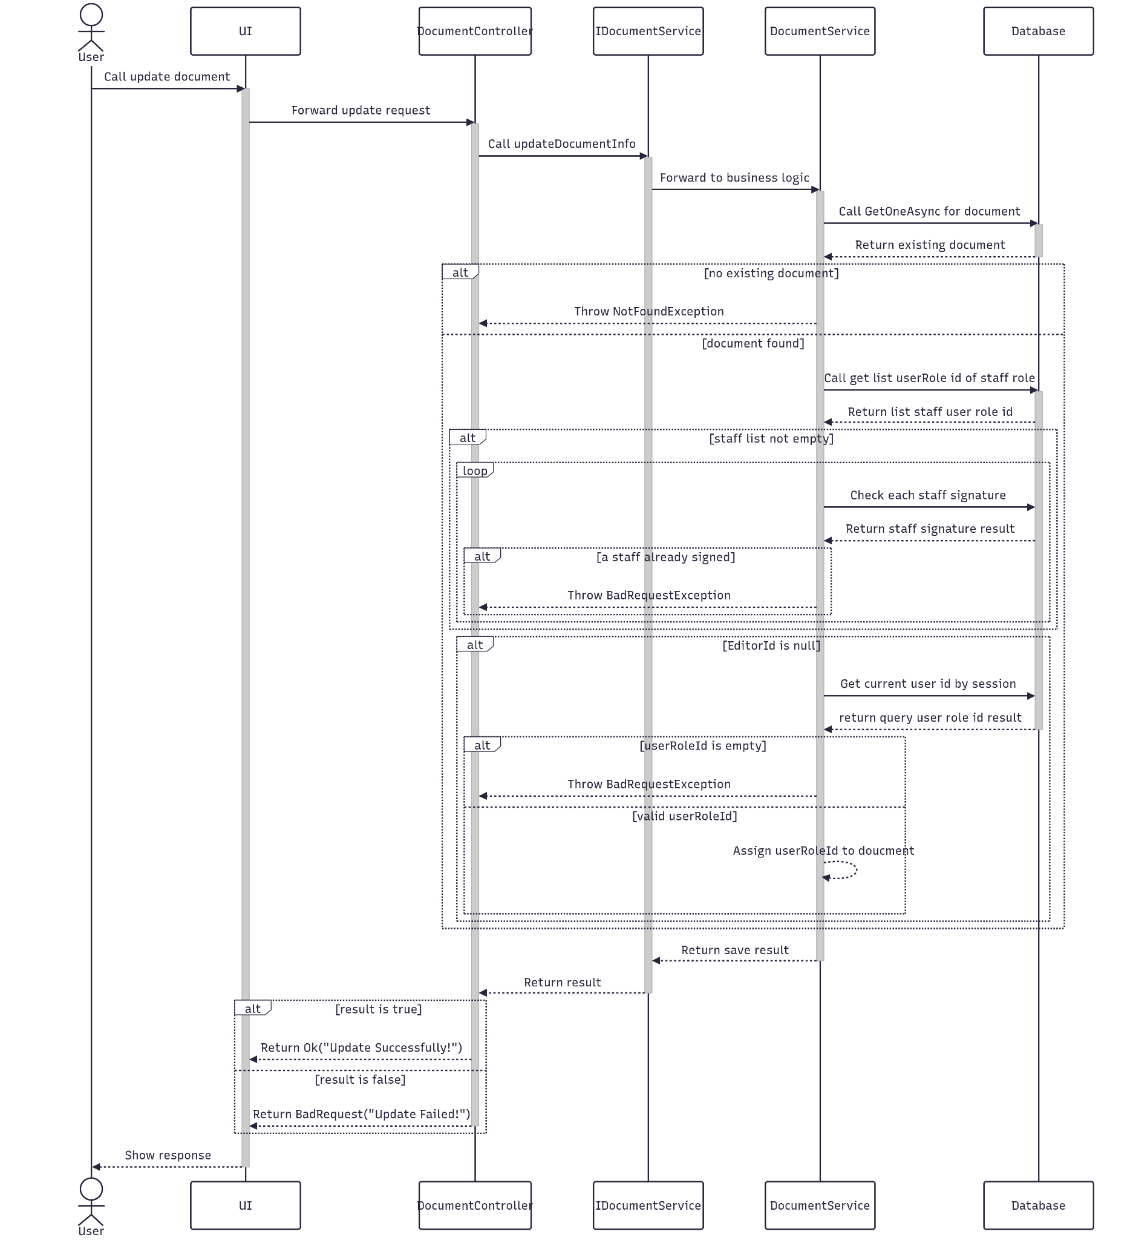

##### 3.4.2.3 Class Specification

###### 3.4.2.3.a DocumentController

| **No** | **Method** | **Description** |
| --- | --- | --- |
| 1 | Update(RQ_Document) | Updates document metadata shown in the Documents Management UI. Validates editor identity and prevents updates if staff signatures exist. |

###### 3.4.2.3.b DocumentService

| **No** | **Method** | **Description** |
| --- | --- | --- |
| 1 | UpdateDocumentInfo(RQ_Document) | Core service method that performs business logic for updating a document. Ensures document exists, checks for staff signatures, preserves immutable fields, and assigns editor identity before saving changes. |

#### 3.4.3.Get By Id

##### 3.4.3.1 Class Diagram

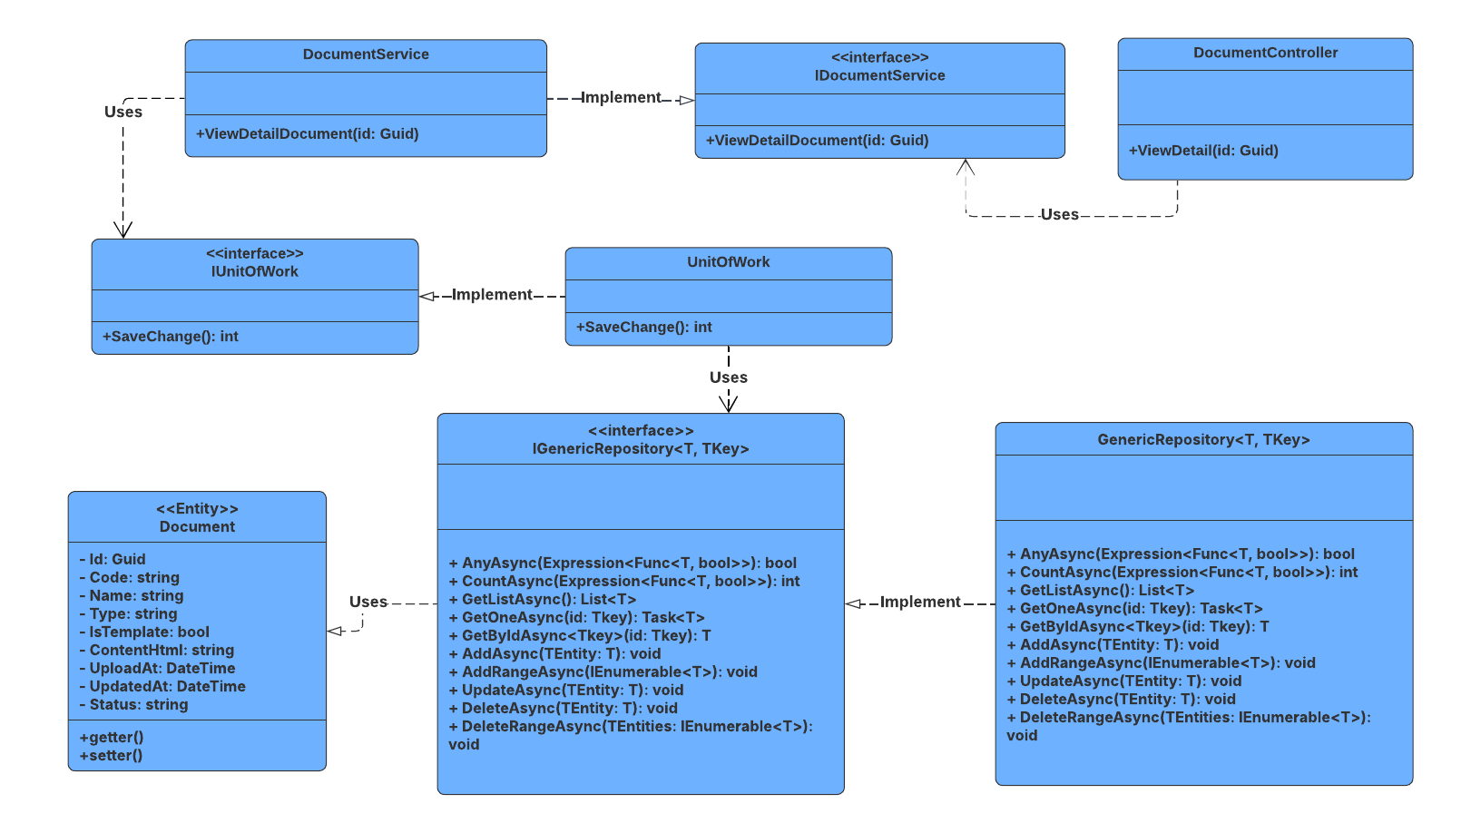

##### 3.4.3.2 Sequence Diagram

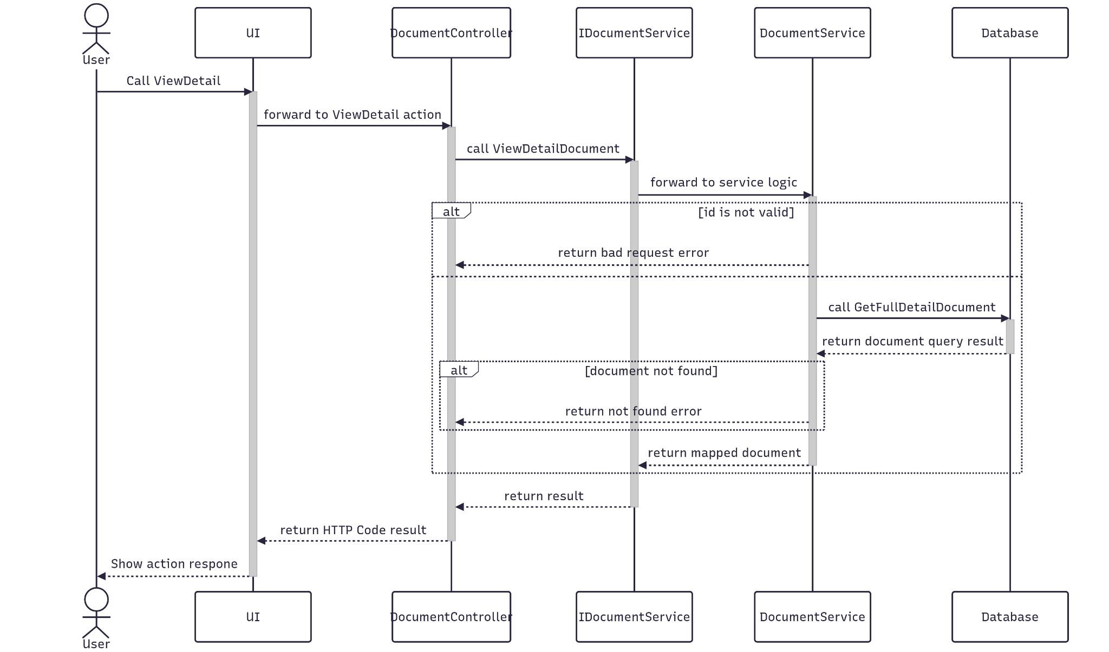

##### 3.4.3.3 Class Specification

###### 3.4.3.3.a DocumentController

| No | Method | Description |
| --- | --- | --- |
| 1 | ViewDetail(Guid id) | Receives Appraisal Council information and call CreateAsync to create it. |

###### 3.4.3.3.b DocumentService

| No | Method | Description |
| --- | --- | --- |
| 1 | ViewDetailDocument(Guid id) | Service method that validates the document ID, fetches full document details from the repository, and maps the result to a response DTO (RS_Document). Throws if ID is empty or document not found. |

#### 3.4.4.Delete

##### 3.4.4.1 Class Diagram

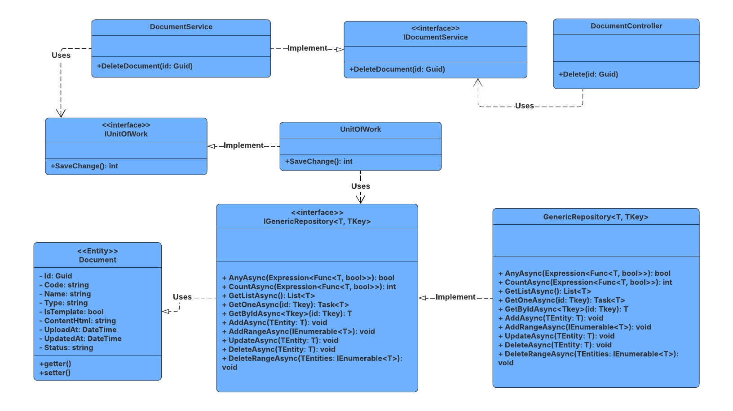

##### 3.4.4.2 Sequence Diagram

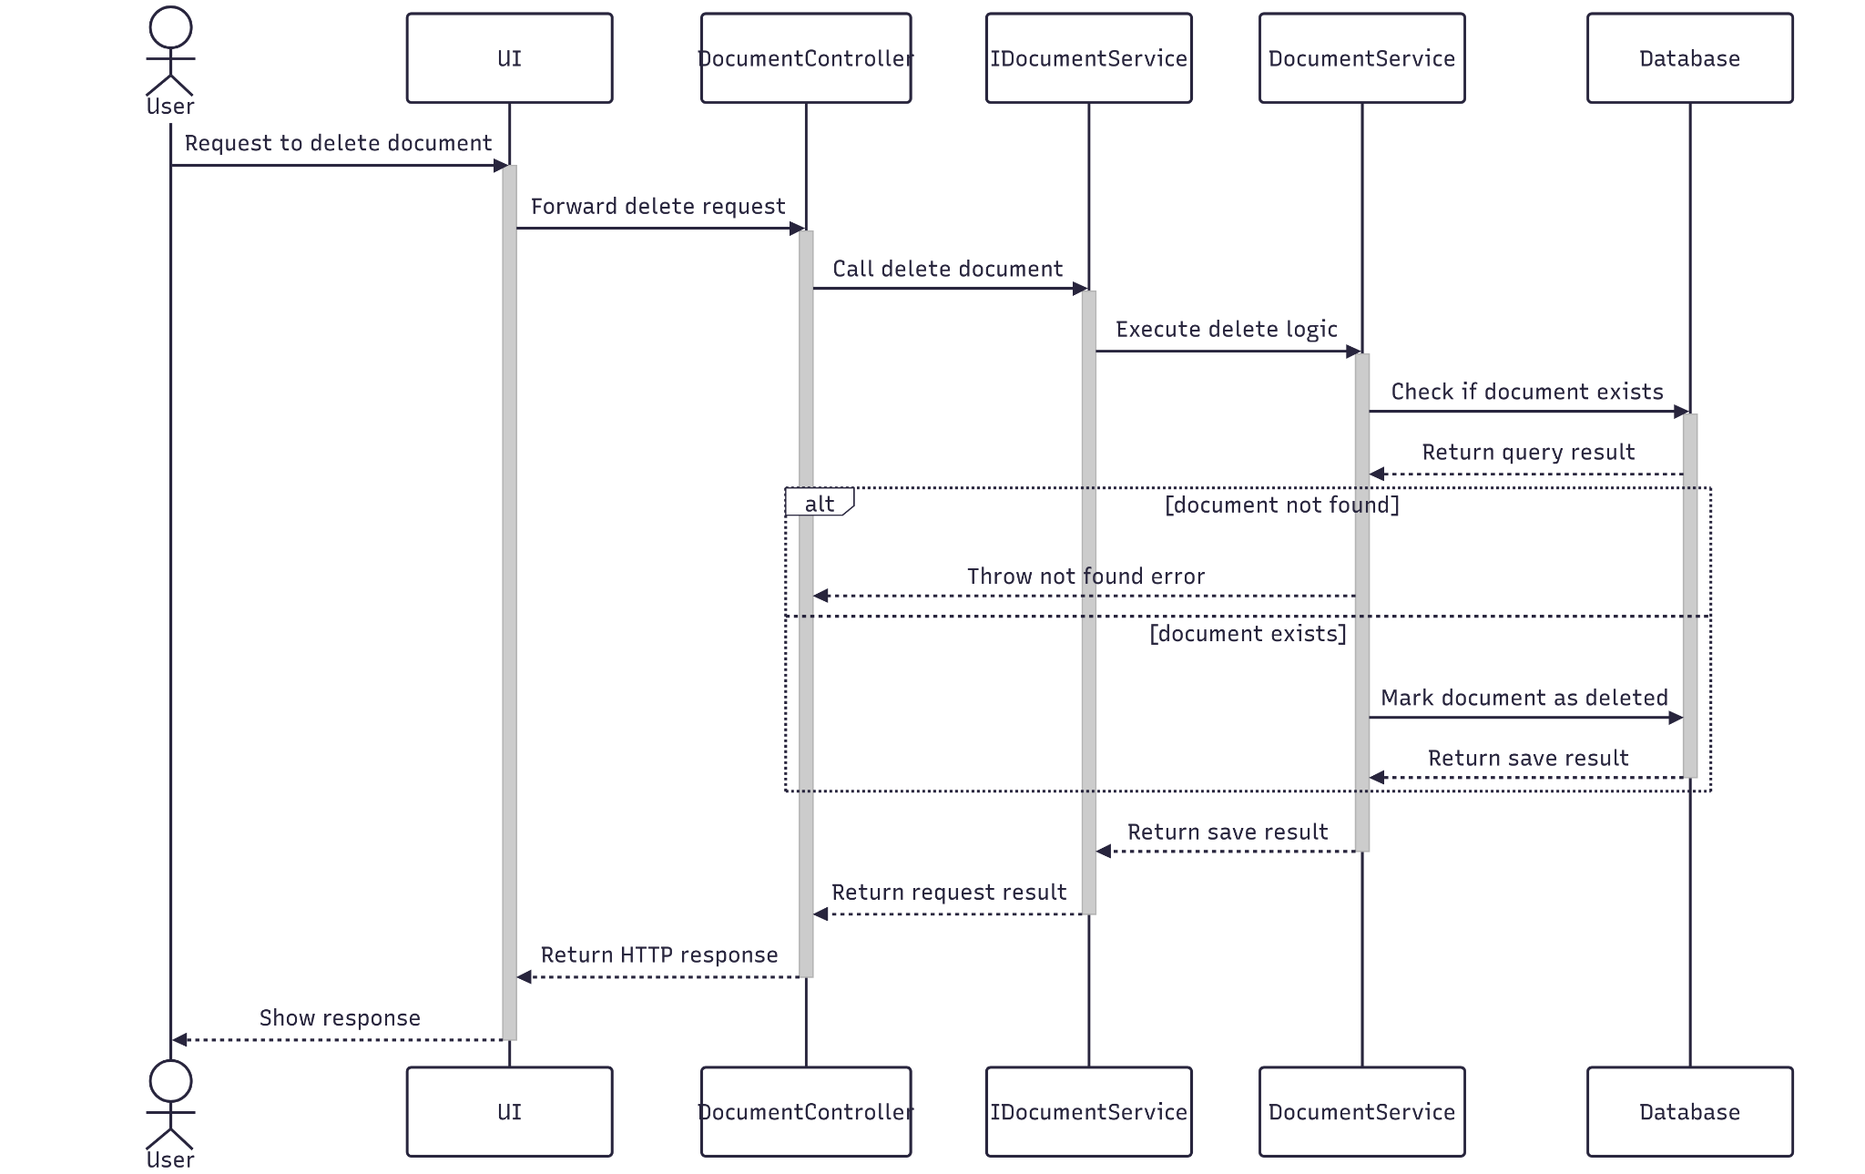

##### 3.4.4.3 Class Specification

###### 3.4.4.3.a DocumentController

| No | Method | Description |
| --- | --- | --- |
| 1 | Delete(Guid id) | Deletes a document by its ID from the Documents Management UI. Returns success or failure message based on the operation result. |

###### 3.4.4.3.b DocumentService

| No | Method | Description |
| --- | --- | --- |
| 1 | DeleteDocument(Guid id) | Service method that validates the document ID, checks existence, and marks the document as "deleted" by updating its status. Intended for soft deletion. Throws if document is not found. |

#### 3.4.5.Get List

##### 3.4.5.1 Class Diagram

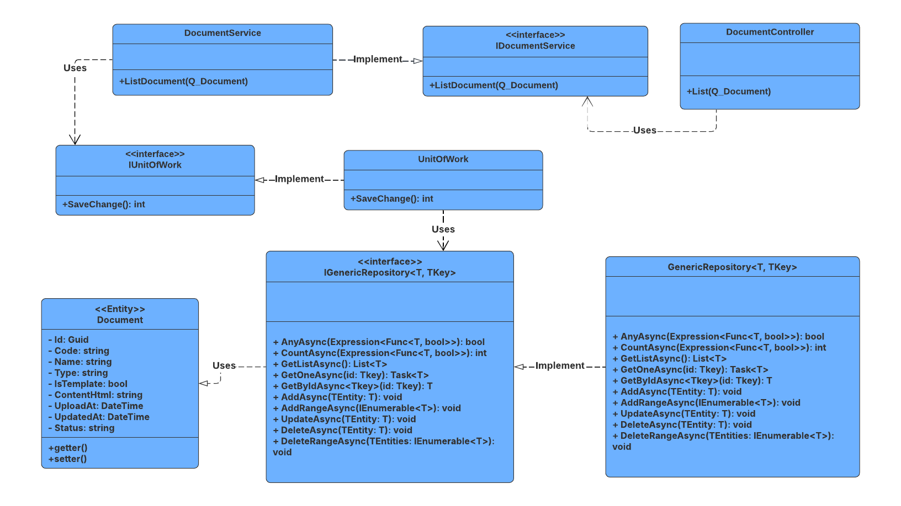

##### 3.4.5.2 Sequence Diagram

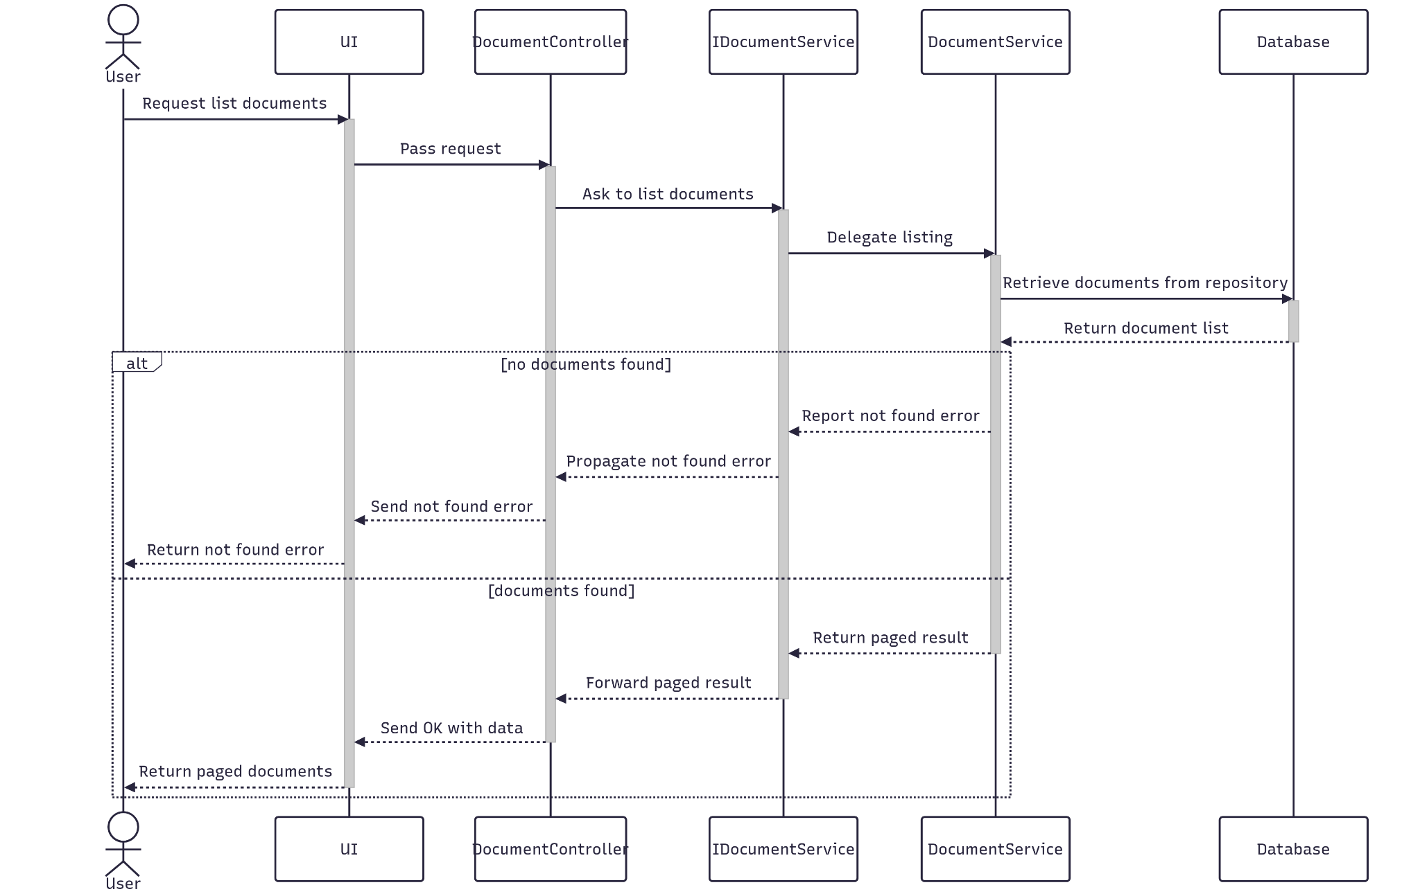

##### 3.4.5.3 Class Specification

###### 3.4.5.3.a DocumentController

| No | Method | Description |
| --- | --- | --- |
| 1 | List(Q_Document) | Retrieves a paginated list of documents based on filter criteria submitted from the Documents Management UI. Returns a structured paging result. |

###### 3.4.5.3.b DocumentService

| No | Method | Description |
| --- | --- | --- |
| 1 | ListDocument(Q_Document) | Service method that validates pagination inputs, queries the repository with multiple filters (e.g., keyword, type, status, date range, project ID), and maps the result to a paginated response DTO. Throws if no documents are found. |

### 3.5 Manage Evaluation

#### 3.5.1.Create

##### 3.5.1.1 Class Diagram

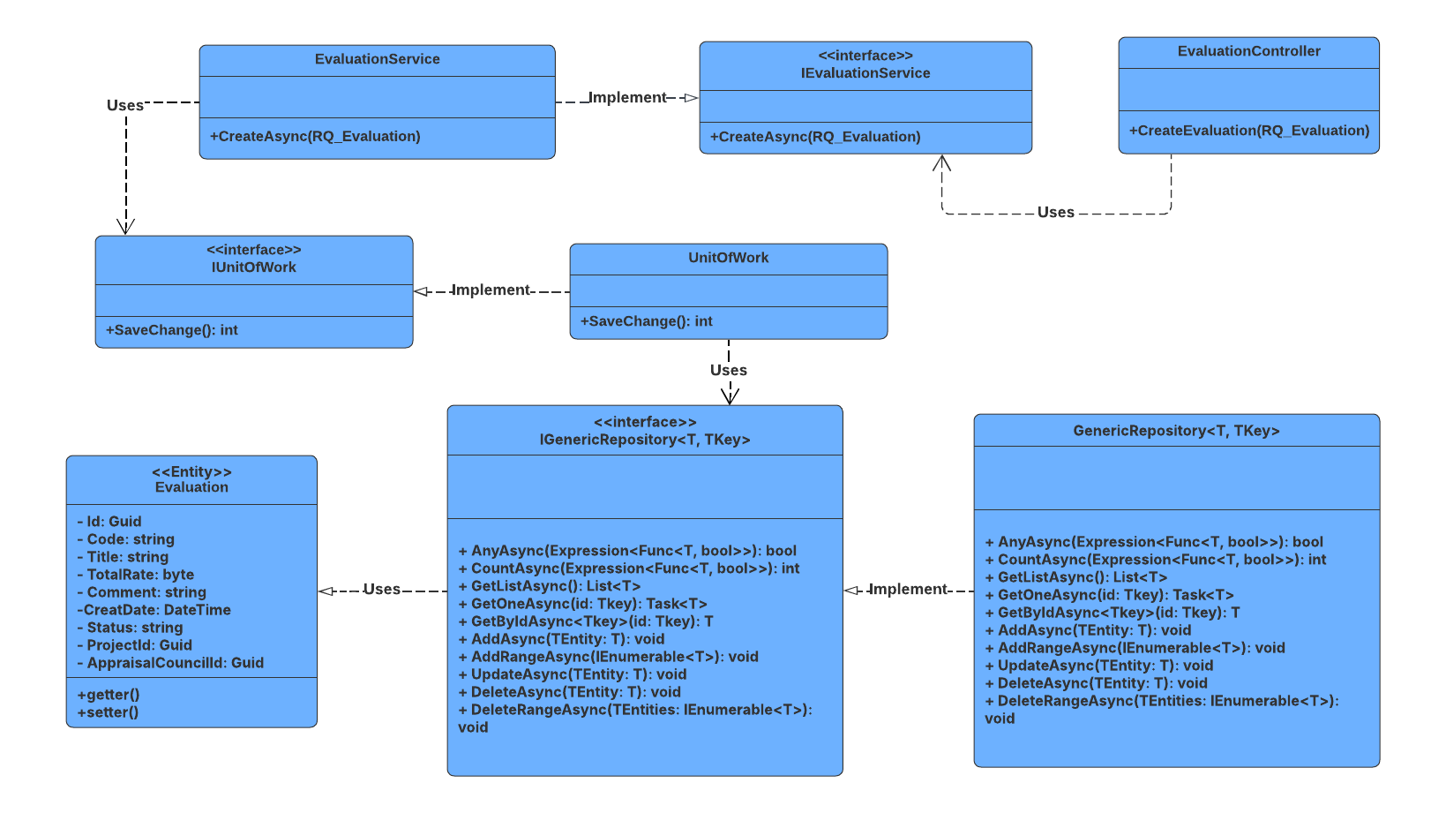

##### 3.5.1.2 Sequence Diagram

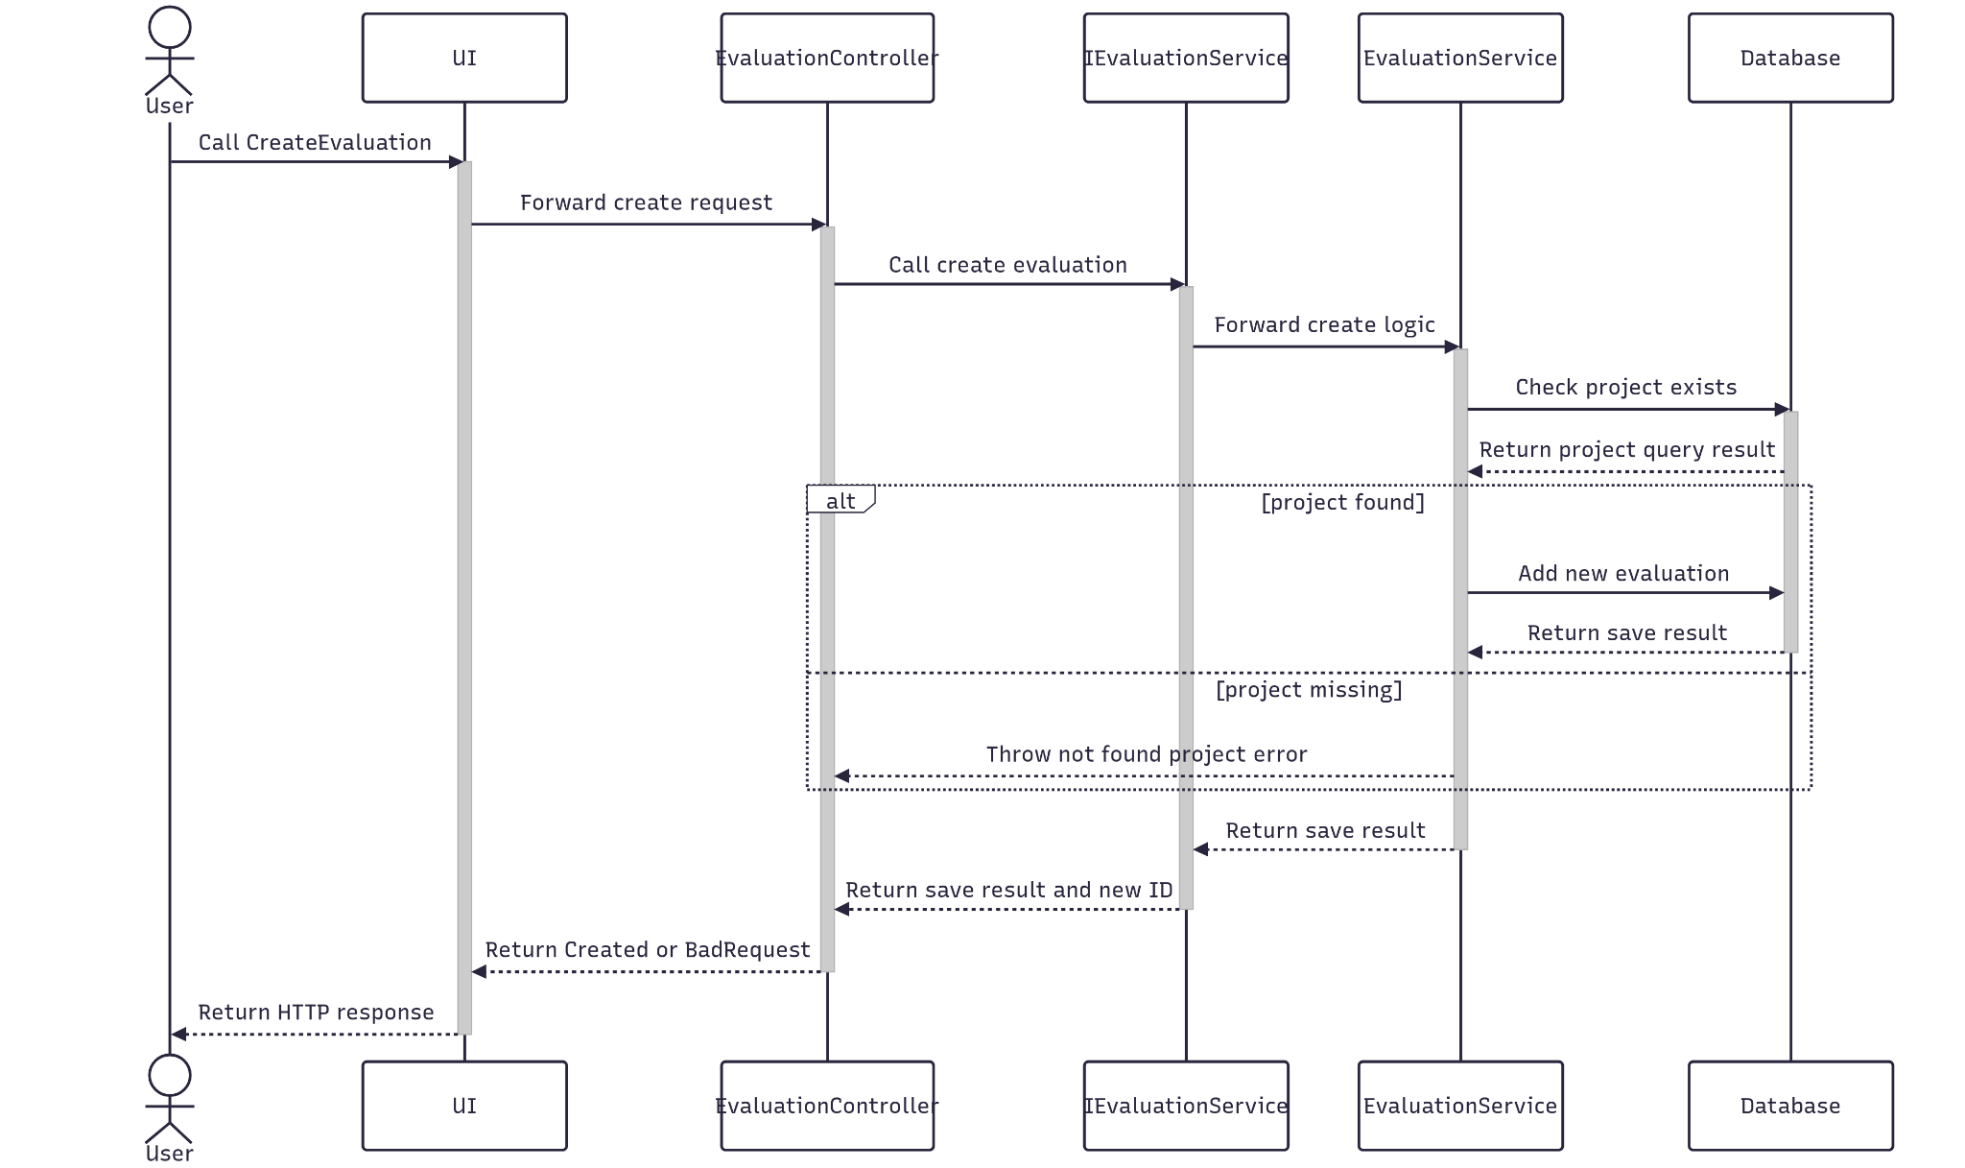

##### 3.5.1.3 Class Specification

###### 3.5.1.3.a EvaluationController

| No | Method | Description |
| --- | --- | --- |
| 1 | CreateEvaluation(RQ_Evaluation) | API endpoint that receives evaluation data from the client, invokes the service to create a new evaluation, and returns either a 201 Created with the new ID or a 400 BadRequest if creation fails. |

###### 3.5.1.3.b EvaluationService

| No | Method | Description |
| --- | --- | --- |
| 1 | CreateAsync(RQ_Document) | Service method that validates the project ID, generates a unique evaluation code using project abbreviation and current date, maps the request to an entity, saves it to the database, and returns the result status and new evaluation ID. |

#### 3.5.2.Update

##### 3.5.2.1 Class Diagram

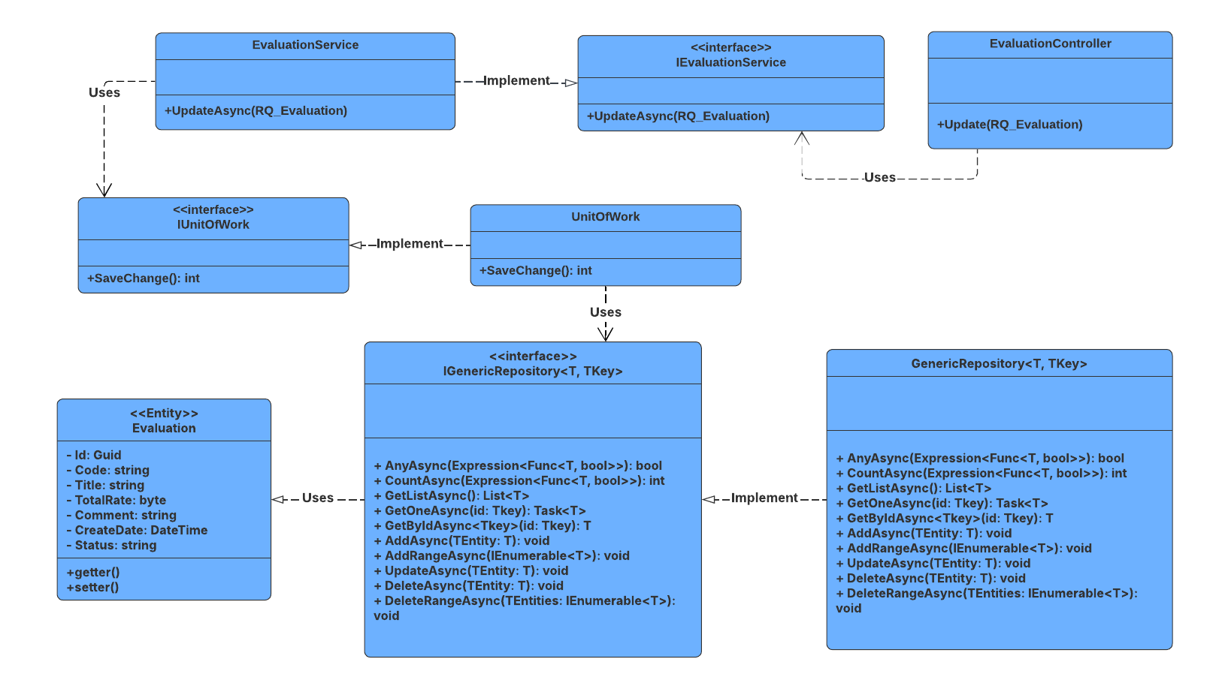

##### 3.5.2.2 Sequence Diagram

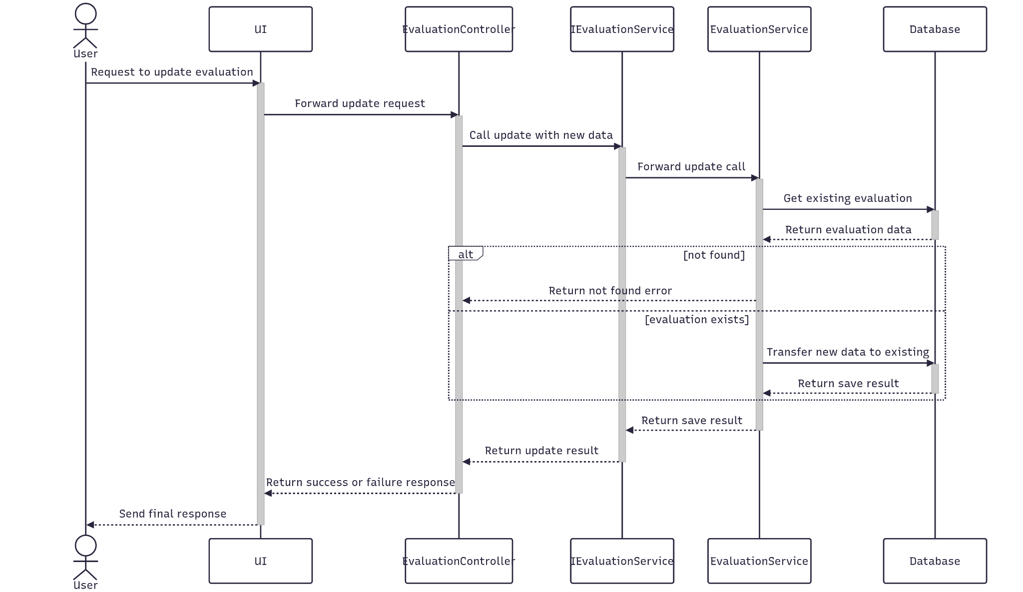

##### 3.5.2.3 Class Specification

###### 3.5.2.3.a EvaluationController

| No | Method | Description |
| --- | --- | --- |
| 1 | UpdateAsync(RQ_Evaluation) | API endpoint that receives updated evaluation data, calls the service to persist changes, and returns either 200 OK or 400 BadRequest based on success. |

###### 3.5.2.3.b EvaluationService

| No | Method | Description |
| --- | --- | --- |
| 1 | UpdateAsync(RQ_Evaluation) | Service method that fetches the existing evaluation by ID, maps the new data onto it, and saves the changes. Throws NotFoundException if the evaluation doesn't exist. |

#### 3.5.3.Get By Id

##### 3.5.3.1 Class Diagram

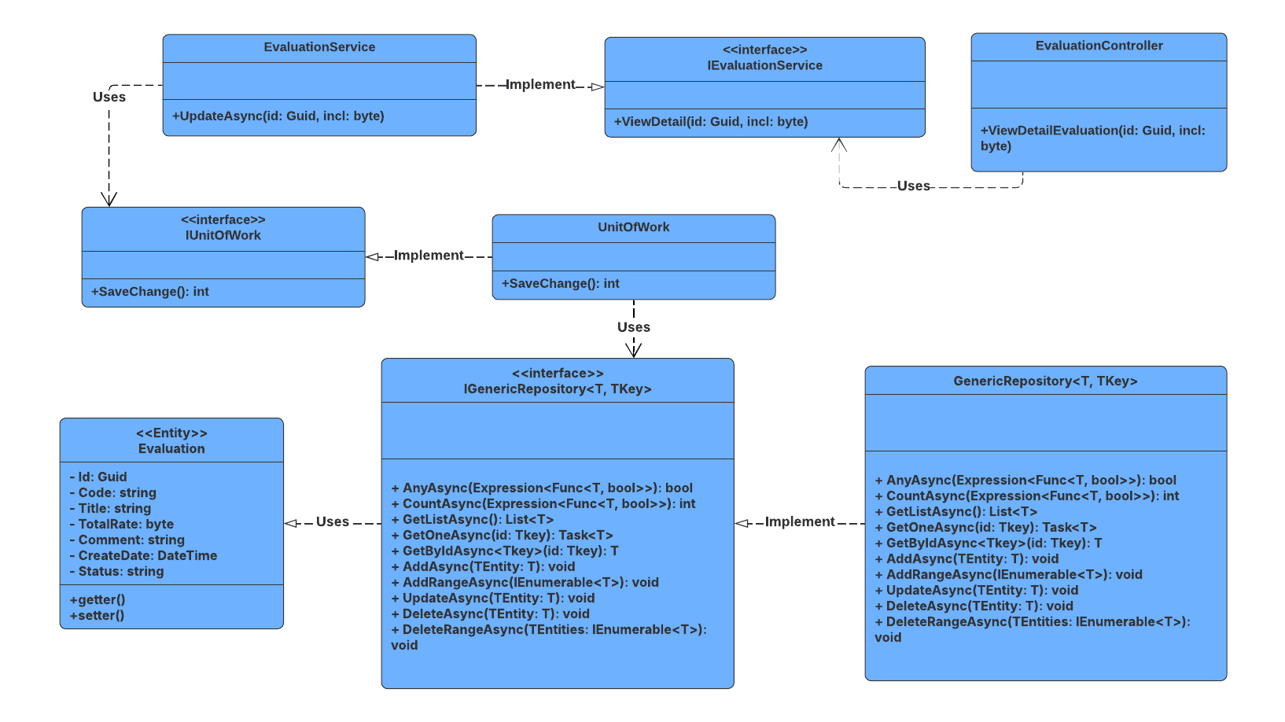

##### 3.5.3.2 Sequence Diagram

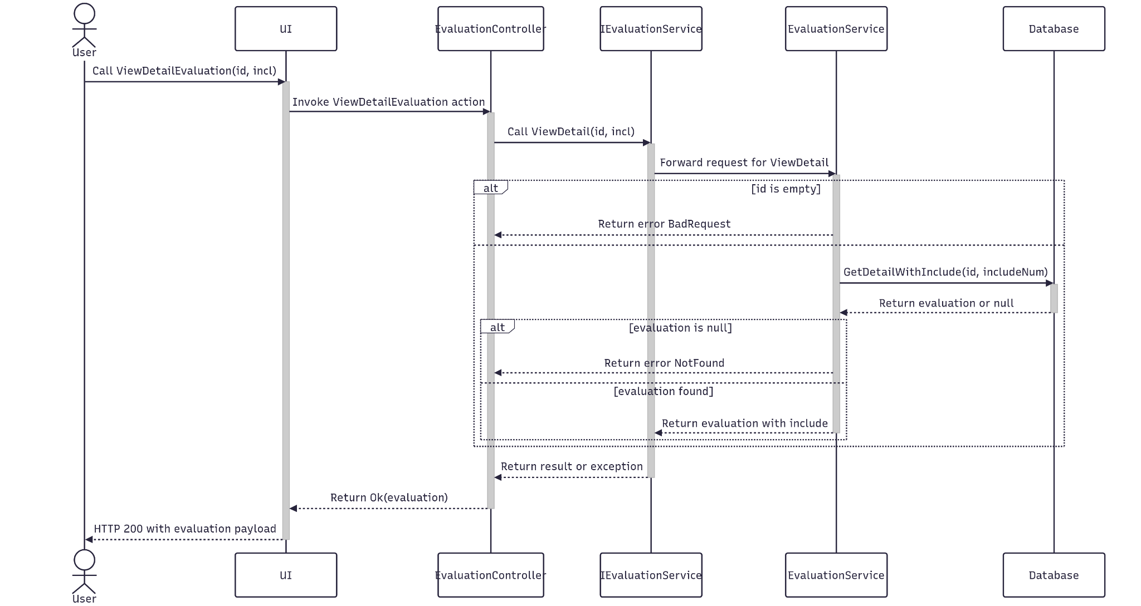

##### 3.5.3.3 Class Specification

###### 3.5.3.3.a EvaluationController

| No | Method | Description |
| --- | --- | --- |
| 1 | ViewDetailEvaluation(Guid id, byte incl) | API endpoint that retrieves detailed information about a specific evaluation by ID. Accepts an optional includeNum flag to control related data inclusion. Returns 200 OK with the evaluation details. |

###### 3.5.3.3.b EvaluationService

| No | Method | Description |
| --- | --- | --- |
| 1 | NewDocument(RQ_Document) | Service method that validates the evaluation ID, fetches detailed data with optional related entities based on includeNum, and maps the result to a response DTO. Throws BadRequestException or NotFoundException as needed. |

#### 

#### 3.5.4.Delete

##### 3.5.4.1 Class Diagram

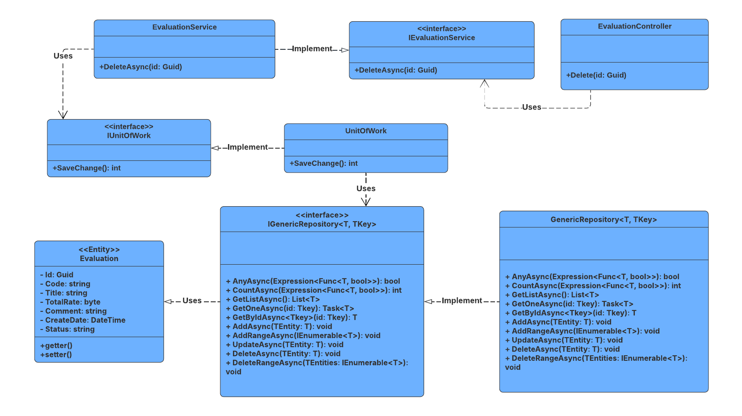

##### 3.5.4.2 Sequence Diagram

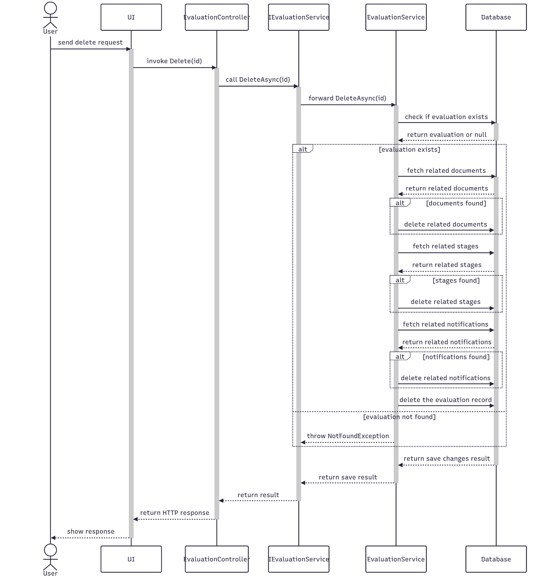

##### 3.5.4.3 Class Specification

###### 3.5.4.3.a EvaluationController

| No | Method | Description |
| --- | --- | --- |
| 1 | DeleteAsync(Guid id) | API endpoint that deletes an evaluation by ID. Returns 200 OK if successful or 400 BadRequest if deletion fails. |

###### 3.5.4.3.b EvaluationService

| No | Method | Description |
| --- | --- | --- |
| 1 | DeleteAsync(Guid id) | Service method that validates the evaluation ID, deletes related entities (documents, stages, notifications, etc.), and removes the evaluation itself. Commits changes and returns success status. |

#### 3.5.5.Get List

##### 3.5.5.1 Class Diagram

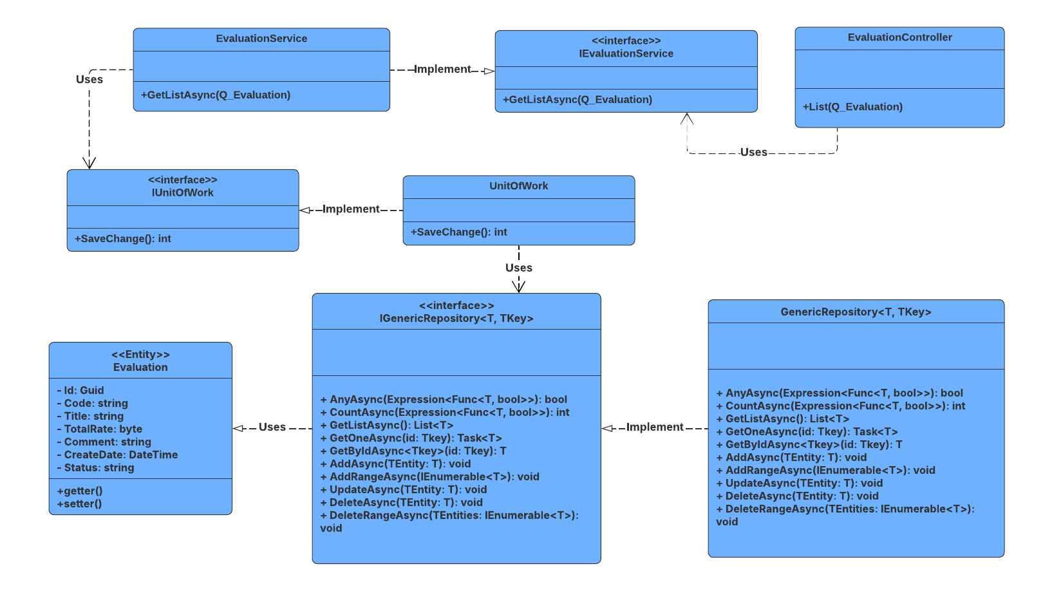

##### 3.5.5.2 Sequence Diagram

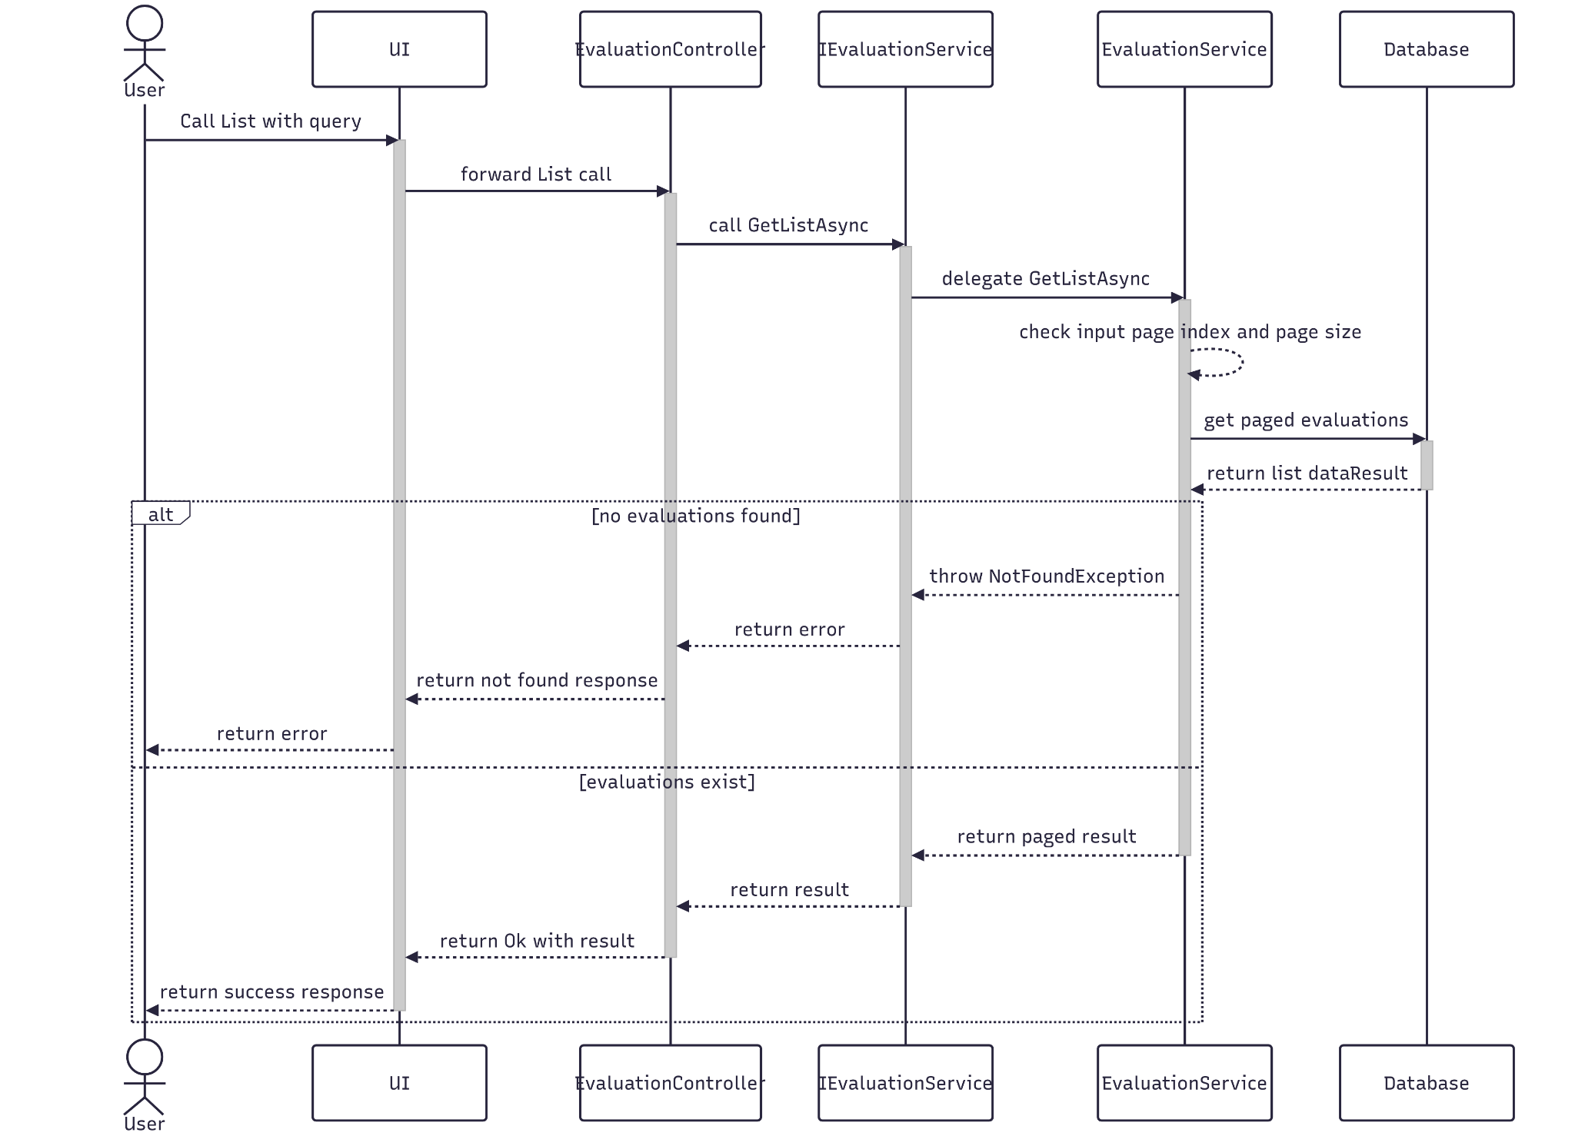

##### 3.5.5.3 Class Specification

###### 3.5.5.3.a EvaluationController

| No | Method | Description |
| --- | --- | --- |
| 1 | List(Q_Evaluation) | API endpoint that retrieves a paginated list of evaluations based on filter criteria. Returns 200 OK with a structured paging result. |

###### 3.5.5.3.b EvaluationService

| No | Method | Description |
| --- | --- | --- |
| 1 | GetListAsync(Q_Evaluation) | Service method that validates pagination inputs, queries the repository with multiple filters (e.g., keyword, status, date range, rating, project ID), and maps the result to a paginated response DTO. Throws if no evaluations are found. |

#### 3.5.6.AI Review

##### 3.5.5.1 Class Diagram

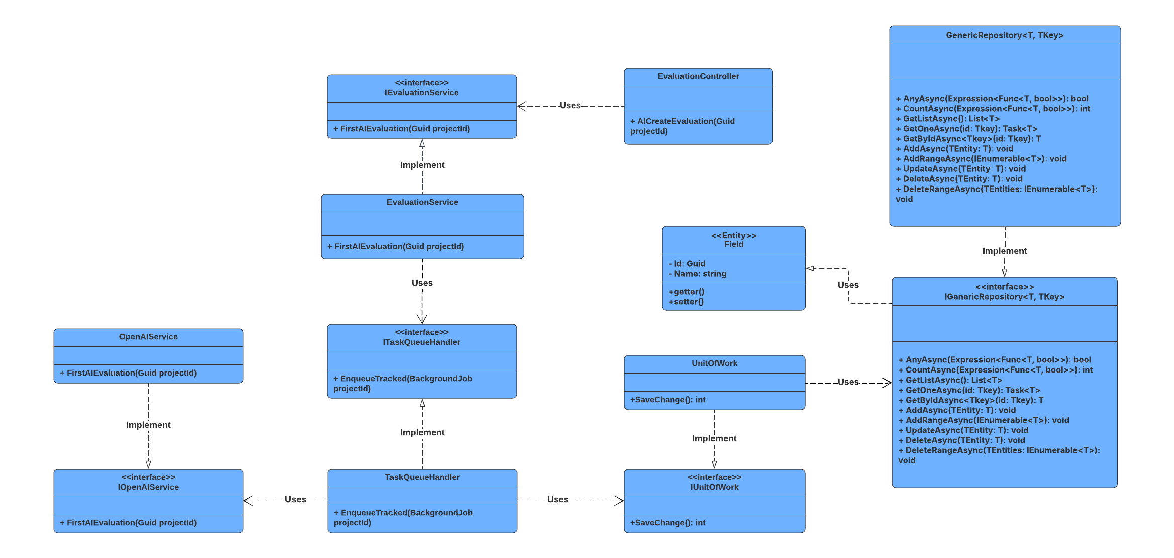

##### 3.5.5.2 Sequence Diagram

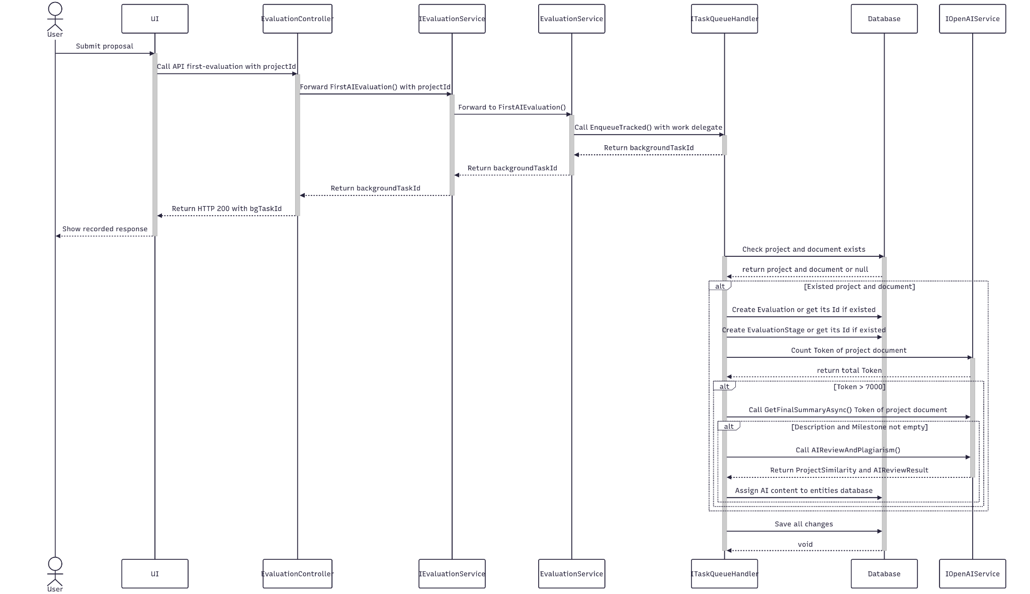

##### 3.5.5.3 Class Specification

###### 3.5.5.3.a EvaluationController

| No | Method | Description |
| --- | --- | --- |
| 1 | AICreateEvaluation(Guid projectId) | The API endpoint receives data from a topic from the client, calls the service to automatically generate a new AI assessment |

###### 

###### 3.5.5.3.b EvaluationService

| No | Method | Description |
| --- | --- | --- |
| 1 | FirstAIEvaluation(Guid projectId) | Initiates the AI ​​evaluation workflow for a specific project. This method creates a background task via ITaskQueueHandler, using IUnitOfWork to retrieve project data, documents, and evaluation entities. The document content is then processed by method AIReviewAndPlagiarism for summarization or analysis. The evaluation results are saved to the database as IndividualEvaluation and ProjectSimilarity. |
| 2 | AIReviewAndPlagiarism(  RQ_ProjectContentForAI,  CancellationToken,  IUnitOfWork,  IOpenAIService  ) | Performs an AI content assessment of a project. This function calls IOpenAIService methods to embed text, analyze content, and compare to other sources to detect plagiarism. Returns an overall assessment result and a list of similar projects. |

###### 

###### 3.5.5.3.c ITaskQueueHandler

| No | Method | Description |
| --- | --- | --- |
| 1 | EnqueueTracked(BackgroundJob) | Registers a background task with progress tracking. Returns the taskId to track its progress. |

###### 

###### 3.5.5.3.d IOpenAIService

| No | Method | Description |
| --- | --- | --- |
| 1 | EmbedTextAsync(string, CancellationToken) | Embed text into feature vectors for content comparison or semantic analysis. |
| 2 | ReviewProjectAsync(RQ_ProjectContentForAI, CancellationToken) | Analyze project content with AI to provide an overview, including comments, scores, and detailed assessment results. |
| 3 | CompareWithSourceAsync(float[], IEnumerable<RS_ProjectSimilarityResult>, CancellationToken) | Compare project content vectors with other sources to determine similarity, for plagiarism checking. |
| 4 | GetFinalSummaryAsync(string, CancellationToken) | Summarize long text content with AI, using language models to shorten information while preserving the main idea. |

### 3.6 Manage Evaluation Stage

#### 3.6.1.Create

##### 3.6.1.1 Class Diagram

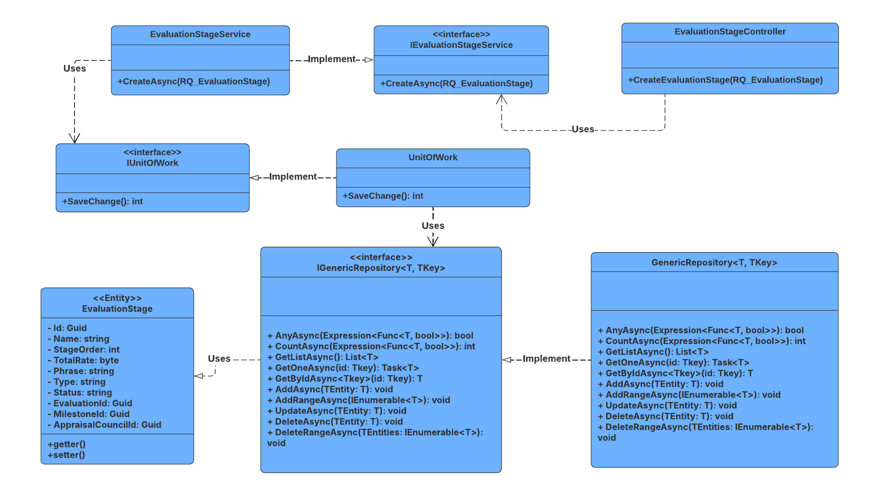

##### 3.6.1.2 Sequence Diagram

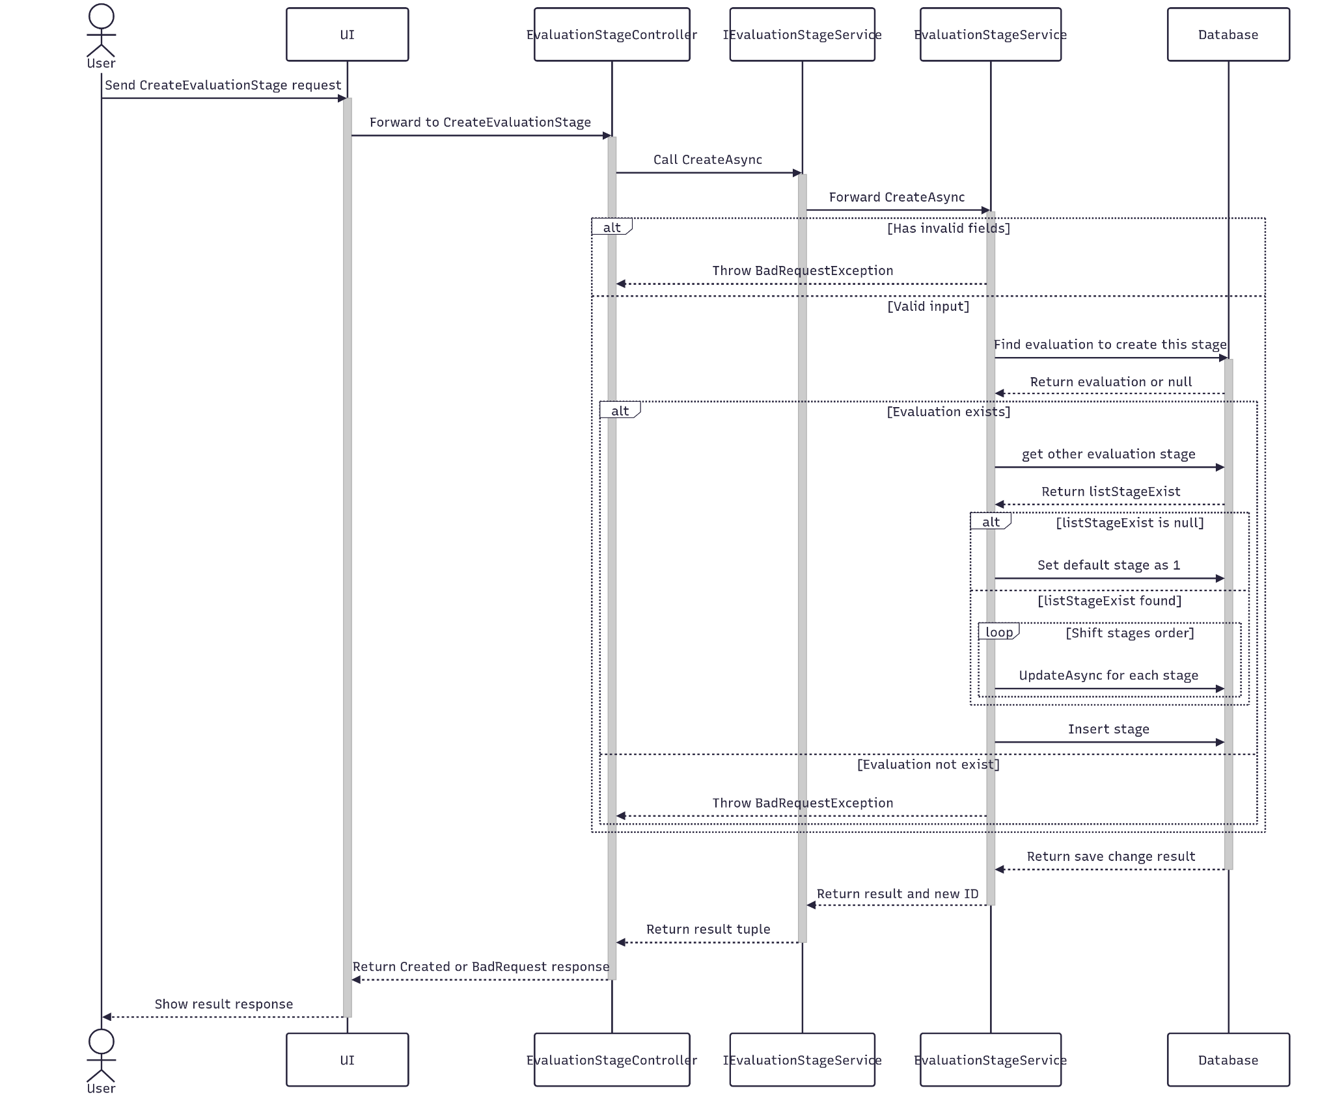

##### 3.6.1.3 Class Specification

###### 3.6.1.3.a EvaluationStageController

| No | Method | Description |
| --- | --- | --- |
| 1 | CreateEvaluationStage(RQ_EvaluationStage) | API endpoint that creates a new evaluation stage. Returns 201 Created with the new stage ID or 400 BadRequest if creation fails. |

###### 3.6.1.3.b EvaluationStageService

| No | Method | Description |
| --- | --- | --- |
| 1 | CreateAsync(RQ_EvaluationStage) | Service method that validates required fields, checks evaluation existence, dynamically adjusts stage ordering, and persists the new stage. Returns success status and new stage ID. |

#### 3.6.2.Update

##### 3.6.2.1 Class Diagram

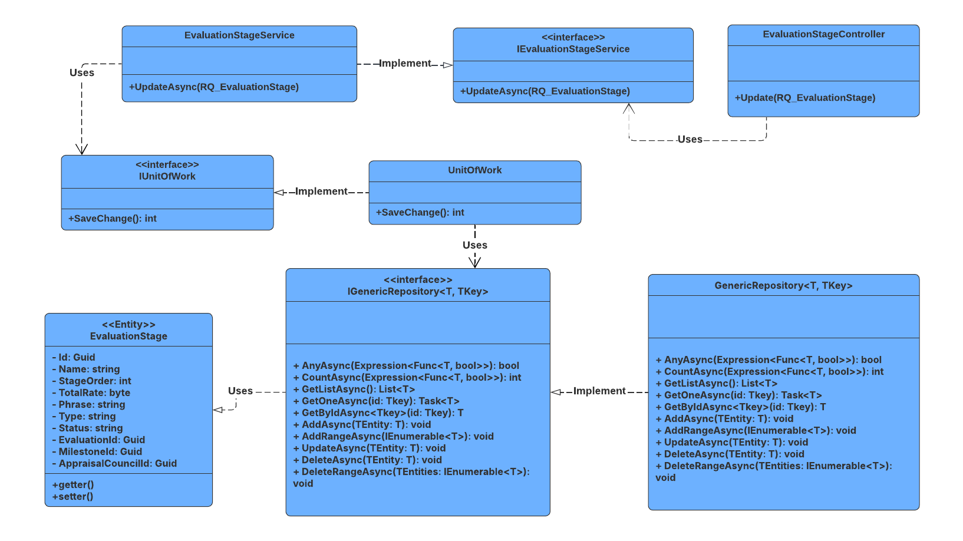

##### 3.6.2.2 Sequence Diagram

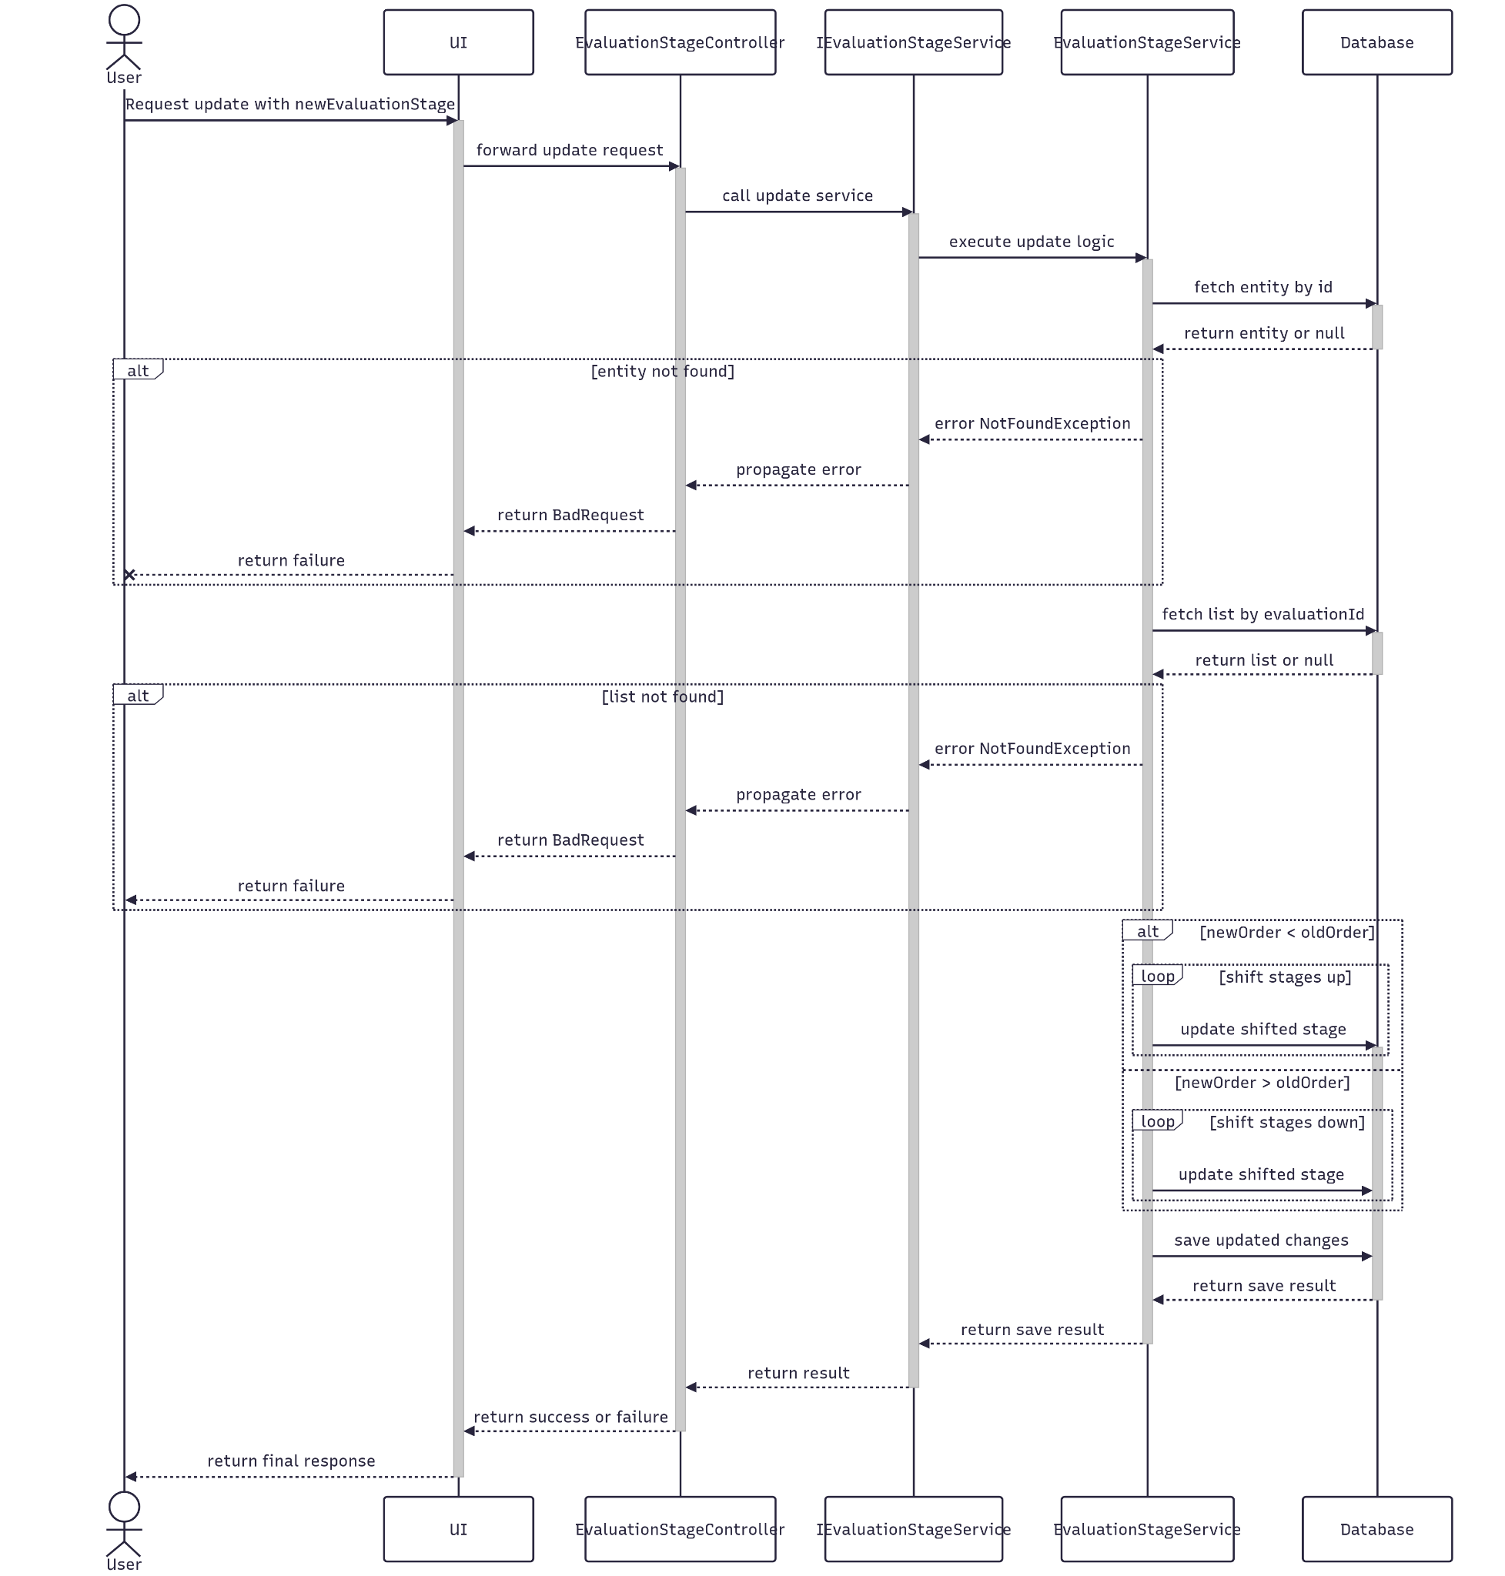

##### 3.6.2.3 Class Specification

###### 3.6.2.3.a EvaluationStageController

| No | Method | Description |
| --- | --- | --- |
| 1 | Update(RQ_EvaluationStage | API endpoint that updates an existing evaluation stage. Returns 200 OK if successful or 400 BadRequest if the update fails. |

###### 3.6.2.3.b EvaluationStageService

| No | Method | Description |
| --- | --- | --- |
| 1 | UpdateAsync(RQ_EvaluationStage) | Service method that validates the stage ID, adjusts ordering of other stages based on the new position, applies updated data, and saves changes. Throws if the stage or its evaluation context is not found. |

#### 3.6.3.Get By Id

##### 3.6.3.1 Class Diagram

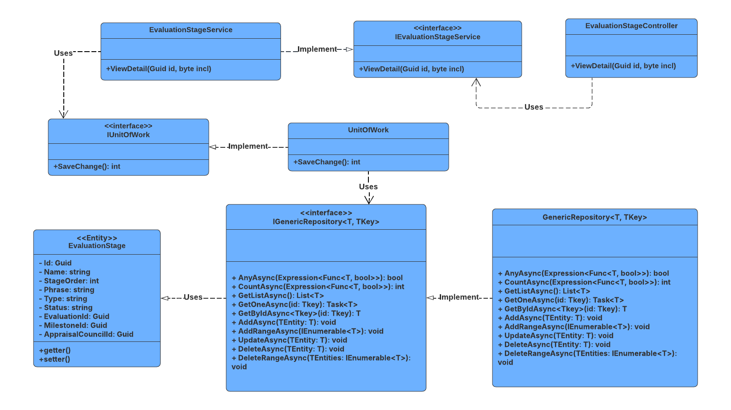

##### 3.6.3.2 Sequence Diagram

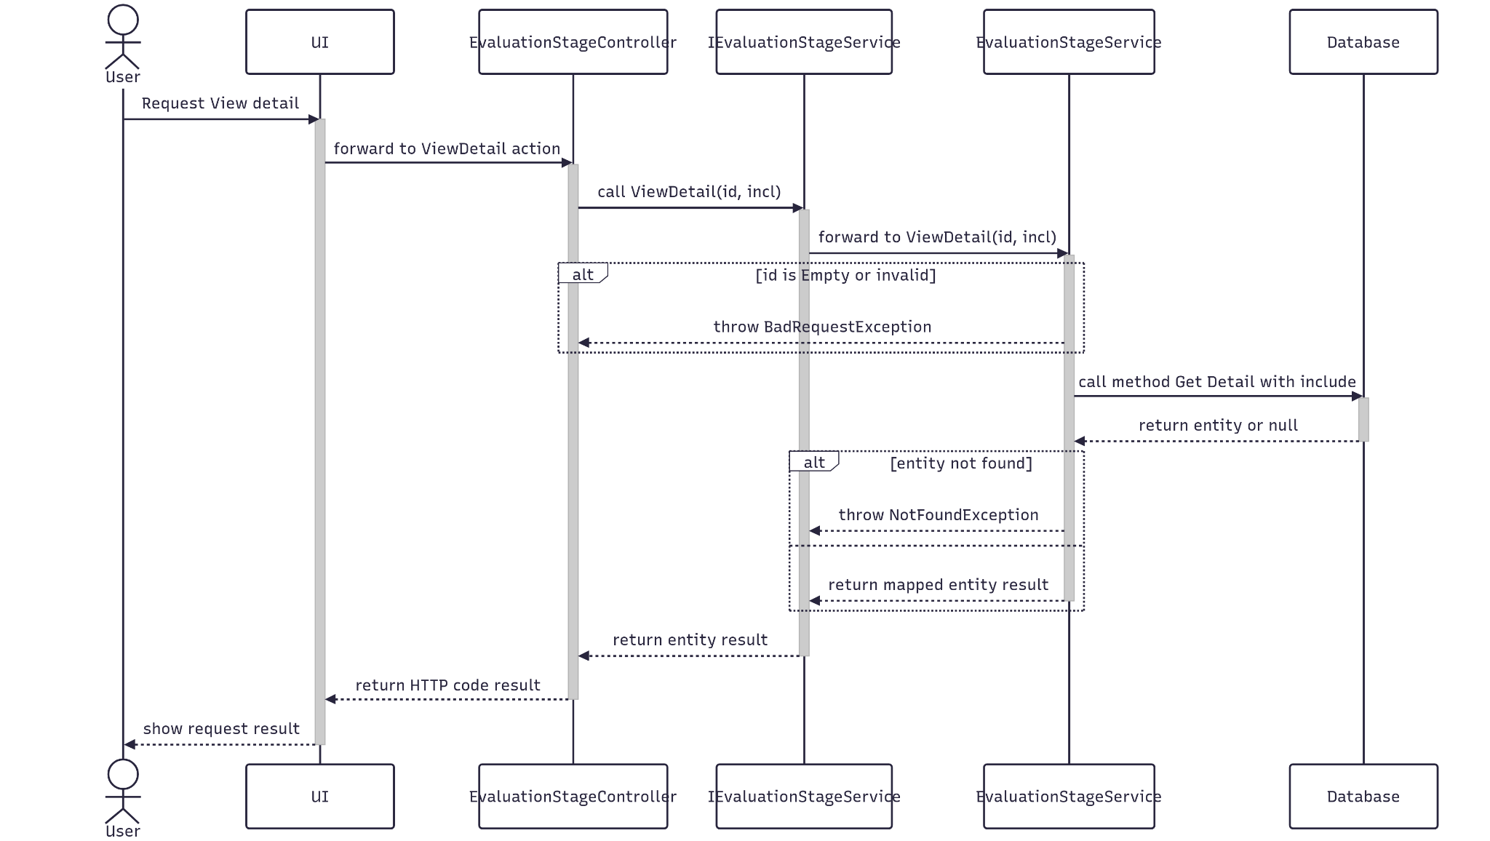

##### 3.6.3.3 Class Specification

###### 3.6.3.3.a EvaluationStageController

| No | Method | Description |
| --- | --- | --- |
| 1 | ViewDetail(Guid id, byte incl) | API endpoint that retrieves detailed information about a specific evaluation stage by ID. Accepts an optional includeNum flag to control related data inclusion. Returns 200 OK with the evaluation stage details. |

###### 3.6.3.3.b EvaluationStageService

| No | Method | Description |
| --- | --- | --- |
| 1 | ViewDetail(Guid id, byte incl) | Service method that validates the evaluation stage ID, fetches detailed data with optional related entities based on includeNum, and maps the result to a response DTO. Throws BadRequestException or NotFoundException as needed. |

#### 3.6.4.Delete

##### 3.6.4.1 Class Diagram

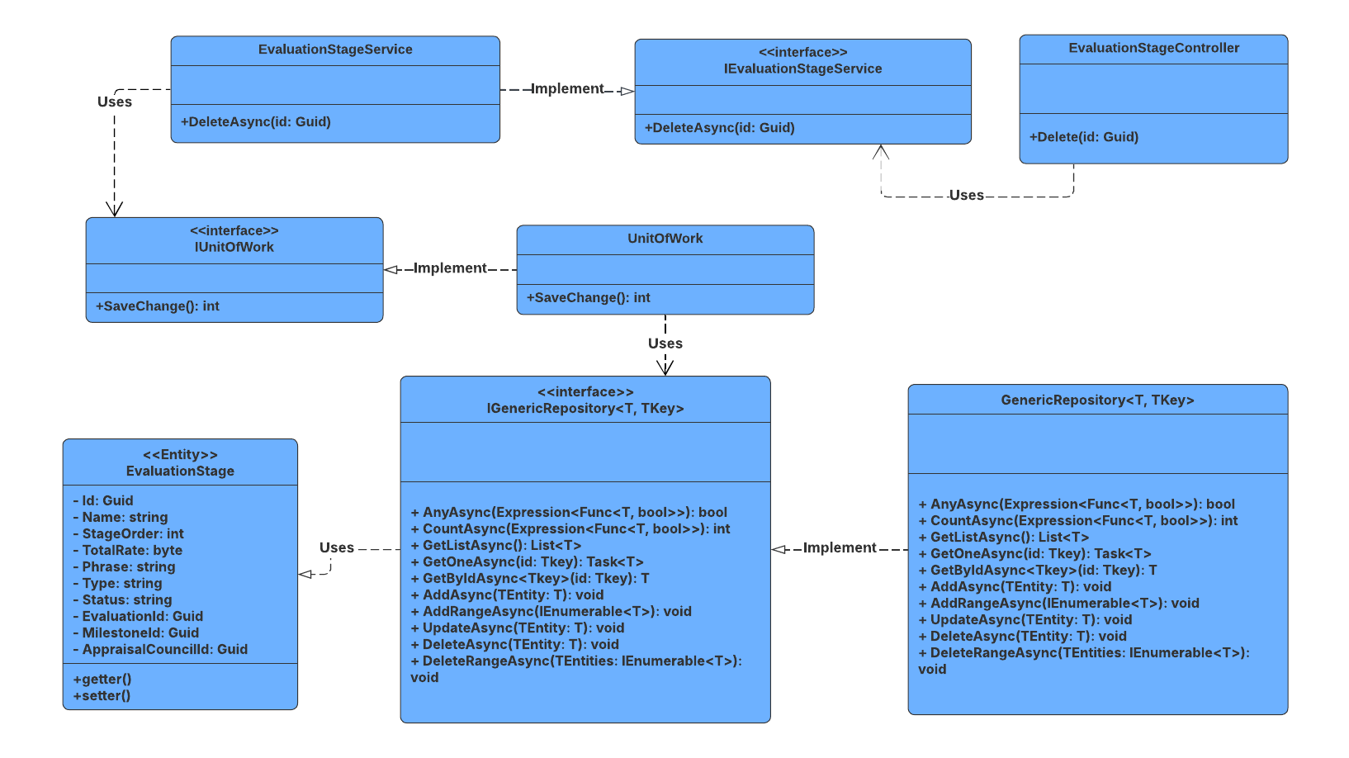

##### 3.6.4.2 Sequence Diagram

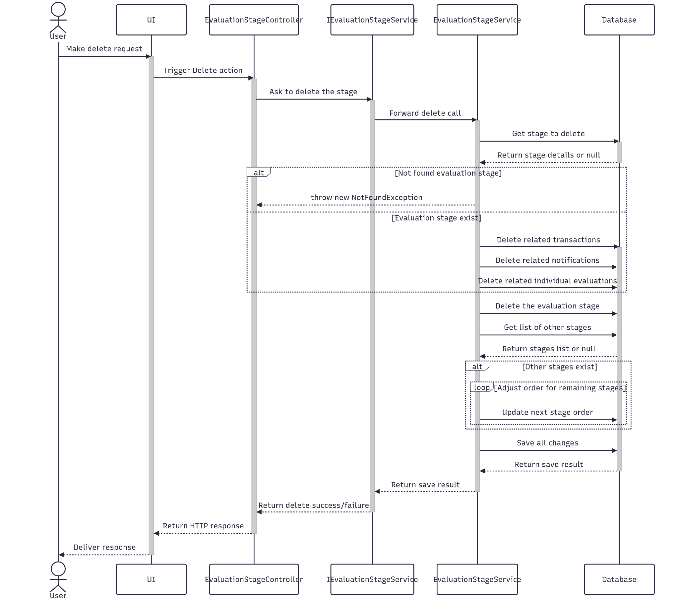

##### 3.6.4.3 Class Specification

###### 3.6.4.3.a EvaluationStageController

| No | Method | Description |
| --- | --- | --- |
| 1 | Delete(Guid id) | API endpoint that deletes an evaluation stage by ID. Returns 200 OK on success or 400 Bad Request on failure. |

###### 3.6.4.3.b EvaluationStageService

| No | Method | Description |
| --- | --- | --- |
| 1 | DeleteAsync(Guid id) | Service method that performs a cascade delete of an evaluation stage and its related transactions, notifications, and individual evaluations. Also reorders remaining stages to maintain sequence integrity. Throws if the stage or related evaluation stages are not found. |

#### 3.6.5.Get List

##### 3.6.5.1 Class Diagram

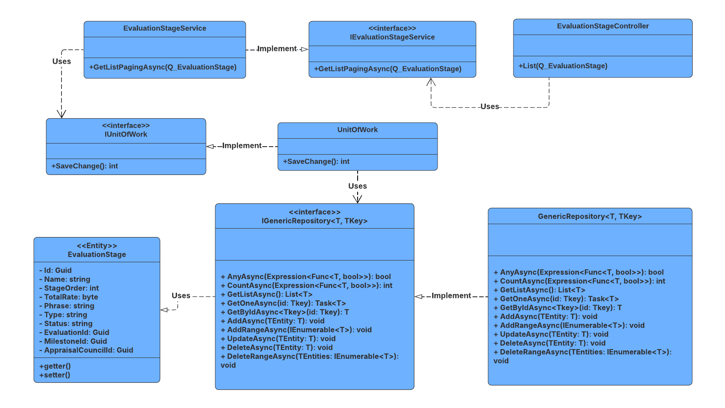

##### 3.6.5.2 Sequence Diagram

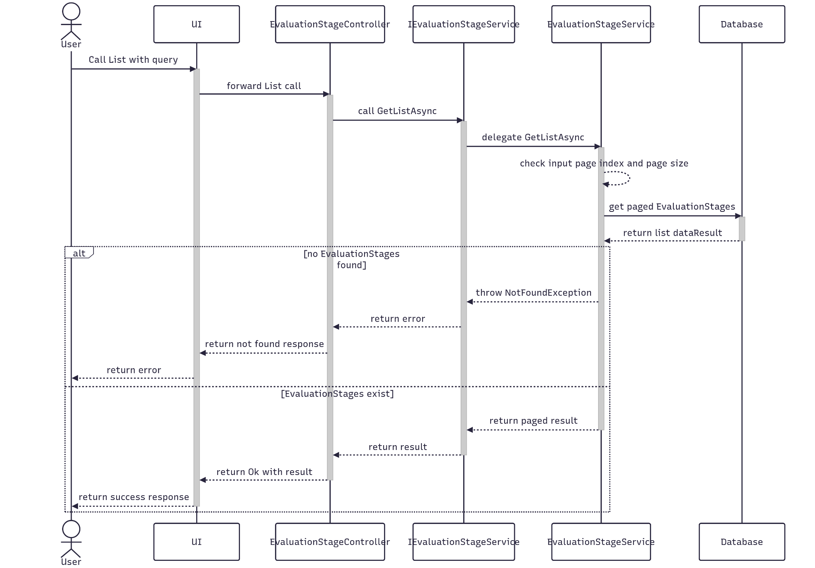

##### 3.6.5.3 Class Specification

###### 3.6.5.3.a EvaluationStageController

| No | Method | Description |
| --- | --- | --- |
| 1 | List(Q_EvaluationStage queryInput) | API endpoint that receives a query payload and returns a paginated list of evaluation stages. Responds with 200 OK and the result from GetListPagingAsync. |

###### 3.6.5.3.b EvaluationStageService

| No | Method | Description |
| --- | --- | --- |
| 1 | GetListPagingAsync(Q_EvaluationStage) | Service method that validates pagination parameters, queries the repository with multiple filters, and returns a paginated list of evaluation stages. Throws NotFoundException if no results are found. |

### 3.7 Manage Individual Evaluation

#### 3.7.1.Create

##### 3.7.1.1 Class Diagram

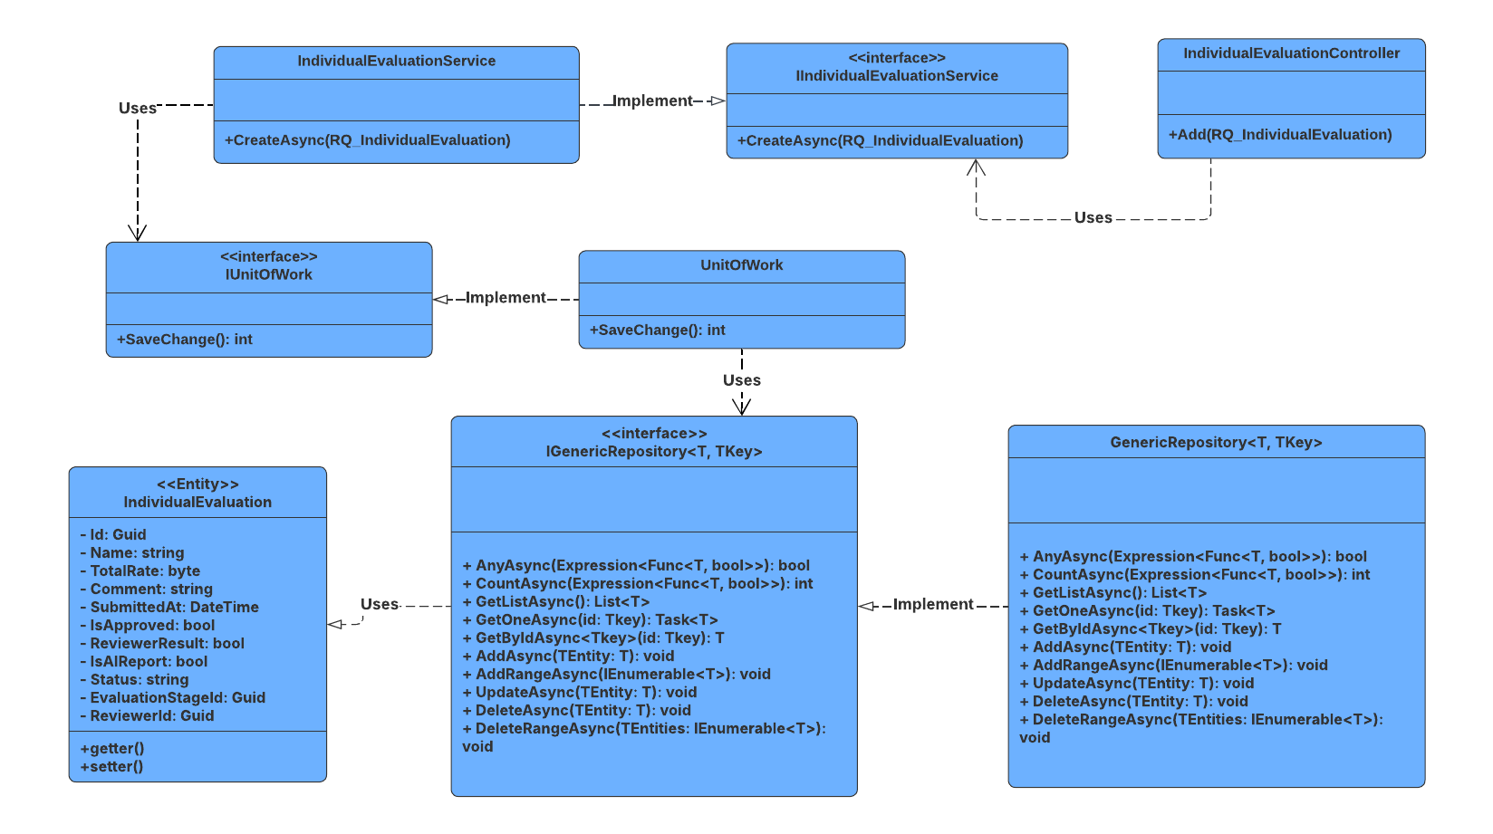

##### 3.7.1.2 Sequence Diagram

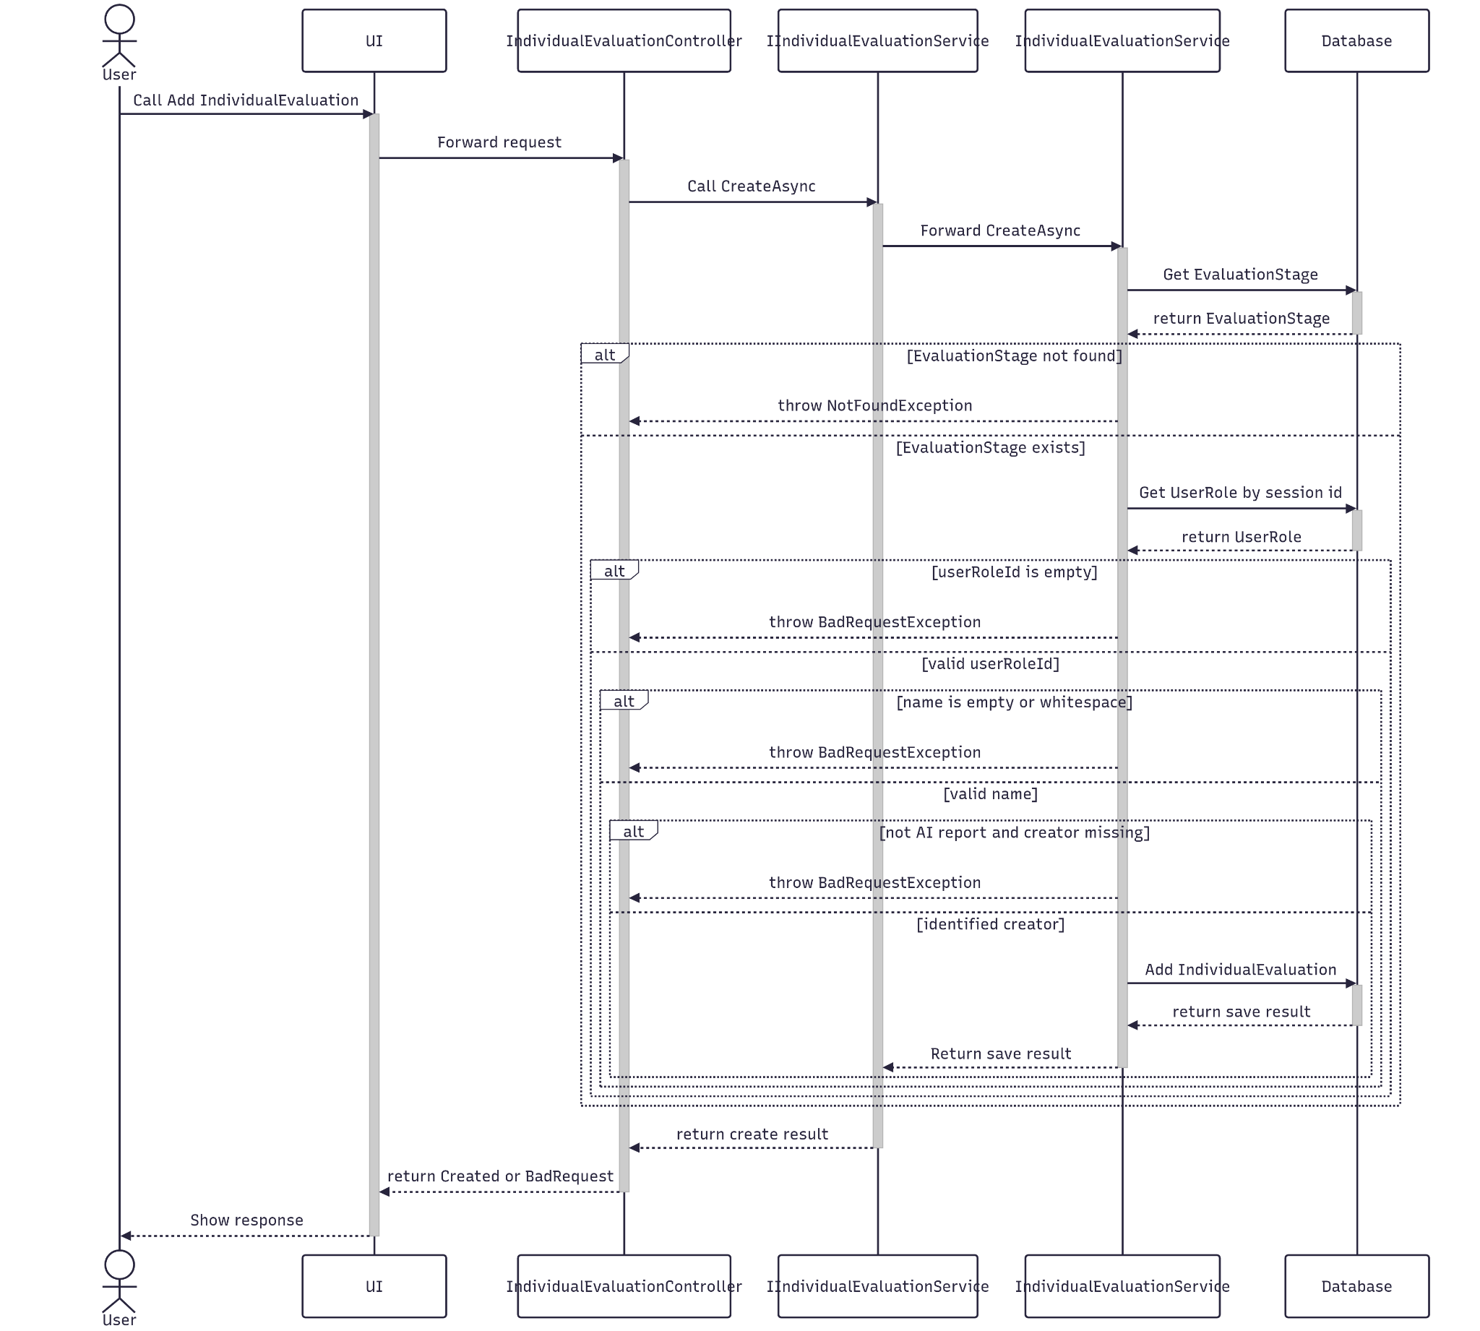

##### 3.7.1.3 Class Specification

###### 3.7.1.3.a IndividualEvalutionController

| No | Method | Description |
| --- | --- | --- |
| 1 | Add(RQ_IndividualEvaluation) | Receives Individual Evaluation information and calls CreateAsync to save it. |

###### 3.7.1.3.b IndividualEvalutiontService

| No | Method | Description |
| --- | --- | --- |
| 1 | CreateAsync(RQ_IndividualEvaluation) | Map it to the database entity and save it in the database. |

#### 3.7.2.Update

##### 3.7.2.1 Class Diagram

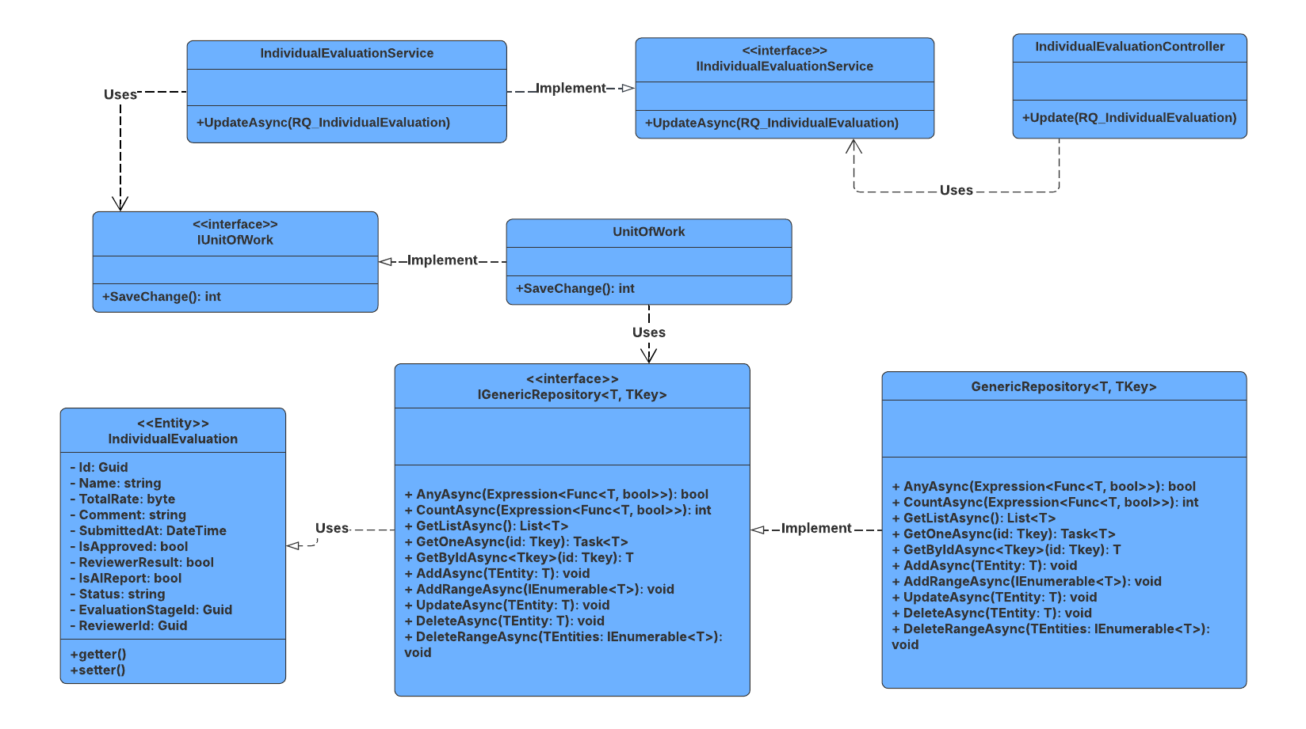

##### 3.7.2.2 Sequence Diagram

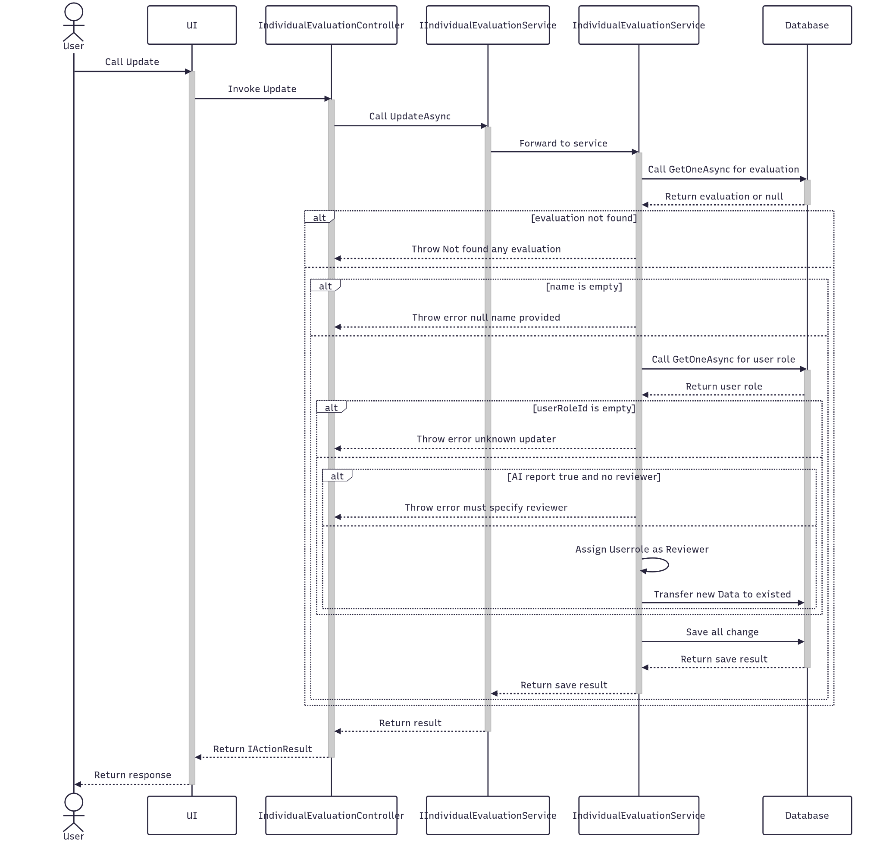

##### 3.7.2.3 Class Specification

###### 3.7.2.3.a IndividualEvalutionController

| No | Method | Description |
| --- | --- | --- |
| 1 | Update(RQ_IndividualEvaluation) | Receives new Individual Evaluation data and calls UpdateAsync to update existing Individual Evaluation in the database. |

###### 3.7.2.3.b IndividualEvalutionService

| No | Method | Description |
| --- | --- | --- |
| 1 | UpdateAsync(RQ_IndividualEvaluation) | Map the received data to existing Individual Evaluation in the database entity and save it. |

#### 3.7.3.Get By Id

##### 3.7.3.1 Class Diagram

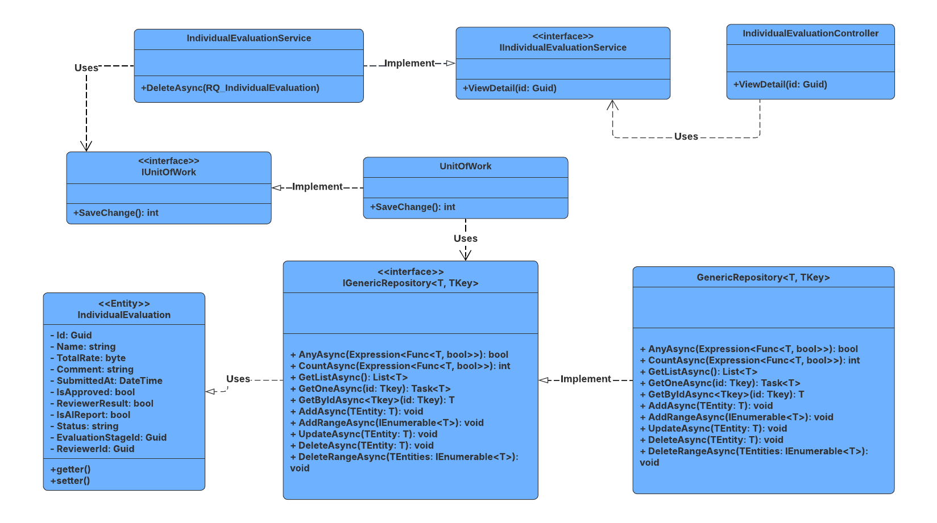

##### 3.7.3.2 Sequence Diagram

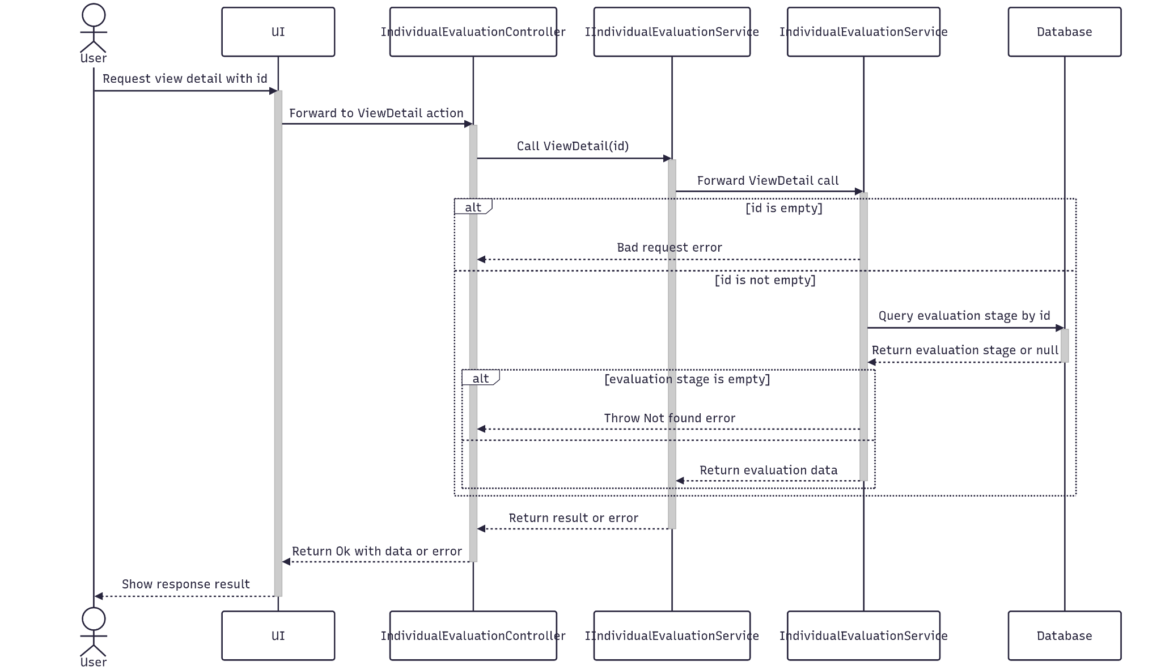

##### 3.7.3.3 Class Specification

###### 3.7.3.3.a IndividualEvalutionController

| No | Method | Description |
| --- | --- | --- |
| 1 | ViewDetail(Guid id) | Receives Individual Evaluation Id and calls ViewDetail in Service to get detailed information of an IndividualEvalution. |

###### 3.7.3.3.b IndividualEvalutionService

| No | Method | Description |
| --- | --- | --- |
| 1 | ViewDetail(Guid id) | Query Individual Evaluation match with this Id in the database to get detailed information. |

#### 3.7.4.Delete

##### 3.7.4.1 Class Diagram

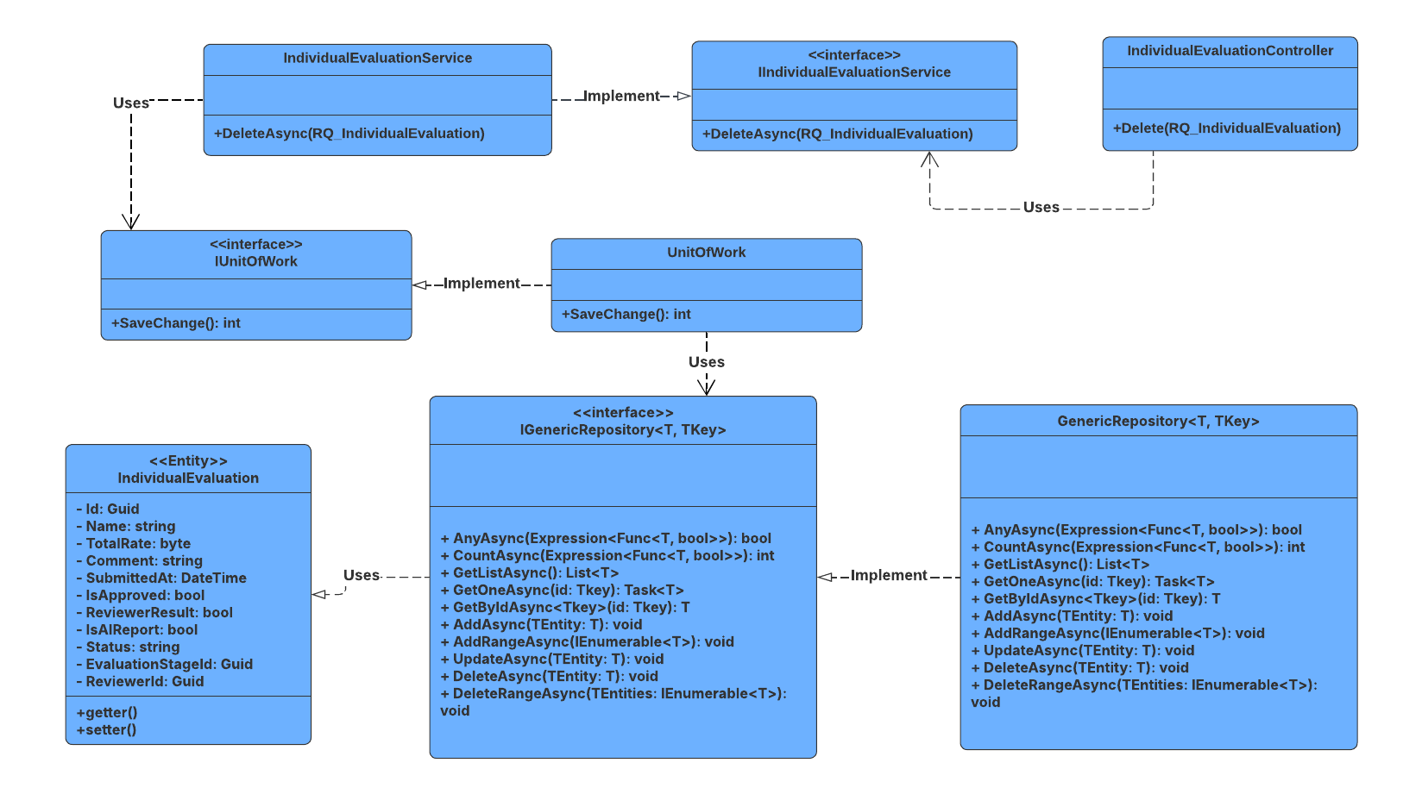

##### 3.7.4.2 Sequence Diagram

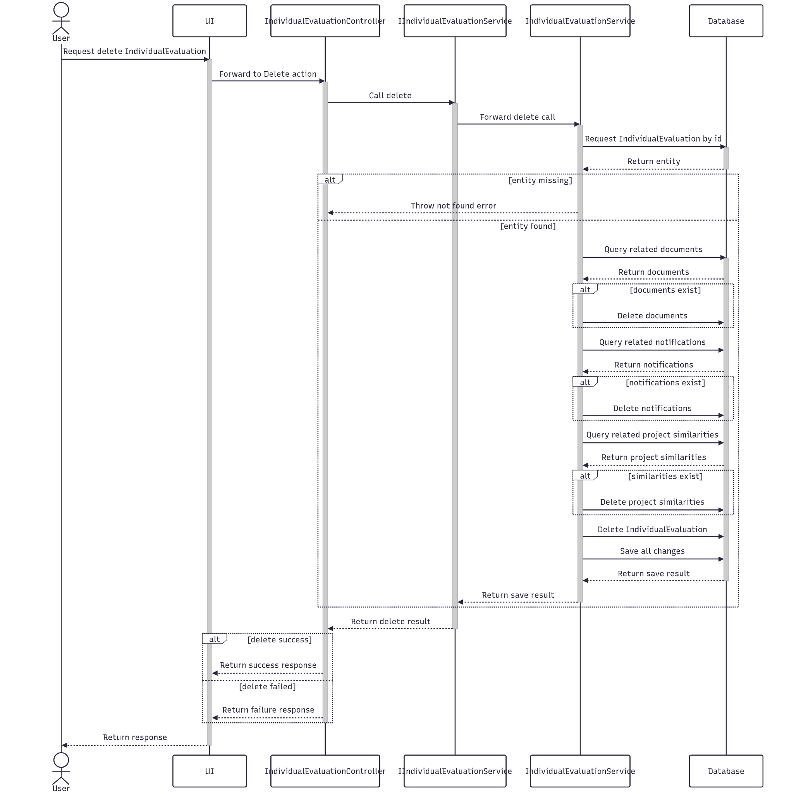

##### 3.7.4.3 Class Specification

###### 3.7.4.3.a IndividualEvalutionController

| No | Method | Description |
| --- | --- | --- |
| 1 | Delete(Guid id) | Receives the evaluation ID and calls DeleteAsync in the service layer to process the deletion. |

###### 3.7.4.3.b IndividualEvalutionService

| No | Method | Description |
| --- | --- | --- |
| 1 | DeleteAsync(Guid id) | Find the corresponding database entity that matches the individual evaluation ID to remove it from the database. |

#### 3.7.5.Get List

##### 3.7.5.1 Class Diagram

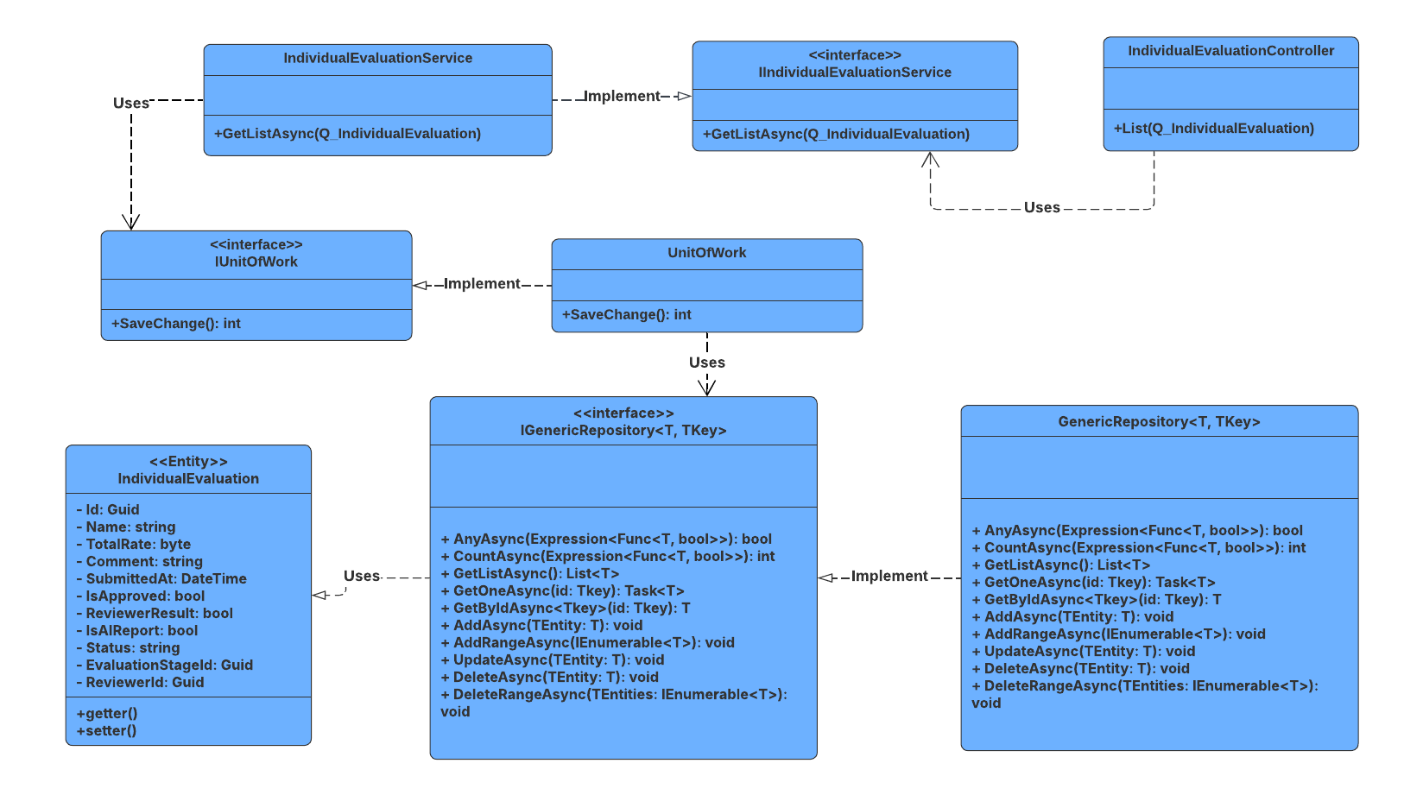

##### 3.7.5.2 Sequence Diagram

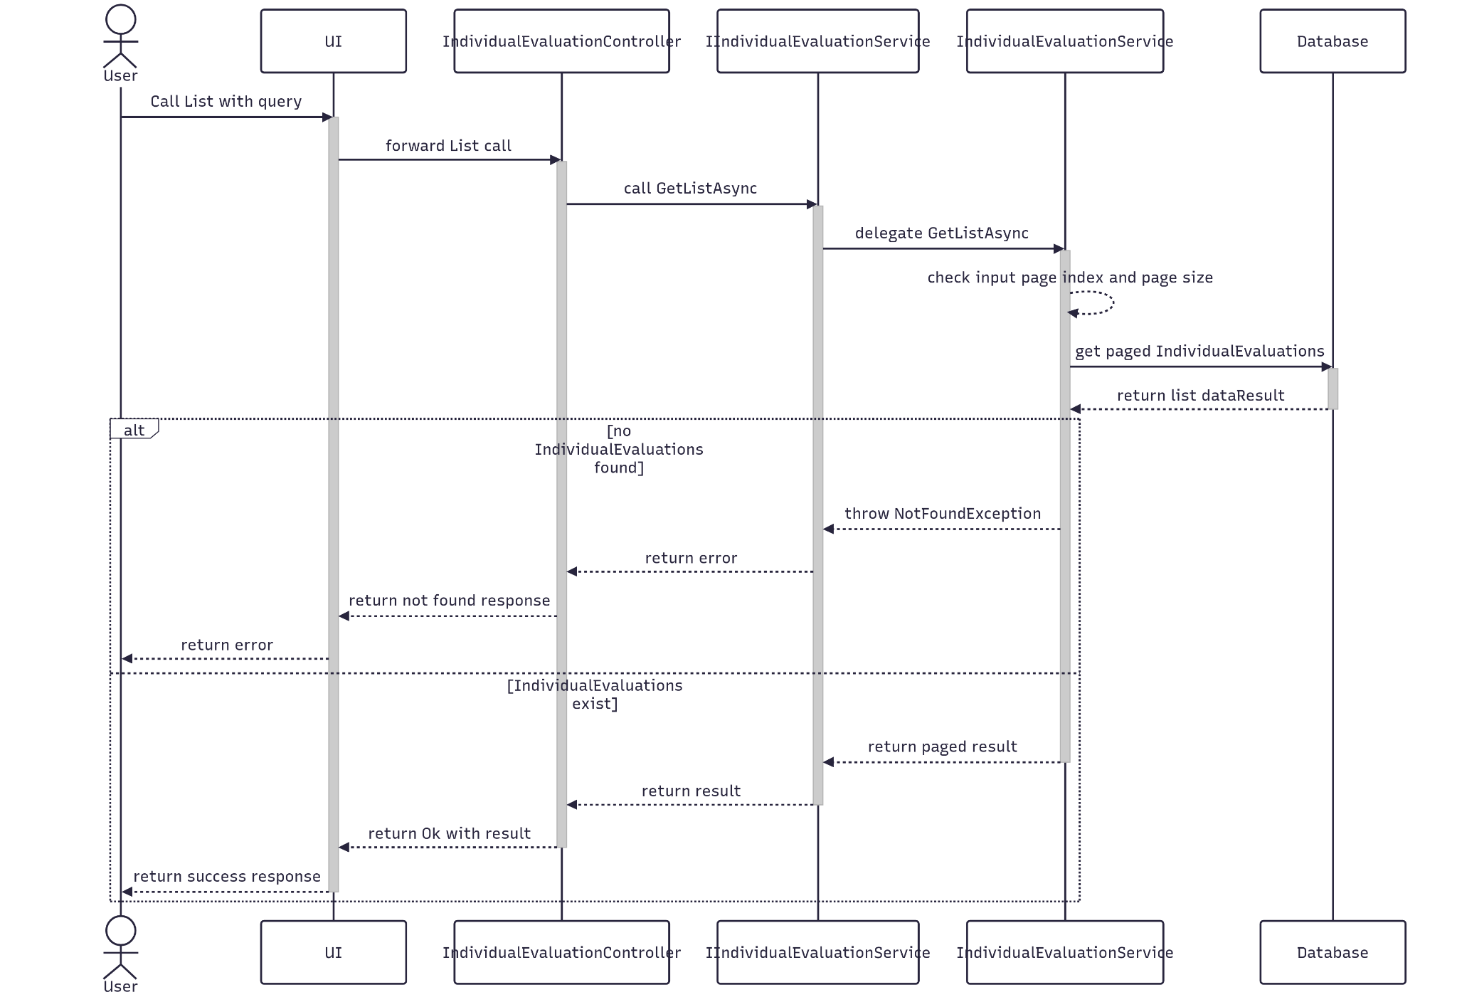

##### 3.7.5.3 Class Specification

###### 3.7.5.3.a IndividualEvalutionController

| No | Method | Description |
| --- | --- | --- |
| 1 | List(Q_IndividualEvaluation) | Receives custom input data and calls GetListAsync to query with paging in the database. |

###### 3.7.5.3.b IndividualEvalutionService

| No | Method | Description |
| --- | --- | --- |
| 1 | GetListAsync(Q_IndividualEvaluation) | Receives input data from controller to query in database entity and return a list of Individual Evalution with paged format. |

### 3.8 Manage Fields

#### 3.8.1.Create

##### 3.8.1.1 Class Diagram

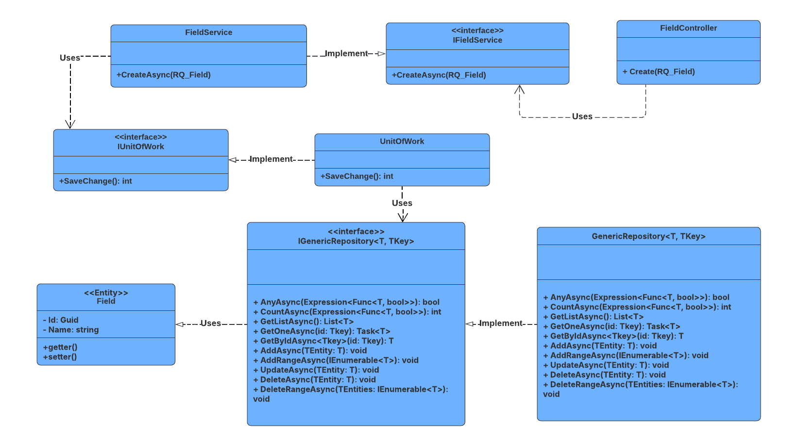

##### 3.8.1.2 Sequence Diagram

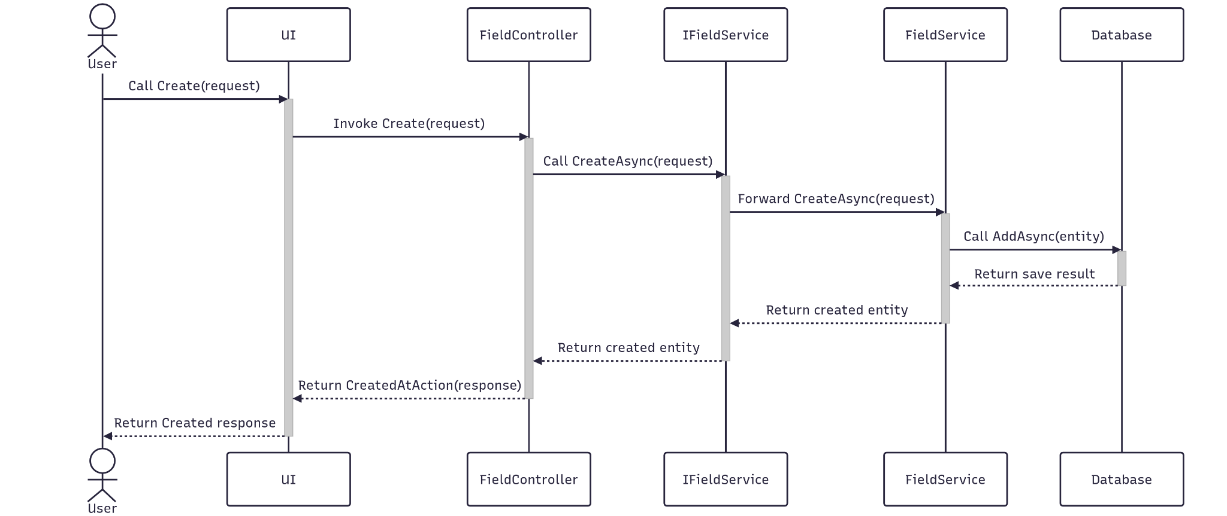

##### 3.8.1.3 Class Specification

###### 3.8.1.3.a FieldController

| No | Method | Description |
| --- | --- | --- |
| 1 | Create(RQ_Field) | API endpoint that creates a new field. Returns 201 Created with the new field ID or 400 BadRequest if creation fails. |

###### 3.8.1.3.b FieldService

| No | Method | Description |
| --- | --- | --- |
| 1 | CreateAsync(RQ_Field) | Service method that returns success status and new field ID. |

#### 3.8.2.Update

##### 3.8.2.1 Class Diagram

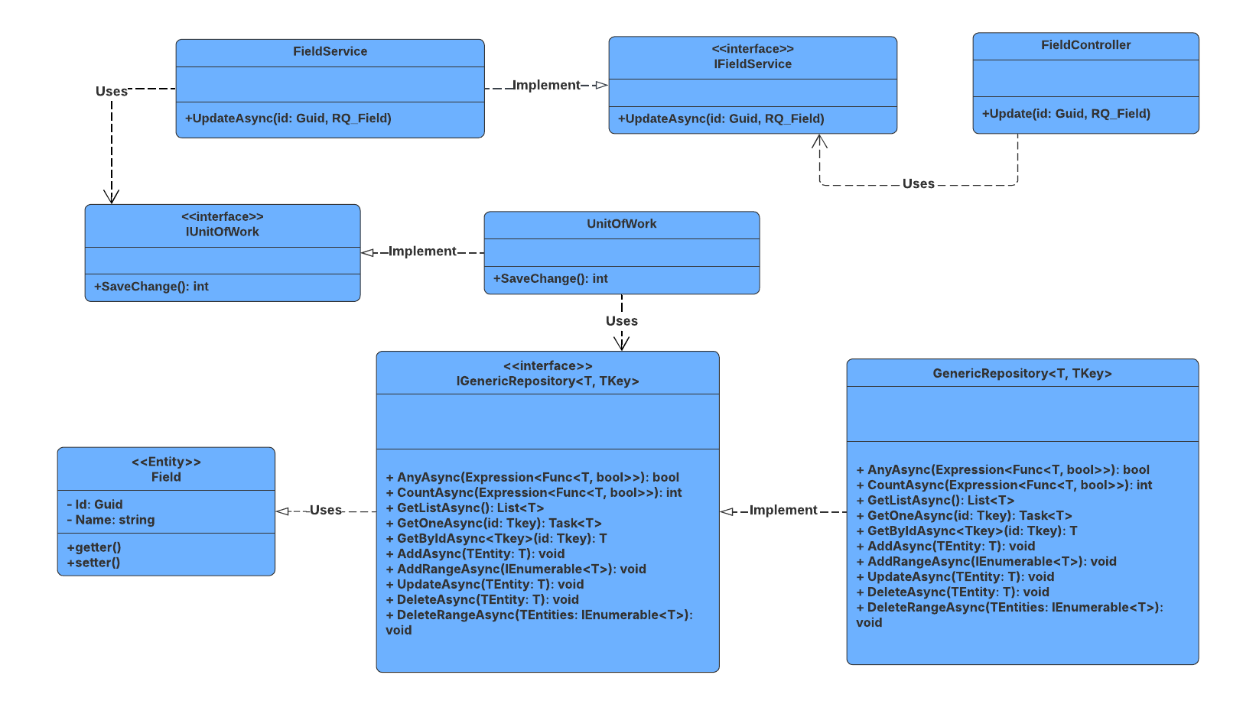

##### 3.8.2.2 Sequence Diagram

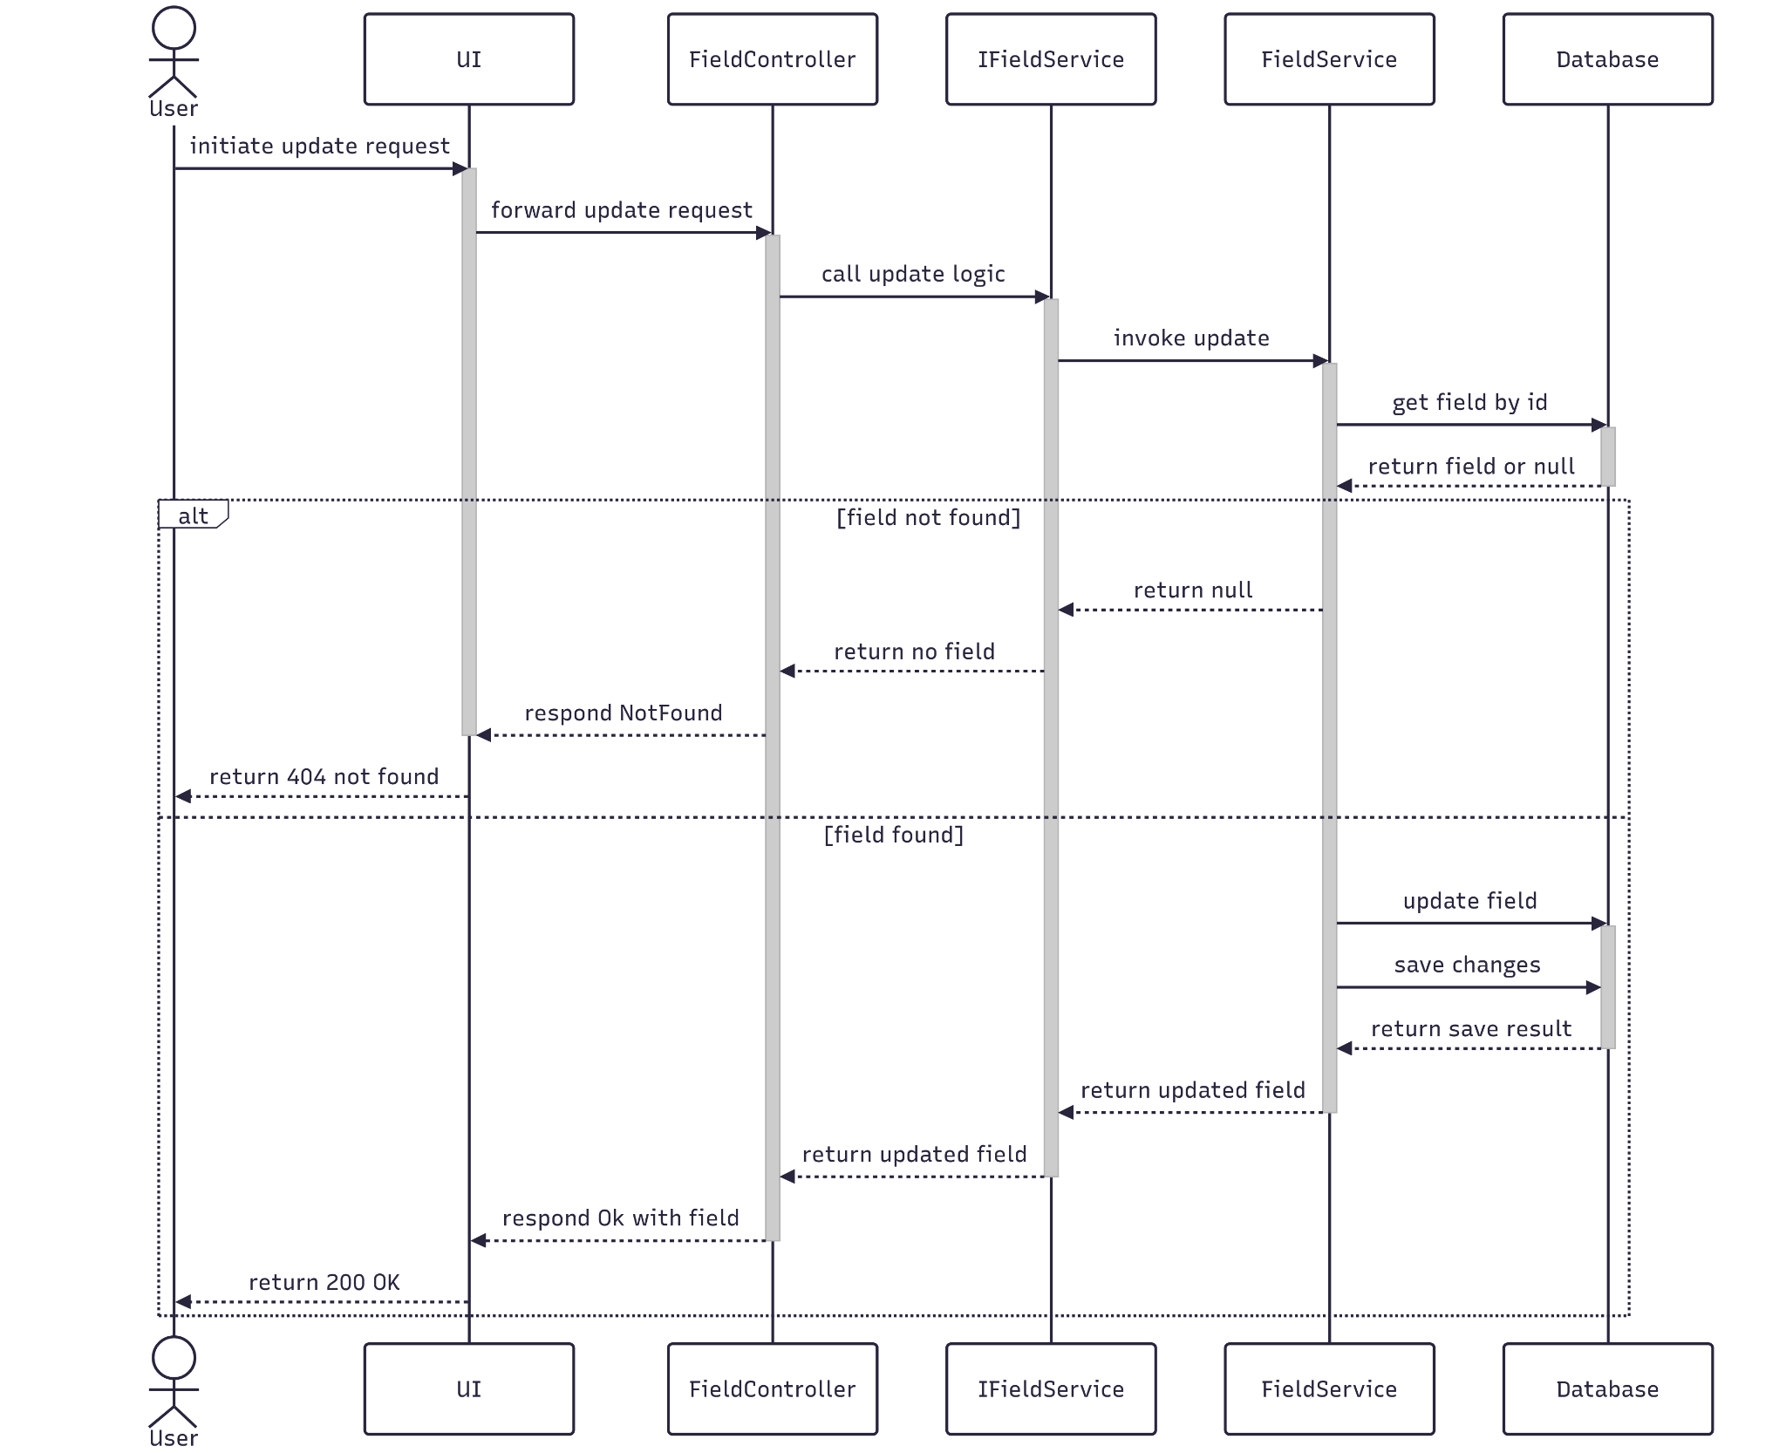

##### 3.8.2.3 Class Specification

##### 3.8.2.3.a FieldController

| No | Method | Description |
| --- | --- | --- |
| 1 | Update(Guid id, RQ_Field) | API endpoint that updates an existing field. Returns 200 OK if successful or 400 BadRequest if the update fails. |

3.8.2.3.b FieldService

| No | Method | Description |
| --- | --- | --- |
| 1 | UpdateAsync(Guid id, RQ_Field) | Service method that applies updated data, and saves changes. Throws if the field or its evaluation context is not found. |

#### 3.8.3.Get By Id

##### 3.8.3.1 Class Diagram

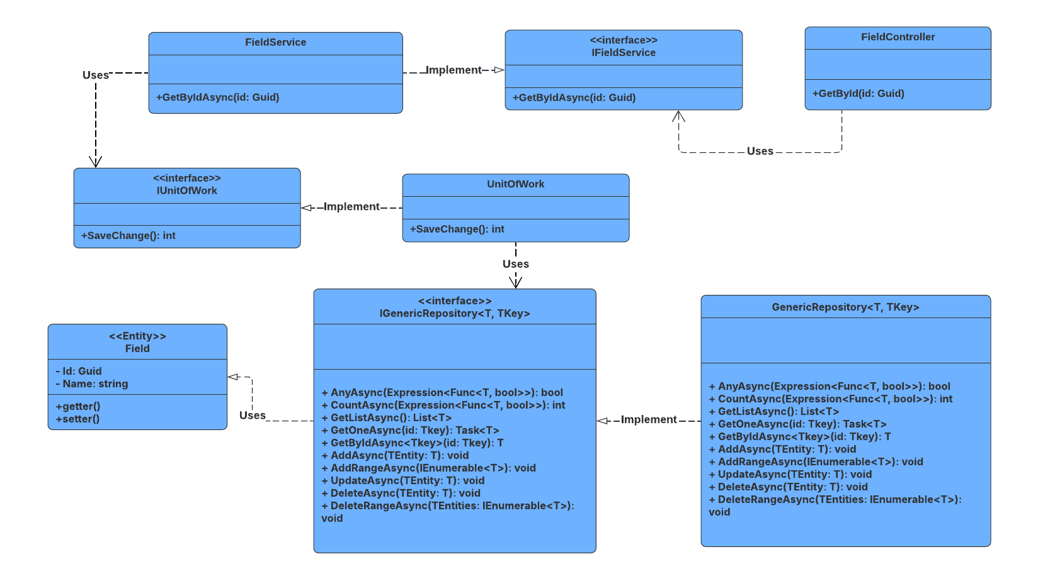

##### 3.8.3.2 Sequence Diagram

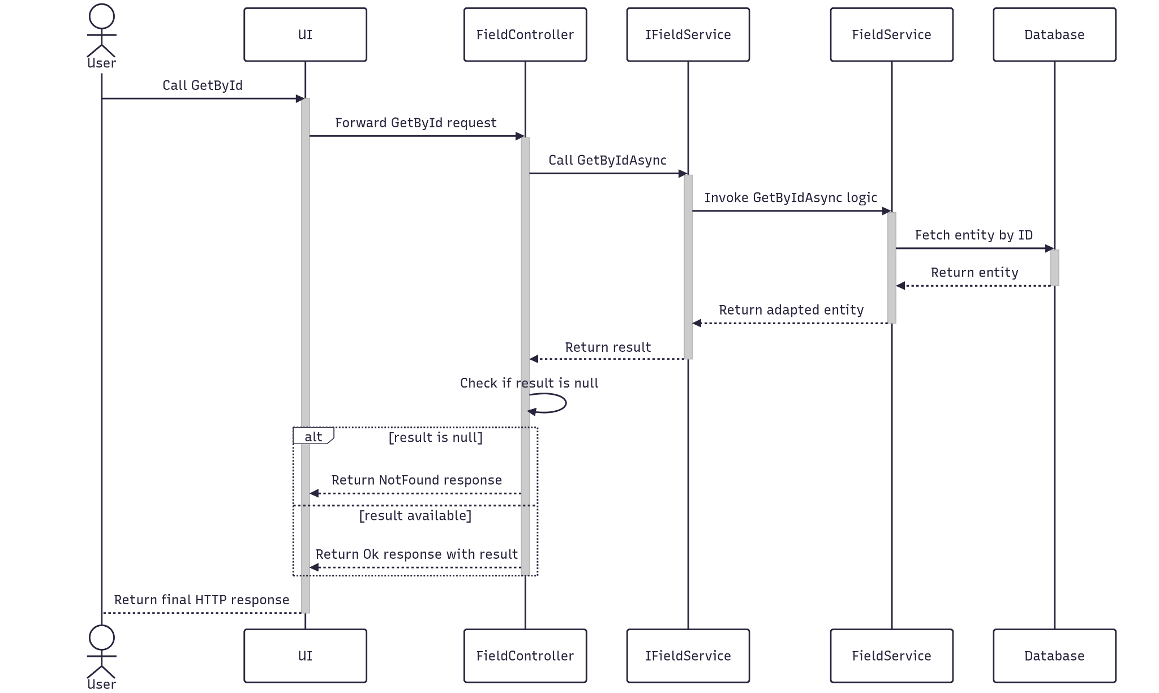

##### 3.8.3.3 Class Specification

###### 3.8.3.3.a FieldController

| No | Method | Description |
| --- | --- | --- |
| 1 | GetById(Guid id) | API endpoint that retrieves detailed information about a specific field by ID. Returns 200 OK with the evaluation stage details. |

###### 3.8.3.3.b FieldService

| No | Method | Description |
| --- | --- | --- |
| 1 | GetByIdAsync(Guid id) | Service method that fetches detailed data, and maps the result to a response DTO. Throws BadRequestException or NotFoundException as needed. |

#### 3.8.4.Delete

##### 3.8.4.1 Class Diagram

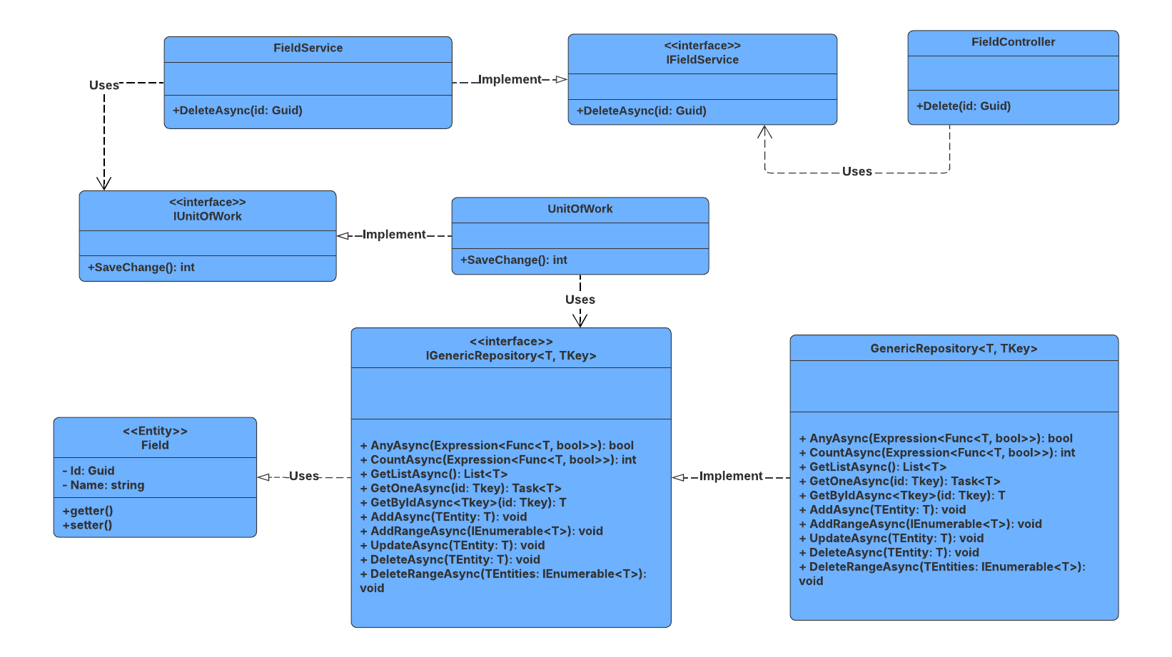

##### 3.8.4.2 Sequence Diagram

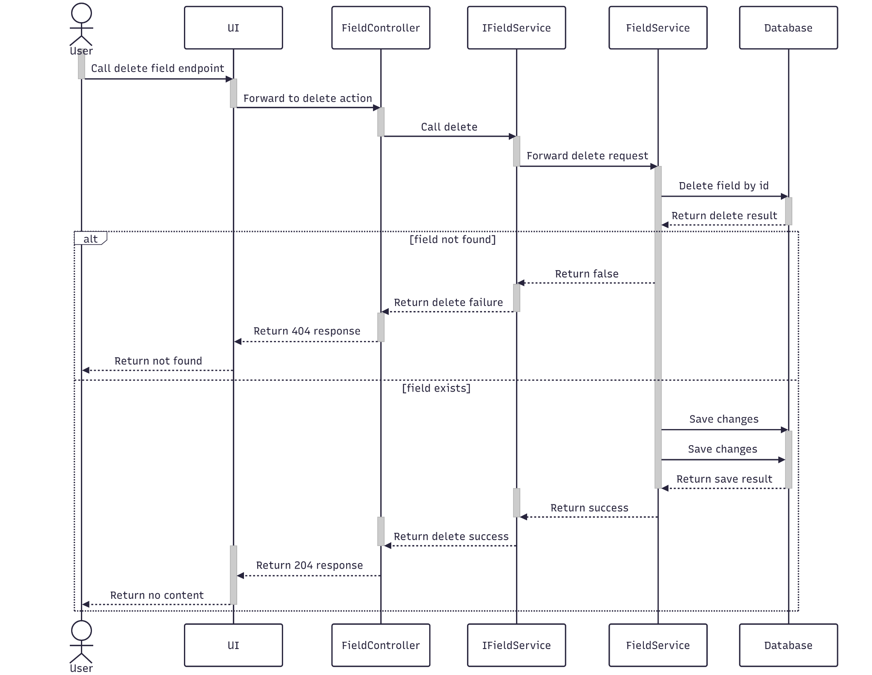

##### 3.8.4.3 Class Specification

###### 3.8.4.3.a FieldController

| No | Method | Description |
| --- | --- | --- |
| 1 | Delete(Guid id) | API endpoint that deletes a field by ID. Returns 200 OK on success or 400 Bad Request on failure. |

###### 3.8.4.3.b FieldService

| No | Method | Description |
| --- | --- | --- |
| 1 | DeleteAsync(Guid id) | Service method that performs a cascade delete of a field. Throws if the field is not found. |

#### 3.8.5.Get List

##### 3.8.5.1 Class Diagram

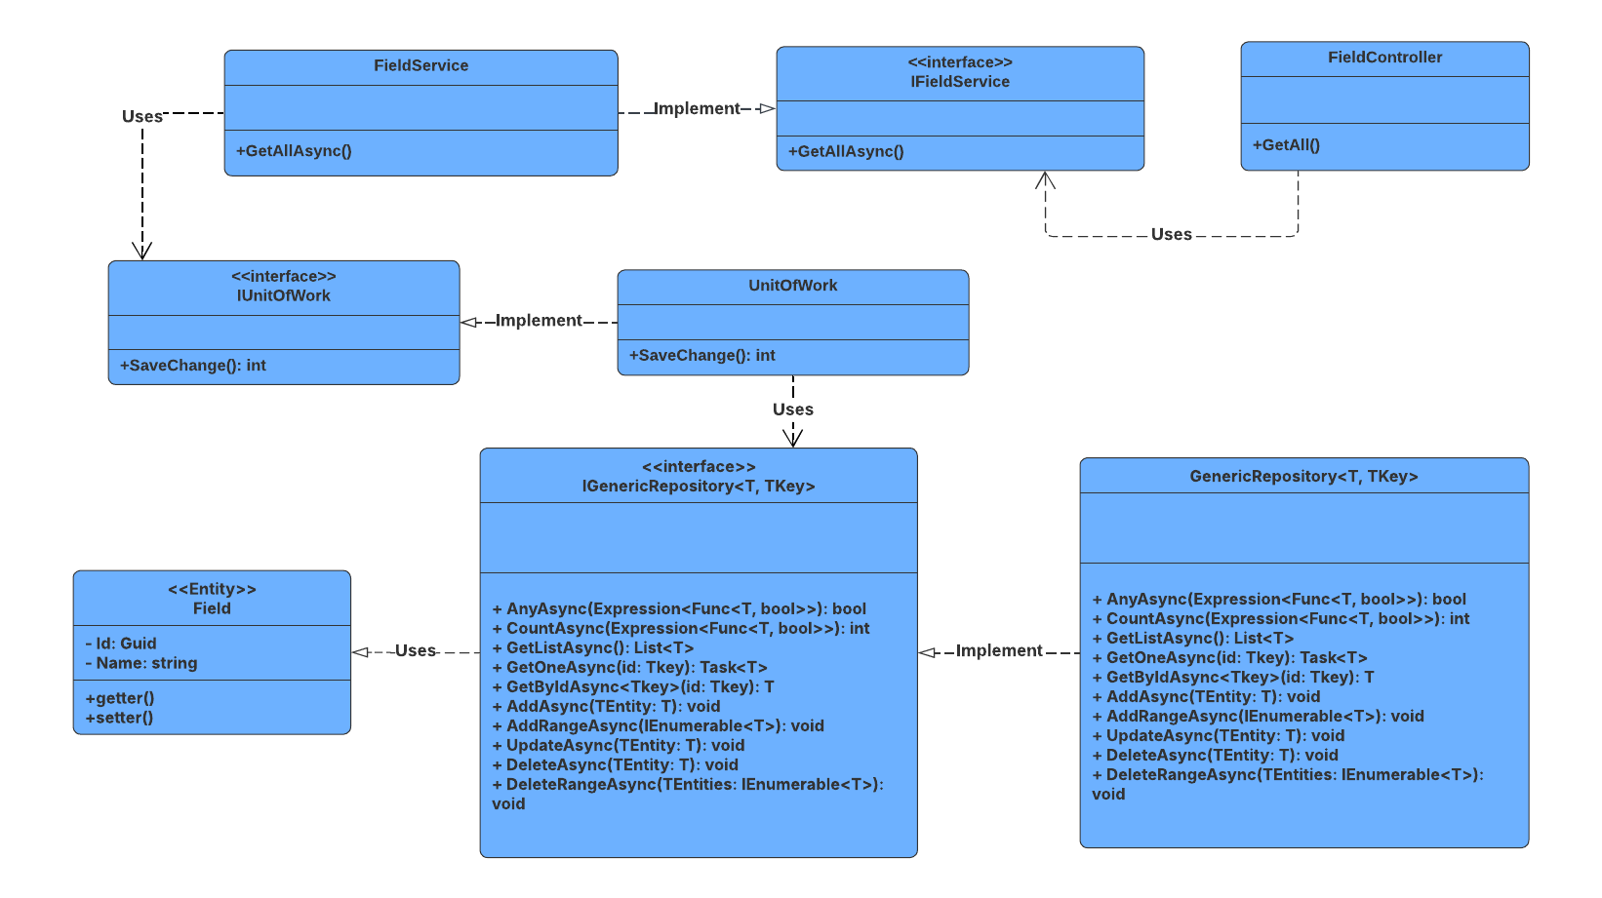

##### 3.8.5.2 Sequence Diagram

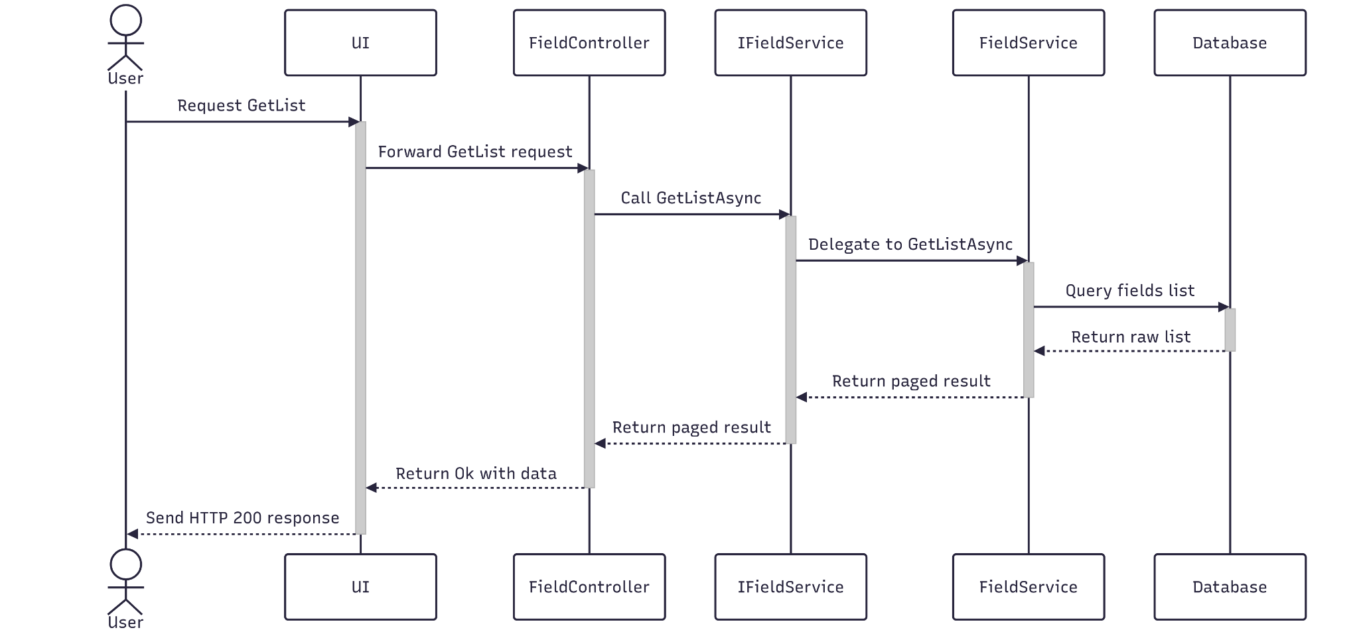

##### 3.8.5.3 Class Specification

###### 3.8.5.3.a FieldController

| No | Method | Description |
| --- | --- | --- |
| 1 | GetList (name, int pageIndex, int pageSize) | API endpoint that receives a query payload and returns a paginated list of fields. Responds with 200 OK and the result from GetListAsync . |

###### 3.8.5.3.b FieldService

| No | Method | Description |
| --- | --- | --- |
| 1 | GetListAsync (name, int pageIndex, int pageSize) | Service method that validates pagination parameters, queries the repository with multiple filters, and returns a paginated list of fields. Throws NotFoundException if no results are found. |

### 3.9 Manage Major

#### 3.9.1.Create

##### 3.9.1.1 Class Diagram

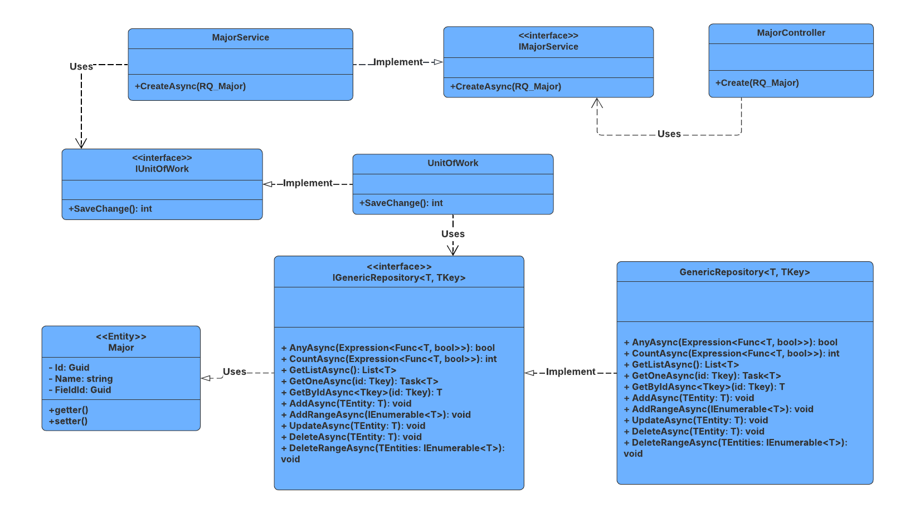

##### 3.9.1.2 Sequence Diagram

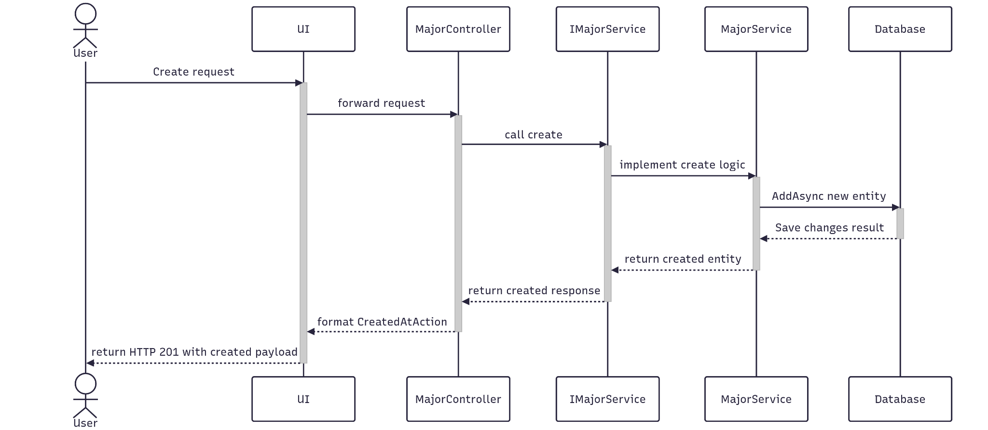

##### 3.9.1.3 Class Specification

###### 3.9.1.3.a MajorController

| No | Method | Description |
| --- | --- | --- |
| 1 | Create(RQ_Major) | API endpoint that creates a new major. Returns 201 Created with the new major ID or 400 BadRequest if creation fails. |

###### 3.9.1.3.b MajorService

| No | Method | Description |
| --- | --- | --- |
| 1 | CreateAsync(RQ_Major) | Service method that persists with the new major. Returns success status and new major ID. |

#### 3.9.2.Update

##### 3.9.2.1 Class Diagram

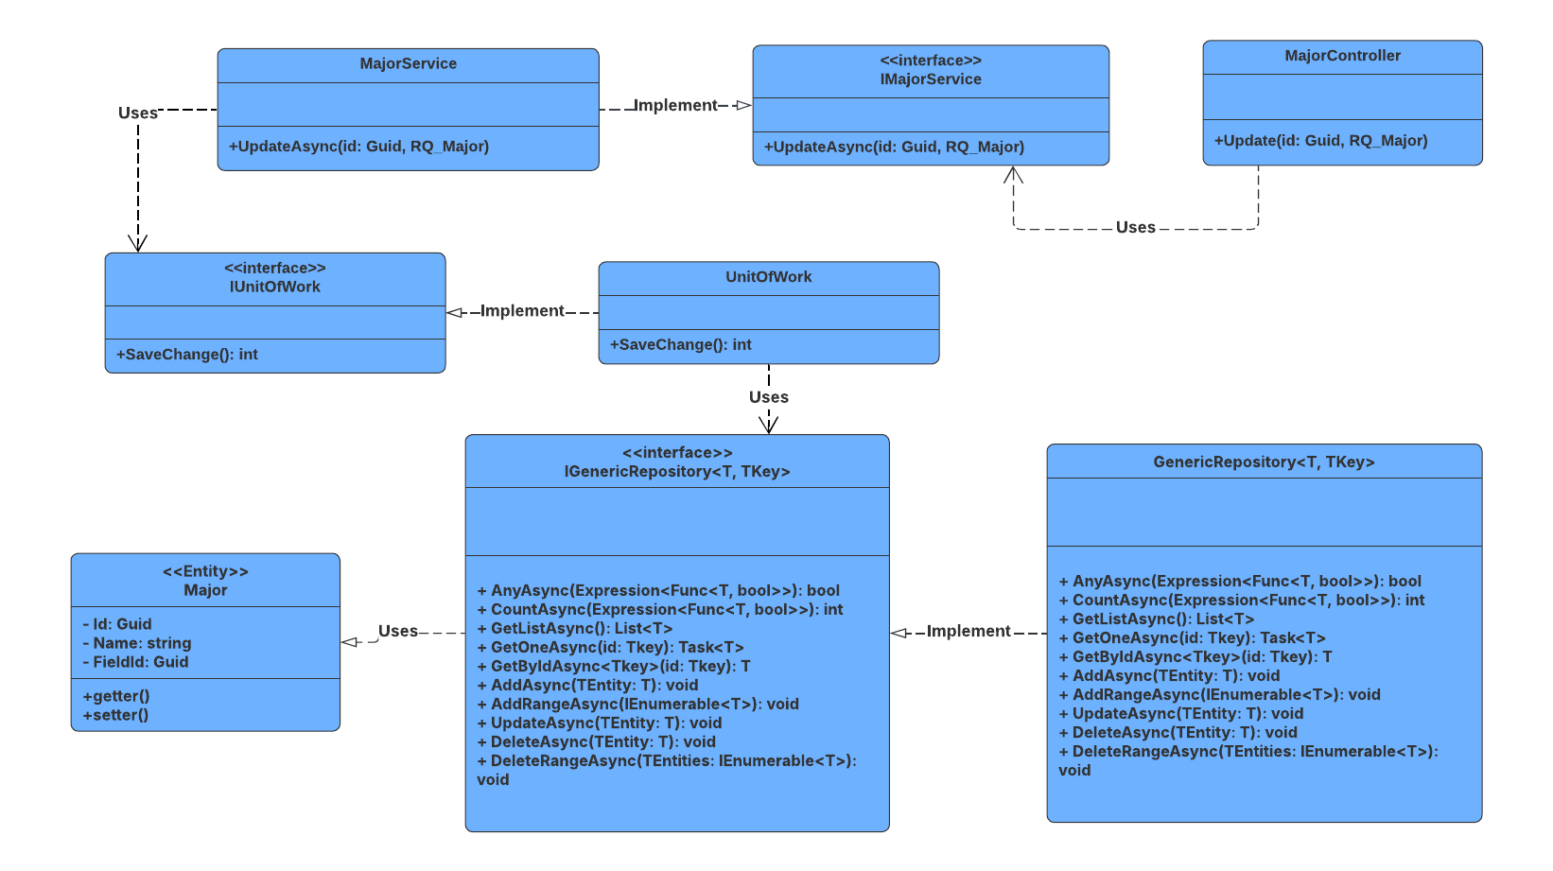

##### 3.9.2.2 Sequence Diagram

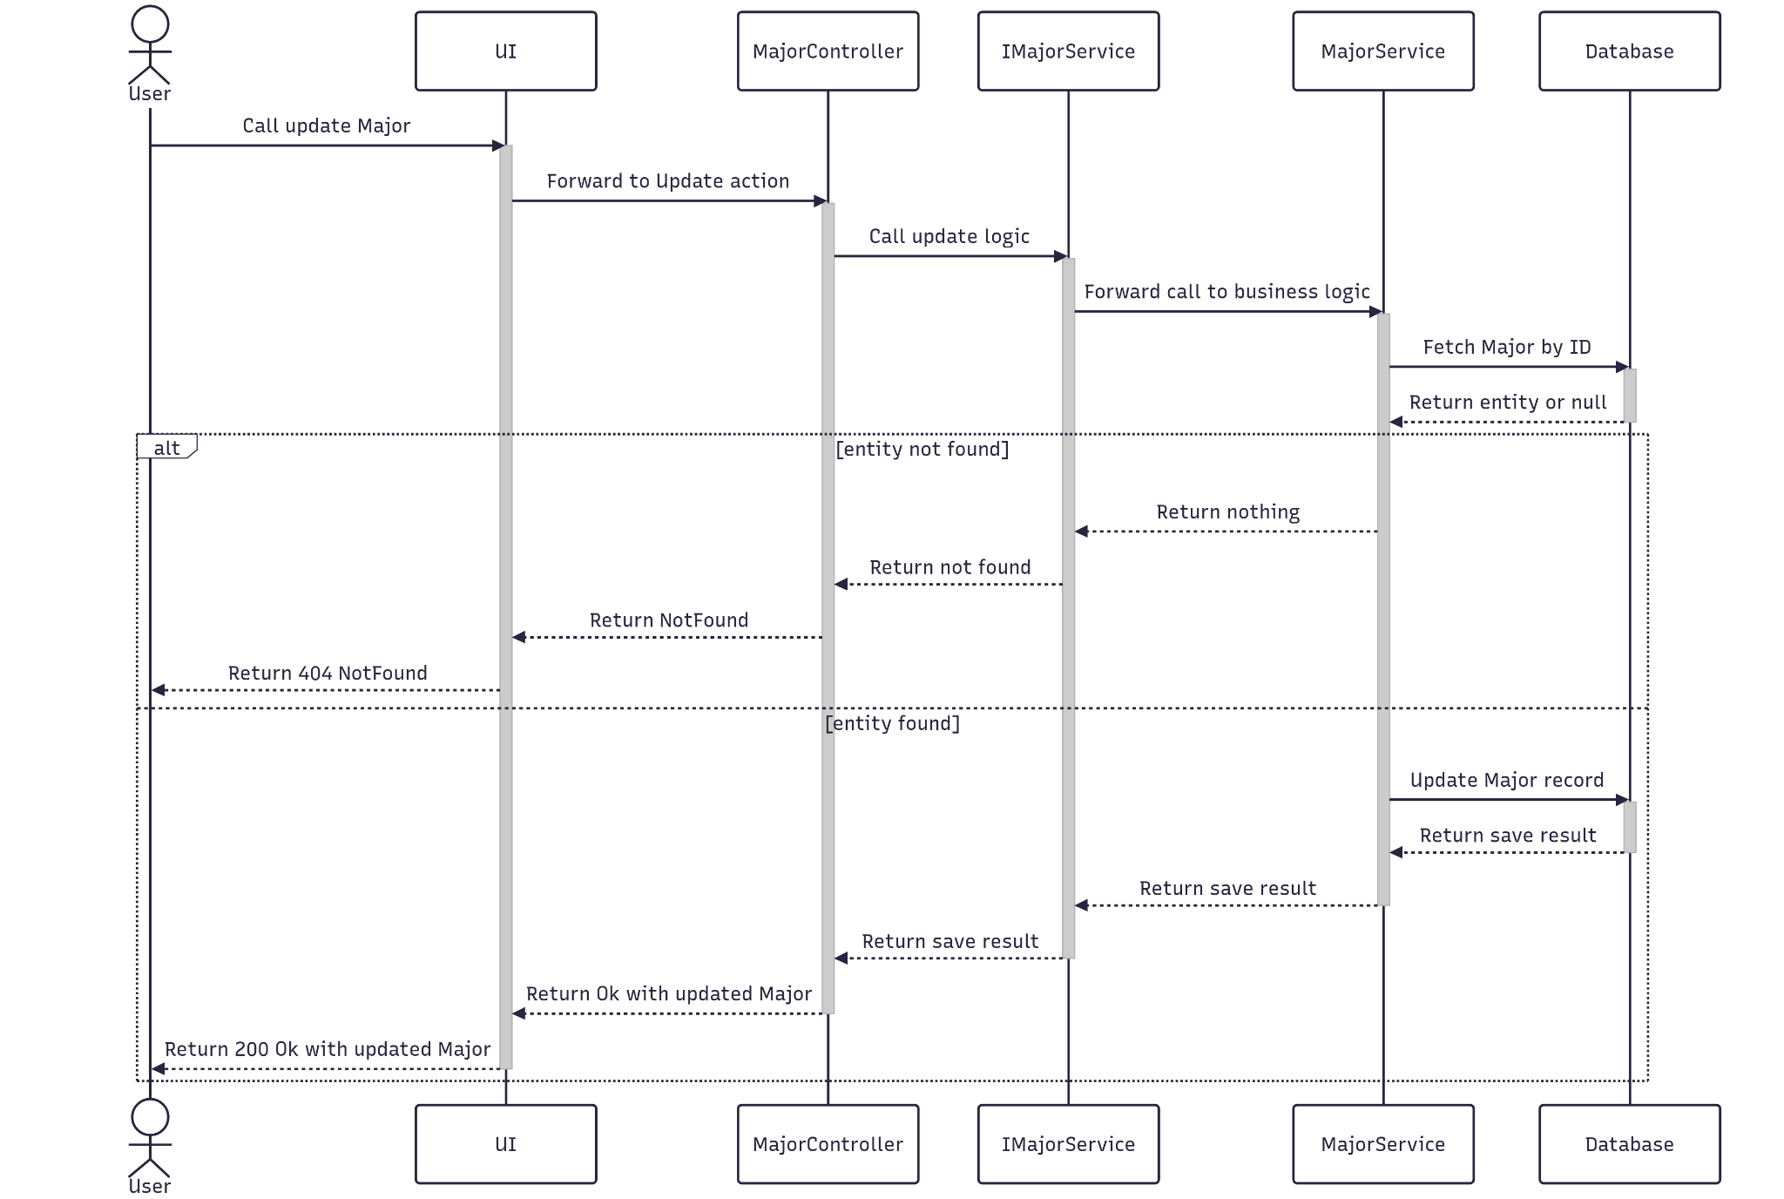

##### 3.9.2.3 Class Specification

###### 3.9.2.3.a MajorController

| No | Method | Description |
| --- | --- | --- |
| 1 | Update(Guid id, RQ_Major) | API endpoint that updates an existing major. Returns 200 OK if successful or 400 BadRequest if the update fails. |

###### 3.9.2.3.b MajorService

| No | Method | Description |
| --- | --- | --- |
| 1 | UpdateAsync(Guid id, RQ_Major) | Service method that validates the major ID applies updated data, and saves changes. Throws if the major or is not found. |

#### 3.9.3.Get By Id

##### 3.9.3.1 Class Diagram

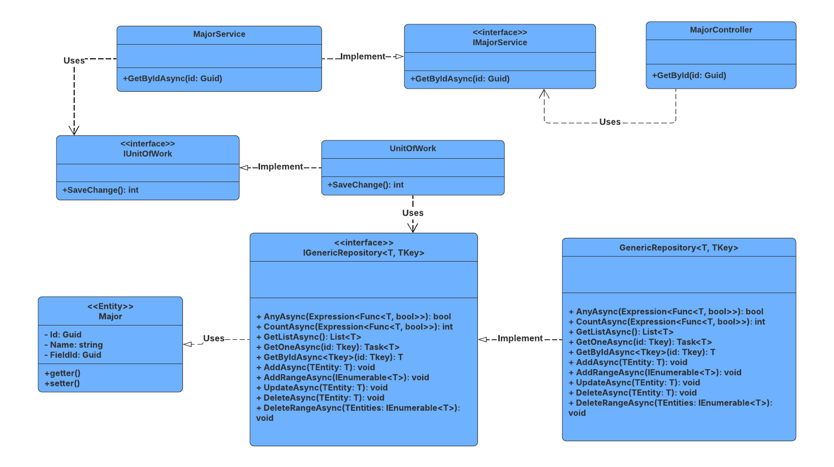

##### 3.9.3.2 Sequence Diagram

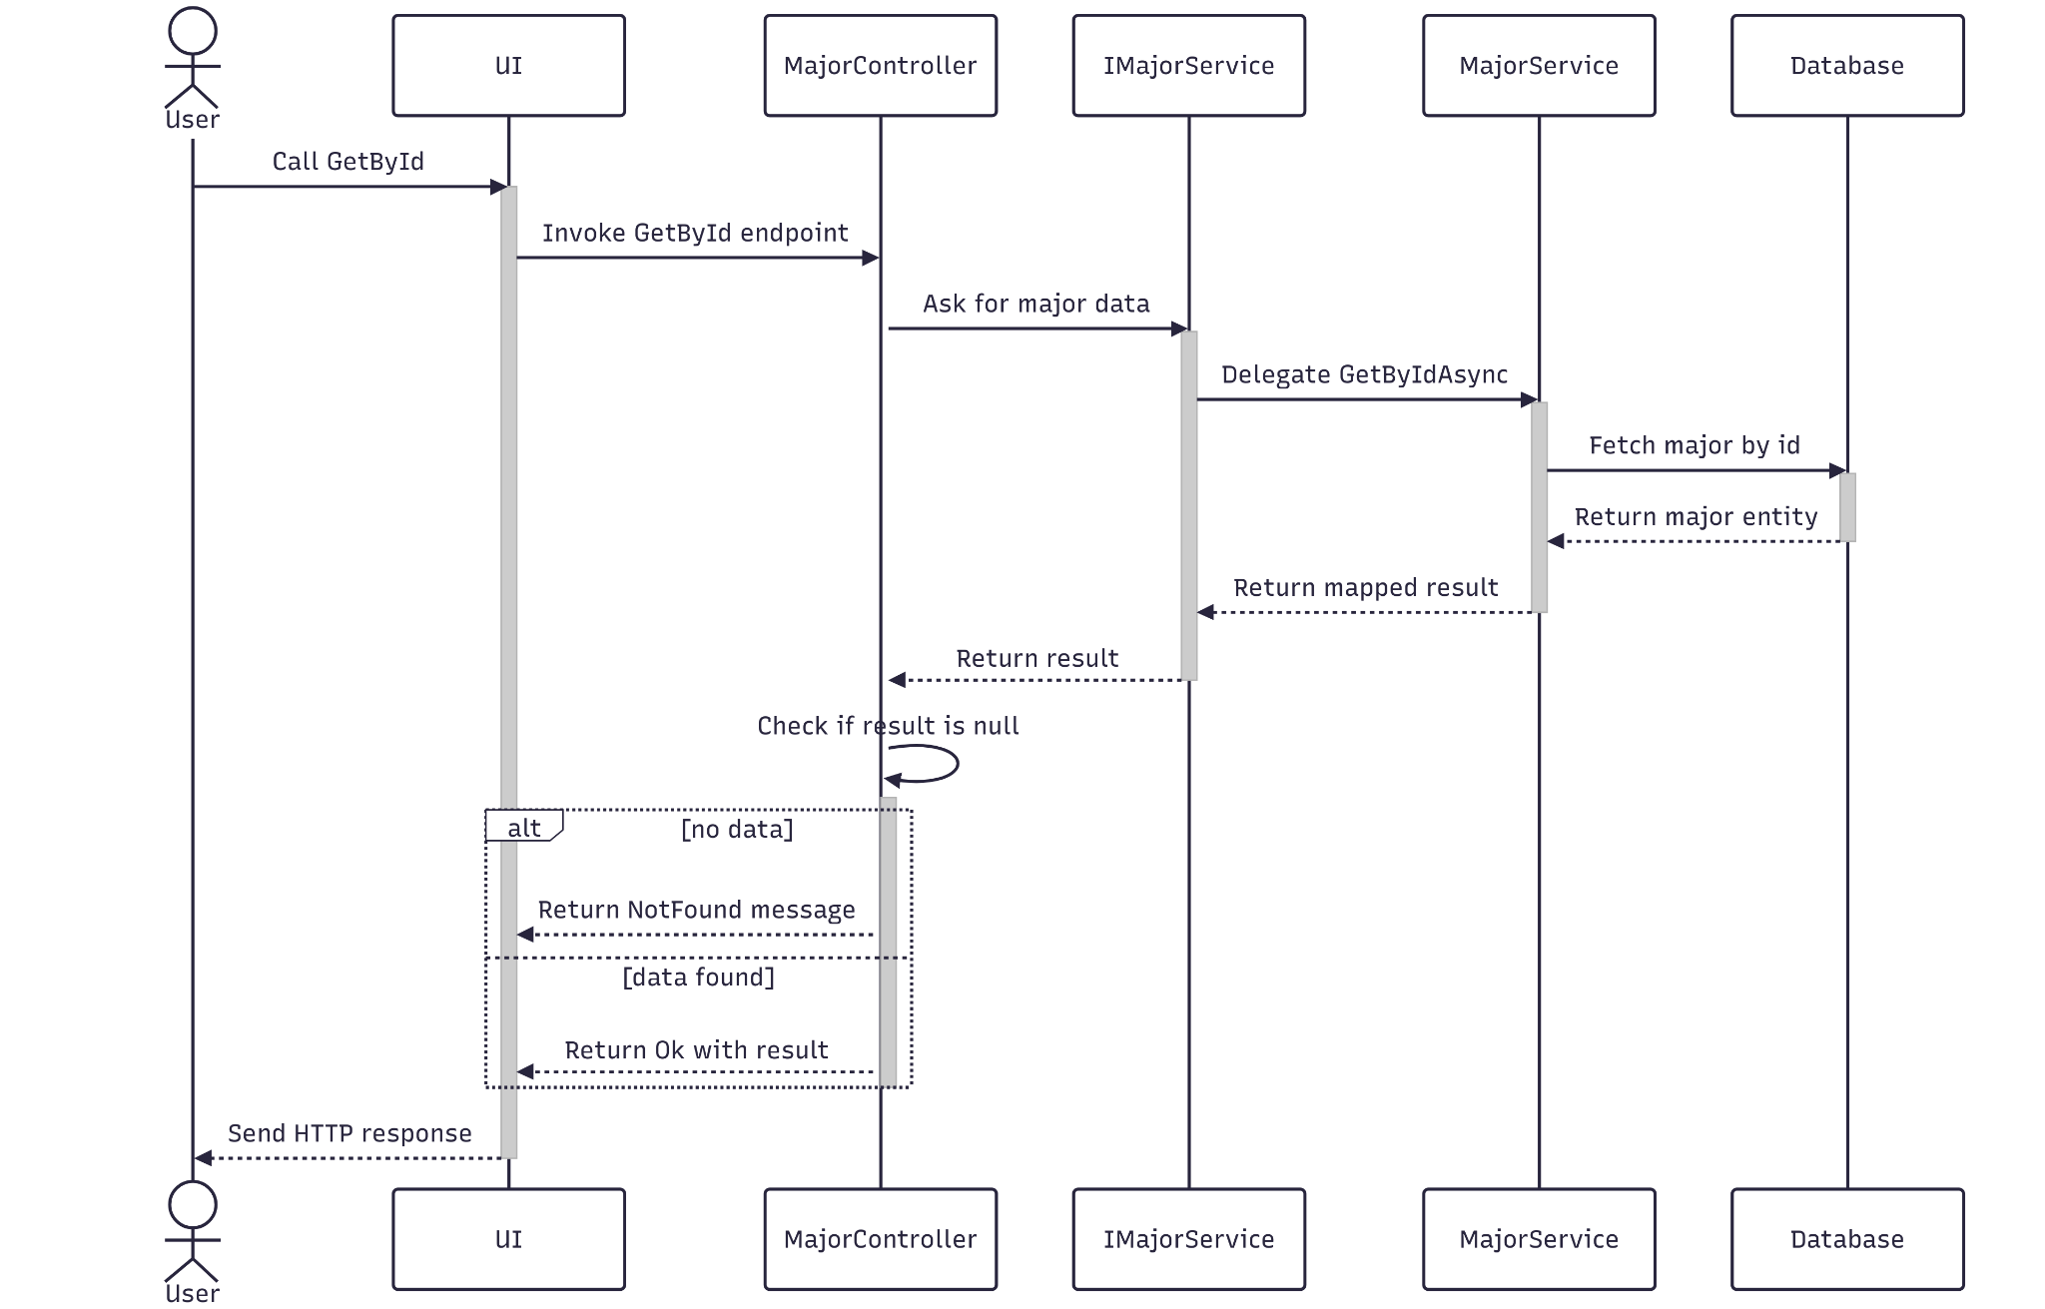

##### 3.9.3.3 Class Specification

###### 3.9.3.3.a MajorController

| No | Method | Description |
| --- | --- | --- |
| 1 | GetById(Guid id) | API endpoint that retrieves detailed information about a specific major by ID. Accepts an optional includeNum flag to control related data inclusion. Returns 200 OK with the major details. |

###### 3.9.3.3.b MajorService

| No | Method | Description |
| --- | --- | --- |
| 1 | GetByIdAsync(Guid id) | Service method that fetches detailed data, and maps the result to a response DTO. Throws BadRequestException or NotFoundException as needed. |

#### 3.9.4.Delete

##### 3.9.4.1 Class Diagram

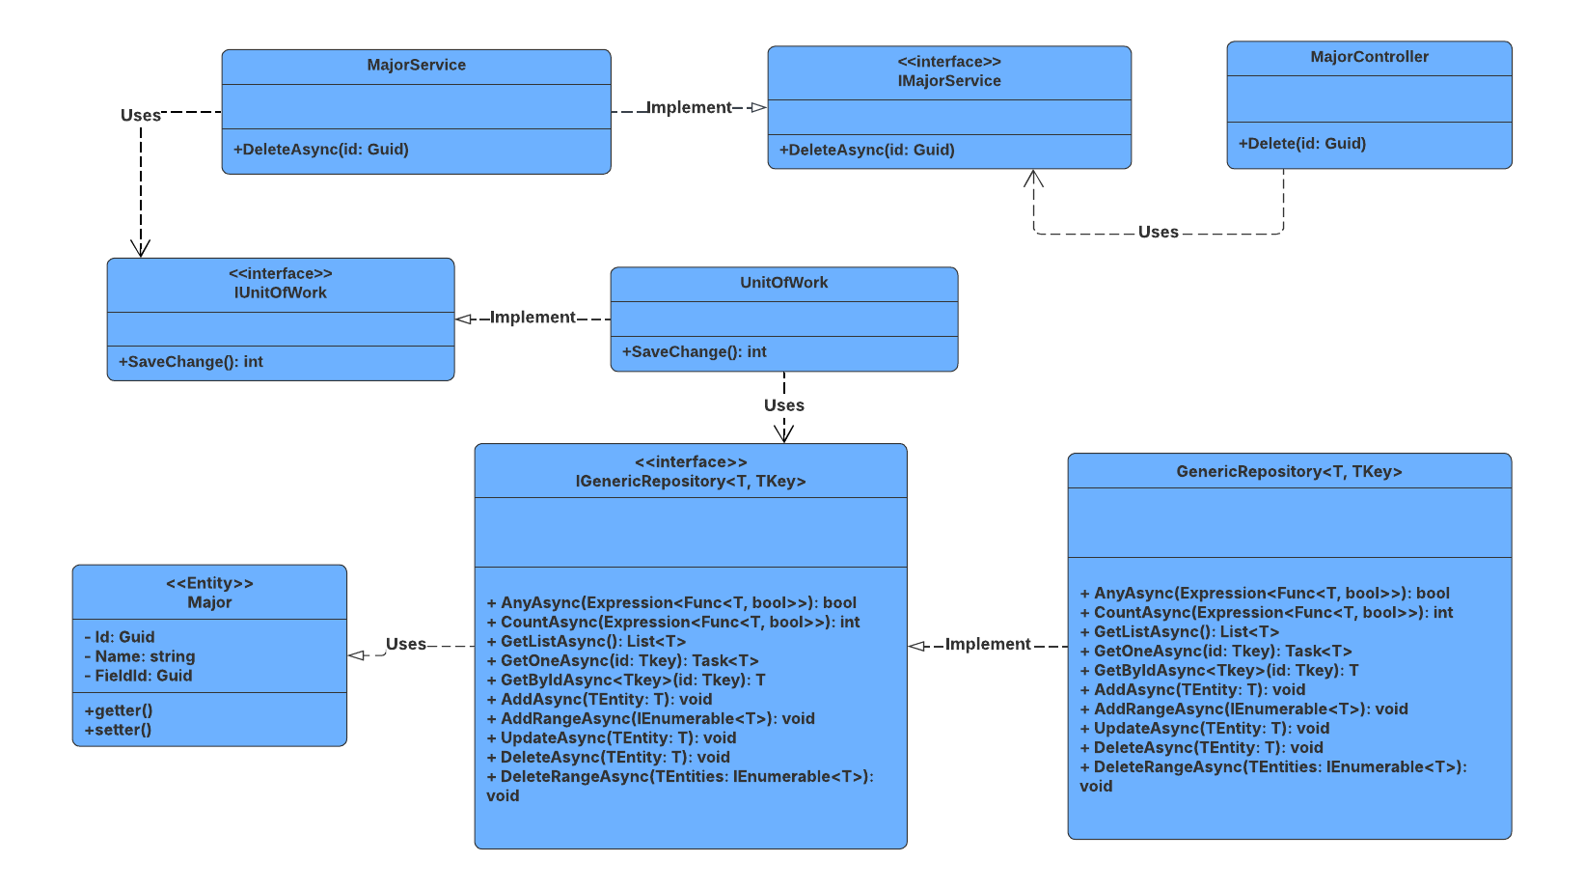

##### 3.9.4.2 Sequence Diagram

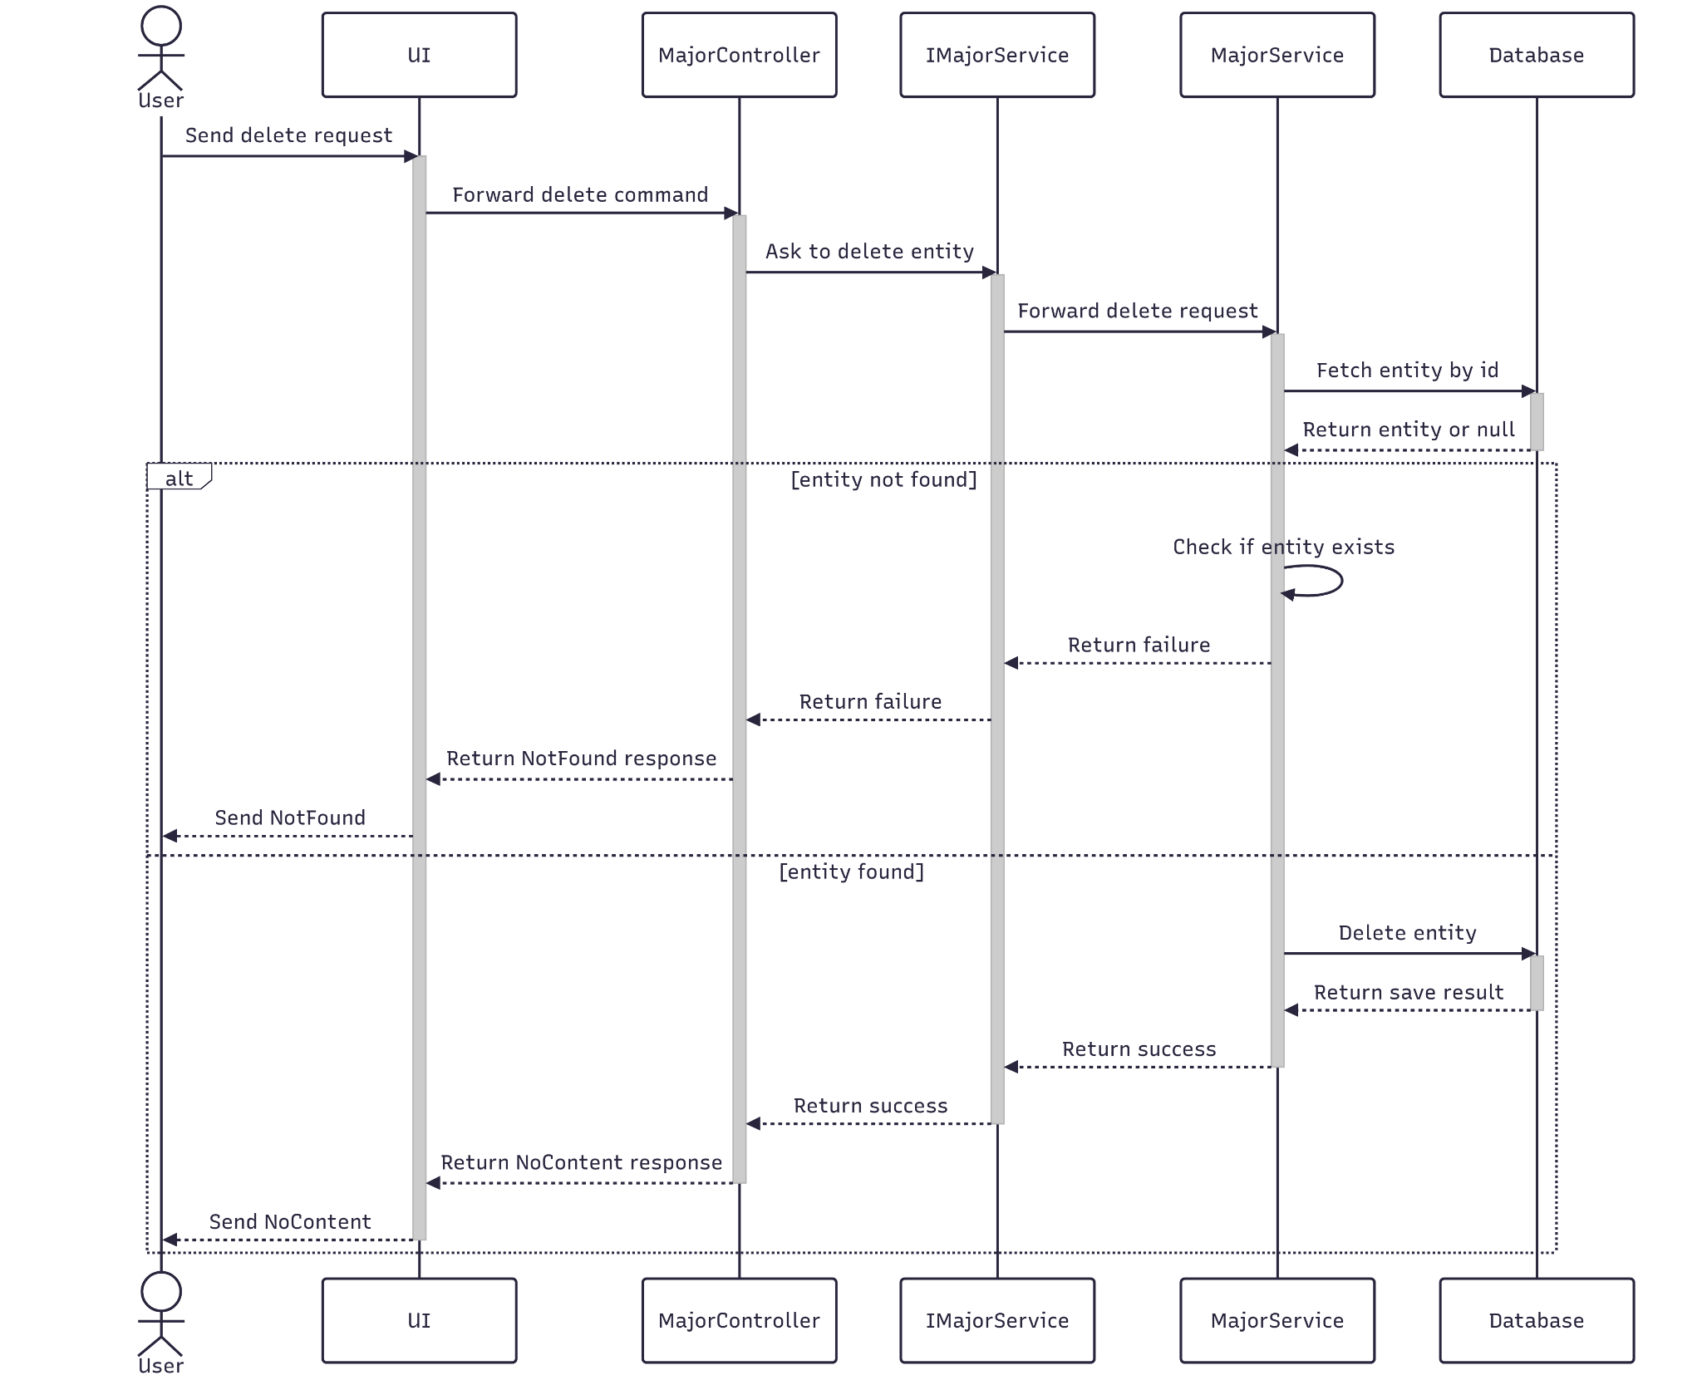

##### 3.9.4.3 Class Specification

###### 3.9.4.3.a MajorController

| No | Method | Description |
| --- | --- | --- |
| 1 | Delete(Guid id) | API endpoint that deletes a major by ID. Returns 200 OK on success or 400 Bad Request on failure. |

###### 3.9.4.3.b 6MajorService

| No | Method | Description |
| --- | --- | --- |
| 1 | DeleteAsync(Guid id) | Service method that performs a cascade delete of a major. Throws if the major is not found. |

#### 3.9.5.Get List

##### 3.9.5.1 Class Diagram

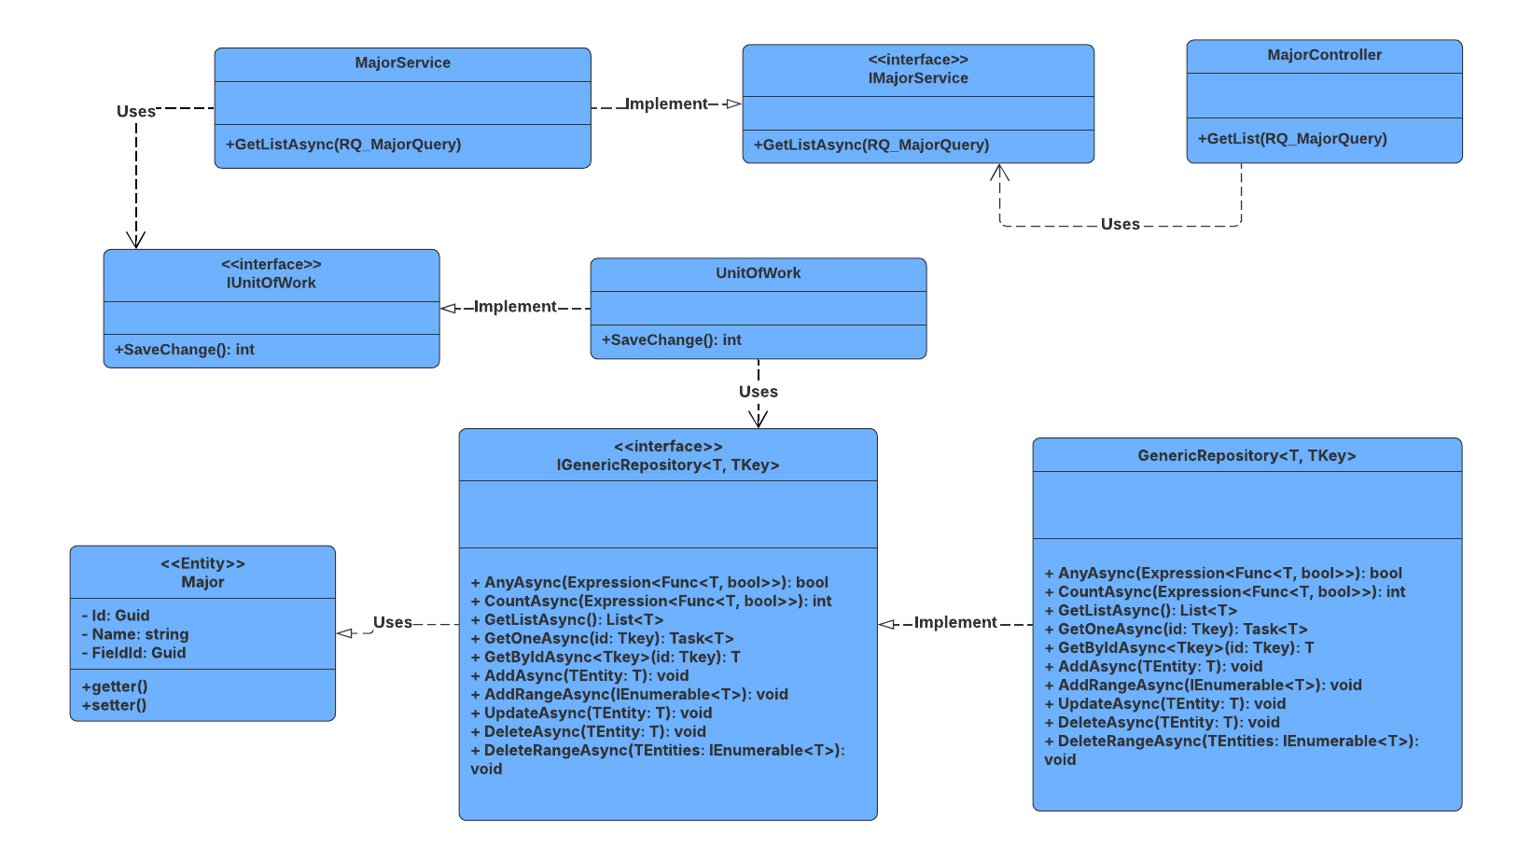

##### 3.9.5.2 Sequence Diagram

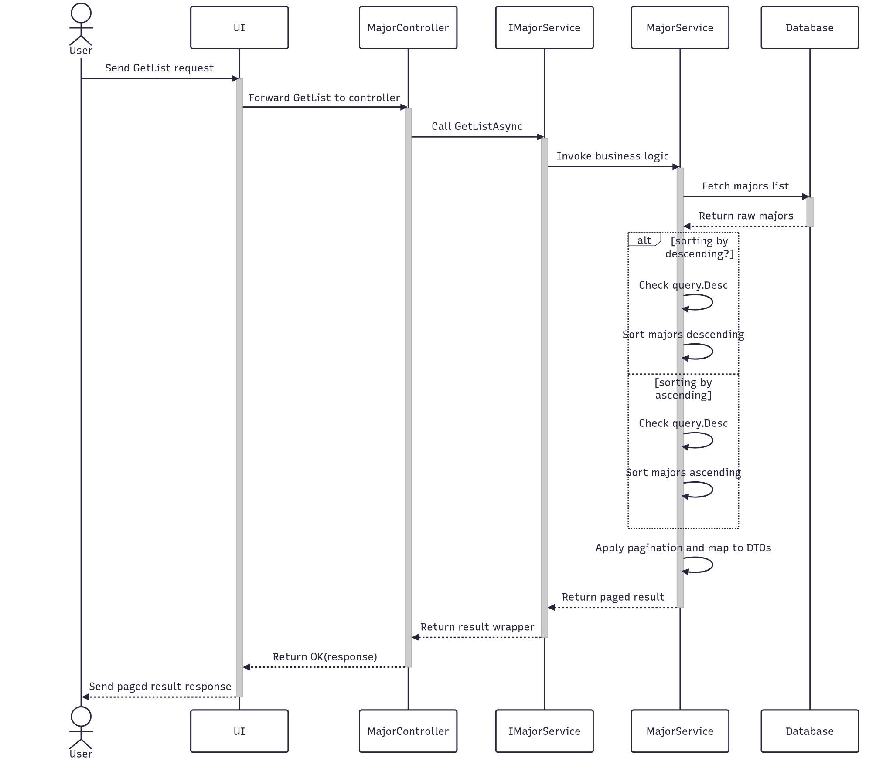

##### 3.9.5.3 Class Specification

###### 3.9.5.3.a MajorController

| No | Method | Description |
| --- | --- | --- |
| 1 | GetList(RQ_MajorQuery) | API endpoint that receives a query payload and returns a paginated list of majors. Responds with 200 OK and the result from GetListAsync. |

###### 3.9.5.3.b MajorService

| No | Method | Description |
| --- | --- | --- |
| 1 | GetListAsync(RQ_MajorQuery) | Service method that validates pagination parameters, queries the repository with multiple filters, and returns a paginated list of majors. Throws NotFoundException if no results are found. |

### 3.10 Manage Role

#### 3.10.1.Create

##### 3.10.1.1 Class Diagram

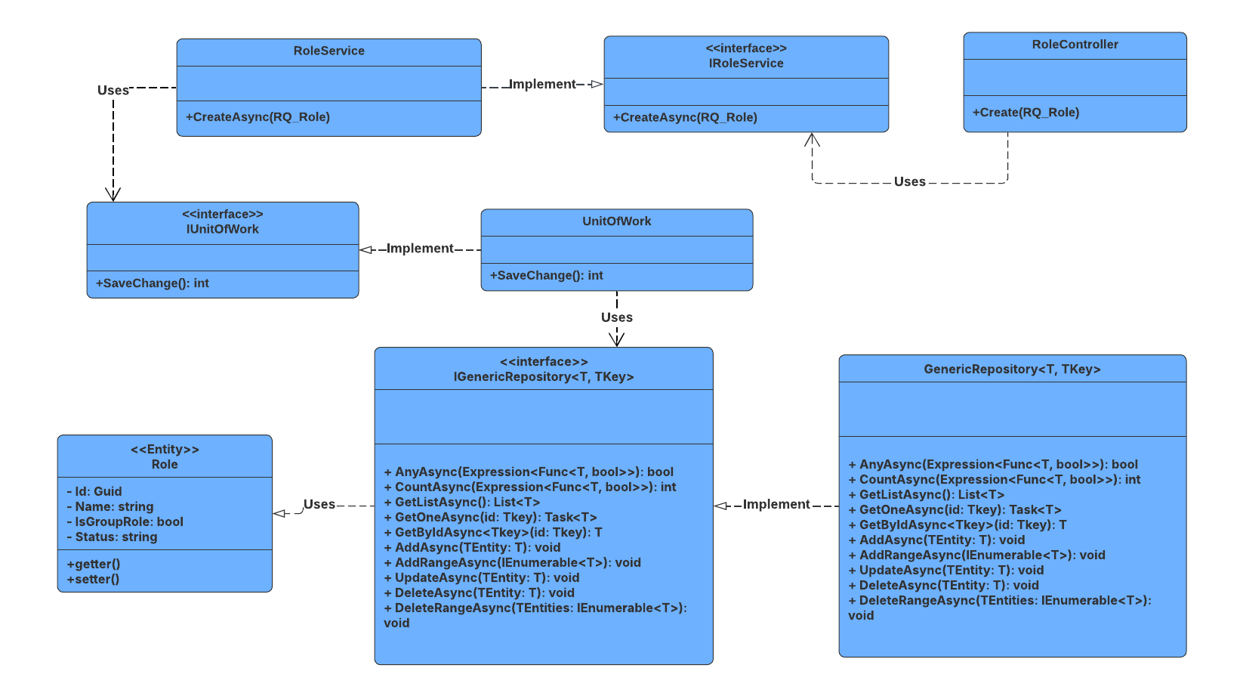

##### 3.10.1.2 Sequence Diagram

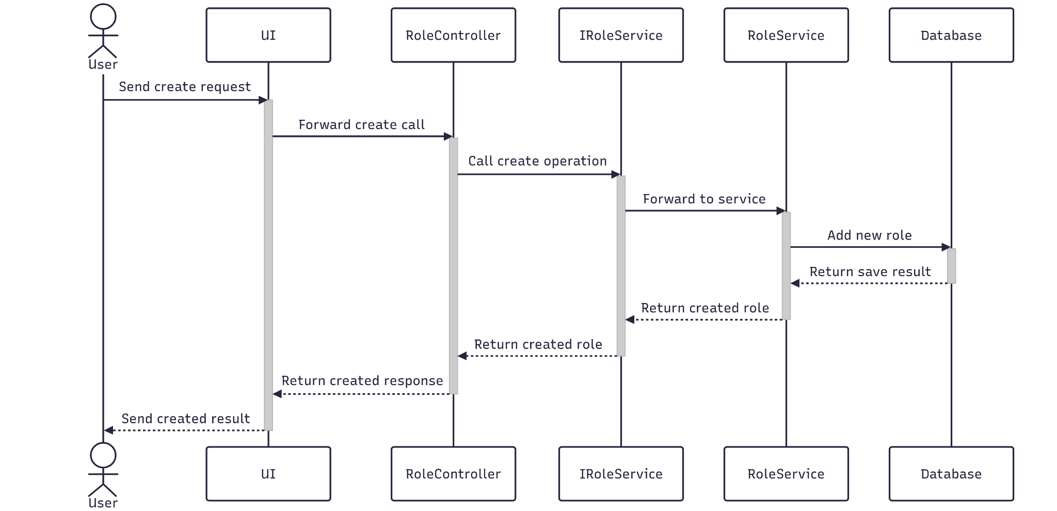

##### 3.10.1.3 Class Specification

###### 3.10.1.3.a RoleController

| No | Method | Description |
| --- | --- | --- |
| 1 | Create(RQ_Role) | API endpoint that creates a new role. Returns 201 Created with the new role entity or 400 BadRequest if creation fails. |

###### 3.10.1.3.b RoleService

| No | Method | Description |
| --- | --- | --- |
| 1 | CreateAsync(RQ_Role) | Service method that persists the new role. Returns success status and new role entity. |

#### 3.10.2.Update

##### 3.10.2.1 Class Diagram

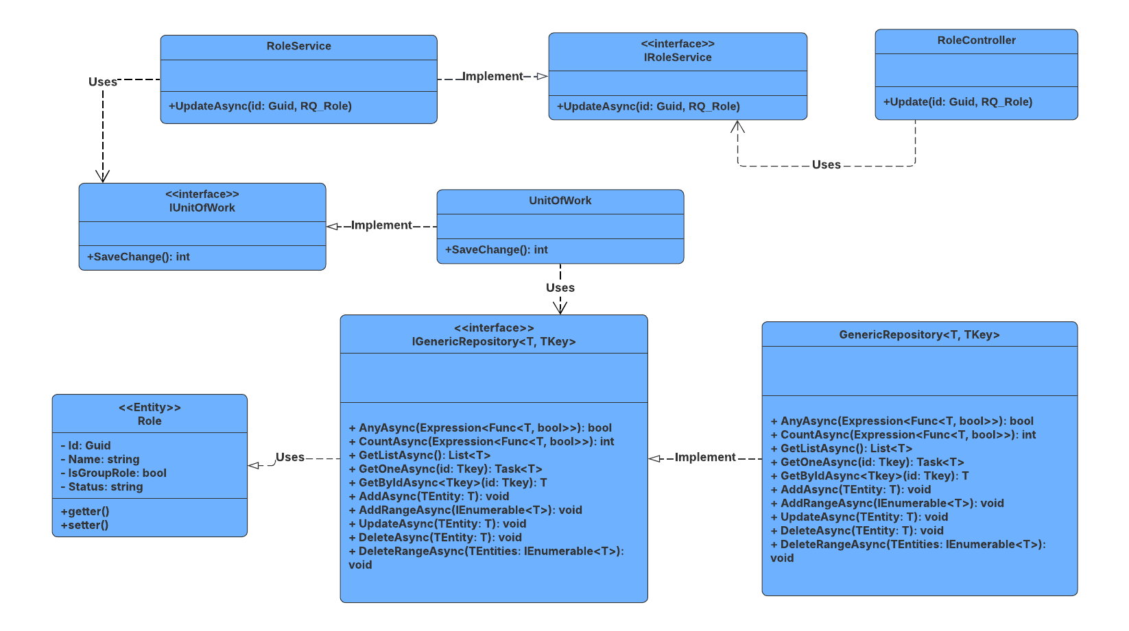

##### 3.10.2.2 Sequence Diagram

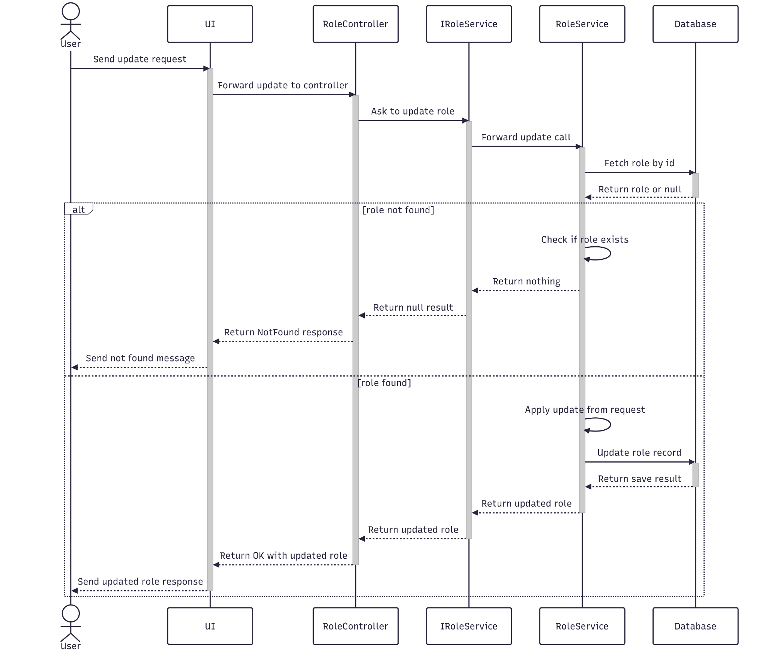

##### 3.10.2.3 Class Specification

###### 3.10.2.3.a RoleController

| No | Method | Description |
| --- | --- | --- |
| 1 | Update(Guid id, RQ_Role) | API endpoint that updates an existing role. Returns 200 OK if successful or 400 BadRequest if the update fails. |

###### 3.10.2.3.b RoleService

| No | Method | Description |
| --- | --- | --- |
| 1 | UpdateAsync(Guid id, RQ_Role) | Service method that validates the role ID, applies updated data, and saves changes. Throws if the role is not found. |

#### 3.10.3.Get By Id

##### 3.10.3.1 Class Diagram

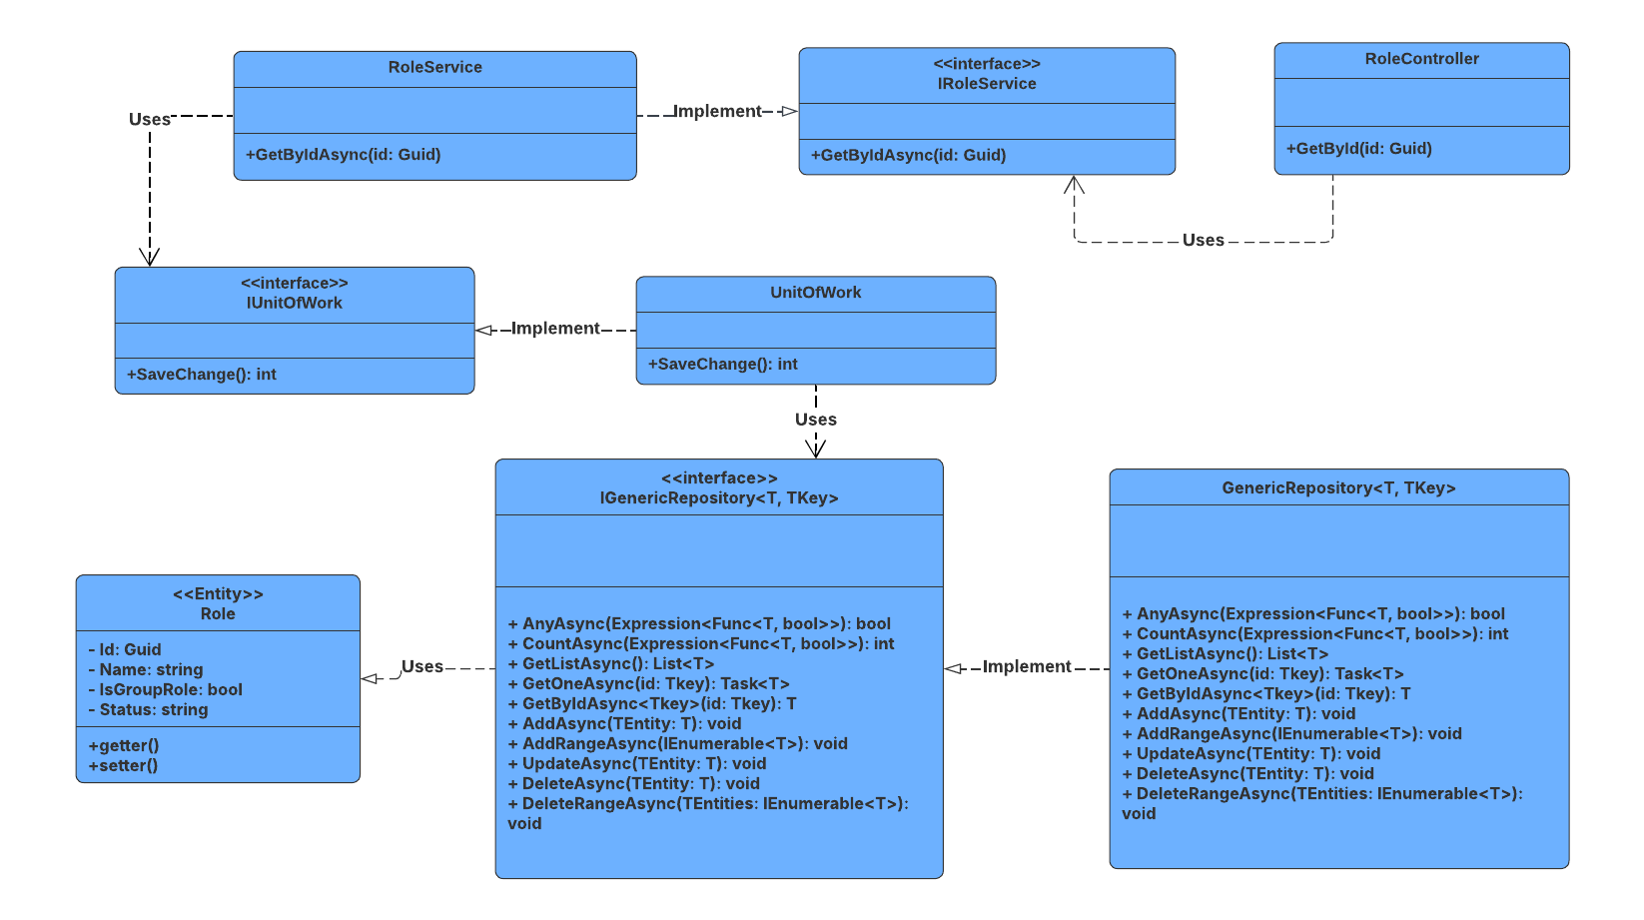

##### 3.10.3.2 Sequence Diagram

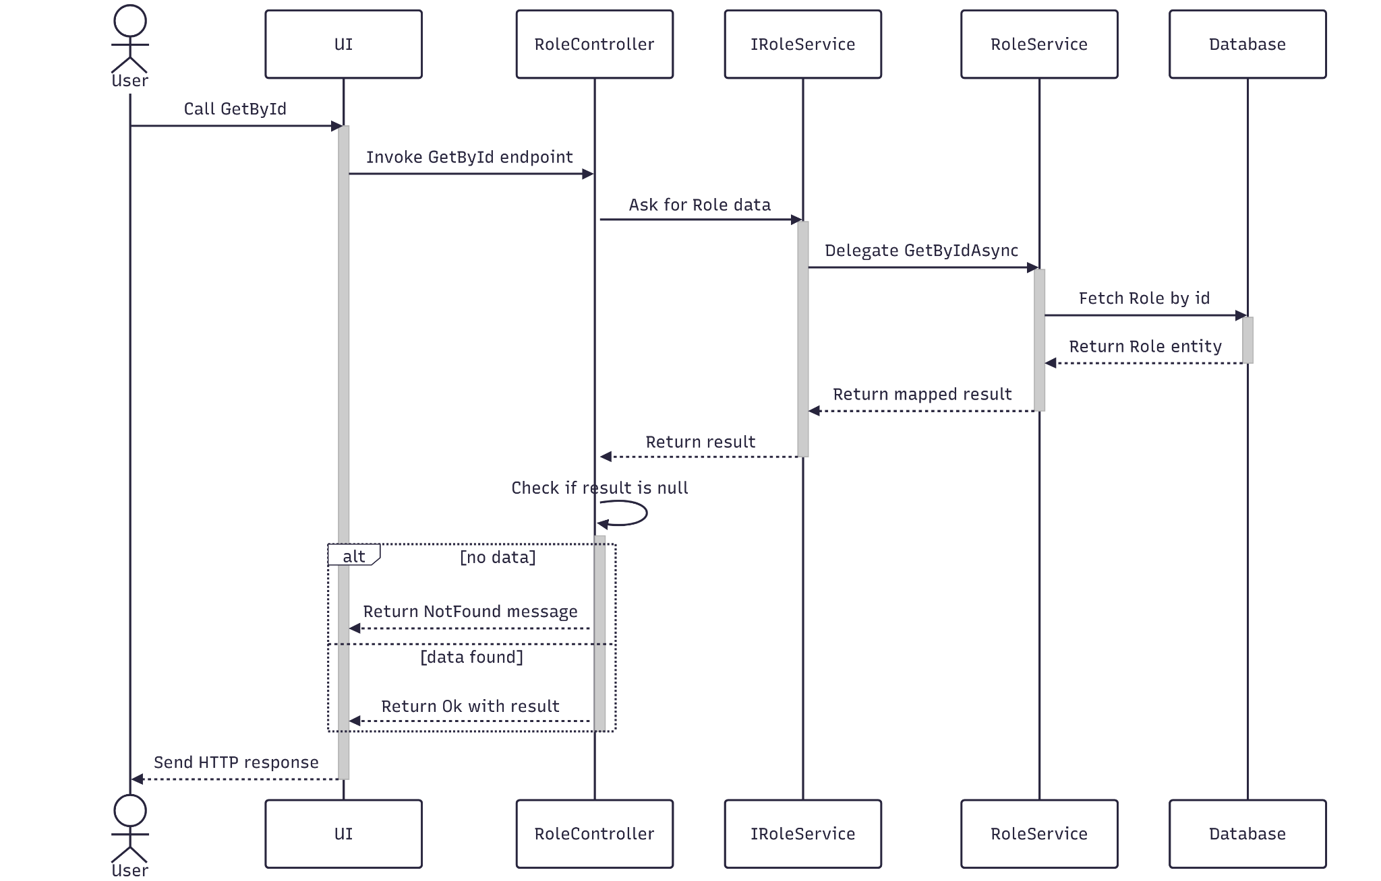

##### 3.10.3.3 Class Specification

###### 3.10.3.3.a RoleController

| No | Method | Description |
| --- | --- | --- |
| 1 | GetById(Guid id) | API endpoint that retrieves detailed information about a specific role by ID. Returns 200 OK with the role details. |

###### 3.10.3.3.b RoleService

| No | Method | Description |
| --- | --- | --- |
| 1 | GetByIdAsync(Guid id) | Service method that fetches detailed data, and maps the result to a response DTO. Throws BadRequestException or NotFoundException as needed. |

#### 

#### 3.10.4.Delete

##### 3.10.4.1 Class Diagram

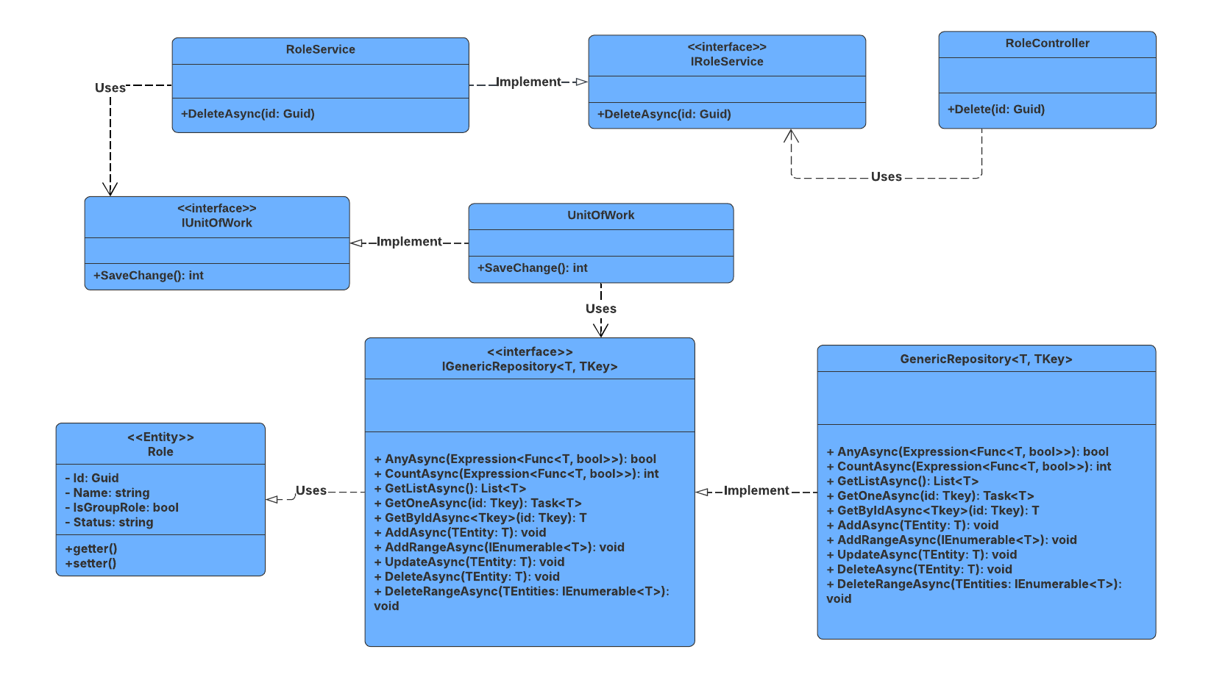

##### 3.10.4.2 Sequence Diagram

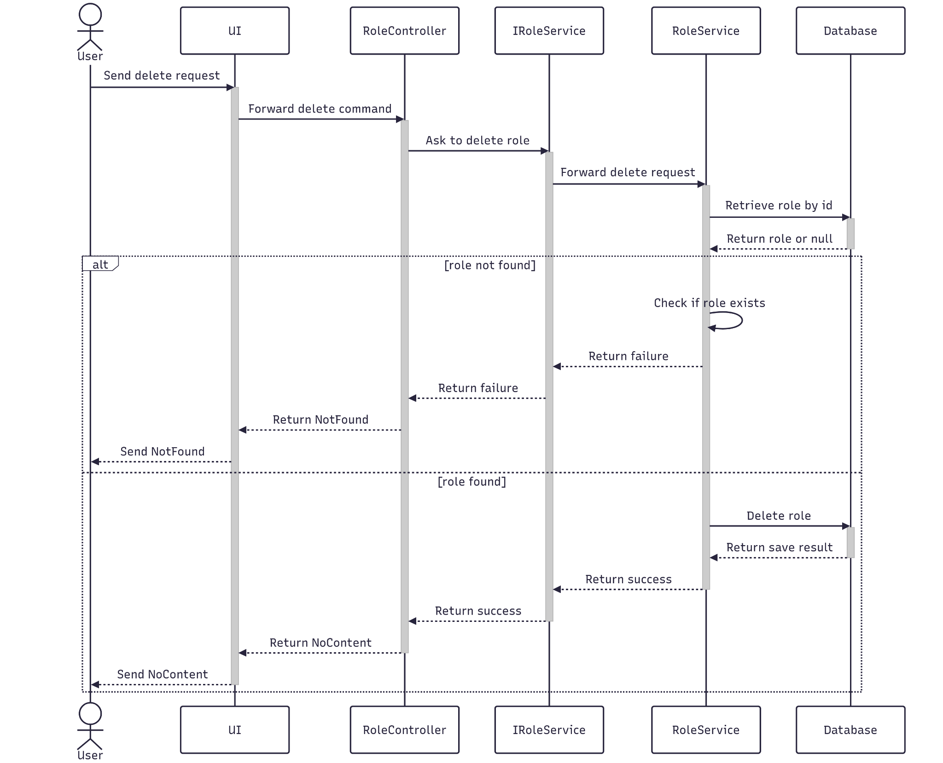

##### 3.10.4.3 Class Specification

###### 3.10.4.3.a RoleController

| No | Method | Description |
| --- | --- | --- |
| 1 | Delete(Guid id) | API endpoint that deletes a role by ID. Returns 200 OK on success or 400 Bad Request on failure. |

###### 3.10.4.3.b RoleService

| No | Method | Description |
| --- | --- | --- |
| 1 | DeleteAsync(Guid id) | Service method that performs a cascade delete of a role. Throws if the role is not found. |

#### 3.10.5.Get All

##### 3.10.5.1 Class Diagram

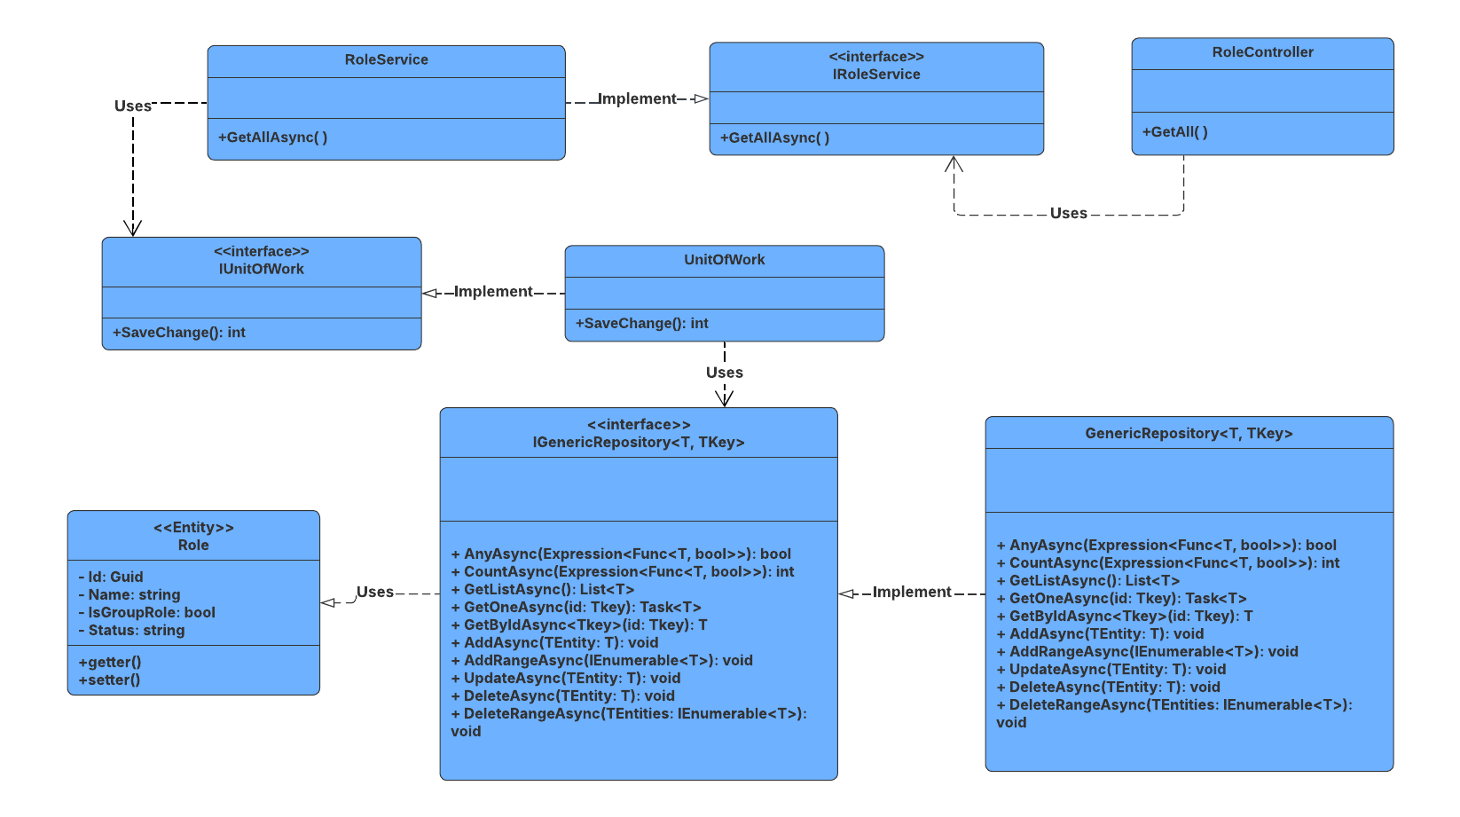

##### 3.10.5.2 Sequence Diagram

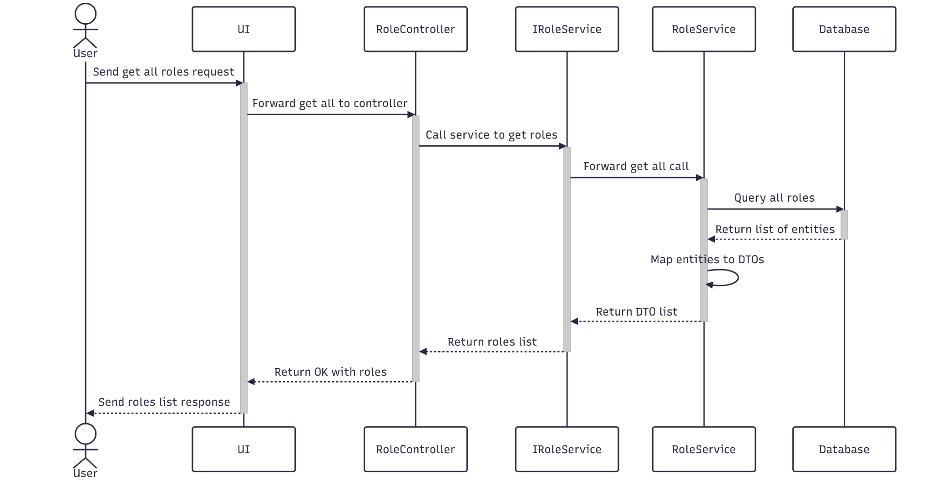

##### 3.10.5.3 Class Specification

###### 3.10.5.3.a RoleController

| No | Method | Description |
| --- | --- | --- |
| 1 | GetAll() | API endpoint that returns list of roles. Responds with 200 OK and the result from GetAllAsync. |

###### 3.10.5.3.b RoleService

| No | Method | Description |
| --- | --- | --- |
| 1 | GetAllAsync() | Service method that returns a list of Roles. |

### 3.11 Manage Transaction

#### 3.11.1.Create

##### 3.11.1.1 Class Diagram

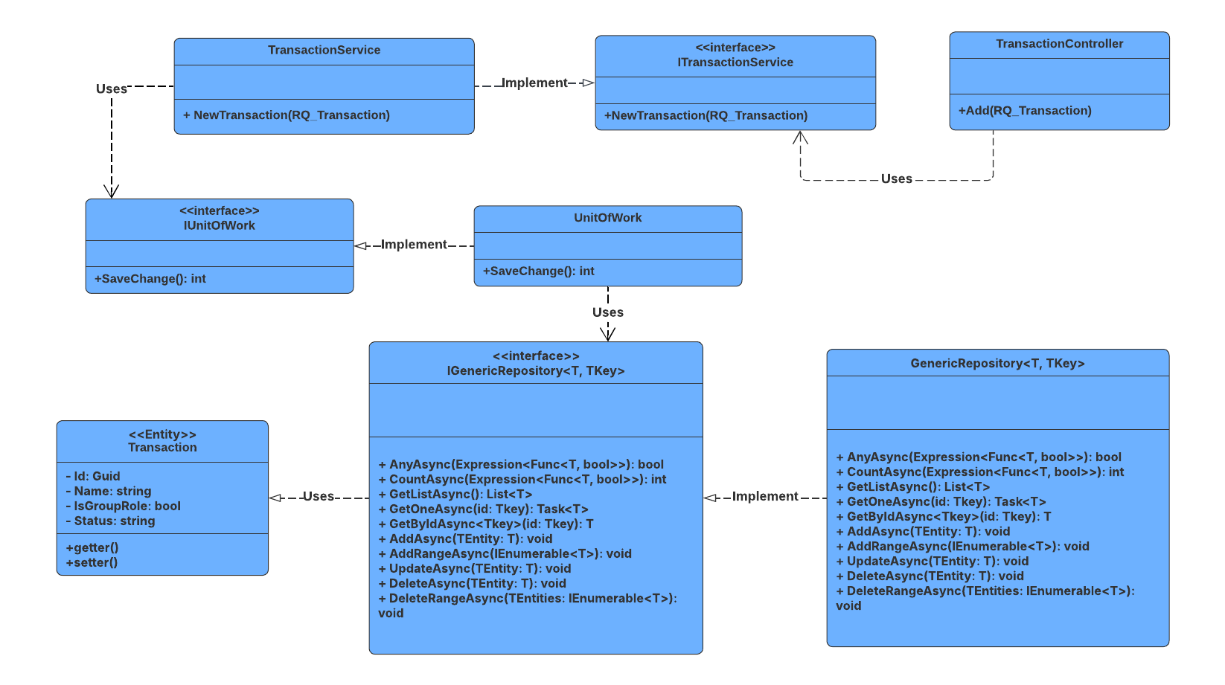

##### 3.11.1.2 Sequence Diagram

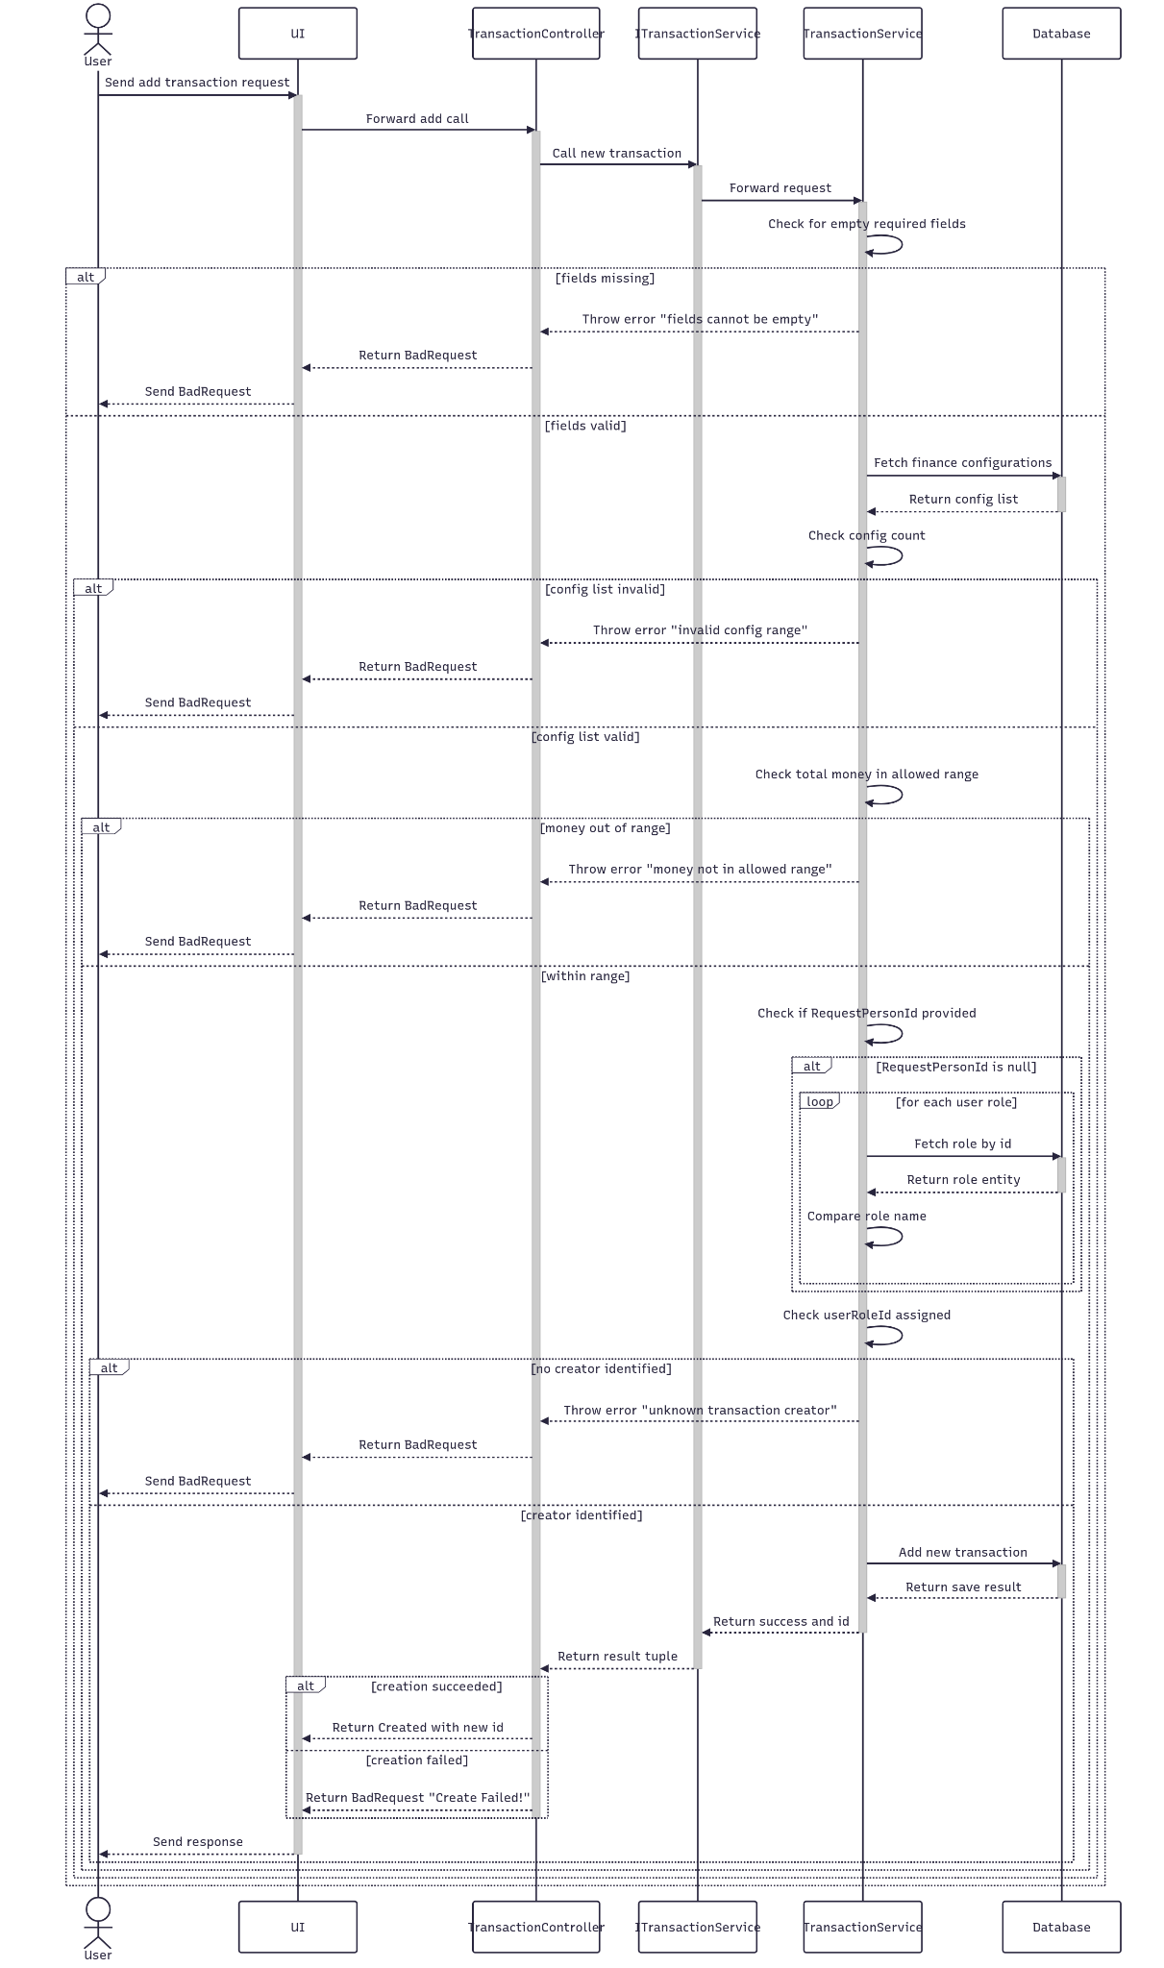

##### 3.11.1.3 Class Specification

###### 3.11.1.3.a TransactionController

| No | Method | Description |
| --- | --- | --- |
| 1 | Add(RQ_Transaction) | API endpoint that creates a new transaction. Returns 201 Created with the new transaction ID or 400 BadRequest if creation fails. |

3.11.1.3.b TransactionService

| No | Method | Description |
| --- | --- | --- |
| 1 | NewTransaction(RQ_Transaction) | Service method that persists the new transaction. Returns success status and new transaction ID. |

#### 3.11.2.Update

##### 3.11.2.1 Class Diagram

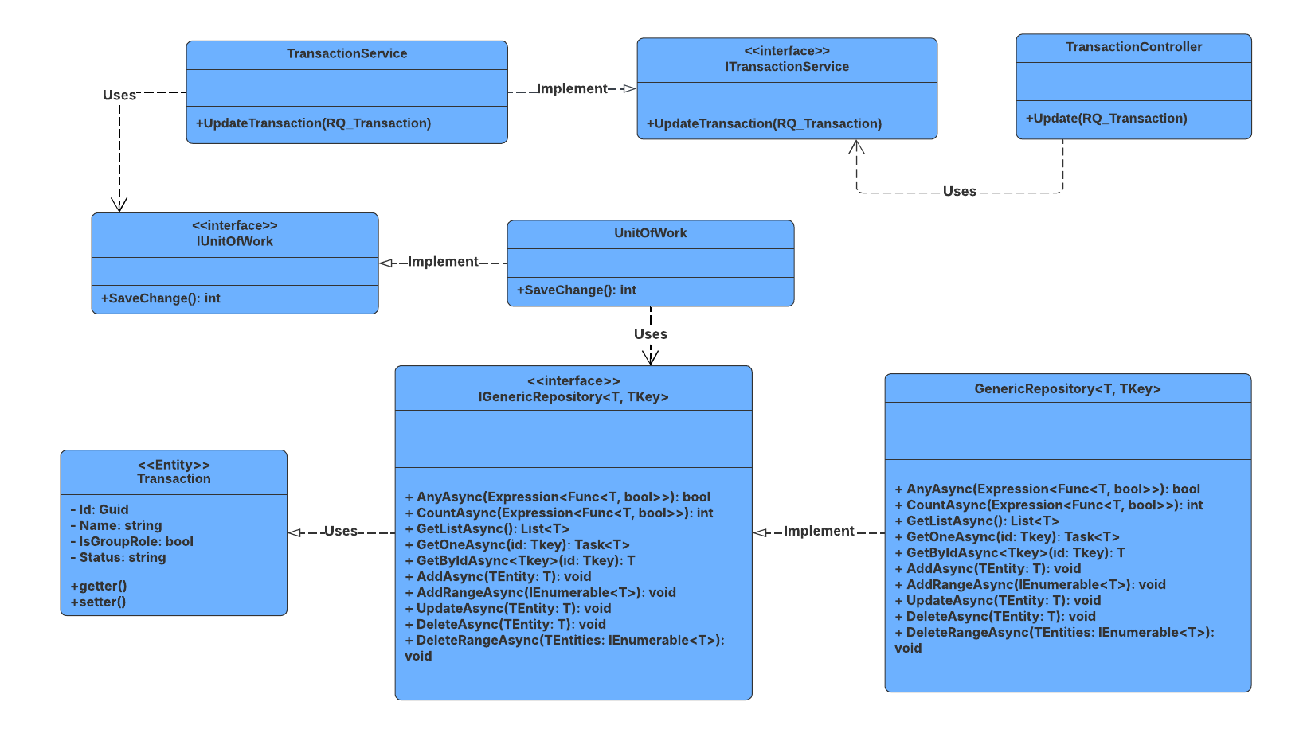

##### 3.11.2.2 Sequence Diagram

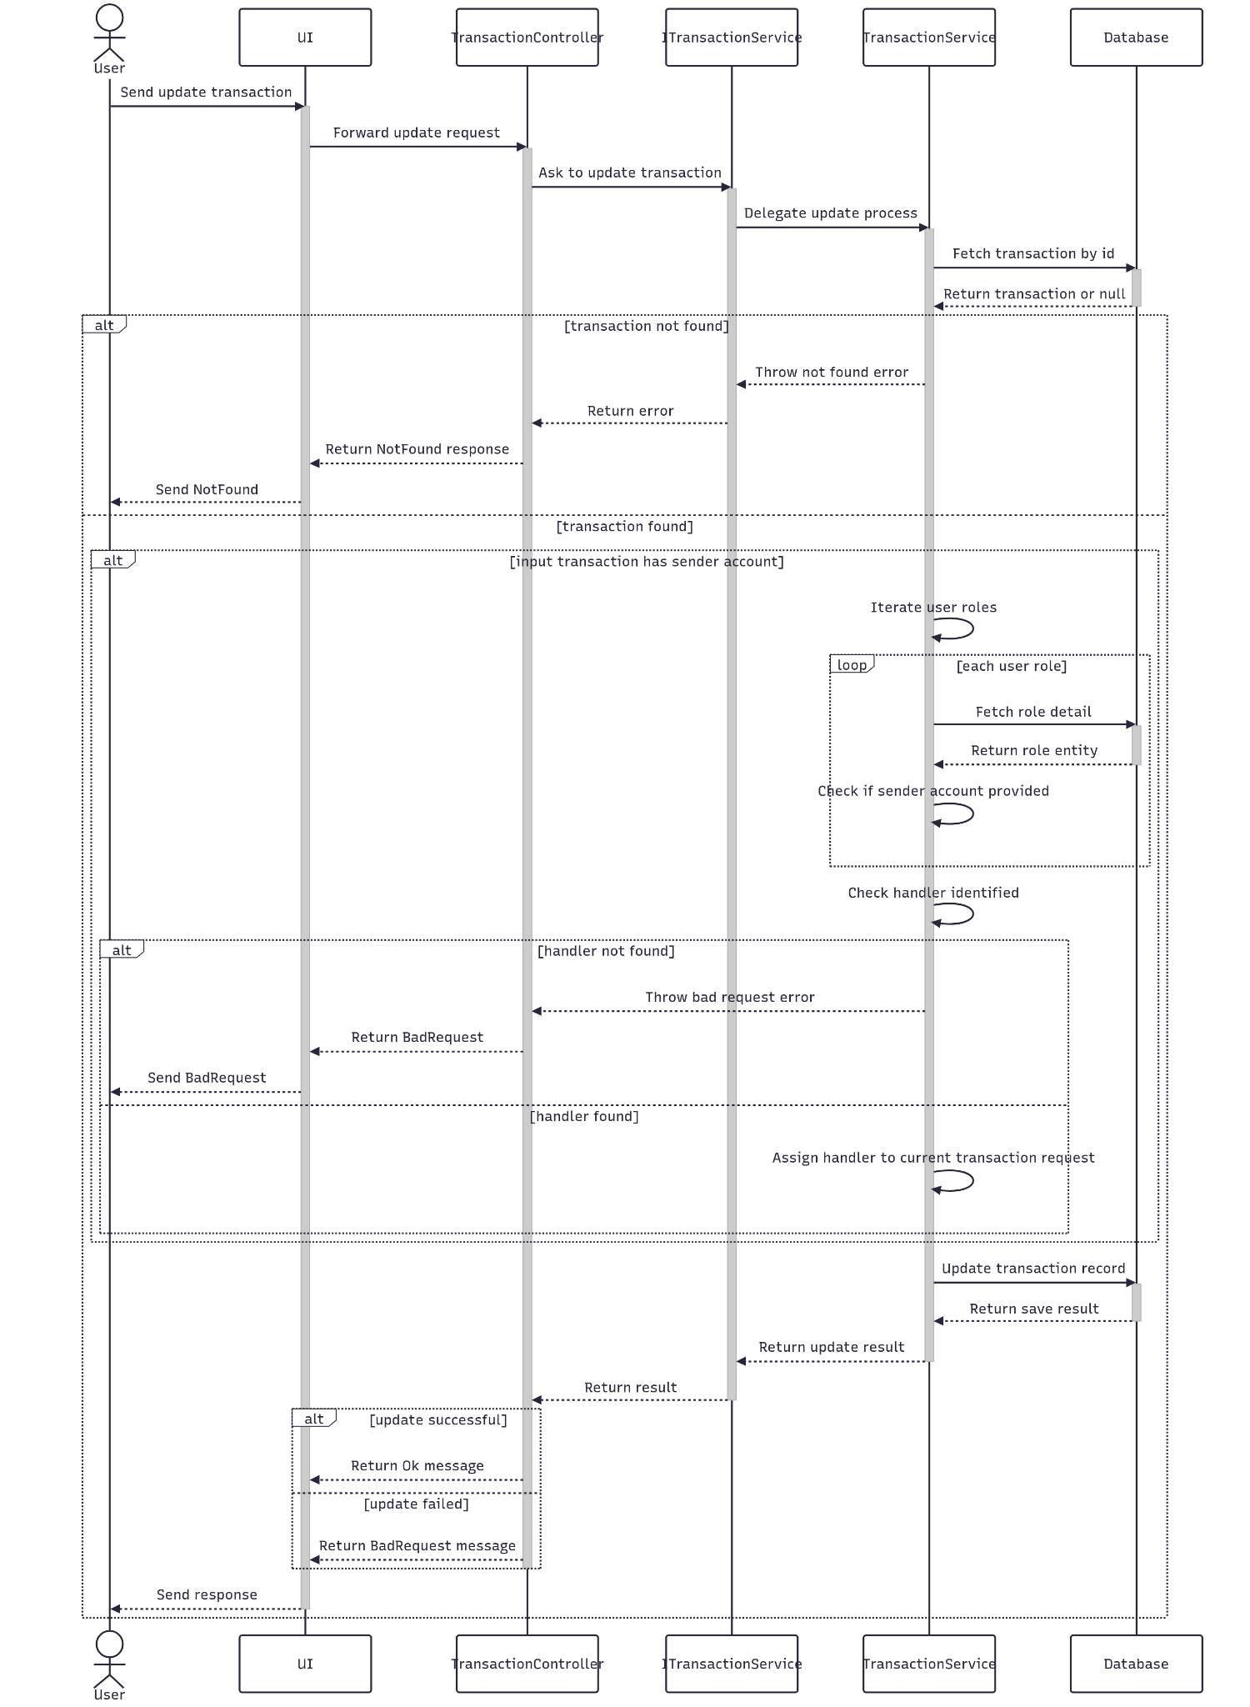

##### 3.11.2.3 Class Specification

###### 3.11.2.3.a TransactionController

| No | Method | Description |
| --- | --- | --- |
| 1 | Update(RQ_Transaction) | API endpoint that updates an existing transaction. Returns 200 OK if successful or 400 BadRequest if the update fails. |

###### 3.11.2.3.b TransactionService

| No | Method | Description |
| --- | --- | --- |
| 1 | UpdateTransaction(RQ_Transaction) | Service method that validates the transaction ID, applies updated data, and saves changes. Throws if the transaction is not found. |

#### 3.11.3.Get By Id

##### 3.11.3.1 Class Diagram

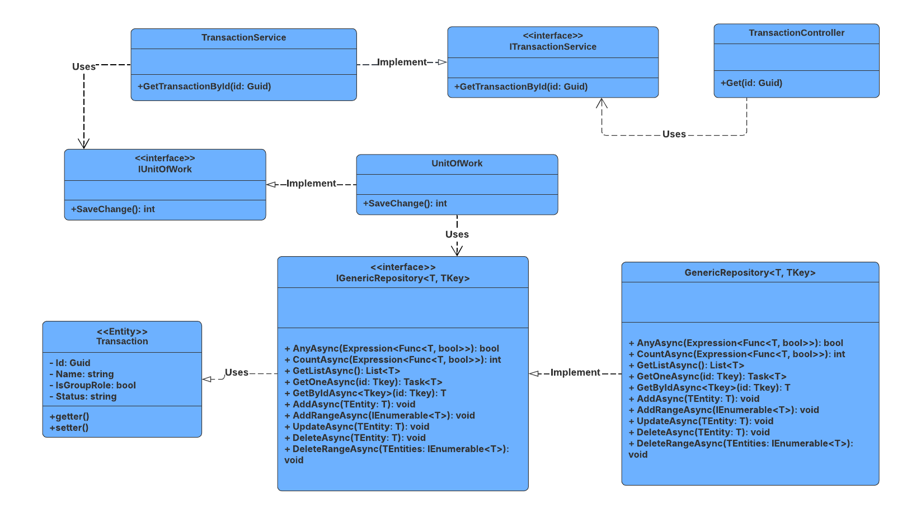

##### 3.11.3.2 Sequence Diagram

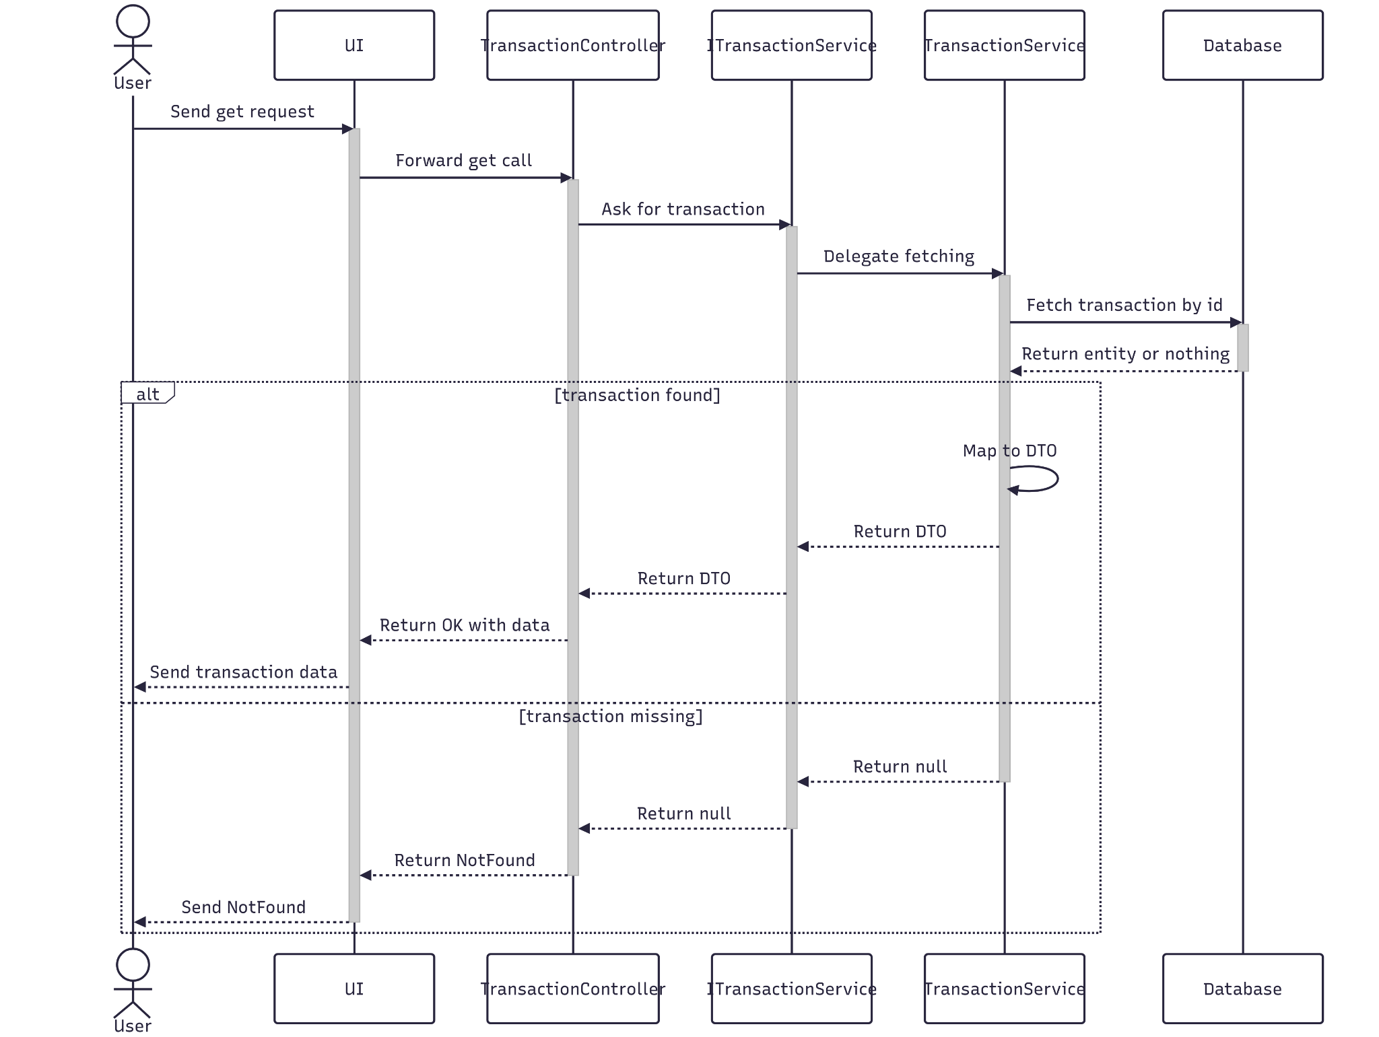

##### 3.11.3.3 Class Specification

###### 3.11.3.3.a TransactionController

| No | Method | Description |
| --- | --- | --- |
| 1 | Get(Guid id) | API endpoint that retrieves detailed information about a specific transaction by ID. Returns 200 OK with the transaction details. |

###### 3.11.3.3.b TransactionService

| No | Method | Description |
| --- | --- | --- |
| 1 | GetTransactionById(Guid id) | Service method that fetches detailed data, and maps the result to a response DTO. Throws BadRequestException or NotFoundException as needed. |

#### 3.11.4.Delete

##### 3.11.4.1 Class Diagram

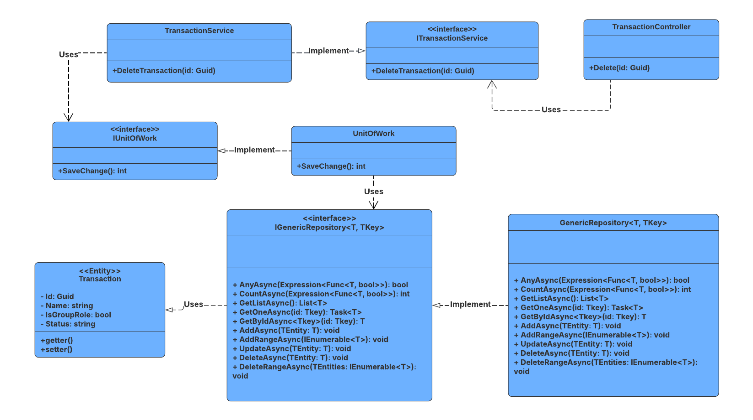

##### 3.11.4.2 Sequence Diagram

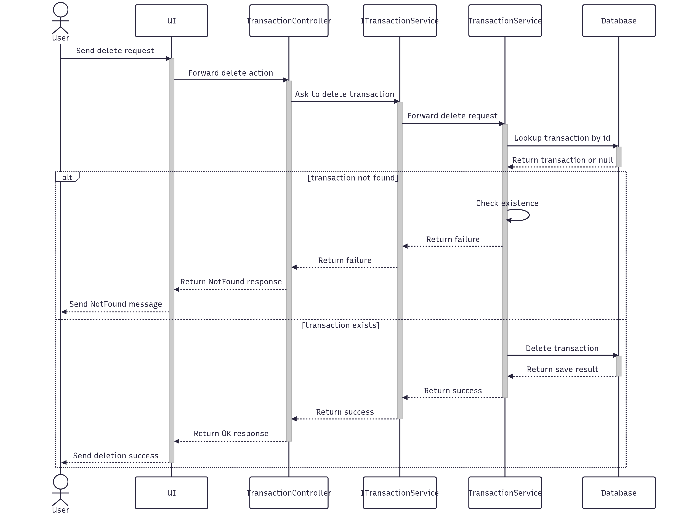

##### 3.11.4.3 Class Specification

###### 3.11.4.3.a TransactionController

| No | Method | Description |
| --- | --- | --- |
| 1 | Delete(Guid id) | API endpoint that deletes a transaction by ID. Returns 200 OK on success or 400 Bad Request on failure. |

###### 3.11.4.3.b TransactionService

| No | Method | Description |
| --- | --- | --- |
| 1 | DeleteTransaction(Guid id) | Service method that performs a delete of a transaction. Throws if the stage or related evaluation stages are not found. |

#### 3.11.5.Get List

##### 3.11.5.1 Class Diagram

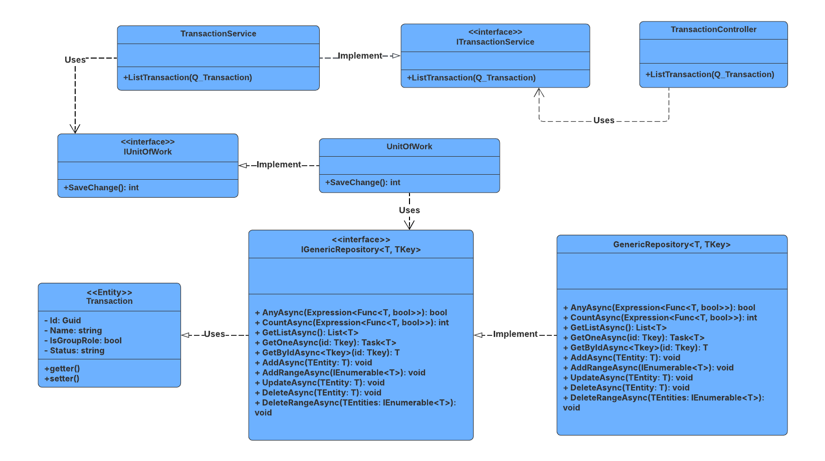

##### 3.11.5.2 Sequence Diagram

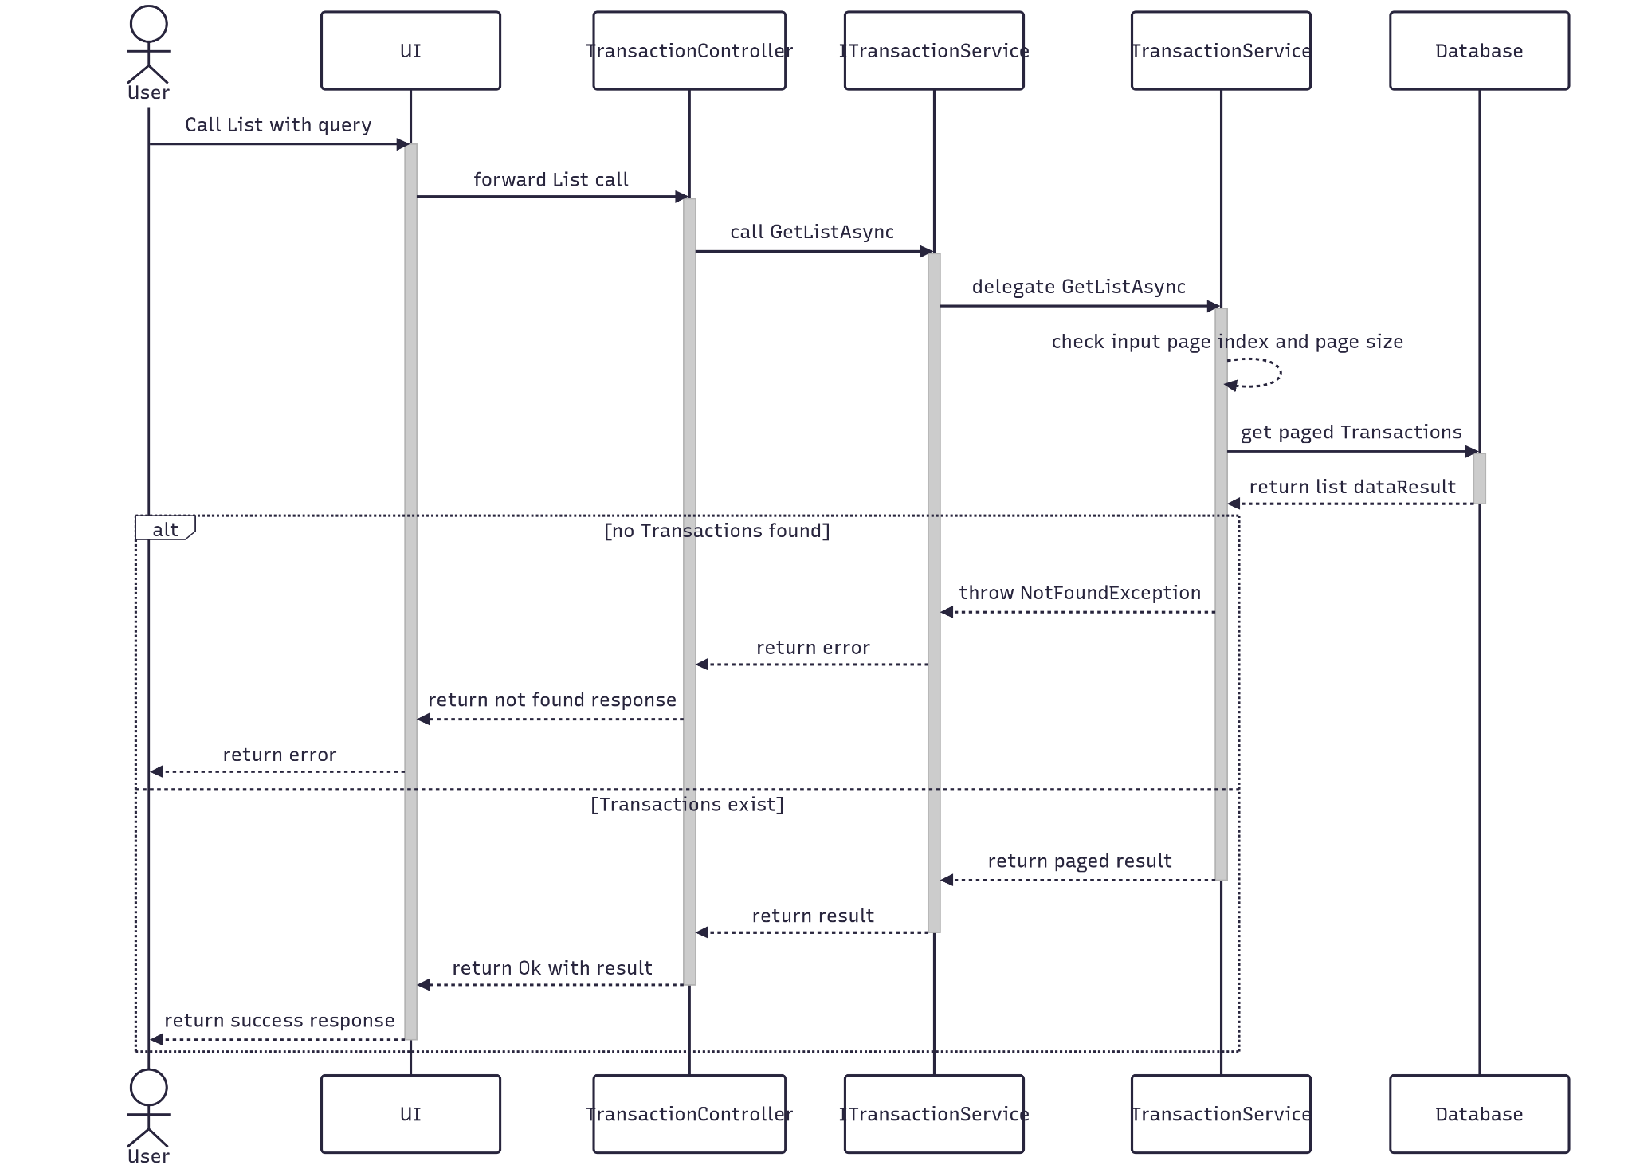

##### 3.11.5.3 Class Specification

###### 3.11.5.3.a TransactionController

| No | Method | Description |
| --- | --- | --- |
| 1 | ListTransaction(Q_Transaction) | API endpoint that receives a query payload and returns a paginated list of transactions. Responds with 200 OK and the result from ListTransaction. |

###### 3.11.5.3.b TransactionService

| No | Method | Description |
| --- | --- | --- |
| 1 | ListTransaction(Q_Transaction) | Service method that validates pagination parameters, queries the repository with multiple filters, and returns a paginated list of transactions. Throws NotFoundException if no results are found. |

### 3.12 Manage ProjectTag

#### 3.12.1.Create

##### 3.12.1.1 Class Diagram

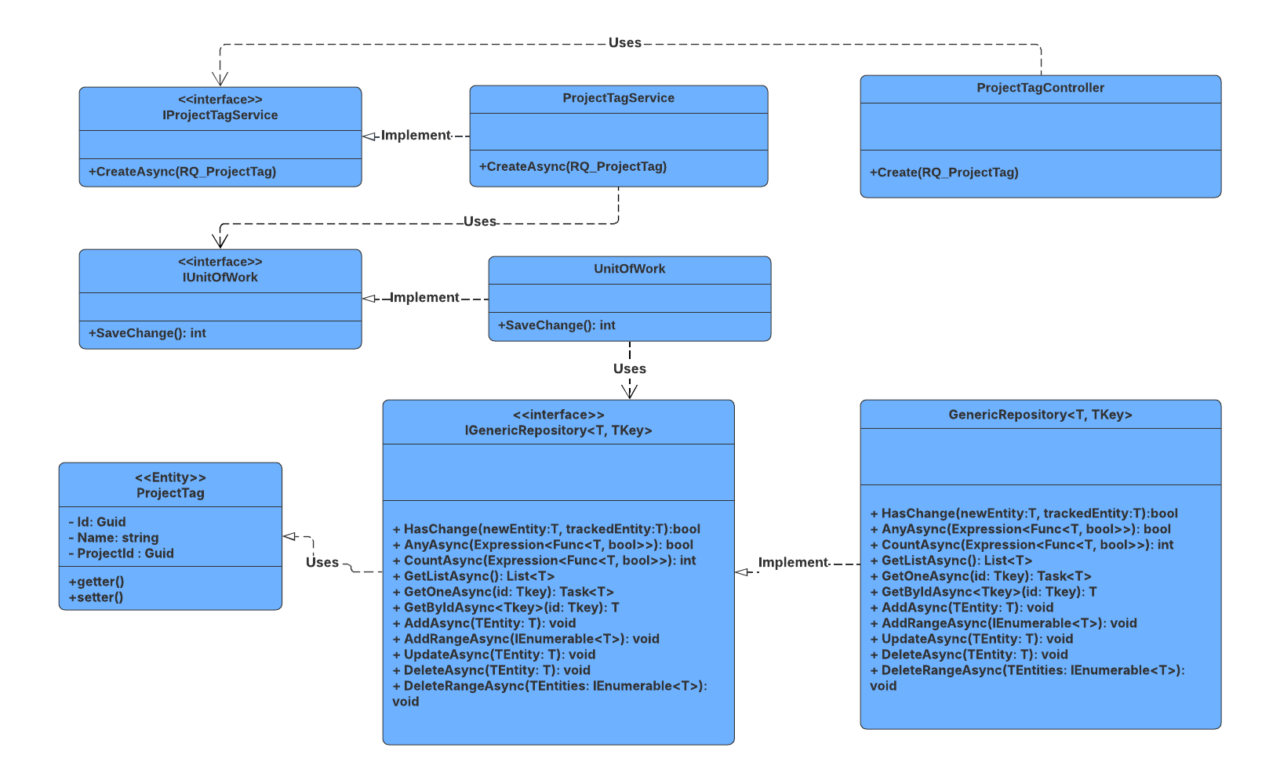

##### 3.12.1.2 Sequence Diagram

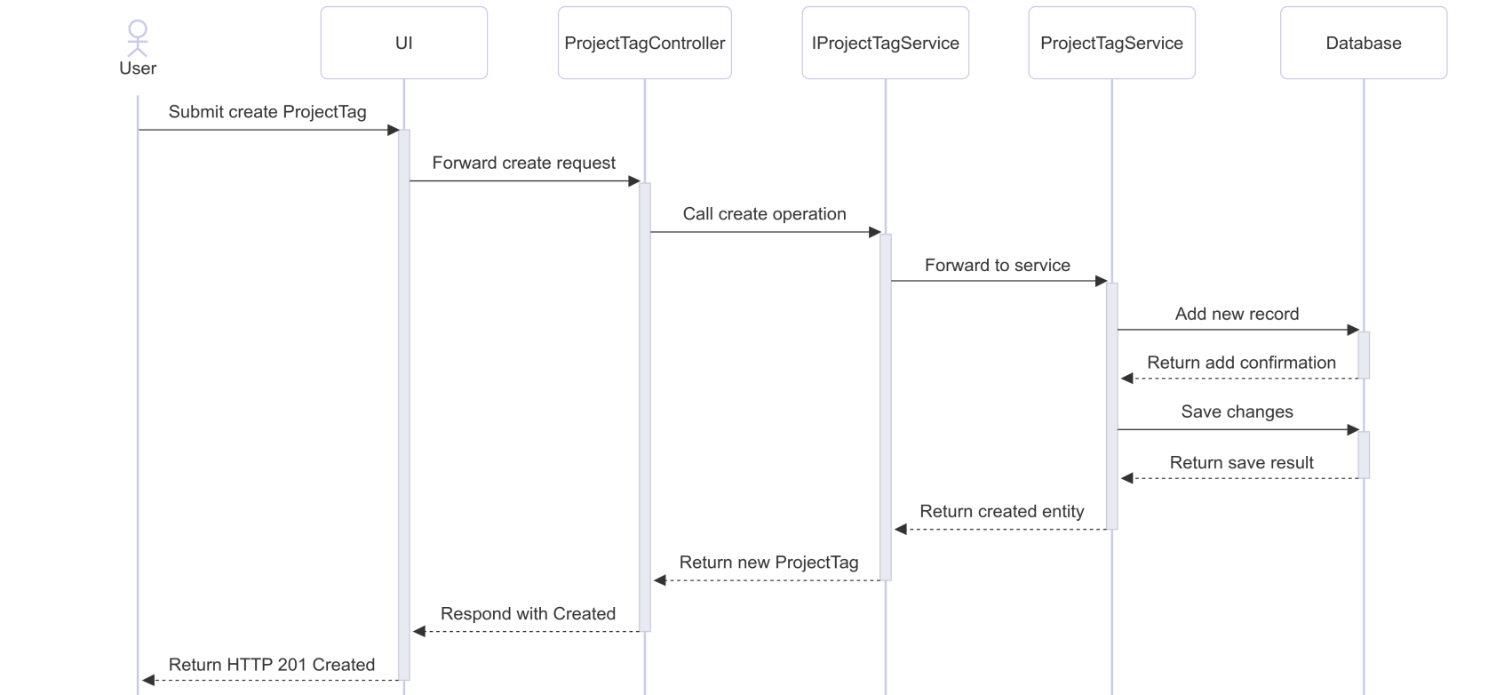

##### 3.12.1.3 Class Specification

###### 3.12.1.3.a ProjectTagController

| No | Method | Description |
| --- | --- | --- |
| 1 | Create(RQ_ProjectTag) | Receives project-tag association data and calls CreateAsync to persist it. Returns 201 Created with route values for projectId and majorId. |

###### 3.12.1.3.b ProjectTagService

| No | Method | Description |
| --- | --- | --- |
| 1 | CreateAsync(RQ_ProjectTag) | Maps the request to a ProjectTag entity, adds it to the repository, saves changes, and returns the result as RS_ProjectTag. |

#### 3.12.2.Update

##### 3.12.2.1 Class Diagram

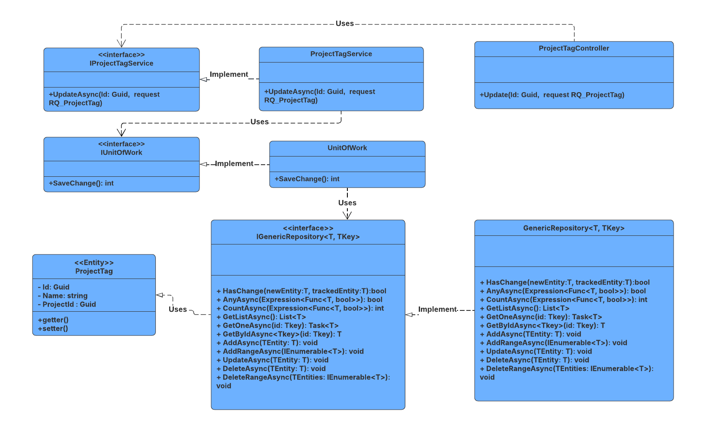

##### 3.12.2.2 Sequence Diagram

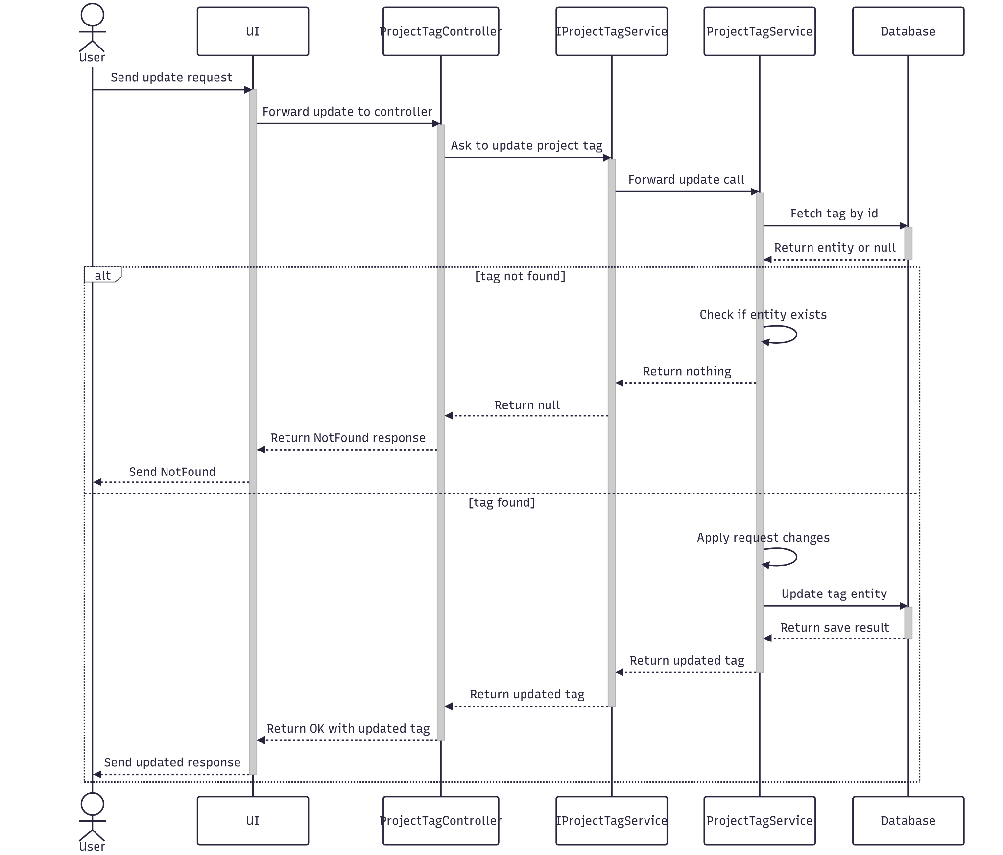

##### 3.12.2.3 Class Specification

###### 3.12.2.3.a ProjectTagController

| No | Method | Description |
| --- | --- | --- |
| 1 | Update(Guid id, RQ_ProjectTag) | API endpoint that updates an existing project tag. Returns 200 OK if successful or 400 BadRequest if the update fails. |

###### 3.12.2.3.b ProjectTagService

| No | Method | Description |
| --- | --- | --- |
| 1 | UpdateAsync(Guid id, RQ_ProjectTag) | Service method that validates the project tag ID, applies updated data, and saves changes. Throws if the project tag is not found. |

#### 3.12.3.Get By Id

##### 3.12.3.1 Class Diagram

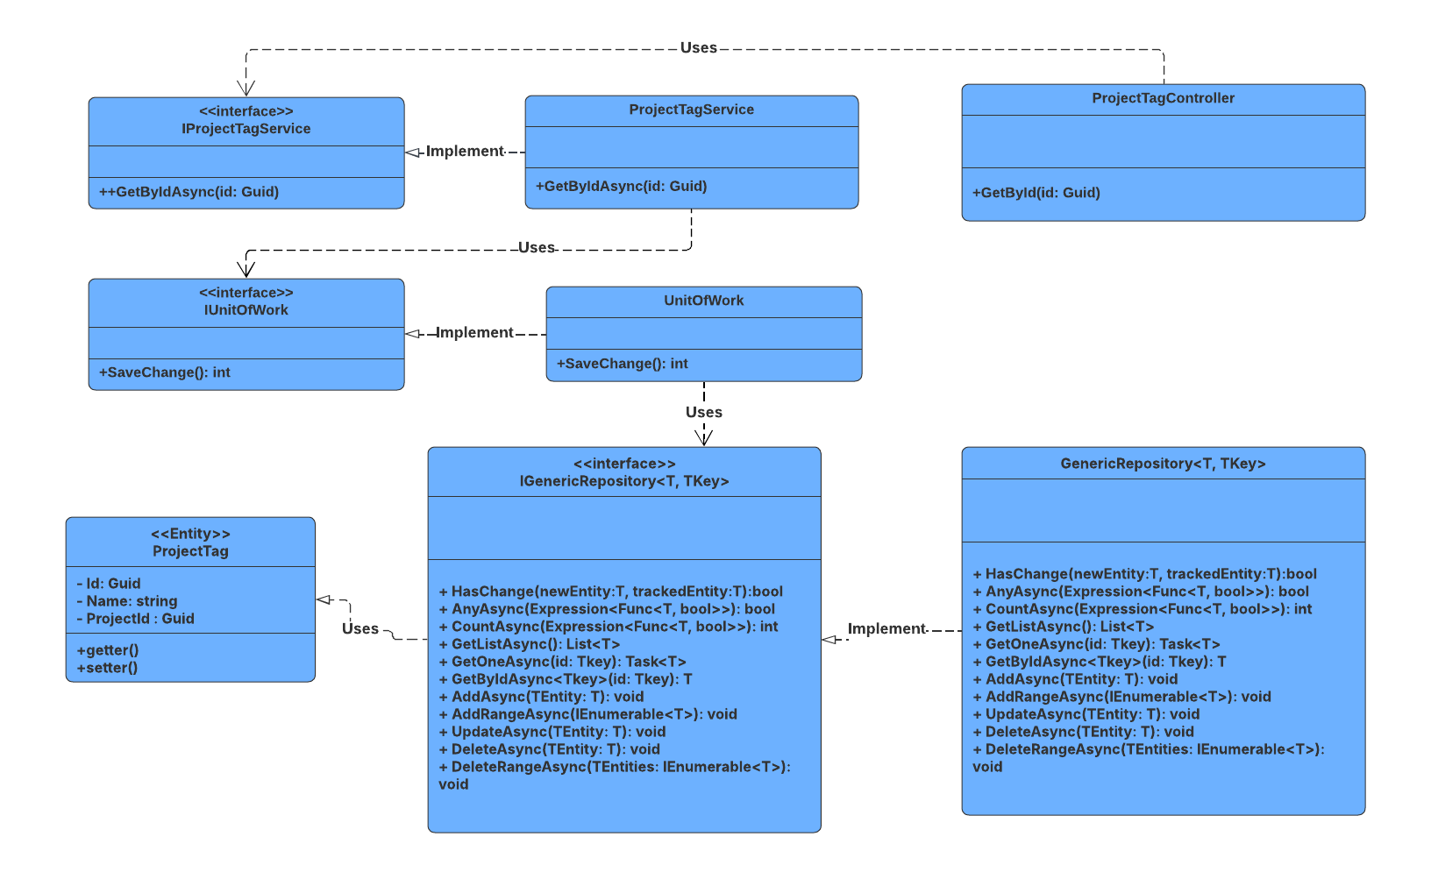

##### 3.12.3.2 Sequence Diagram

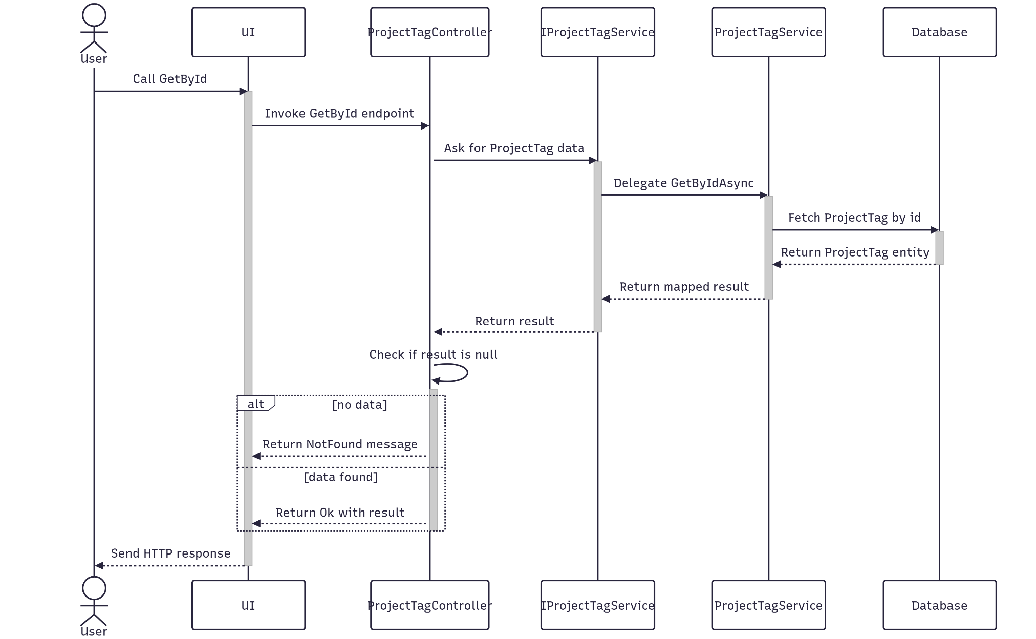

##### 3.12.3.3 Class Specification

###### 3.12.3.3.a ProjectTagController

| No | Method | Description |
| --- | --- | --- |
| 1 | GetById(Guid id) | API endpoint that retrieves detailed information about a specific project tag by ID. Returns 200 OK with the project tag details. |

###### 3.12.3.3.b ProjectTagService

| No | Method | Description |
| --- | --- | --- |
| 1 | GetByIdAsync(Guid id) | Service method that fetches detailed data, and maps the result to a response DTO. Throws BadRequestException or NotFoundException as needed. |

#### 3.12.4.Delete

##### 3.12.4.1 Class Diagram

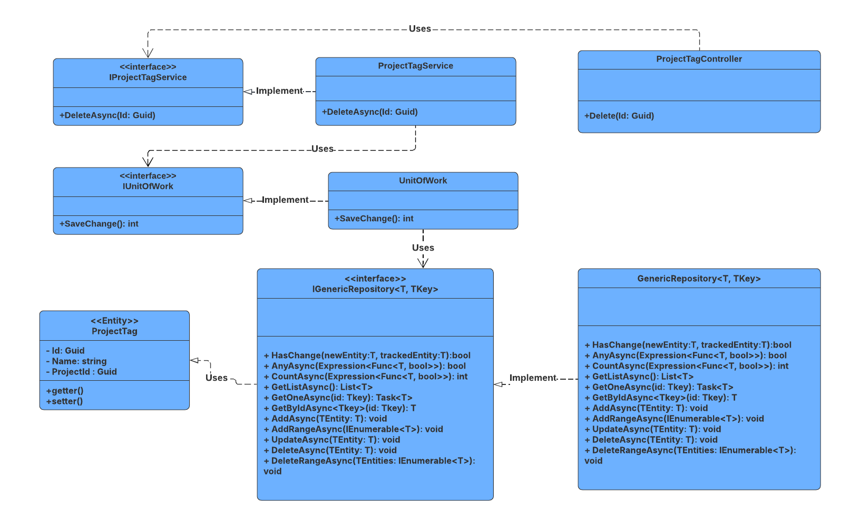

##### 3.12.4.2 Sequence Diagram

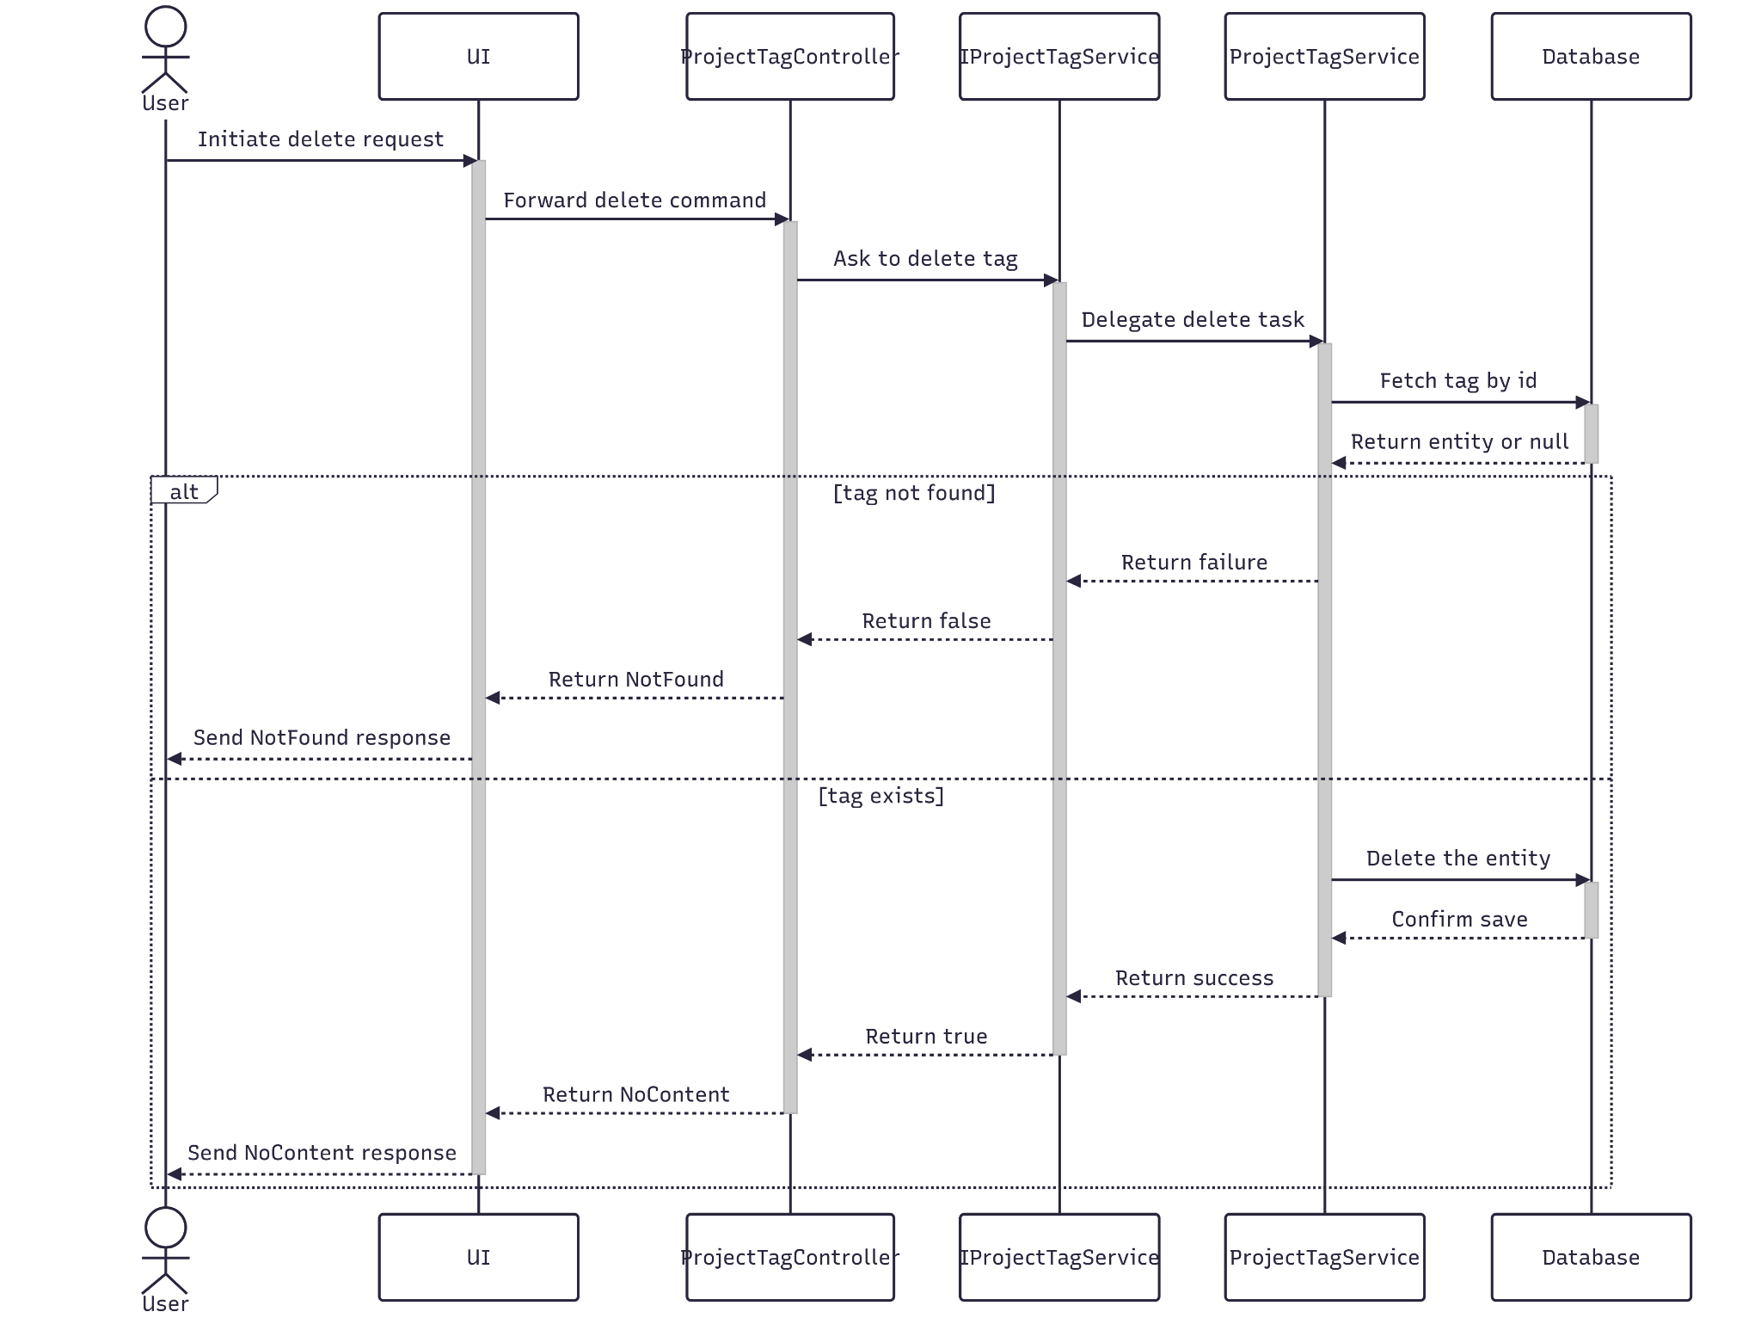

##### 3.12.4.3 Class Specification

###### 3.12.4.3.a ProjectTagController

| No | Method | Description |
| --- | --- | --- |
| 1 | Delete(RQ_ProjectTag) | API endpoint that deletes a project tag by ID. Returns 200 OK on success or 400 Bad Request on failure. |

###### 3.12.4.3.b ProjectTagService

| No | Method | Description |
| --- | --- | --- |
| 1 | DeleteAsync(RQ_ProjectTag) | Service method that performs a cascade delete of a project tag. |

#### 3.12.5.Get List

##### 3.12.5.1 Class Diagram

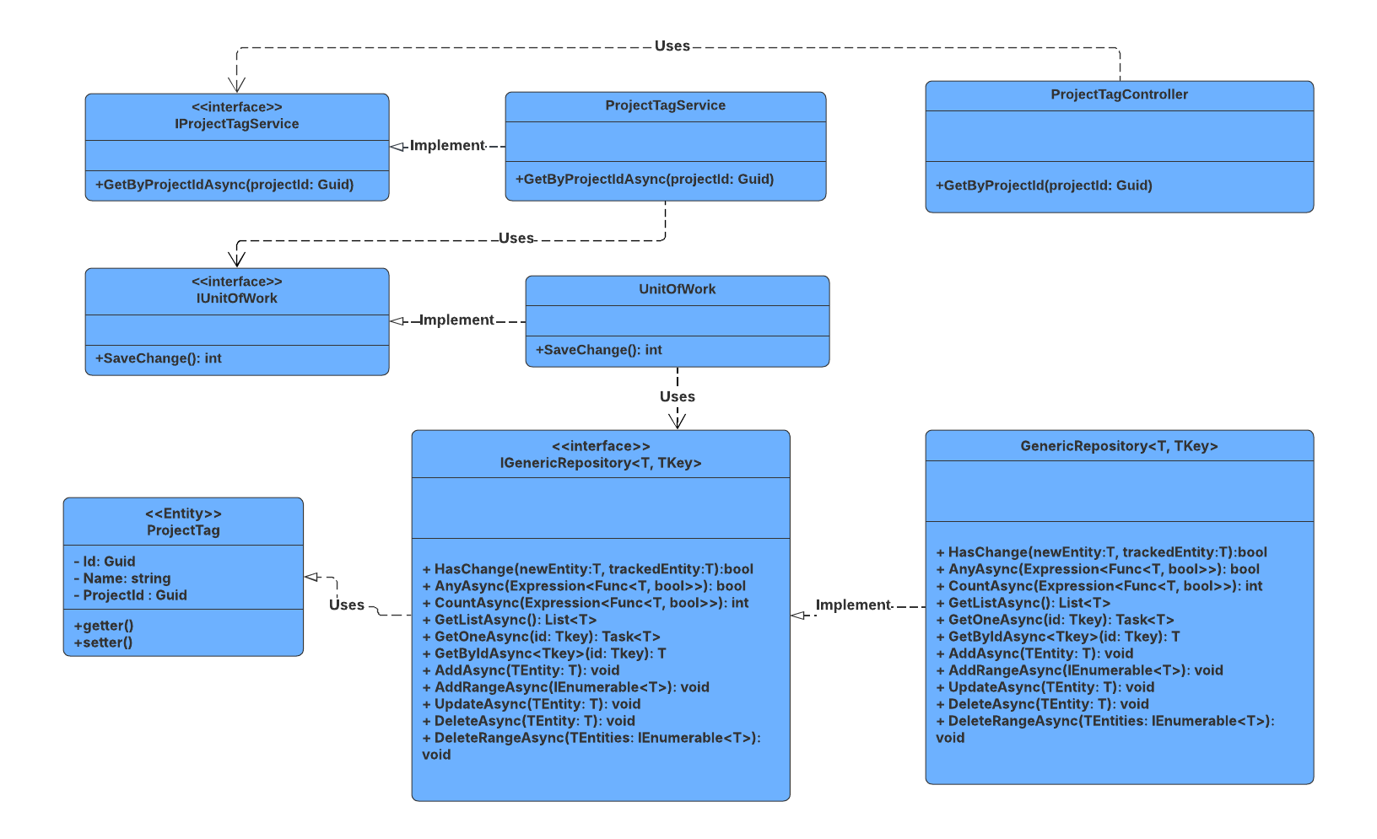

##### 3.12.5.2 Sequence Diagram

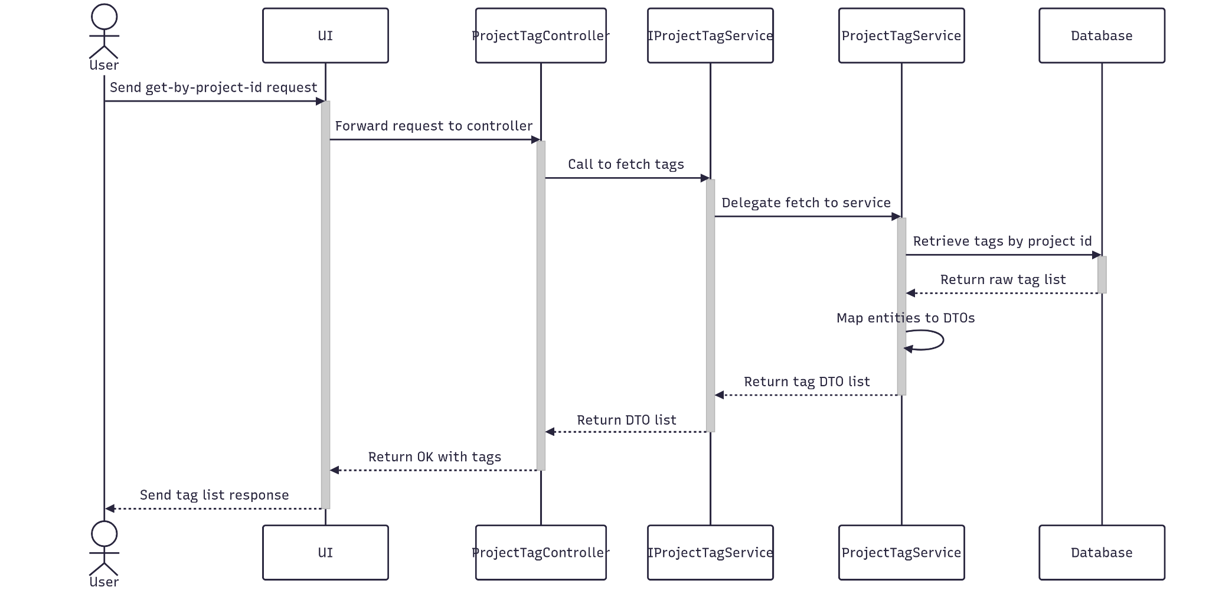

##### 3.12.5.3 Class Specification

###### 3.12.5.3.a ProjectTagController

| No | Method | Description |
| --- | --- | --- |
| 1 | GetByProjectId(Guid id) | API endpoint that receives a project id and returns a list of project tags. Responds with 200 OK and the result from GetByProjectIdAsync. |

###### 3.12.5.3.b ProjectTagService

| No | Method | Description |
| --- | --- | --- |
| 1 | GetByProjectIdAsync (Guid id) | Service method that receives a project id, queries the repository, and returns a list of project tags. |

### 3.13 Manage Project Result

#### 3.13.1.Create

##### 3.13.1.1 Class Diagram

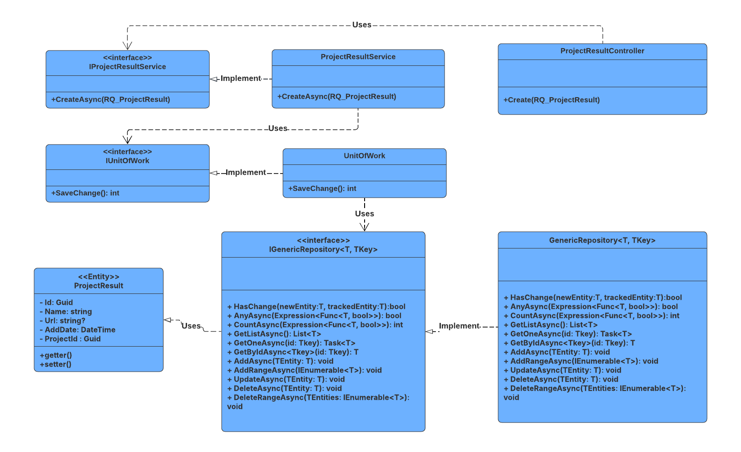

##### 3.13.1.2 Sequence Diagram

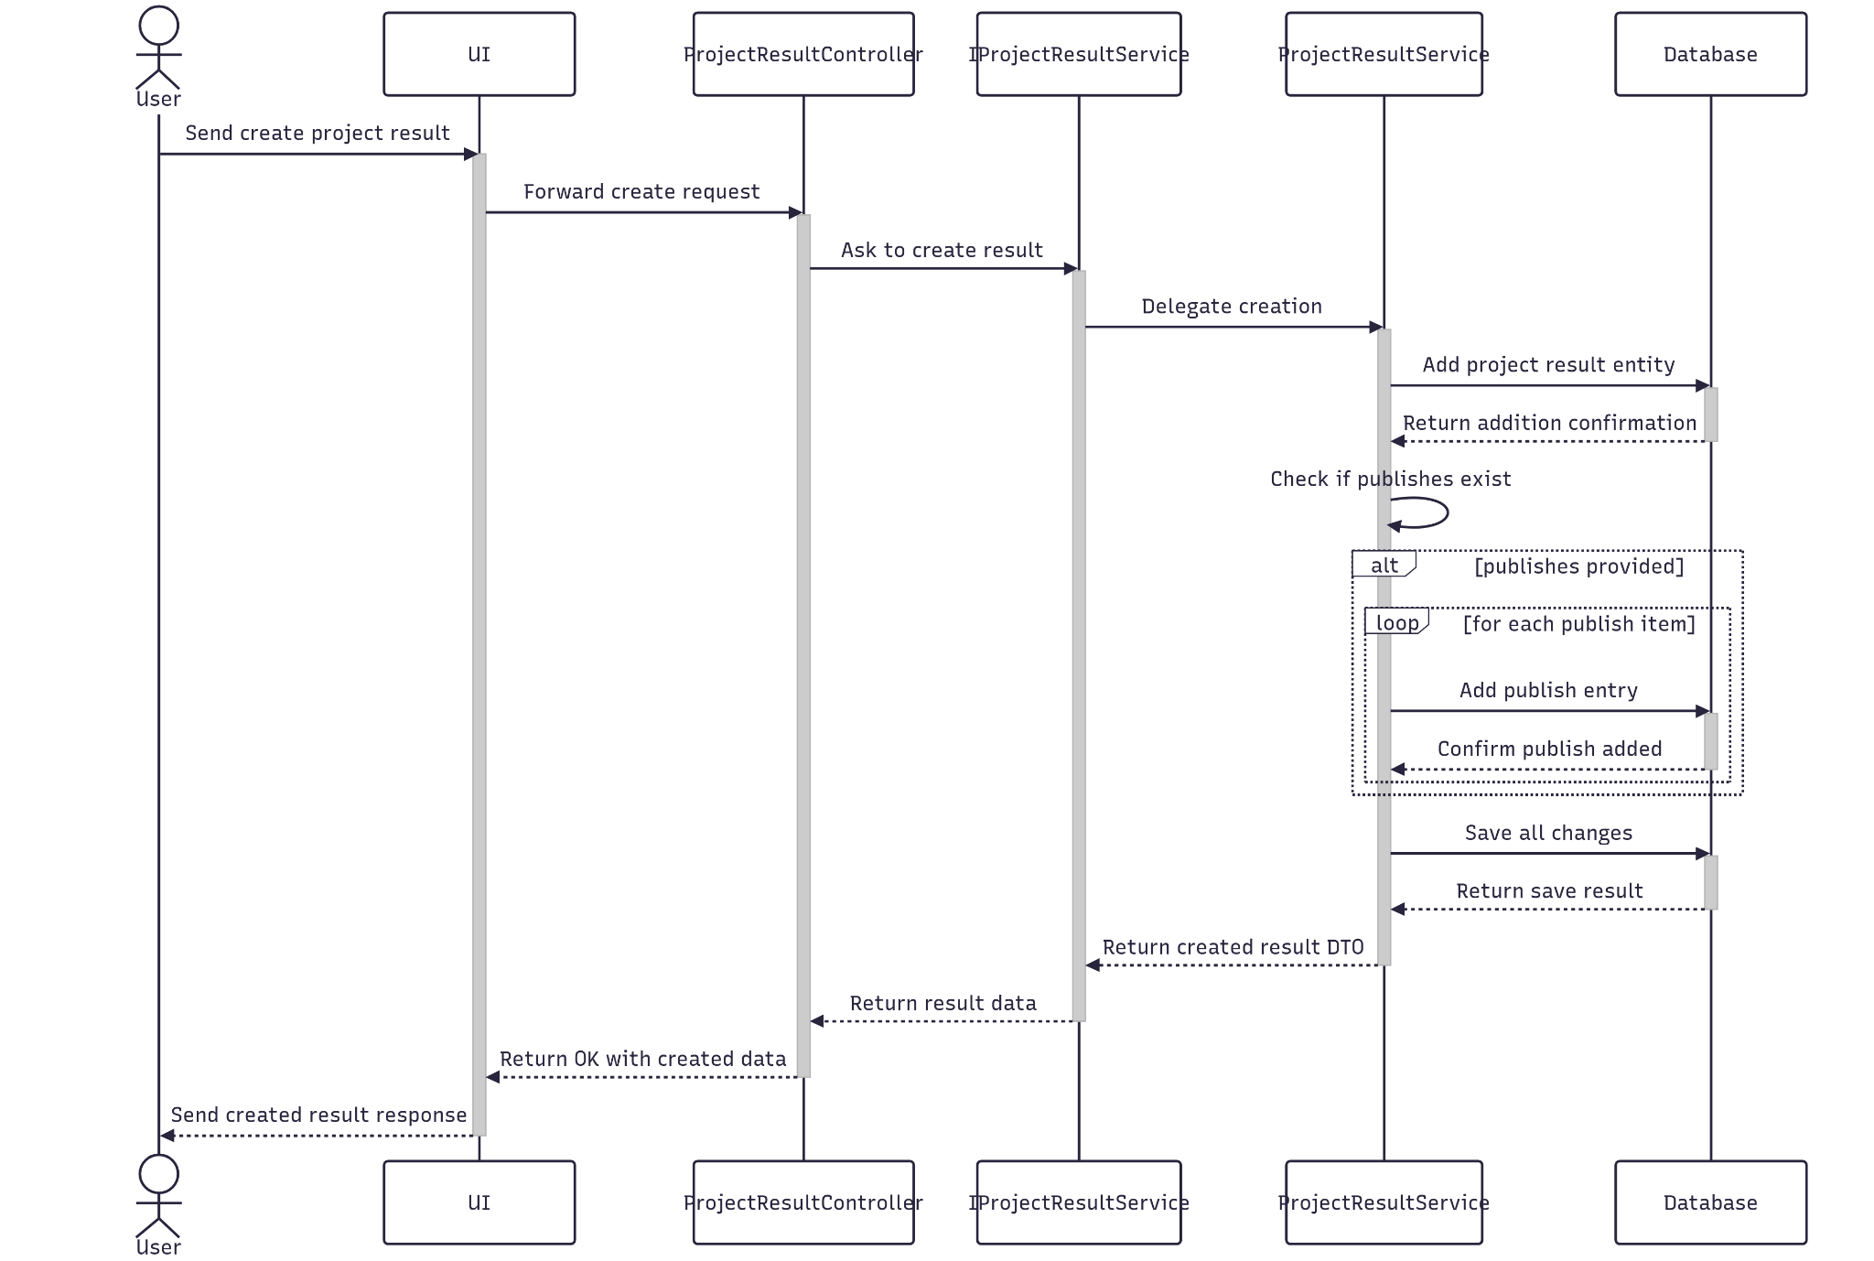

##### 3.13.1.3 Class Specification

###### 3.13.1.3.a ProjectResultController

| No | Method | Description |
| --- | --- | --- |
| 1 | Create(RQ_ProjectResult) | API endpoint that creates a new project result. Returns 201 Created with the new project result entity or 400 BadRequest if creation fails. |

###### 3.13.1.3.b ProjectResultService

| No | Method | Description |
| --- | --- | --- |
| 1 | CreateAsync(RQ_ProjectResult) | Service method that persists the new project result. Returns success status and new project result entity. |

#### 3.13.2.Update

##### 3.13.2.1 Class Diagram

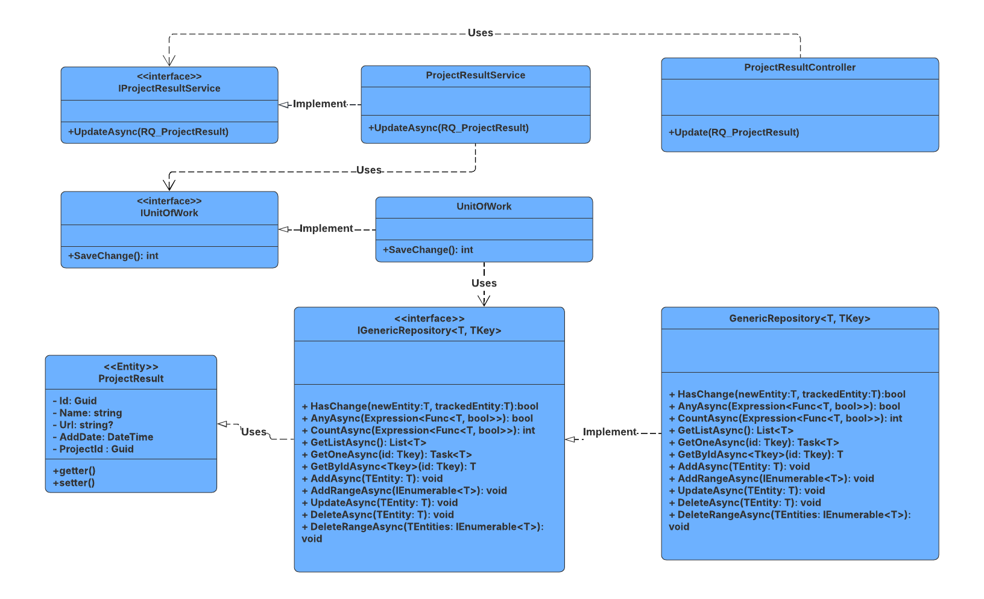

##### 3.13.2.2 Sequence Diagram

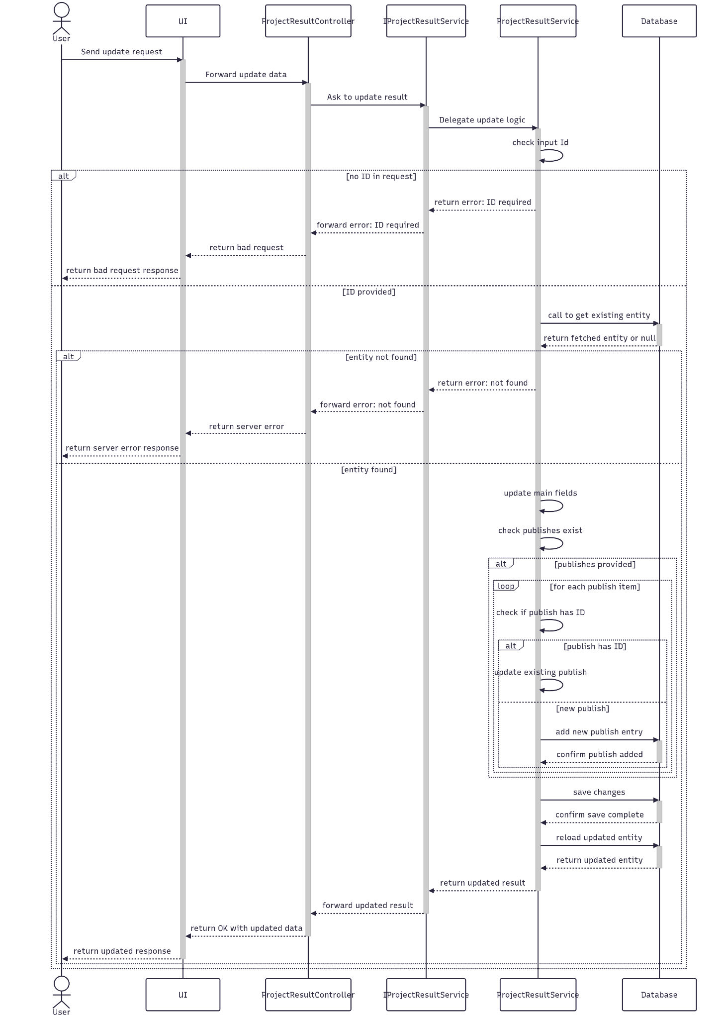

##### 3.13.2.3 Class Specification

###### 3.13.2.3.a ProjectResultController

| No | Method | Description |
| --- | --- | --- |
| 1 | Update(RQ_ProjectResult) | API endpoint that updates an existing project result. Returns 200 OK if successful or 400 BadRequest if the update fails. |

###### 3.13.2.3.b ProjectResultService

| No | Method | Description |
| --- | --- | --- |
| 1 | UpdateAsync(RQ_ProjectResult) | Service method that validates the project result ID, applies updated data, and saves changes. Throws if the project result is not found. |

#### 3.13.3.Get By Id

##### 3.13.3.1 Class Diagram

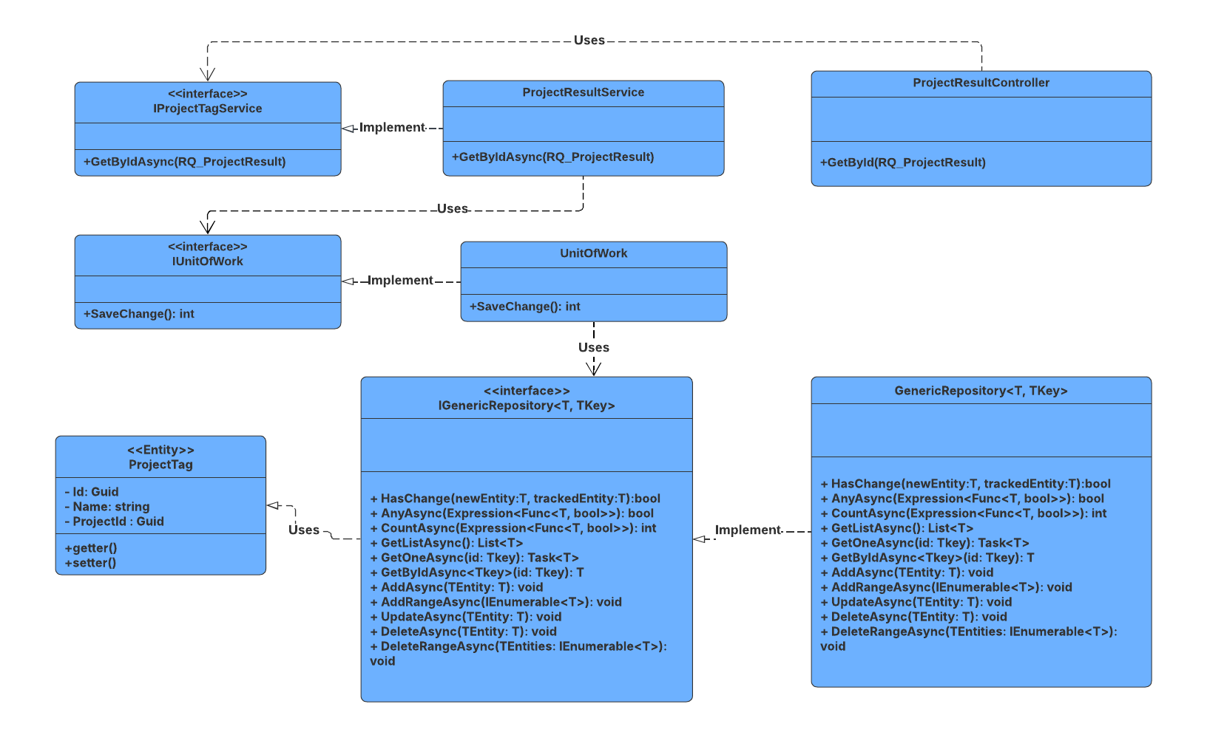

##### 3.13.3.2 Sequence Diagram

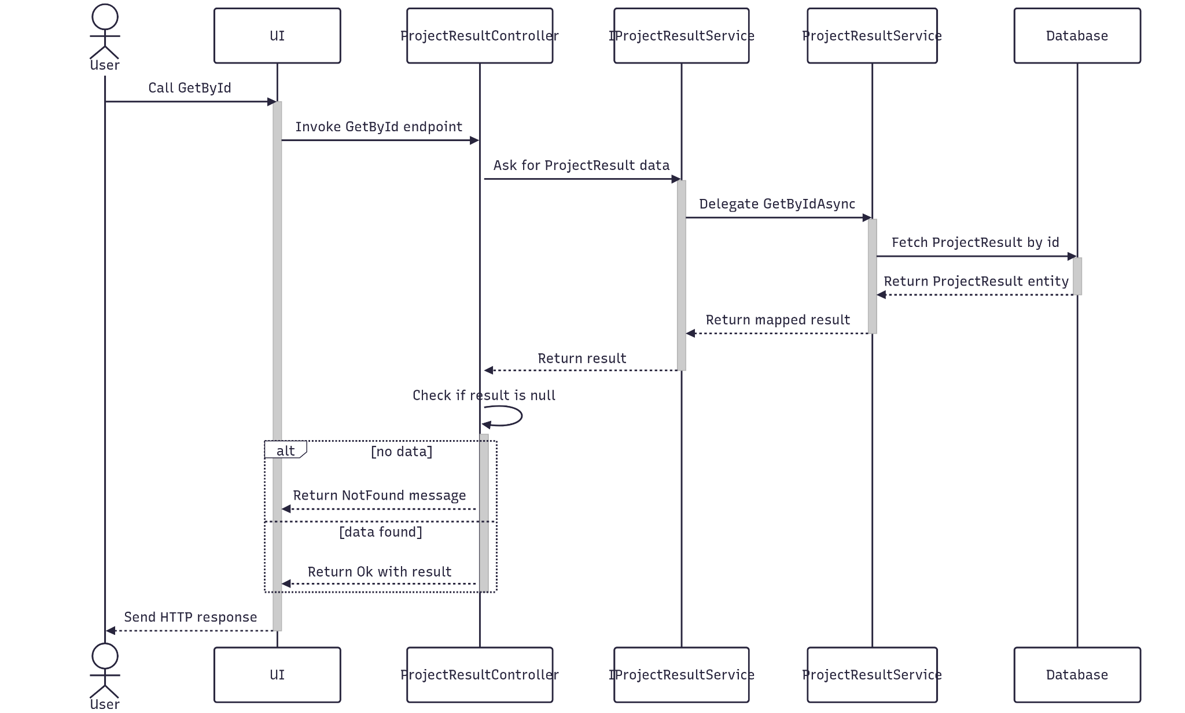

##### 3.13.3.3 Class Specification

###### 3.13.3.3.a ProjectResultController

| No | Method | Description |
| --- | --- | --- |
| 1 | GetById(Guid id) | API endpoint that retrieves detailed information about a specific project result by ID. Returns 200 OK with the project result details. |

###### 3.13.3.3.b ProjectResultService

| No | Method | Description |
| --- | --- | --- |
| 1 | GetByIdAsync(Guid id) | Service method that fetches detailed data, and maps the result to a response DTO. Throws BadRequestException or NotFoundException as needed. |

#### 3.13.4.Delete

##### 3.13.4.1 Class Diagram

##### 

##### 3.13.4.2 Sequence Diagram

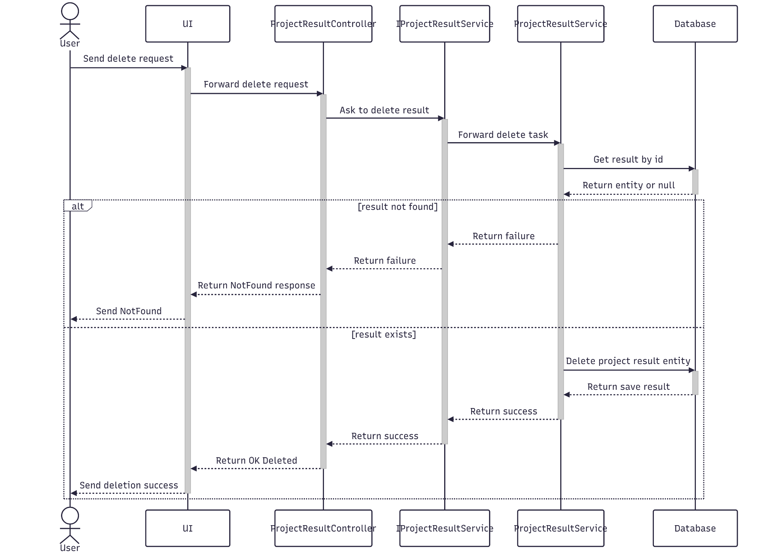

3.13.4.3 Class Specification

###### 3.13.4.3.a ProjectResultController

| No | Method | Description |
| --- | --- | --- |
| 1 | Delete(Guid id) | API endpoint that deletes a project result by ID. Returns 200 OK on success or 400 Bad Request on failure. |

###### 3.13.4.3.b ProjectResultService

| No | Method | Description |
| --- | --- | --- |
| 1 | DeleteAsync(Guid id) | Service method that performs a cascade delete of a project result. |

#### 3.13.5.Get List

##### 3.13.5.1 Class Diagram

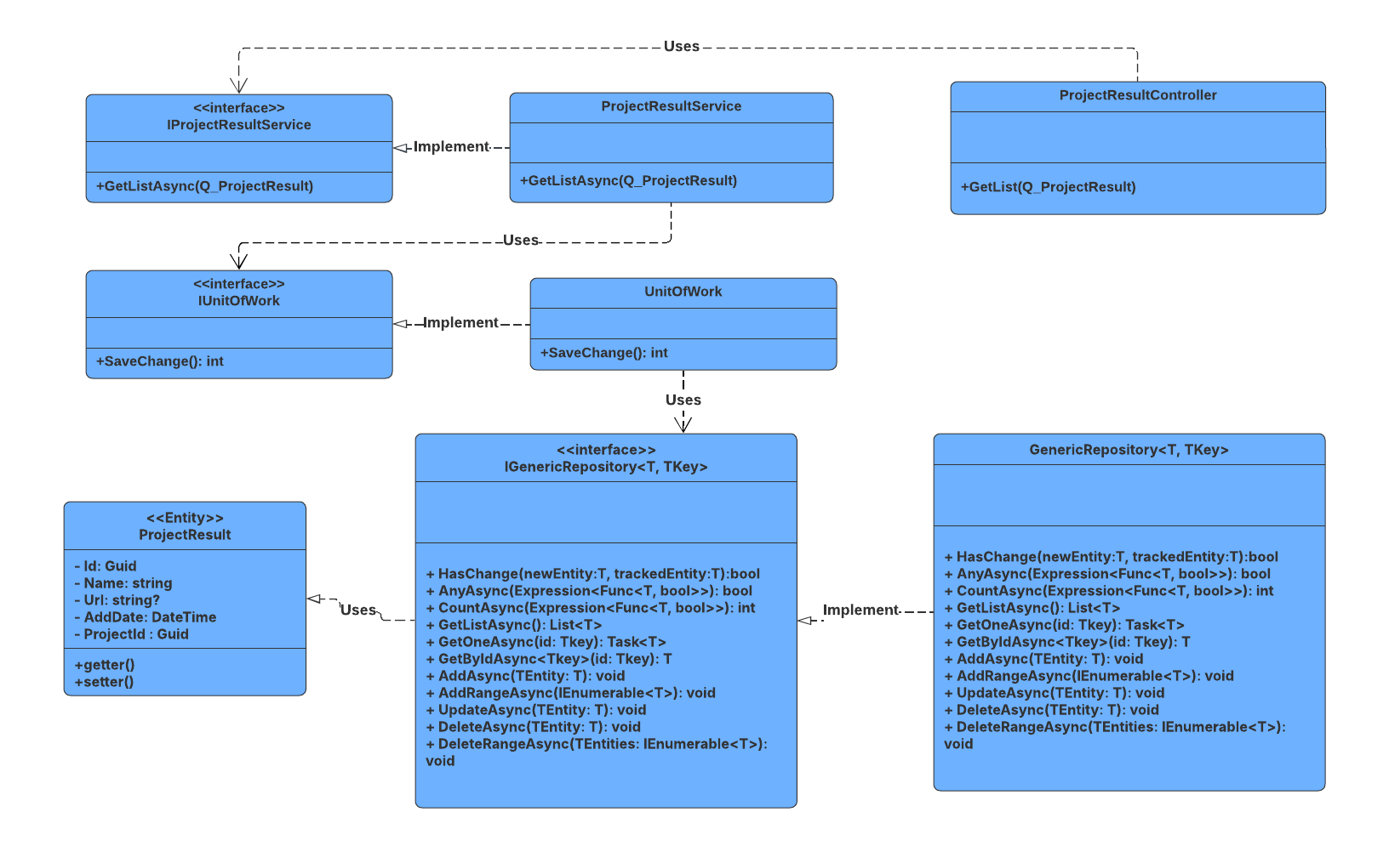

##### 3.13.5.2 Sequence Diagram

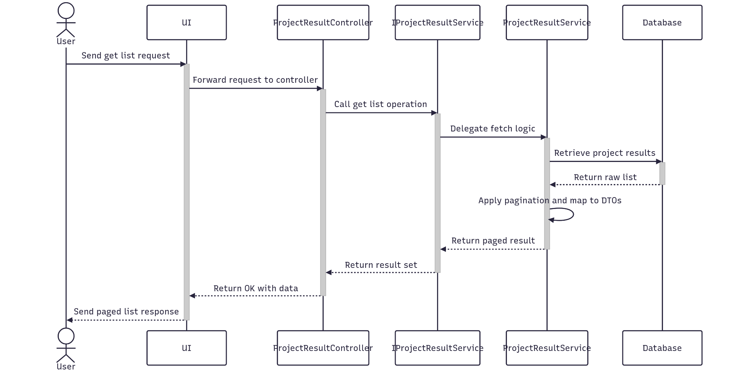

##### 3.13.5.3 Class Specification

###### 3.13.5.3.a ProjectResultController

| No | Method | Description |
| --- | --- | --- |
| 1 | GetList(Q_ProjectResult) | API endpoint that receives a query payload and returns a paginated list of project results. Responds with 200 OK and the result from GetListAsync. |

###### 3.13.5.3.b ProjectResultService

| No | Method | Description |
| --- | --- | --- |
| 1 | GetListAsync(Q_ProjectResult) | Service method that validates pagination parameters, queries the repository with multiple filters, and returns a paginated list of project results. |

### 3.14 Manage MemberTask

#### 3.14.1.Create

##### 3.14.1.1 Class Diagram

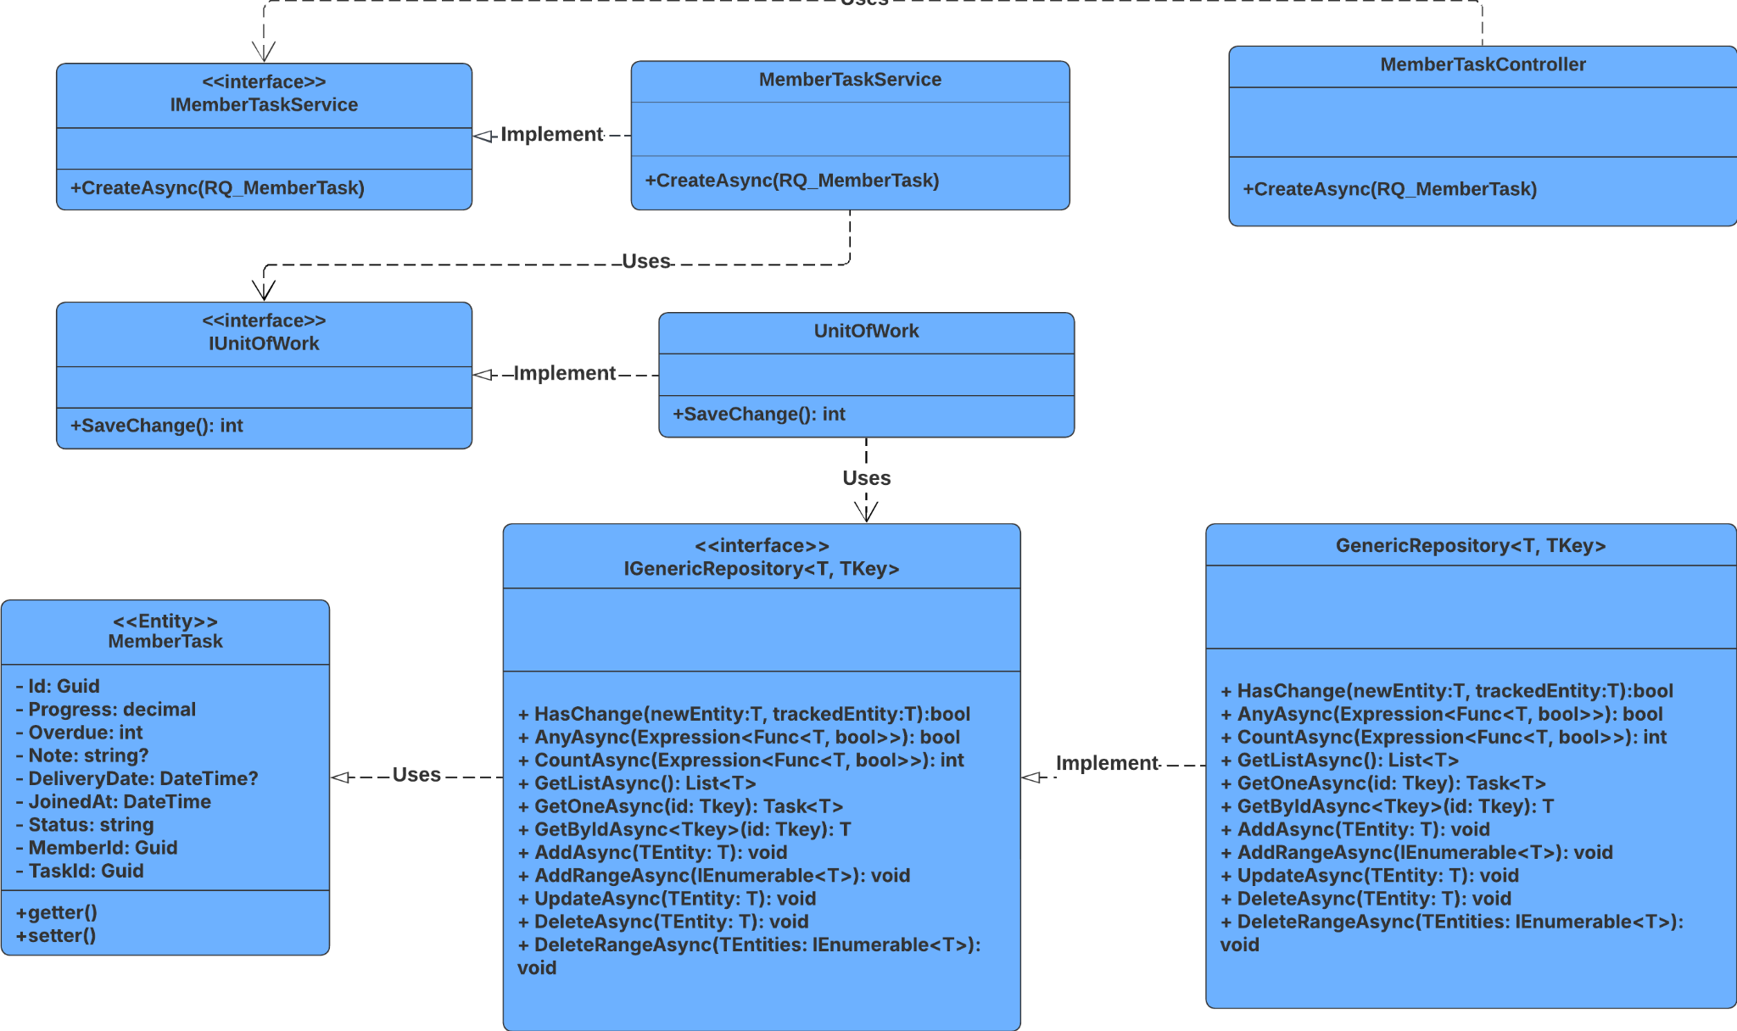

##### 3.14.1.2 Sequence Diagram

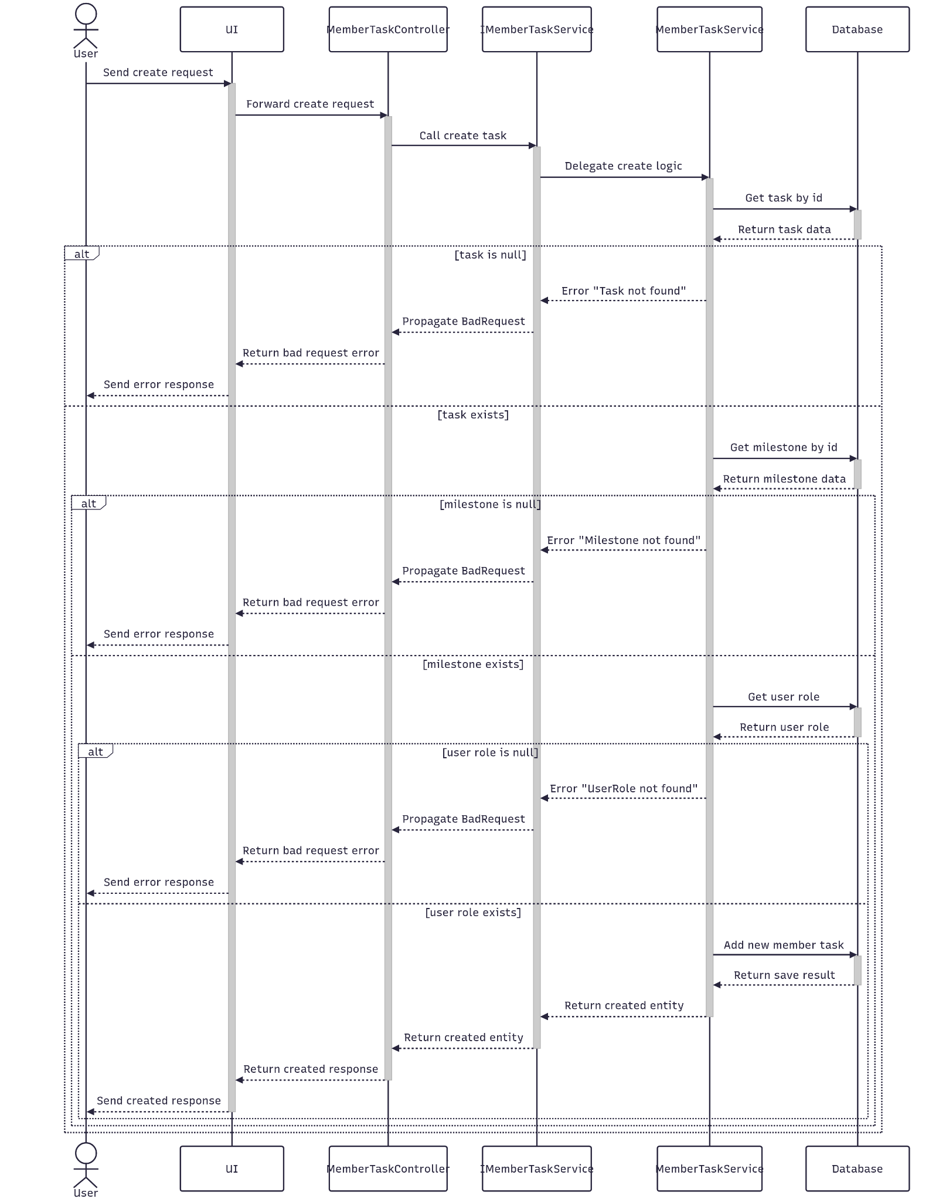

##### 3.14.1.3 Class Specification

###### 3.14.1.3.a MemberTaskController

| No | Method | Description |
| --- | --- | --- |
| 1 | Create(RQ_MemberTask) | API endpoint that creates a new member task. Returns 201 Created with the new member task ID or 400 BadRequest if creation fails. |

###### 3.14.1.3.b MemberTaskService

| No | Method | Description |
| --- | --- | --- |
| 1 | CreateAsync(RQ_MemberTask) | Service method that persists the new member task. Returns success status and new stage ID. |

#### 3.14.2.Update

##### 3.14.2.1 Class Diagram

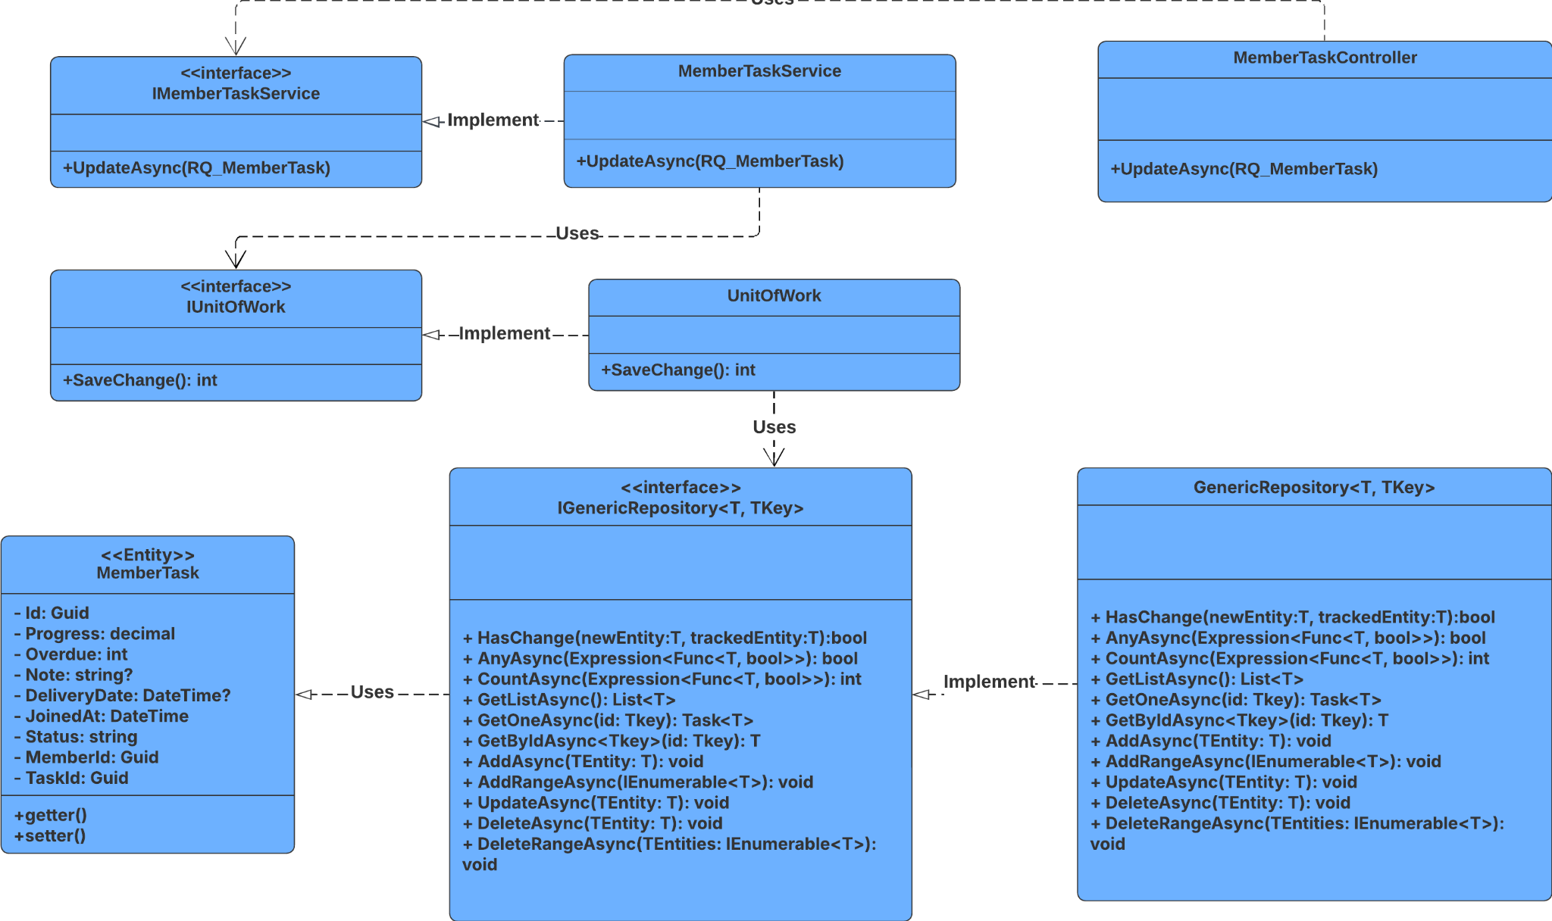

##### 3.14.2.2 Sequence Diagram

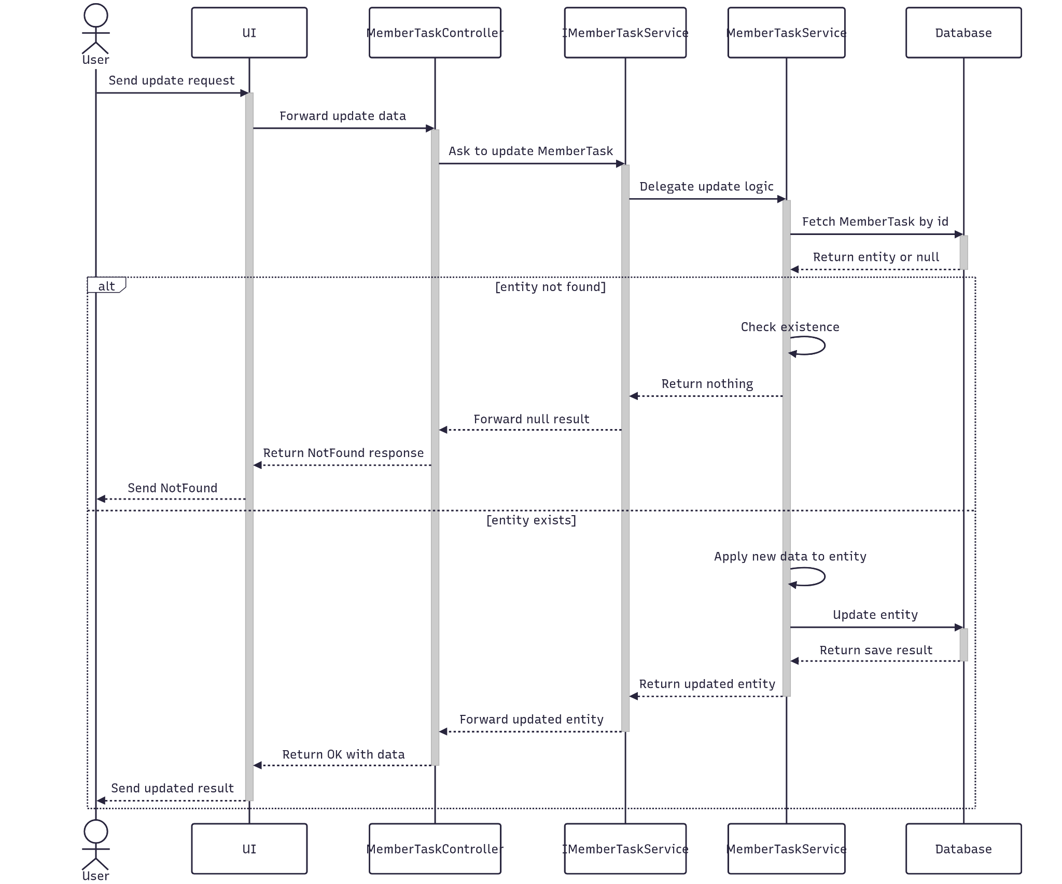

##### 3.14.2.3 Class Specification

###### 3.14.2.3.a MemberTaskController

| No | Method | Description |
| --- | --- | --- |
| 1 | Update(RQ_MemberTask) | API endpoint that updates an existing member task. Returns 200 OK if successful or 400 BadRequest if the update fails. |

###### 3.14.2.3.b MemberTaskService

| No | Method | Description |
| --- | --- | --- |
| 1 | UpdateAsync(RQ_MemberTask) | The service method applies updated data, and saves changes. |

#### 3.14.3.Get By Id

##### 3.14.3.1 Class Diagram

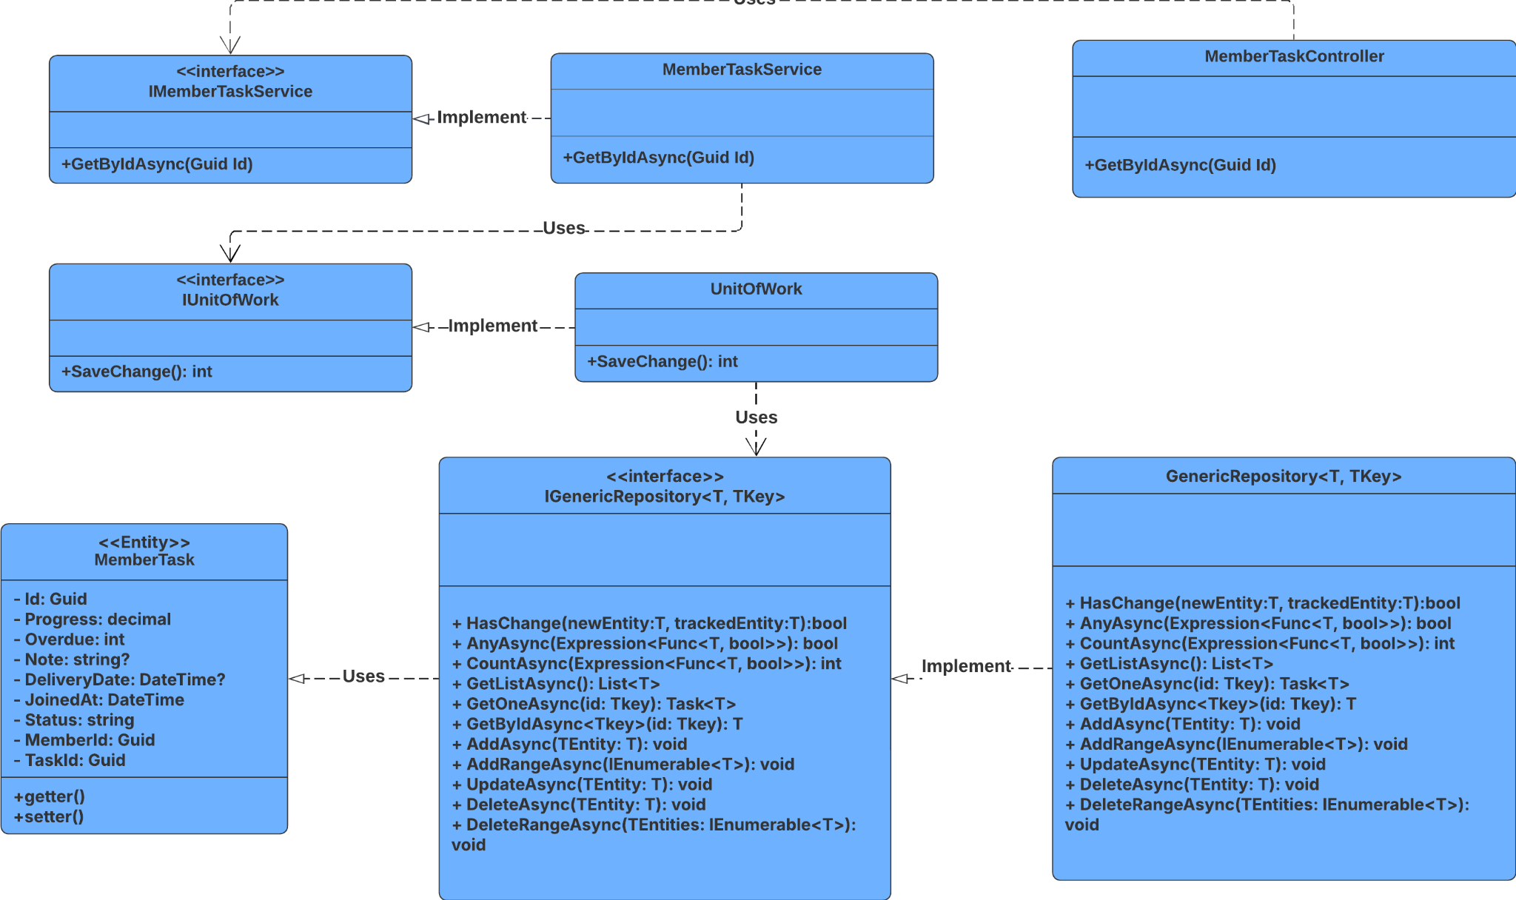

##### 3.14.3.2 Sequence Diagram

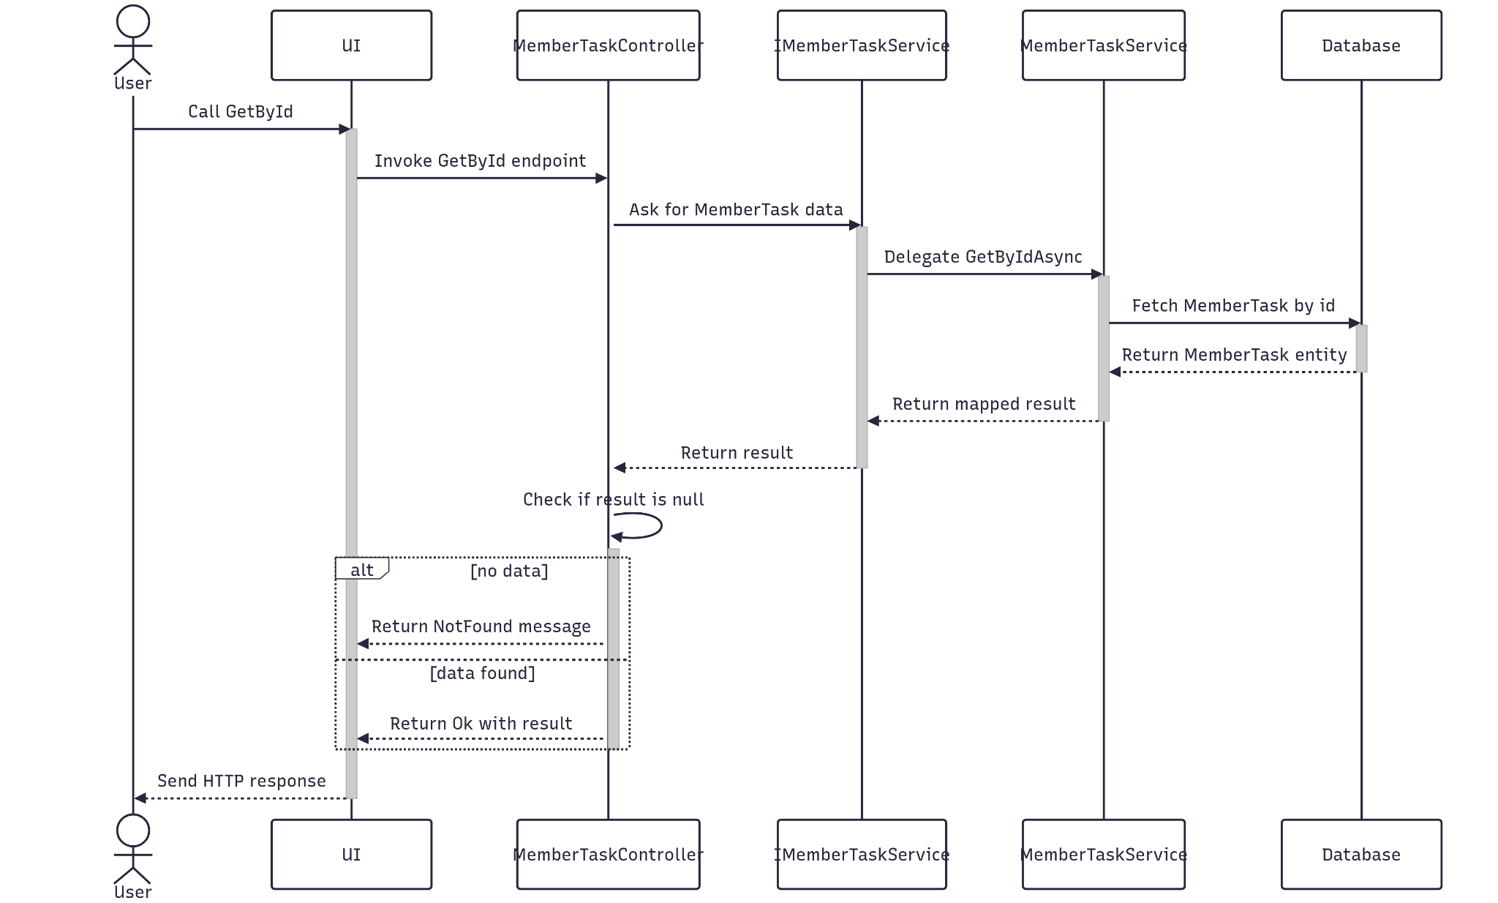

##### 3.14.3.3 Class Specification

###### 3.14.3.3.a MemberTaskController

| No | Method | Description |
| --- | --- | --- |
| 1 | GetById(Guid id) | API endpoint that retrieves detailed information about a specific member task by ID. Returns 200 OK with the member task details. |

###### 3.14.3.3.b MemberTaskService

| No | Method | Description |
| --- | --- | --- |
| 1 | GetByIdAsync(Guid id) | Service method that fetches detailed data, and maps the result to a response DTO. Throws BadRequestException or NotFoundException as needed. |

#### 3.14.4.Delete

##### 3.14.4.1 Class Diagram

##### 

##### 3.14.4.2 Sequence Diagram

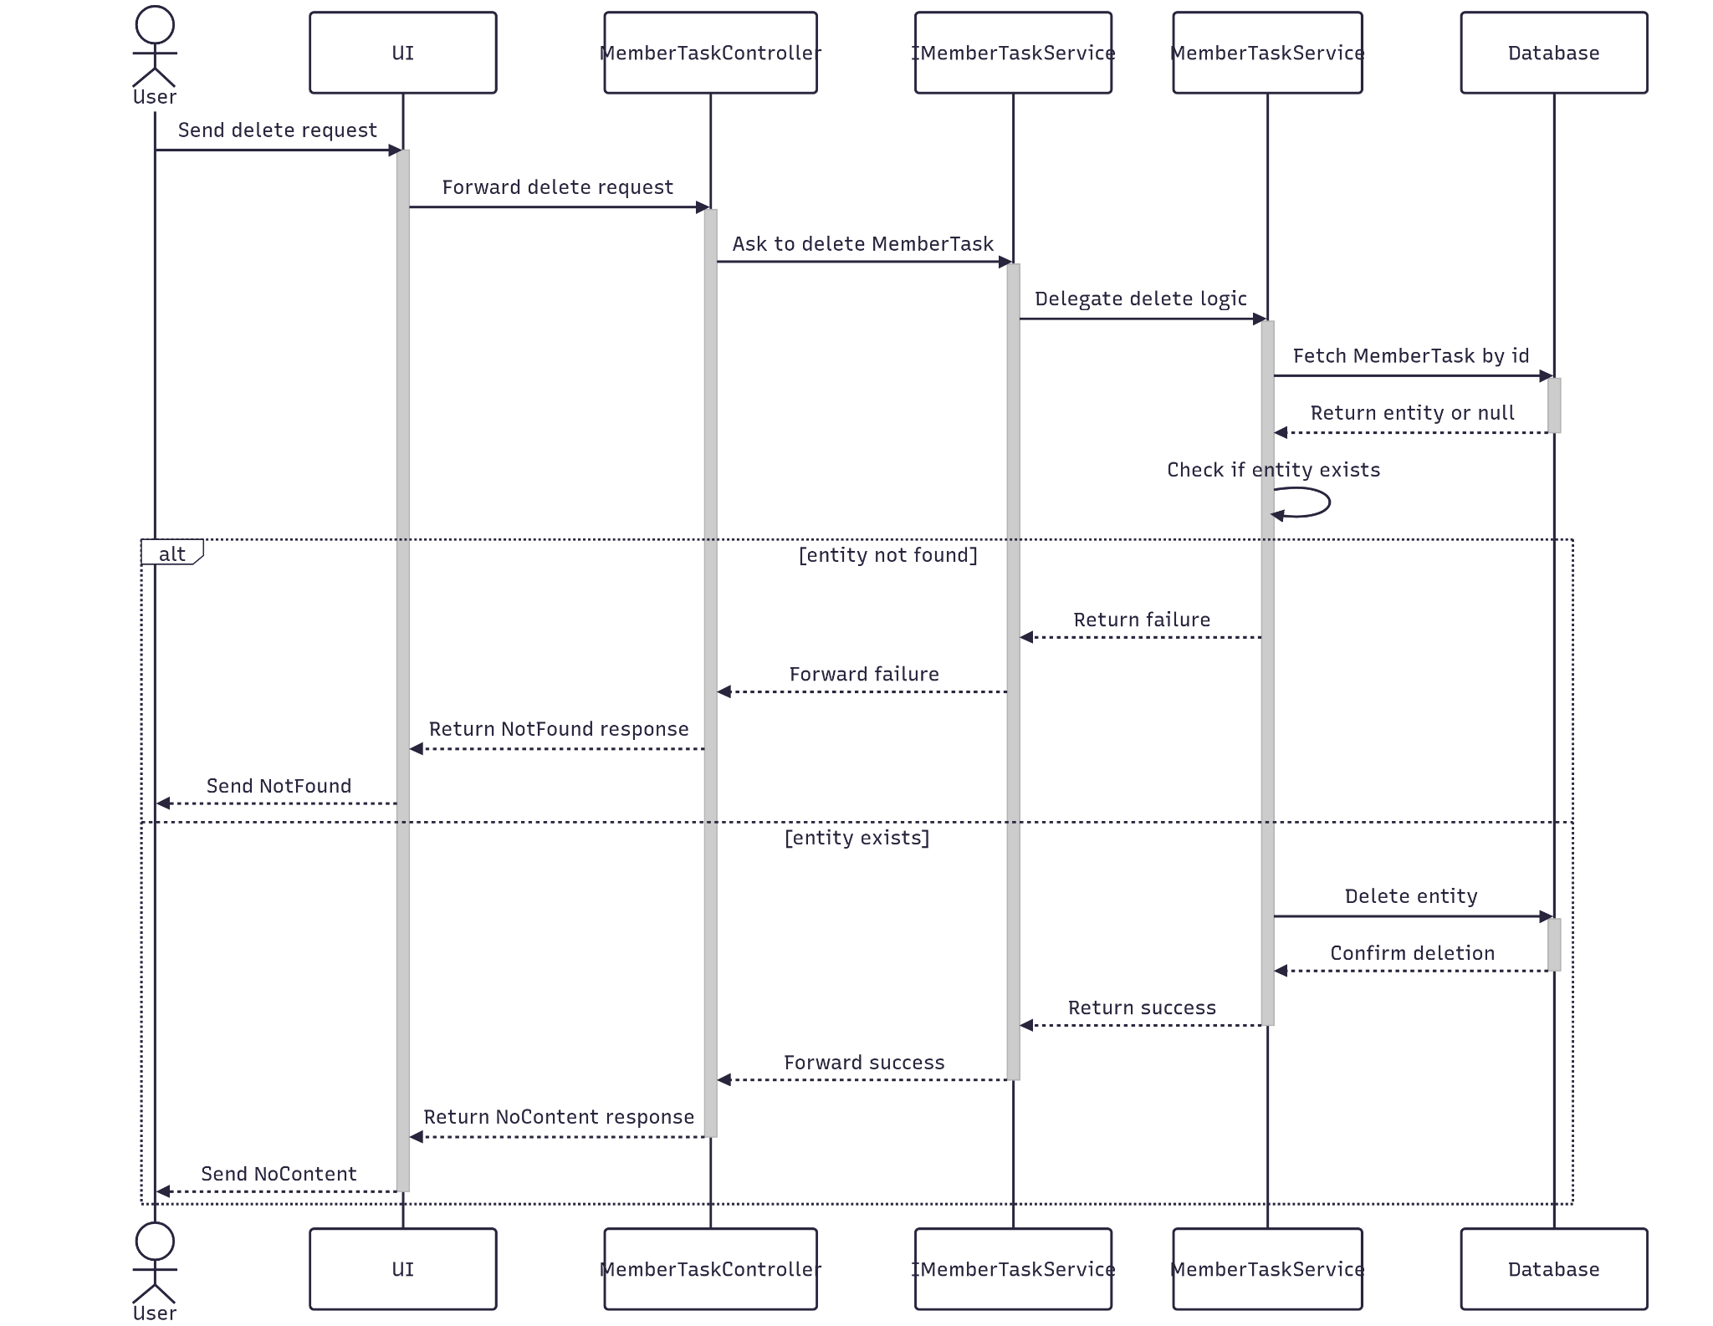

##### 3.14.4.3 Class Specification

###### 3.14.4.3.a MemberTaskController

| No | Method | Description |
| --- | --- | --- |
| 1 | Delete(Guid id) | API endpoint that deletes an member task by ID. Returns 200 OK on success or 400 Bad Request on failure. |

###### 3.14.4.3.b MemberTaskService

| No | Method | Description |
| --- | --- | --- |
| 1 | DeleteAsync(Guid id) | Service method that performs a delete of a member task. |

#### 3.14.5.Get List

##### 3.14.5.1 Class Diagram

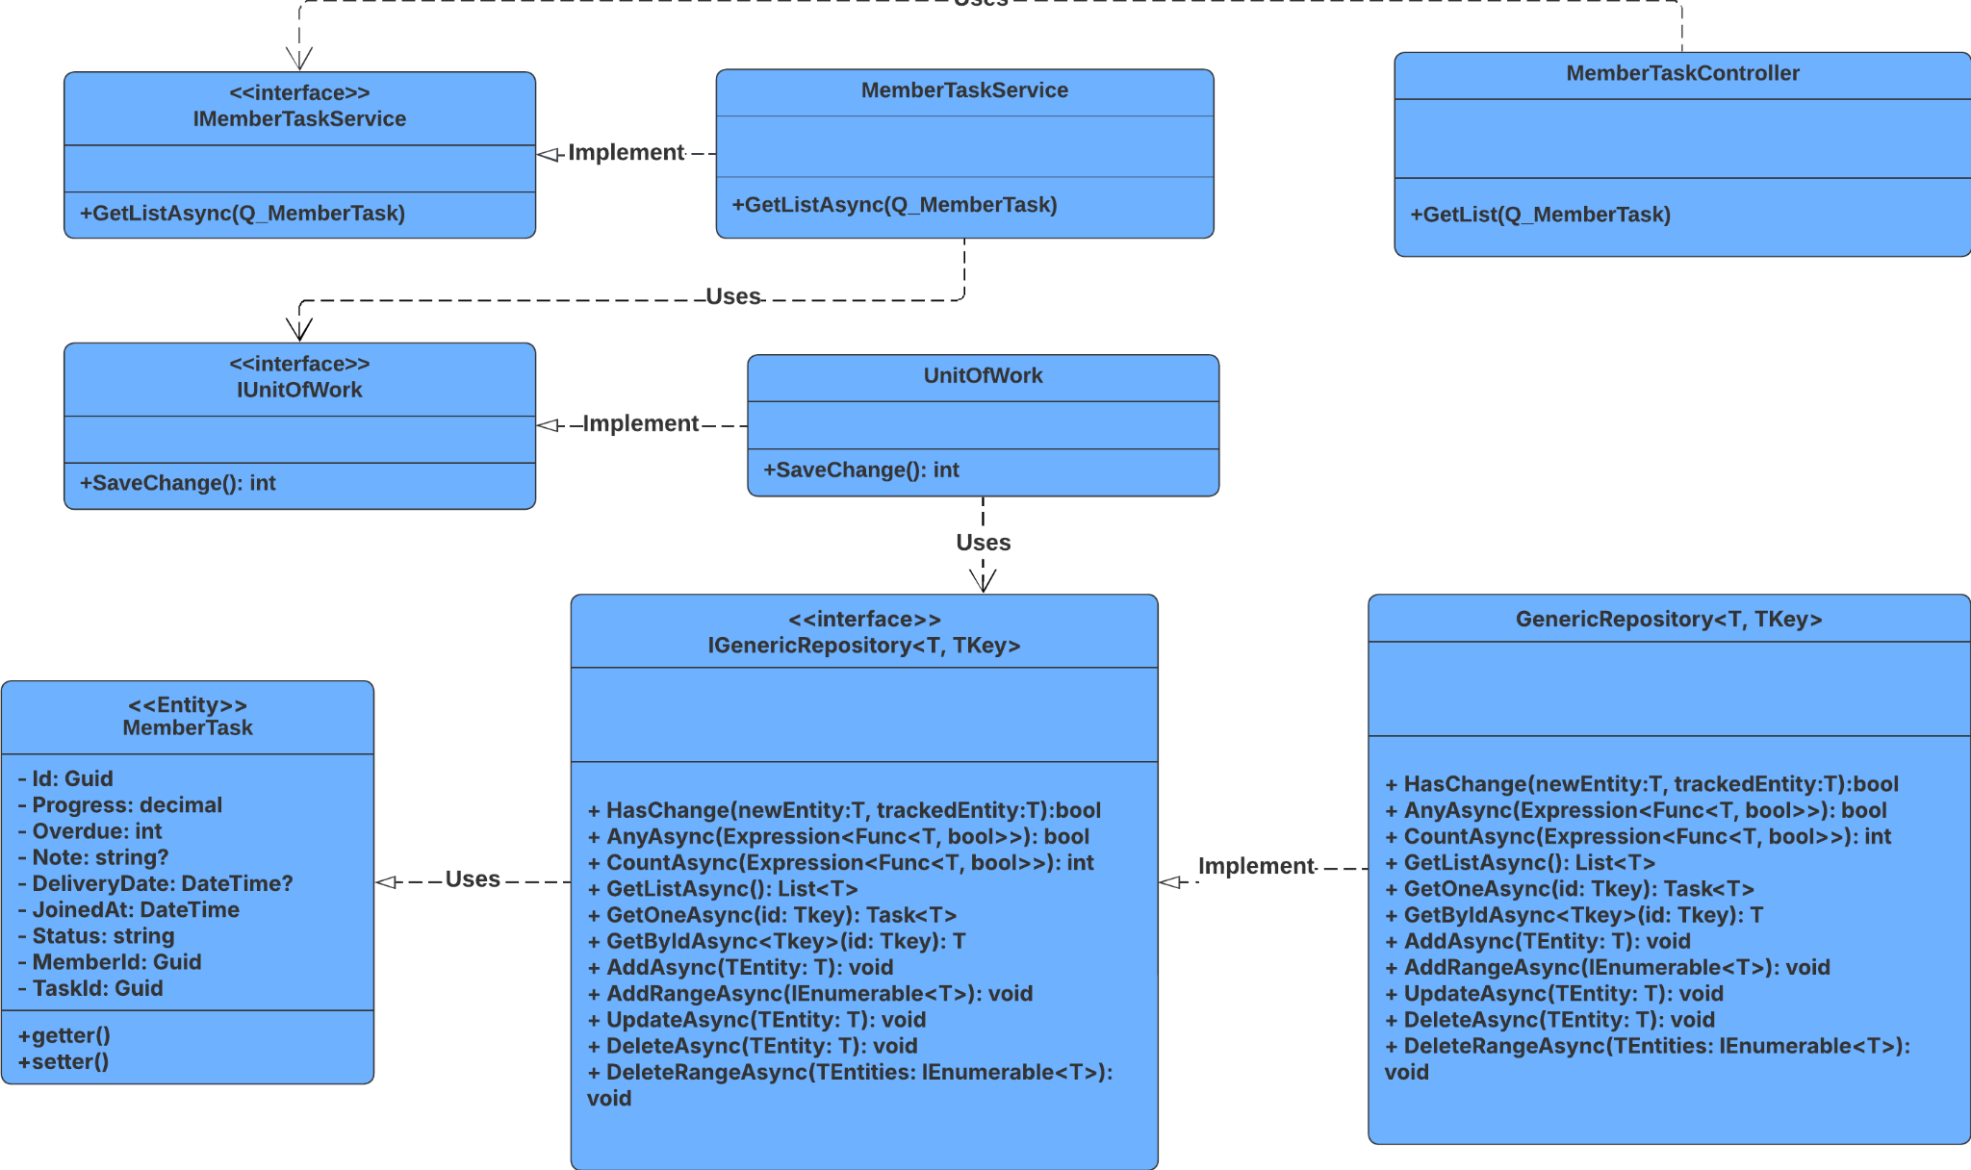

##### 3.14.5.2 Sequence Diagram

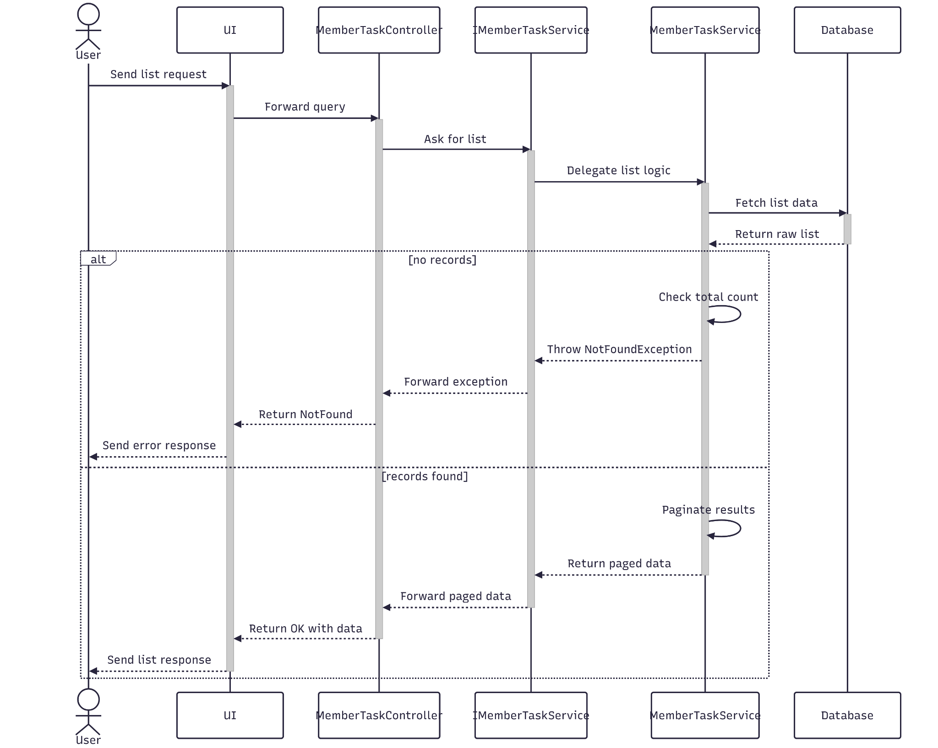

##### 3.14.5.3 Class Specification

###### 3.14.5.3.a MemberTaskController

| No | Method | Description |
| --- | --- | --- |
| 1 | GetList(RQ_MemberTaskQuery) | API endpoint that receives a query payload and returns a paginated list of member tasks. Responds with 200 OK and the result from GetListPagingAsync. |

###### 3.14.5.3.b MemberTaskService

| No | Method | Description |
| --- | --- | --- |
| 1 | GetListAsync(RQ_MemberTaskQuery) | Service method that validates pagination parameters, queries the repository with multiple filters, and returns a paginated list of member tasks. Throws NotFoundException if no results are found. |

### 3.15 Manage Milestone

#### 3.15.1.Create

##### 3.15.1.1 Class Diagram

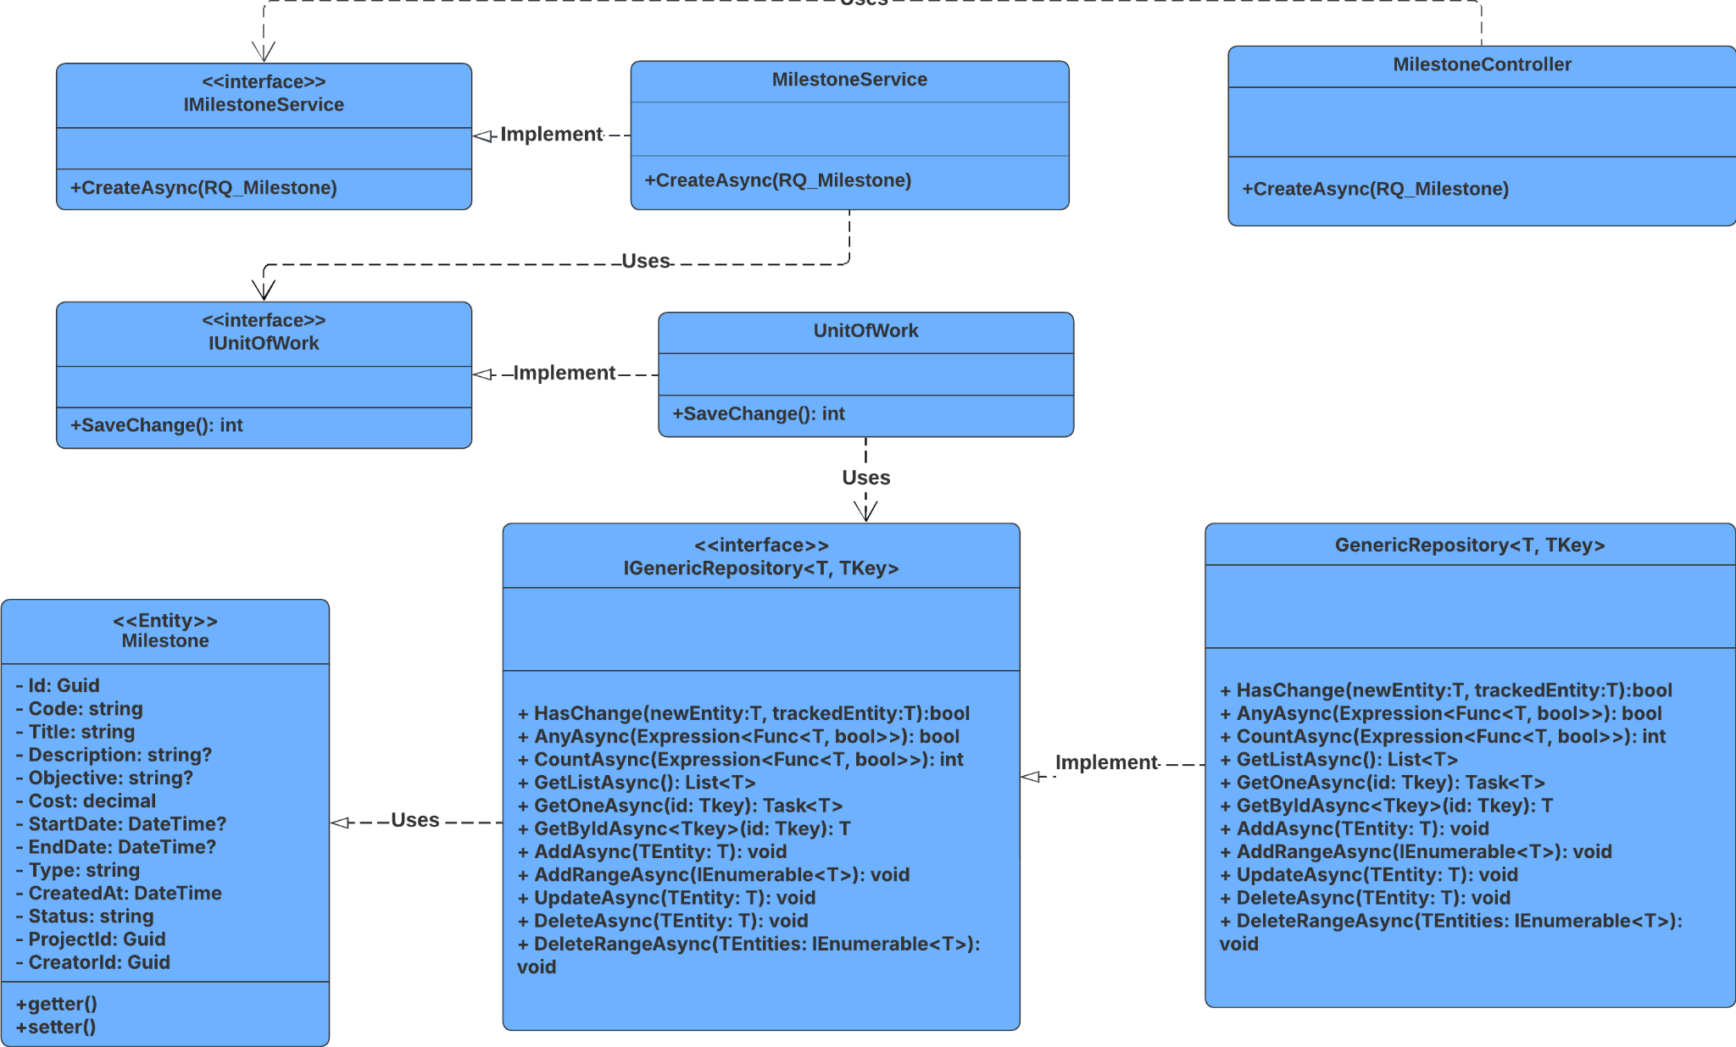

##### 3.15.1.2 Sequence Diagram

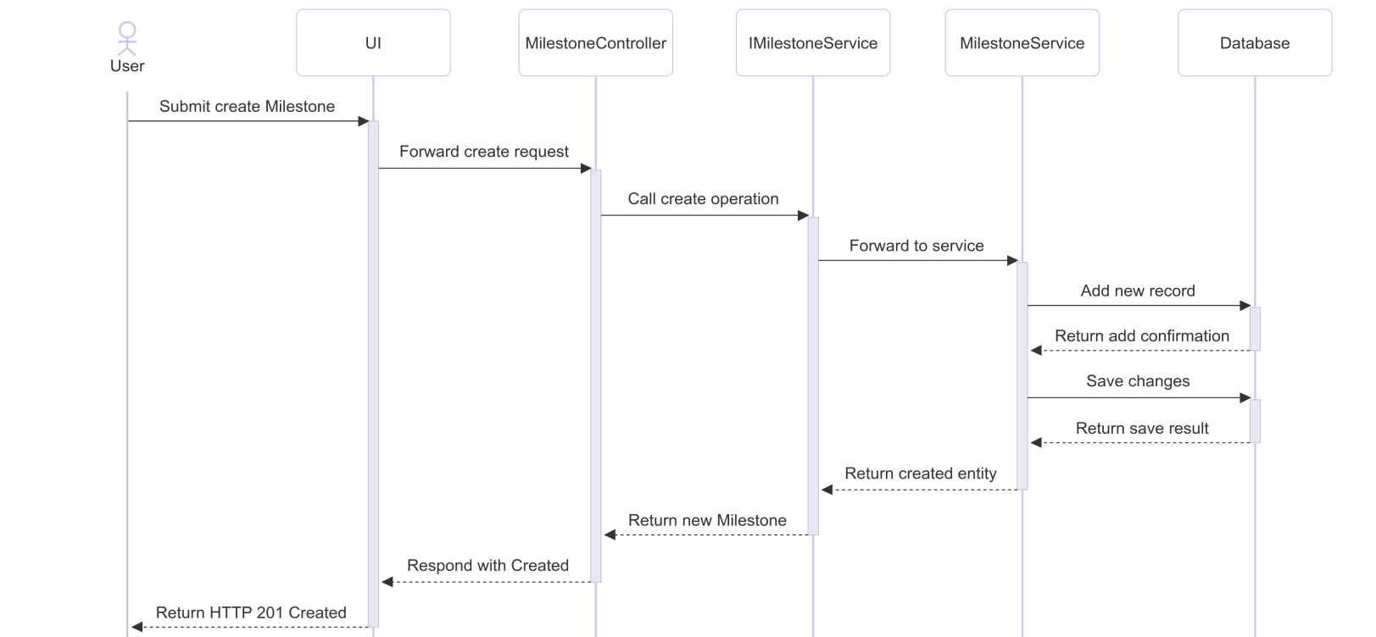

##### 3.15.1.3 Class Specification

###### 3.15.1.3.a MilestoneController

| No | Method | Description |
| --- | --- | --- |
| 1 | Create(RQ_Milestone) | Accepts milestone creation data, calls CreateAsync, and returns 201 Created with the new milestone's ID. |

###### 3.15.1.3.b MilestoneService

| No | Method | Description |
| --- | --- | --- |
| 1 | CreateAsync(RQ_Milestone) | Maps request to Milestone entity, assigns a new GUID, sets creation timestamp and status, generates a unique code (e.g. MS-202507-001), saves to repository, and returns the result as RS_Milestone. |

#### 3.15.2.Update

##### 3.15.2.1 Class Diagram

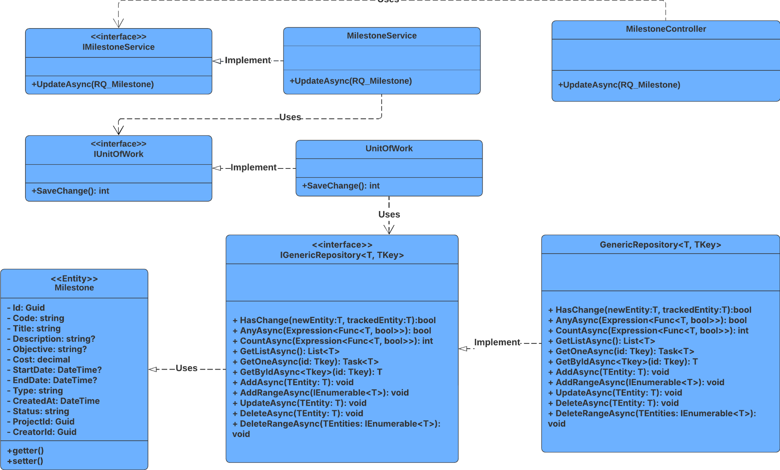

##### 3.15.2.2 Sequence Diagram

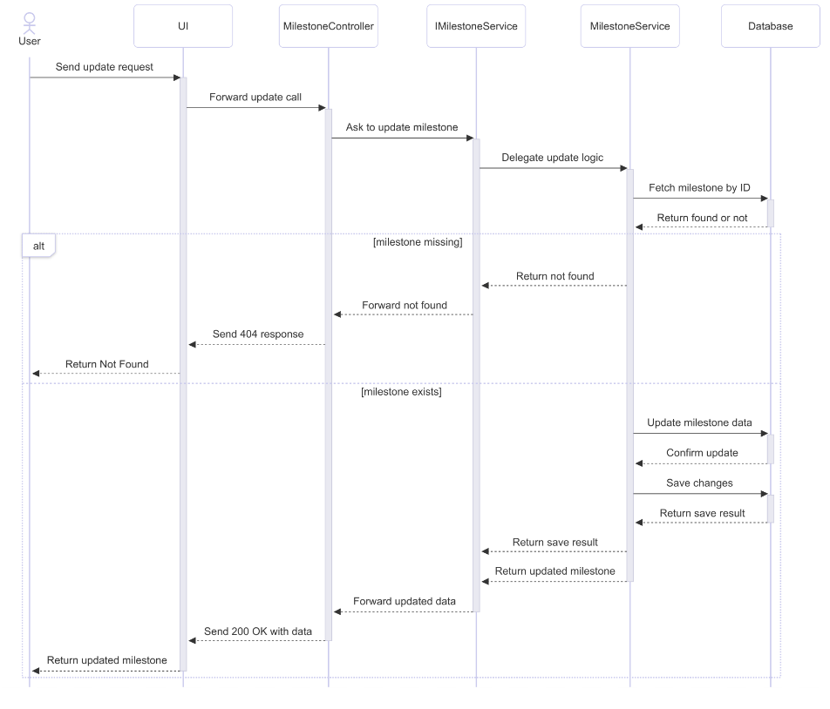

##### 3.15.2.3 Class Specification

###### 3.15.2.3.a MilestoneController

| No | Method | Description |
| --- | --- | --- |
| 1 | UpdateAsync(Guid id, RQ_Milestone) | Handles HTTP PUT requests to update an existing milestone. Returns 200 OK with the updated milestone if successful, or 404 Not Found if the milestone doesn't exist. |

###### 3.3.2.3.b MilestoneService

| No | Method | Description |
| --- | --- | --- |
| 1 | UpdateAsync(Guid id, RQ_Milestone) | Retrieves the milestone by ID, maps the incoming request data onto the existing entity, updates it in the repository, commits the changes, and returns the updated milestone as a response DTO. Returns null if the milestone is not found. |

#### 3.15.3.Get By Id

##### 3.15.3.1 Class Diagram

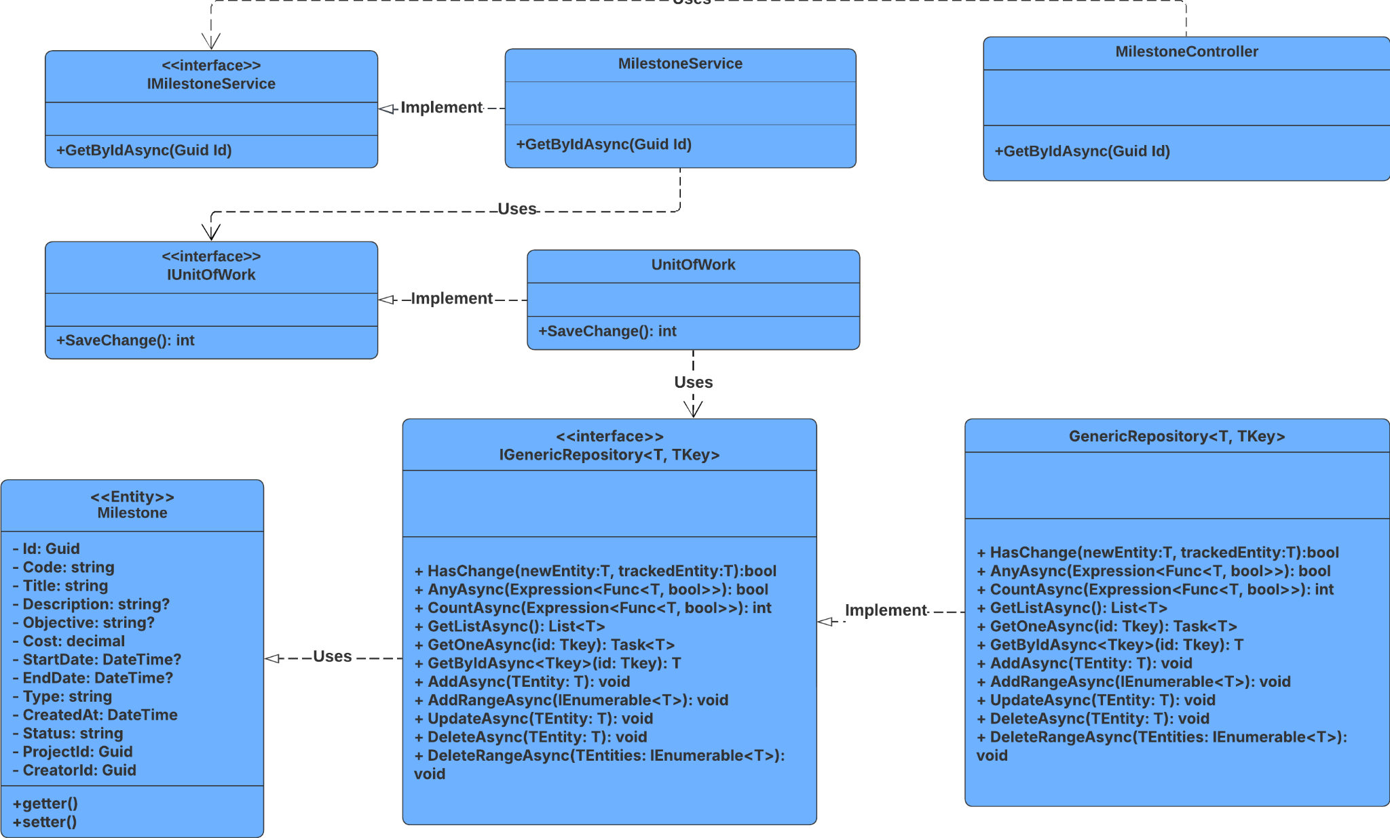

##### 3.15.3.2 Sequence Diagram

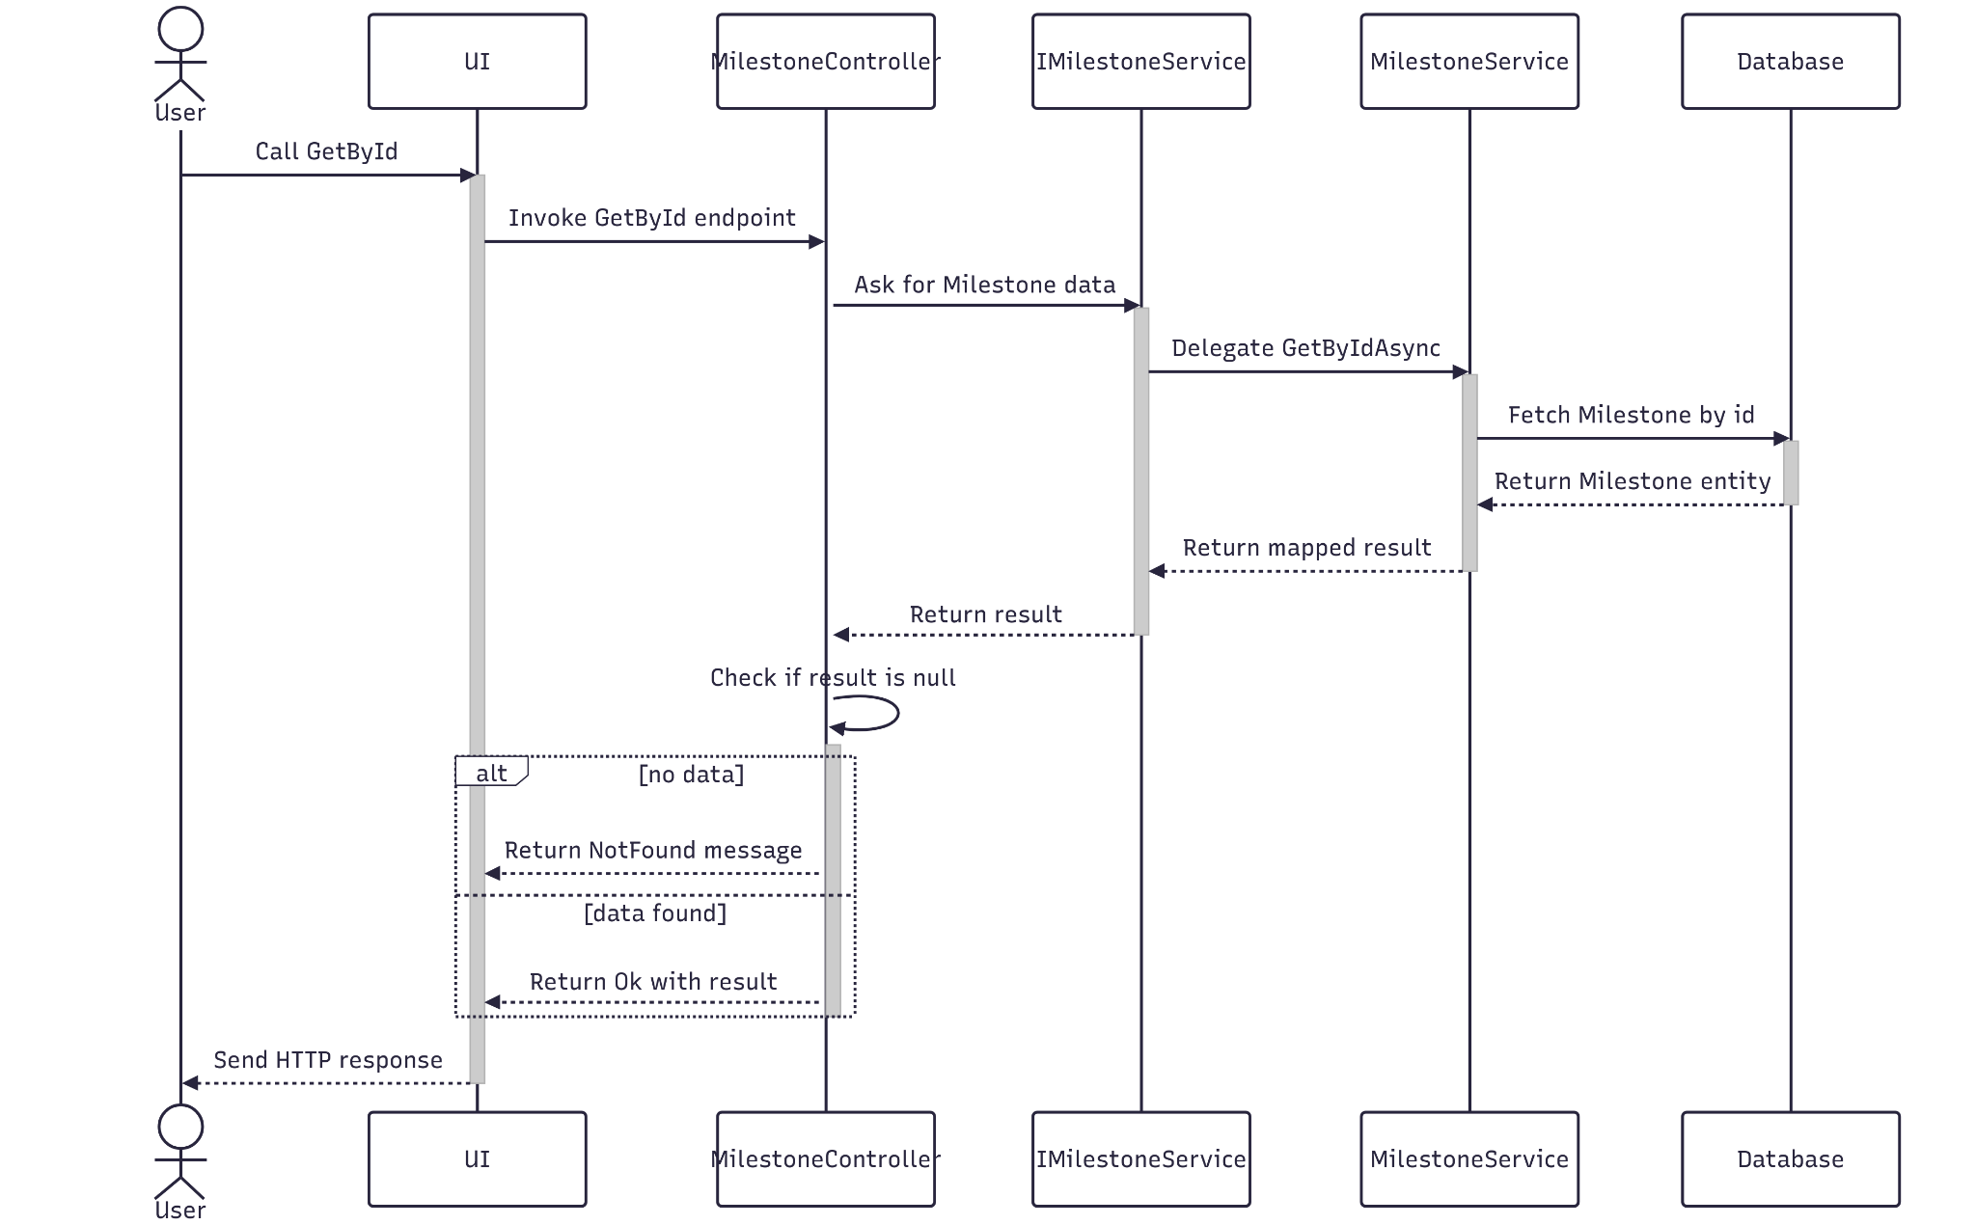

##### 3.15.3.3 Class Specification

###### 3.15.3.3.a MilestoneController

| No | Method | Description |
| --- | --- | --- |
| 1 | GetById(Guid id) | API endpoint that retrieves detailed information about a specific MileStone by ID. Accepts an optional includeNum flag to control related data inclusion. Returns 200 OK with the evaluation stage details. |

###### 3.15.3.3.b MilestoneService

| No | Method | Description |
| --- | --- | --- |
| 1 | GetByIdAsync(Guid id) | Service method that fetches detailed data, and maps the result to a response DTO. Throws BadRequestException or NotFoundException as needed. |

#### 3.15.4.Delete

##### 3.15.4.1 Class Diagram

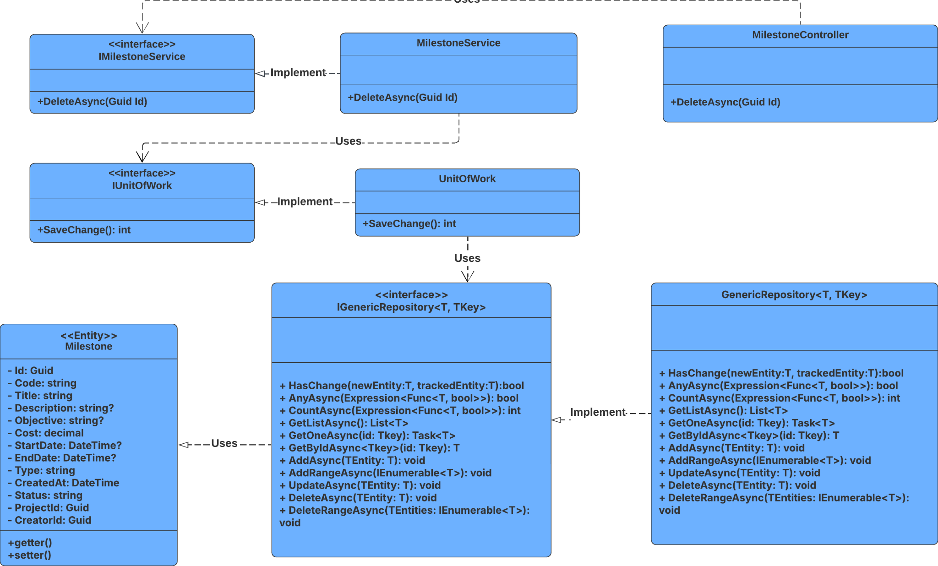

##### 3.15.4.2 Sequence Diagram

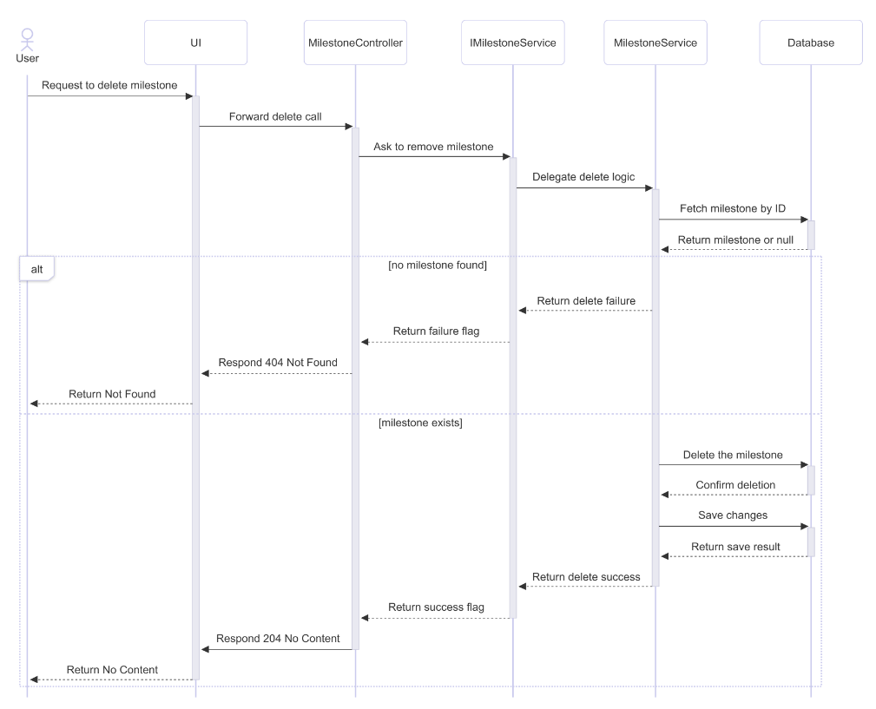

##### 3.15.4.3 Class Specification

###### 3.15.4.3.a MilestoneController

| No | Method | Description |
| --- | --- | --- |
| 1 | DeleteAsync(Guid id) | Handles HTTP DELETE request to remove a milestone by ID. Returns 204 No Content if successful, or 404 Not Found if the milestone doesn't exist. |

###### 3.15.4.3.b MilestoneService

| No | Method | Description |
| --- | --- | --- |
| 1 | DeleteAsync(Guid id) | Retrieves the milestone by ID, deletes it from the repository, commits the change, and returns true if successful. Returns false if the milestone is not found. |

#### 3.15.5.Get List

##### 3.15.5.1 Class Diagram

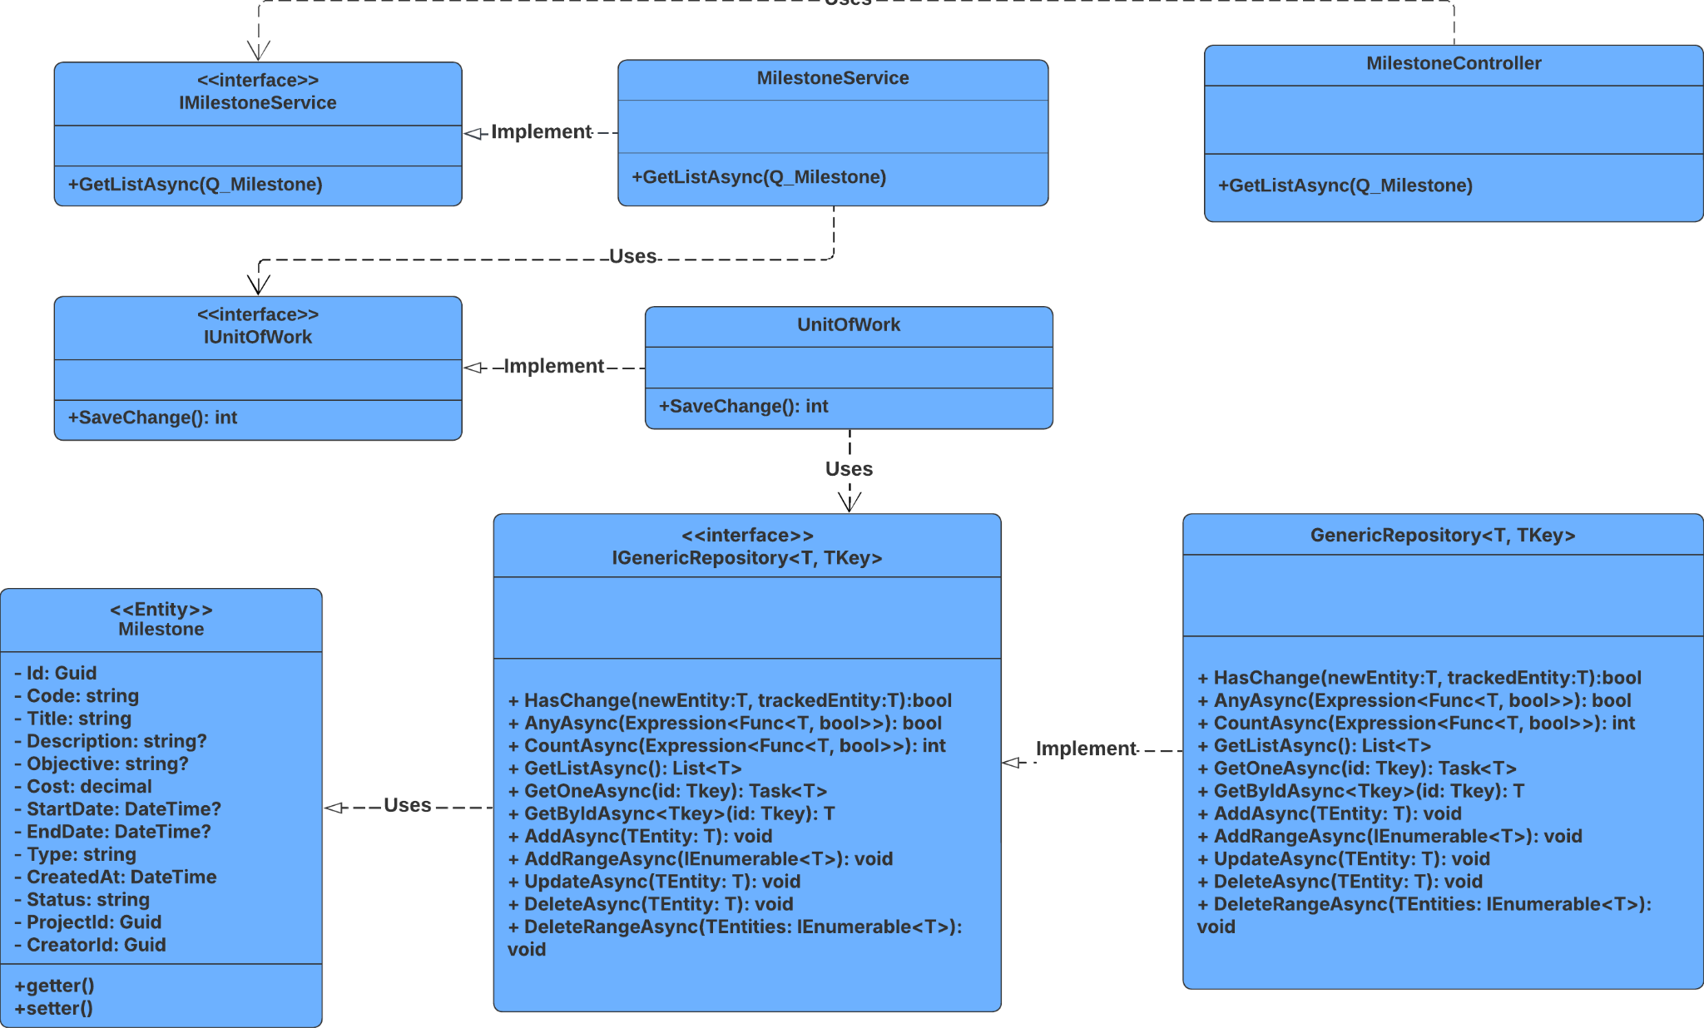

##### 3.15.5.2 Sequence Diagram

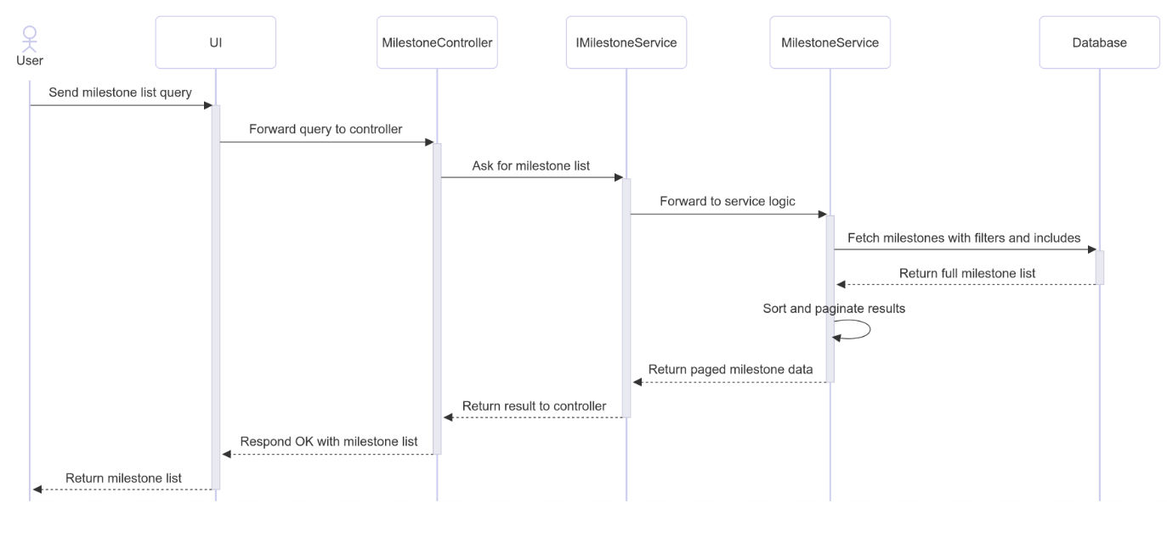

##### 3.15.5.3 Class Specification

###### 3.15.5.3.a MilestoneController

| No | Method | Description |
| --- | --- | --- |
| 1 | GetListAsync(RQ_MilestoneQuery) | Receives project query parameters from the client and calls GetListAsync in the service layer. Handles exceptions and returns appropriate HTTP responses. |

###### 3.15.5.3.b MilestoneService

| No | Method | Description |
| --- | --- | --- |
| 1 | GetListAsync(RQ_MilestoneQuery) | Validates pagination input, builds dynamic filtering logic, includes related entities conditionally, applies sorting, paginates results, and maps to response DTOs. |

### 3.16 Manage Notification

#### 3.16.1.Create

##### 3.16.1.1 Class Diagram

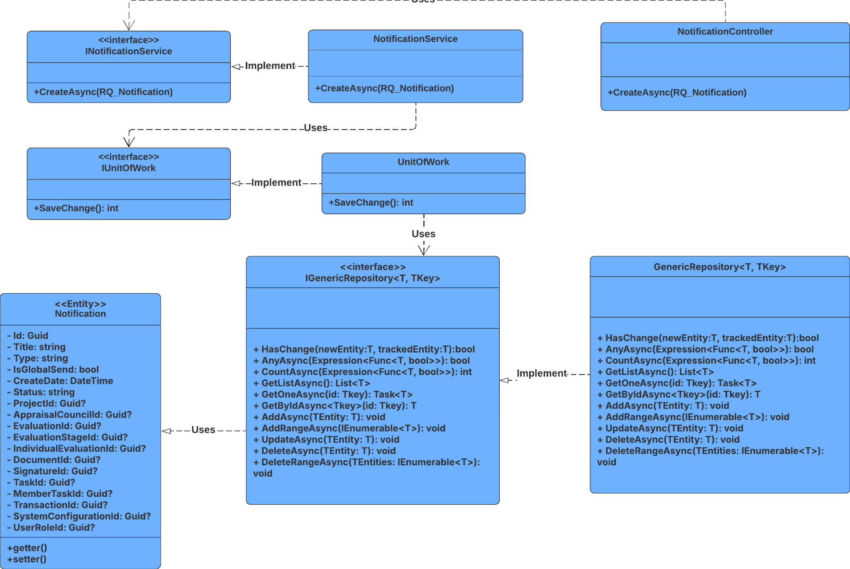

##### 3.16.1.2 Sequence Diagram

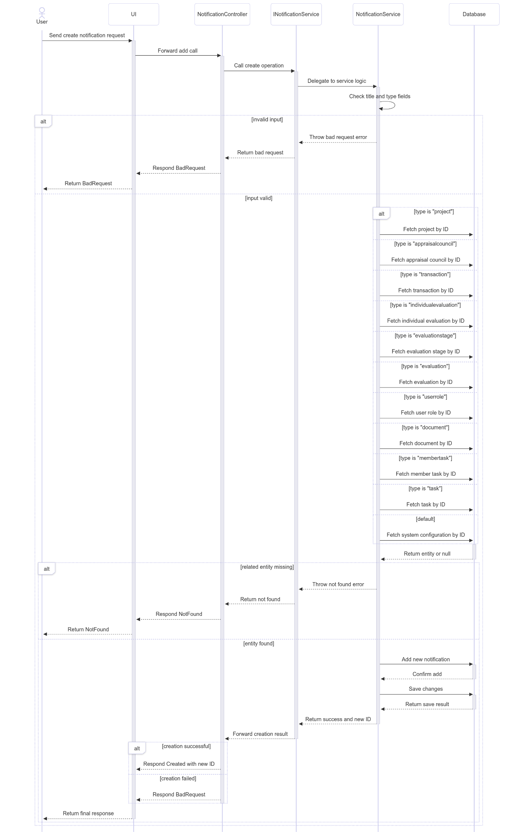

##### 3.16.1.3 Class Specification

###### 3.16.1.3.a NotificationController

| No | Method | Description |
| --- | --- | --- |
| 1 | Add(RQ_Notification inputData) | Handles HTTP POST requests to create a new notification. Returns 201 Created with the new notification ID if successful, or 400 Bad Requests if creation fails. |

###### 3.16.1.3.b NotificationService

| No | Method | Description |
| --- | --- | --- |
| 1 | CreateNew(RQ_Notification newNotification) | Validates input, maps to entity, dynamically assigns related object ID based on type, saves the notification, and triggers user notification. Returns a tuple of success flag and notification ID. |

#### 3.16.2.Update

##### 3.16.2.1 Class Diagram

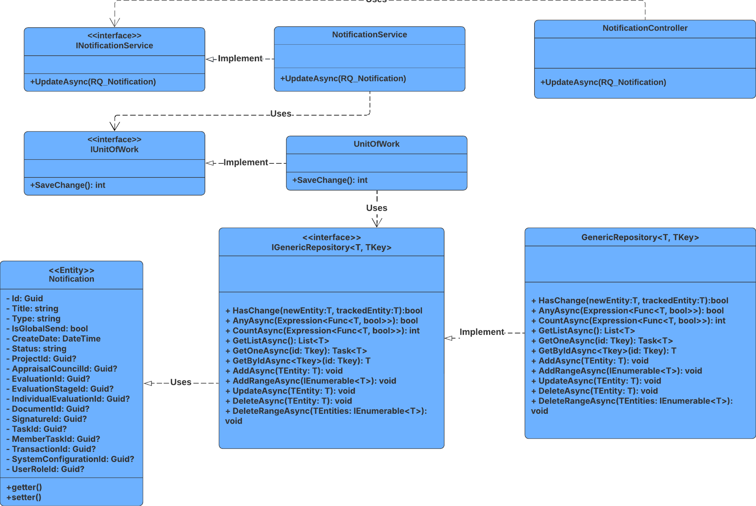

##### 3.16.2.2 Sequence Diagram

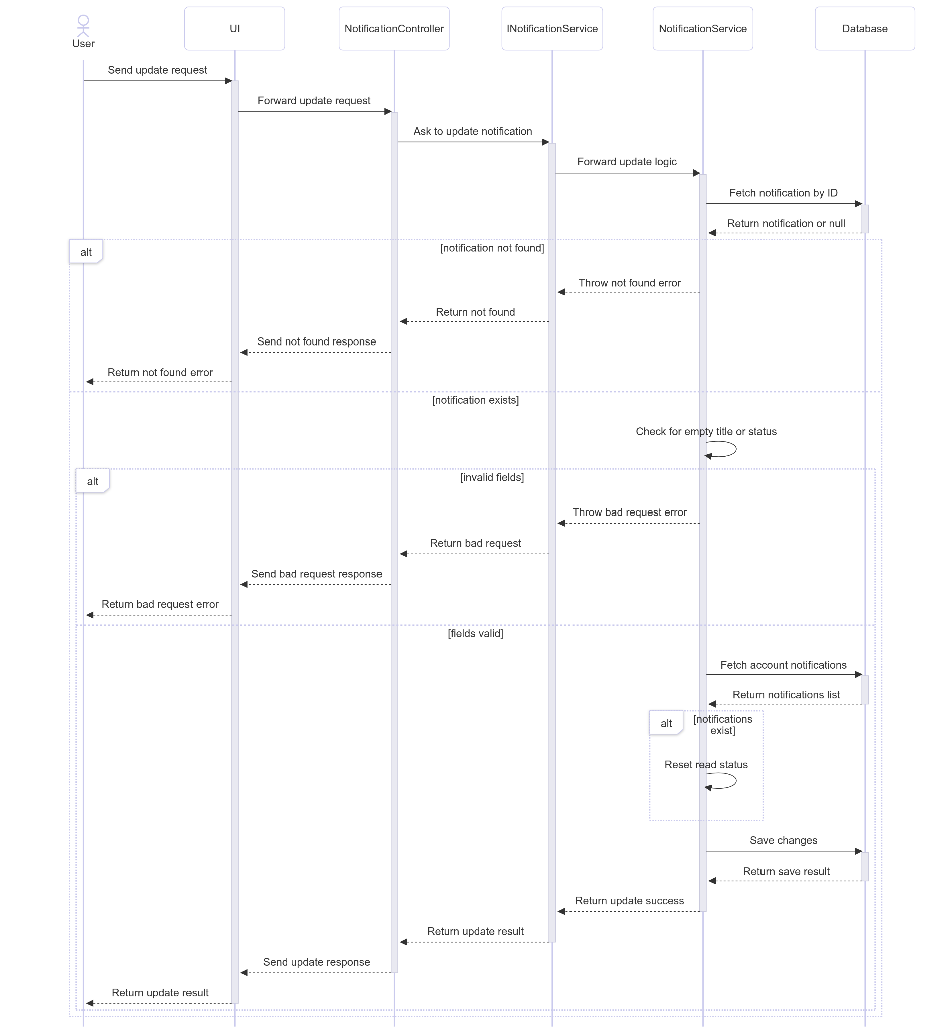

##### 3.16.2.3 Class Specification

###### 3.16.2.3.a NotificationController

| No | Method | Description |
| --- | --- | --- |
| 1 | Update(RQ_Notification inputData) | Handles HTTP PUT requests to update a notification. Returns 200 OK on success or 400 Bad Request on failure. |

###### 3.16.2.3.b DocumentService

| No | Method | Description |
| --- | --- | --- |
| 1 | UpdateNotification(RQ_Notification newNotification | Validates input, updates title and status, resets read flags for associated accounts, and persists changes. Throws NotFoundException or BadRequestException if validation fails. |

#### 3.16.3.Get User’s Notifications

##### 3.16.3.1 Class Diagram

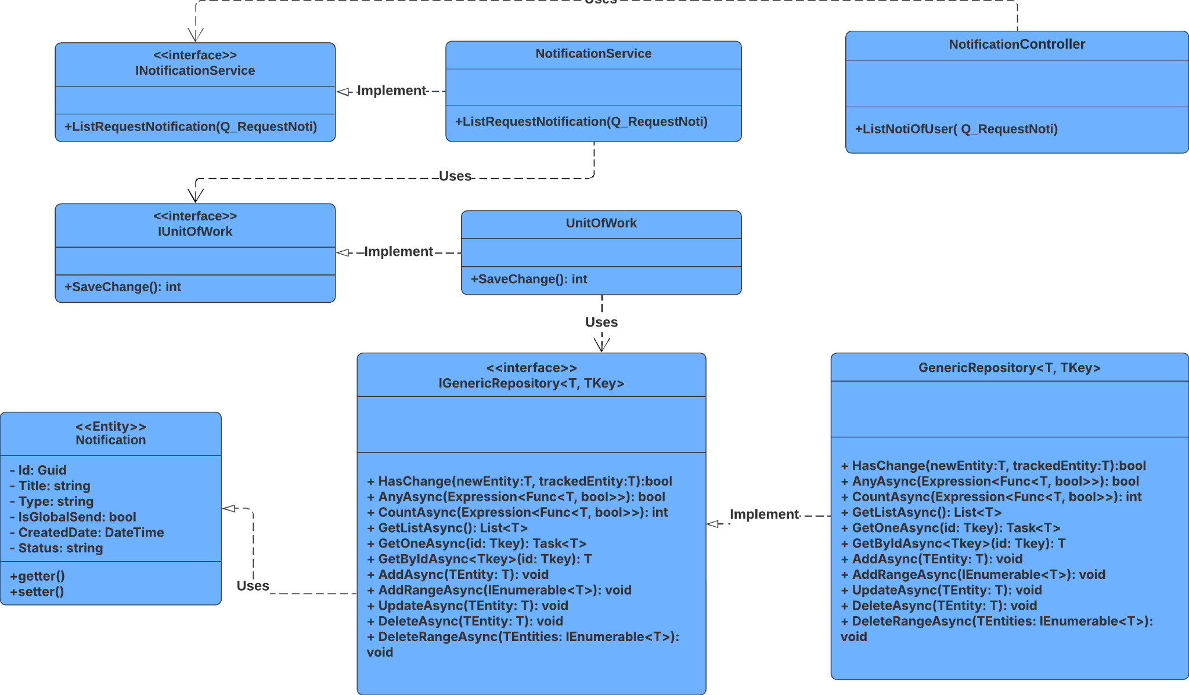

##### 3.16.3.2 Sequence Diagram

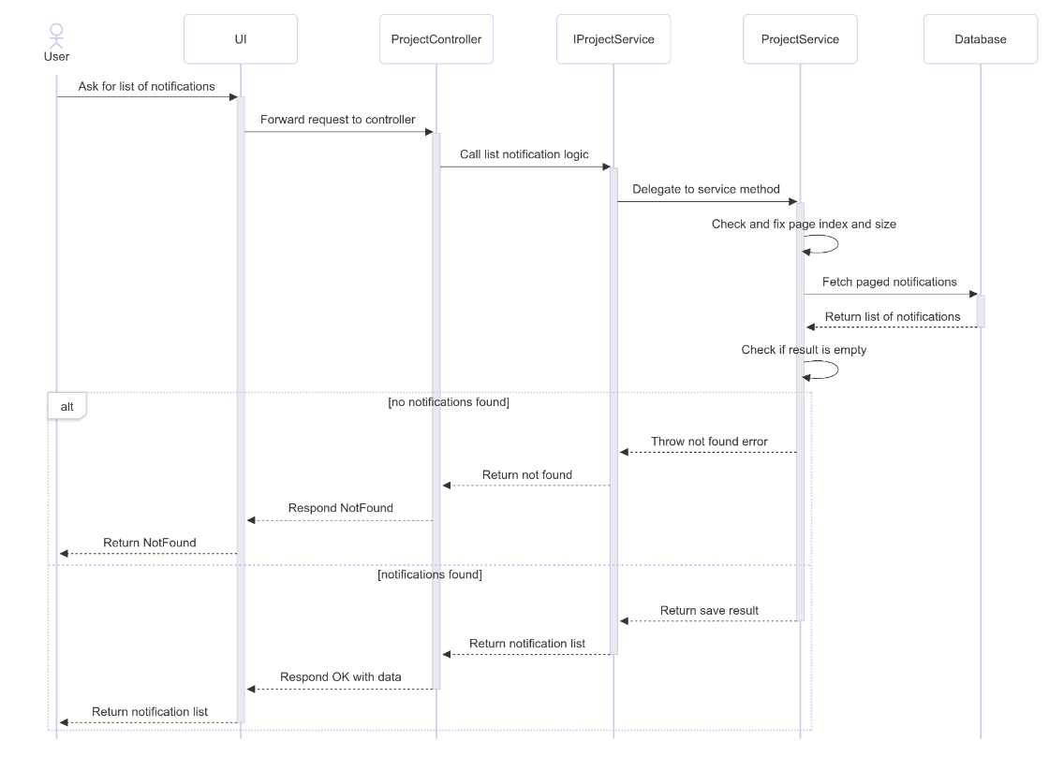

##### 3.16.3.3 Class Specification

###### 3.16.3.3.a NotificationController

| No | Method | Description |
| --- | --- | --- |
| 1 | ListNotiOfUser(Q_RequestNoti queryInput) | Controller method that receives a query object and returns a paginated list of notifications for a user |

###### 3.16.3.3.b NotificationService

| No | Method | Description |
| --- | --- | --- |
| 1 | ListRequestNotification(Q_RequestNoti queryInput) | Service method that validates pagination input, queries the repository with filters, and returns a paginated result. Throws NotFoundException if no notifications are found. |

#### 3.16.4.Delete

##### 3.16.4.1 Class Diagram

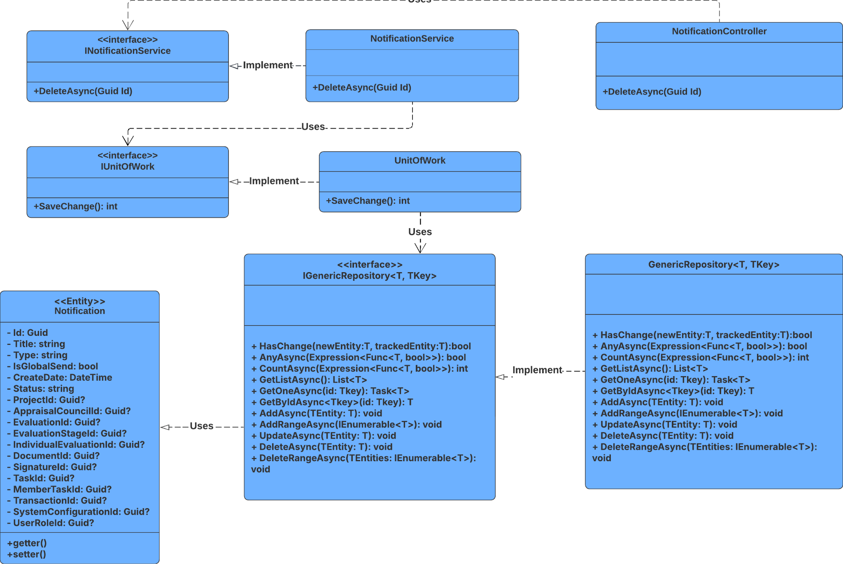

##### 3.16.4.2 Sequence Diagram

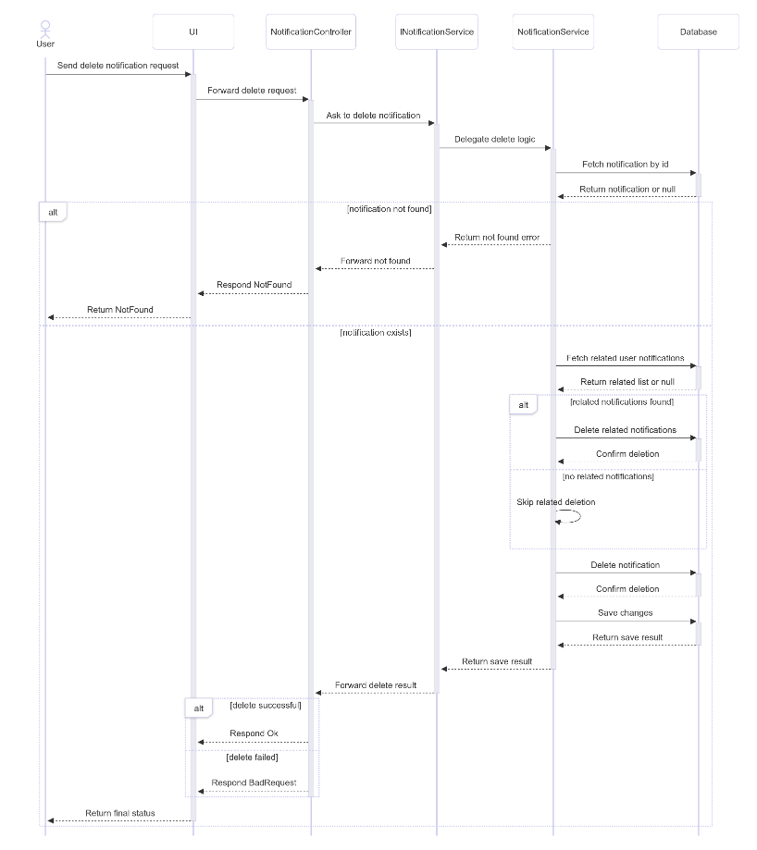

##### 3.16.4.3 Class Specification

###### 3.16.4.3.a NotificationController

| No | Method | Description |
| --- | --- | --- |
| 1 | Delete(Guid id) | Controller method that receives a notification ID and attempts to delete it. Returns 200 OK if successful, or 400 Bad Requests if deletion fails. |

###### 3.16.4.3.b NotificationService

| No | Method | Description |
| --- | --- | --- |
| 1 | DeleteNotification(Guid id) | Service method that checks for existence, deletes related AccountNotification records, removes the notification, and commits the change. Throws NotFoundException if the notification is missing |

#### 3.16.5.Get List

##### 3.16.5.1 Class Diagram

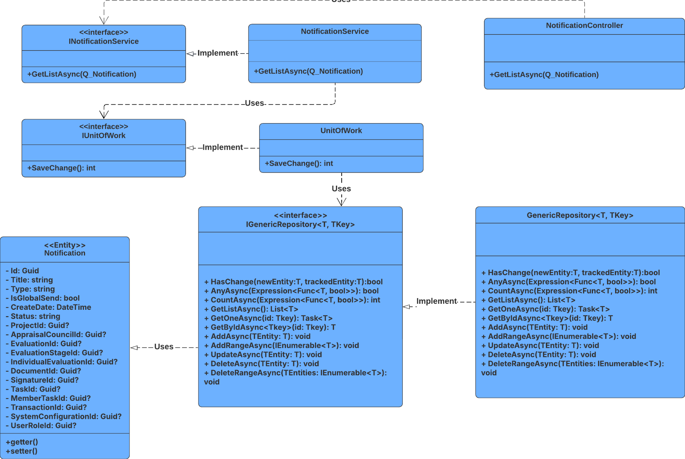

##### 3.16.5.2 Sequence Diagram

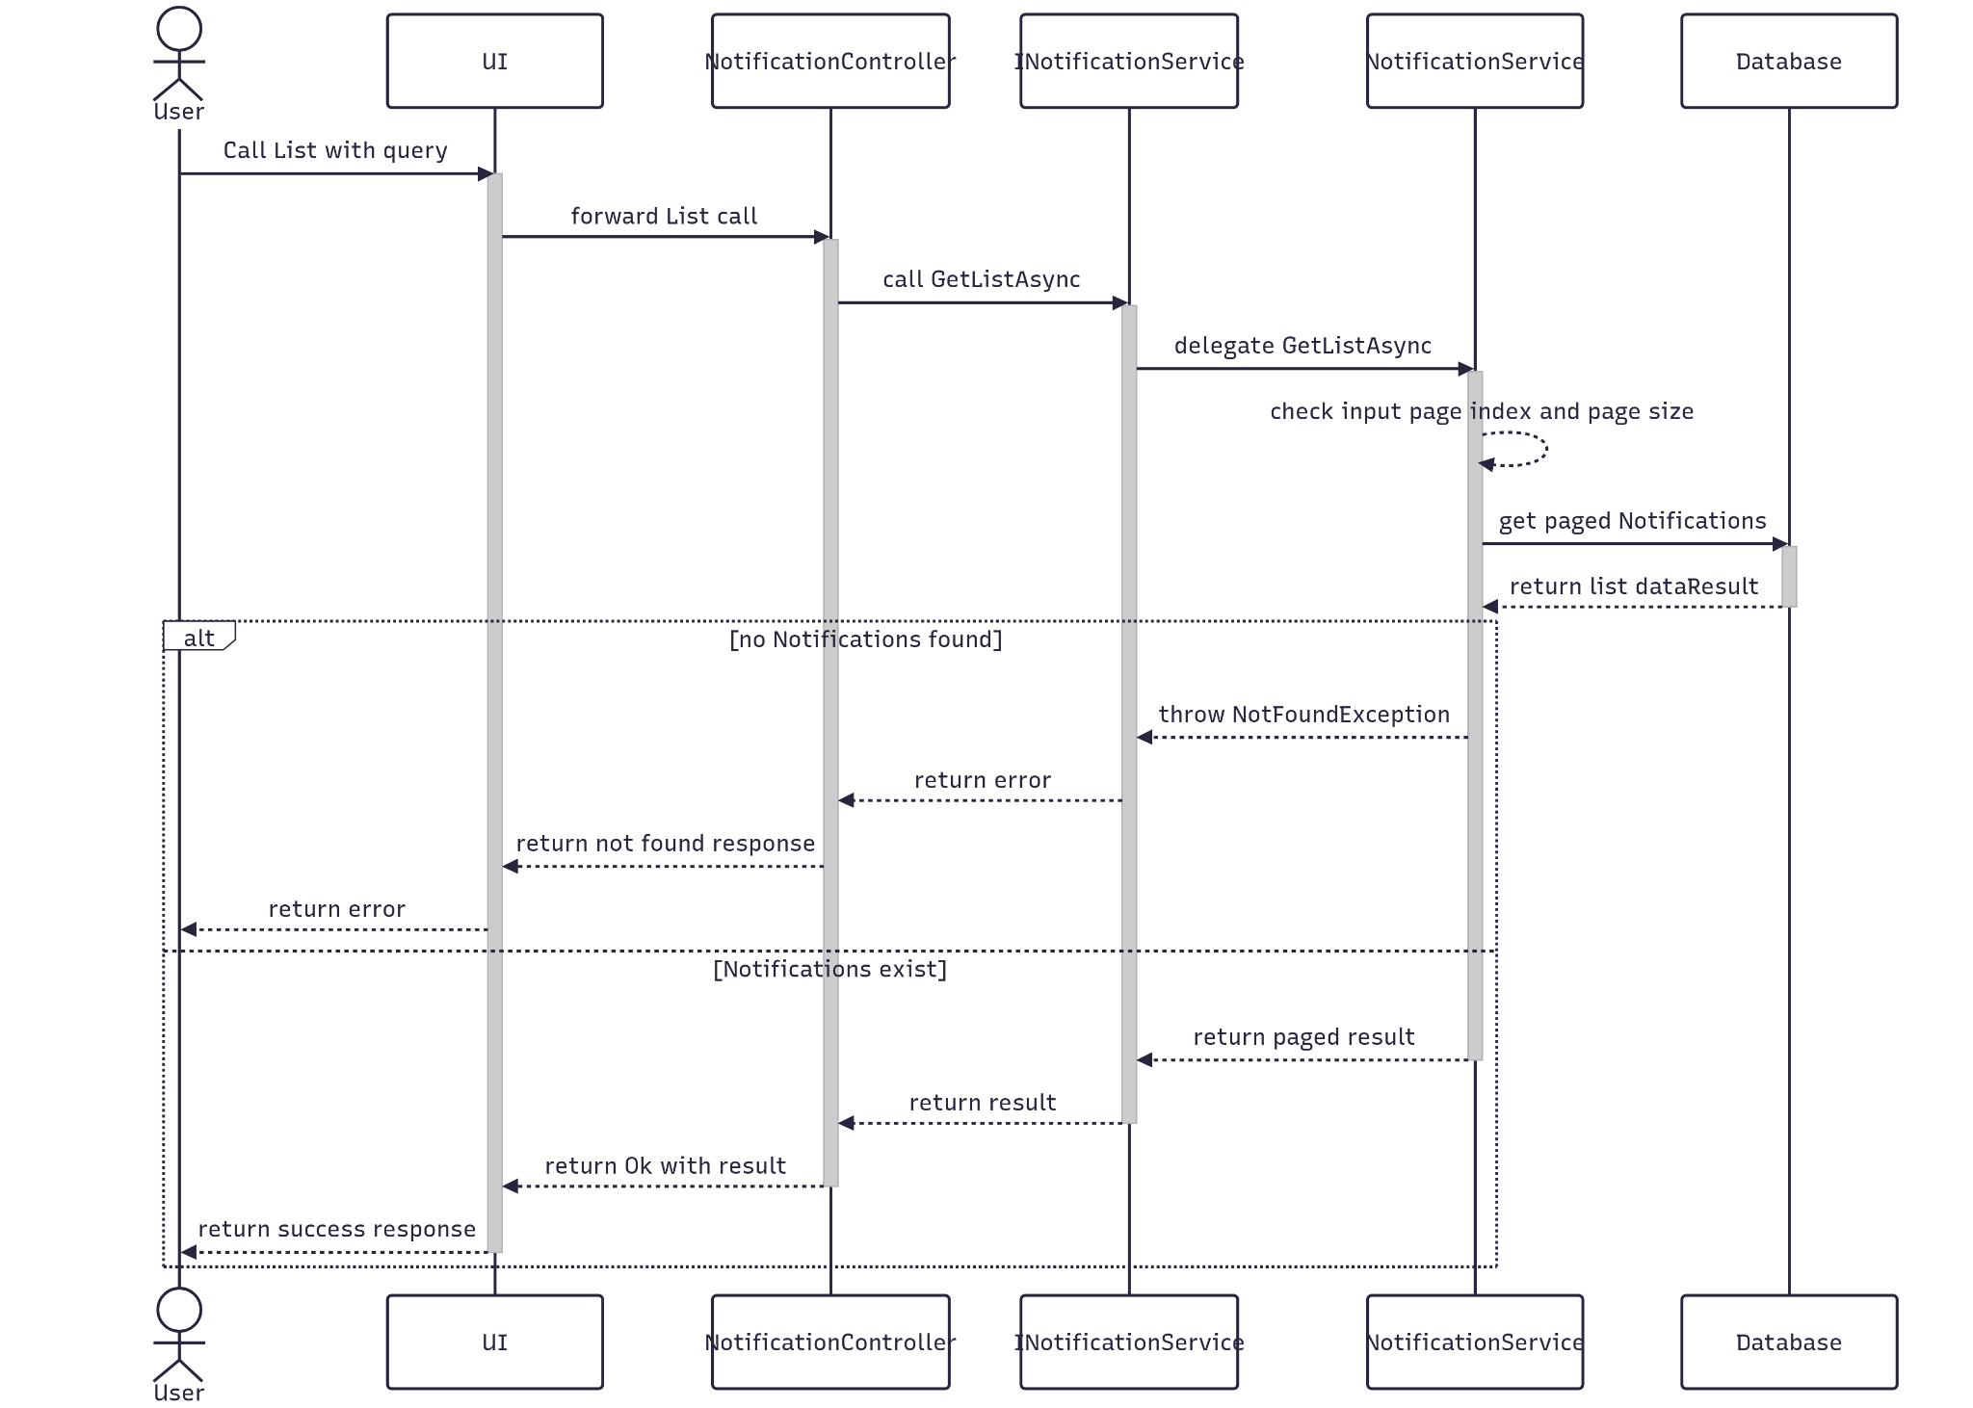

##### 3.16.5.3 Class Specification

###### 3.16.5.3.a NotificationController

| No | Method | Description |
| --- | --- | --- |
| 1 | Add(RQ_Document) | Controller method that receives a query object and returns a paginated list of notifications |

###### 3.16.5.3.b NotificationService

| No | Method | Description |
| --- | --- | --- |
| 1 | NewDocument(RQ_Document) | Service method that validates pagination input, queries the repository with filters, and returns a paginated result. Throws NotFoundException if no notifications are found. |

### 3.17 Manage Project

#### 3.17.1.Create

##### 3.17.1.1 Class Diagram

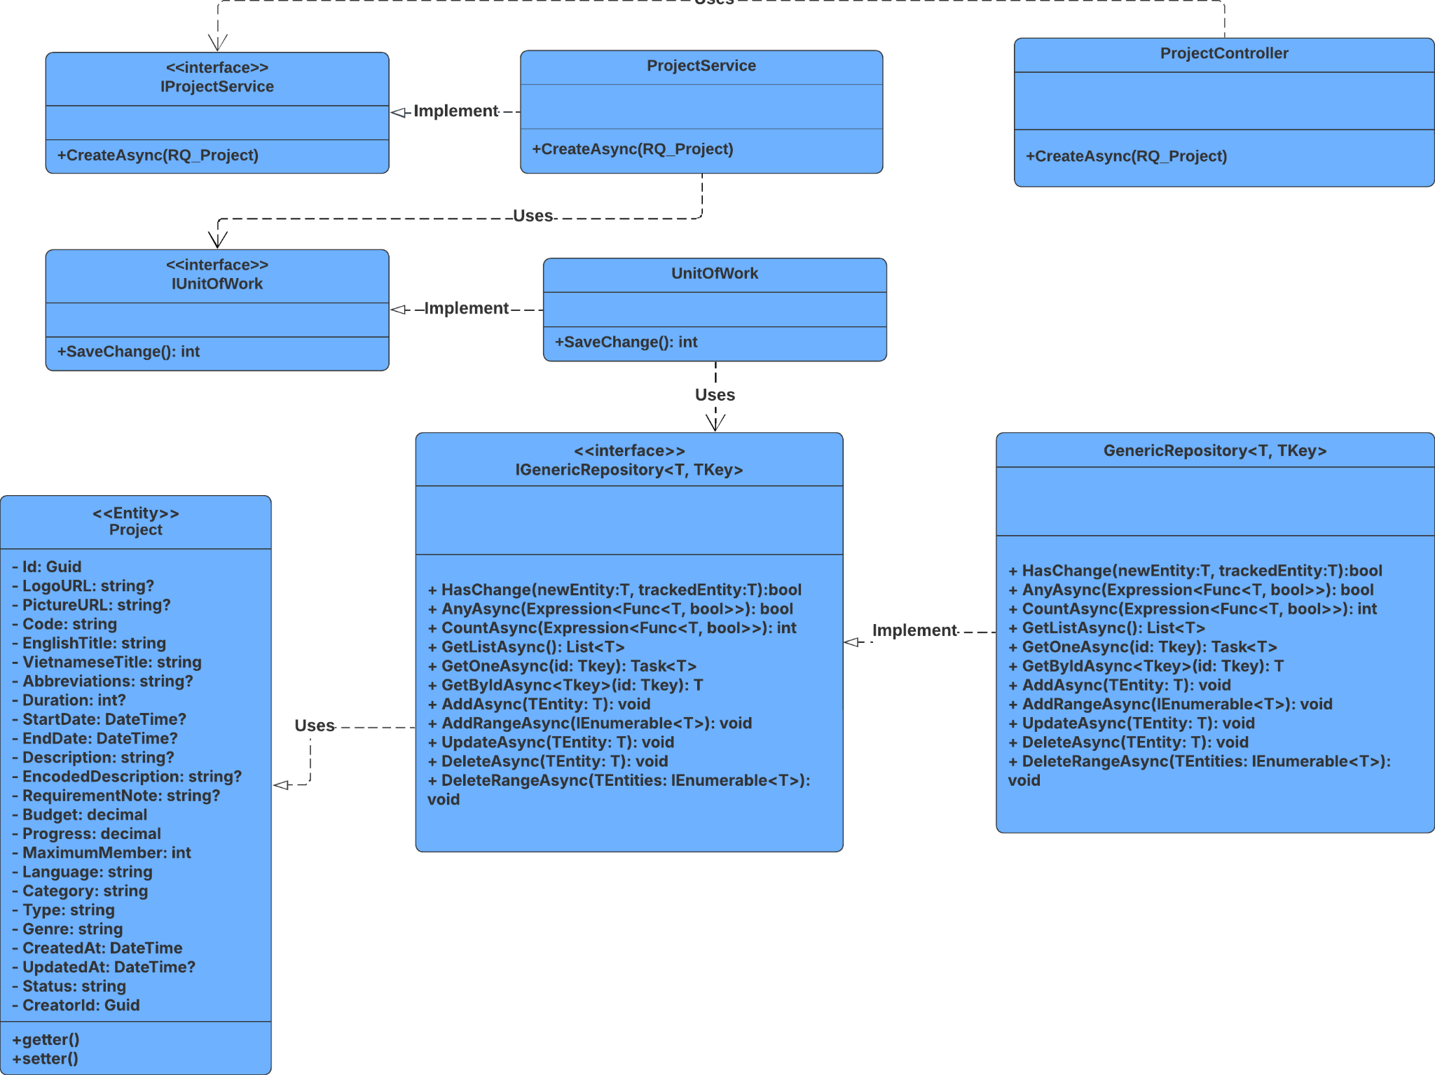

##### 3.17.1.2 Sequence Diagram

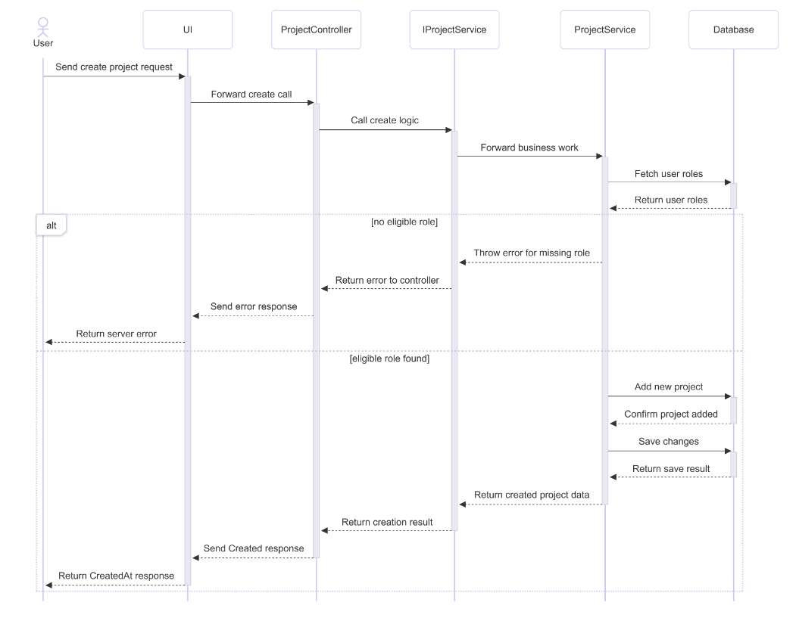

##### 3.17.1.3 Class Specification

###### 3.17.1.3.a ProjectController

| No | Method | Description |
| --- | --- | --- |
| 1 | Create(RQ_Project request) | Handles HTTP POST requests to create a new project. Returns 201 Created with the new project ID or appropriate error codes (401, 400, 500) based on exception type. |

###### 3.17.1.3.b ProjectService

| No | Method | Description |
| --- | --- | --- |
| 1 | CreateAsync(RQ_Project request) | Maps request to entity, assigns defaults, generates code, validates user role, sets genre and creator, persists entity, and returns the result. Throws exception if user lacks valid role. |

#### 3.17.2.Update

##### 3.17.2.1 Class Diagram

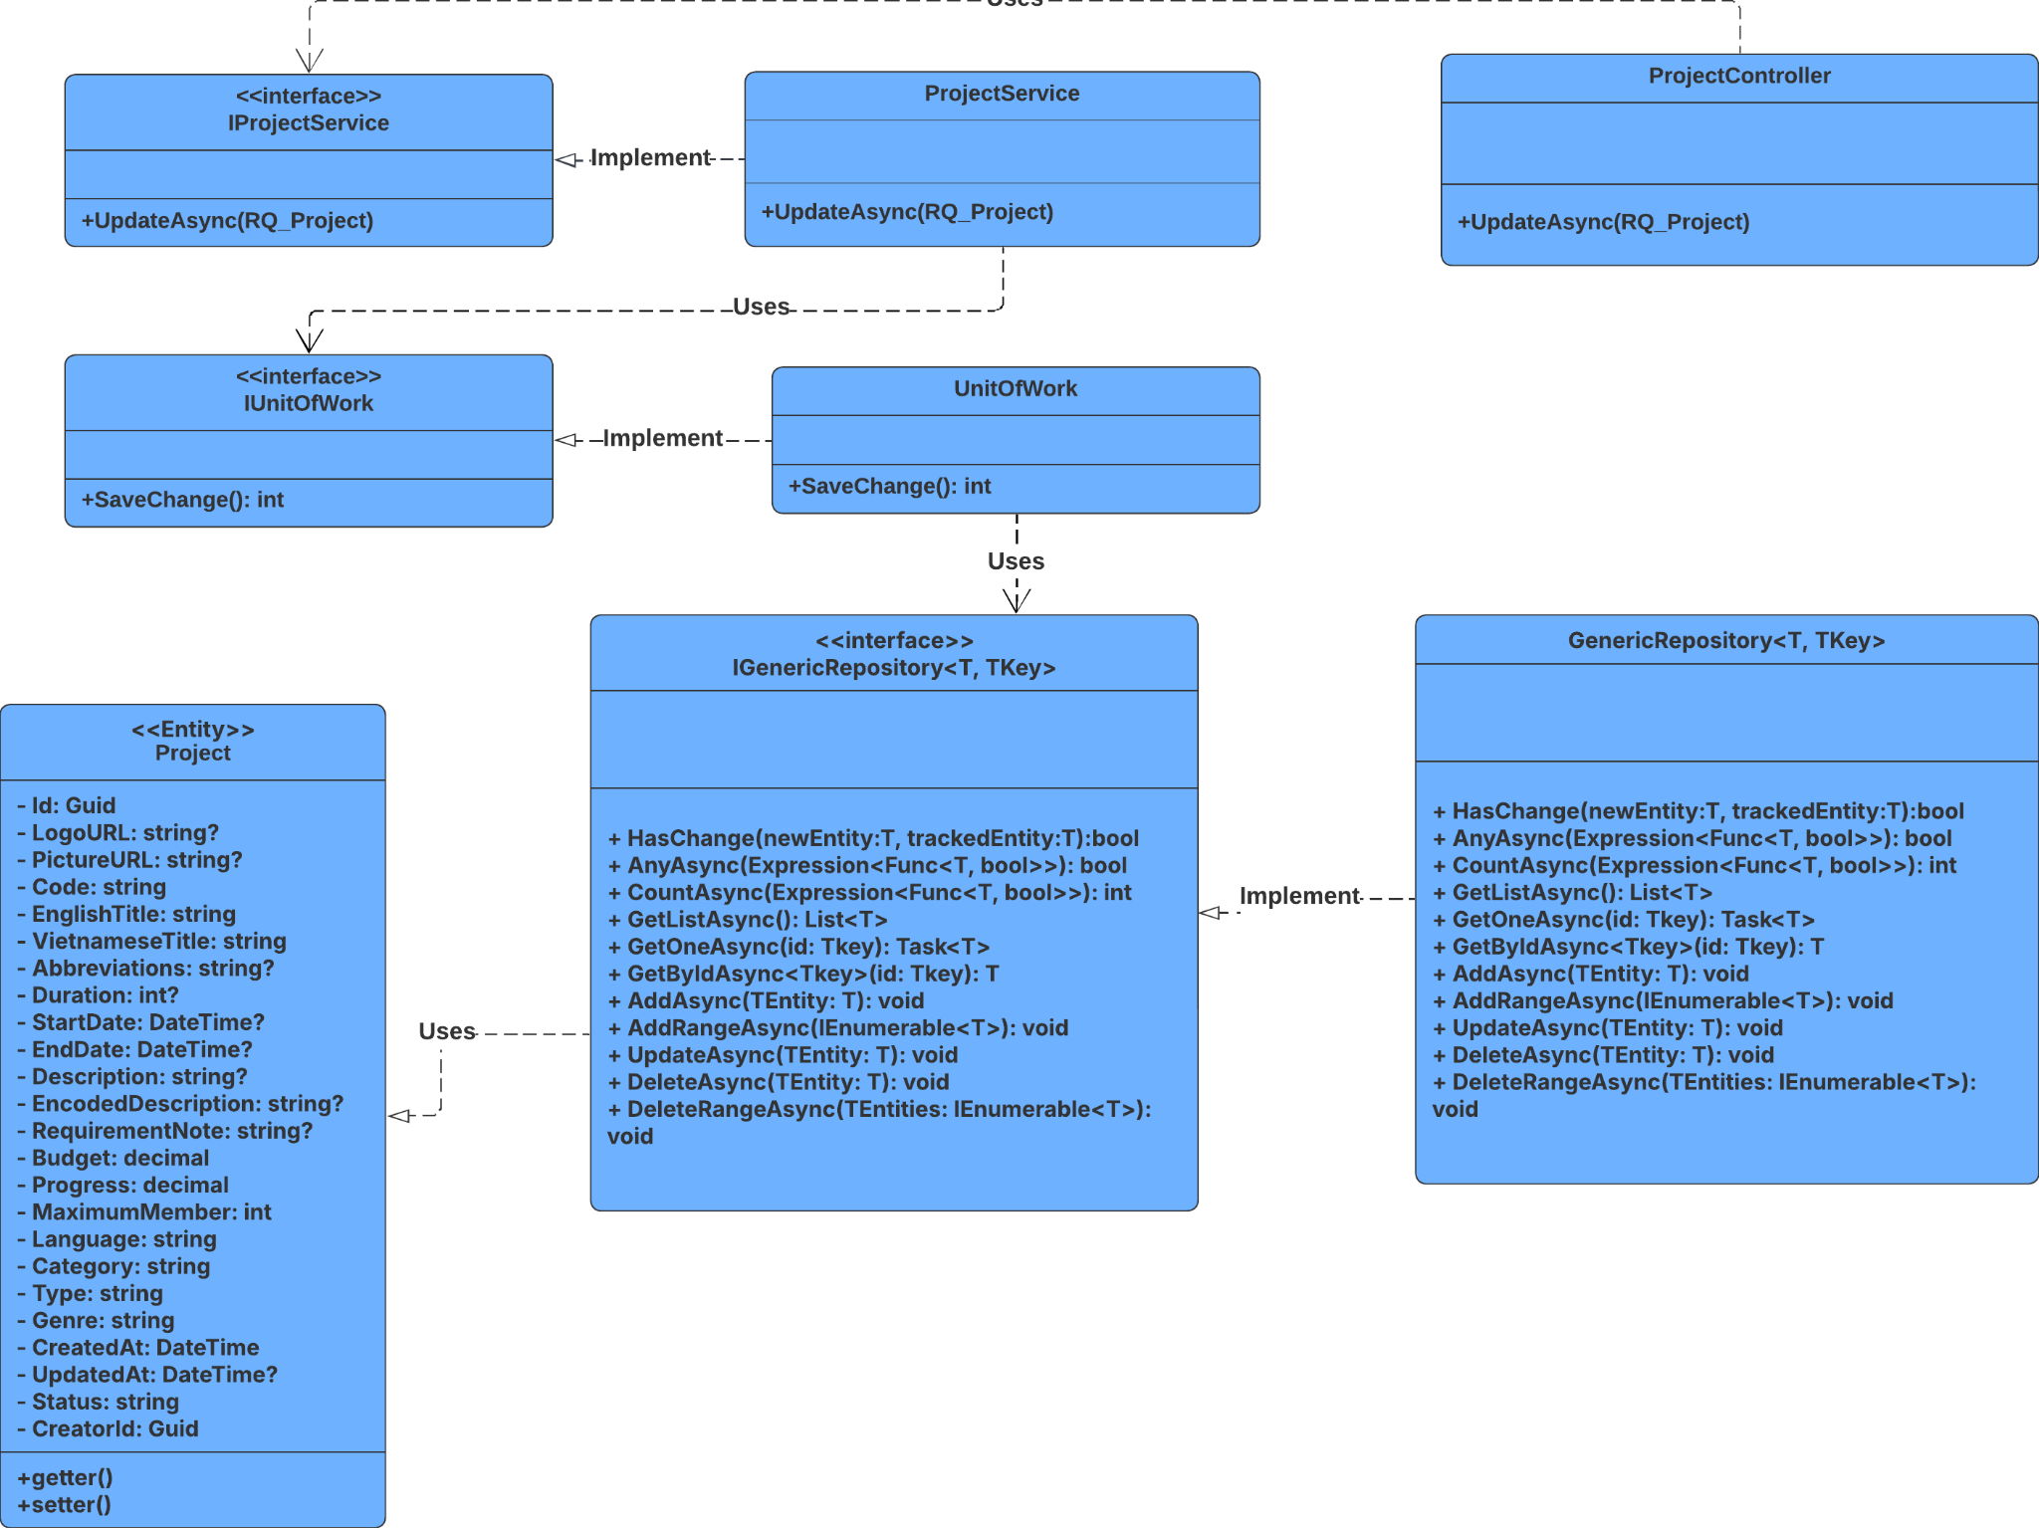

##### 3.17.2.2 Sequence Diagram

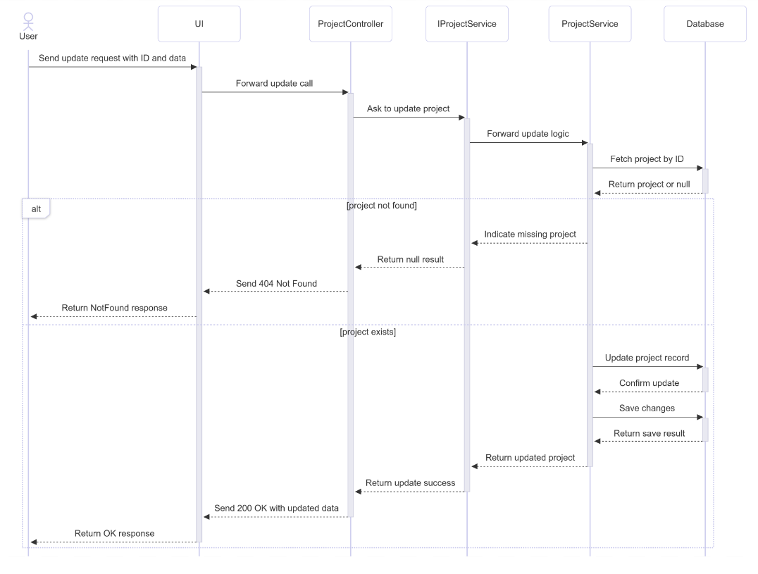

##### 3.17.2.3 Class Specification

###### 3.17.2.3.a ProjectController

| No | Method | Description |
| --- | --- | --- |
| 1 | Update(Guid id, RQ_Project, string status) | Handles HTTP PUT requests to update a project by ID and status. Returns 200 OK with updated project or appropriate error codes (404, 401, 400, 500) based on exception type. |

###### 3.17.2.3.b ProjectService

| No | Method | Description |
| --- | --- | --- |
| 1 | UpdateAsync(Guid id, RQ_Project, string status) | Retrieves the project by ID, updates its fields and status, sets UpdatedAt, saves changes, and returns the updated result. Returns null if not found. |

#### 3.17.3.Get By Id

##### 3.17.3.1 Class Diagram

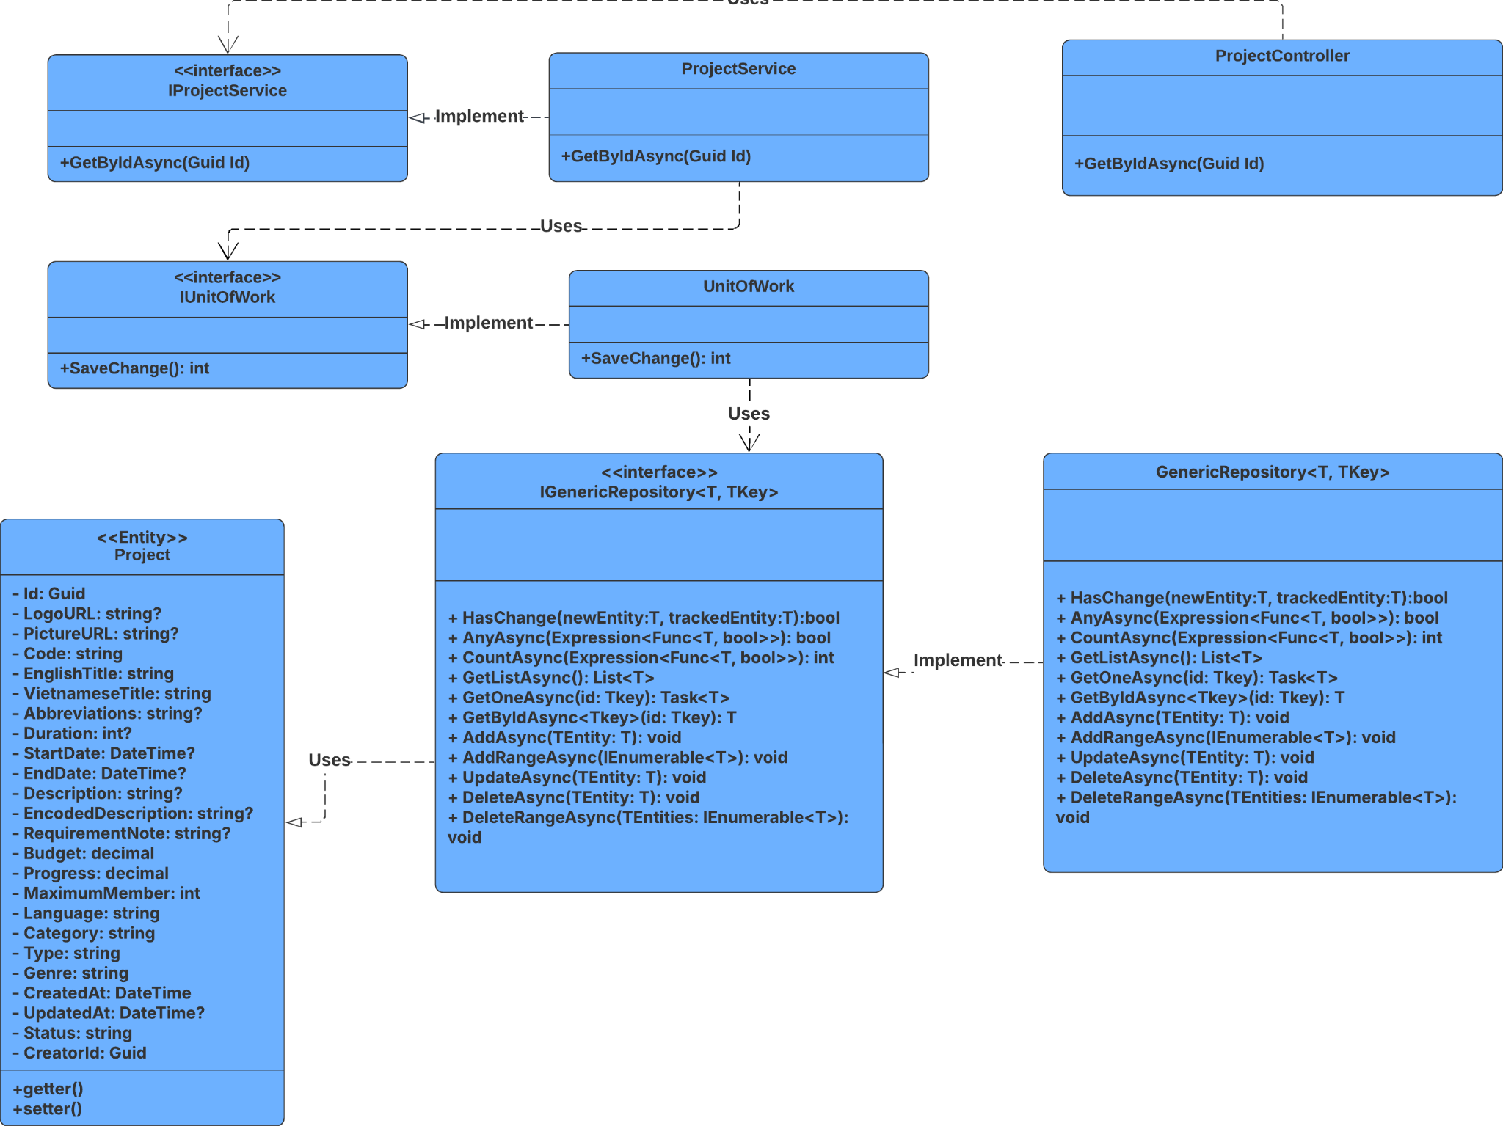

##### 3.17.3.2 Sequence Diagram

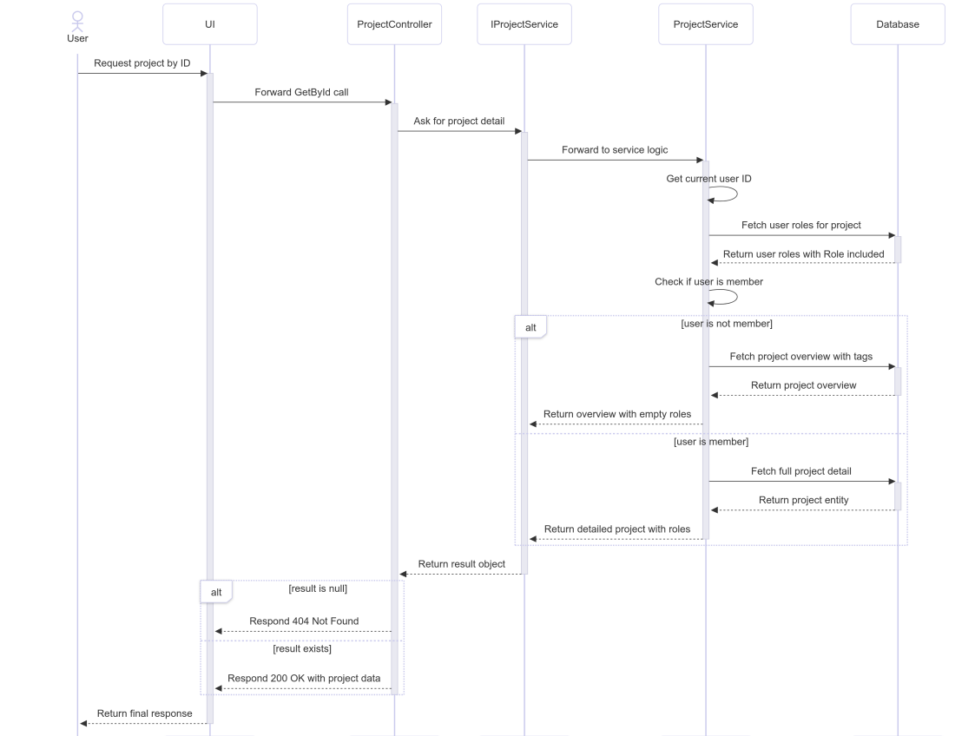

##### 3.17.3.3 Class Specification

###### 3.17.3.3.a ProjectController

| No | Method | Description |
| --- | --- | --- |
| 1 | GetById(Guid) | Handles HTTP GET requests to retrieve project details by ID. Returns 200 OK with project data, 404 Not Found if the project doesn't exist, 403 Forbidden for unauthorized access, or 500 Internal Server Error for unexpected issues. |

###### 3.17.3.3.b ProjectService

| No | Method | Description |
| --- | --- | --- |
| 1 | GetByIdAsync(Guid) | Retrieves project details based on the current user's role. Determines membership and role type (group vs. non-group). Returns either a detailed or overview response depending on membership status. |

#### 3.17.4.Delete

##### 3.17.4.1 Class Diagram

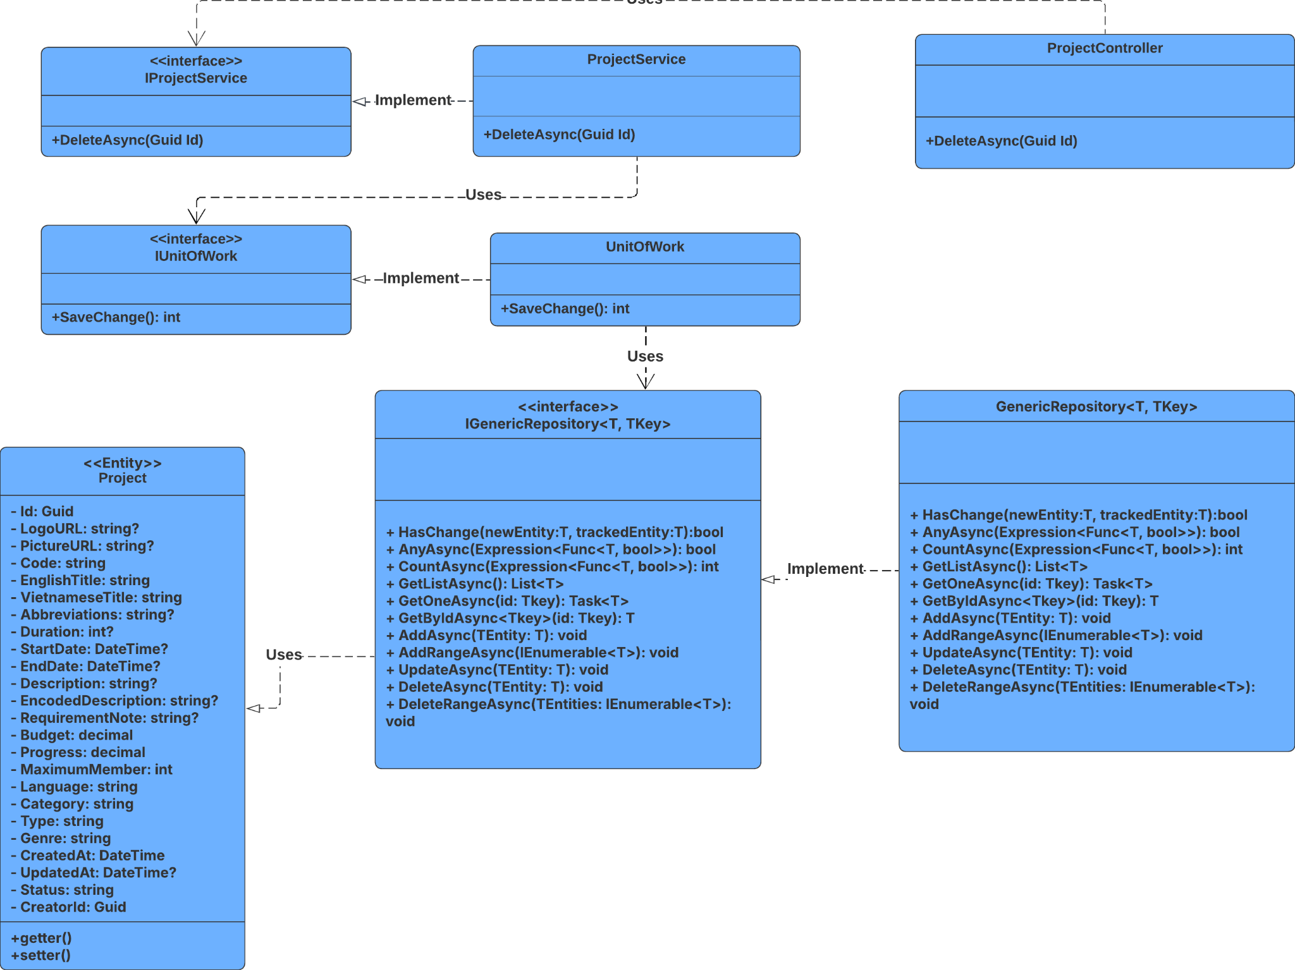

##### 3.17.4.2 Sequence Diagram

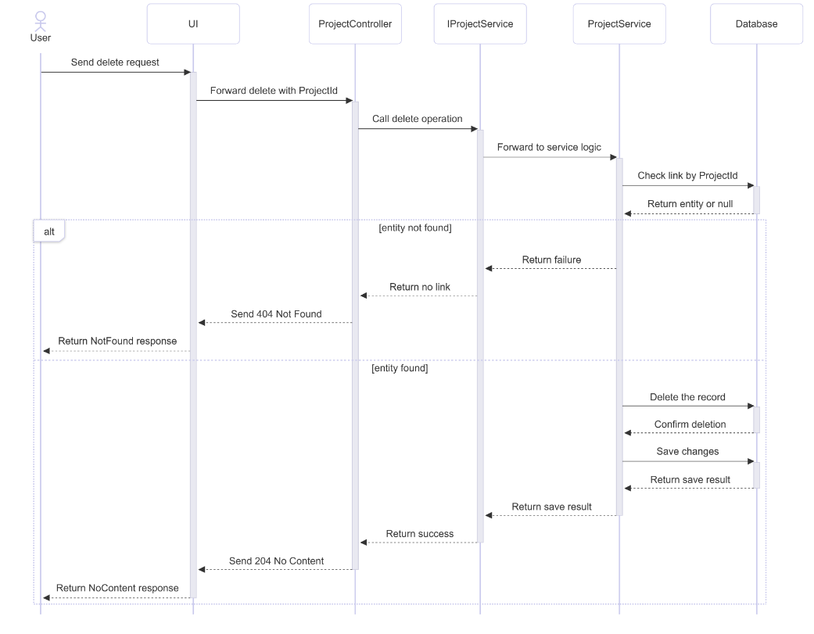

##### 3.17.4.3 Class Specification

###### 3.17.4.3.a ProjectController

| No | Method | Description |
| --- | --- | --- |
| 1 | Delete(Guid id) | Handles HTTP DELETE request to remove a project and its related entities. Returns 204 No Content if successful, 404 Not Found if the project doesn't exist, or appropriate error codes for exceptions. |

###### 3.17.4.3.b ProjectService

| No | Method | Description |
| --- | --- | --- |
| 1 | DeleteAsync(Guid id) | Retrieves the project by ID with all related entities. If found, deletes associated records (members, notifications, milestones, etc.), deletes the project itself, commits changes, and returns true. Returns false if not found. |

#### 3.17.5.Get List

##### 3.17.5.1 Class Diagram

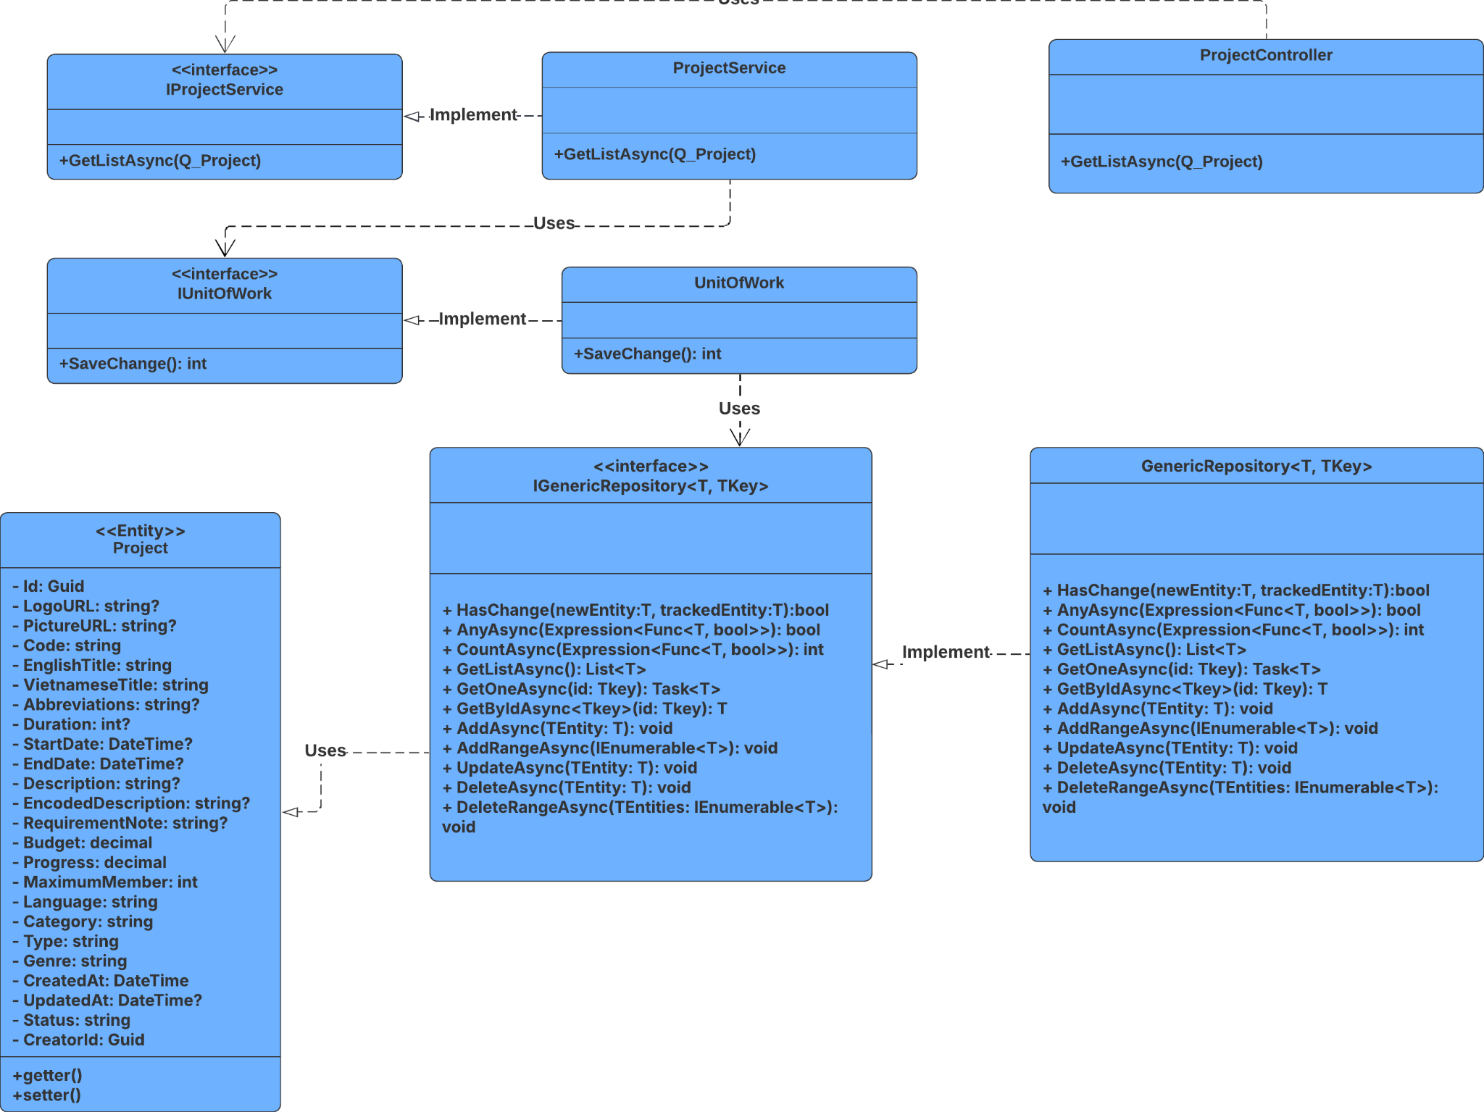

##### 3.17.5.2 Sequence Diagram

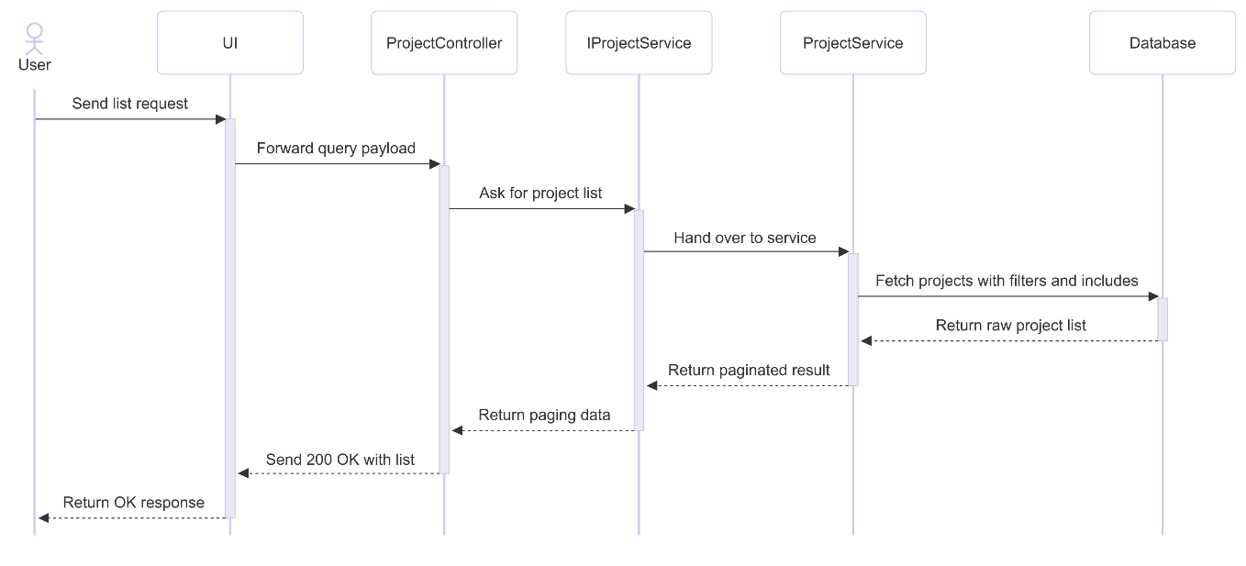

##### 3.17.5.3 Class Specification

###### 3.17.5.3.a ProjectController

| No | Method | Description |
| --- | --- | --- |
| 1 | GetList(RQ_ProjectQuery query) | Handles HTTP POST request to retrieve a paginated list of projects based on complex filters. Returns 200 OK with results or appropriate error codes (400, 401, 500) based on exception type. |

###### 3.17.5.3.b ProjectService

| No | Method | Description |
| --- | --- | --- |
| 1 | GetListAsync(RQ_ProjectQuery query) | Applies dynamic filters (title, code, category, type, genre, status, language, major, field, tags) and conditional includes (creator, members, milestones, etc.). Sorts and paginates the result, then maps to RS_Project. Returns a PagingResult. |

### 3.18 Manage ProjectMajor

#### 3.18.1.Create

##### 3.18.1.1 Class Diagram

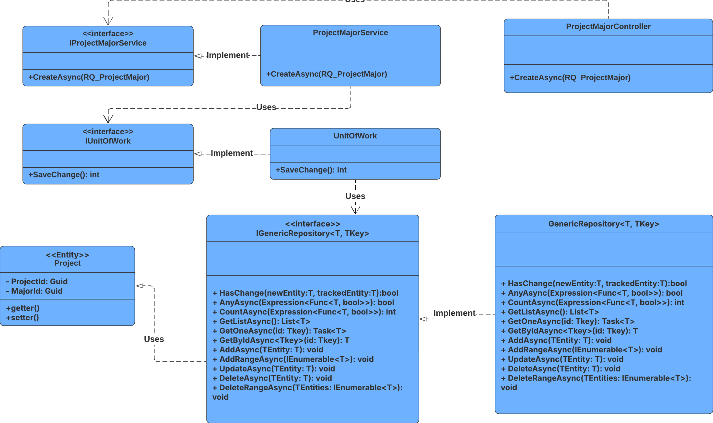

##### 3.18.1.2 Sequence Diagram

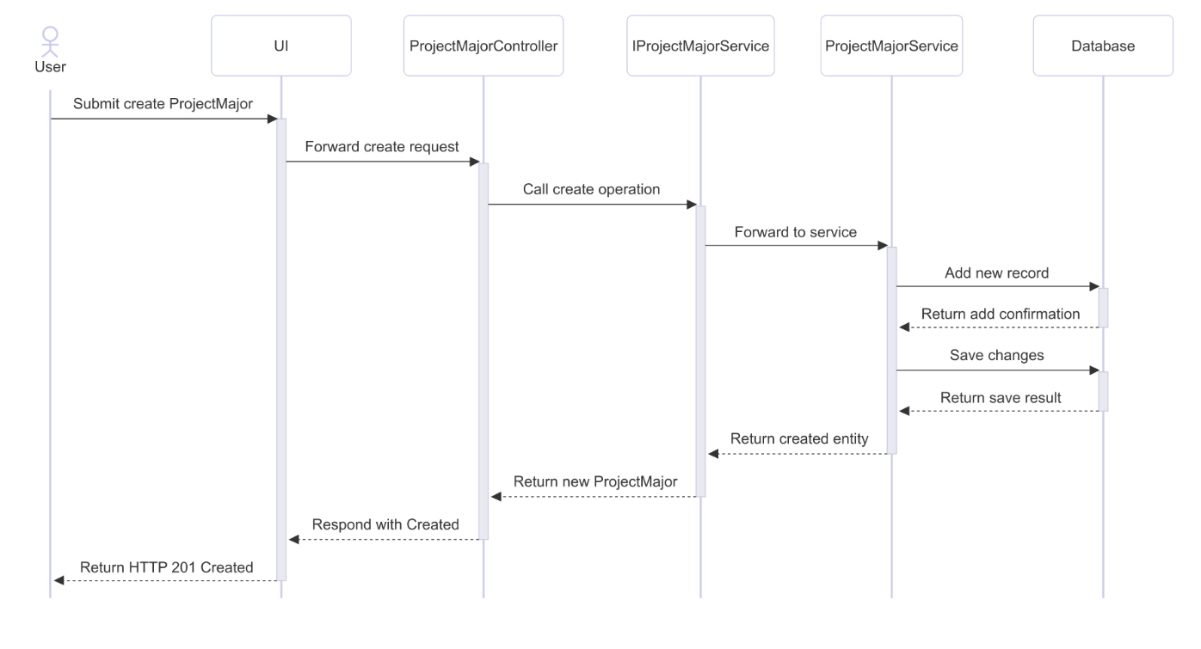

##### 3.18.1.3 Class Specification

###### 3.18.1.3.a ProjectMajorController

| No | Method | Description |
| --- | --- | --- |
| 1 | Create(RQ_ProjectMajor) | Receives project-major association data and calls CreateAsync to persist it. Returns 201 Created with route values for projectId and majorId. |

###### 3.18.1.3.b ProjectMajorService

| No | Method | Description |
| --- | --- | --- |
| 1 | CreateAsync(RQ_ProjectMajor) | Maps the request to a ProjectMajor entity, adds it to the repository, saves changes, and returns the result as RS_ProjectMajor. |

#### 3.18.2.Update

##### 3.18.2.1 Class Diagram

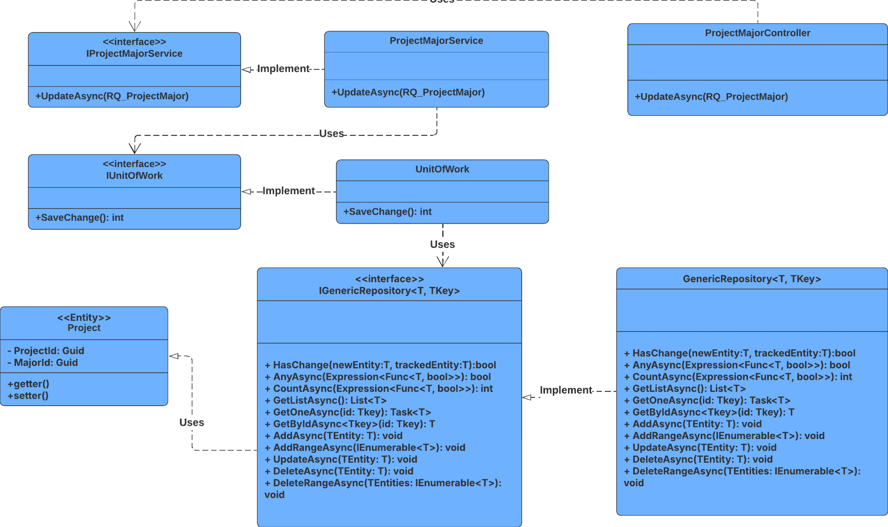

##### 3.18.2.2 Sequence Diagram

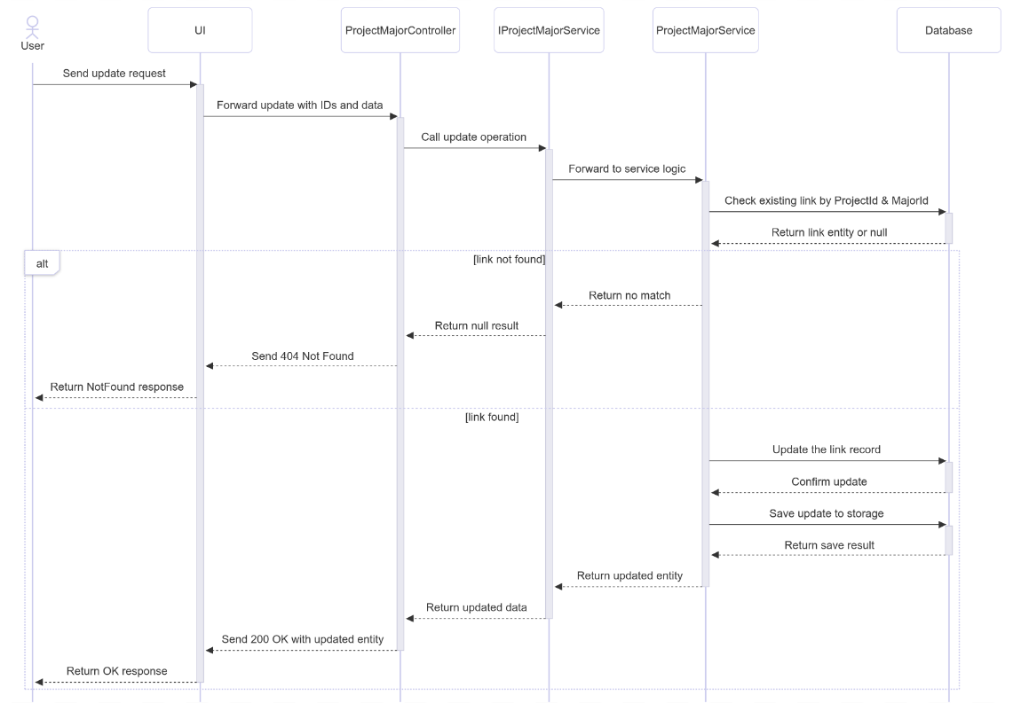

##### 3.18.2.3 Class Specification

###### 3.18.2.3.a ProjectMajorController

| No | Method | Description |
| --- | --- | --- |
| 1 | Update(Guid projectId, Guid majorId, RQ_ProjectMajor) | Handles HTTP PUT request to update a project-major link. Calls UpdateAsync and returns 200 OK with the updated result or 404 Not Found if no match is found. |

###### 3.18.2.3.b ProjectMajorService

| No | Method | Description |
| --- | --- | --- |
| 1 | UpdateAsync(Guid projectId, Guid majorId, RQ_ProjectMajor) | Retrieves the existing project-major link by composite key. If found, maps the request data to the entity, updates it, saves changes, and returns the updated result. Returns null if not found. |

#### 3.18.3.Delete

##### 3.18.3.1 Class Diagram

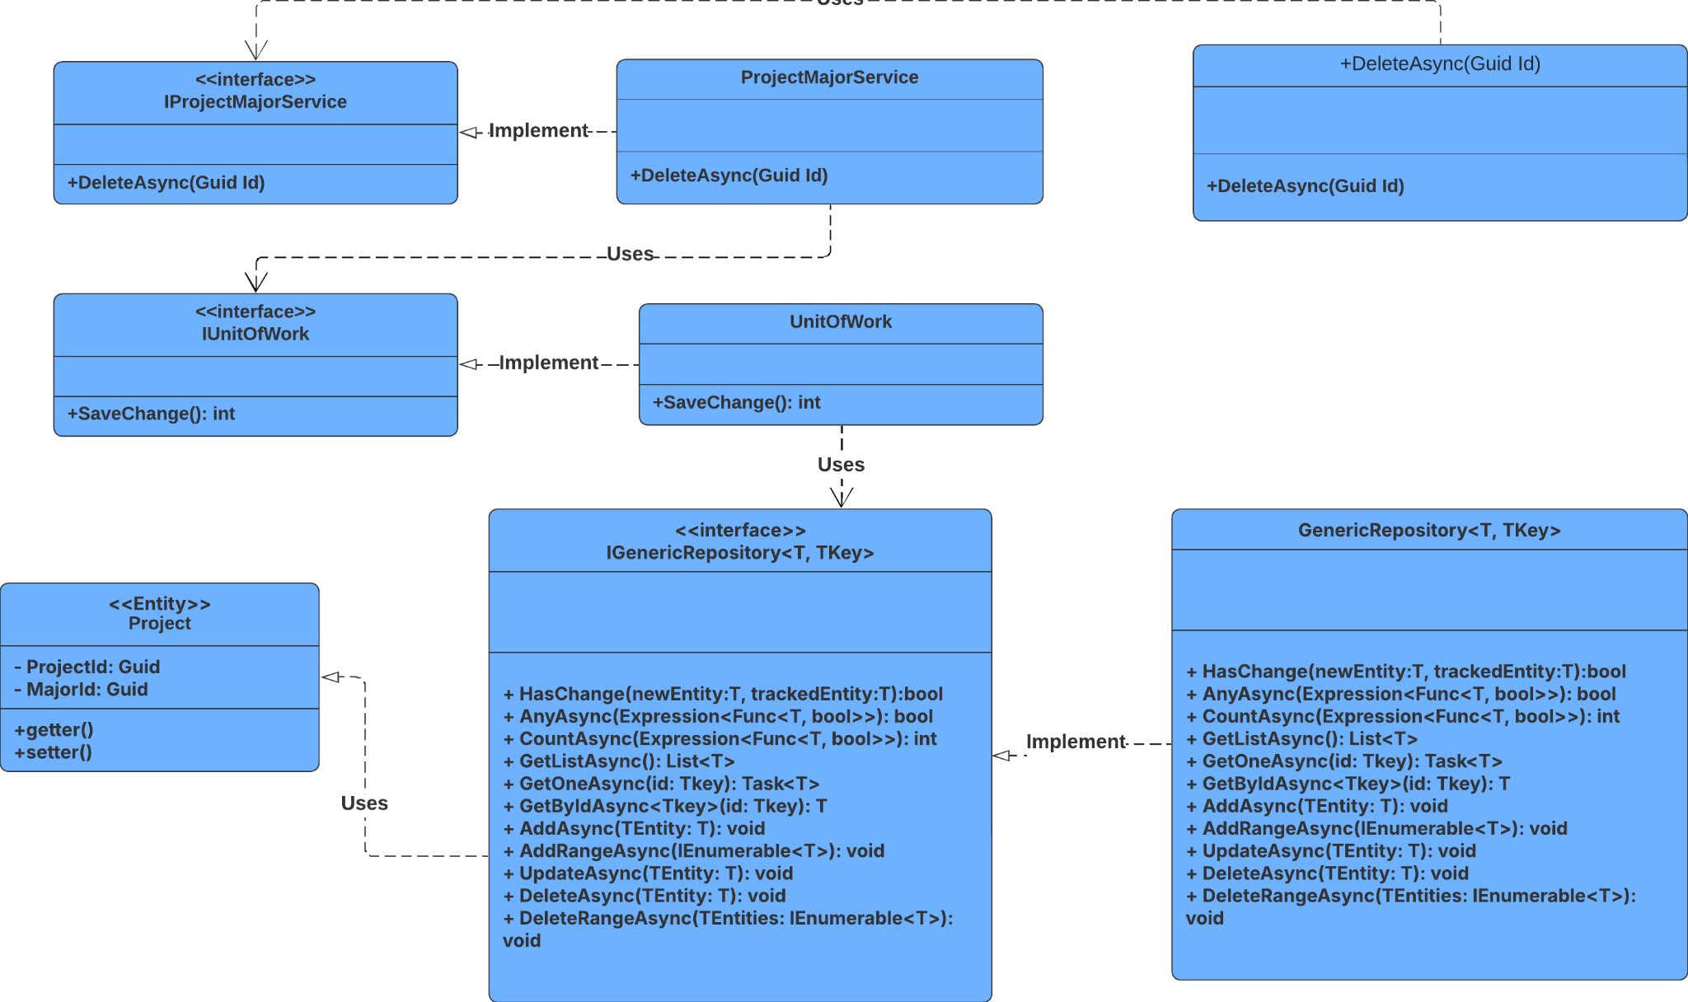

##### 3.18.3.2 Sequence Diagram

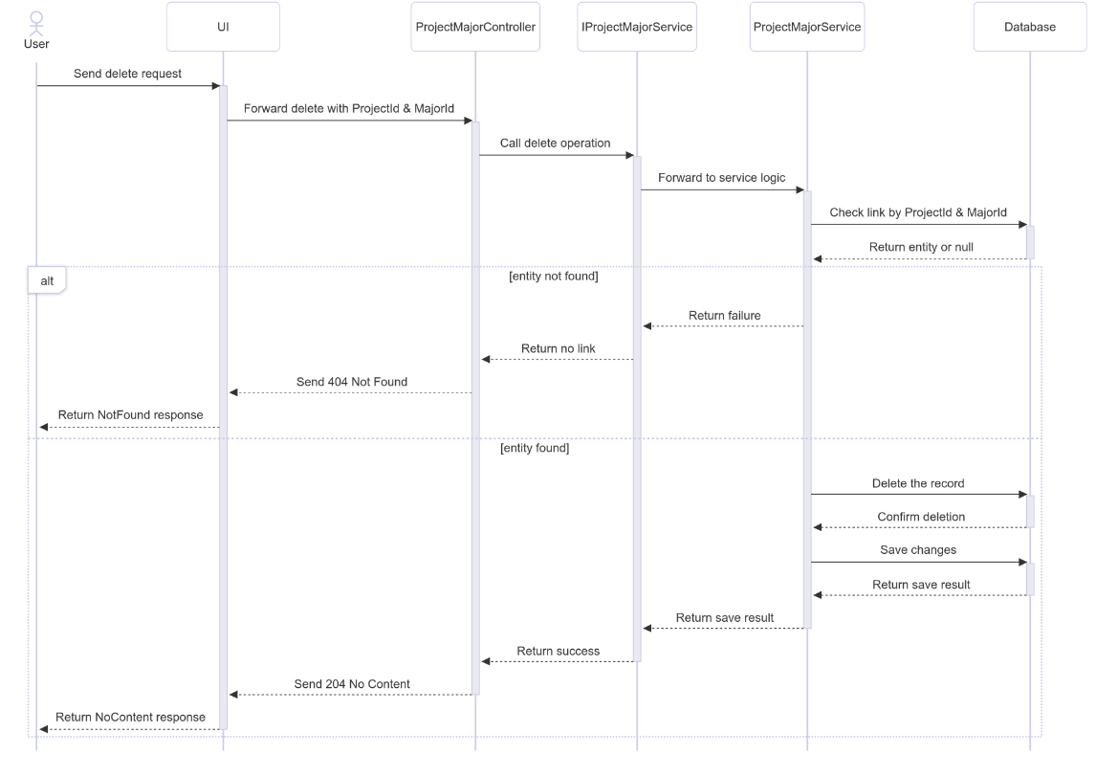

##### 3.18.3.3 Class Specification

###### 3.18.3.3.a ProjectMajorController

| No | Method | Description |
| --- | --- | --- |
| 1 | Delete(Guid projectId, Guid majorId) | Handles HTTP DELETE request to remove a project-major link. Returns 204 No Content if successful or 404 Not Found if no matching record exists. |

###### 3.18.3.3.b ProjectMajorService

| No | Method | Description |
| --- | --- | --- |
| 1 | DeleteAsync(Guid projectId, Guid majorId) | Retrieves the project-major link by composite key. If found, deletes the entity and commits changes. Returns true if deleted, false if not found. |

#### 3.18.4.Get List

##### 3.18.4.1 Class Diagram

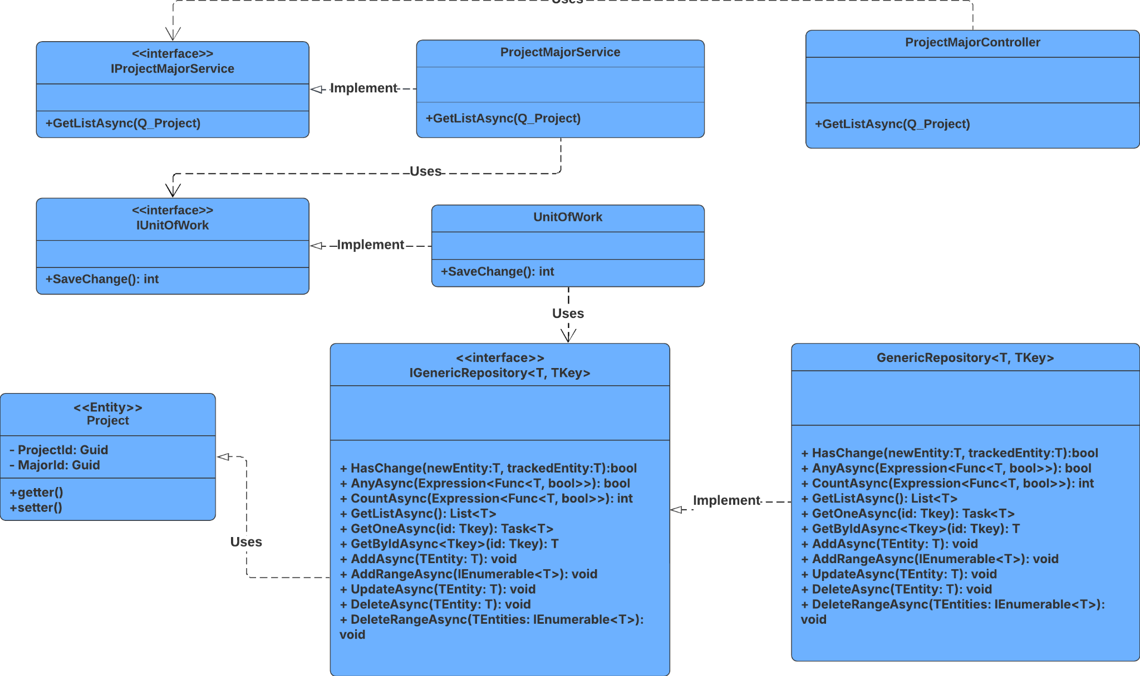

##### 3.18.4.2 Sequence Diagram

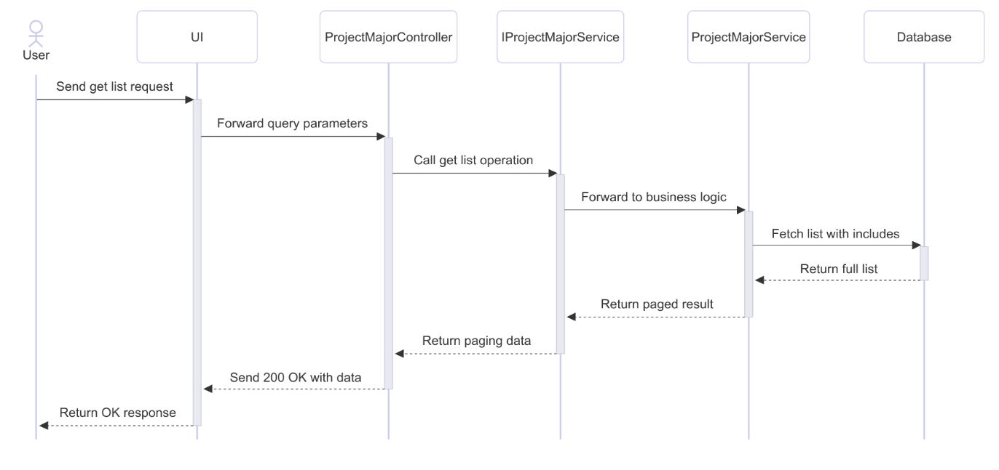

##### 3.18.4.3 Class Specification

###### 3.18.4.3.a ProjectMajorController

| No | Method | Description |
| --- | --- | --- |
| 1 | GetList(RQ_ProjectMajorQuery query) | Handles HTTP GET request with query parameters to retrieve a paginated list of project-major links. Returns 200 OK with the result. |

###### 3.18.4.3.b ProjectMajorService

| No | Method | Description |
| --- | --- | --- |
| 1 | GetListAsync(RQ_ProjectMajorQuery query) | Fetches all matching records with related data using ProjectId and MajorId. Applies pagination and maps the result to RS_ProjectMajor. Returns a PagingResult object. |

### 3.19 Manage Signature

#### 3.19.1.Create

##### 3.19.1.1 Class Diagram

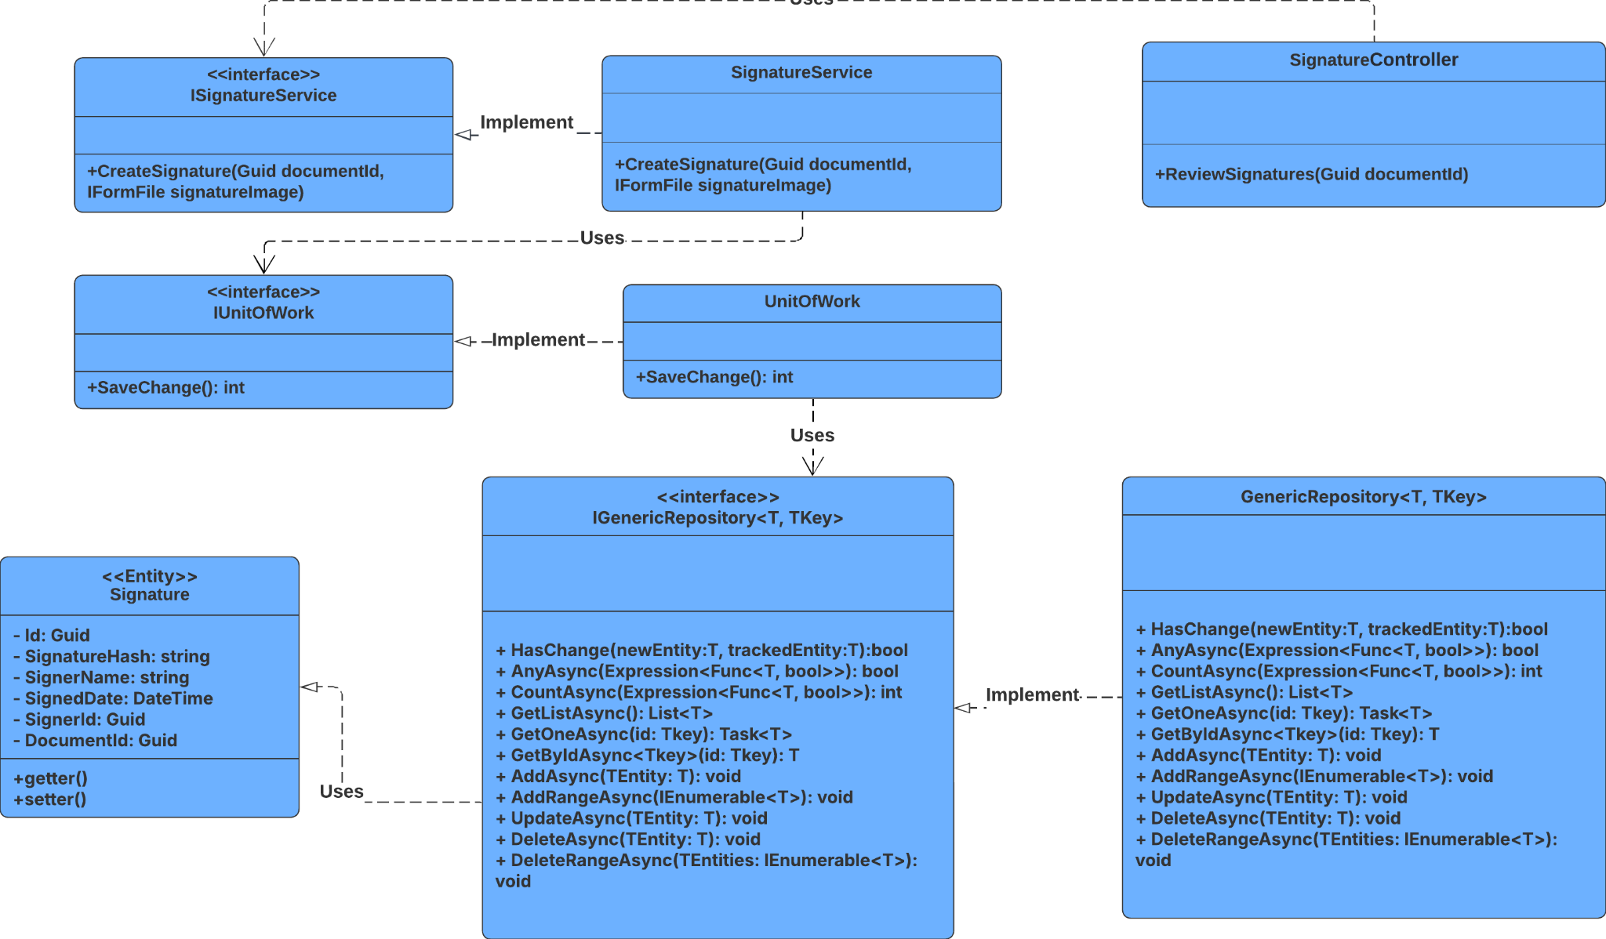

##### 3.19.1.2 Sequence Diagram

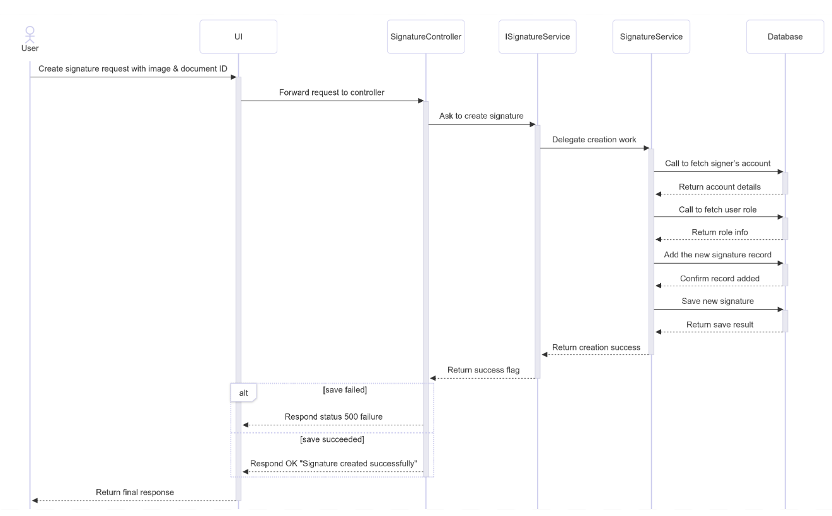

##### 3.19.1.3 Class Specification

###### 3.19.1.3.a SignatureController

| No | Method | Description |
| --- | --- | --- |
| 1 | CreateSignature(Guid documentId, IFormFile signatureImage) | Handles HTTP POST request to create a signature for a document. Validates the image input and calls CreateSignatureAsync. Returns 200 OK if successful or 500 Internal Server Error if creation fails. |

###### 3.19.1.3.b SignatureService

| No | Method | Description |
| --- | --- | --- |
| 1 | CreateSignature(Guid documentId, IFormFile signatureImage) | Converts the uploaded image to a byte array, generates a SHA256 hash, retrieves signer info and role, creates a new Signature entity, saves it to the repository, and returns true if successful. |

#### 3.19.2.Get Document’s Signature

##### 3.19.2.1 Class Diagram

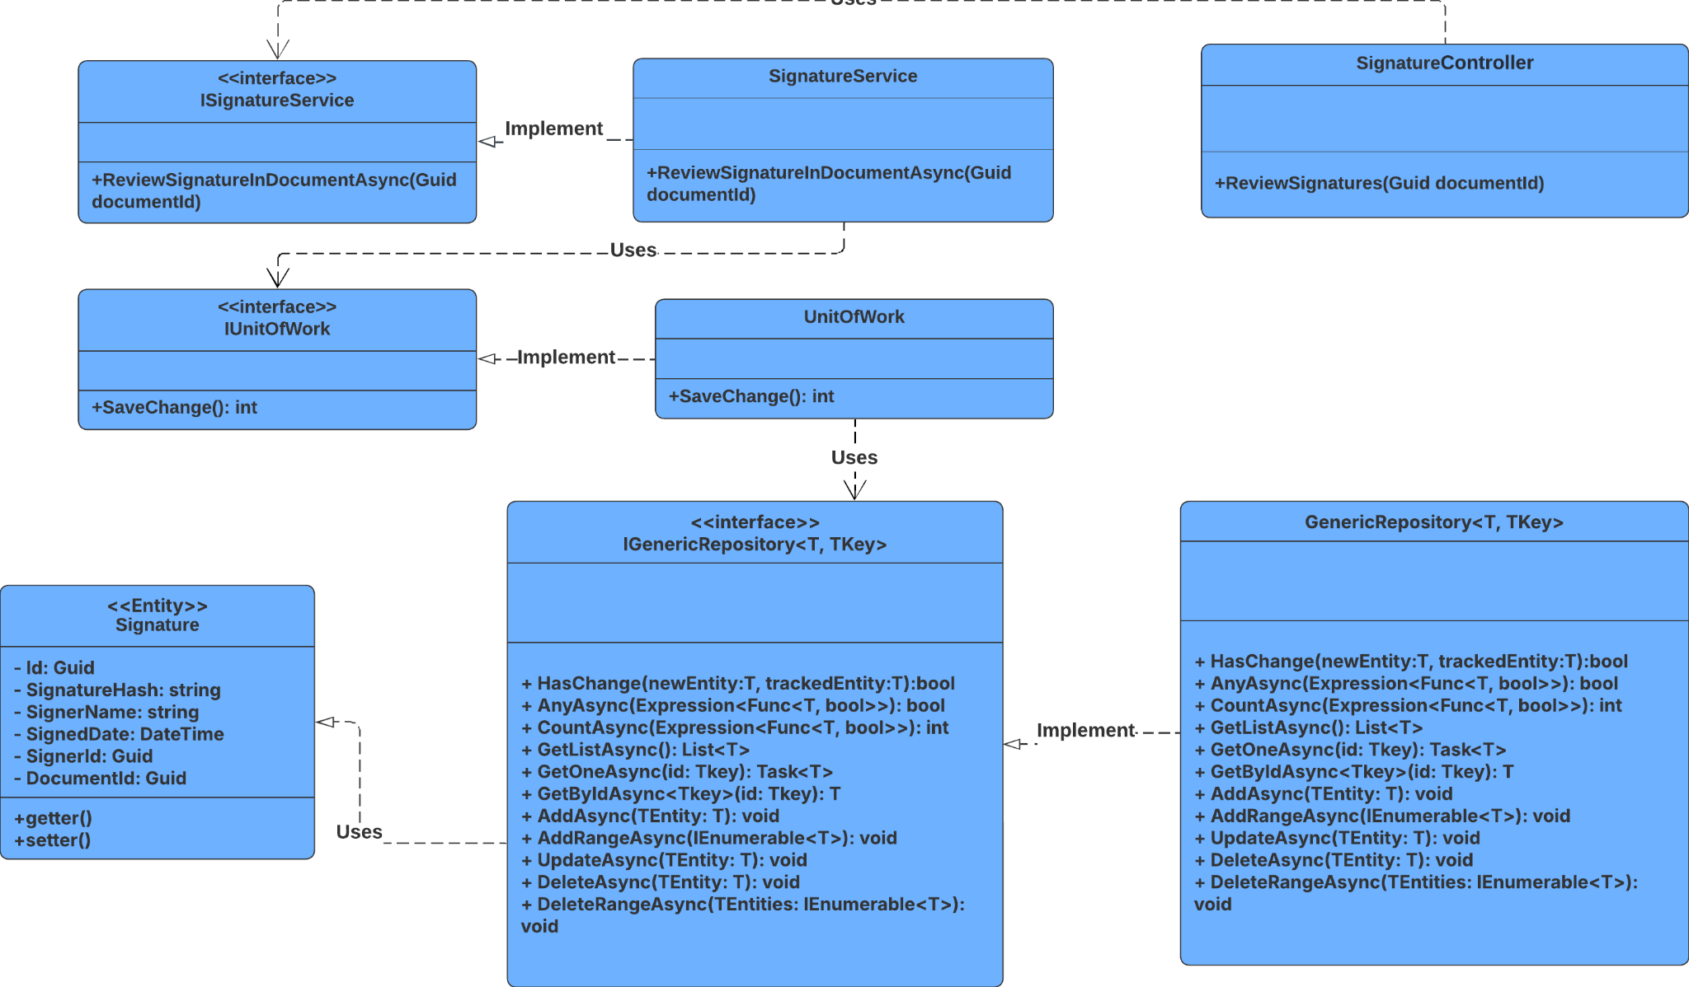

##### 3.19.2.2 Sequence Diagram

##### 3.19.2.3 Class Specification

###### 3.19.2.3.a SignatureController

| No | Method | Description |
| --- | --- | --- |
| 1 | ReviewSignatures(Guid documentId) | Handles HTTP GET requests to retrieve all signatures associated with a specific document. Returns 200 OK with a list of signature response DTOs. |

###### 3.19.2.3.b SignatureService

| No | Method | Description |
| --- | --- | --- |
| 1 | ReviewSignatureInDocumentAsync(Guid documentId) | Queries the signature repository for all signatures linked to the given document ID. Maps each signature to a response DTO, including a preview of the hash, and returns the list. |

#### 3.19.3.Delete

##### 3.19.3.1 Class Diagram

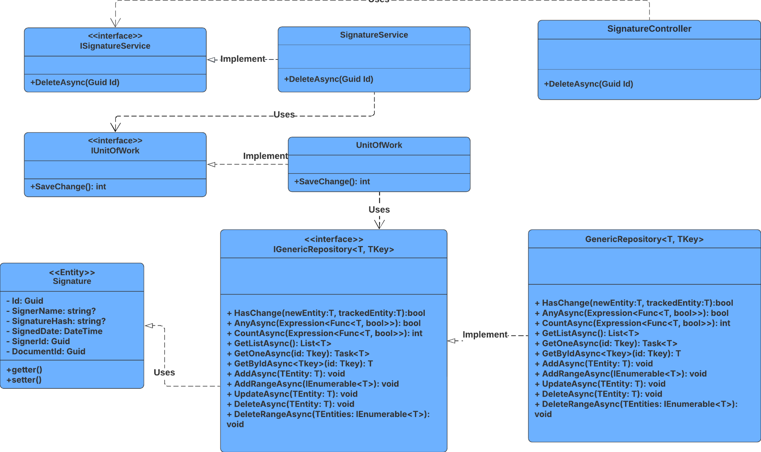

##### 3.19.3.2 Sequence Diagram

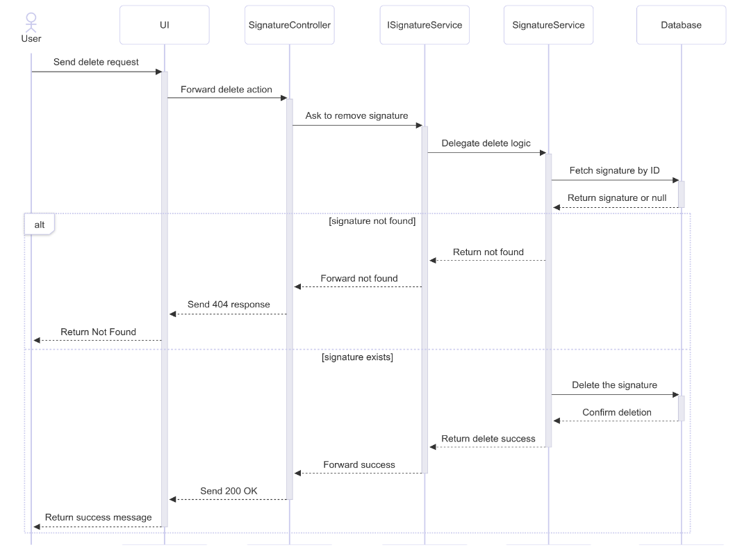

##### 3.19.3.3 Class Specification

###### 3.19.3.3.a SignatureController

| No | Method | Description |
| --- | --- | --- |
| 1 | DeleteAsync(Guid) | Handles HTTP DELETE request to remove a signature by ID. Returns 200 OK with a success message if deleted, or 404 Not Found if the signature doesn't exist. |

###### 3.19.3.3.b SignatureService

| No | Method | Description |
| --- | --- | --- |
| 1 | DeleteAsync(Guid) | Retrieves the signature by ID, deletes it from the repository, and returns true if successful. Returns false if the signature is not found. |

### 3.20 Manage System Configuration

#### 3.20.1.Create

##### 3.20.1.1 Class Diagram

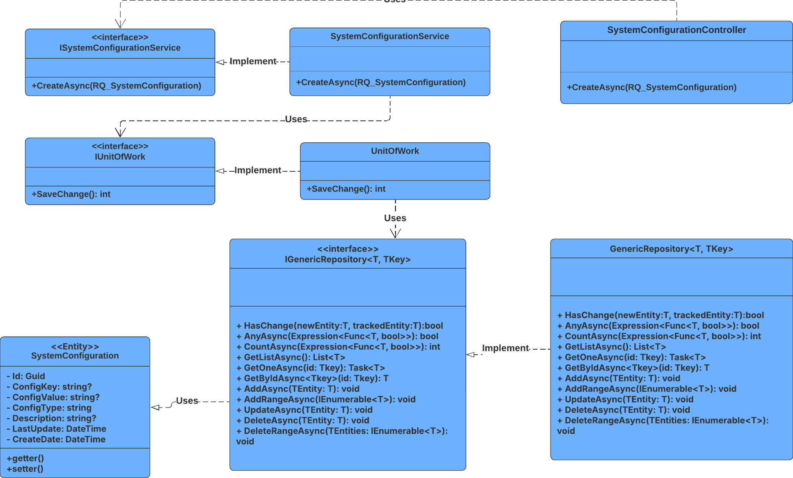

##### 3.20.1.2 Sequence Diagram

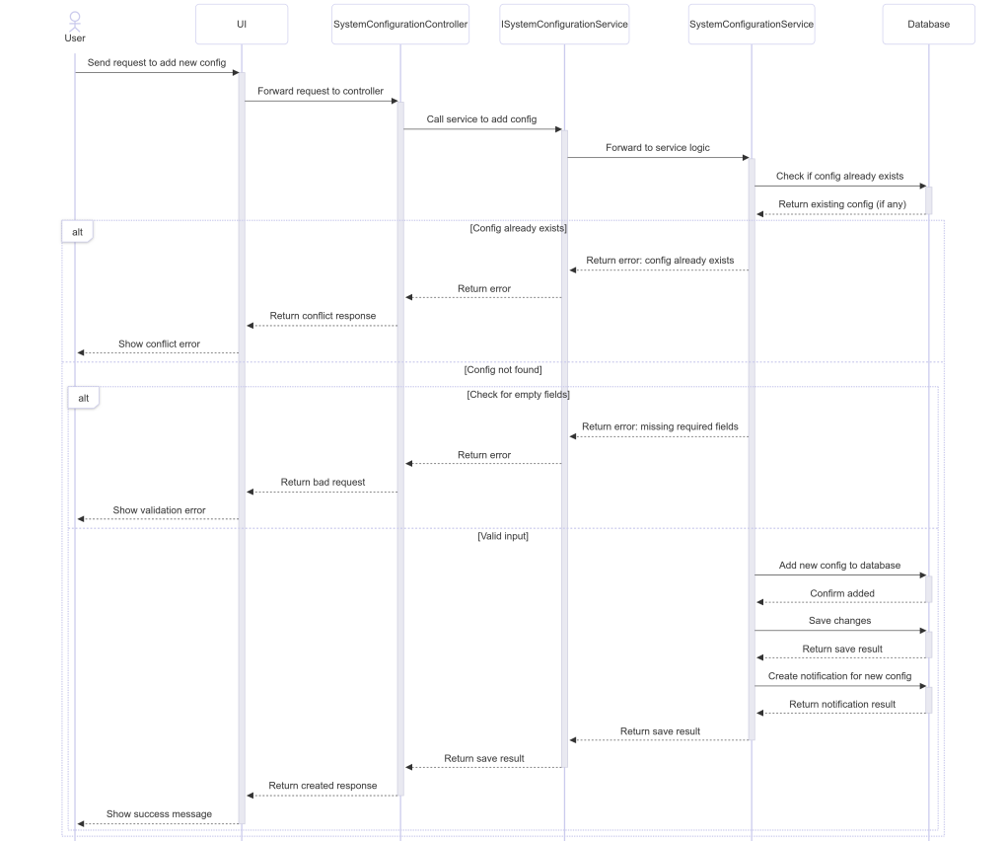

##### 3.20.1.3 Class Specification

###### 3.20.1.3.a SystemConfigurationController

| No | Method | Description |
| --- | --- | --- |
| 1 | AddNew(RQ_SystemConfiguration) | Receives system configuration data and calls AddNewConfig to process and persist it. Returns appropriate HTTP response based on creation and notification results |

###### 3.20.1.3.b SystemConfigurationService

| No | Method | Description |
| --- | --- | --- |
| 1 | AddNewConfig(RQ_SystemConfiguration) | Validates input, checks for duplicates, saves new configuration, and triggers notification creation. Returns a tuple indicating success of both operations. |

#### 3.20.2.Update

##### 3.20.2.1 Class Diagram

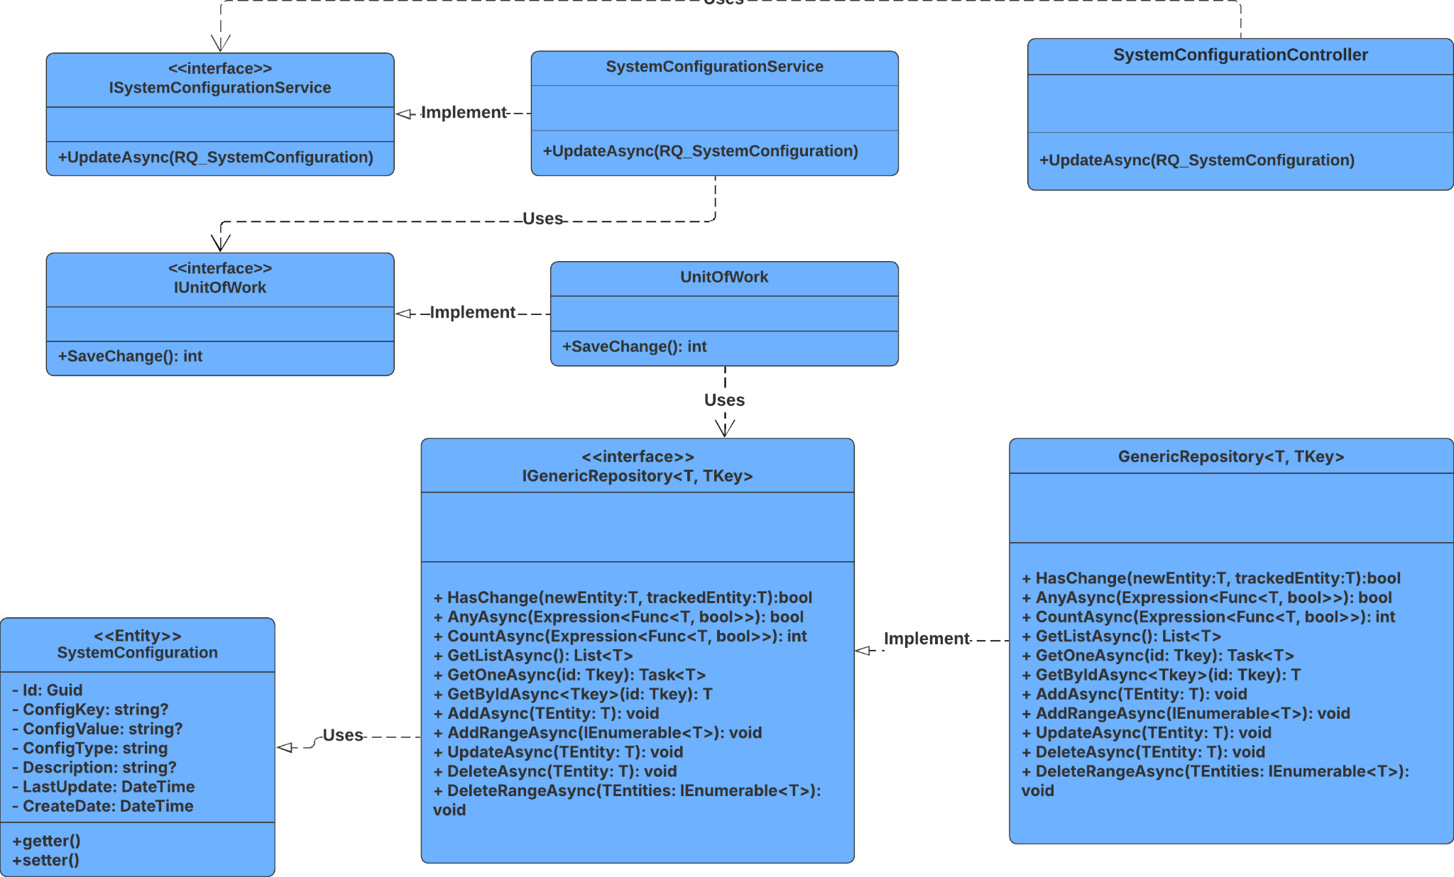

##### 3.20.2.2 Sequence Diagram

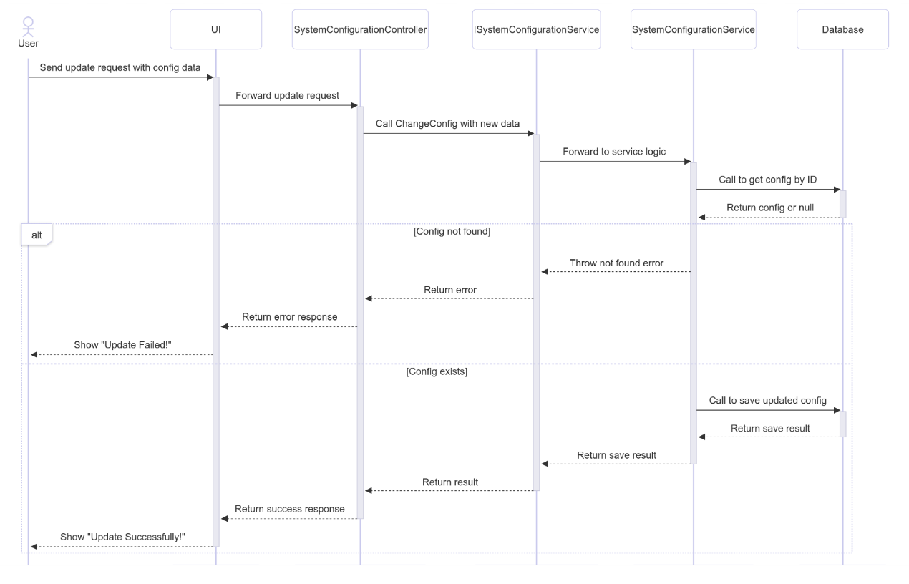

##### 3.20.2.3 Class Specification

###### 3.20.2.3.a SystemConfigurationController

| No | Method | Description |
| --- | --- | --- |
| 1 | UpdateConfig( RQ_SystemConfiguration) | Handles HTTP PUT request to update a system configuration. Calls ChangeConfig in the service layer and returns 200 OK if successful, or 400 BadRequest if the update fails. |

###### 3.20.2.3.b SystemConfigurationService

| No | Method | Description |
| --- | --- | --- |
| 1 | ChangeConfig(RQ_SystemConfiguration) | Retrieves the existing configuration by ID, maps new data onto it, and saves the changes. Throws NotFoundException if the config is not found. Returns a boolean indicating success. |

#### 3.20.3.Get By Id

##### 3.20.3.1 Class Diagram

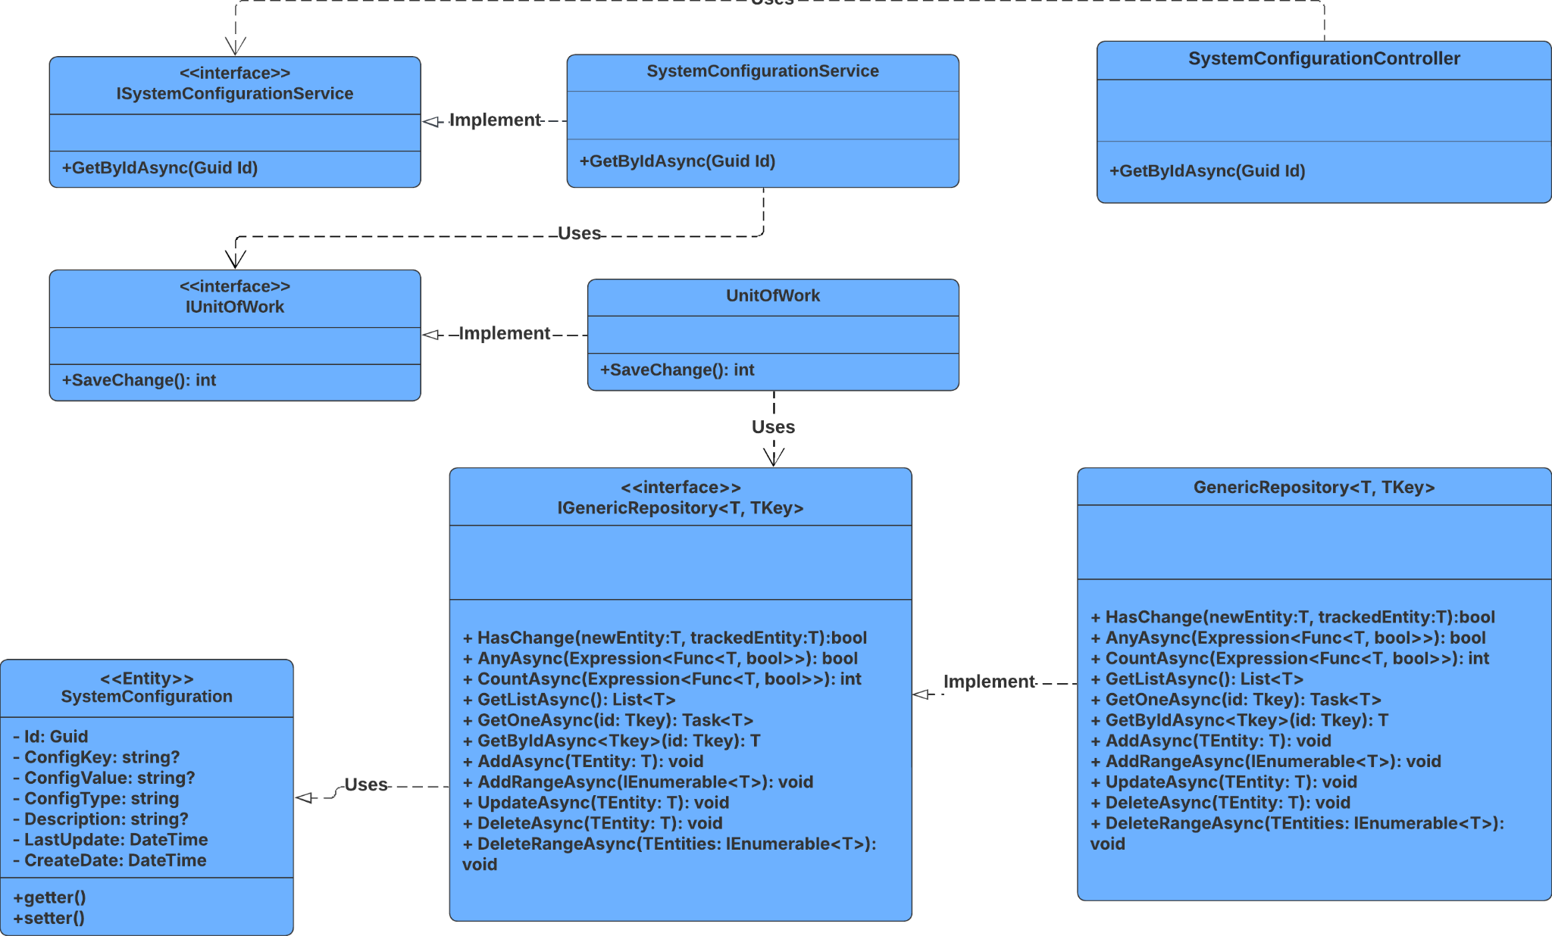

##### 3.20.3.2 Sequence Diagram

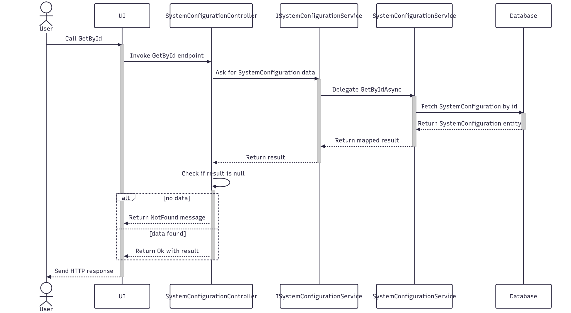

##### 3.20.3.3 Class Specification

###### 3.20.3.3.a SystemConfigurationController

| No | Method | Description |
| --- | --- | --- |
| 1 | ViewDetail(Guid) | API endpoint that retrieves detailed information about a specific System Configuration by ID. Returns 200 OK with the Configuration details. |

###### 3.20.3.3.b SystemConfigurationService

| No | Method | Description |
| --- | --- | --- |
| 1 | ViewDetailConfig(Guid) | Service method that fetches detailed data, and maps the result to a response DTO. Throws BadRequestException or NotFoundException as needed. |

#### 3.20.4.Delete

##### 3.20.4.1 Class Diagram

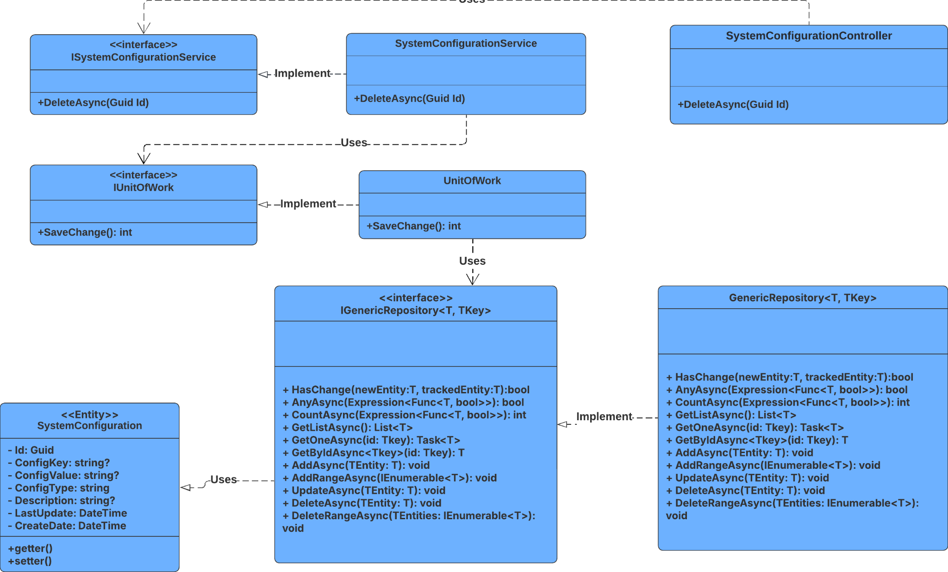

##### 3.20.4.2 Sequence Diagram

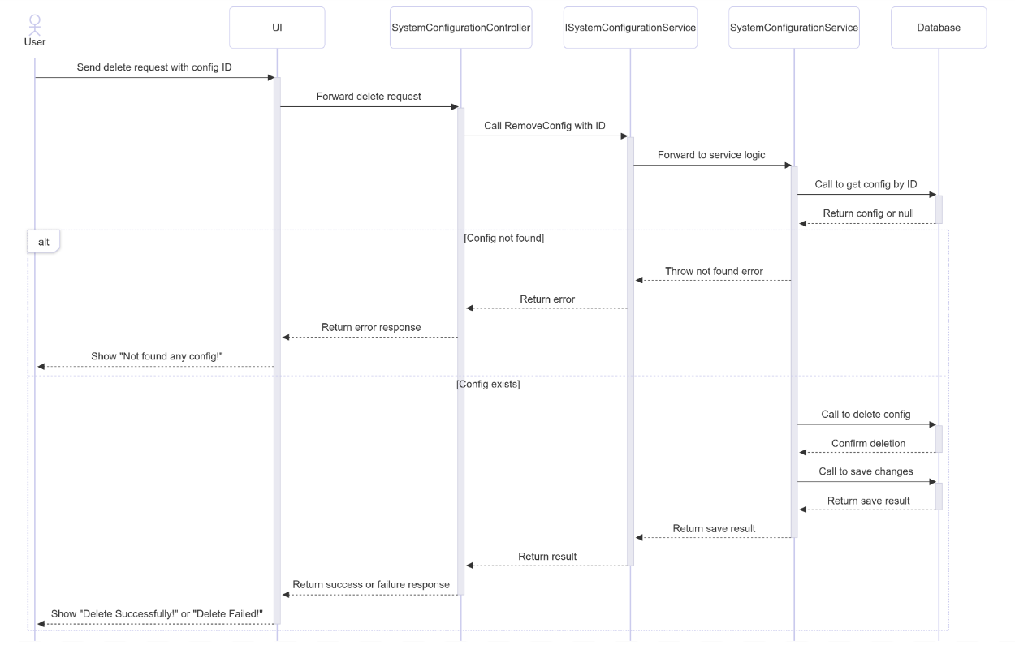

##### 3.20.4.3 Class Specification

###### 3.20.4.3.a SystemConfigurationController

| No | Method | Description |
| --- | --- | --- |
| 1 | DeleteCategory(Guid) | Handles HTTP DELETE request to remove a system configuration by ID. Returns 200 OK with success message or 400 BadRequest with failure message. |

###### 3.20.4.3.b SystemConfigurationService

| No | Method | Description |
| --- | --- | --- |
| 1 | RemoveConfig(Guid) | Business logic to remove a system configuration and its related notifications. Returns a boolean indicating success or failure. |

#### 3.20.5.Get List

##### 3.20.5.1 Class Diagram

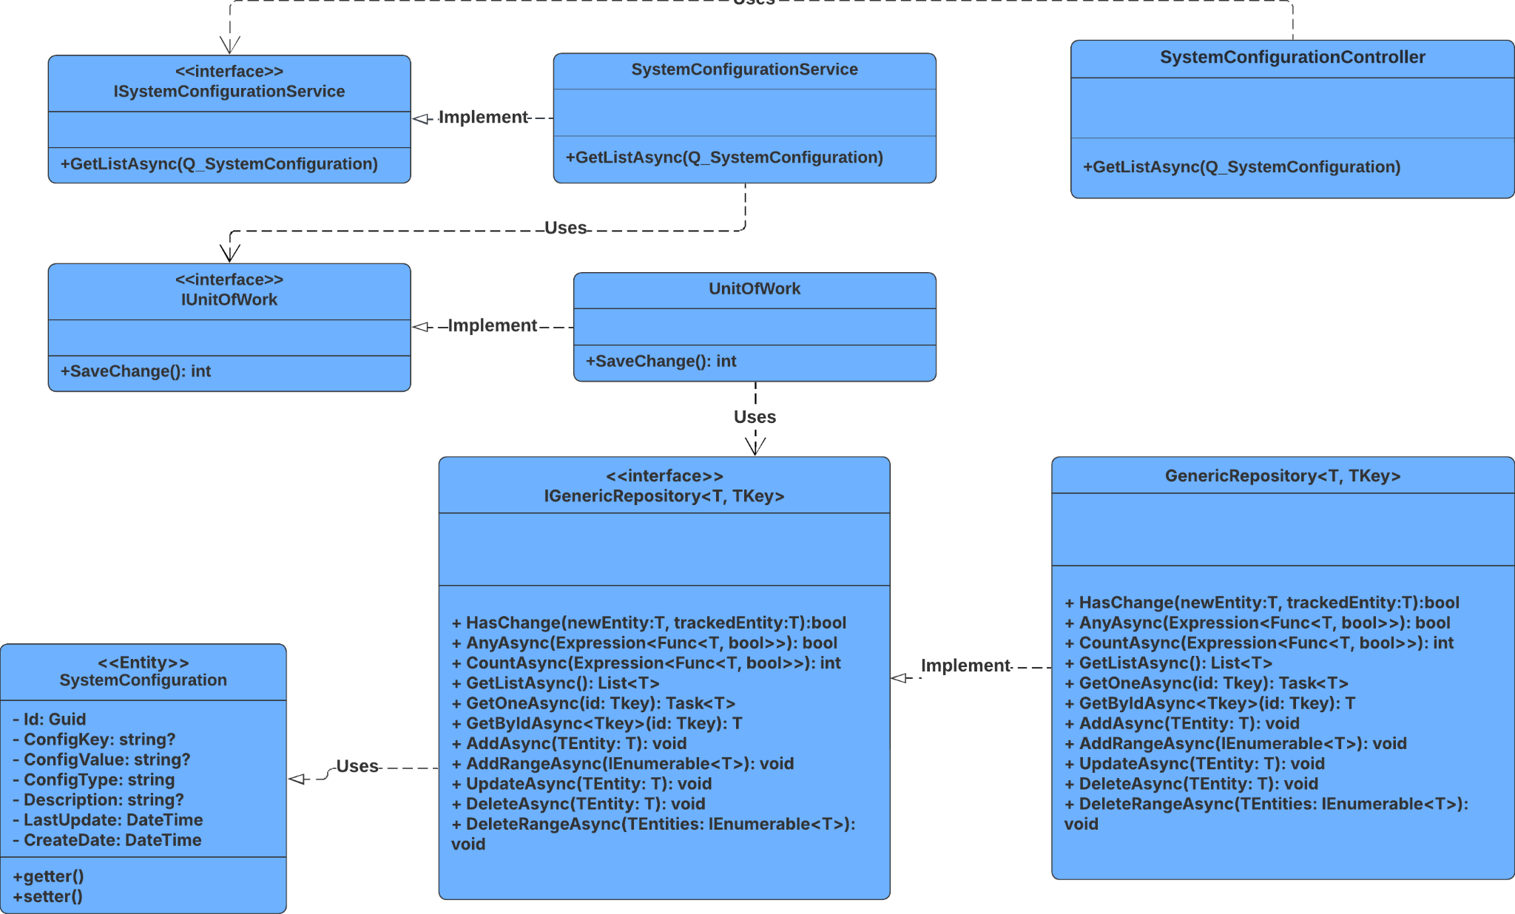

##### 3.20.5.2 Sequence Diagram

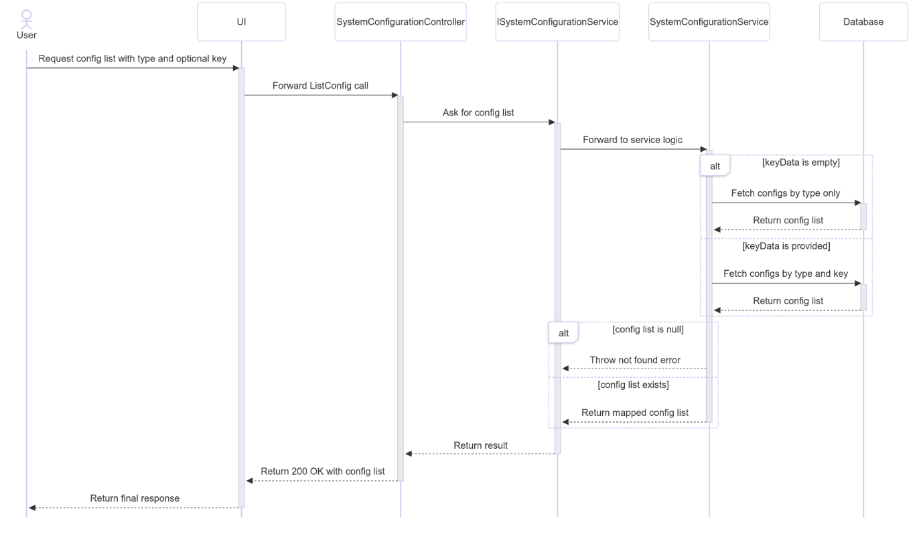

##### 3.20.5.3 Class Specification

###### 3.20.5.3.a SystemConfigurationController

| No | Method | Description |
| --- | --- | --- |
| 1 | ListConfig(string, string?) | Handles HTTP GET request to retrieve system configuration data based on type and optional key. Returns 200 OK with the result. |

###### 3.20.5.3.b SystemConfigurationService

| No | Method | Description |
| --- | --- | --- |
| 1 | ListConfig(string, string?) | Retrieves system configuration entries filtered by ConfigType and optionally ConfigKey. Throws NotFoundException if no matching records are found. Returns a list of RQ_SystemConfiguration. |

### 3.21 Manage Task

#### 3.21.1.Create

##### 3.21.1.1 Class Diagram

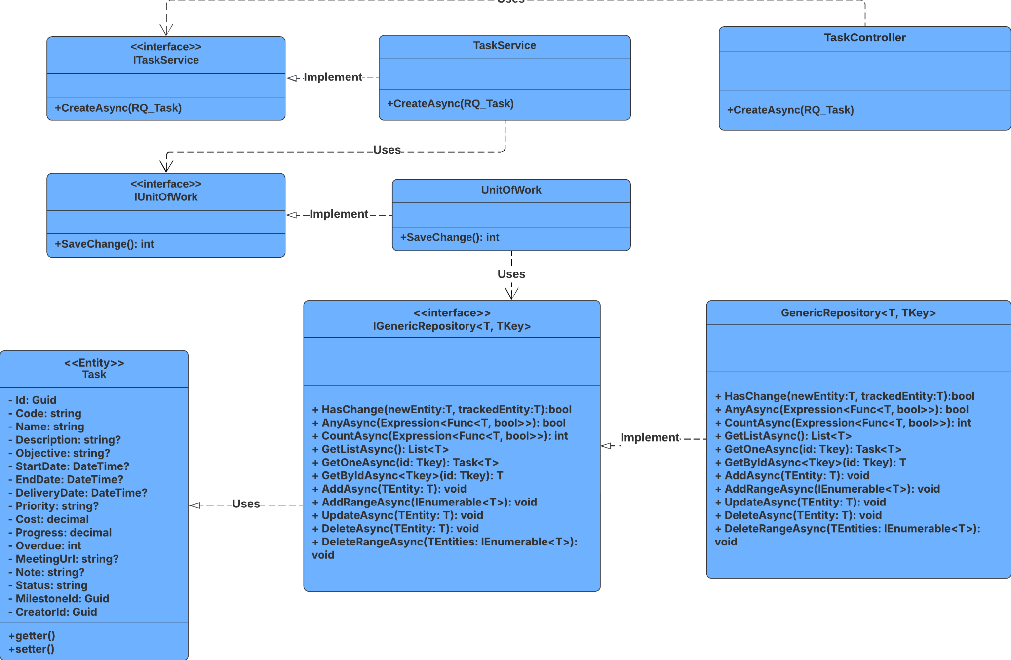

##### 3.21.1.2 Sequence Diagram

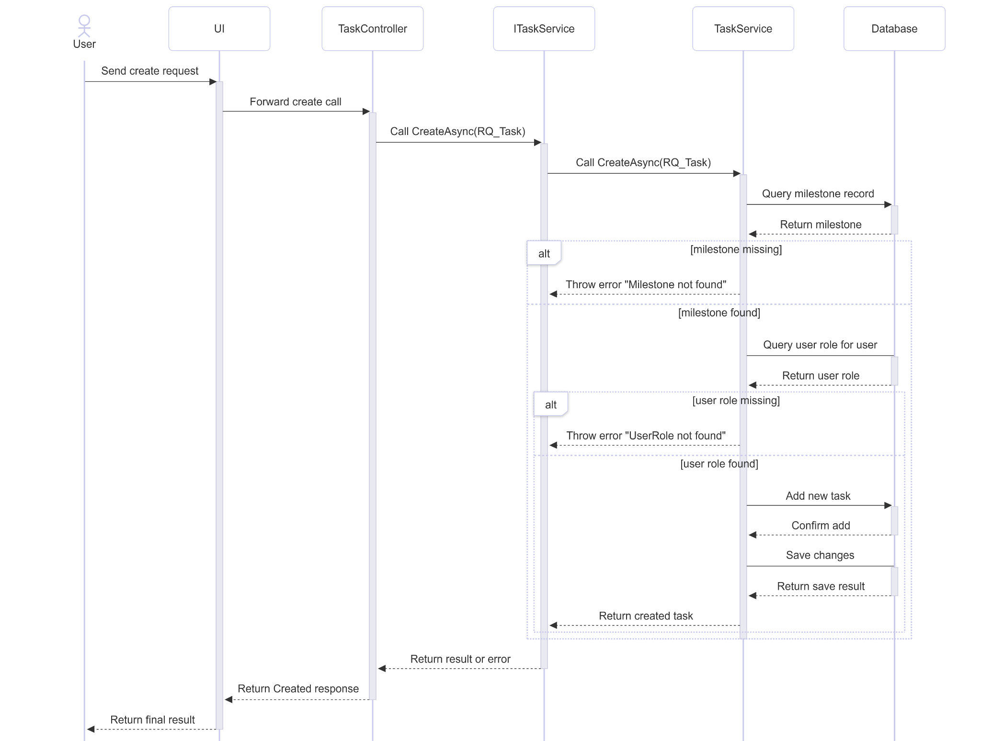

##### 3.21.1.3 Class Specification

###### 3.21.1.3.a TaskController

| No | Method | Description |
| --- | --- | --- |
| 1 | CreateAsync(RQ_Task) | Handles HTTP POST request to create a new task. Returns 201 Created with location header pointing to the newly created task. |

###### 3.21.1.3.b TaskService

| No | Method | Description |
| --- | --- | --- |
| 1 | CreateAsync(RQ_Task) | Creates a new task entity from the request. Generates a unique ID and code, sets default status, assigns creator based on current user’s role in the project, and persists the task. Returns the created task as RS_Task. |

#### 3.21.2.Update

##### 3.21.2.1 Class Diagram

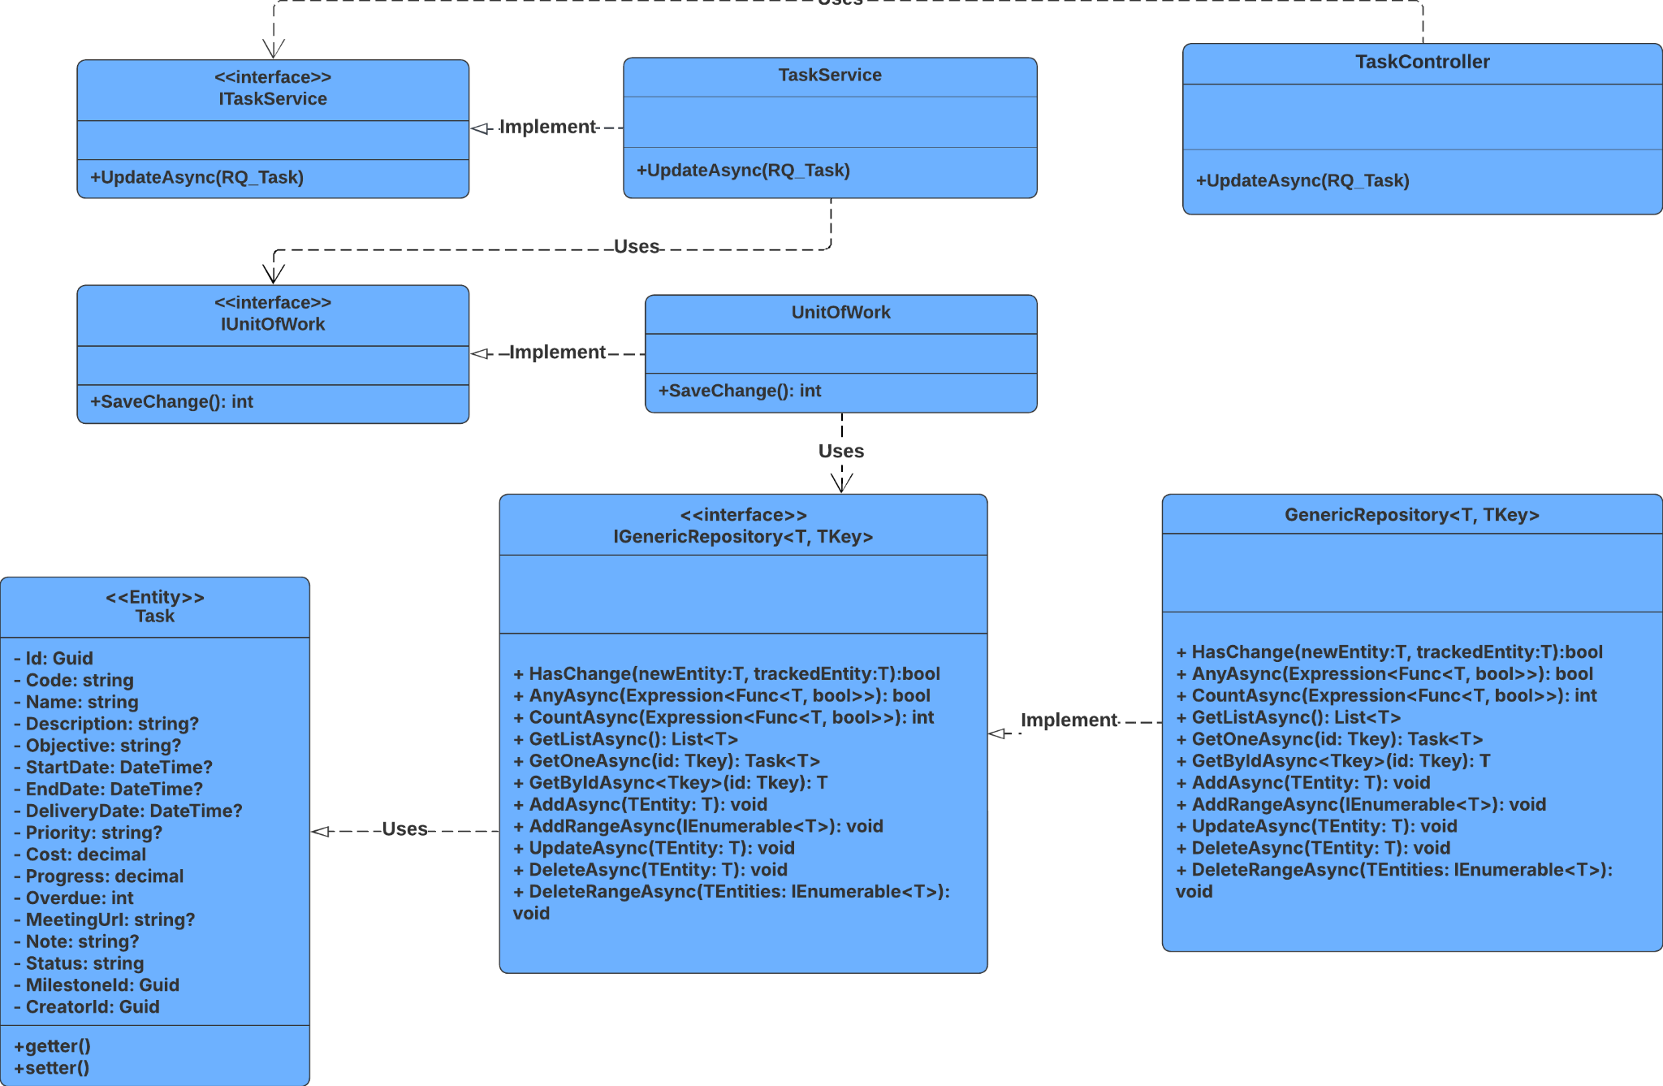

##### 3.21.2.2 Sequence Diagram

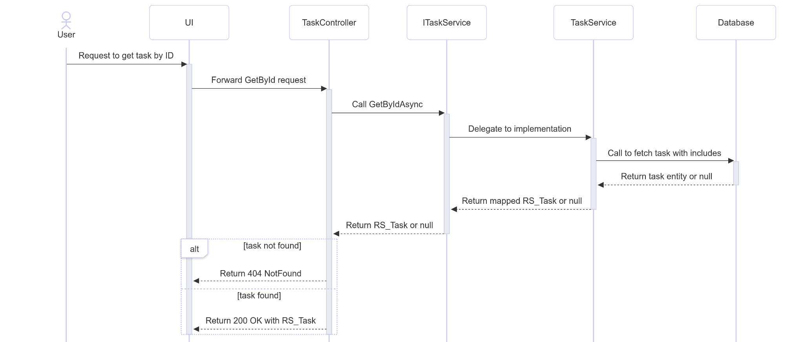

##### 3.21.2.3 Class Specification

###### 3.21.2.3.a TaskController

| No | Method | Description |
| --- | --- | --- |
| 1 | Update(Guid, RQ_Task) | Handles HTTP PUT request to update a task by ID. Returns 200 OK with the updated task, or 404 Not Found if the task doesn't exist. |

###### 3.21.2.3.b TaskService

| No | Method | Description |
| --- | --- | --- |
| 1 | UpdateAsync(Guid, RQ_Task) | Retrieves the task entity by ID with tracking enabled. Applies updates from the request using Adapt, saves changes, and returns the updated task. Returns null if the task is not found. |

#### 3.21.3.Get By Id

##### 3.21.3.1 Class Diagram

##### 3.21.3.2 Sequence Diagram

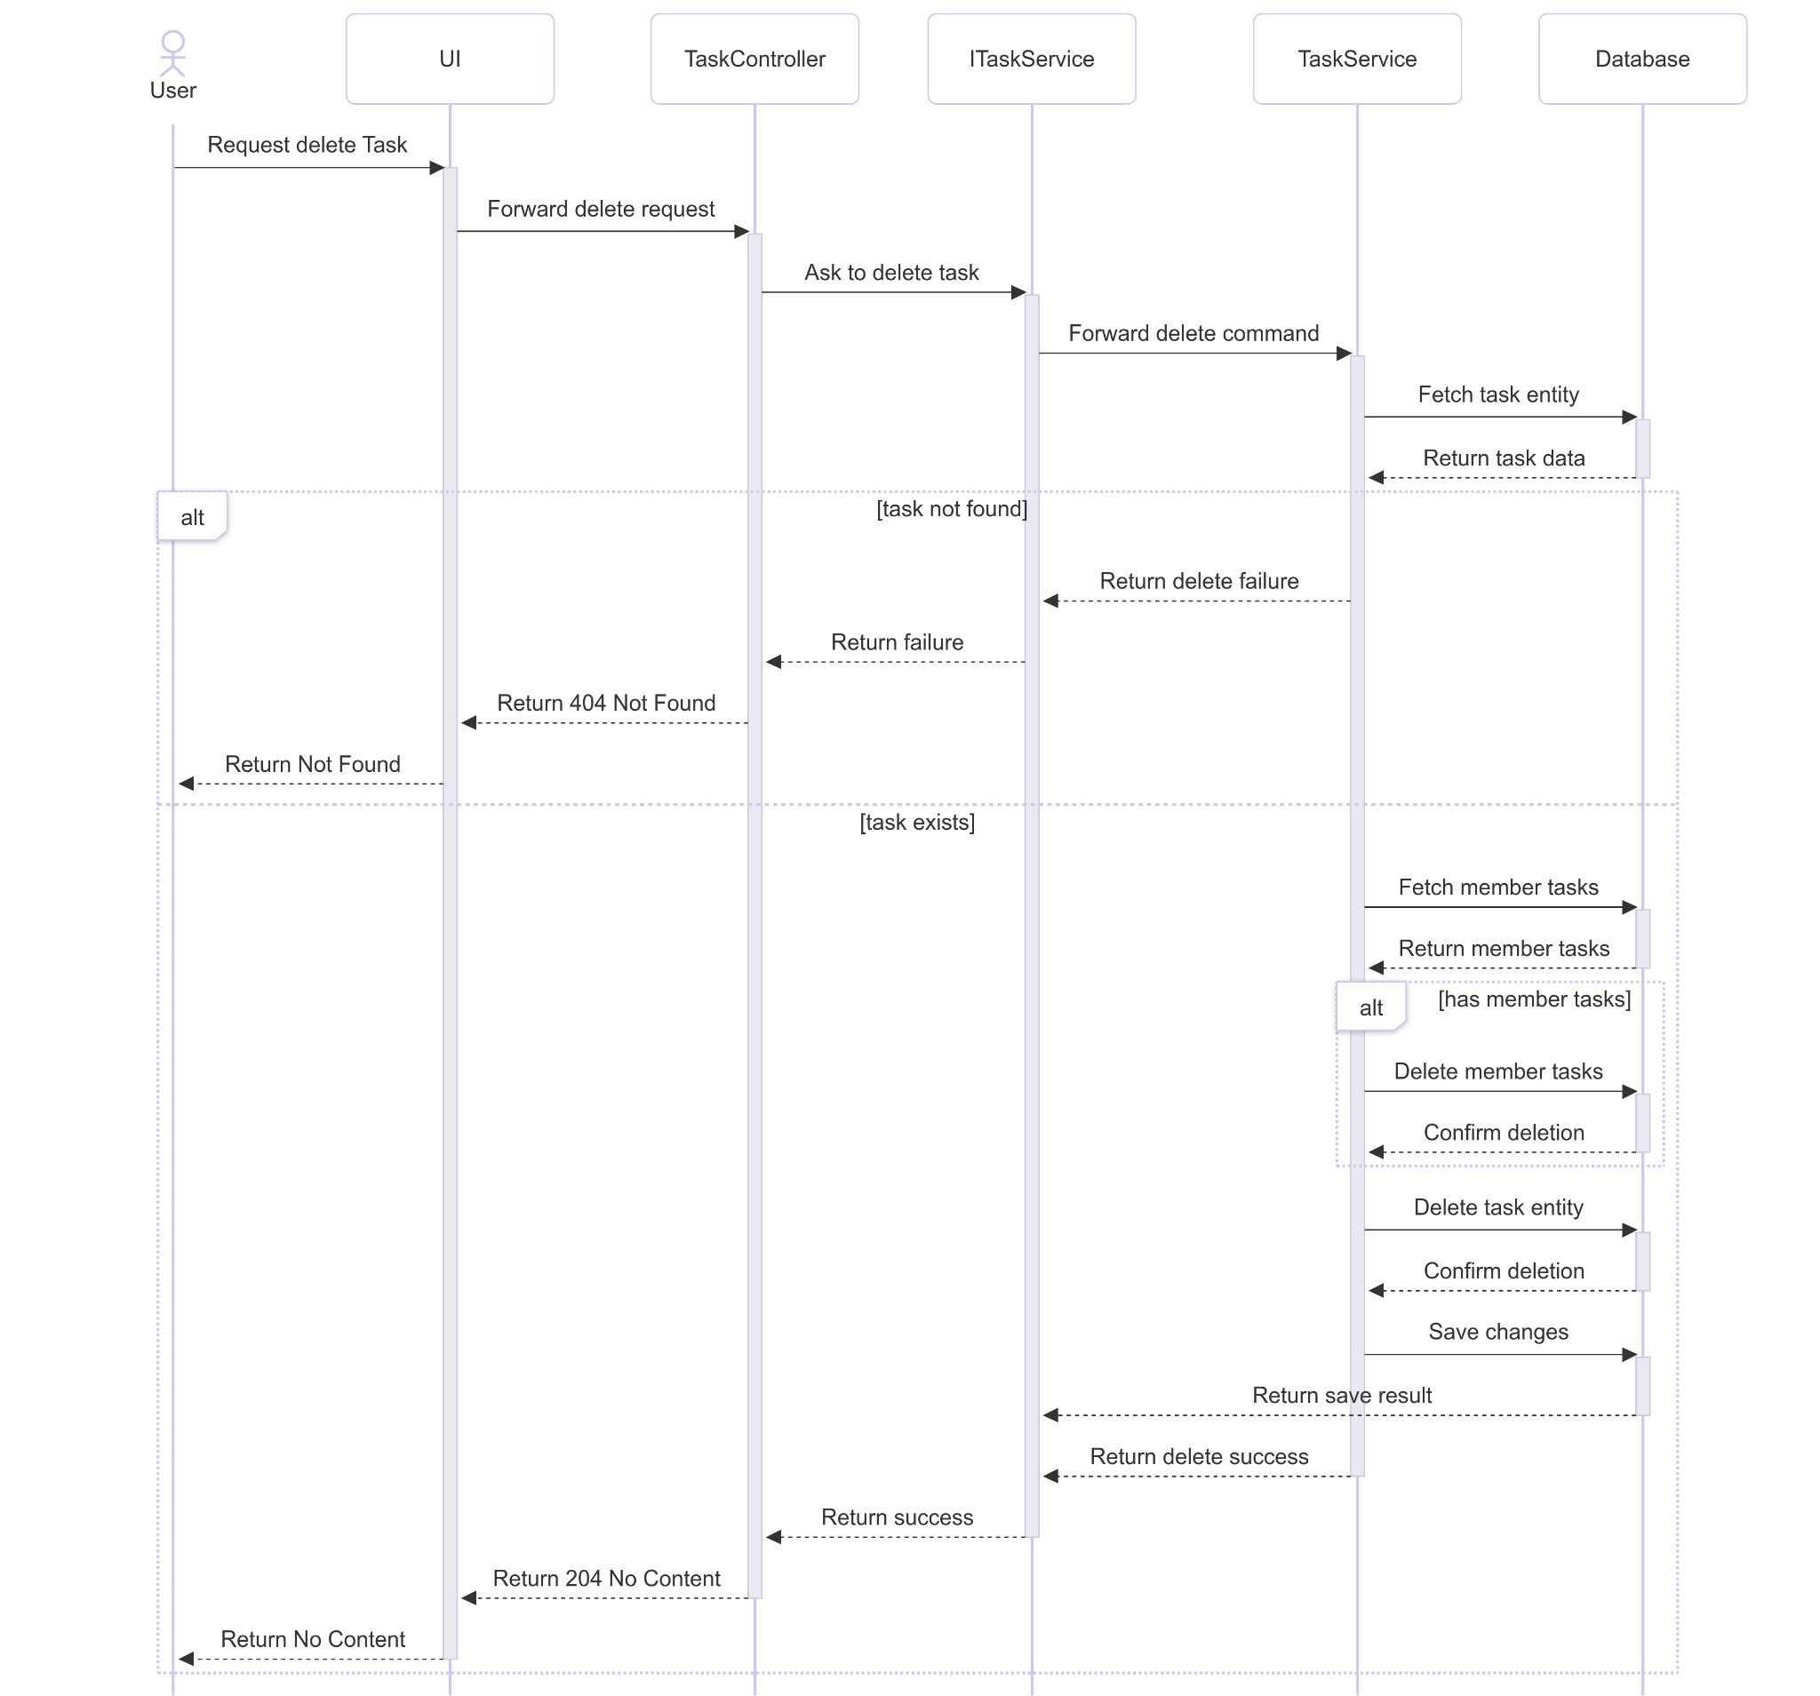

##### 3.21.3.3 Class Specification

###### 3.21.3.3.aTaskController

| No | Method | Description |
| --- | --- | --- |
| 1 | GetById(Guid) | Handles HTTP GET request to retrieve a task by ID. Returns 200 OK with the task if found, or 404 Not Found if not. |

###### 3.21.3.3.b TaskService

| No | Method | Description |
| --- | --- | --- |
| 1 | GetByIdAsync(Guid) | Retrieves a task entity by ID with eager loading of related entities (Milestone, Creator, MemberTasks → Member → Account/Role). Maps the result to RS_Task. Returns null if not found. |

#### 3.21.4.Delete

##### 3.21.4.1 Class Diagram

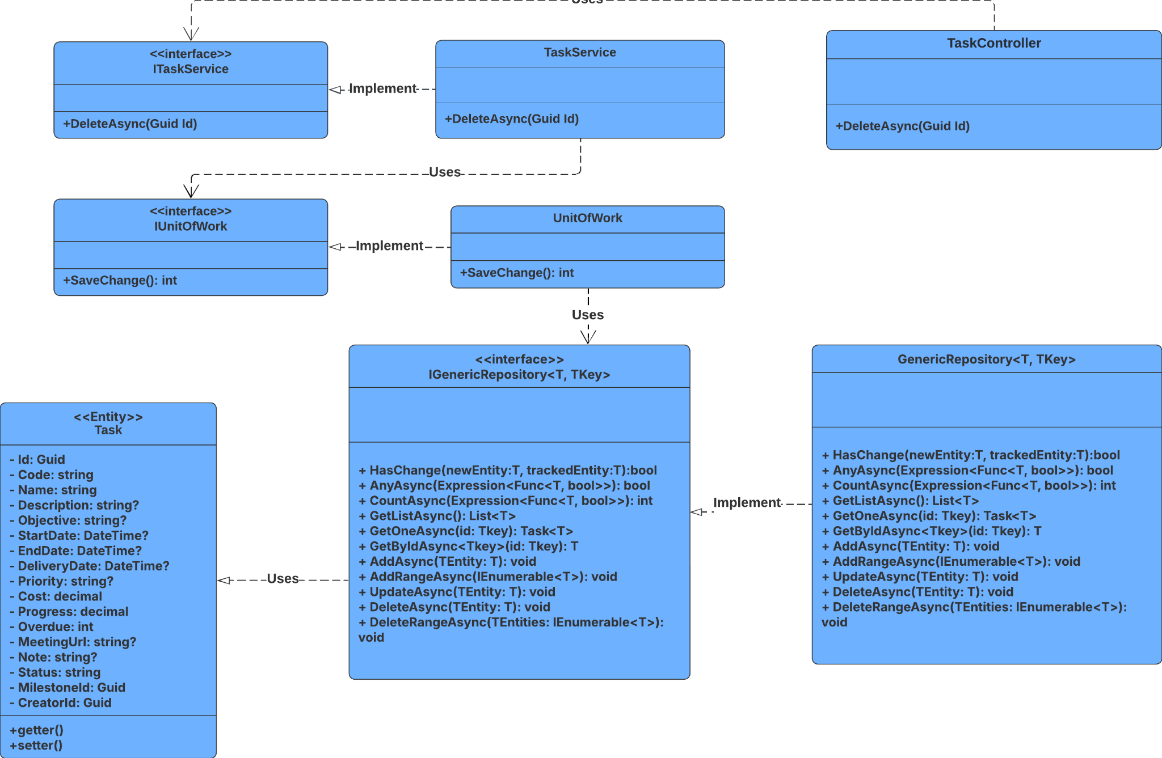

##### 3.21.4.2 Sequence Diagram

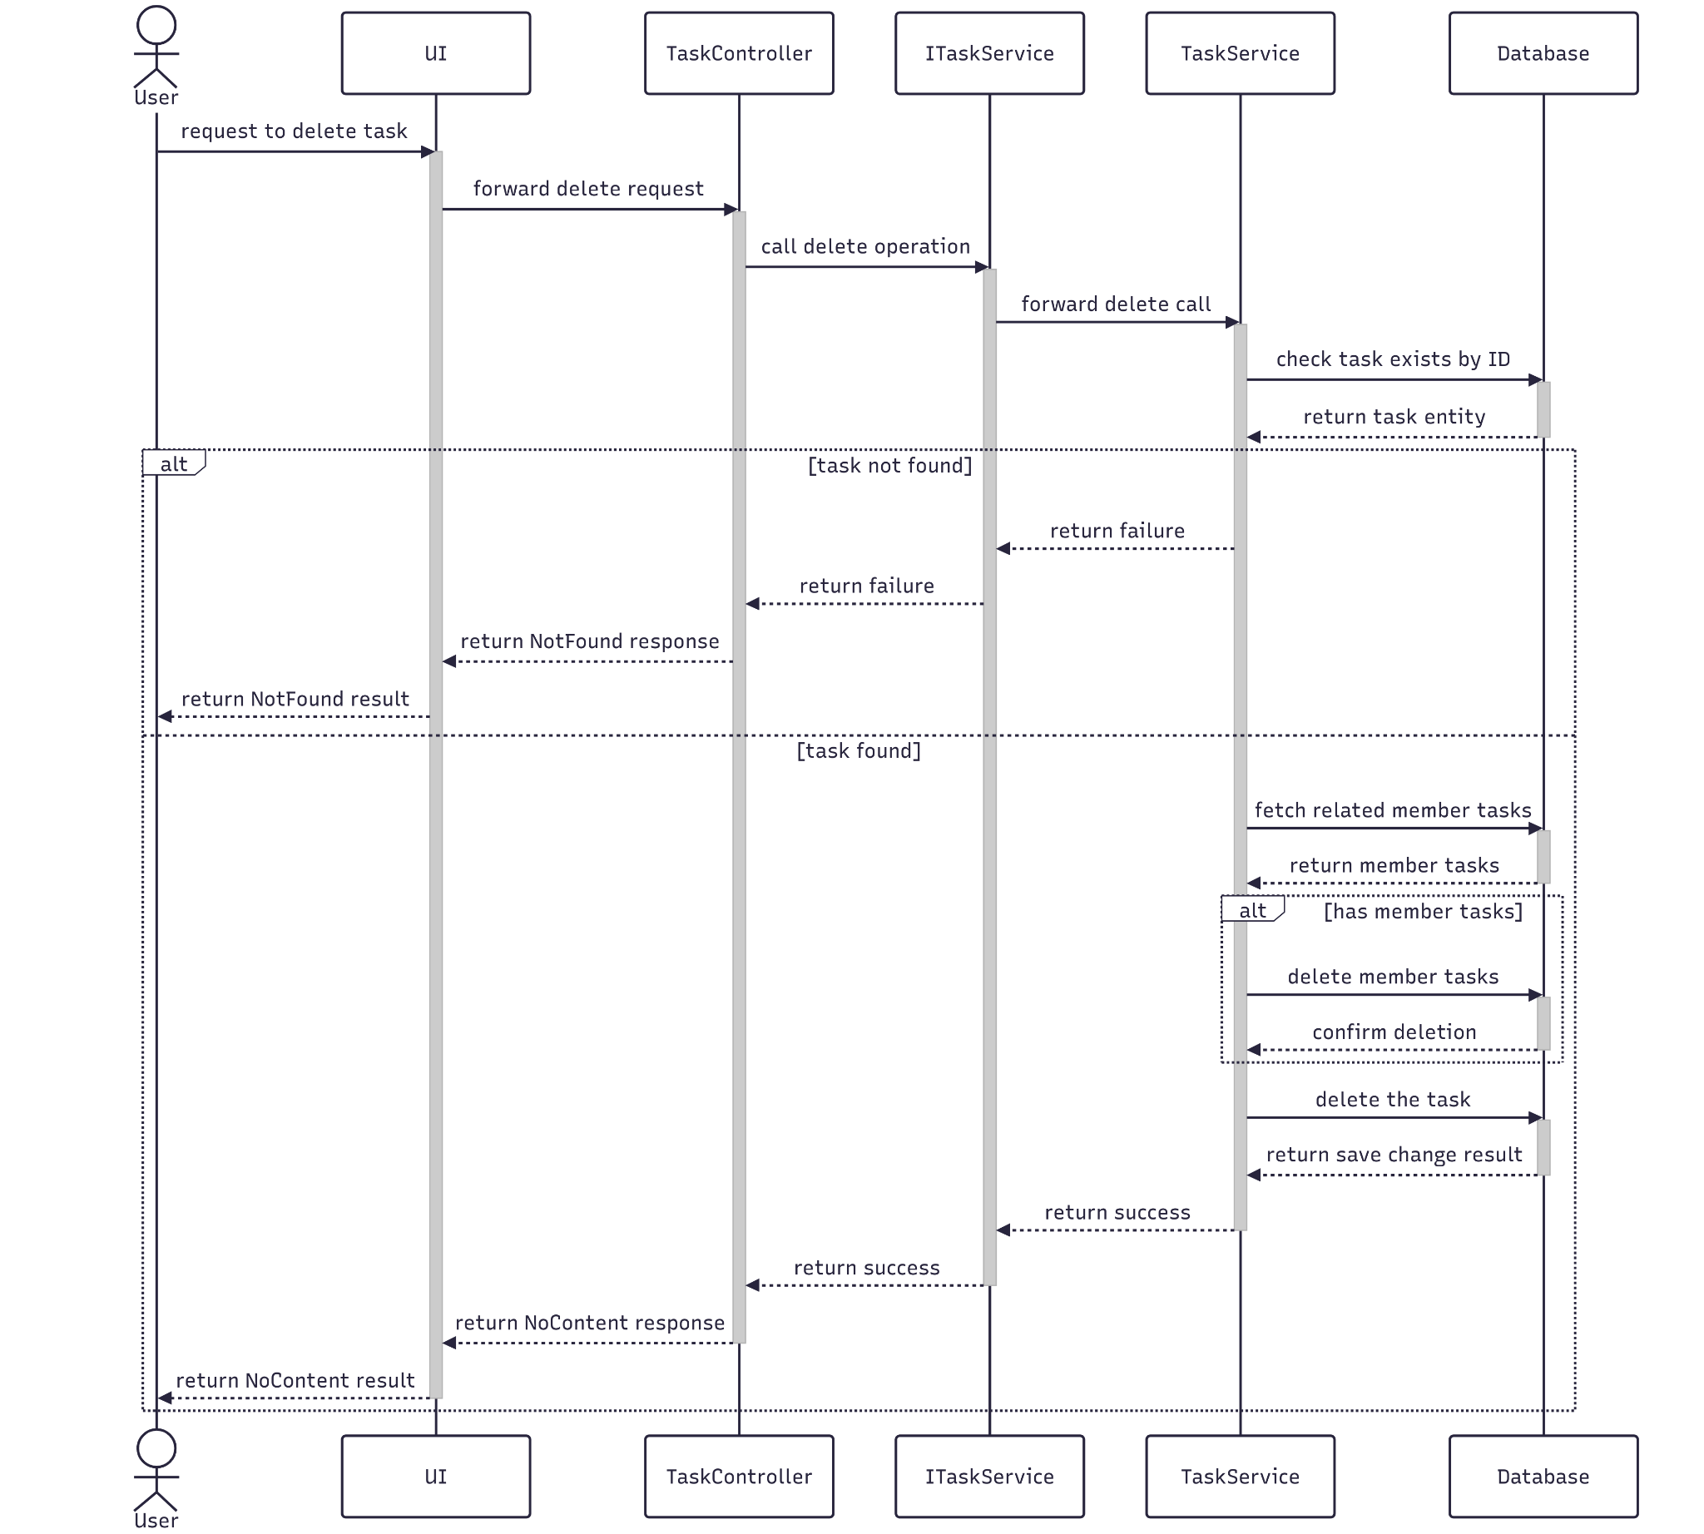

##### 3.21.4.3 Class Specification

###### 3.21.4.3.a TaskController

| No | Method | Description |
| --- | --- | --- |
| 1 | Delete(Guid) | Handles HTTP DELETE request to remove a task by ID. Returns 204 No Content if successful, or 404 Not Found if the task doesn't exist. |

###### 3.21.4.3.b TaskService

| No | Method | Description |
| --- | --- | --- |
| 1 | DeleteAsync(Guid) | Service-layer method that deletes a task and its related member-task records. Returns true if successful, false if the task doesn't exist. |

#### 3.21.5.Get List

##### 3.21.5.1 Class Diagram

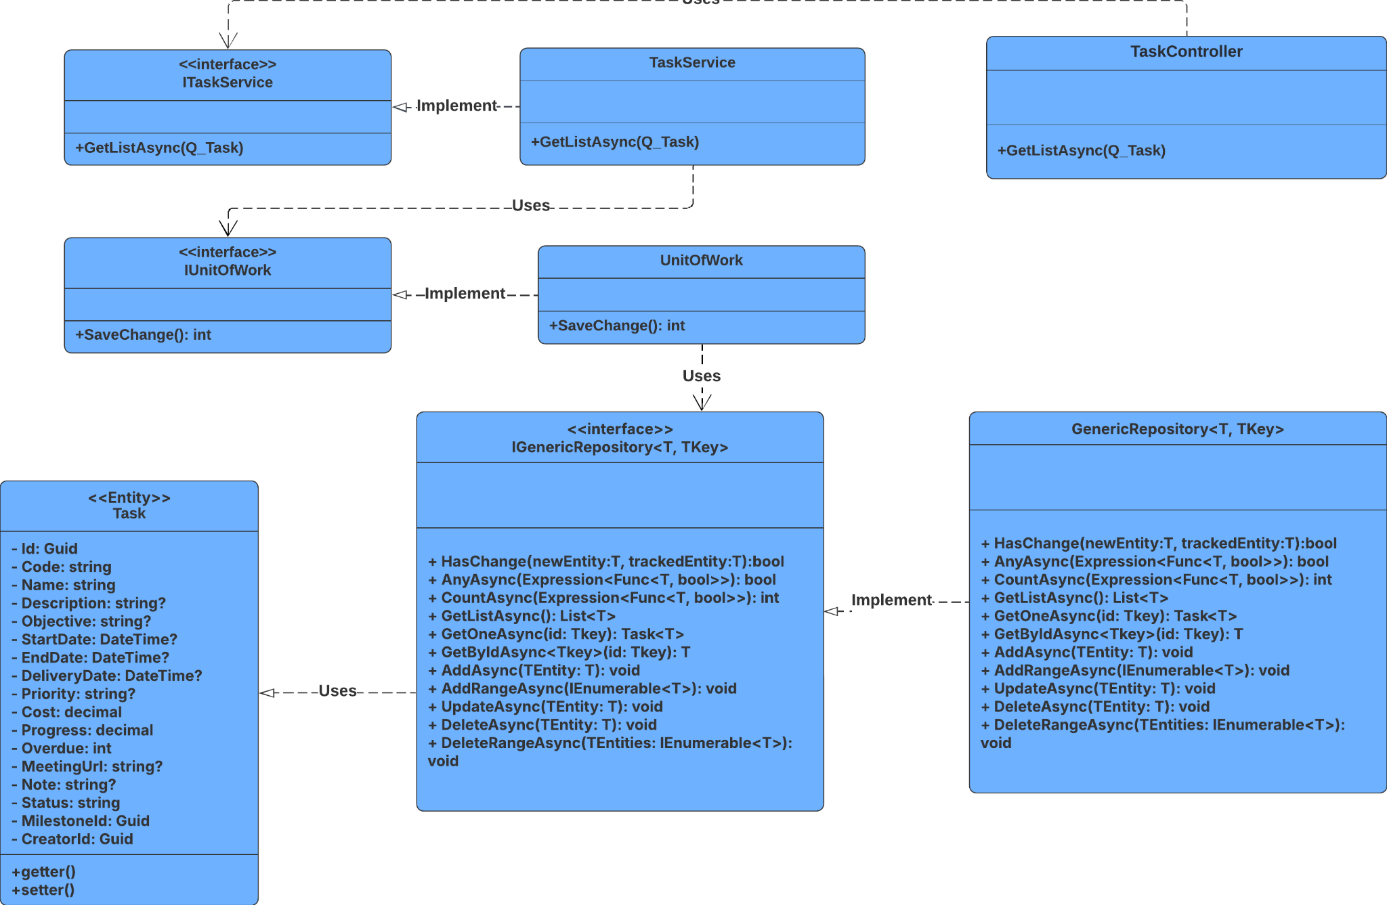

##### 3.21.5.2 Sequence Diagram

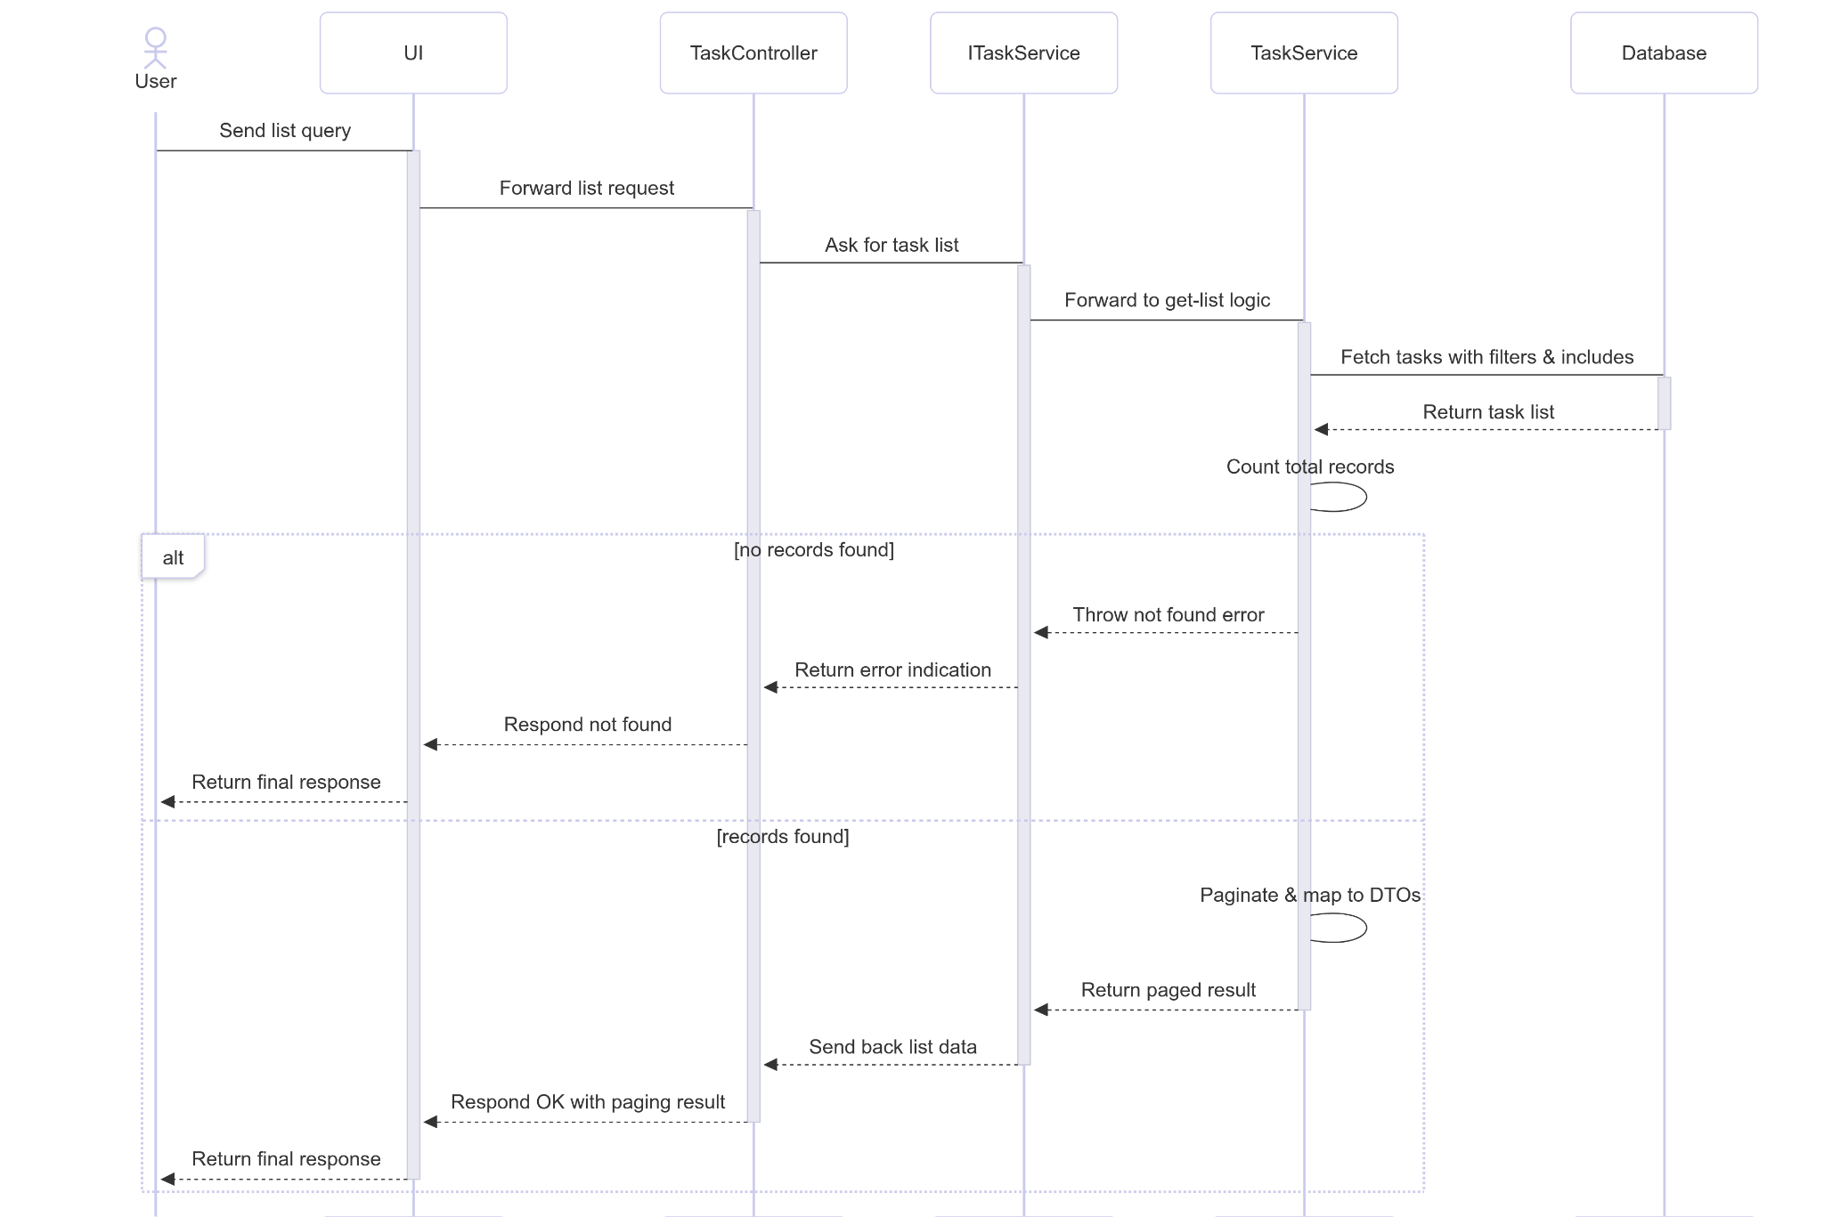

##### 3.21.5.3 Class Specification

###### 3.21.5.3.a TaskController

| No | Method | Description |
| --- | --- | --- |
| 1 | GetList(RQ_TaskQuery) | Handles HTTP GET requests with query parameters to retrieve a paginated list of tasks. Calls GetListAsync and returns 200 OK with results. |

###### 3.21.5.3.b TaskService

| No | Method | Description |
| --- | --- | --- |
| 1 | GetListAsync(RQ_TaskQuery) | Filters tasks based on query parameters (Code, Name, Priority, MilestoneId, CreatorId, Status). Includes related entities and paginates the result. Throws NotFoundException if no tasks match. |

### 3.22 Manage UserRole

#### 3.22.1.Create

##### 3.22.1.1 Class Diagram

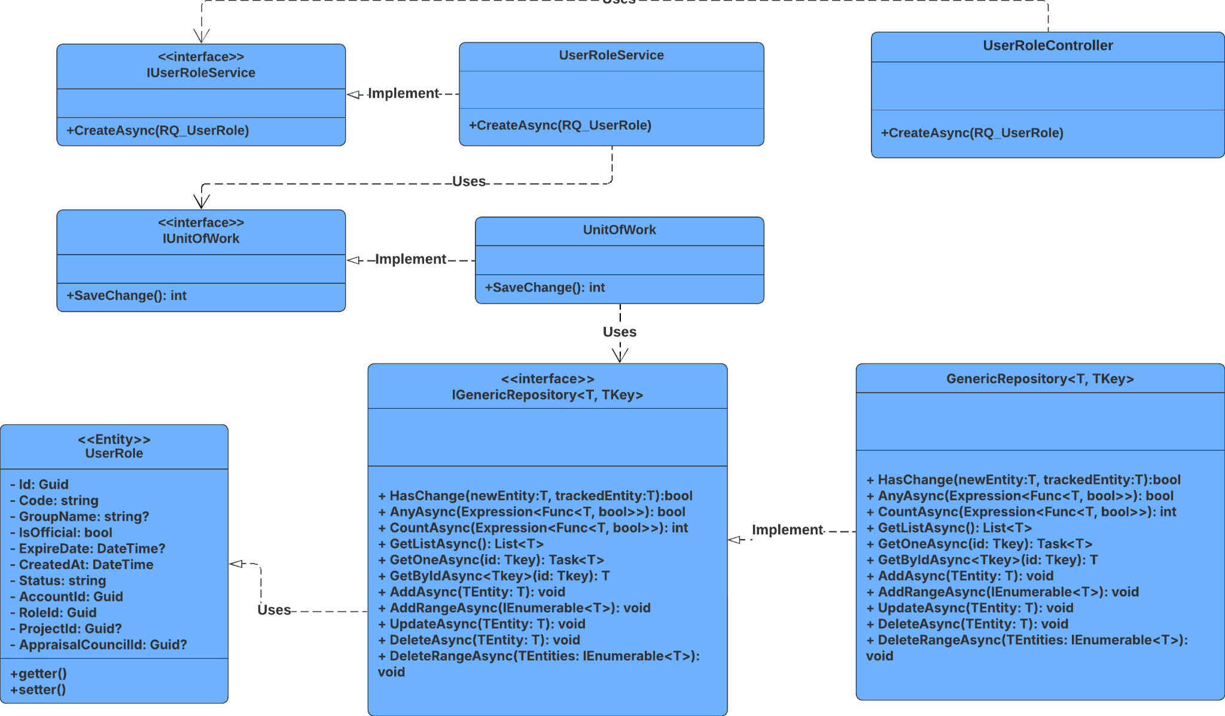

##### 3.22.1.2 Sequence Diagram

##### 3.22.1.3 Class Specification

###### 3.22.1.3.a UserRoleController

| No | Method | Description |
| --- | --- | --- |
| 1 | CreateAsync(RQ_UserRole) | Handles HTTP POST requests to create a new user role. Calls CreateAsync and returns 201 Created with the new role. Handles various exceptions with appropriate HTTP status codes. |

###### 3.22.1.3.b UserRoleService

| No | Method | Description |
| --- | --- | --- |
| 1 | CreateAsync(RQ_UserRole) | Validates related entities (Account, Role, AppraisalCouncil, Project). Applies business rules for role assignment, checks for duplicates, generates metadata (e.g., Code, ExpireDate), and persists the new user role. Returns the created role. |

#### 3.22.2.Update

##### 3.22.2.1 Class Diagram

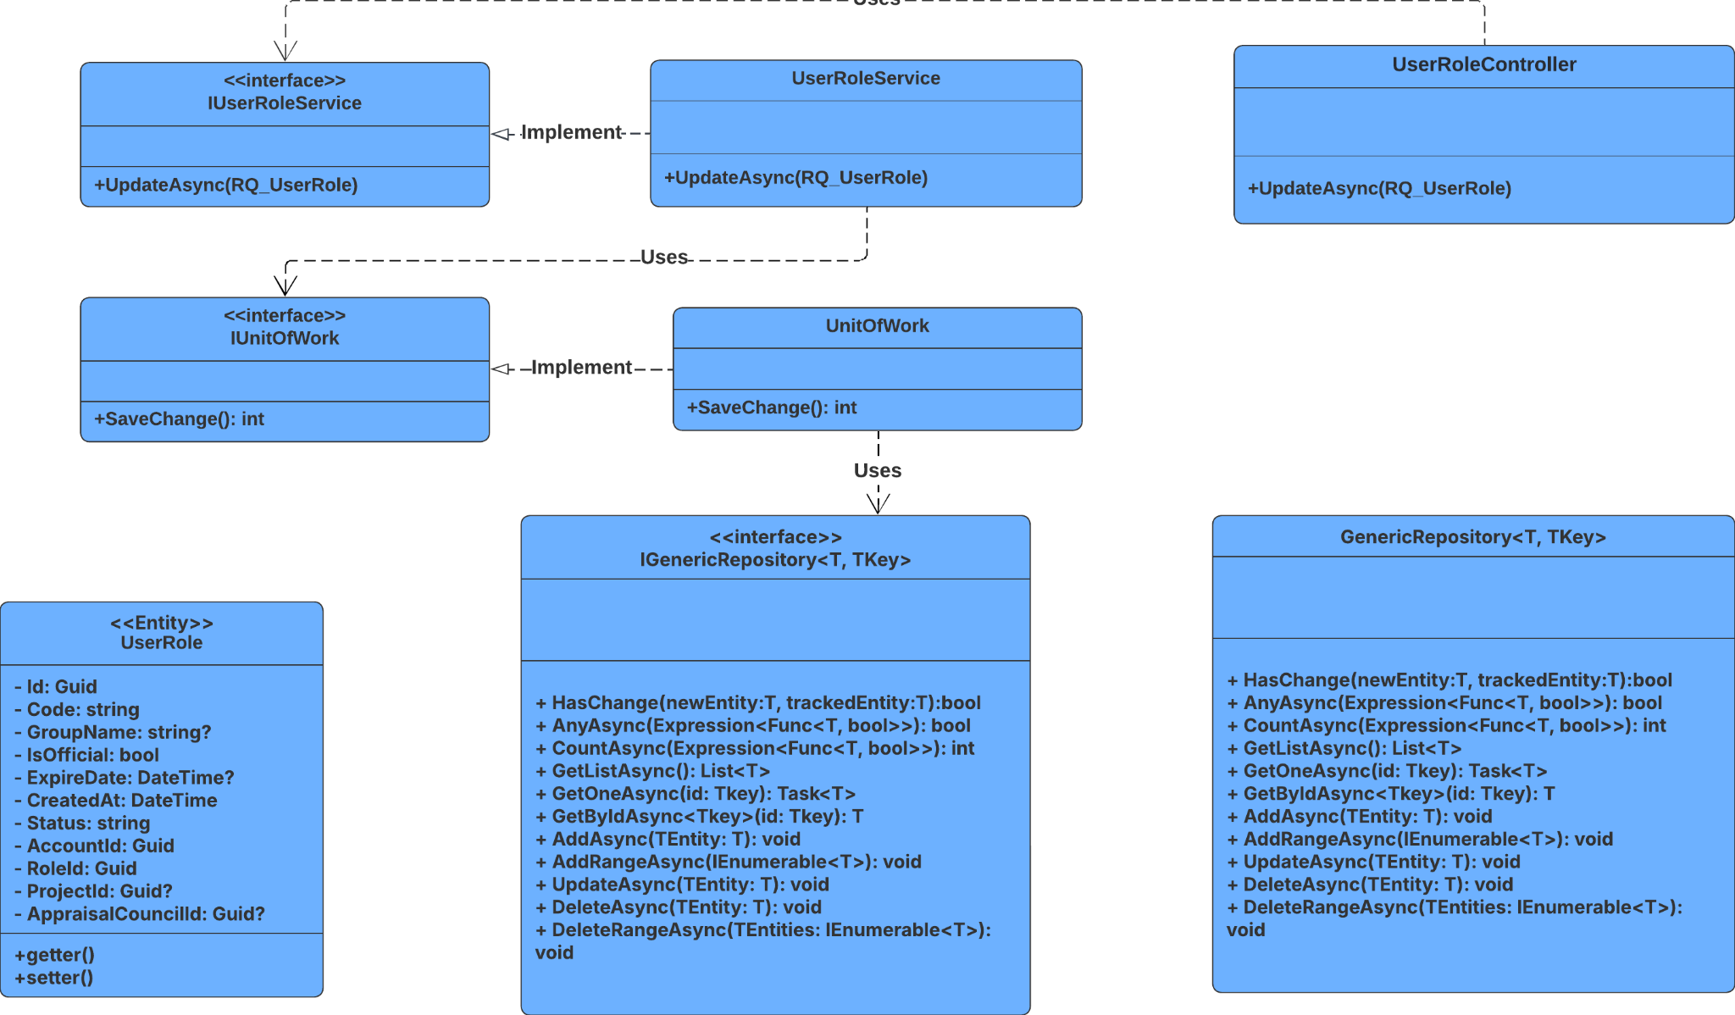

##### 3.22.2.2 Sequence Diagram

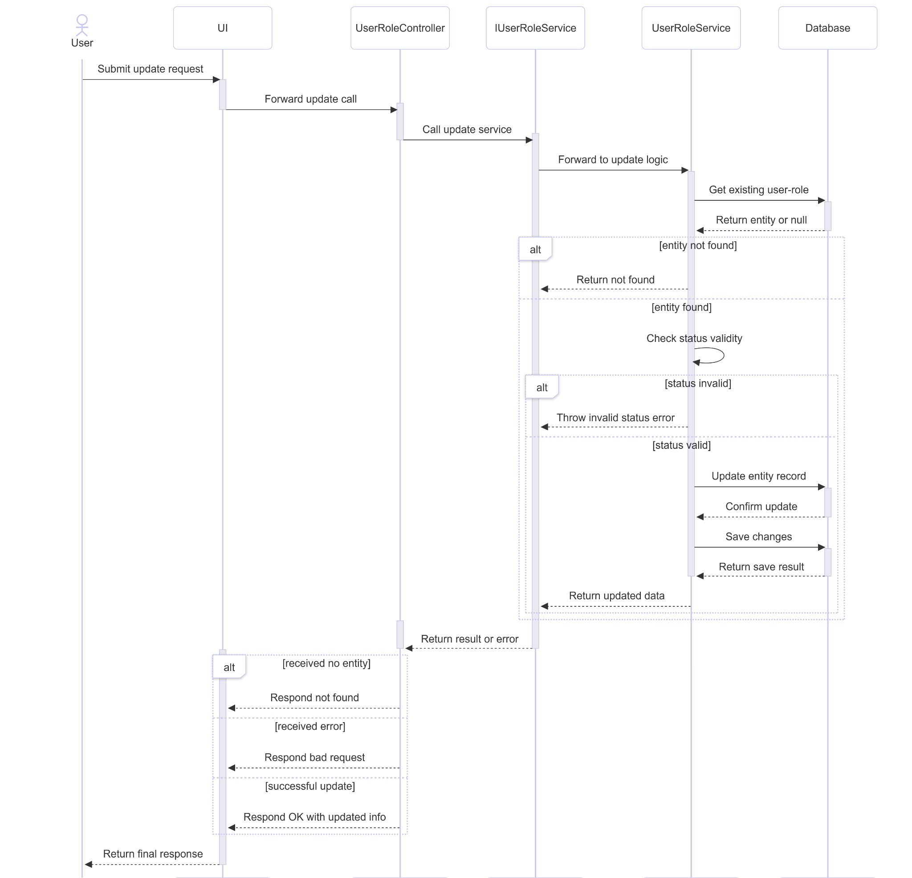

##### 3.22.2.3 Class Specification

###### 3.22.2.3.a UserRoleController

| No | Method | Description |
| --- | --- | --- |
| 1 | Update(Guid, RQ_UserRole, string?) | Handles HTTP PUT request to update a user role by ID. Calls UpdateAsync and returns 200 OK with the updated role, 404 Not Found if the role doesn't exist, or 400 Bad Request if an exception occurs. |

###### 3.22.2.3.b UserRoleService

| No | Method | Description |
| --- | --- | --- |
| 1 | UpdateAsync(Guid, RQ_UserRole, string?) | Retrieves the user role entity by ID with related entities. Validates the status value, applies updates from the request, saves changes, and returns the updated role. Throws BadRequestException for invalid status. |

#### 3.22.3.Get By Id

##### 3.22.3.1 Class Diagram

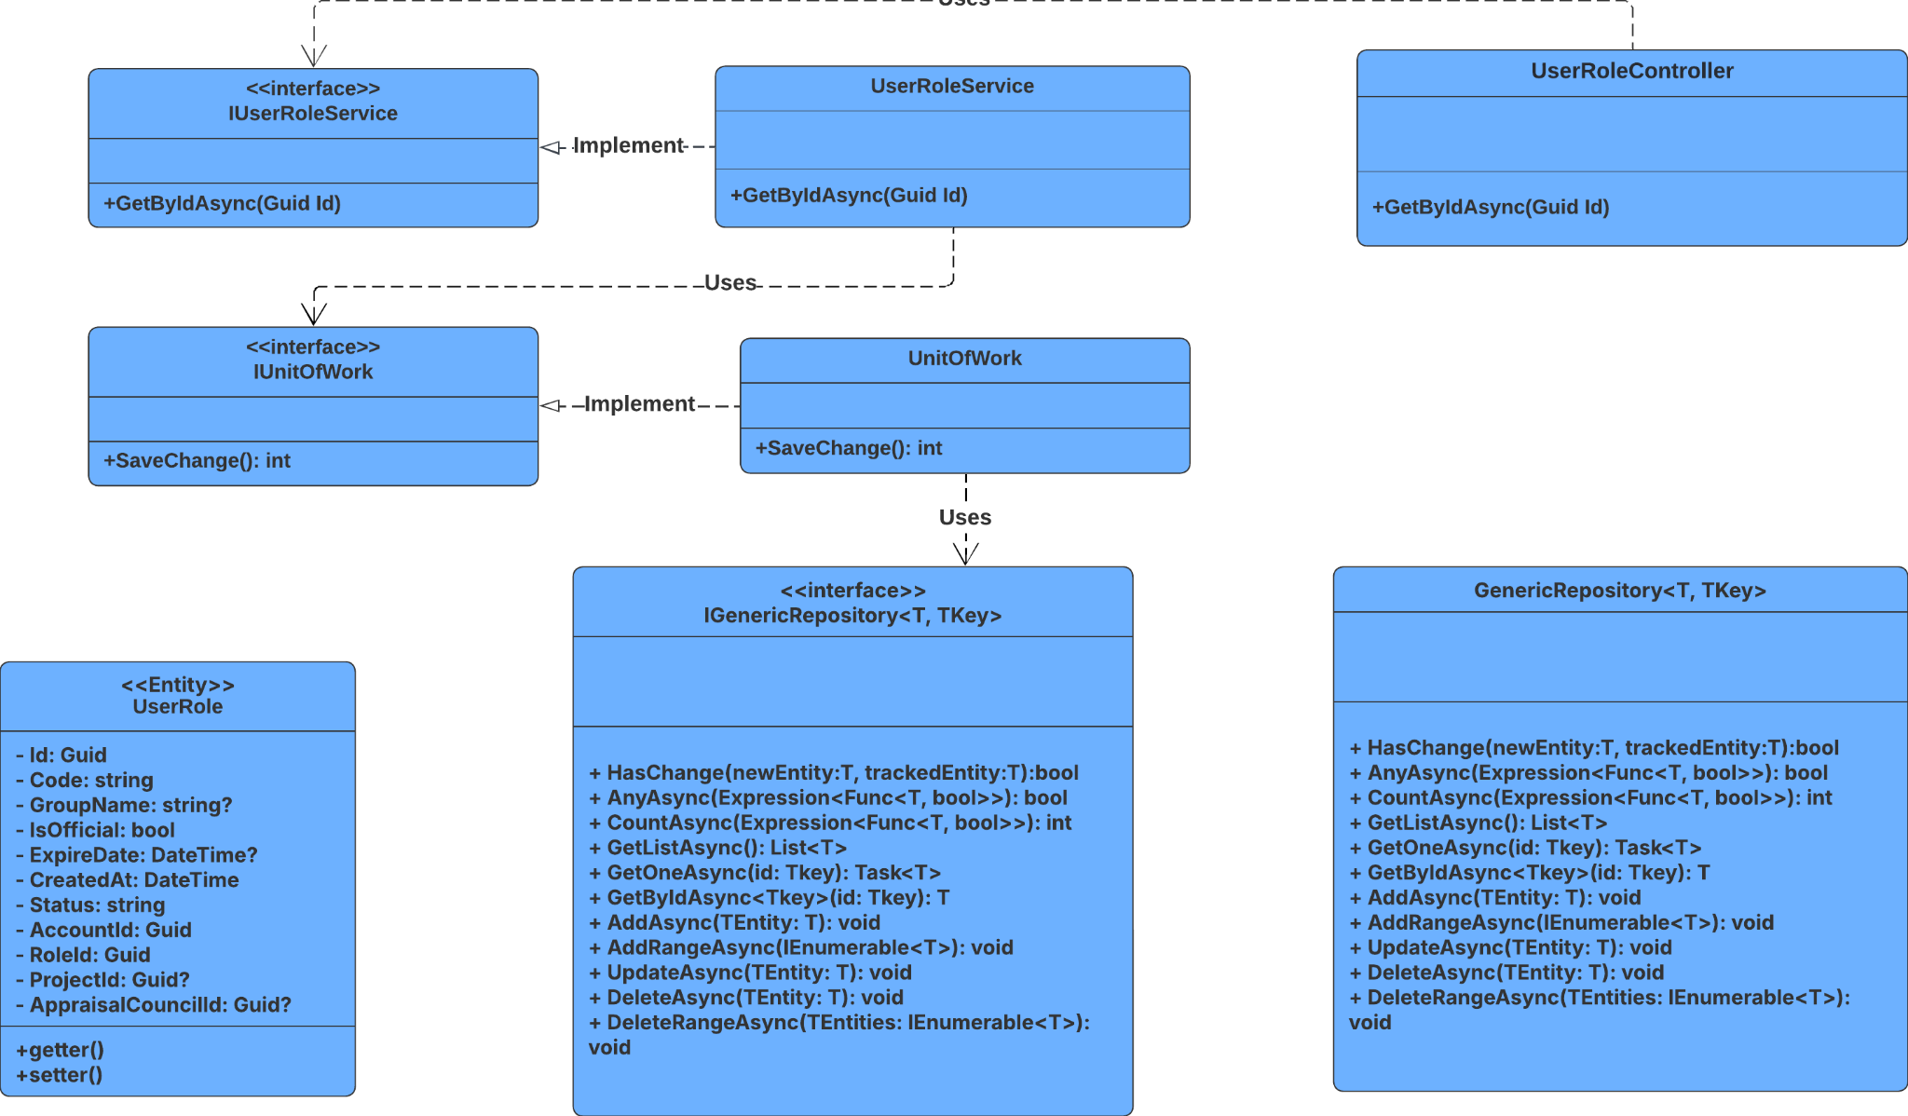

##### 3.22.3.2 Sequence Diagram

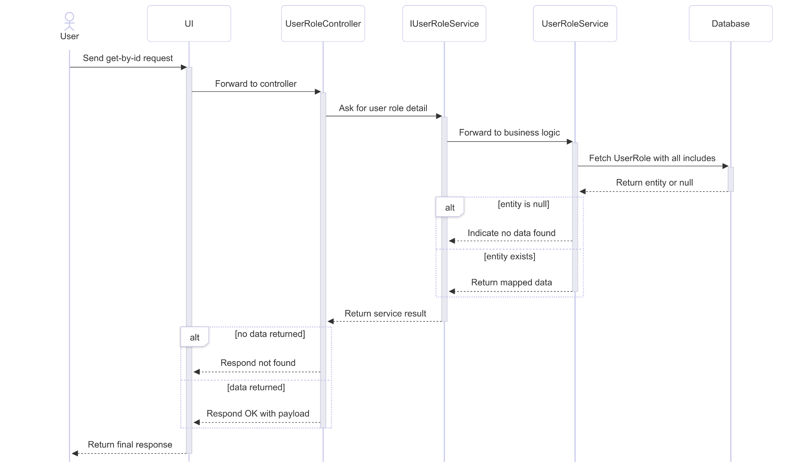

##### 3.22.3.3 Class Specification

###### 3.22.3.3.a UserRoleController

| No | Method | Description |
| --- | --- | --- |
| 1 | GetById(Guid) | Handles HTTP GET requests to retrieve a user role by ID. Returns 200 OK with the role if found, otherwise 404 Not Found. |

###### 3.22.3.3.b UserRoleService

| No | Method | Description |
| --- | --- | --- |
| 1 | GetByIdAsync(Guid) | Queries the repository for a user role entity by ID, including related entities (Role, Account, Project, AppraisalCouncil). Maps the result to RS_UserRole. Returns null if not found. |

#### 3.22.4.Delete

##### 3.22.4.1 Class Diagram

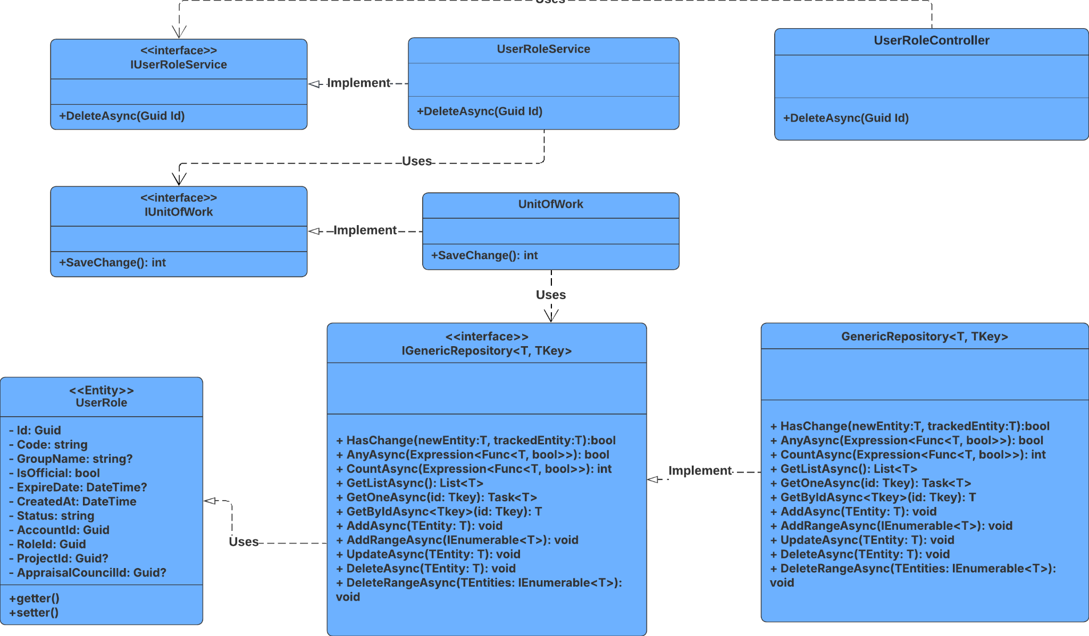

##### 3.22.4.2 Sequence Diagram

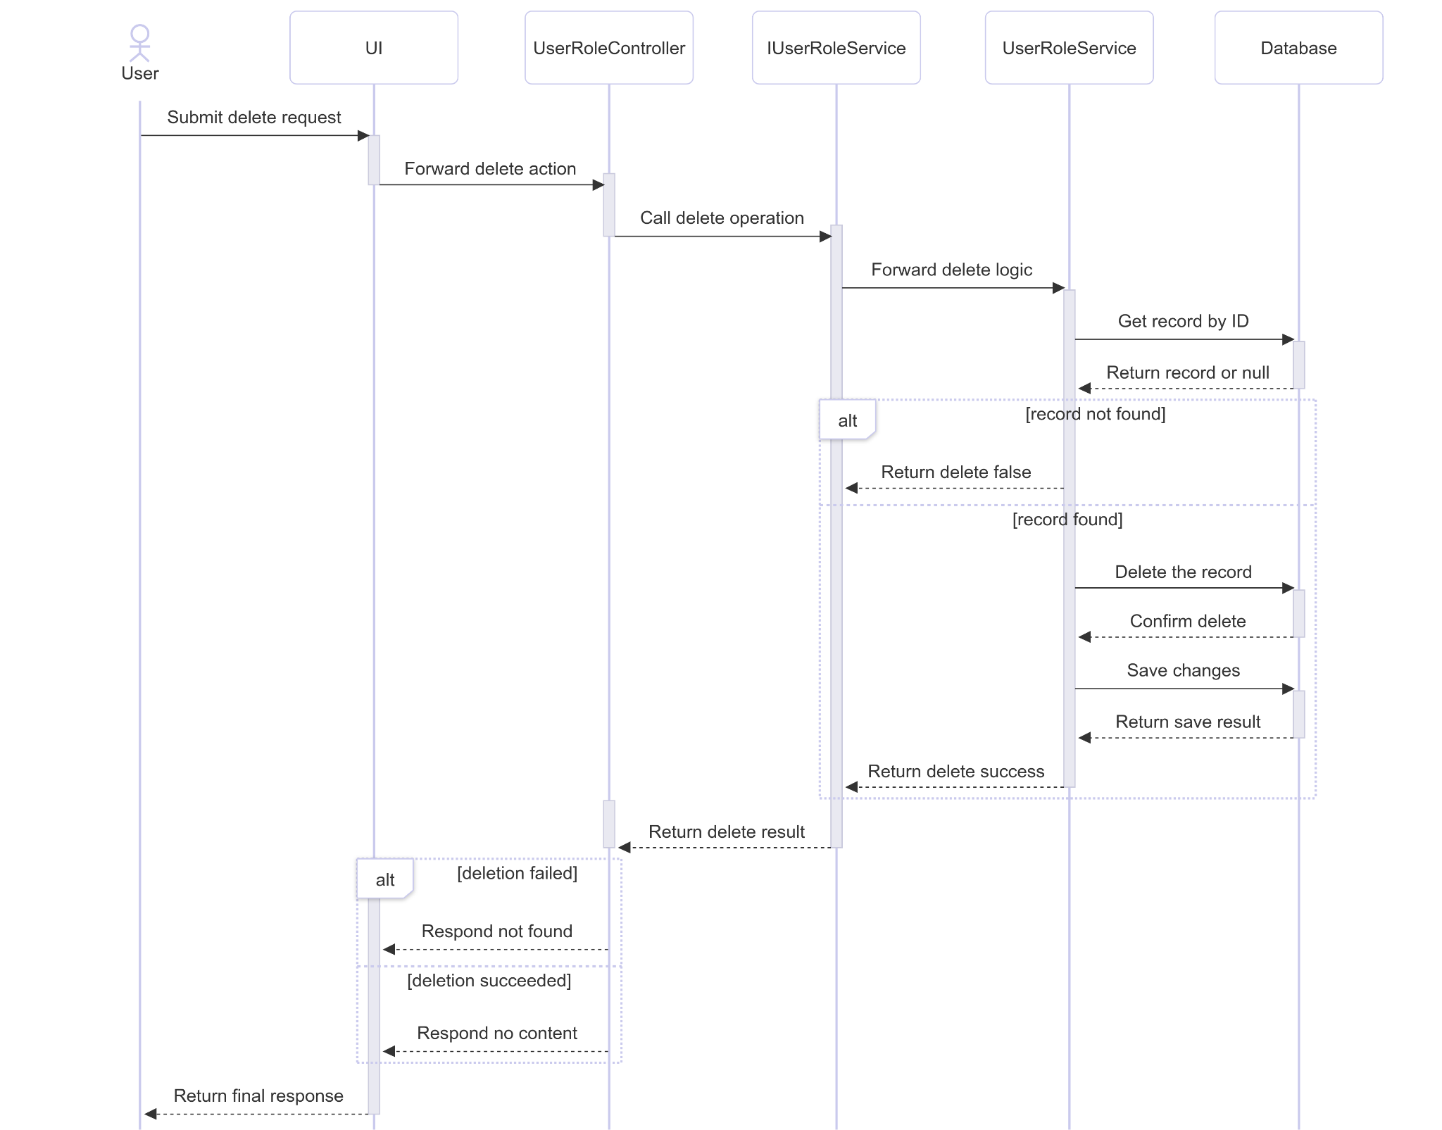

##### 3.22.4.3 Class Specification

###### 3.22.4.3.a UserRoleController

| No | Method | Description |
| --- | --- | --- |
| 1 | Delete(Guid) | Handles HTTP DELETE requests. Calls DeleteAsync to remove a user role by ID. Returns 404 Not Found if the entity doesn't exist, otherwise 204 No Content. |

###### 3.22.4.3.b UserRoleService

| No | Method | Description |
| --- | --- | --- |
| 1 | DeleteAsync(Guid) | Retrieves a user role entity by ID. If found, delete it from the repository and commit the change. Returns true if successful, false if not found. |

#### 3.22.5.Get List

##### 3.22.5.1 Class Diagram

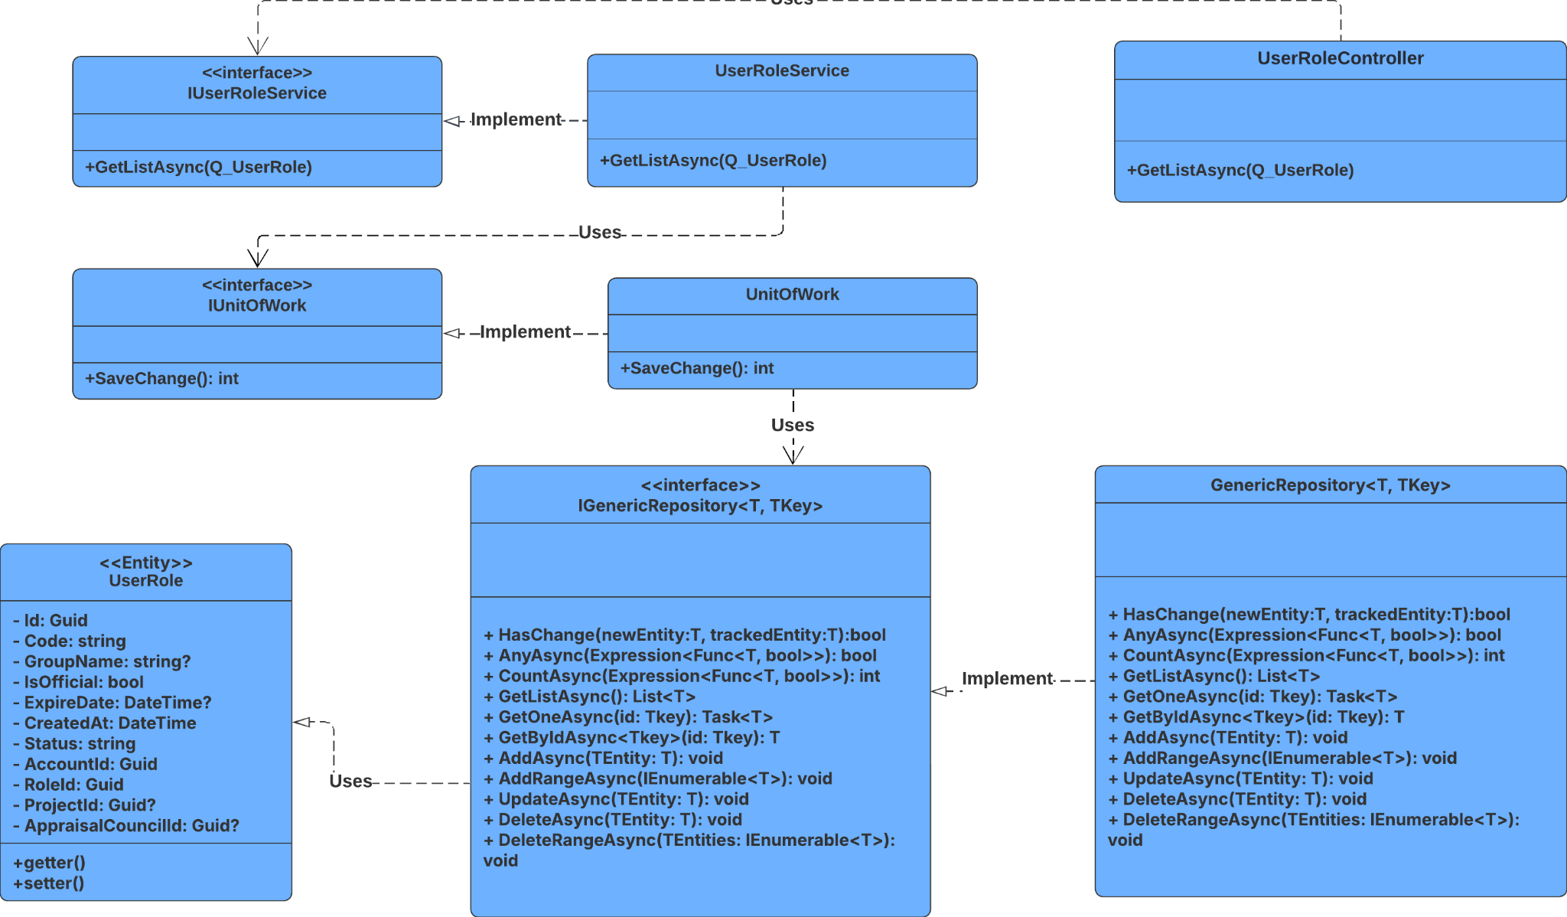

##### 3.22.5.2 Sequence Diagram

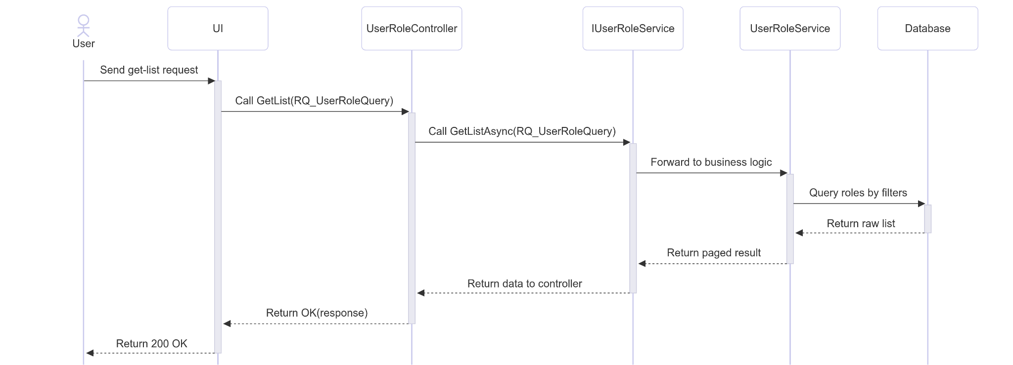

##### 3.22.5.3 Class Specification

###### 3.22.5.3.a UserRoleController

| No | Method | Description |
| --- | --- | --- |
| 1 | GetList(RQ_UserRoleQuery) | Receives user role query parameters and returns a paginated list of user roles by calling GetListAsync. |

###### 3.22.5.3.b UserRoleService

| No | Method | Description |
| --- | --- | --- |
| 1 | GetListAsync(RQ_UserRoleQuery) | Filters user roles based on query parameters, paginates the result, and returns a PagingResult<RS_UserRole>. |

# V. Software Testing Documentation

## 1. Scope of Testing

##### Table 5.1 : Scope of Testing

| **Feature** | **Function** | **Role** | **Description** |
| --- | --- | --- | --- |
| **Authentication** | Sign In with Password | All Roles | Check that the user can sign in with correct credentials. |
|  | Sign In with Google | Researcher, Principal Investigator, Host Institution | Verify access token is issued after Google sign-in, accepted when valid, and rejected when expired, incorrect, or reused. |
|  | Resend OTP | Staff | Confirm the user can request a new OTP, and receive a different code. |
|  | Forgot Password | Staff | Test the password‑reset flow: request link, receive email, follow link, set new password. |
|  | Change Password | Staff | Verify a registered user can update their password. |
| **User Management** | View User List | Staff, Admin | Verify staff can view and manage user accounts with proper pagination and filtering. |
|  | Update User Status | Staff, Admin | Check admin can activate/deactivate user accounts and status changes are reflected immediately. |
|  | Update User Role | Staff, Admin | Verify admin can assign/modify user roles and permissions are updated correctly. |
|  | Search Users | Staff, Admin | Check user search functionality with filters by name, email, role, and status. |
| **Project Management** | Create Project | Staff, Host | Verify PI can create new research projects with all required fields and validation. |
|  | View Project Details | All Roles | Check users can view project information based on their role permissions. |
|  | Edit Project | Staff | Verify authorized users can modify project details and changes are saved properly. |
|  | Delete Project | Staff, Admin | Check project deletion functionality with proper confirmation and cascade deletion. |
|  | Project Enrollment | Researcher | Verify researchers can enroll in projects and enrollment status is updated correctly. |
|  | Invite Members | Principal Investigator | Check PI can invite team members to projects via email with proper notification. |
| **Task Management** | Create Task | Team Members | Check task creation within projects with proper assignment and due dates. |
|  | Assign Task | Team Members | Verify task assignment to team members with notification and status tracking. |
|  | Update Task Status | Team Members | Check task status updates by assigned members with proper workflow validation. |
|  | View Task Board | Team Members | Verify Kanban-style task board display with drag-and-drop functionality. |
| **Milestone Management** | Create Milestone | Staff | Verify milestone creation for projects with proper date validation and dependencies. |
|  | View Milestone Progress | Team Members, Principal Investigator, Team Members | Verify milestone progress tracking with visual indicators and completion percentage. |
| **Document Management** | Upload Document | Principal Investigator, Team Members | Check document upload functionality with file type and size validation. |
|  | View Documents | All Roles | Verify document viewing based on role permissions with proper access control. |
|  | Document Approval | Staff, Admin | Verify document approval workflow with status tracking and notification system. |
| **Evaluation System** | Create Evaluation | Appraisal Council | Check evaluation creation for projects with proper criteria and scoring system. |
|  | Submit Individual Evaluation | Appraisal Council | Verify individual evaluation submission with validation and conflict resolution. |
|  | View Evaluation Results | All Roles | Check evaluation results displayed based on permissions with proper aggregation. |
|  | AI Evaluation Display | Appraisal Council, Principal Investigator, Team Members | Verify AI-generated evaluation content display with proper formatting and accuracy. |
| **Council Management** | Create Appraisal Council | Staff, Admin | Check council creation functionality with member assignment and role definition. |
|  | Assign Council Members | Staff, Admin | Verify council member assignment with proper role validation and conflict checking. |
|  | Schedule Meetings | Staff, Admin | Check meeting scheduling for councils with calendar integration and notifications. |
| **Notification System** | View Notifications | All Roles | Check notification display and management with proper categorization and filtering. |
|  | Mark as Read | All Roles | Verify notification read status updates with proper state management and persistence. |
| **Profile Management** | View Profile | All Roles | Verify user profile display with complete information and proper data formatting. |
|  | Edit Profile | All Roles | Check profile editing functionality with validation and change tracking. |
|  | Scientific CV | Researchers, Principal Investigator | Verify CV creation and management with proper academic formatting and export options. |
| **Dashboard** | View Dashboard | All Roles | Check role-specific dashboard display with relevant widgets and real-time data. |
|  | Dashboard Statistics | Staff, Admin | Verify statistical data display with proper calculations and visual representations. |
| **Security** | Role-based Access Control | All Roles | Verify proper permission enforcement across all system functions and data access. |
|  | Session Management | All Roles | Check secure session handling with proper timeout and activity tracking. |
|  | Data Encryption | All Roles | Verify sensitive data encryption in transit and at rest with proper key management. |
| **Performance** | Page Load Time | All Roles | Verify acceptable page loading performance under normal and high load conditions. |
|  | Data Loading | All Roles | Check data loading and pagination with proper optimization and caching strategies. |
| **Error Handling** | Error Boundaries | All Roles | Check error boundary functionality with proper user feedback and recovery options. |
|  | 404 Not Found | All Roles | Verify 404 page display with proper navigation and helpful error messages. |
|  | Unauthorized Access | All Roles | Check unauthorized access handling with proper redirection and security logging. |

## 

## 2. Test Strategy

### 2.1 Testing Types

##### Table 5.2.1 : Testing Types

| **Objective** | **Technique** | **Completion criteria** |
| --- | --- | --- |
| Verify and validate each individual code units (functions, classes) | Unit testing | Most of the methods and classes covered by tests. |
| Testing application environment in real situations | End-to-end testing | - Database CRUD operations validated.  - External integrations (payment, map, etc.) response properly. |
| Check correct interaction among modules | Integration testing | Data passed between modules matches expected schemas. |
| Testing how parts of a system communicate and exchange data. | Interface testing | Requests, response, etc. |

### 2.2 Test Levels

##### Table 5.2.2 : Test Levels

| **Type of Tests** |  | **Test Level** | |  |
| --- | --- | --- | --- | --- |
| **Unit** | **Integration** | **System** | **Acceptance** |
| Unit testing | X |  |  |  |
| Interface testing | X | X |  |  |
| Integration testing |  | X |  |  |
| End-to-end testing |  |  |  | X |

### 2.3 Supporting Tools

##### Table 5.2.3: Supporting Tools

| **Purpose** | **Tool** | **Vendor/In-house** | **Completion criteria** |
| --- | --- | --- | --- |
| API testing | Swagger | Open Source | Latest stable |

## 3. Test Plan

### 3.1 Human Resources

##### Table 5.3.1 Human Resources

| **Worker/Doer** | **Role** | **Specific Responsibilities/Comments** |
| --- | --- | --- |
| Phan Trần Bảo Thiên | Leader | Planning, assigning test functions to members and verifying test results. |
| Phùng Trần Mai Hà | Member | Execute test and report. |
| Đoàn Huỳnh Tường Vy | Member | Execute test and report. |
| Phạm Huy Hoàng | Member | Execute test and report. |

### 3.2 Test Environment

#### Table 5.3.2 : Test Environment

| **Purpose** | **Tool** | **Provider** | **Version** |
| --- | --- | --- | --- |
| API testing | Window | Microsoft | Latest stable |

### 3.3 Test Milestones

##### Table 5.3.3 : Test Milestones

| **Milestone Task** | **Start Date** | **End Date** |
| --- | --- | --- |
| Unit test |  |  |
| Other Test Case (IT, ST, AT) |  |  |

## 4. Test Cases

* Unit Test Cases:[*Report5_Unit Test.xls*](https://docs.google.com/spreadsheets/d/1ESv5hOCQz3gv2IvVej7tbp6TNlGsKQ8K/edit?gid=785140706#gid=785140706)

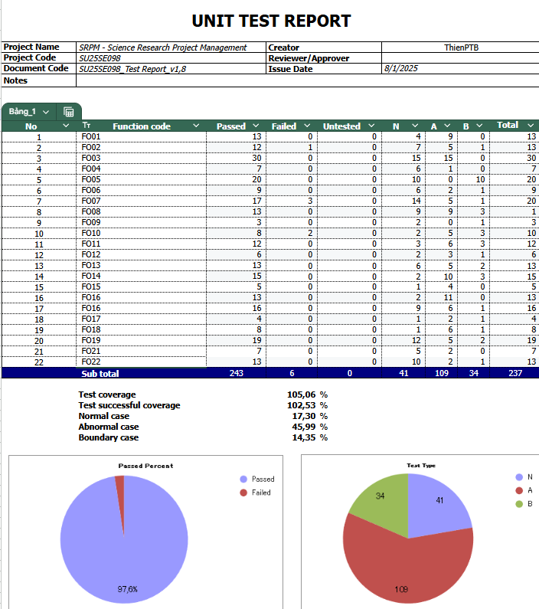

##### Figure 5.4.1 : Unit test case

* Test Cases and Test Reports:[*Report5_Test Report*](https://docs.google.com/spreadsheets/d/1pl6odlMX0a-aN0eoFejLN8Osm1hff-z-/edit?gid=1064316990#gid=1064316990)

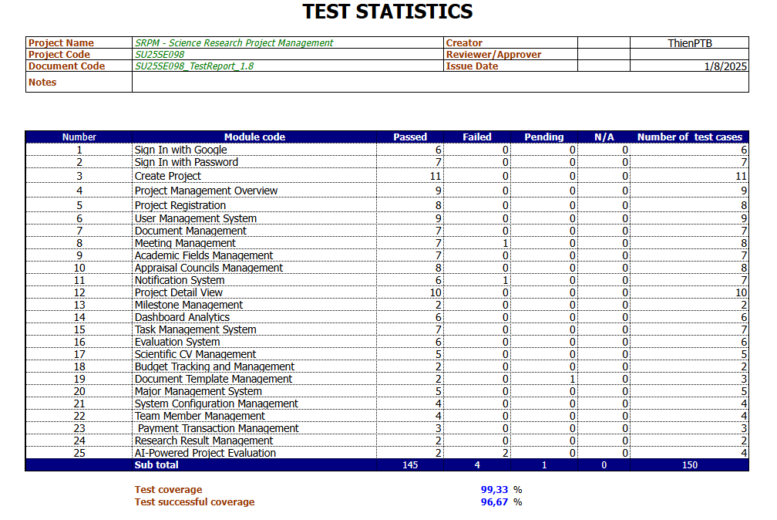

##### Figure 5.4.2 : Test Statistic

# VI. Release Package & User Guides

## 1. Deliverable Package

| **No.** | **Deliverable Item** | **Description** |
| --- | --- | --- |
| 1 | Schedule/Task Tracking | We use Google Sheet, Google Meet to track our progress, Zalo to store schedules, notes and Google Doc to write the documents:   * **Google Meet** * **Zalo** * **Google Sheet** * **Google Doc** |
| 2 | Project Backlog | The project backlog is managed using Google Sheet for task tracking and prioritisation. |
| 3 | Source Codes | We have multiple private repositories for different parts of the application:   * Frontend website: [[Github SRPM Web]](https://github.com/J1410T/fe-capstone) * Backend: [[Github SRPM Server]](https://github.com/ttlihao/SRPM-Capstone-Project) |
| 4 | Database Script(s) | The database scripts are stored in the project repository. The database used is **SQL Server** for managing all data. |
| 5 | Final Report Document | The final report is prepared using Google Docs and is stored in Google Drive for sharing and version control. |
| 6 | Test Cases Document | The test case documentation is managed using Google Docs and Google Sheets. It includes all test cases for functionality validation. |
| 7 | Defects List | The defect list is maintained in Google Sheets for tracking and resolution during meetings. |
| 8 | Issues List | The issues list is managed in GitHub (via Issues tab) and Google Sheet for task management and Meeting team coordination. |
| 9 | Slide | Presentation slides are designed using Canva and stored in Google Drive. |

## 2. Installation Guides

### 2.1 System Requirements

#### 2.1.1 Hardware requirements

##### Table 6.2.1.1 : Hardware requirements

|  | **Minimum** | **Recommended** |
| --- | --- | --- |
| Internet connection | LAN Cable, Wi-Fi (4 Mbps) | LAN Cable, Wi-Fi (4 Mbps) |
| Processor | 1.8GHz | Multi-core |
| Memory | 8GB | 16GB or higher |
| Storage | 128GB | 25GB or higher |

#### 2.1.2 Software requirements

##### Table 6.2.1.2 : Software requirements

|  | **Name/Version** | **Description** |
| --- | --- | --- |
| Operating System | Windows 10 or higher | OS for PC |
| Browser | Latest version | Browser for web application |
| .NET SDK | .NET 8 SDK | .NET Standard Development Kit |
| Nodejs Runtime | Version 20 or higher |  |
| SQL Server | Version 19 or higher |  |
| IDEs | Visual Studio Code, Visual Studio 2022 |  |
| Version Control | GitHub |  |
| Deployment Servers | Azure Container Registry |  |

### 2.2 Installation Instruction

#### 2.2.1 Front-end

* Step 1: [Download & Install Visual Studio Code](https://code.visualstudio.com/download)

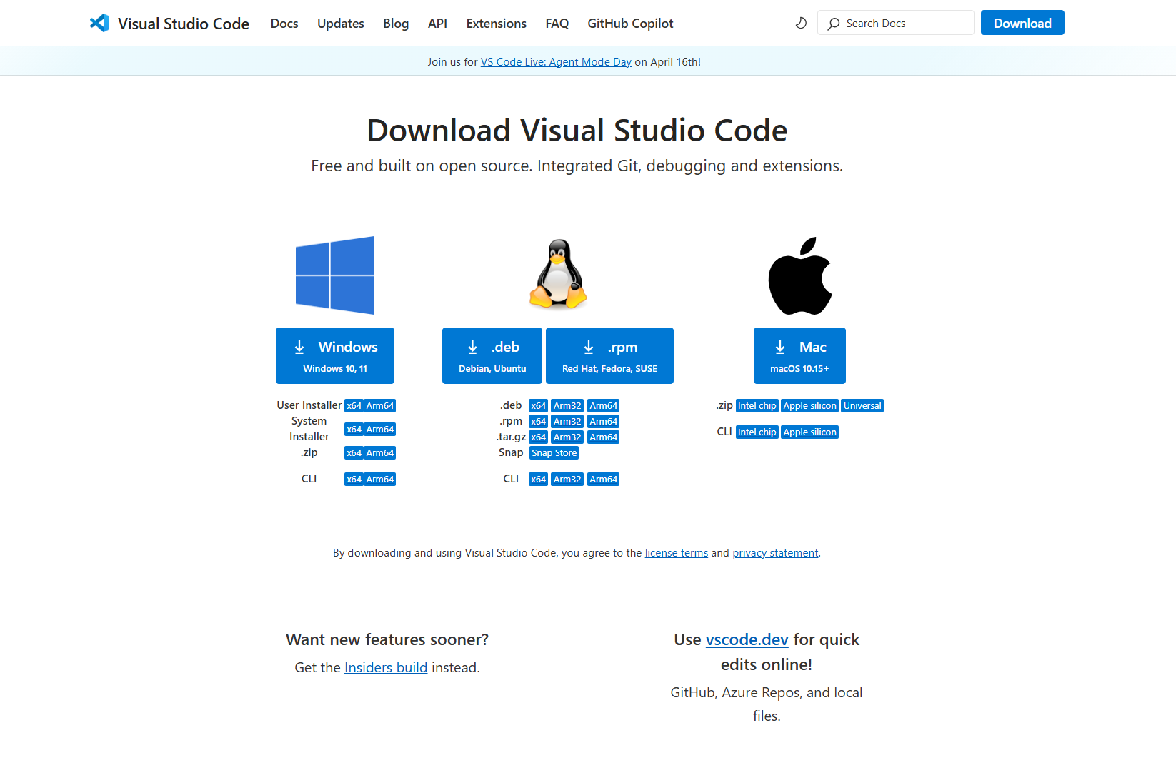

##### Figure 6.2.2.1.1: Front-end

* Step 2: [Download and install git](https://git-scm.com/downloads)

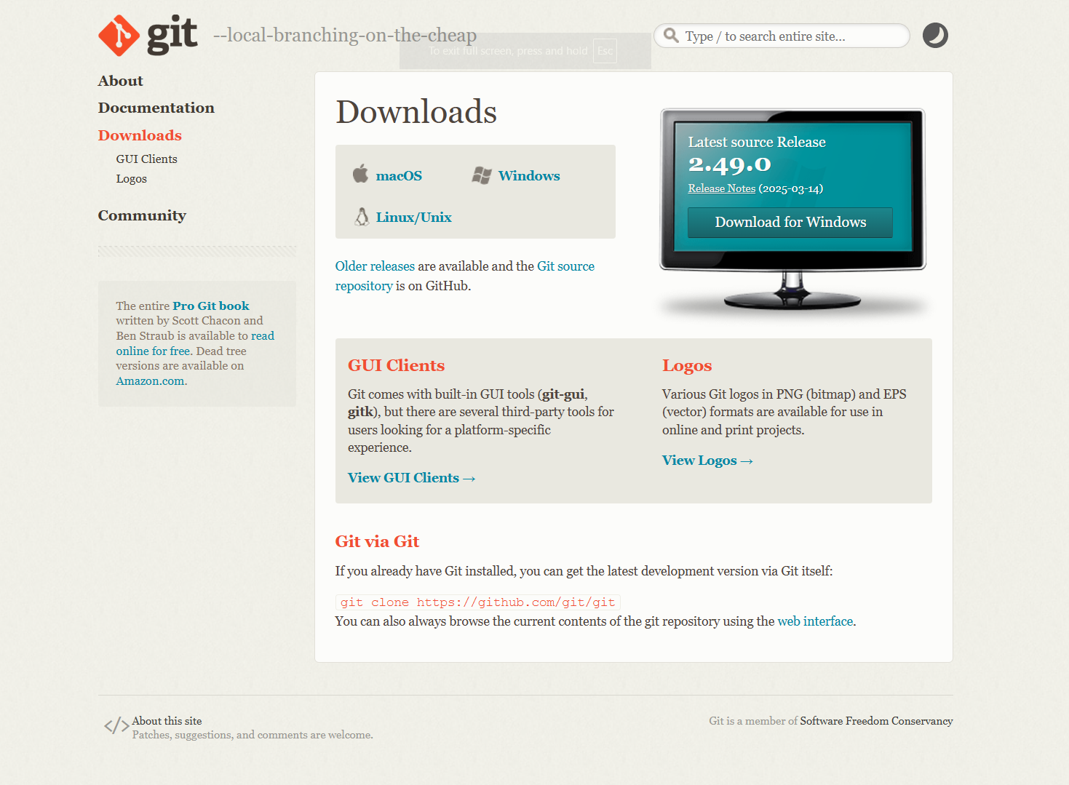

##### Figure 6.2.2.1.2: Front-end

* Step 3: Move to the specific folder, then open the terminal

- Right click to the specific folder, then open the terminal and enter the command line:

*“git clone https://github.com/J1410T/fe-capstone.git”*

- Type “code .” in the terminal window to open the source code.

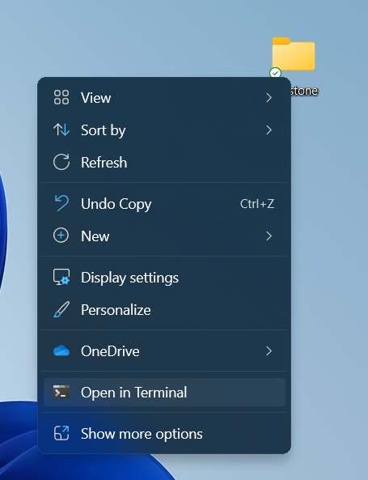

##### Figure 6.2.2.1.3: Front-end

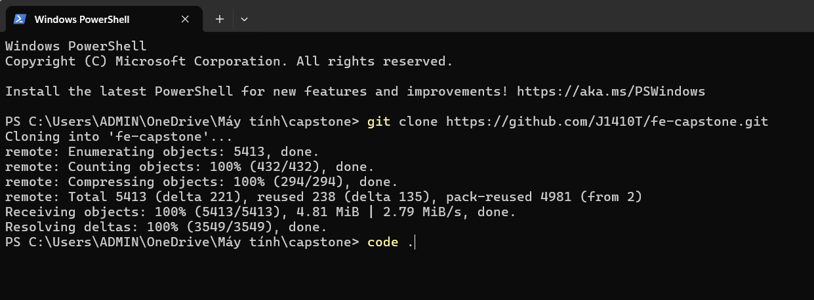

##### Figure 6.2.2.1.4: Front-end

* Step 4: To install the library packages (node_modules), enter the command line   
  “*npm install -g pnpm*” and “*pnpm install*”

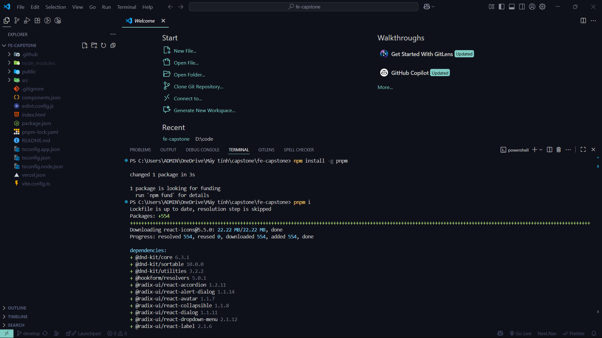

##### Figure 6.2.2.1.5: Front-end

* Step 5: Create the .env file to verify some keys

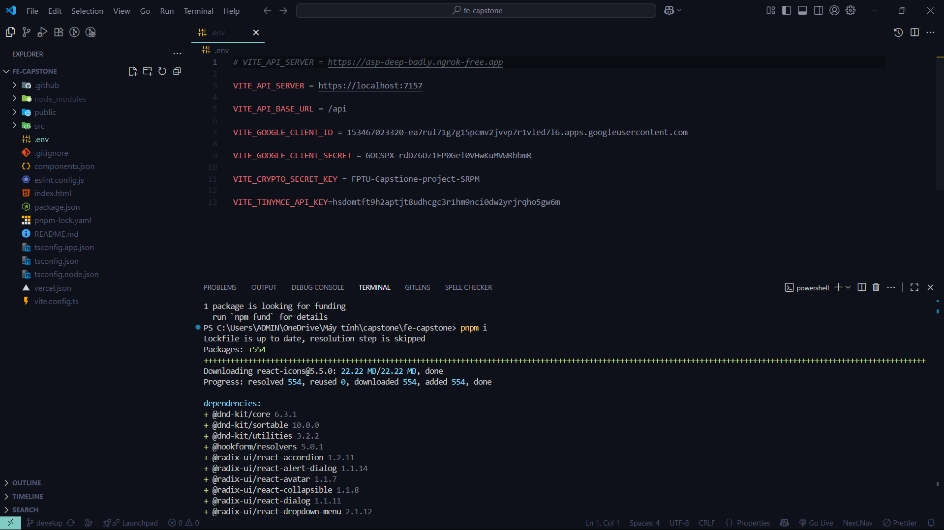

##### Figure 6.2.2.1.6: Front-end

* Step 6: Run command line “*npm run dev*” to run the frontend source code at the http://localhost:5173/.

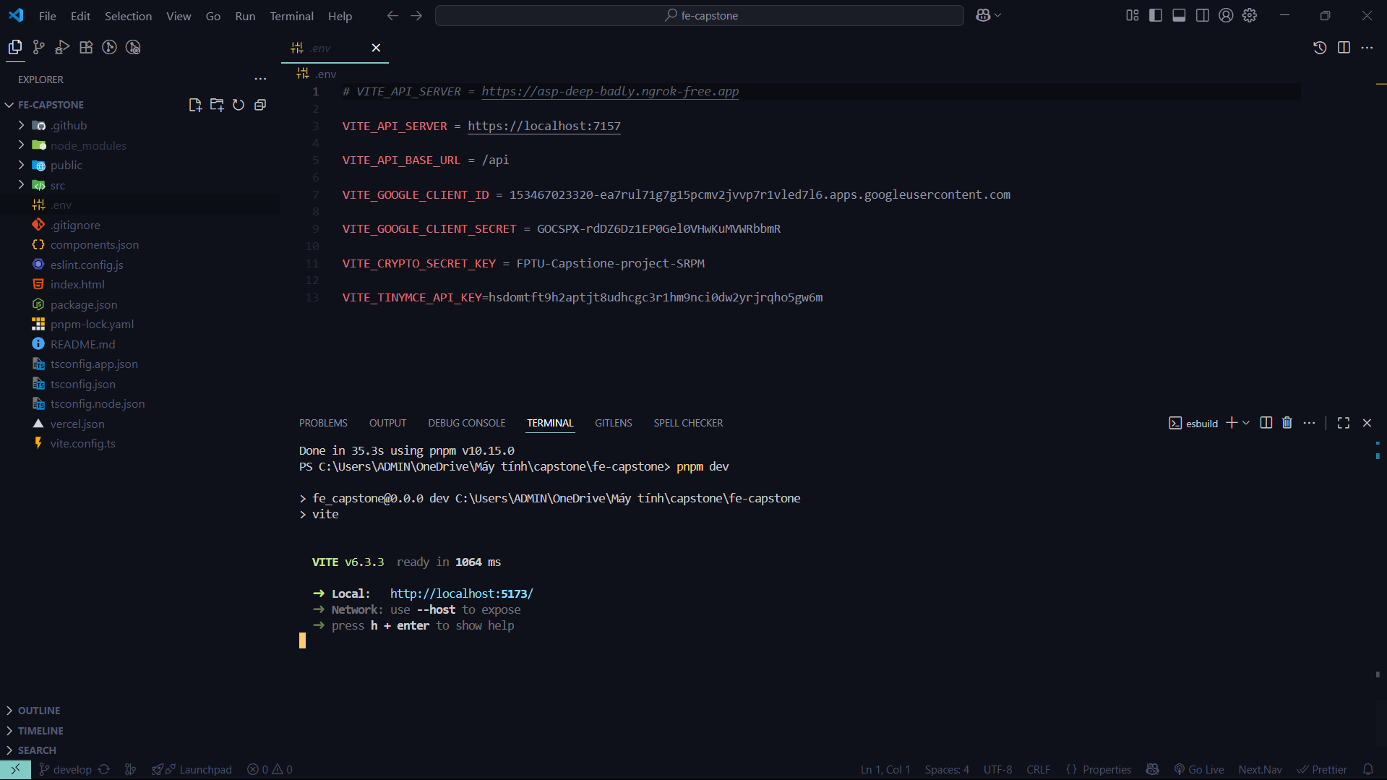

##### Figure 6.2.2.1.7: Front-end

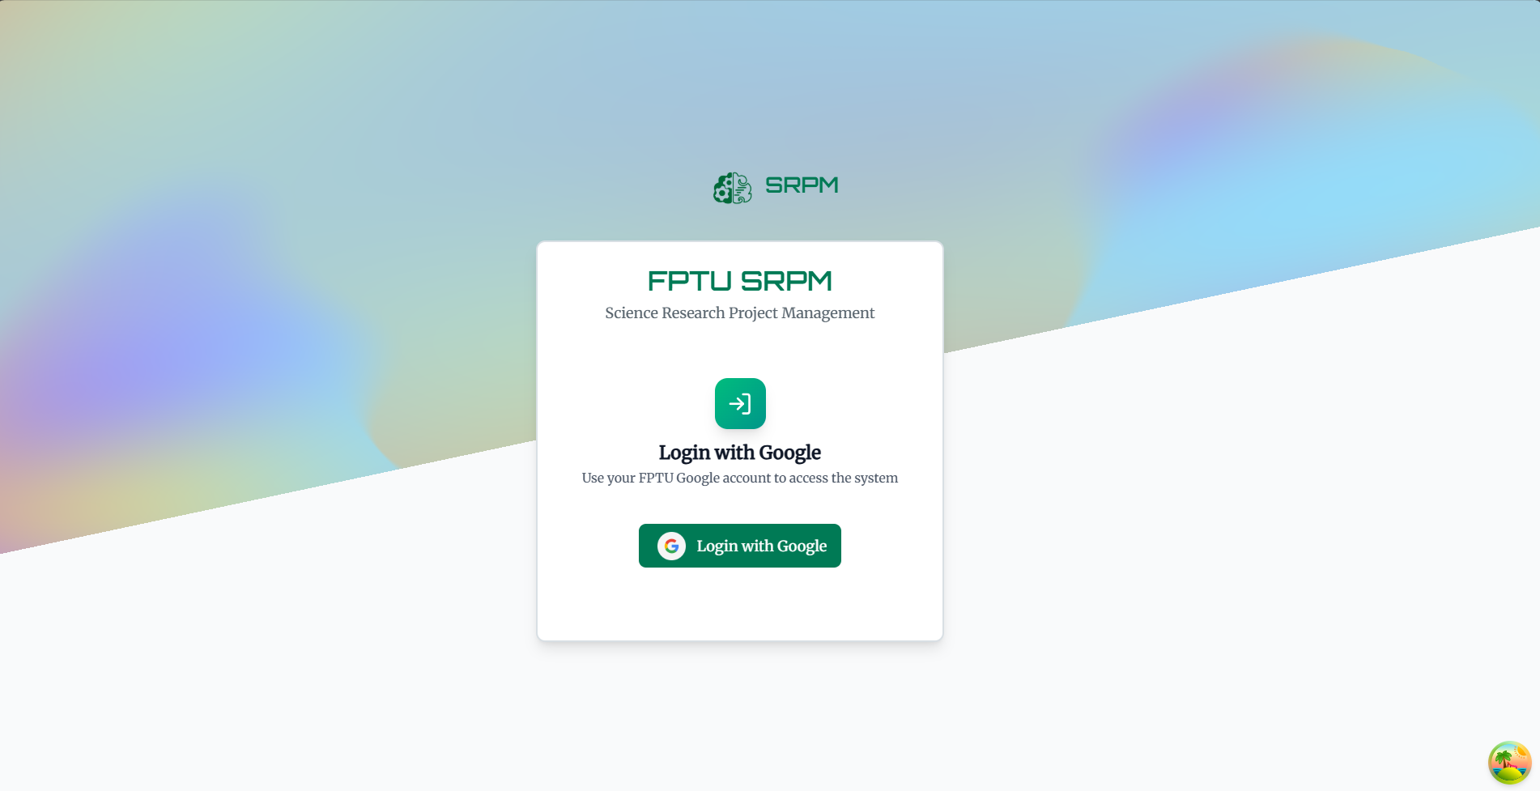

##### Figure 6.2.2.1.8: Front-end

#### 2.2.2 Back-end

* Step 1: [Download and install git](https://git-scm.com/downloads)



##### Figure 6.2.2.2.1: Back-end

* Step 2: [Download and install Visual Studio 2022](https://visualstudio.microsoft.com/)

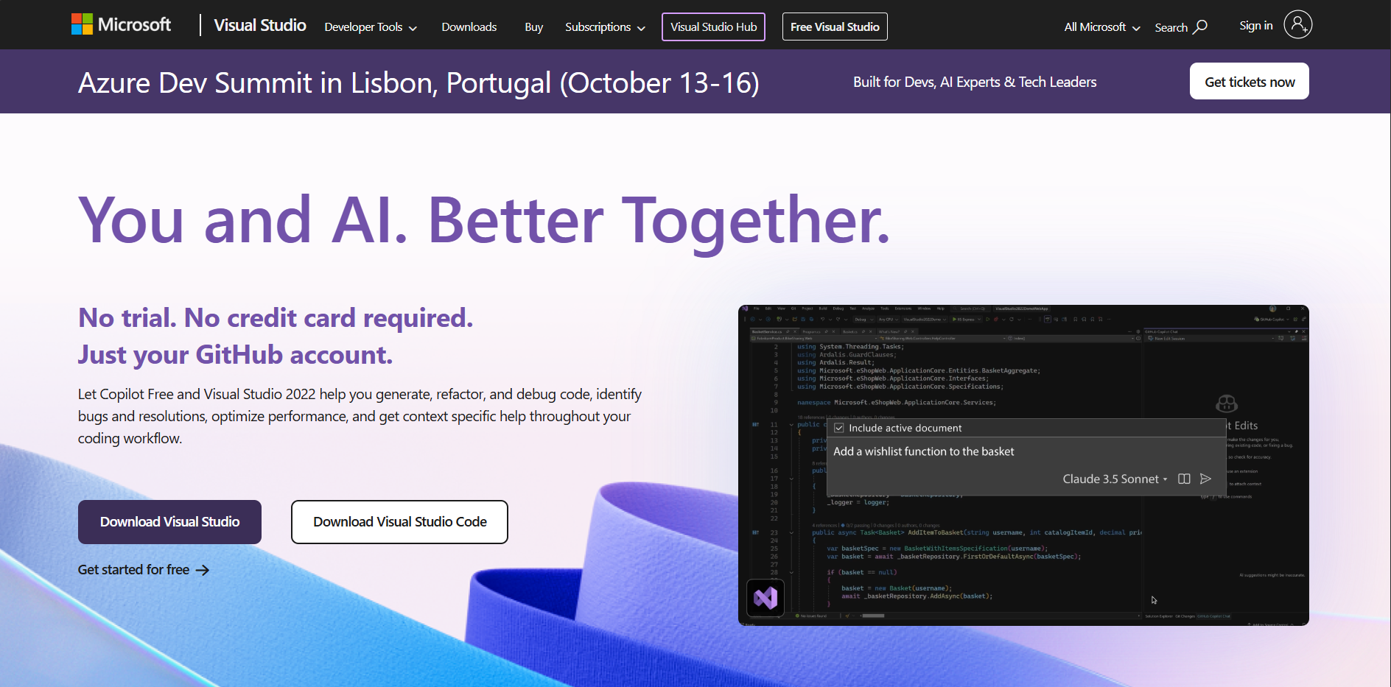

##### Figure 6.2.2.2.2: Back-end

* Step 3: [Download and install SQL Server](https://learn.microsoft.com/en-us/ssms/install/install)

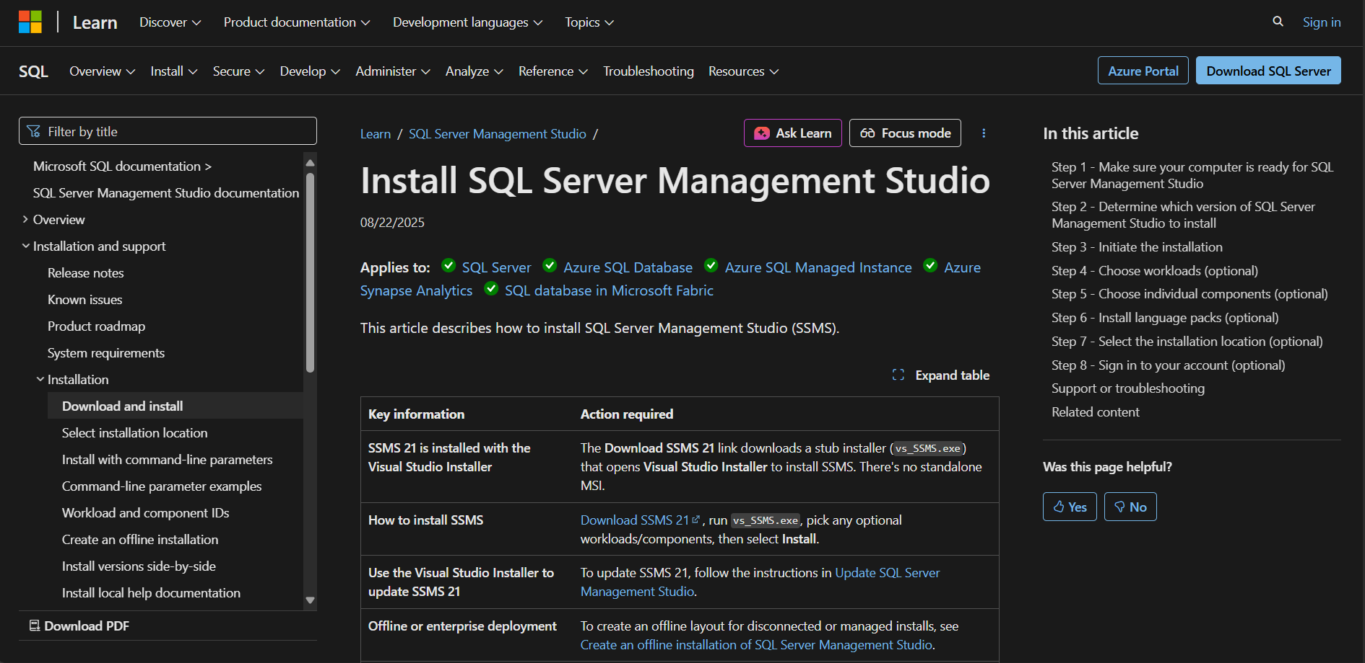

##### Figure 6.2.2.2.3: Back-end

* Step 4: Clone git repository: [https://github.com/ttlihao/SRPM-Capstone-Project](https://github.com/ttlihao/SRPM-Capstone-Project/tree/main-local)
* Step 5: Navigate to folder **SRPM**

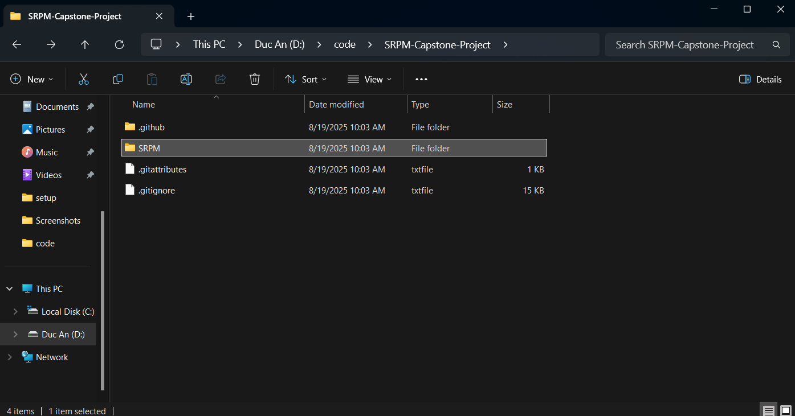

##### Figure 6.2.2.2.4: Back-end

* Step 6: Open file SRPM.sln with Visual Studio 2022

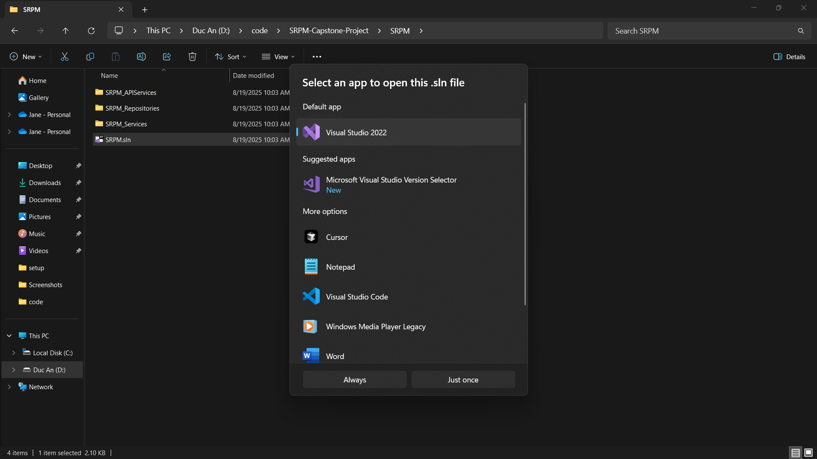

##### Figure 6.2.2.2.5: Back-end

* Step 6: Open fileappsettings.json and add on file some keys to verify

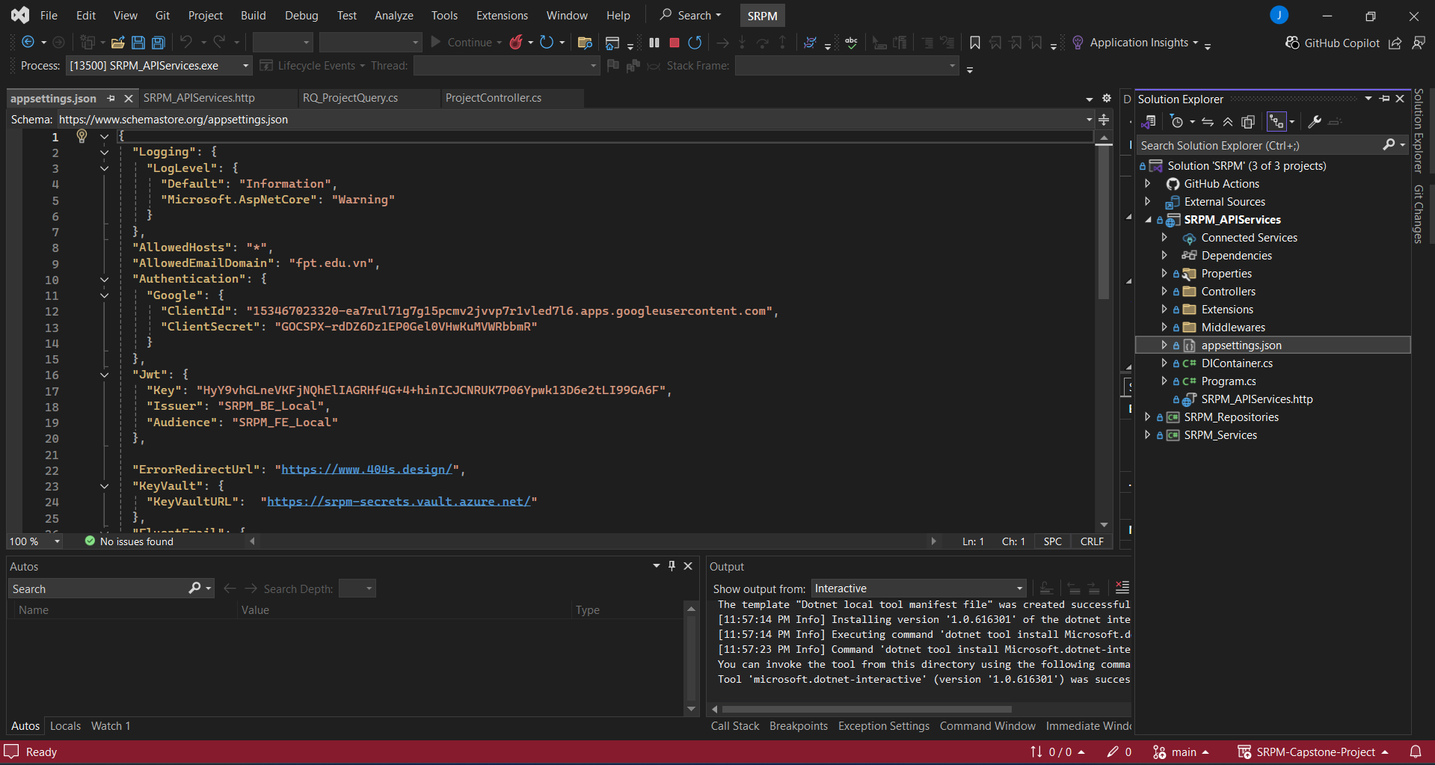

##### Figure 6.2.2.2.6: Back-end

* Step 7: Click on Run https

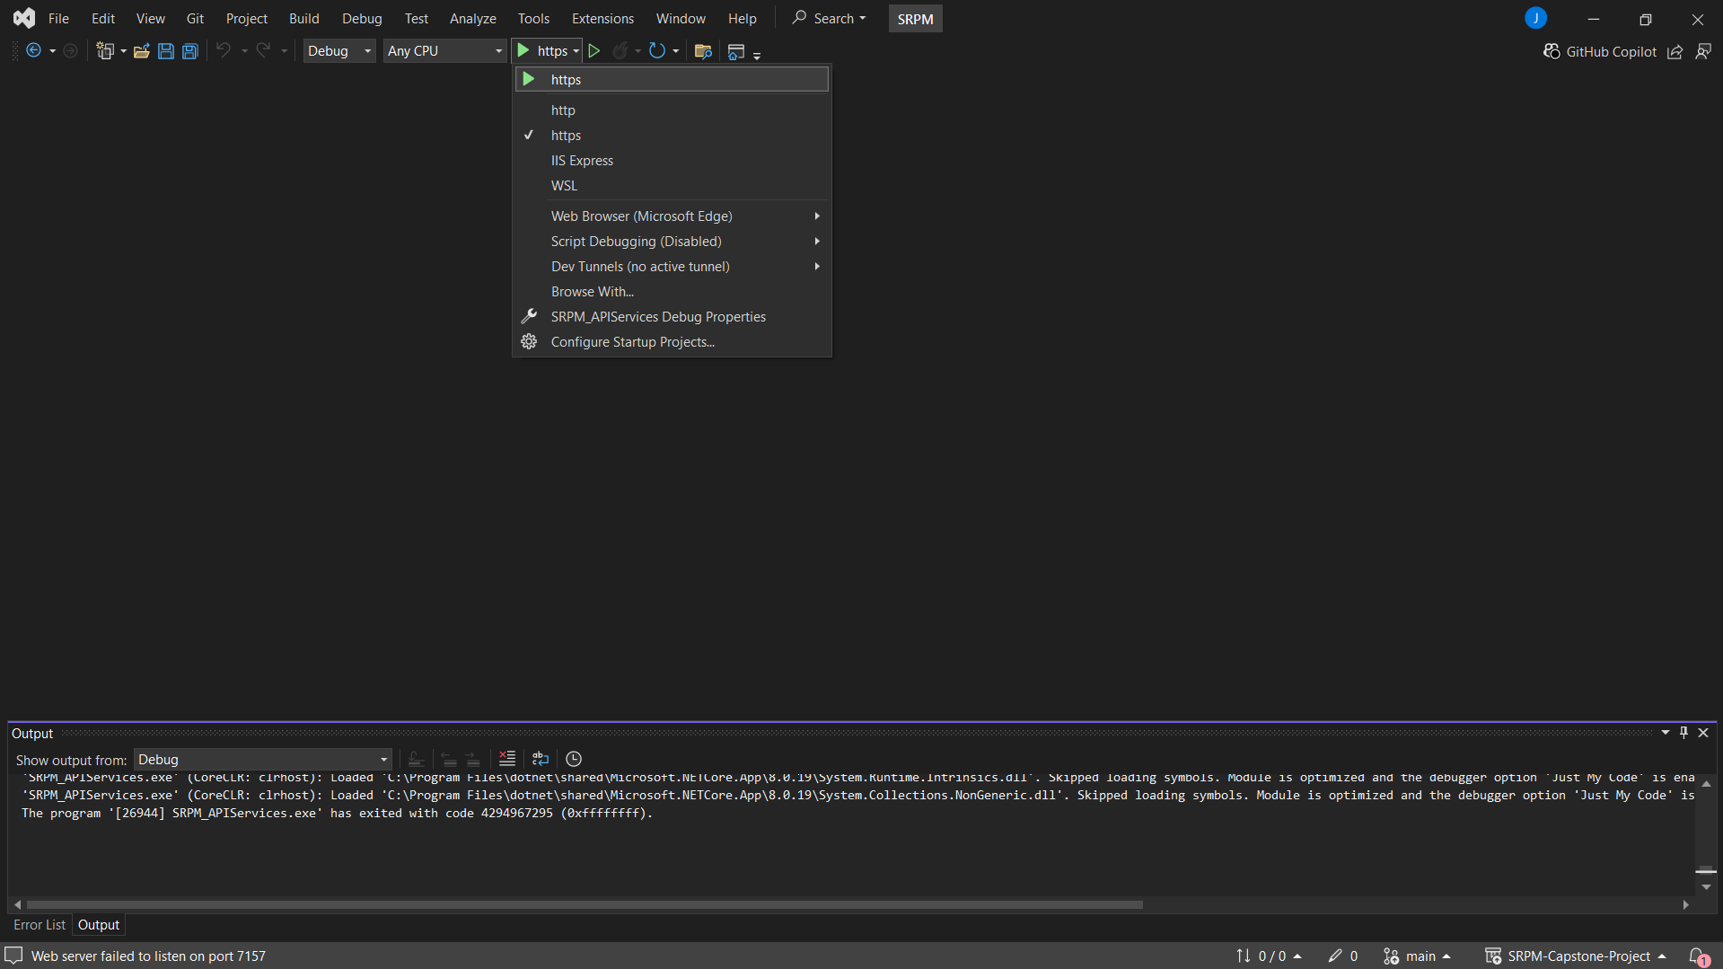

##### Figure 6.2.2.2.7: Back-end

* Step 8: Go to <https://localhost:7157/swagger/index.html> to see the website.

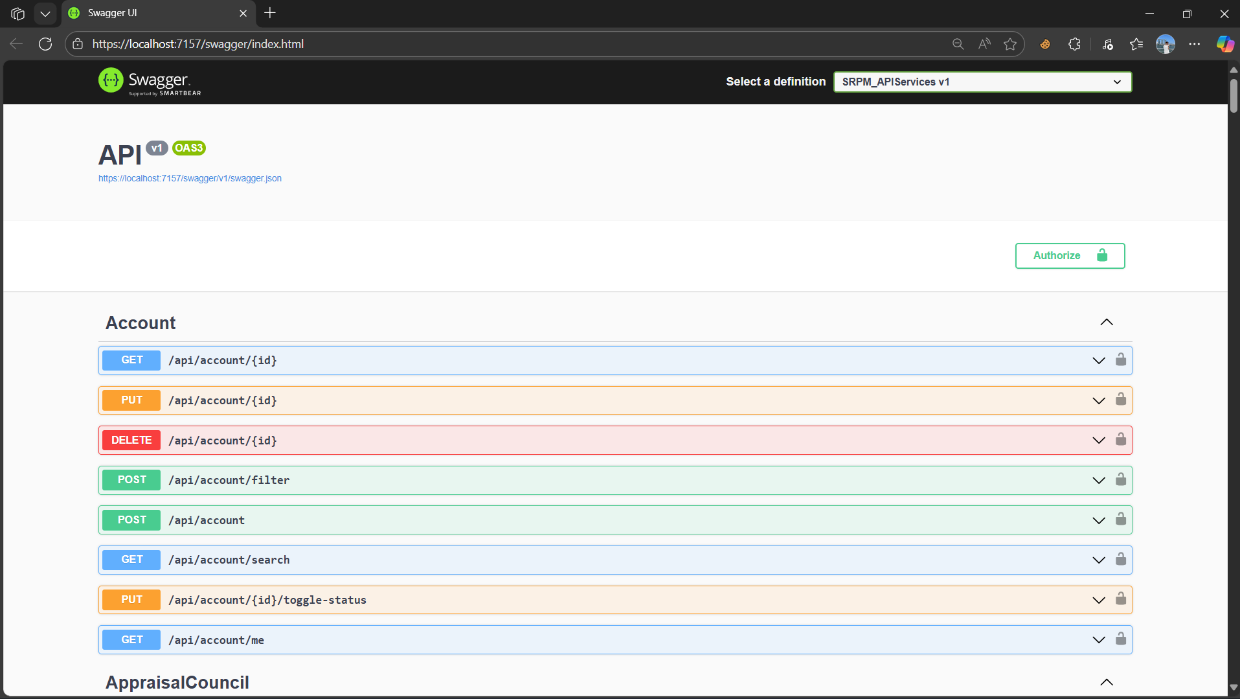

##### Figure 6.2.2.2.8: Back-end

## 3. User Manual

### 3.1 Overview

**WorkFlow 1: Project Registration**

* **Staff/Host** logs in and navigates to **Create Project**, filling out the form with the project name, description, maximum number of members, and specific requirements.
* Click **Save** to create a new project. The project will then appear in the **Projects** list.
* **PI** logs in, goes to **Projects** to view the list of available topics.
* Selects a suitable project and clicks **Request Enroll**.
* Completes the **Enroll Form**, which includes PI’s qualifications, research idea, development plan, timeline, activities, and budget estimation. Click **Save** to submit the request.

**WorkFlow 2: Initial Evaluation & Project Approval**

* **PI** opens the **Project Detail** page, invites available **Researchers** in the system, and uploads or creates a new **Scientific CV** under **Profile Detail**.
* The system sends an invitation notification to the Researchers, who can either **Approve** or **Reject**.
* If **Approved** and a CV already exists, the Researcher is automatically added to the project. If no CV is available, the system prompts them to upload or create one.
* **PI** reviews each Researcher’s participation status and CV, then clicks **Propose Project** to submit the proposal (including detailed forms and member list).
* **Staff** accesses the **Project Overview**, selects the proposal, and assigns an **Appraisal Council** (by creating or selecting a Council consisting of Chairman, Secretary, and Members).

**WorkFlow 3: Progress & Task Management**

* Once the proposal is **Approved** by the **Council Chairman**, the project status changes to **In Progress**.
* **Staff** creates a **Contract** using the available form, then clicks **Save** to send it to the **PI**.
* **PI** opens the **Project Detail**, reviews the contract, makes adjustments if needed, and signs it.
* **Staff** verifies the signature, sets up the **Milestones** and **Milestone Meetings**, manually adding missing entries if required, then clicks **Save & Close**.
* The project officially starts. The **Leader** (PI or an assigned member) uses **Task Management** to create tasks and assign them to Researchers.
* **Researchers** carry out tasks and update progress in **Task Management**, while the **PI** monitors the overall team progress.

**WorkFlow 4: Milestone Reporting & Evaluation**

* When a milestone is due, the **PI** prepares a progress report form and submits it via the system.
* The system notifies the **Appraisal Council**; the PI organizes a **Meeting** with the Council to evaluate milestone results.
* **Council Members** score the milestone as **Pass/Fail**, and the **Chairman** announces the result.
* If **Pass**, the **PI** clicks **Request Transaction** to propose milestone payment; if **Fail**, the PI revises the plan and continues implementation.

**WorkFlow 5: Payment & Project Closure**

* **Staff** receives the transaction request, reviews the documents, and processes milestone payment for the PI.
* Once all milestones are completed, the **PI** organizes a **Final Meeting** with the Council. The Council evaluates the project as **Pass/Fail**.
* If the project **Passes** and is of **Application type**, the team compresses the results into a ZIP file (≤ 30 MB) and uploads it to the system.
* If the project **Passes** and is of **Basic type**, the team must publish an article in the Vietnam Professors Association Journal (or equivalent) and provide the link in **Project Result** within 30 days of completion.
* **Staff** closes the project. After closure, the **PI** and **Researchers** retain **view-only access** to all project documents (no further edits allowed).

### 3.2 WorkFlow 1

* **Staff/Host** logs in and navigates to **Create Project**, filling out the form with the project name, description, maximum number of members, and specific requirements.

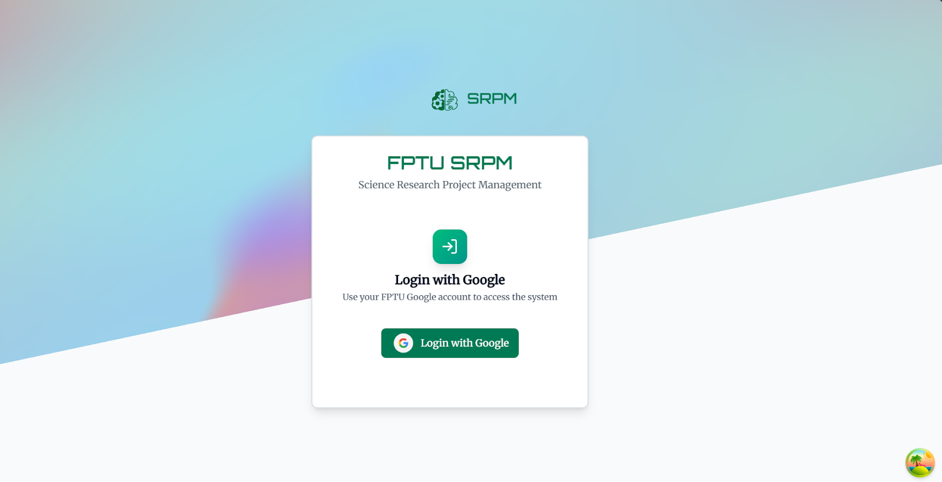

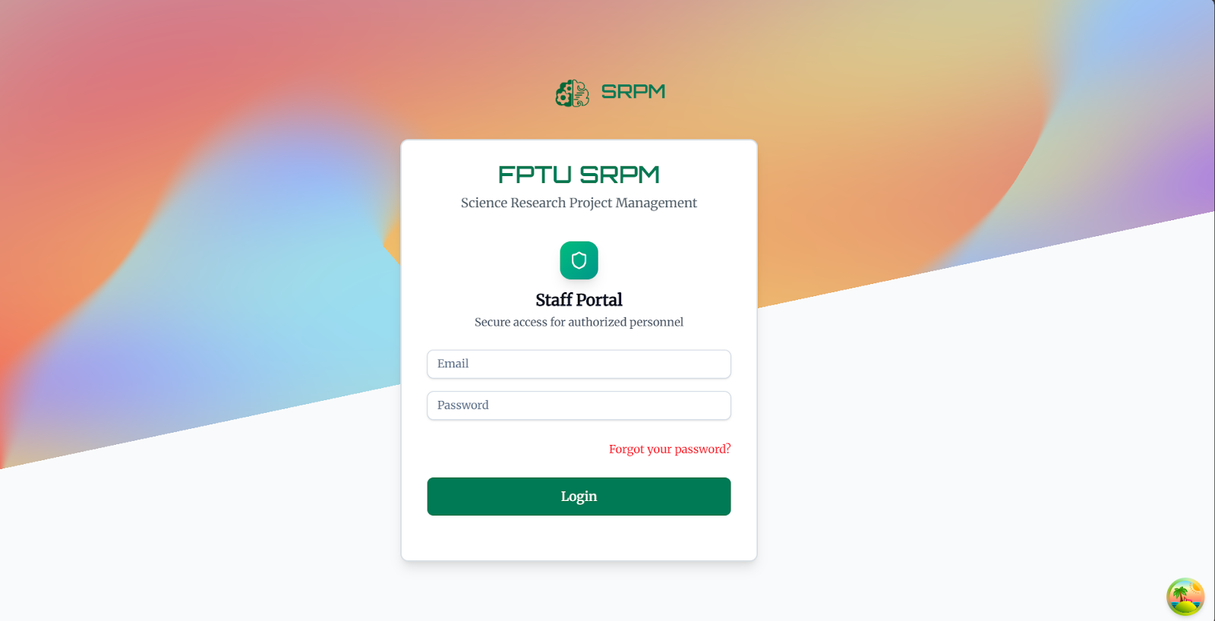

##### 

* Click **Save** to create a new project. The project will then appear in the **Projects** list.

  
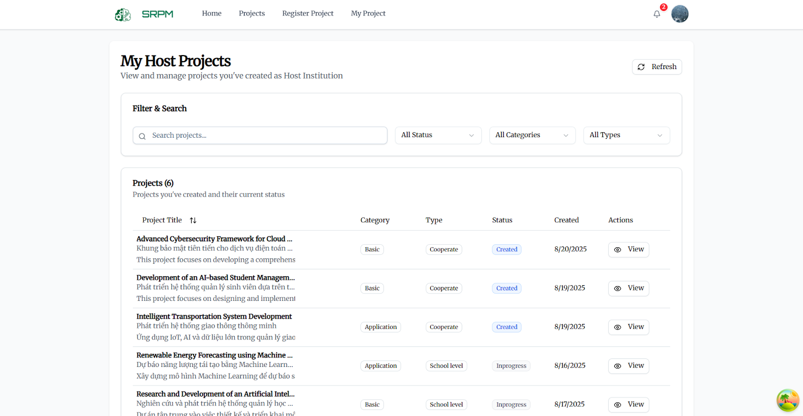

* **PI** logs in, goes to **Projects** to view the list of available topics.

##### 

* Selects a suitable project and clicks **Request Enroll**.

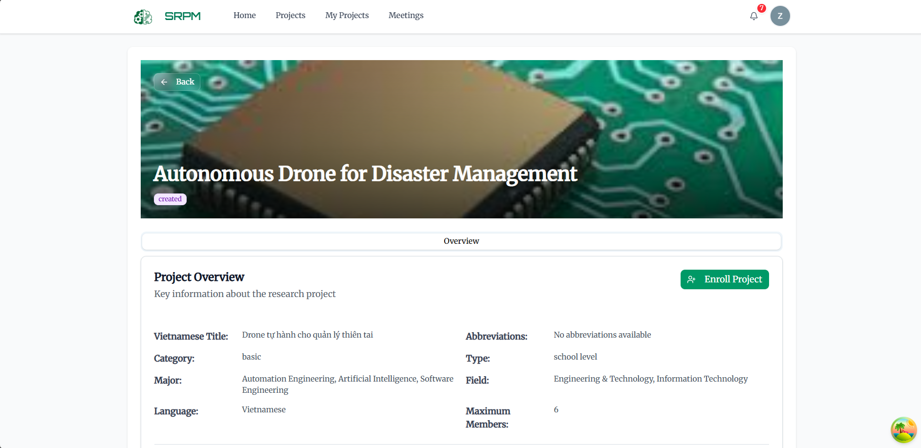

* Completes the **Enroll Form**, which includes PI’s qualifications, research idea, development plan, timeline, activities, and budget estimation. Click **Save** to submit the request.

##### 

### 3.3 WorkFlow 2

* **PI** opens the **Project Detail** page, invites available **Researchers** in the system, and uploads or creates a new **Scientific CV** under **Profile Detail**.

##### 

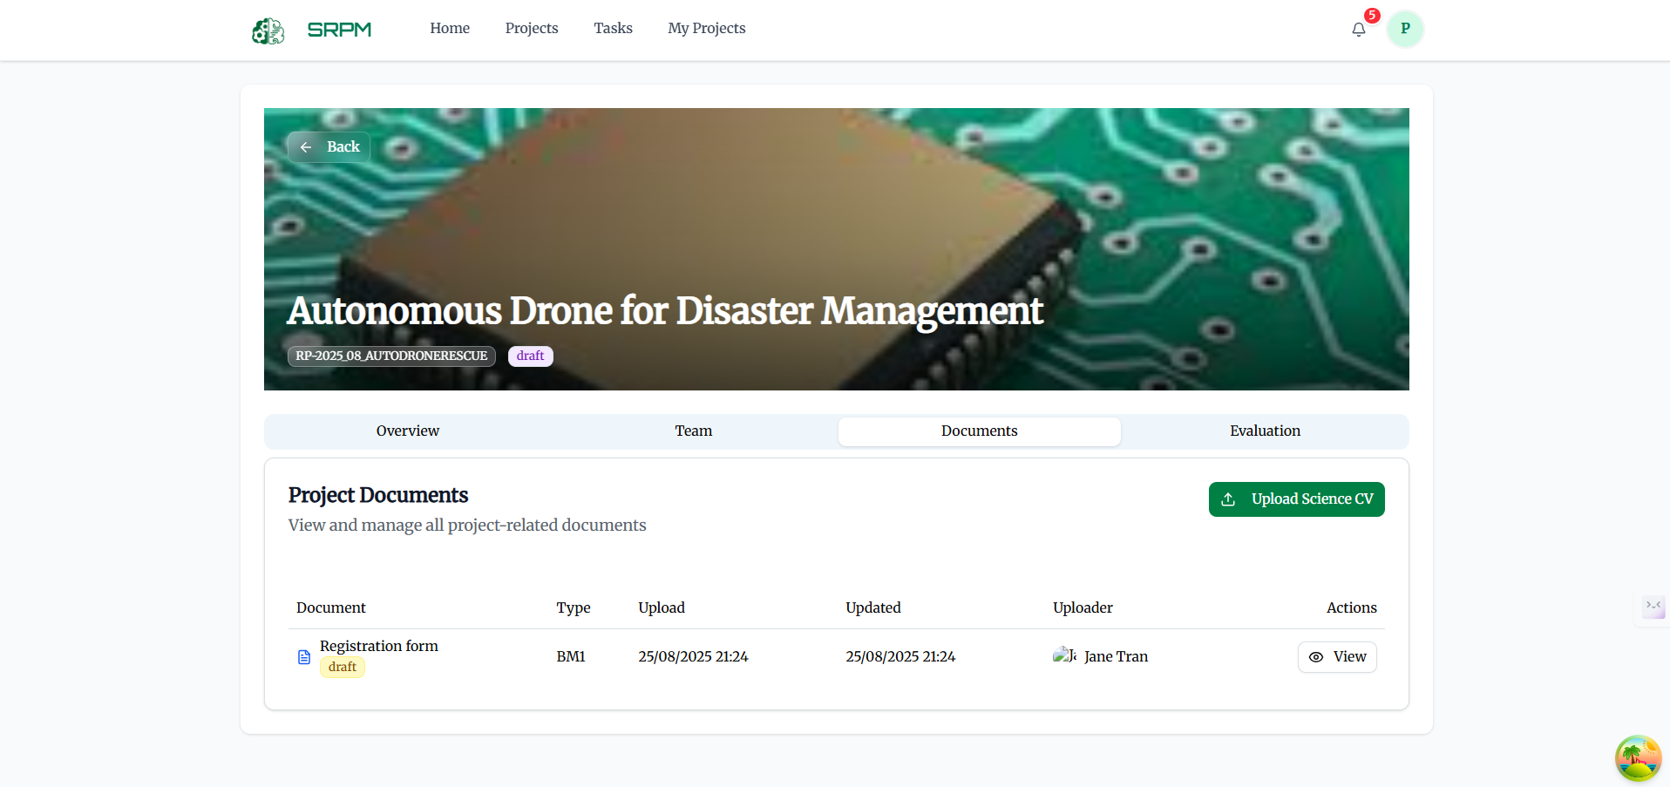

* The system sends an invitation notification to the Researchers, who can either **Approve** or **Reject**.

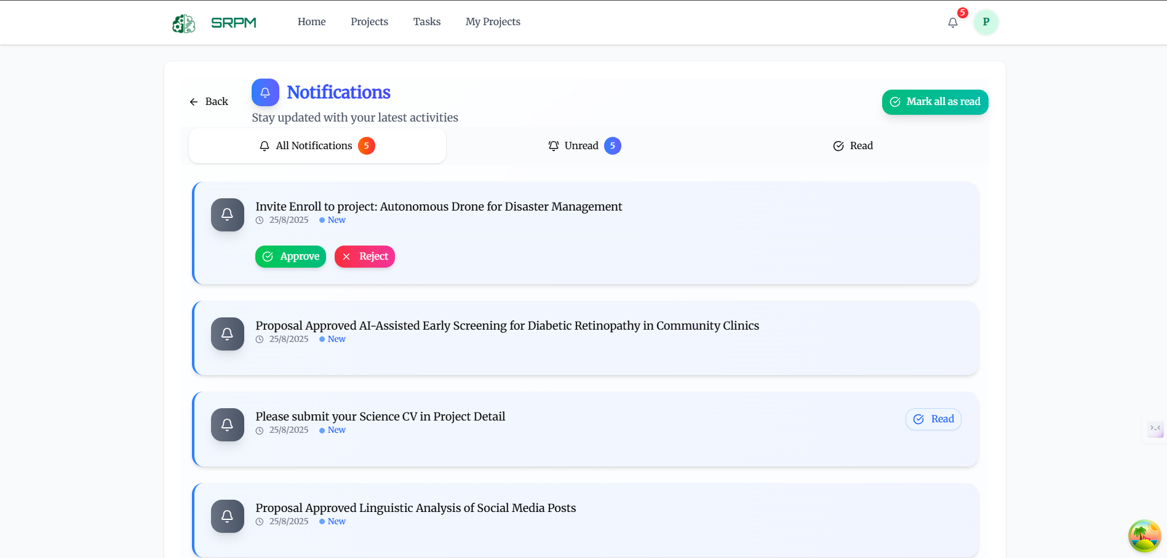

* If **Approved** and a CV already exists, the Researcher is automatically added to the project. If no CV is available, the system prompts them to upload or create one.

##### 

* **PI** reviews each Researcher’s participation status and CV, then clicks **Propose Project** to submit the proposal (including detailed forms and member list).

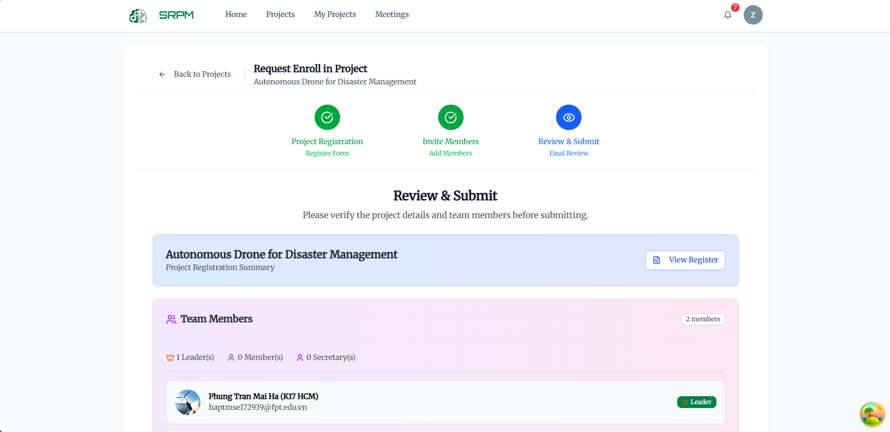

* **Staff** accesses the **Project Overview**, selects the proposal, and assigns an **Appraisal Council** (by creating or selecting a Council consisting of Chairman, Secretary, and Members).



### 3.4 WorkFlow 3

* Once the proposal is **Approved** by the **Council Chairman**, the project status changes to **In Progress**.



* **Staff** creates a **Contract** using the available form, then clicks **Save** to send it to the **PI**.



* **PI** opens the **Project Detail**, reviews the contract, makes adjustments if needed, and signs it.

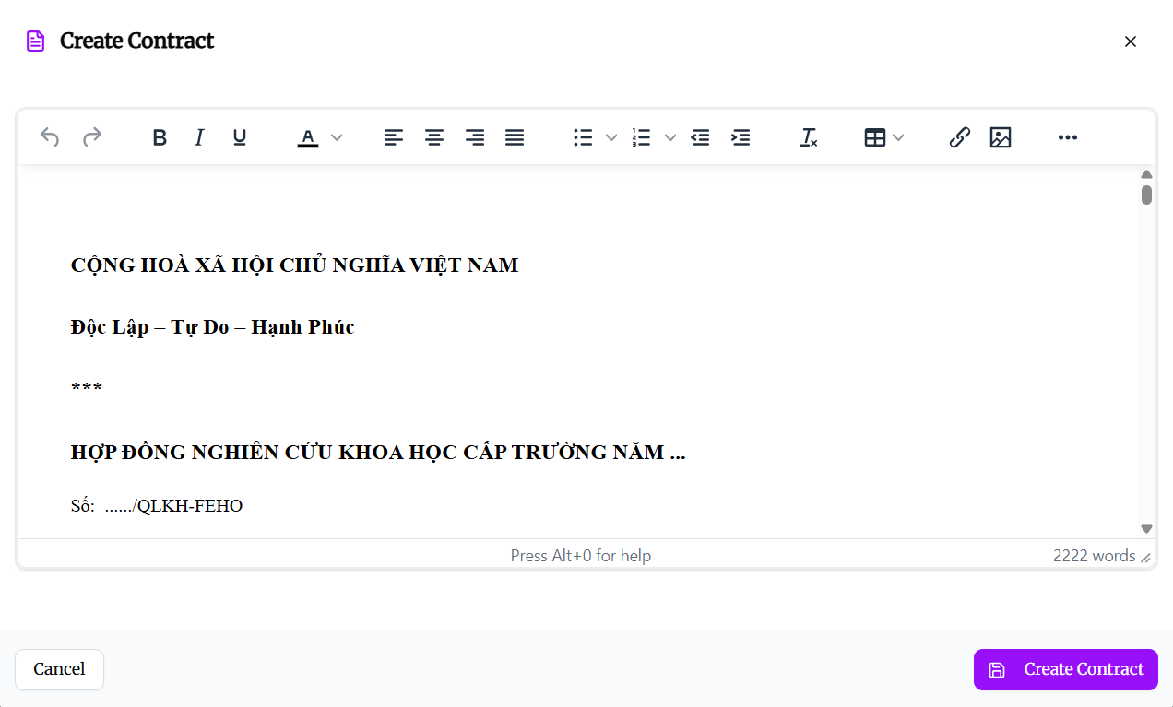

* **Staff** verifies the signature, sets up the **Milestones** and **Milestone Meetings**, manually adding missing entries if required, then clicks **Save & Close**.

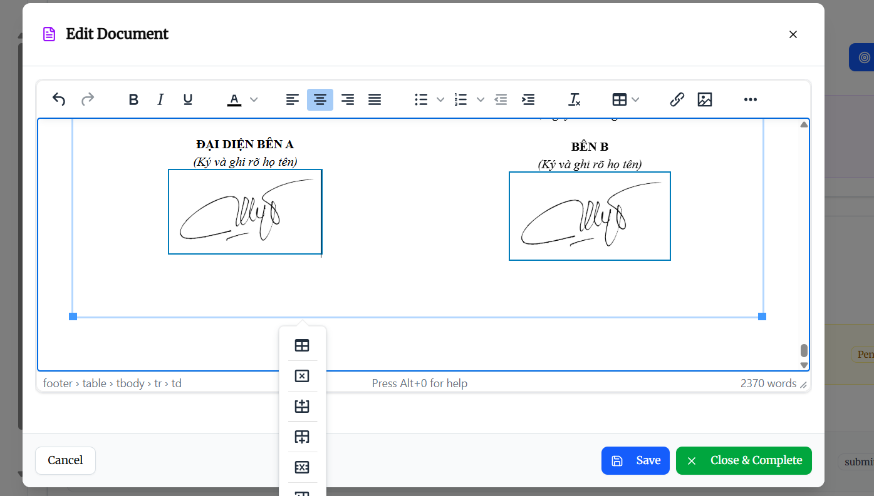

* The project officially starts. The **Leader** uses **Task Management** to create tasks and assign them to Researchers.



* **Researchers** carry out tasks and update progress in **Task Management**, while the **PI** monitors the overall team progress.

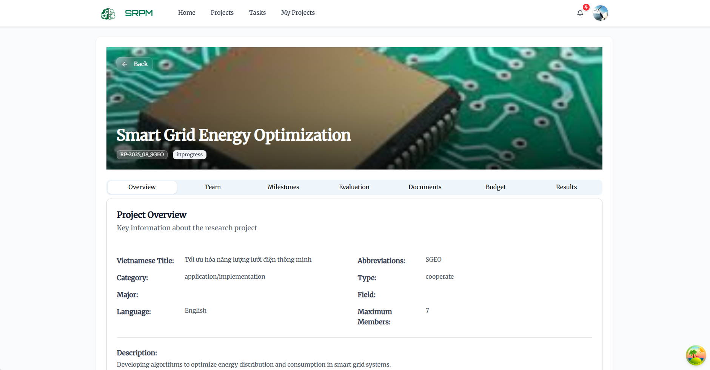

### 3.5 WorkFlow 4

* When a milestone is due, the **PI** prepares a progress report form and submits it via the system.

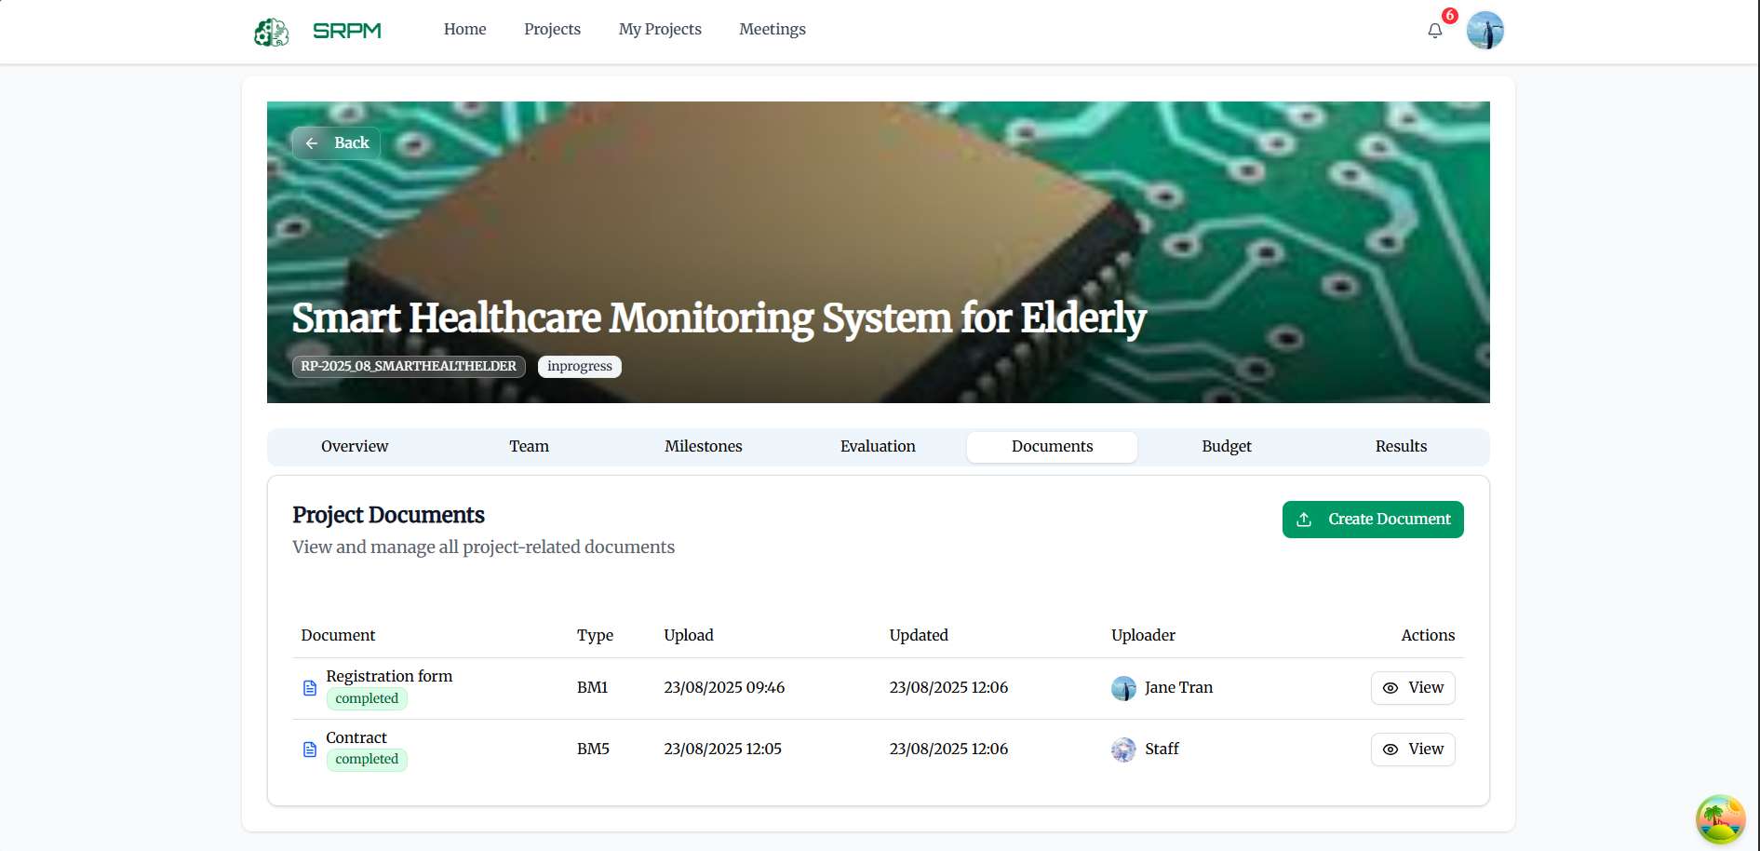

* The system notifies the **Appraisal Council**; the PI organizes a **Meeting** with the Council to evaluate milestone results.

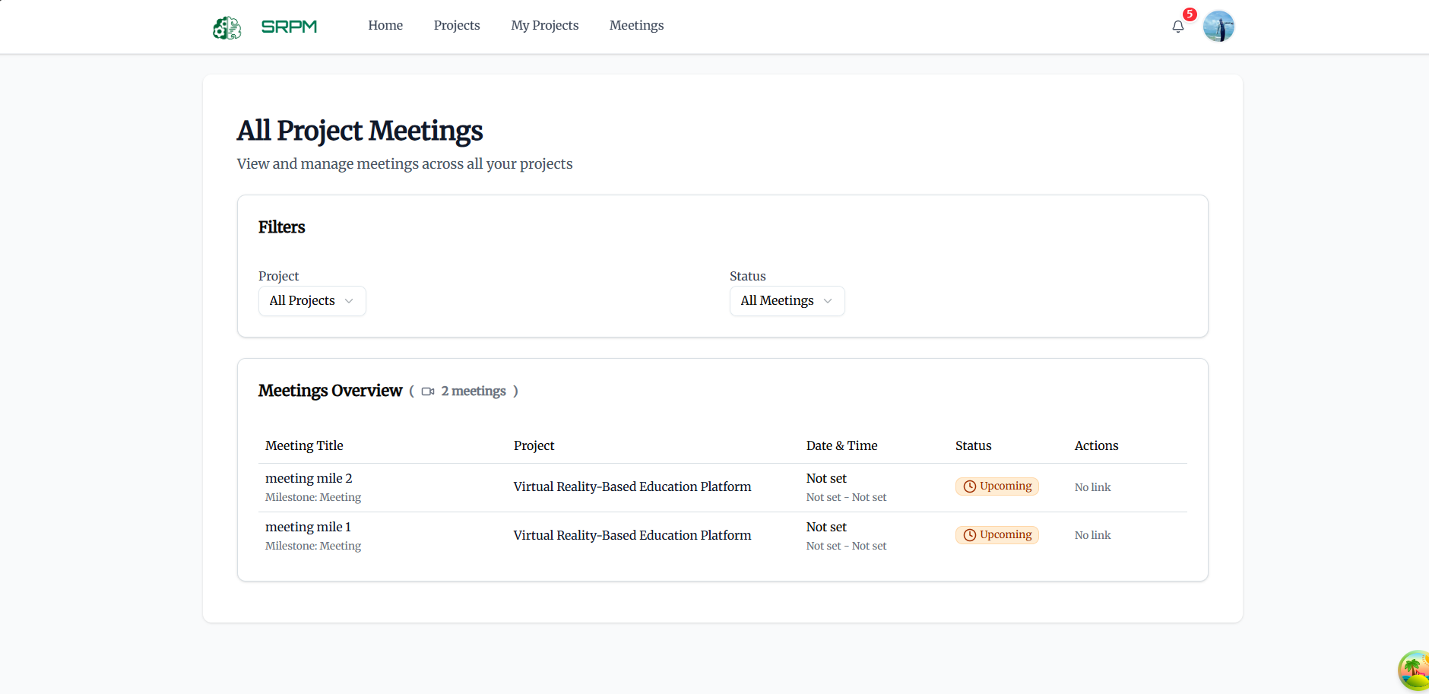

* **Council Members** score the milestone as **Pass/Fail**, and the **Chairman** announces the result.

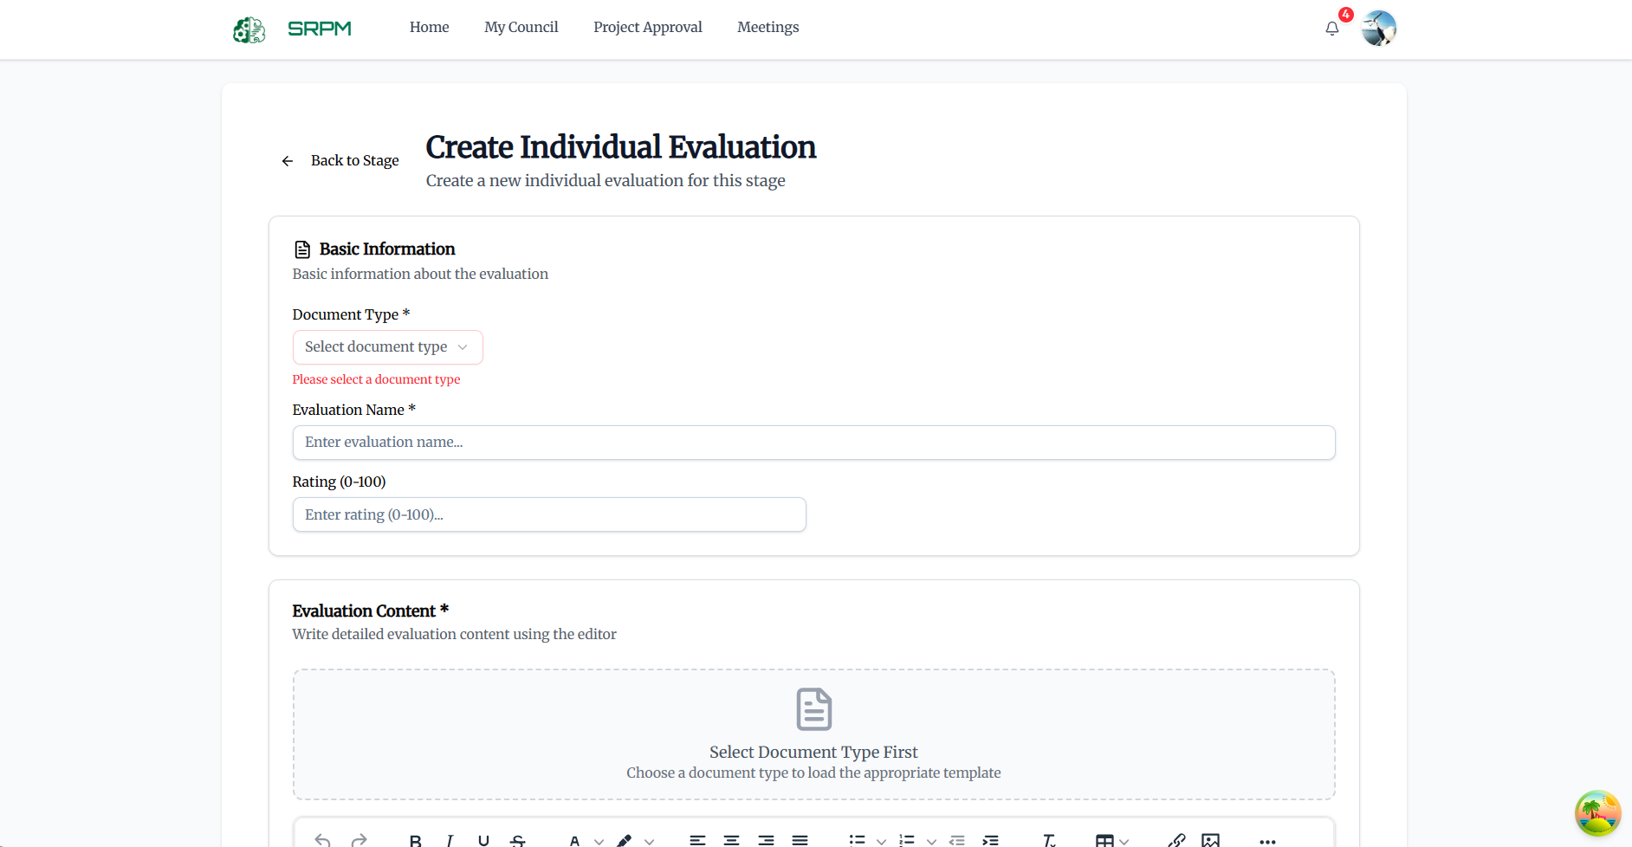

* If **Pass**, the **PI** clicks **Request Transaction** to propose milestone payment; if **Fail**, the PI revises the plan and continues implementation.

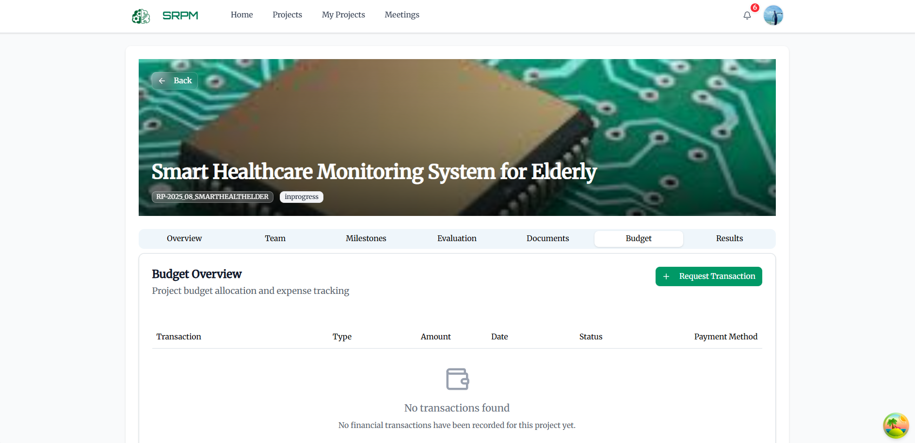

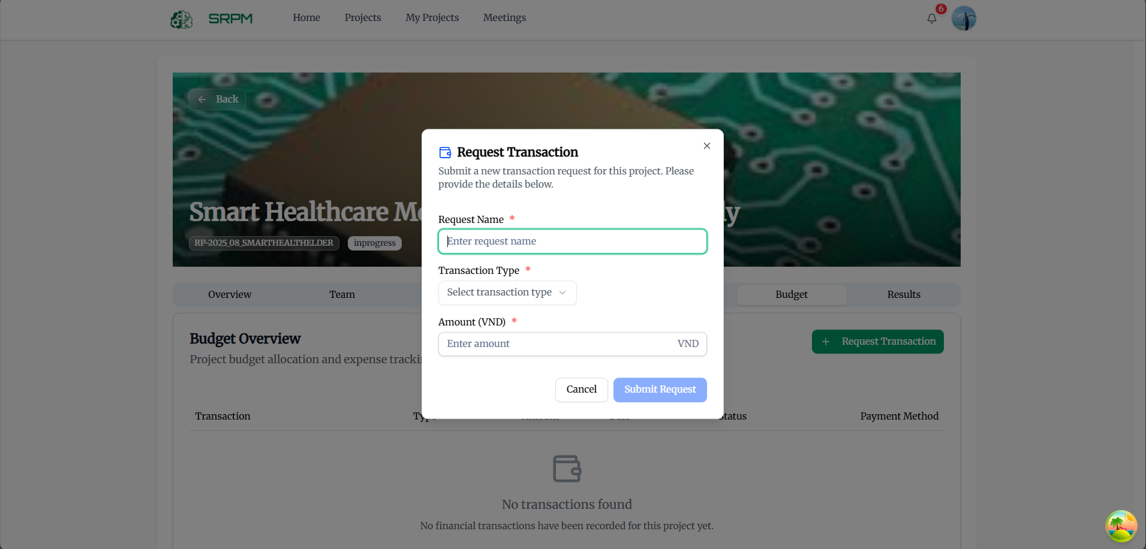

### 3.6 WorkFlow 5

* **Staff** receives the transaction request, reviews the documents, and processes milestone payment for the PI.

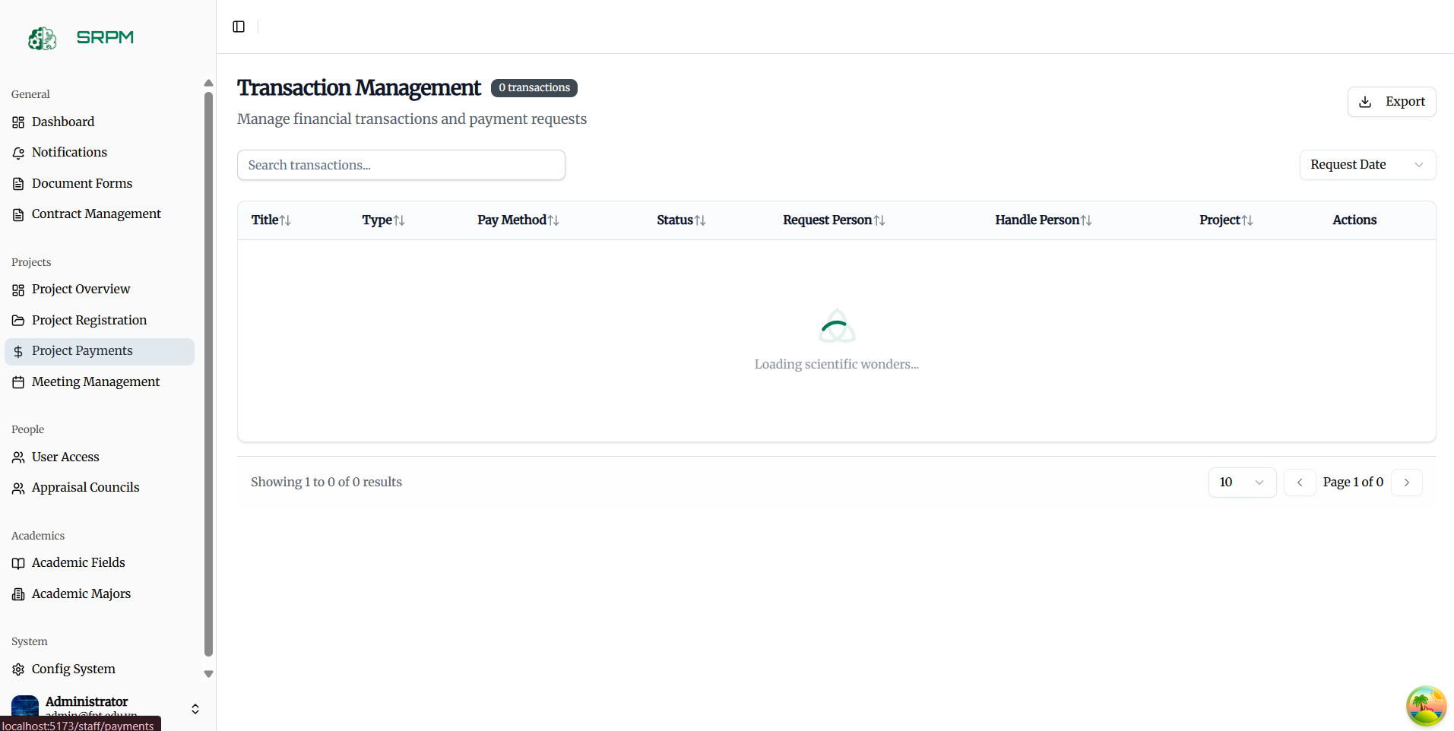

* Once all milestones are completed, the **PI** organizes a **Final Meeting** with the Council. The Council evaluates the project as **Pass/Fail**.





* If the project **Passes** and is of **Application type**, the team compresses the results into a ZIP file (≤ 30 MB) and uploads it to the system.



* If the project **Passes** and is of **Basic type**, the team must publish an article in the Vietnam Professors Association Journal (or equivalent) and provide the link in **Project Result** within 30 days of completion.

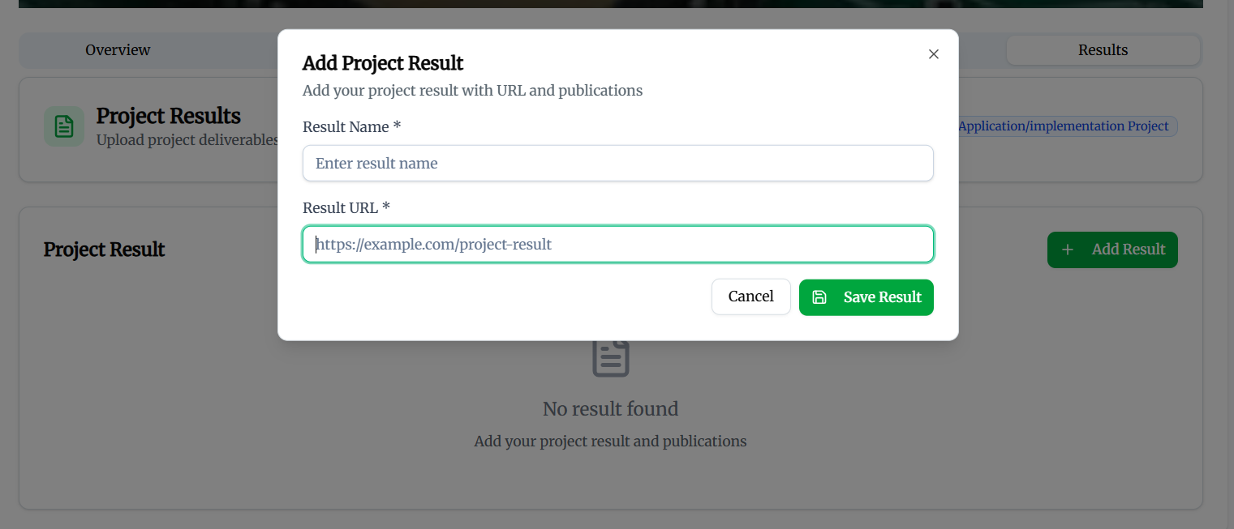

* **Staff** closes the project. After closure, the **PI** and **Researchers** retain **view-only access** to all project documents (no further edits allowed).